Extended Data Figures
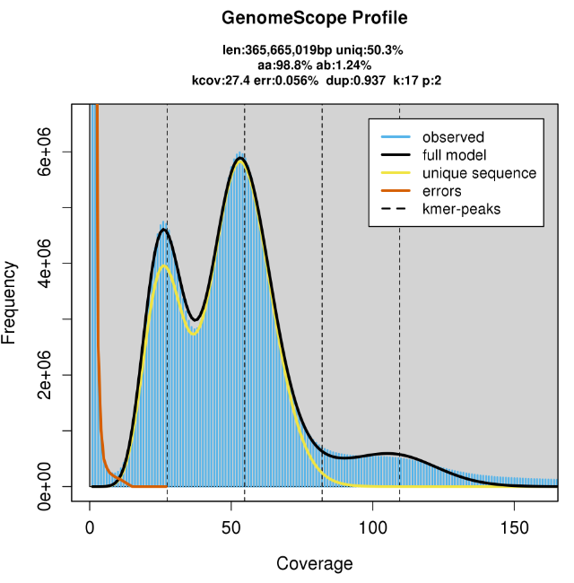
Extended Data Fig. 1 K-mer profile (K=17) spectrum generated in the Genome Scope for M. indica cv. 'Irwin'. K-mer profiles reveal the complexity of the genomes. Heterozygous genomes show a distinct bimodal profile and a simple poisson profile represents homozygous genomes. The relative heights of the peaks are proportional to the heterozygosity of the genome. Here, the characteristic bimodal profile indicated that the genome is heterozygous. The heterozygosity was estimated as 1.24% (Fig. 1). and the genome size was estimated as 365Mbp.

Extended Data Fig. 2 Alignment of (a) M. indica cv. 'Alphonso' genome vs 'Irwin' collapsed assembly, (b) 'Irwin' collapsed genome (20 chromosomes) vs 'Irwin' hap1 assembly, (c) 'Irwin' collapsed genome (20 chromosomes) vs 'Irwin' hap2 assembly.

Extended Data Fig 3 Alignments between contigs in chromosomes 8, 11, and 19 conducted in CLC-Genomic Workbench. A: alignment between the contigs ptg000014l and ptg000079l in chromosome 8; B: alignment between the contigs ptg000015l and ptg000035l in chromosome 11; C: alignment between the contigs ptg000813l and ptg000020l in chromosome 19. Here, regions aligned between two contigs have the same repetitive sequence. Among the two contigs in each alignment, the contig on the top is considered as the reference and the contig at the bottom is considered as the query. Colours indicate the sequence similarities/differences between two contigs. Green: both reference and query sequence have the identical nucleotide sequence; Red: Nucleotides are different between two contigs and bottom/query sequence has nucleotide Adenine (A); Blue: Nucleotides are different between two contigs and bottom/query sequence has nucleotide Cytosine (C); Yellow: Nucleotides are different between two contigs and bottom/query sequence has nucleotide Guanine (G); Yellowish green: Nucleotides are different between two contigs and bottom/query sequence has nucleotide Thymine (T).

Extended Data Fig. 4 Alignment of smaller contigs ranged between 16-1000Kb to chloroplast genome (a), mitochondrial genome (b), and ribosomal RNA repeats (c).

Extended Data Fig. 5 Summary of functional annotation for (a) collapsed, (b) Hap1, (c) Hap2 genomes and top hit species distribution for BLAST hits in (d) collapsed, (e) Hap1, (f) Hap2 genomes. A blastx search with an e-value cut-off of 1e-3 generated 40,679 CDS sequences (33,013 genes) having BLAST hits whereas hap1 and hap2 had 40,115 (32,576 genes) and 39,333 (31,690 genes) CDS sequences, respectively. For all three genomes, the largest number of BLAST hits were from M. indica and 32, 689 (76.12%), 32,140 (76.03%), and 31,667(77.33%) genes were annotated in the collapsed, hap1 and hap2 genomes respectively with at least one gene ontology (GO) term.

Extended Data Fig. 6 The coding potential assessment of CDS sequences that did not give a blast hit during functional annotation in the collapsed genome, hap1, and hap2 using (a) Arabidopsis thaliana, (b) Manifera indica and as model species. The analysis identified that 1,946 (80.4%), 2,005 (87.6%), and 1512 (88.0%) CDS sequences in respective collapsed, hap1 and hap2 genomes, which did not show any BLAST hits had coding potential when M. indica was used as the model. With Arabidopsis thaliana, the coding potential of the CDS was higher for all three genomes indicating 99.3%, 98.78%, and 99.07% of the CDS sequences showing coding potential in collapsed, hap1 and hap2 genomes.

Extended Data Fig. 7 Venn diagram displaying the shared and unique gene clusters among 'Irwin' collapsed genome, Hap1, and Hap2. Comparison among the three genomes ('Irwin' collapsed, hap1 and hap2) produced a total of 28,277 clusters from which 4,596 clusters were shared at least among two assemblies. A total of 88, 83, and 78 clusters were unique to the 'Irwin' collapsed genome, hap1 and hap2, respectively, including 687, 510, and 460 genes in the respective clusters. Furthermore, 1048, 936, and 817 singletons (genes which do not belong to any cluster but are unique in the genome) were identified in collapsed, hap1 and hap2 genomes, respectively, including a total of 1735, 1446, and 1223 unique genes in the respective genomes. GO analysis revealed that cellular processes is the biological process to which most of the unique genes of the three genomes were associated with while majority of the genes were related to binding function and catalytic activity in terms of molecular process. KEGG pathway analysis revealed that most of the unique genes/sequences in the collapsed genome were associated with purine metabolism followed by plant-pathogen interaction and thymine metabolism. In hap1, the highest number of unique genes were related to purine metabolism, where thymine and alpha-Linolenic acid metabolism were the two pathways involving the second and third highest number of genes. Furthermore, in hap2, the highest number of genes was involved in purine metabolism followed by thymine metabolism and the Ras signalling pathway.

Extended Data Fig. 8 Functions of unique genes obtained from gene family analysis with related to biological process and molecular function. In the collapsed genome, cellular processes and binding functions were the biological process and molecular function to which the highest number of genes were related. In both hap1 and hap2, most of the unique genes were related to cellular processes and catalytic activity in terms of biological process and molecular function, respectively. Many of the other unique genes in the collapsed genome were related to metabolic processes, response to stimuli, biosynthesis process and catalytic activity. In hap1, organic substance and cellular metabolic process, response to stimuli and organic cyclic compound, ion and cation binding were the other abundant GO terms while for hap 2, they were organic substance, organonitrogen compound, and cellular metabolic process, hydrolase activity, protein and ion binding.

