Supplementary material

Real-Time ENSO Forecast Skill Evaluated Over the Last Two Decades: Onset of ENSO Events

Authors: Muhammad Azhar Ehsan¹, Michelle L. L’Heureux², Michael K. Tippett³, Andrew W. Robertson¹, Jeffrey Turmelle¹

- International Research Institute for Climate and Society, Columbia Climate School at Columbia University, Palisades, New York, USA.
- Climate Prediction Center, National Oceanic and Atmospheric Administration, National Weather Service (NWS), National Centers for Environmental Prediction (NCEP), College Park, MD, United States.
- Department of Applied Physics and Applied Mathematics, Columbia University, New York, USA.

Nov 2023
Submission to
npj Climate and Atmospheric Science
______________________________________________________________________________
*To whom correspondence should be addressed: Muhammad Azhar Ehsan, International Research Institute for Climate and Society, Earth Institute at Columbia University, Palisades, New York, United States of America. Email: azhar@iri.columbia.edu

ABSTRACT
Containing supplementary figures for main manuscript.

- Supplementary Figures

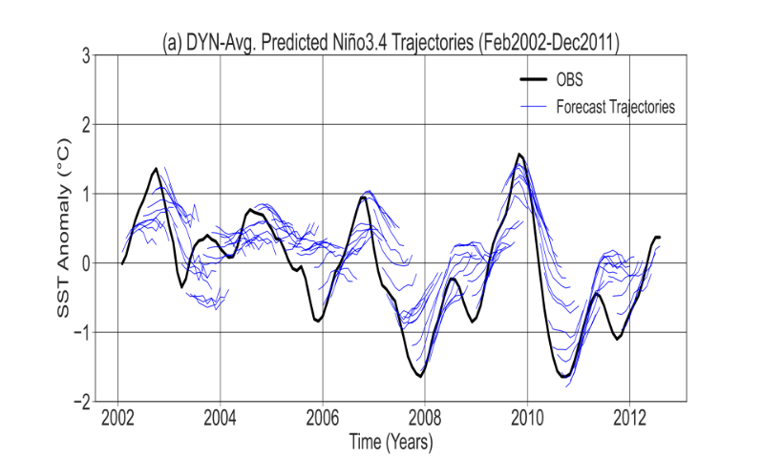 | 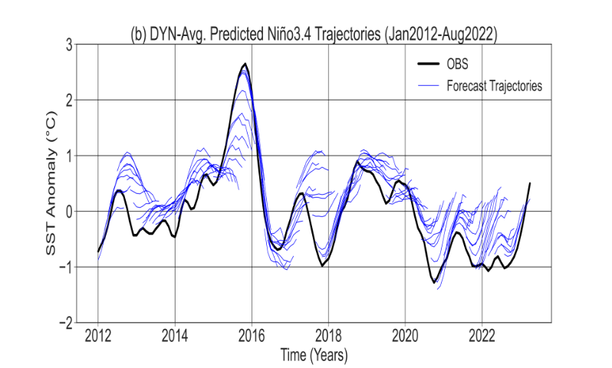
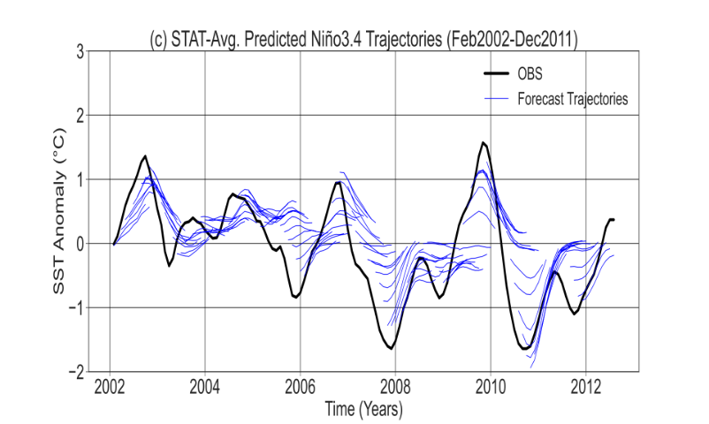 | 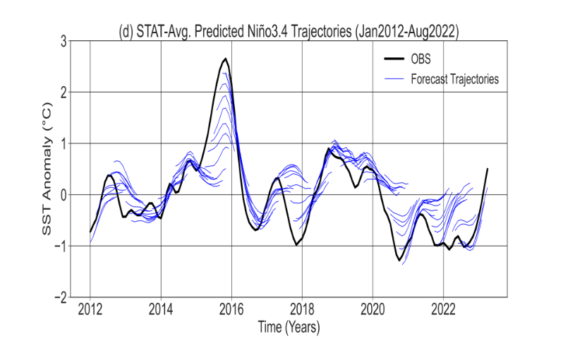
Figure S1: Dynamical (DYN: a, b) and statistical (STAT: c, d) forecasts for the Niño3.4 SST anomaly for overlapping 3-month periods from Feb-2002 to Aug-2022 initializations (247 Forecasts) and the corresponding observations. The observations are shown by the black line, while the forecasts are shown by the blue line. The verifying observed data is from the ERSSTv5.

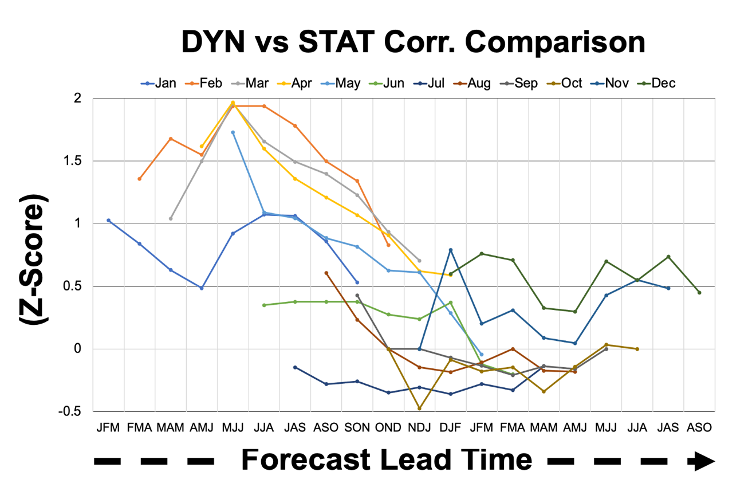
Figure S2: Correlation comparison analysis between the DYN and STAT forecasts, considering different start months and lead times. The z-score values greater than 1.5, indicating statistical significance at the 95% confidence levels. Negative values indicate instances where the STAT forecasts outperform the DYN forecasts. Notably, the figure demonstrates that during the forecasting period initialized in the boreal spring (specifically, February, March, April, and May), the DYN forecasts exhibit an advantage over the STAT forecasts.

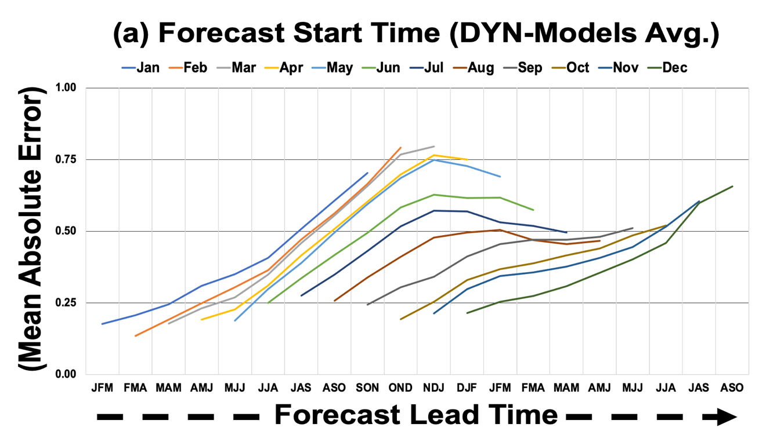
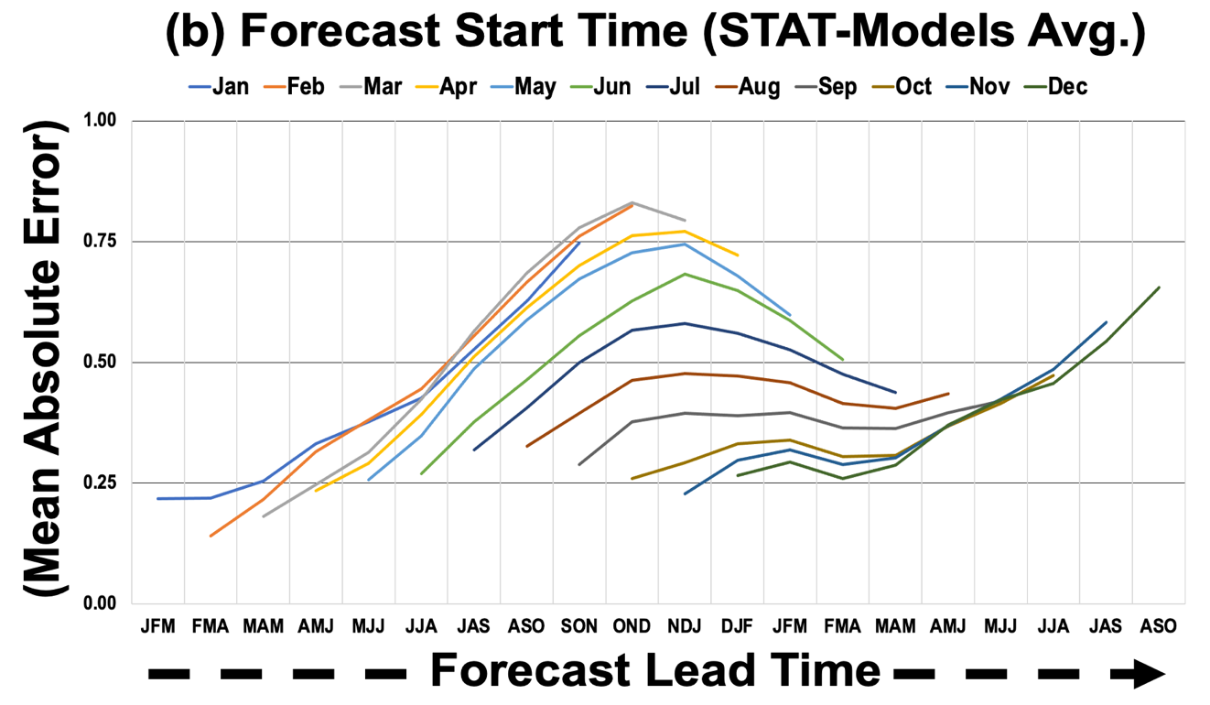
Figure S3: Mean absolute error for each start month and lead time for (a) DYN, (b) STAT forecasts. The forecast lead time specified in this context refers to the nine consecutive seasons starting from the issue month. It is based on the three-month overlapping seasonal average of the Niño 3.4 index value.

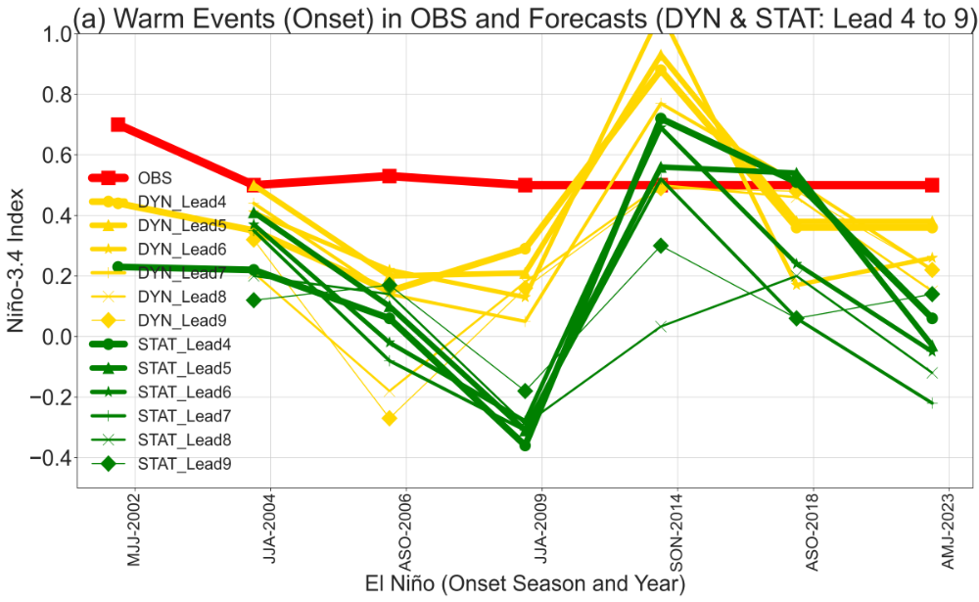
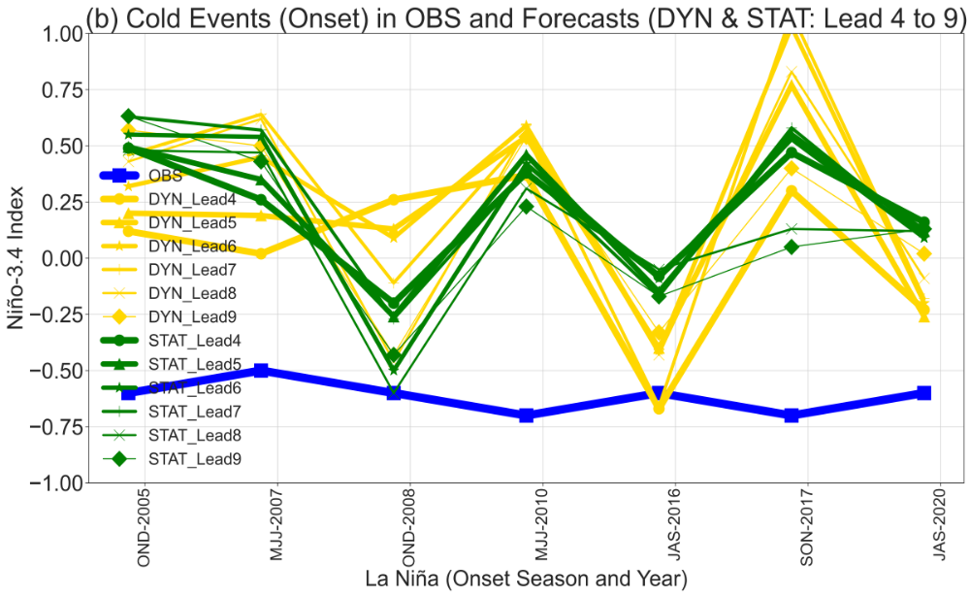
Figure S4: Onset (season and year) of (a) El Niño and (b) La Niña in observation (thick red and blue lines) and Forecasts (DYN and STAT). The DYN and STAT forecasts are shown by yellow and green lines for Lead-4, 5, 6, 7, 8, and 9.
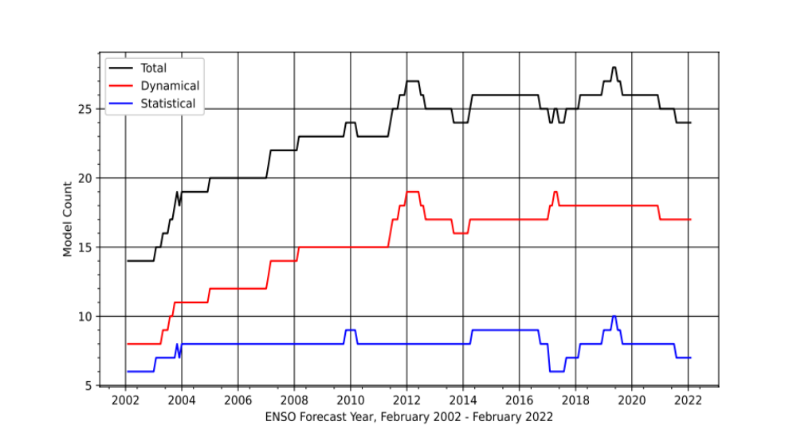
Figure S5: The count of dynamical (illustrated by the red curve) and statistical (represented by the blue curve) models that have made contributions to the IRI ENSO Plume since its initiation in February 2002. The combined total of models (dynamical + statistical) that have contributed to the plume is represented by the black curve. The horizontal axis of the graph indicates the forecast year.

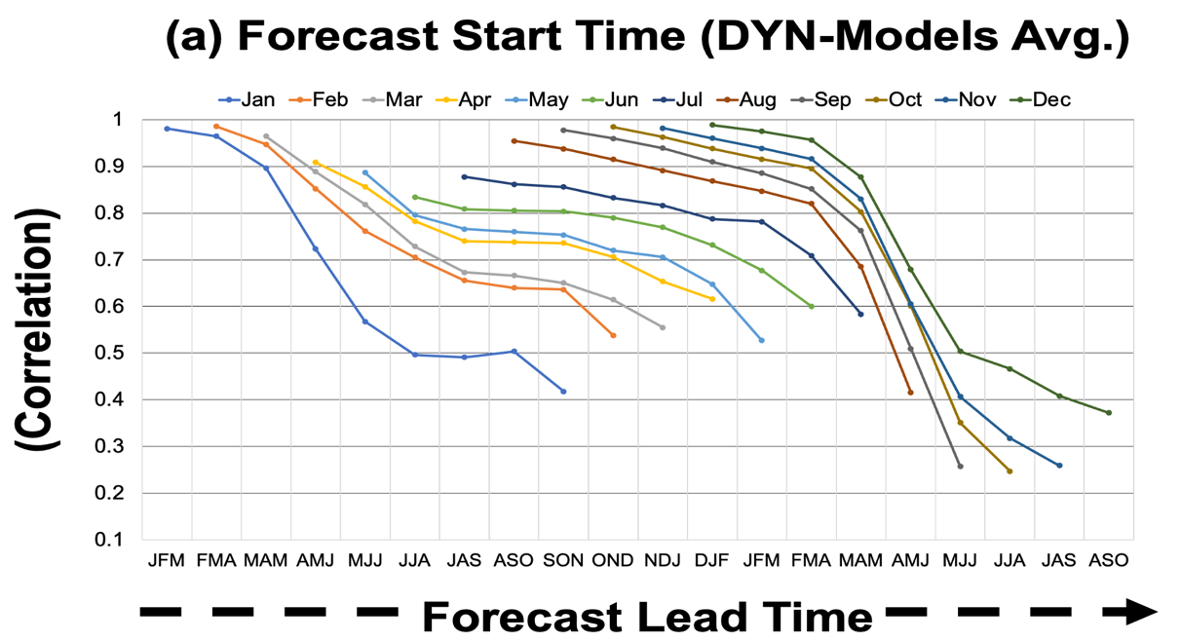
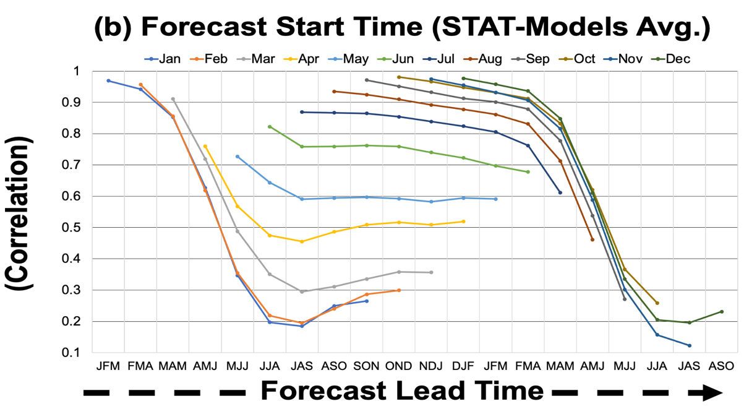
Figure S6: Like the Figure 3. The presented figure illustrates correlation coefficients for (a) DYN, (b) STAT forecasts, calculated using a variable observed climatology period. The forecast lead time specified in this context refers to the nine consecutive seasons starting from the issue month. It is based on the three-month overlapping seasonal average of the Niño 3.4 index value. A value higher than 0.45 shows a statistically significant correlation.

