Supplementary Online Materials for:
Do Infants Expect Reciprocity Between Strangers?
Kyong-sun Jin, Fransisca Ting, Zijing He, and Renée Baillargeon

Supplementary materials include:
A. Table S1, presenting infants’ mean looking times in the familiarization and test trials of Experiments 1−3.
B. Figures S1 and S2, depicting the events shown to infants in Experiment 3.
C. Overall analyses of the test data obtained with infants in Experiments 2 and 3.
D. Online surveys with adults.
E. Reference.
A. Table S1
Mean looking times (and standard deviations) during the familiarization and test trials of Experiments 1−3, by group, subgroup, and condition.
 |  | Familiarization Trials |  |  | Test Trial
 | N | Give Condition | Steal Condition | Both Conditions | Give Condition | Steal Condition | Both Conditions
Experiment 1: Baseline  Group | 40 (20 per condition) | 14.48  (4.83) | 14.28  (5.41) | 14.38  (5.06) | . | . | .
Experiment 2: Inconsistent Group | 40 (20 per condition) | 13.12  (4.48) | 14.96  (6.62) | 14.04  (5.66) | 19.08  (7.79) | 19.74  (7.30) | 19.41  (7.46)
Experiment 2: Control  Group | 40 (20 per condition) | 14.06  (7.14) | 12.89  (5.83) | 13.48  (6.46) | 12.04  (5.42) | 12.42  (5.64) | 12.23  (5.46)
New-Agent Subgroup | 20 (10 per condition) | 15.18  (7.82) | 13.88  (6.91) | 14.53  (7.21) | 12.15  (5.06) | 11.79  (6.19) | 11.97  (5.51)
No-Knowledge Subgroup | 20 (10 per condition) | 12.94  (6.61) | 11.90  (4.66) | 12.42  (5.59) | 11.92  (6.03) | 13.04  (5.28) | 12.48  (5.55)
Experiment 3: Consistent Group | 40 (20 per condition) | 11.87  (3.47) | 12.33  (5.68) | 12.10  (4.65) | 10.18  (4.52) | 11.37  (4.97) | 10.78  (4.73)
In-Kind Subgroup | 20 (10 per condition) | 11.41  (4.47) | 14.52  (6.50) | 12.97  (5.66) | 10.02  (5.98) | 12.18  (5.29) | 11.10  (5.61)
No-Engagement Subgroup | 20 (10 per condition) | 12.32  (2.24) | 10.14  (3.89) | 11.23  (3.28) | 10.34  (2.69) | 10.56  (4.76) | 10.45  (3.77)

B. Figures S1 and S2 for Experiment 3
Figure captions
Fig. S1. Familiarization and test trials presented in the give and steal conditions of the in-kind subgroup of the consistent group in Experiment 3. In each condition, agent2 chose to respond in kind to agent1’s actions: She helpfully stored agent1’s decorated paper in the give condition, and tore it up in the steal condition. In each condition, the actions shown in the first two squares of the test trial were repeated as agent1 decorated and stored two papers. The test trial was preceded by a brief pretest trial (not shown) in which agent1 sat alone (agent2’s window was closed) and prepared and stored two additional papers.
Fig. S2. Familiarization and test trials presented in the give and steal conditions of the no-engagement subgroup of the consistent group in Experiment 3. In each condition, agent2 opted to not engage with agent1 further: She picked up the decorated paper, looked at it, and then returned it to its original position on the apparatus floor, out of agent1’s reach. In each condition, the actions shown in the first two squares of the test trial were repeated as agent1 decorated and stored two papers. The test trial was preceded by a brief pretest trial (not shown) in which agent1 sat alone (agent2’s window was closed) and prepared and stored two additional papers.
C. Overall analyses of the test data in Experiments 2 and 3
In a final overall analysis (N = 120), we compared the looking times of infants in the give and steal conditions of the inconsistent (Experiment 2), control (Experiment 2), and consistent (Experiment 3) groups during the final phase of the test trial. To this end, we conducted an ANOVA with group (inconsistent, control, consistent) and condition (give, steal) as between-subjects factors. The only significant effect was the main effect of group, F(2, 114) = 23.27, p = .000, η_{p}² = 0.29.
We followed up this main effect with six planned comparisons, using a Bonferroni-adjusted α-level of .05/6 = 0.008. First, overall contrasts confirmed that infants in the inconsistent group looked significantly longer than those in the control and consistent groups, F(1, 114) = 45.40, p = .000, η_{p}² = 0.28, who did not differ significantly, F(1, 114) = 1.15, p = .287, η_{p}² = 0.01. Next, we conducted the same two contrasts within each condition, with similar results. Thus, in the give condition (N = 60), the inconsistent group looked significantly longer than the other two groups, F(1, 114) = 23.06, p = .000, η_{p}² = 0.17, who did not differ significantly, F(1, 114) = 0.94, p = .335, η_{p}² = 0.01. Similarly, in the steal condition (N = 60), the inconsistent group looked significantly longer than the other two groups, F(1, 114) = 22.34, p = .000, η_{p}² = 0.16, who did not differ significantly, F(1, 114) = 0.30, p = .587, η_{p}² = 0.00.
As discussed in the main text, these results support several conclusions. First, in each group, infants in the give and steal conditions showed the same response pattern, indicating that, in this situation at least, infants were equally adept at reasoning about positive and negative reciprocity. Second, infants in the inconsistent group detected a reciprocity violation in agent2’s actions: After agent1 gave cookies to agent2, infants viewed it as unacceptable for agent2 to harm her; similarly, after agent1 stole agent2’s cookies, infants viewed it as unacceptable for agent2 to help her. Third, infants in the control group detected no violation in agent2’s actions; even though these actions were the same as in the inconsistent group, they were no longer knowingly directed at agent1, so that considerations of reciprocity did not apply. Lastly, infants in the give and steal conditions of the consistent group also detected no violation in agent2’s actions, suggesting that they viewed the test outcomes they were shown (with agent2 choosing to respond in kind to agent1 or to not engage with her further) as broadly consistent with reciprocity.
D. Online surveys with adults
How would adults respond to scenarios such as those we showed infants in Experiments 1−3? To find out, we conducted two online Qualtrics surveys. The first asked adults to rate the value of individual actions similar to those produced by agent1 and agent2 in our infant experiments. The second survey asked adults to rate the plausibility of various actions produced by agent2 in response to positive or negative actions by agent1, again using scenarios similar to those in our infant experiments. We speculated that finding salient similarities between infants’ and adults’ evaluations would support our interpretation of infants’ responses.
Value survey. Our first survey asked adults to rate the value (valence and magnitude) of actions similar to those we showed infants in our experiments; we told participants that we were preparing scenarios for a study with young children. Each scenario described a brief interaction between two strangers who happened to be sitting near each other in a waiting room. In each scenario, one stranger produced a particular action toward the other; across scenarios, different letters were used to refer to the two strangers (e.g., A and B, C and D, and so on), but for ease of description we use agent1 and agent2 here. There were eight scenarios in total. Two involved cookie stories: In one, agent1 gave a cookie to agent2, who had none; in the other, agent1 and agent2 each had a cookie, and agent1 stole agent2’s cookie. Three scenarios involved sticker stories: While agent1 watched, agent2 affixed stickers to a page in a sticker book; one sticker fell out of her reach under agent1’s chair, just before agent2 was called away; after she left, leaving her things behind, agent1 picked up the sticker and chose to help (she placed the sticker near the sticker book), ignore (she looked at the sticker then dropped it back under her chair), or harm (she tore up the sticker then dropped the pieces back under her chair). The final three scenarios involved coloring stories: Agent1 and agent2 were both coloring in their coloring books, and one of them was missing a green crayon to finish the page she was working on; agent1 again chose to help (she gave her green crayon to agent2, who lacked one), ignore (she did nothing to help agent2), or harm (she herself lacked a green crayon and stole that of agent2 after she was called away). Scenarios were presented in random order. After reading a scenario, participants rated agent1’s action on a 1-7 scale, ranging from very negative to very positive, with 4 as a neutral point (neither negative nor positive). Ratings for the help, ignore, and harm scenarios were averaged across the sticker and coloring stories.
Participants were 115 adults (63 male, 46 female, and 6 other; mean age = 26.33 years, range = 18-35 years); they were recruited through Prolific and paid $1.25 for their participation. Another 4 participants were tested but excluded because the difference in their mean ratings of the moderately positive and negative scenarios was over 3 standard deviations from the group mean. Each participant provided informed consent, and the protocol was approved by the Institutional Review Board at the University of Illinois at Urbana-Champaign (We did not conduct a power analysis to determine how many adults to include in each survey. In a recent report¹ on infant sociomoral reasoning where we also used an online survey with adults as a manipulation check, we tested 110 adults; in line with this number, we simply chose to include at least 100 adults in each of the present surveys, and ended up with 115 participants in the first and 130 in the second).
The give-cookie story was rated as moderately positive (M = 6.63, SD = 0.61), as were the help scenarios (M = 6.30, SD = 0.84). Conversely, the steal-cookie (M = 1.20, SD = 0.44) and harm scenarios (M = 1.54, SD = 0.54) were rated as moderately negative. Finally, the ignore scenarios were rated as mildly negative (M = 3.23, SD = 0.64). Participants were highly consistent in their rankings, with 95% giving higher ratings to (a) to the help vs. the ignore scenarios and (b) the ignore vs. the harm scenarios. Finally, 98% of participants gave ratings above 4 (i.e., in the positive range) to the help scenarios, 87% gave ratings below 4 (i.e., in the negative range) to the ignore scenarios, and 100% did the same for the harm scenarios. These results dovetailed well with our descriptions of the valences and magnitudes of the actions shown to infants in our experiments.
Reciprocity survey. Our second survey built closely on the first and presented a new group of adults with scenarios depicting a sequence of two brief interactions between two strangers. As before, different letters were used to refer to the two strangers in each scenario (e.g., A and B, C and D, and so on), but here we use agent1 and agent2 for ease of description. In each scenario, agent1 first either gave a cookie to agent2 or stole her cookie. Next, agent2 produced the help, ignore, or harm actions from the sticker and coloring stories used in the first survey.
Adults were presented with 12 scenarios in total, in four blocks of three scenarios. The first block always involved the give-sticker scenarios, as pilot data suggested that seeing give scenarios first helped anchor adults’ ratings. The other three blocks (the give-crayon, steal-sticker, and steal-crayon scenarios) were presented in random order. Within each block, the help, ignore, and harm scenarios were presented in random order. After reading each scenario, adults were asked to rate the plausibility of agent2’s action, in the context of agent1’s action, on a 1-7 scale ranging from very plausible to very implausible (reverse-scored), with 4 as a neutral point (neither plausible nor implausible); reciprocity was never mentioned. As before, ratings were averaged across the sticker and coloring stories.
Participants were 130 adults (63 male, 61 female, and 6 other; mean age = 27.19 years, range = 18-35 years); they were recruited through Prolific and paid $1.25 for their participation. Another 47 participants were tested but excluded: 26 failed to understand or comply with the survey’s instructions and rated agent2’s action without taking account of agent1’s action, 13 completed the survey very quickly, and 8 gave identical answers throughout the survey. Each participant provided informed consent, and the protocol was approved by the Institutional Review Board at the University of Illinois at Urbana-Champaign.
To facilitate comparisons between our infant and adult data, we organized the scenarios presented to adults in two conditions (give, steal) and three groups: inconsistent scenarios (give/harm, steal/help), consistent in-kind scenarios (give/help, steal/harm), and consistent no-engagement scenarios (give/ignore, steal/ignore). Next, we analyzed adults’ ratings using an ANOVA with group (inconsistent, consistent in-kind, consistent no-engagement) and condition (give, steal) as within-subjects factors (Fig. S3). This analysis yielded a significant main effect of group, F(2, 258) = 334.09, p = .000, η_{p}² = 0.72, a significant main effect of condition, F(1, 129) = 8.65, p = .004, η_{p}² = 0.06, and a significant Group × Condition interaction, F(2, 258) = 43.63, p = .000, η_{p}² = 0.25.
To follow up on these results, we conducted eight contrasts, using a Bonferroni-adjusted α-level of .05/8 = 0.006. The first six contrasts indicated that (a) overall, adults rated the inconsistent scenarios as significantly more implausible than either the consistent in-kind scenarios, F(1, 129) = 478.17, p = .000, η_{p}²= 0.79, or the consistent no-engagement scenarios, F(1, 129) = 259.90, p = .000, η_{p}²= 0.67; (b) in the give condition alone, the inconsistent scenarios were again rated as significantly more implausible than either the consistent in-kind scenarios, F(1, 129) = 658.90, p = .000, η_{p}²= 0.84, or the consistent no-engagement scenarios, F(1, 129) = 179.12, p = .000, η_{p}²= 0.58; and (c) the same pattern also held in the steal condition alone, with the inconsistent scenarios receiving significantly higher ratings than either the consistent in-kind scenarios, F(1, 129) = 94.59, p = .000, η_{p}²= 0.42, or the consistent no-engagement scenarios, F(1, 129) = 135.17, p = .000, η_{p}²= 0.51.
The last two contrasts followed up on the significant Group × Condition interaction found in the ANOVA. Inspection of Fig. S3 suggested that adults responded somewhat differently to the two types of consistent scenarios in the give and steal conditions. Indeed, our final contrasts indicated that in the steal condition, the in-kind (steal/harm) and no-engagement (steal/ignore) scenarios tended to receive similar ratings, F(1, 129) = 1.11, p = .295, η_{p}² = 0.01, whereas in the give condition, the no-engagement (give/ignore) scenarios received significantly higher ratings than the in-kind (give/help) scenarios, F(1, 129) = 239.27 p = .000, η_{p}² = 0.65. Adults thus viewed the give/ignore scenarios as somewhat more implausible than the give/help scenarios. Nevertheless, one-sample t-tests confirmed that adults rated both the give/ignore scenarios, t(129) = -7.19, p = .000, and the give/help scenarios, t(129) = -42.58, p = .000, as significantly below 4, the neutral point on the scale, and thus as broadly plausible.
Harking back to the results of the value survey described above, the following patterns emerged. First, after agent1 gave agent2 a cookie (a moderately positive action), adults viewed it as implausible for agent2 to harm agent1 (a moderately negative action), but they viewed it as plausible for agent2 to help her (a moderately positive action) and, to a lesser extent, to ignore her need for help (a mildly negative action). Second, after agent1 stole agent2’s cookie (a moderately negative action), adults viewed it as implausible for agent2 to help agent1 (a moderately positive action), but they viewed it as equally plausible for agent2 to harm her (a moderately negative action) or to ignore her need for help (a mildly negative action). Thus, in each condition, adults did not rate only reciprocal actions that exactly matched agent1’s initial action in valence and magnitude as plausible: They considered a range of actions by agent2 as broadly plausible.
In conclusion, the adults in our reciprocity survey rated the inconsistent scenarios as more implausible than the consistent in-kind and no-engagement scenarios, presumably because they viewed the inconsistent scenarios as violating reciprocity. Moreover, this finding held true in the give and steal conditions separately. Adults’ responses thus echoed those of infants, supporting our interpretations of infants’ looking-time patterns. The main difference between the two age groups involved the give/ignore scenarios. To infants, these scenarios seemed merely to convey agent1’s decision not to engage with agent1 further. To adults, however, the actions needed to help agent1 (i.e., picking up her fallen sticker and bringing it closer to her sticker book, loaning her a green crayon) may have appeared so trivial that choosing to ignore her instead came across as conveying some degree of unfriendliness toward her, rather than a mere decision not to engage with her further. This difference aside, adults’ and infants’ responses were markedly similar, hinting at underlying similarities in their intuitions about reciprocity between strangers. Still, caution is needed in drawing this conclusion, as our scenarios were specifically designed to study infants’ rather than adults’ intuitions about reciprocity.

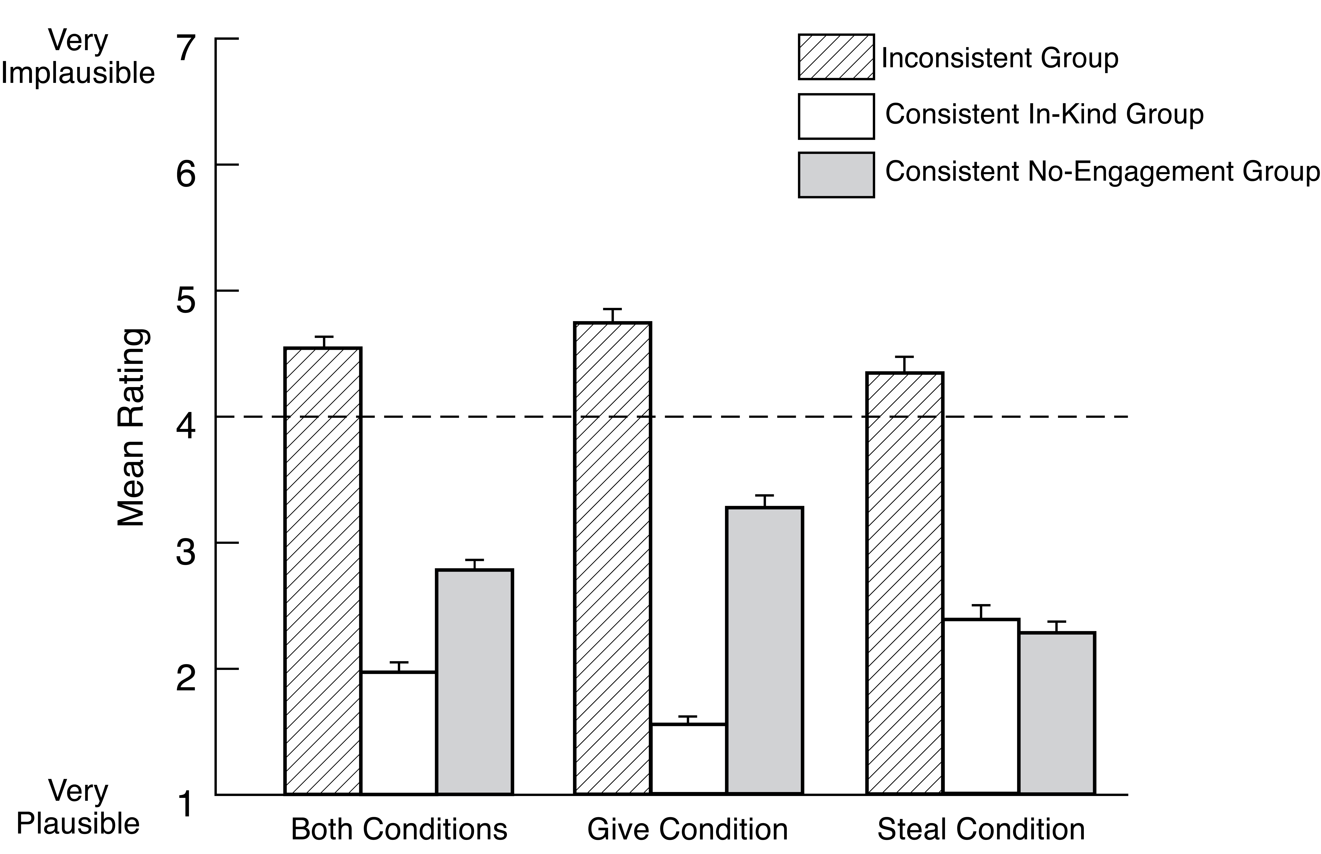
Fig. S3. Adults’ mean plausibility ratings for the different groups of scenarios, in the give and steal conditions separately as well as in both conditions overall.

E. Reference
1. Bian L, Baillargeon R (2022) When are similar individuals a group? Early reasoning about similarity and in-group support. Psychol Sci 33:752-764.

