Supplementary Material

Effect of Stress Urinary Incontinence on Vaginal Microbiota Stability
Man Zhang^{1†}, Yanhua Zhou^{2†}, Siqi Yao¹, Yiming Zhao¹, Syeda Sundas Batool ¹, Jing Huang³, Li Jiang², Dayu Yan⁴, Wenguang Yan^{2*}, Zheng Yu^{1*}
* Correspondence:
Zheng Yu, E-mail: yuzheng@csu.edu.cn
Wenguang Yan, E-mail: ywgpmn@csu.edu.cn

Supplementary Tables
Table.S1 Clinical characteristics of the study subjects
Variables | Urinary incontinence (UI)  Non-SUI (n = 19) SUI (n = 13) |  | P
Age | 33.5(28-43) | 33.5(25-42) | 1.00
BMI | 21.43±1.18 | 23.53±2.61 | 0.03
Overweight (BMI>24)
yes | 2(10.52%) | 6(46.15%)
no | 17(89.48%) | 7(53.85%)
Gestation | 2.05±1.22 | 1.76±1.09 | 0.47
Parturition | 1.57±0.60 | 1.46±0.66 | 0.57
Vaginal Delivery(VD) vs cesarean section(CS)
VD | 12(63.16%) | 7(53.84%)
CS | 7(46.84%) | 6(46.16%)
gainweight | 12.55±3.55 | 13.76±4.86 | 0.73
birthweight | 3.46±0.30 | 3.17±0.73 | 0.52
Continuous data were reported by mean ± standard deviation (SD).
The Mann-Whitney U test was used to count the differences between SUI and Non-SUI.
Continuous data were reported by mean ± standard deviation (SD).
The Mann-Whitney U test was used to count the differences between SUI and Non-SUI.

Table.S2 Binary logstics regression analysis
 | Bª | Standard Error^{b} | Wald^{c} | P^{e} | OR^{f}
age | -0.141 | 0.108 | 1.686 | 0.194 | 0.869
SUI (1) | 4.419 | 1.831 | 5.821 | 0.016 | 82.977
Way (1) | 0.306 | 1.228 | 0.062 | 0.803 | 1.358
Gestation | 0.089 | 0.436 | 0.042 | 0.838 | 1.093
Parturition | -0.307 | 1.081 | 0.08 | 0.777 | 0.736
BMI | -0.523 | 0.294 | 3.173 | 0.075 | 0.593
gainweight | -0.181 | 0.151 | 1.423 | 0.233 | 0.835
birthweight | -0.767 | 1.844 | 0.173 | 0.677 | 0.464
Independent variable: age, SUI, way, Gestation, Parturition, BMI, gainweight, birthweight
Dependent variable: vaginal dysbacteriosis
SUI (1): stress urinary incontinence (0 means no stress urinary incontinence)
way (1): Vaginal Delivery (0 means cesarean section)
OR^{f}: Reflections where there is an effect of the independent variable on the dependent variable, OR > 1 indicates that the independent variable will promote the occurrence of the dependent variable outcome.

Table S3. The topological features of network
 | Nodes ª | Edges^{b} | Average modularity_class ^{c} |  | Average clustering ^{d} | Average triangles ^{e} | Average closnesscentrality ^{f} | Average degree ^{g}
Non-SUI  SUI | 96  200 | 133  409 | 15.69  18.07 | 0.22  0.31 |  | 2.94  4.35 | 0.51  0.21 |  | 2.77  4.09
a Number of OTUs with the correlation r > 0.6 or r < –0.6 and statistical significance (P < 0.05)
b Number of strong and significant correlations between nodes
c The number of modular structures, modularity indicates that some nodes in the network are more densely connected to each other than to the rest of the network and that their density is significantly higher than the average value of the graph.
d The extent to which nodes are clustered together
e The more the number of triangles formed, the more connected the nodes are in the network
f The node is connected to the whole network, the higher the value, the greater the role played in the network diagram
g The average number of steps along the shortest paths for all possible pairs of network nodes

Supplementary Figures
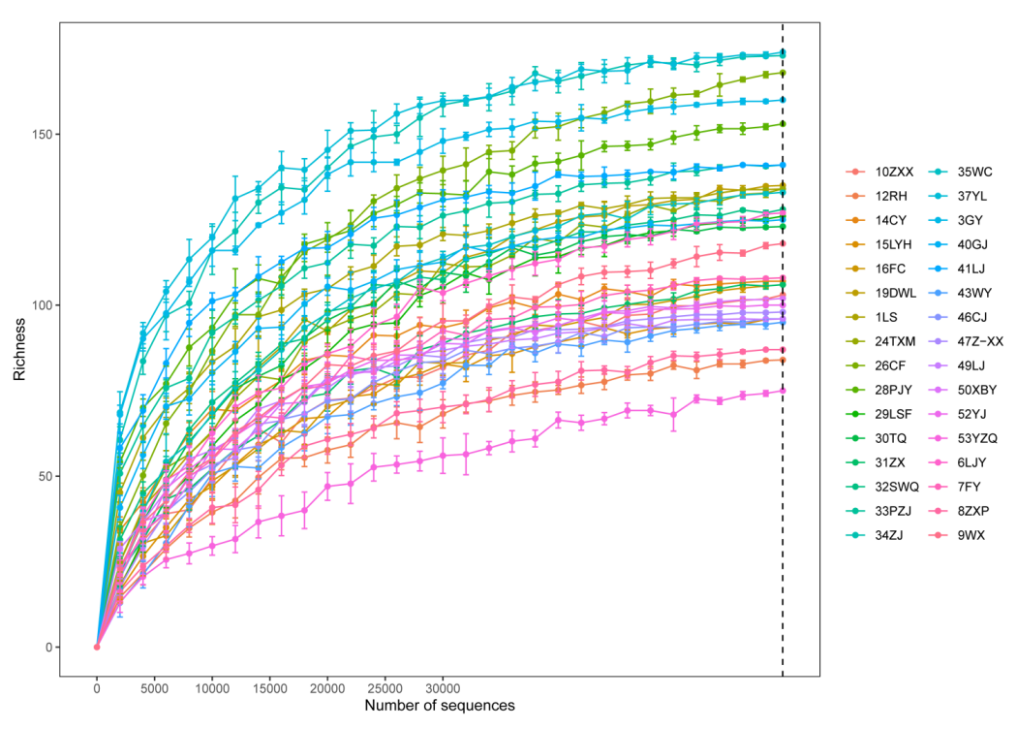

Supplementary Figure 1. Alpha dilution curve for all samples. As the sequencing depth increases, the dilution curve of bacterial Operational Taxonomic Units (OTUs) detected from the vaginal microbiota reaches the saturation stage. Each error line represents the standard error.
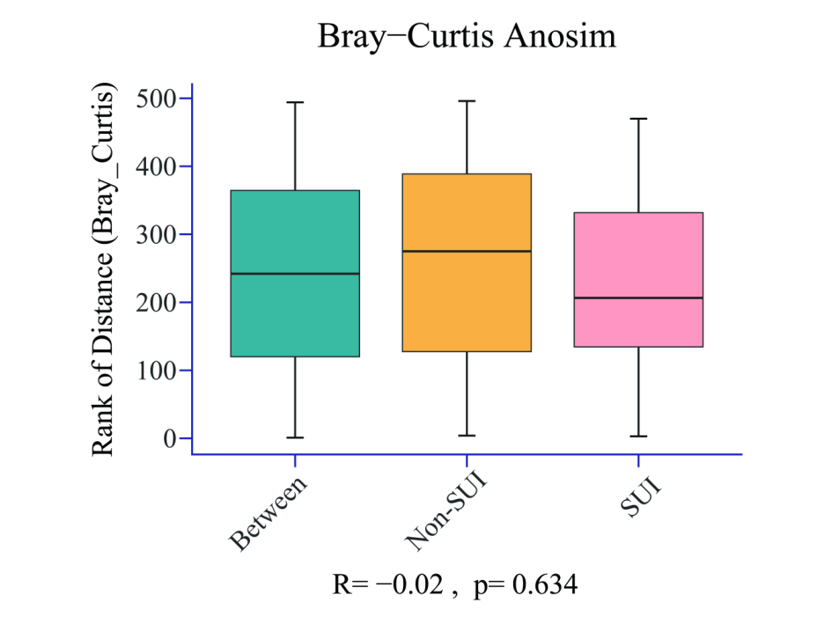
Supplementary Figure 2 Bray-Curtis Anosim. Analysis of similarities (Anosim) is a non-parametric testing method based on permutation and rank sum tests: Using the adosim function in the vegan package for adosim analysis with permutations=999 based on Bray Curtis Distance.

