Unlocking NUE Potential via PASP-Ca Synergist: Insights into physio-biochemical, enzymatic and molecular analyses of contrasting potato genotypes in aeroponics
Hafsa Nazir Cheemaª, Ke-Xiu Wang^{c}, Haiyan Maª, Mingxia Tang^{c}, Tahseen Saba^{d}, Tingyuan Huª, Ambreen jahandad^{e}, Xiaoting Fangª, Kaiqin Zhangª, Muhammad Ansar^{e}, Wei He^{c}, Shunlin Zheng^{a,b,f,}*
ª State Key Laboratory of Crop Gene Exploration and Utilization in Southwest China, College of Agronomy, Sichuan Agricultural University, Chengdu, 611130, China
^{b} Crop Ecophysiology and Cultivation Key Laboratory of Sichuan Province, Chengdu, 611130, China
^{c} Crop Research Institute, Sichuan Academy of Agricultural Sciences / Sichuan Key Laboratory of Green Germplasm Innovation and Genetic Improvement of Grain and Oil Crops, Chengdu 610066, Sichuan, China
^{d} Key Laboratory of Ecological Forestry Engineering of Sichuan Province, College of Forestry, Sichuan Agricultural University, Chengdu, 611130, China
^{e} Department of Agronomy, PMAS-Arid Agriculture University Rawalpindi, Rawalpindi, Pakistan
^{f} Key Laboratory of Tuber Crop Genetics and Breeding, Ministry of Agriculture, Chengdu Joyson Ag-ricultural Technology Co., Ltd, Xindu, 610500, China
These authors contributed equally to this work.
* For correspondence. E-mail: 248977311@qq.com; Tel.: +86-138-8244-3935.

Supplementary Table
Table S1. Primer sequences used for quantitative real-time PCR
Gene Name | Forward sequence(5’-3’) | Reverse sequence(5’-3’)
StNADH-GOGAT | GTGGTGGTGTTGCCTATGTTCTTGA | TTGTGTTACGCTGGTGTTGCTGTAT
StFd-GOGAT | CAAGCGGATTCGTAGAAGGATTGGT | CGTTGAAGGTCAAGAACAGCATTGC
StGDH | TCGGCGGTGGTGATGTAATGAGTA | CTCCTCCCAGAGCACAGGGTATAAG
StGS1 | AATGAGCGTCGTCTCACTGG | GGCTGGCCTGTCCTCAAAG
StGS1-3 | TGGACAAGCACCTGGAGAAGACA | CCAAGATGTTGTTACCACCACGGAA
StGS1-2 | GGAAGTGATGCCTGGACAGTGG | CAGCAACCTCAGCAATCCTCTCG
StGS2 | TGCTGCTTATGGGGTTGGC | CTGTGTGTCCCTTCCGATCCT
StNR | ACGCTGAACTTGCTAACGCTGAA | ATGGCACGGAGTTGTAATGACAGAG
StNRT2.5 | ACCTGCTCTGTTTCAGGCTT | GTTTCGCGTAATCTCCATCGG
StNRT2.7 | GCAGACGGTGGCTGGATTGATG | AAGCACGCCATAACCAGAACAGAC
Reference-StEF1a | GATGGTCAGACCCGTGAACA | CCTTGGAGTACTTCGGGGTG

Supplementary Figures
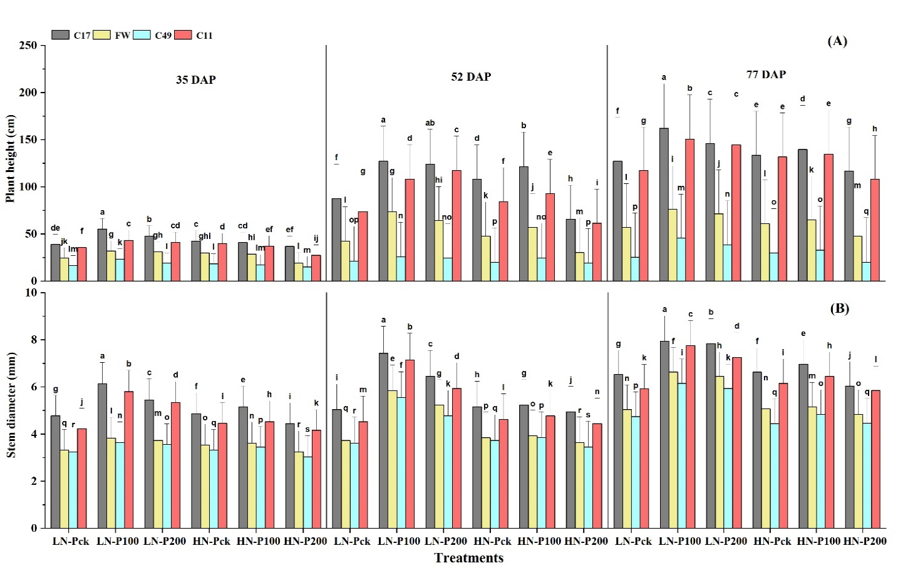
Fig. S1a. Effects of PASP-Ca synergist levels (CK, 100, & 200 mg/L) on (A) Plant height (cm) and (B) Stem diameter (mm) in contrasting potato genotypes under low and high nitrogen supplies at 35, 52, and 77 days after transplanting (DAP) in aeroponics. Data represent means ± standard deviations (n = 3); bars labeled with different letters indicate significant differences (p < 0.05) between genotypes within each treatment.

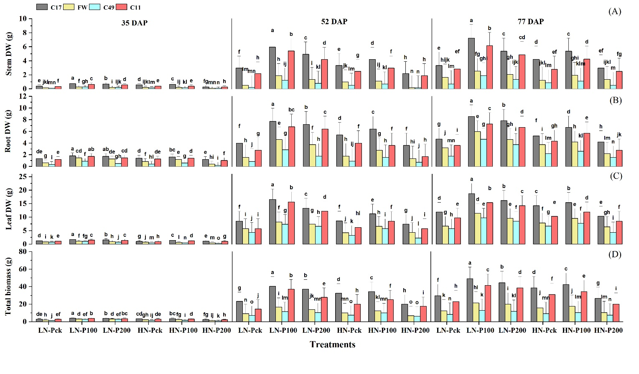
Fig. S1b. Effects of PASP-Ca synergist levels (CK, 100, & 200 mg/L) on (A) Stem dry weight (g), (B) Root dry weight (g), (C) Leaf dry weight (g), and (D) Total biomass (g) in contrasting potato genotypes under low and high nitrogen supplies at 35, 52, and 77 days after transplanting (DAP) in aeroponics. Data represent means ± standard deviations (n = 3); bars labeled with different letters indicate significant differences (p < 0.05) between genotypes within each treatment.
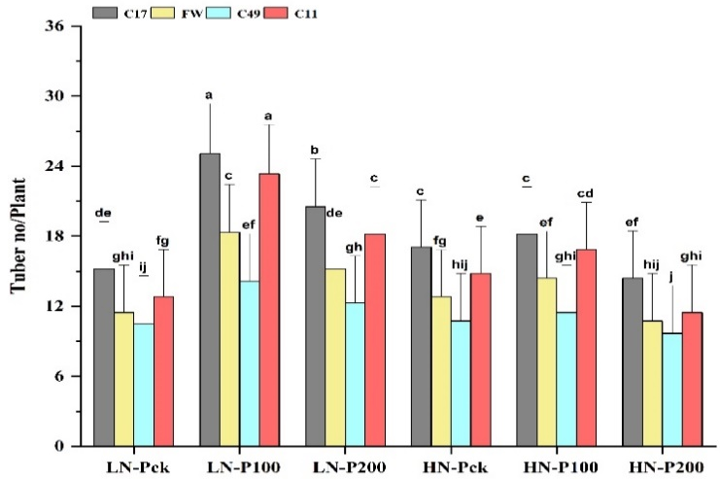
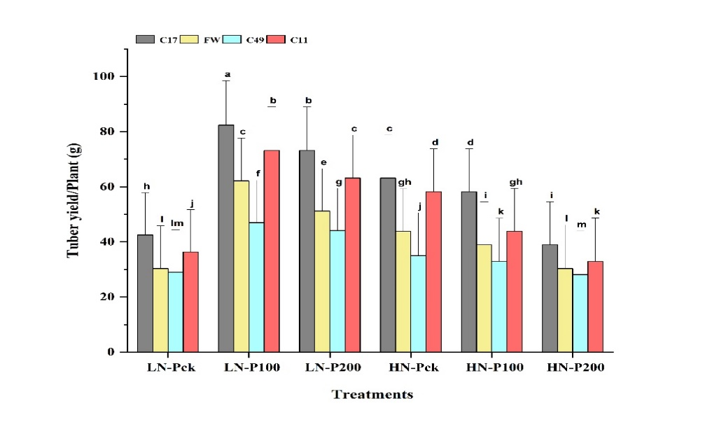
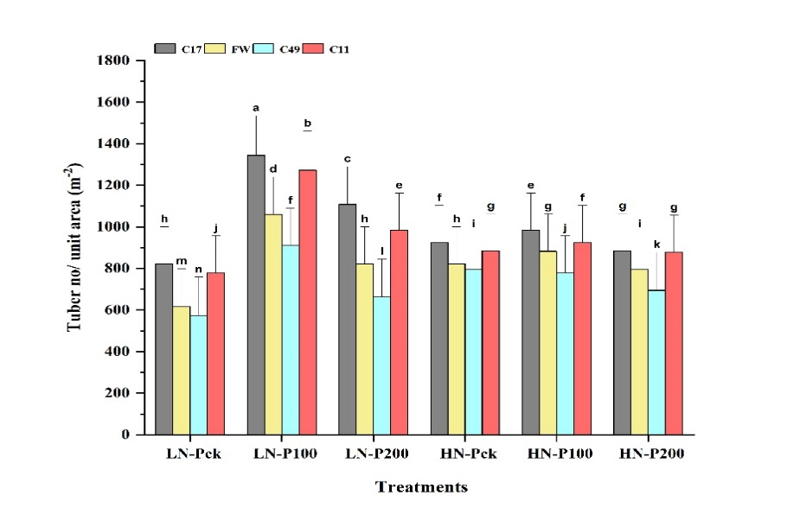
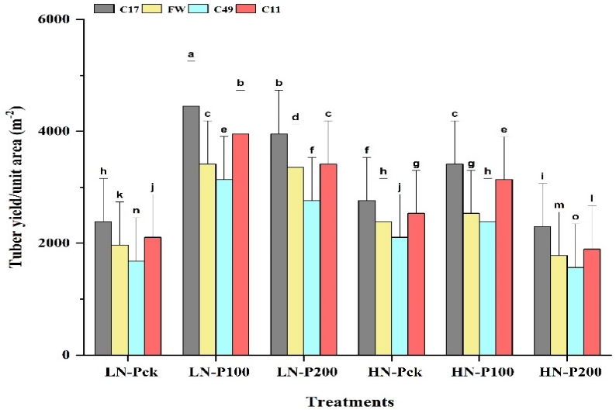
Fig. S1c. Effects of PASP-Ca synergist levels (CK, 100, & 200 mg/L) on (A) Tuber number/plant, (B) Tuber yield/plant (g), (C) Tuber number/unit area (m⁻²) and (D) Tuber yield/unit area (m⁻²) in contrasting potato genotypes under low and high nitrogen supplies in aeroponics. Data represent means ± standard deviations (n = 3); bars labeled with different letters indicate significant differences (p < 0.05) between genotypes within each treatment.
(D)
(B)
(C)
(A)
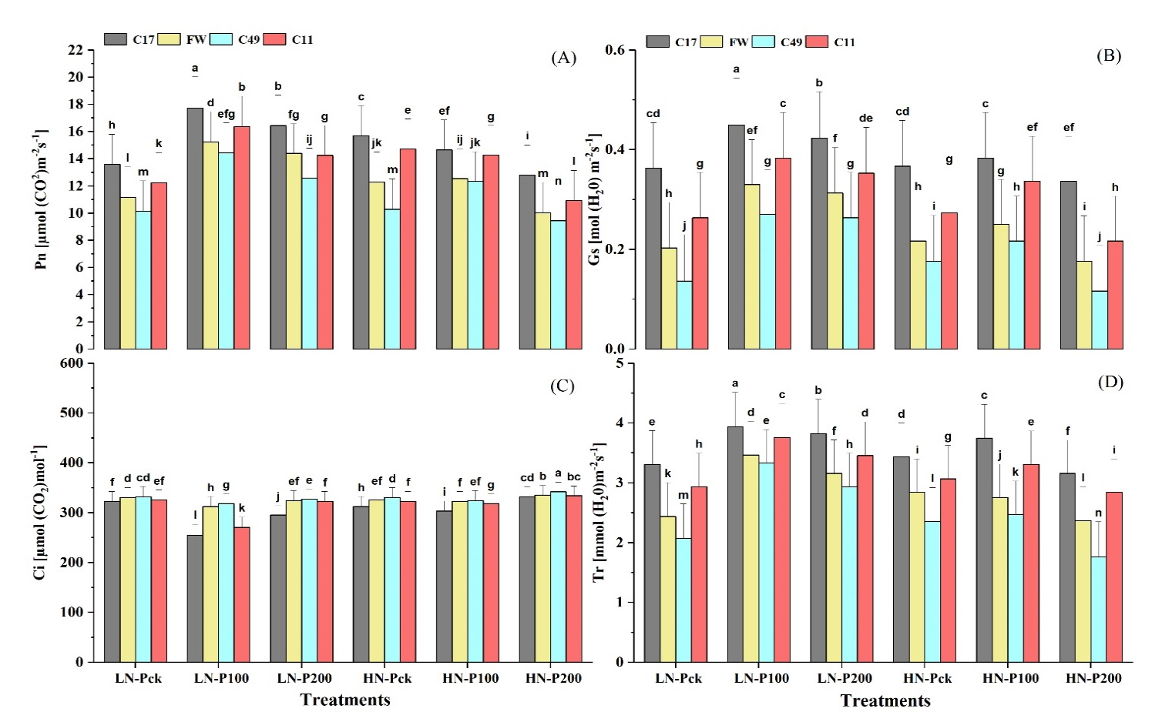
Fig. S2. Effects of PASP-Ca synergist levels (CK, 100, & 200 mg/L) on (A) Net photosynthetic rate (Pn) [μmol(CO₂) m^{–2}s^{–1}], (B) stomatal conductance (Gs) [mol(H₂O) m^{–2}s^{–1}], (C) intercellular CO₂ concentration (Ci) (μmol CO₂ mol⁻¹), and (D) Transpiration rate (Tr) [mmol(H₂O) m^{–2}s^{–1}] in contrasting potato genotypes under low and high nitrogen supplies at vegetative stage in aeroponics. Data represent means ± standard deviations (n = 3); bars labeled with different letters indicate significant differences (p < 0.05) between genotypes within each treatment.
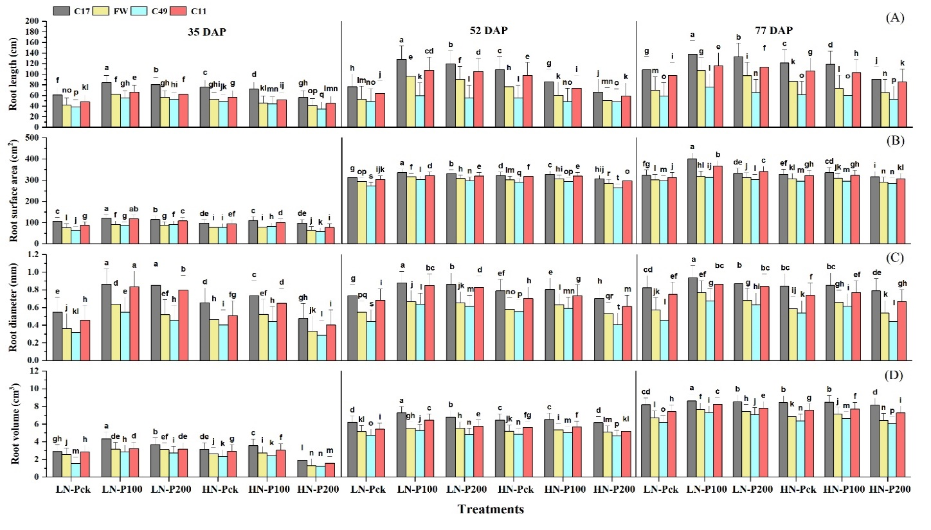
Fig. S3. Effects of PASP-Ca synergist levels (CK, 100, & 200 mg/L) on (A) Root length (cm), (B) Root surface area (cm²), (C) Root diameter (mm), and (D) Root volume (cm³) in contrasting potato genotypes under low and high nitrogen supplies at 35, 52, and 77 days after transplanting (DAP) in aeroponics. Data represent means ± standard deviations (n = 3); bars labeled with different letters indicate significant differences (p < 0.05) between genotypes within each treatment.
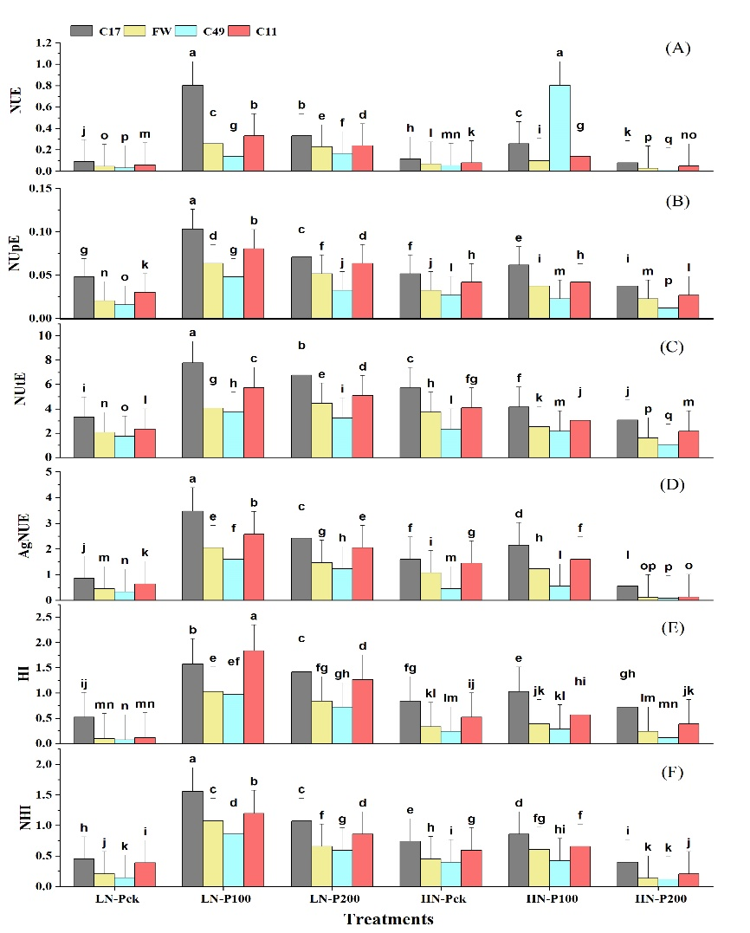
Fig. S4a. Effects of PASP-Ca synergist levels (CK, 100, & 200 mg/L) on (A) Nitrogen use efficiency (NUE), (B) Nitrogen uptake efficiency (NUpE), (C) Nitrogen utilization efficiency (NUtE), (D) Agronomic nitrogen use efficiency, (E) Harvest index, and (F) Nitrogen harvest index in contrasting potato genotypes under low and high nitrogen supplies at harvest stage in aeroponics. Data represent means ± standard deviations (n = 3); bars labeled with different letters indicate significant differences (p < 0.05) between genotypes within each treatment.
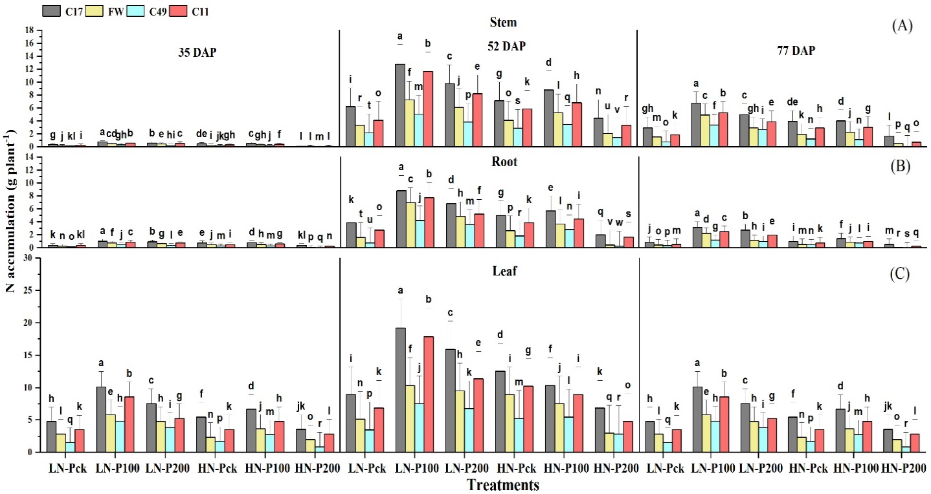
Fig. S4b. Effects of PASP-Ca synergist levels (CK, 100, & 200 mg/L) on (A) Stem N accumulation (g plant⁻¹), (B) Root N accumulation (g plant⁻¹), and (C) Leaf N accumulation (g plant⁻¹) in contrasting potato genotypes under low and high nitrogen supplies at 35, 52, and 77 days after transplanting (DAP) in aeroponics. Data represent means ± standard deviations (n = 3); bars labeled with different letters indicate significant differences (p < 0.05) between genotypes within each treatment.
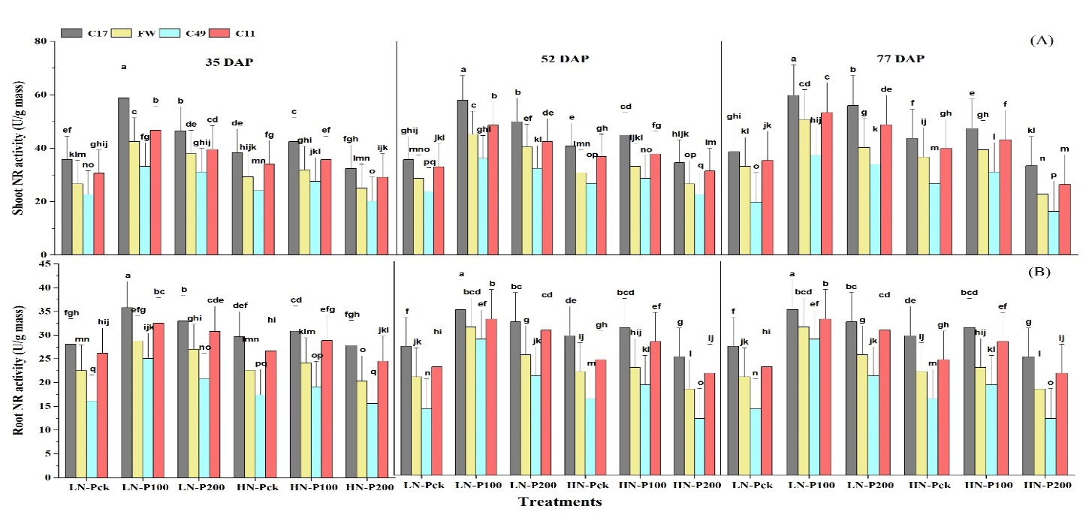
Fig. S5a. Effects of PASP-Ca synergist levels (CK, 100, & 200 mg/L) on (A) Shoot NR activity (U/g mass) and (B) Root NR activity (U/g mass) in contrasting potato genotypes under low and high nitrogen supplies at 35, 52, and 77 days after transplanting (DAP) in aeroponics. Data represent means ± standard deviations (n = 3); bars labeled with different letters indicate significant differences (p < 0.05) between genotypes within each treatment.
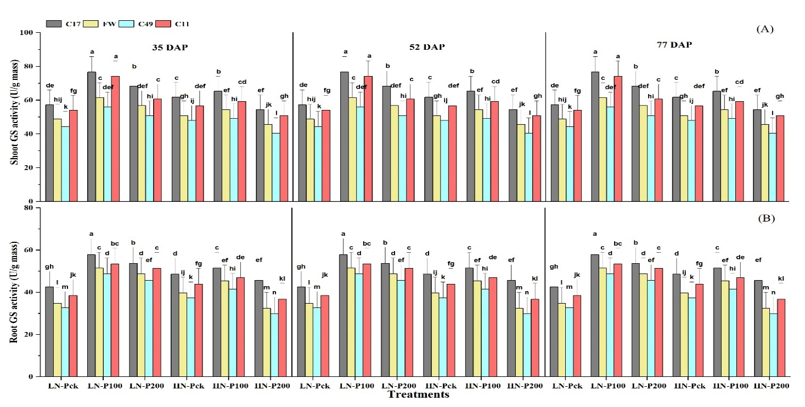
Fig. S5b. Effects of PASP-Ca synergist levels (CK, 100, & 200 mg/L) on (A) Shoot GS activity (U/g mass) and (B) Root glutamine synthetase activity (U/g mass) in contrasting potato genotypes under low and high nitrogen supplies at 35, 52, and 77 days after transplanting (DAP) in aeroponics. Data represent means ± standard deviations (n = 3); bars labeled with different letters indicate significant differences (p < 0.05) between genotypes within each treatment.
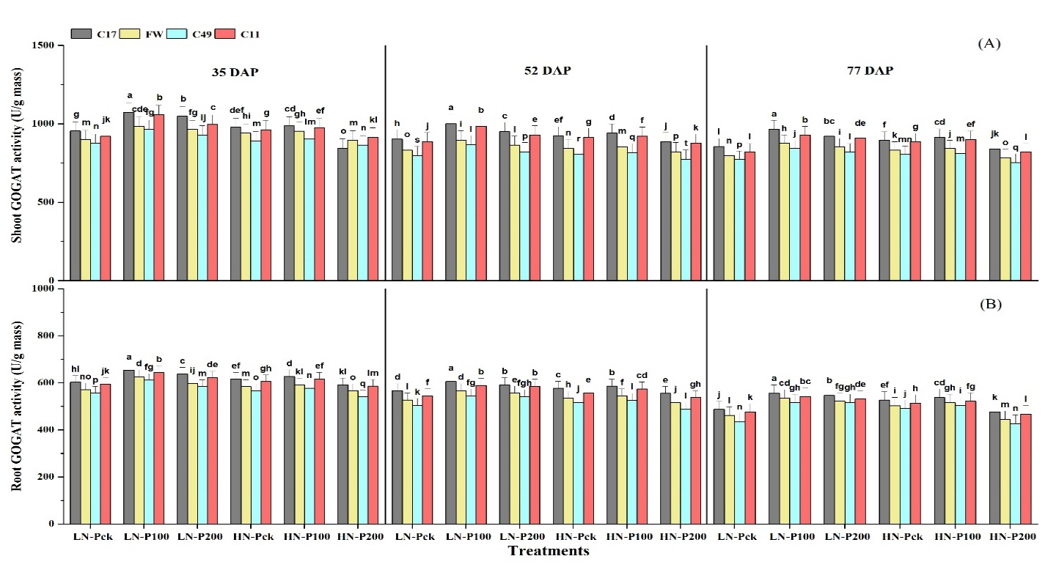
Fig S5c. Effects of PASP-Ca synergist levels (CK, 100, & 200 mg/L) on (A) Shoot GOGAT activity (U/g mass) and (B) Root GOGAT activity (U/g mass) in contrasting potato genotypes under low and high nitrogen supplies at 35, 52, and 77 days after transplanting (DAP) in aeroponics. Data represent means ± standard deviations (n = 3); bars labeled with different letters indicate significant differences (p < 0.05) between genotypes within each treatment.
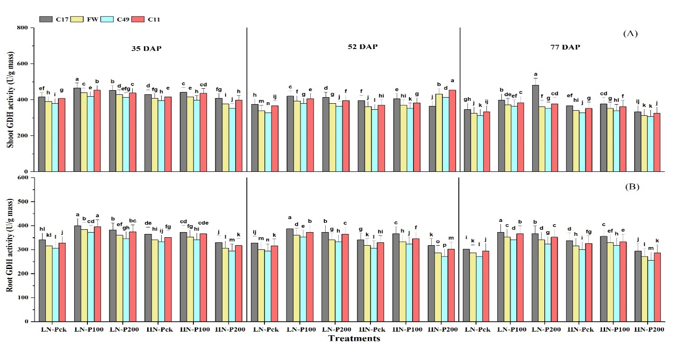
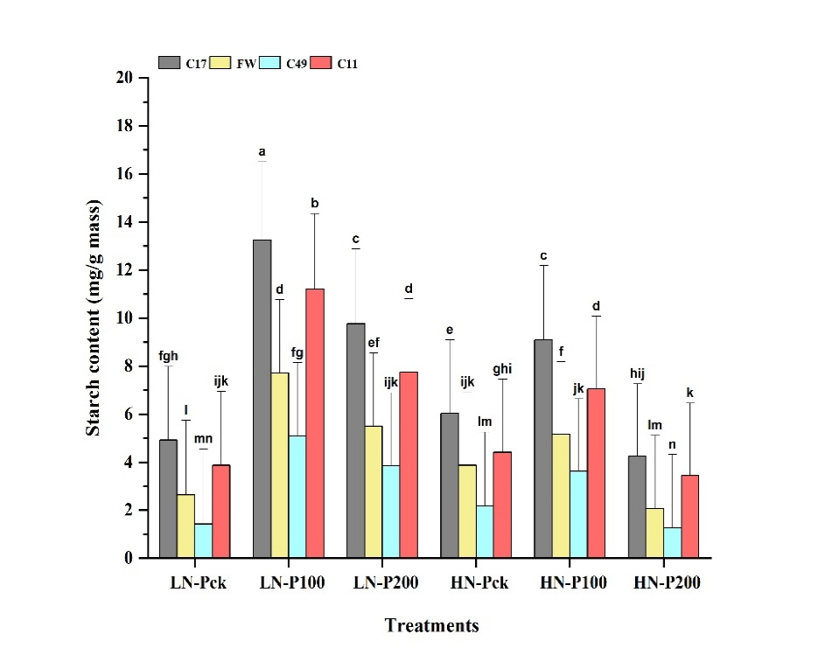
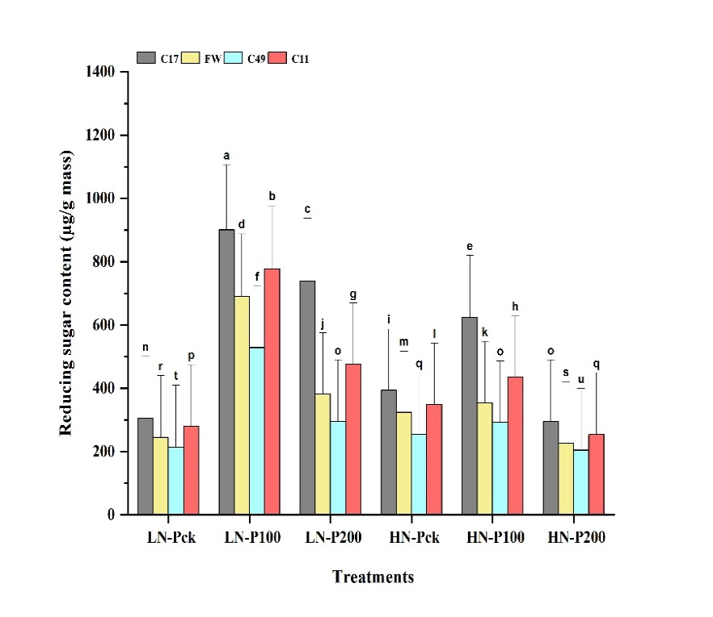
Fig. S5d. Effects of PASP-Ca synergist levels (CK, 100, & 200 mg/L) on (A) Shoot GDH activity (U/g mass) and (B) Root GDH activity (U/g mass) in contrasting potato genotypes under low and high nitrogen supplies at 35, 52, and 77 days after transplanting (DAP) in aeroponics. Data represent means ± standard deviations (n = 3); bars labeled with different letters indicate significant differences (p < 0.05) between genotypes within each treatment.
(B)
Fig. S6. Effects of PASP-Ca synergist levels (CK, 100, & 200 mg/L) on (A) Reducing sugar content (µg/g mass) and (B) Starch content (mg/g mass) in contrasting potato genotypes under low and high nitrogen supplies in aeroponics. Data represent means ± standard deviations (n = 3); bars labeled with different letters indicate significant differences (p < 0.05) between genotypes within each treatment.
(A)
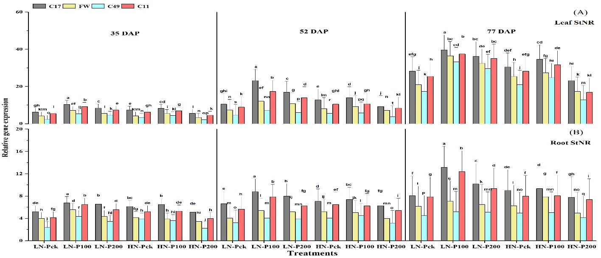
Fig. S7. Effects of PASP-Ca synergist levels (CK, 100, & 200 mg/L) on relative gene expression of the nitrate reductase gene (StNR) in (A) leaf and (B) root of contrasting potato genotypes under low and high nitrogen supplies at 35, 52, and 77 days after transplanting (DAP) in aeroponics. Data represent means ± standard deviations (n = 3); bars labeled with different letters indicate significant differences (p < 0.05) between genotypes within each treatment.
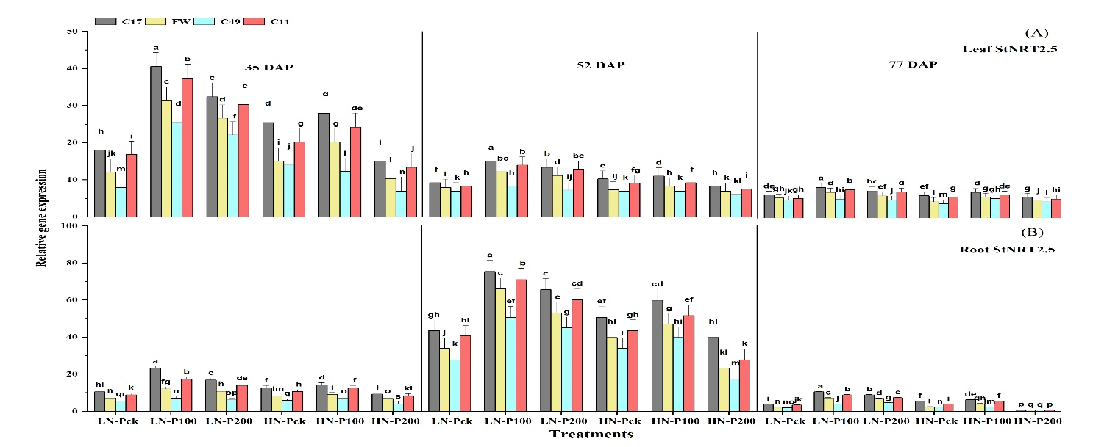
Fig. S8. Effects of PASP-Ca synergist levels (CK, 100, & 200 mg/L) on relative gene expression of the nitrate transporter gene (StNRT2.5) in (A) leaf, and (B) root of contrasting potato genotypes under low and high nitrogen supplies at 35, 52, and 77 days after transplanting (DAP) in aeroponics. Data represent means ± standard deviations (n = 3); bars labeled with different letters indicate significant differences (p < 0.05) between genotypes within each treatment.
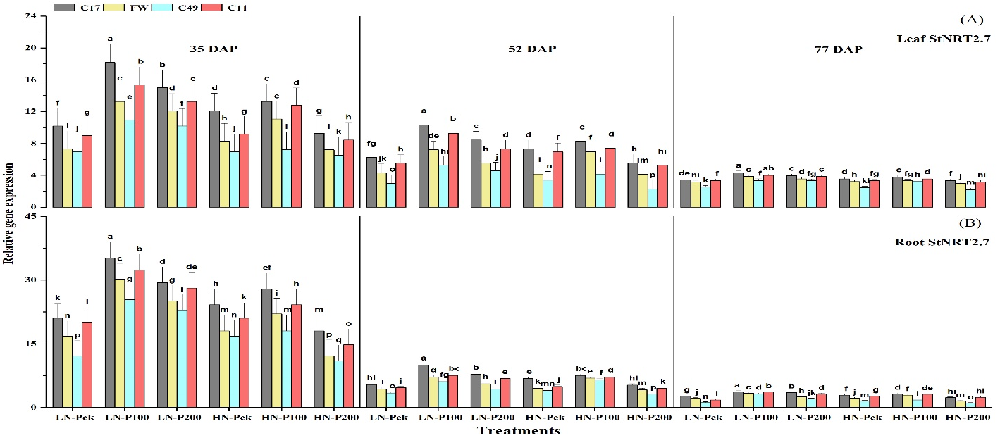
Fig. S9. Effects of PASP-Ca synergist levels (CK, 100, & 200 mg/L) on relative gene expression of nitrate transporter gene (StNRT2.7) in (A) leaf, and (B) root of contrasting potato genotypes under low and high nitrogen supplies at 35, 52, and 77 days after trasnplanting (DAP) in aeroponics. Data represent means ± standard deviations (n = 3); bars labeled with different letters indicate significant differences at (p < 0.05) between genotypes within each treatment.
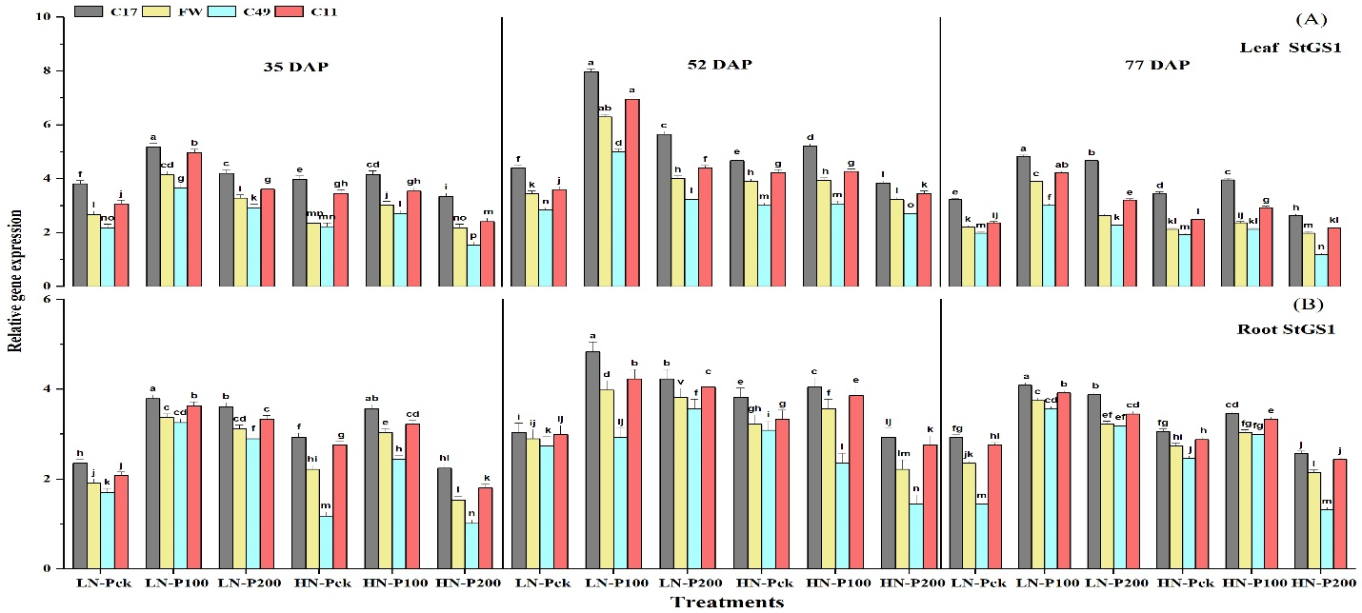
Fig. S10. Effects of PASP-Ca synergist levels (CK, 100, & 200 mg/L) on relative gene expression of glutamine synthase gene (StGS1) in (A) leaf and (B) root of contrasting potato genotypes under low and high nitrogen supplies at 35, 52, and 77 days after transplanting (DAP) in aeroponics. Data represent means ± standard deviations (n = 3); bars labeled with different letters indicate significant differences (p < 0.05) between genotypes within each treatment.
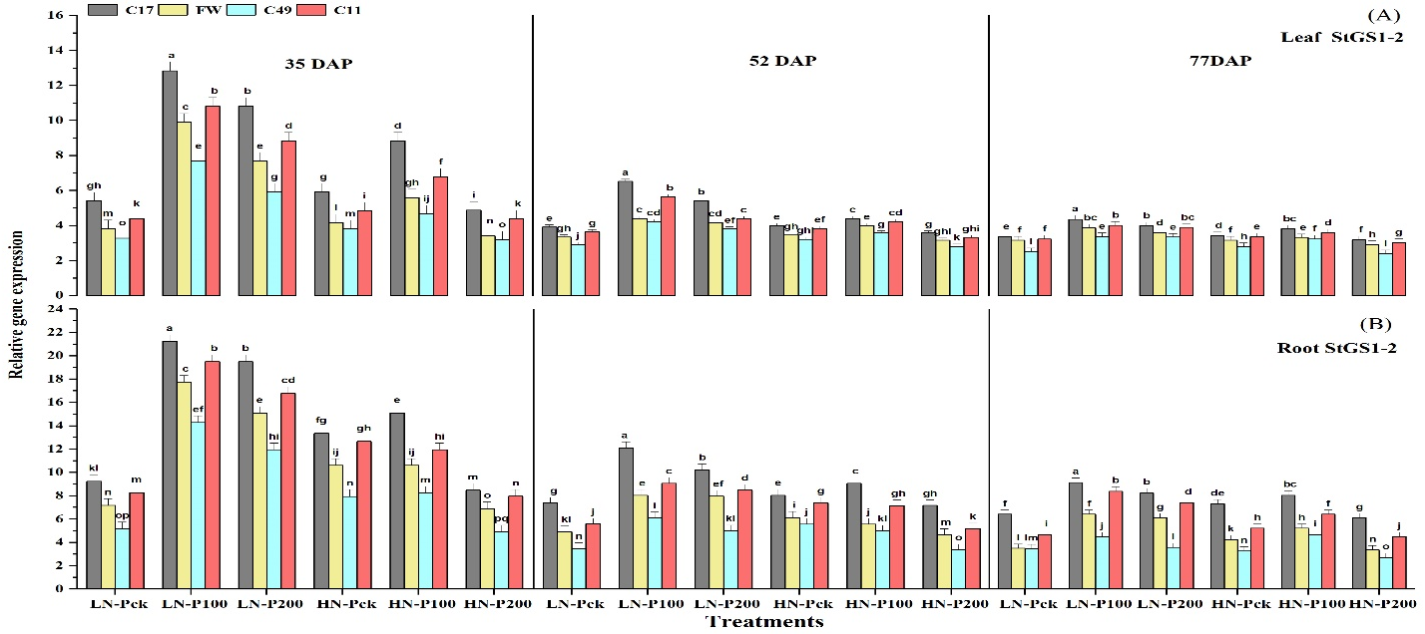
Fig. S11. Effects of PASP-Ca synergist levels (CK, 100, & 200 mg/L) on relative gene expression of the glutamine synthase gene (StGS1-2) in (A) leaf, and (B) root of contrasting potato genotypes under low and high nitrogen supplies at 35, 52, and 77 days after transplanting (DAP) in aeroponics. Data represent means ± standard deviations (n = 3); bars labeled with different letters indicate significant differences (p < 0.05) between genotypes within each treatment.
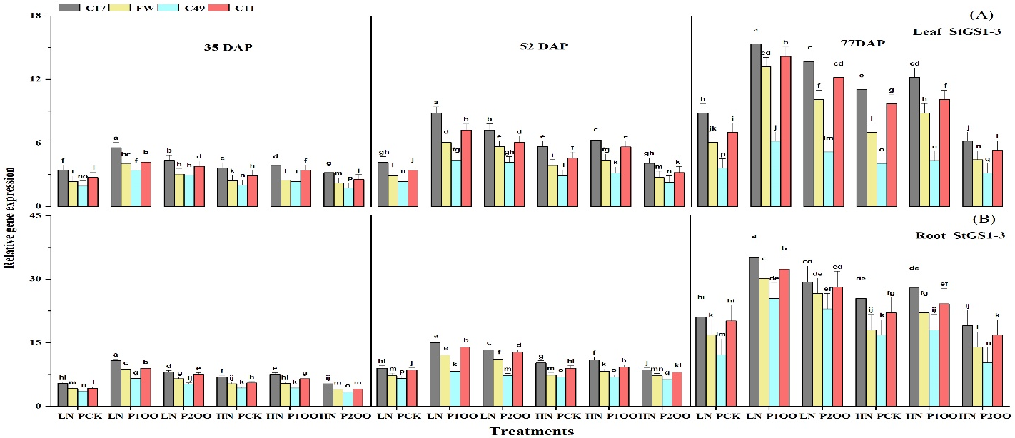
Fig. S12. Effects of PASP-Ca synergist levels (CK, 100, & 200 mg/L) on relative gene expression of the glutamine synthase gene (StGS1-3) in (A) Leaf, and (B) Root of contrasting potato genotypes under low and high nitrogen supplies at 35, 52, and 77 days after transplanting (DAP) in aeroponics. Data represent means ± standard deviations (n = 3); bars labeled with different letters indicate significant differences (p < 0.05) between genotypes within each treatment.
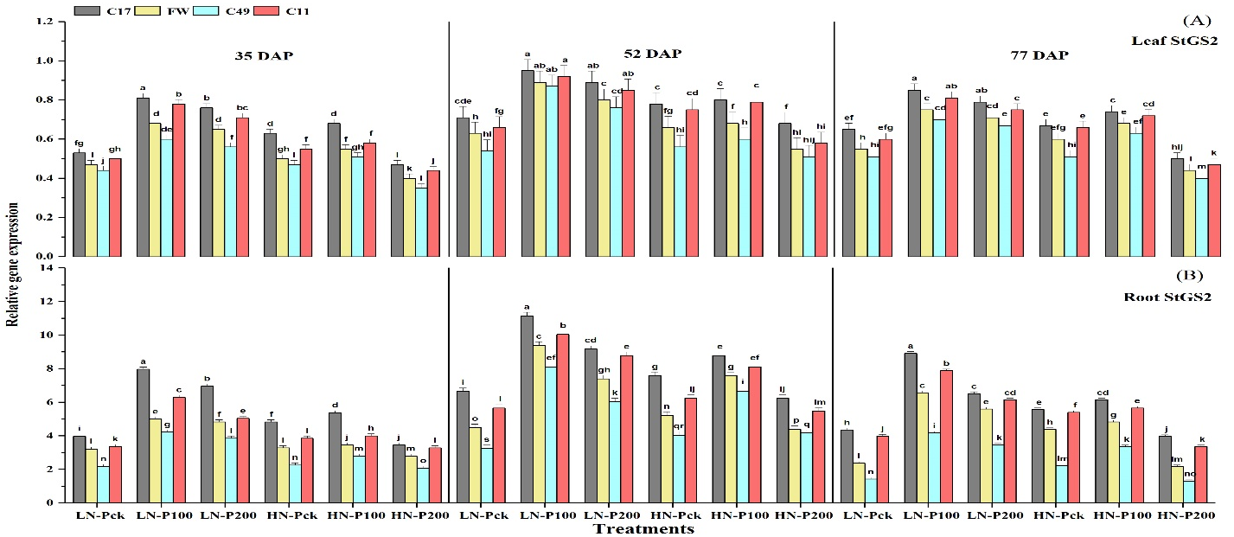
Fig. S13. Effects of PASP-Ca synergist levels (CK, 100, & 200 mg/L) on relative gene expression of glutamine synthase gene (StGS2) in (A) leaf and (B) root of contrasting potato genotypes under low and high nitrogen supplies at 35, 52, and 77 days after transplanting (DAP) in aeroponics. Data represent means ± standard deviations (n = 3); bars labeled with different letters indicate significant differences (p < 0.05) between genotypes within each treatment.
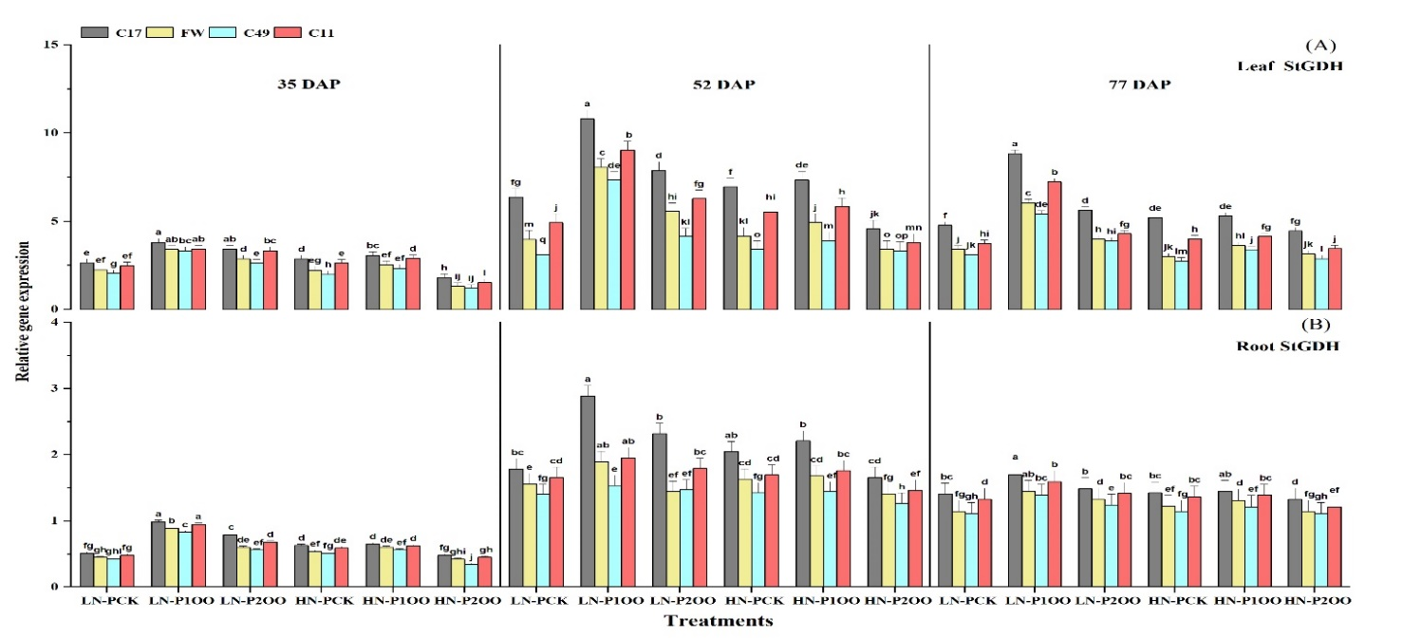
Fig. S14. Effects of PASP-Ca synergist levels (CK, 100, & 200 mg/L) on relative gene expression of the glutamine synthase gene (StGDH) in (A) leaf, and (B) root of contrasting potato genotypes under low and high nitrogen supplies at 35, 52, and 77 days after transplanting (DAP) in aeroponics. Data represent means ± standard deviations (n = 3); bars labeled with different letters indicate significant differences (p < 0.05) between genotypes within each treatment.

