SUPPLEMENTARY INFORMATION
Towards sustainable photoelectrodes for solar to hydrogen conversion through the combination of earth-abundant elements
Nathália C. Verissimo^{1†}, Fabio A. Pires^{1,2†}, Ingrid Rodríguez-Gutiérrez^{1,3}, Jefferson Bettini¹, Tanna E. R. Fiuza¹, Cleyton A. Biffe¹, Fabiano E. Montoro¹, Gabriel R. Schleder^{1,4}, Ricardo H. R. Castro^{1,5}, Edson R. Leite^{1,6}, Flavio L. Souza^{1,2,3*}

¹ Brazilian Nanotechnology National Laboratory (LNNano), Brazilian Center for Research in Energy and Materials (CNPEM) – Campinas, SP, Brazil.
² Institute of Chemistry, State University of Campinas (UNICAMP) – Campinas, SP, Brazil.
³ Center for Natural and Human Sciences, Federal University of ABC (UFABC) – Santo André, SP, Brazil.
⁴ John A. Paulson School of Engineering and Applied Sciences, Harvard University, Cambridge, MA, 02138, USA
⁵ Department of Materials Science and Engineering, Lehigh University, Bethlehem, Pennsylvania, USA.
⁶ Departamento de Química, Universidade Federal de São Carlos, 13565-905, Brazil.

† These authors contributed equally to this work.
*Corresponding Author: flavio.souza@lnnano.cnpem.br

METHODS
NiFeO_{x} electrodeposition. NiFeO_{x} alloy was electrodeposited under illumination onto H-0.5Al-3.0Zr photoanode by immersing the film in an aqueous solution (pH 5.3) consisting of 16.0 mM (NiSO₄⋅6H₂O, Sigma Aldrich, 99.9%), 5.0 mM Fe₂(SO₄).3H₂O (Sigma Aldrich, 97%), and 0.1 M NaCH₃COO⋅3H₂O (Sigma Aldrich, 99%). The procedure was carried out in a three‐electrode electrochemical cell containing a platinum counter electrode and a commercial (Metrohm Autolab) Ag/AgCl(sat) reference electrode. The deposition was carried out into a potentiostat/galvanostat (Autolab PGSTAT 128N) by the employment of the linear sweep voltammetry technique, from 0.5 to 0.9 V vs. Ag/AgCl, at a scan rate of 10 mV s⁻¹, under simulated sunlight illumination of 100 mW cm⁻². No additional thermal treatments were employed for NiFeO_{x}-modified thin films after its deposition.

Photoelectrochemical characterization. The photocurrent (J_{ph}) measured at 1.23 V vs. reversible hydrogen electrode (RHE) can be described by equation S1, where J_{ph} is defined as the product of the maximum current values permitted by the absorption properties (J_{abs}) of the photoanodes and the efficiencies of charge separation (η_{sep.}) at the bulk and charge injection ate the surface, described as the catalytic efficiency (η_{cat.}). ¹
$J_{ph}= J_{abs} . η_{sep} . η_{cat}$ (Eq. S1)
The maximum current generated due to absorption properties of the nanoporous structures (J_{abs}) was calculated from the absorbance measurements as presented in Equation S2, where q is the elementary electron charge, ø is the photon flux in the AM 1.5 G filter, and λ is in the visible range for the absorption spectra of all samples analyzed. ²
$J_{abs}=-q ø \left(1-e^{\left(-\int{Abs dλ}\right)}\right)$ (Eq. S2)
In the presence of H₂O₂ hole scavenger, the catalytic efficiency can be neglected (η_{cat.} = 1), assuming H₂O₂ collects every photogenerated hole that reaches the semiconductor-electrolyte interface. ¹
Equation S1 is then rewritten as equation S3:
$J_{ph} (H_{2}O_{2})= J_{abs} . η_{sep}$ (Eq. S3)
Substituting equation S3 into equation S1, the charge separation efficiency (η_{sep.}) and the catalytic efficiency (η_{cat.}) can be obtained:
$η_{sep}= \frac{J_{ph} (H_{2}O_{2})}{J_{abs}}$ (Eq. S4)
$η_{cat}= \frac{J_{ph}}{J_{ph} (H_{2}O_{2})}$ (Eq. S5)
Moreover, by calling η_{overall} the product of charge separation and catalytic efficiencies, equation S1 can be rewritten as equation S6, where η_{overall} represents the total yield of current generated in relation to the maximum current permitted by the absorption properties (J_{abs}) of the photoanodes.
$η_{overall}= \frac{J_{ph}}{J_{abs}}$ (Eq. S6)
The flat band potentials (V_{fb}) and donor density (N_{D}) values were estimated from the Mott-Schottky model, according to equation S7. ³
$\frac{1}{C^{2}}= \frac{2}{ε_{0} ε_{r} e N_{D}} \left(V- V_{fb}- \frac{k_{B} T}{e}\right)$ (Eq. S7)
Where C is the space charge region capacitance, ε₀ is the vacuum permittivity, ε_{r} is hematite dielectric constant, e is the fundamental electron charge, k_{B} is the Boltzmann constant and T is the temperature.
All potentials used to report electrochemical data were converted to the reversible hydrogen electrode (RHE) using the Nernst Equation S8:
$E_{RHE}= E_{Ag/AgCl}+ E_{Ag/AgCl}^{0}+0.059 pH$ (Eq. S8)

Electrochemical surface area (ECSA). The electrochemically active surface area (ECSA) of each modified photoanode was estimated by determining the double-layer capacitance of the interface via cyclic voltammetry. The analysis was performed in 1 M NaOH solution with a pH value of 13.6. The double-layer optimal region was estimated by its non-Faradaic region, and the work potential was established by a 0.2 V window near the open circuit potential. A potentiostat/galvanostat, Autolab PGSTAT 302N was used to perform cyclic voltammetry experiments. The charging current (i_{c}) is assumed to be equal to the product of the electrochemical double-layer capacitance (C_{DL}) and the scan rate (υ), as shown in Equation S9. ^{4,5}
$i_{c}=υ. C_{DL}$ (Eq. S9)
Plotting i_{c} as a function of υ yields produces a straight line, of which the slope equals C_{DL}. The active surface area (ECSA) of the electrode can be calculated by dividing C_{DL} by the specific capacitance (C_{s}) of the sample, as shown in Equation S10. ⁴⁻⁶
$ECSA= {C_{DL}}/{C_{S}}$ (Eq. S10)
Where the specific capacitance (C_{s}) is 0.040 mF cm⁻² for 1 M NaOH. ⁷

Optical band gap determination. The optical band gap values for the photoanodes were estimated by the Tauc relation, as shown in equation S11. ⁸
${\left(αhν\right)}^{n}=A \left(hν- E_{g}\right)$ (eq. S11)
Where: α is the absorption coefficient, h is the Planck constant, ν is the frequency, n is ½ for allowed indirect electronic transitions and 2 for allowed direct transitions, A is a constant, and E_{g} is the estimated optical band gap energy.

RESULTS AND DISCUSSION

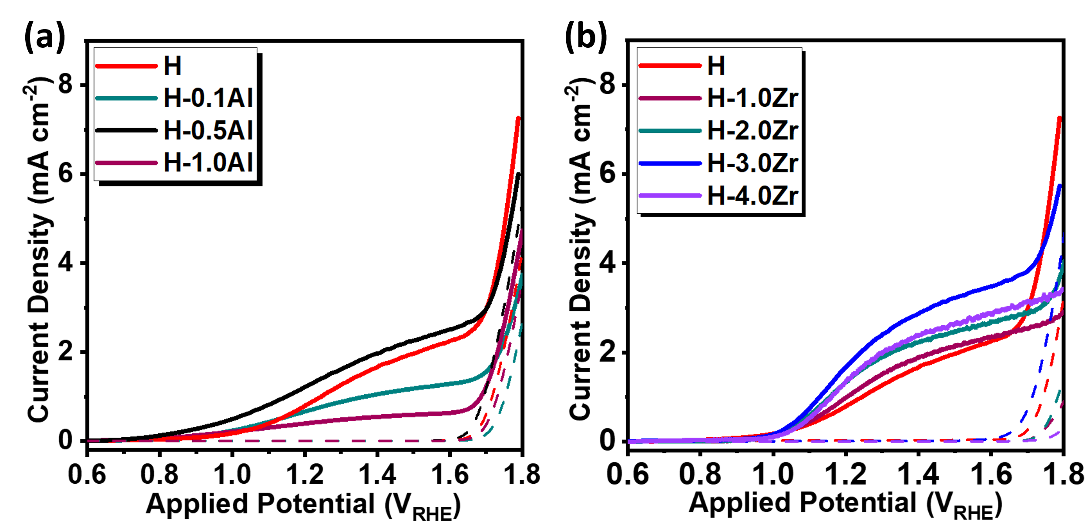
Figure S1. (a) Linear voltammetry photocurrent density profiles of H, H-0.1Al, H-0.5Al, and H-1.0Al under AM1.5G 100 mW cm⁻² illumination in 1M NaOH electrolyte. (b) Linear voltammetry photocurrent density profiles of H, H-1.0Zr, H-2.0Zr, H-3.0Zr, and H-4.0Zr under AM1.5G 100 mW cm⁻² illumination in 1M NaOH electrolyte.

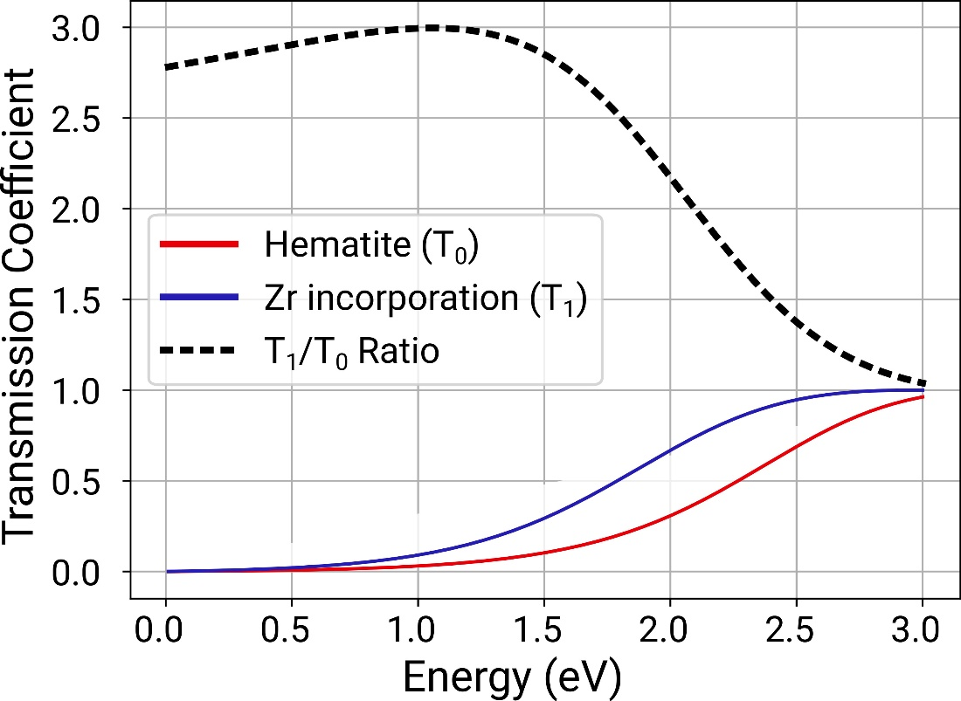
Figure S2. Transmission coefficient for the quantum tunneling problem of a rectangular barrier potential profile, as compared for the pure hematite vs with Zr incorporation, where the potential barrier decreases, and the ratio between them. The parameters for the model are given in the main text.
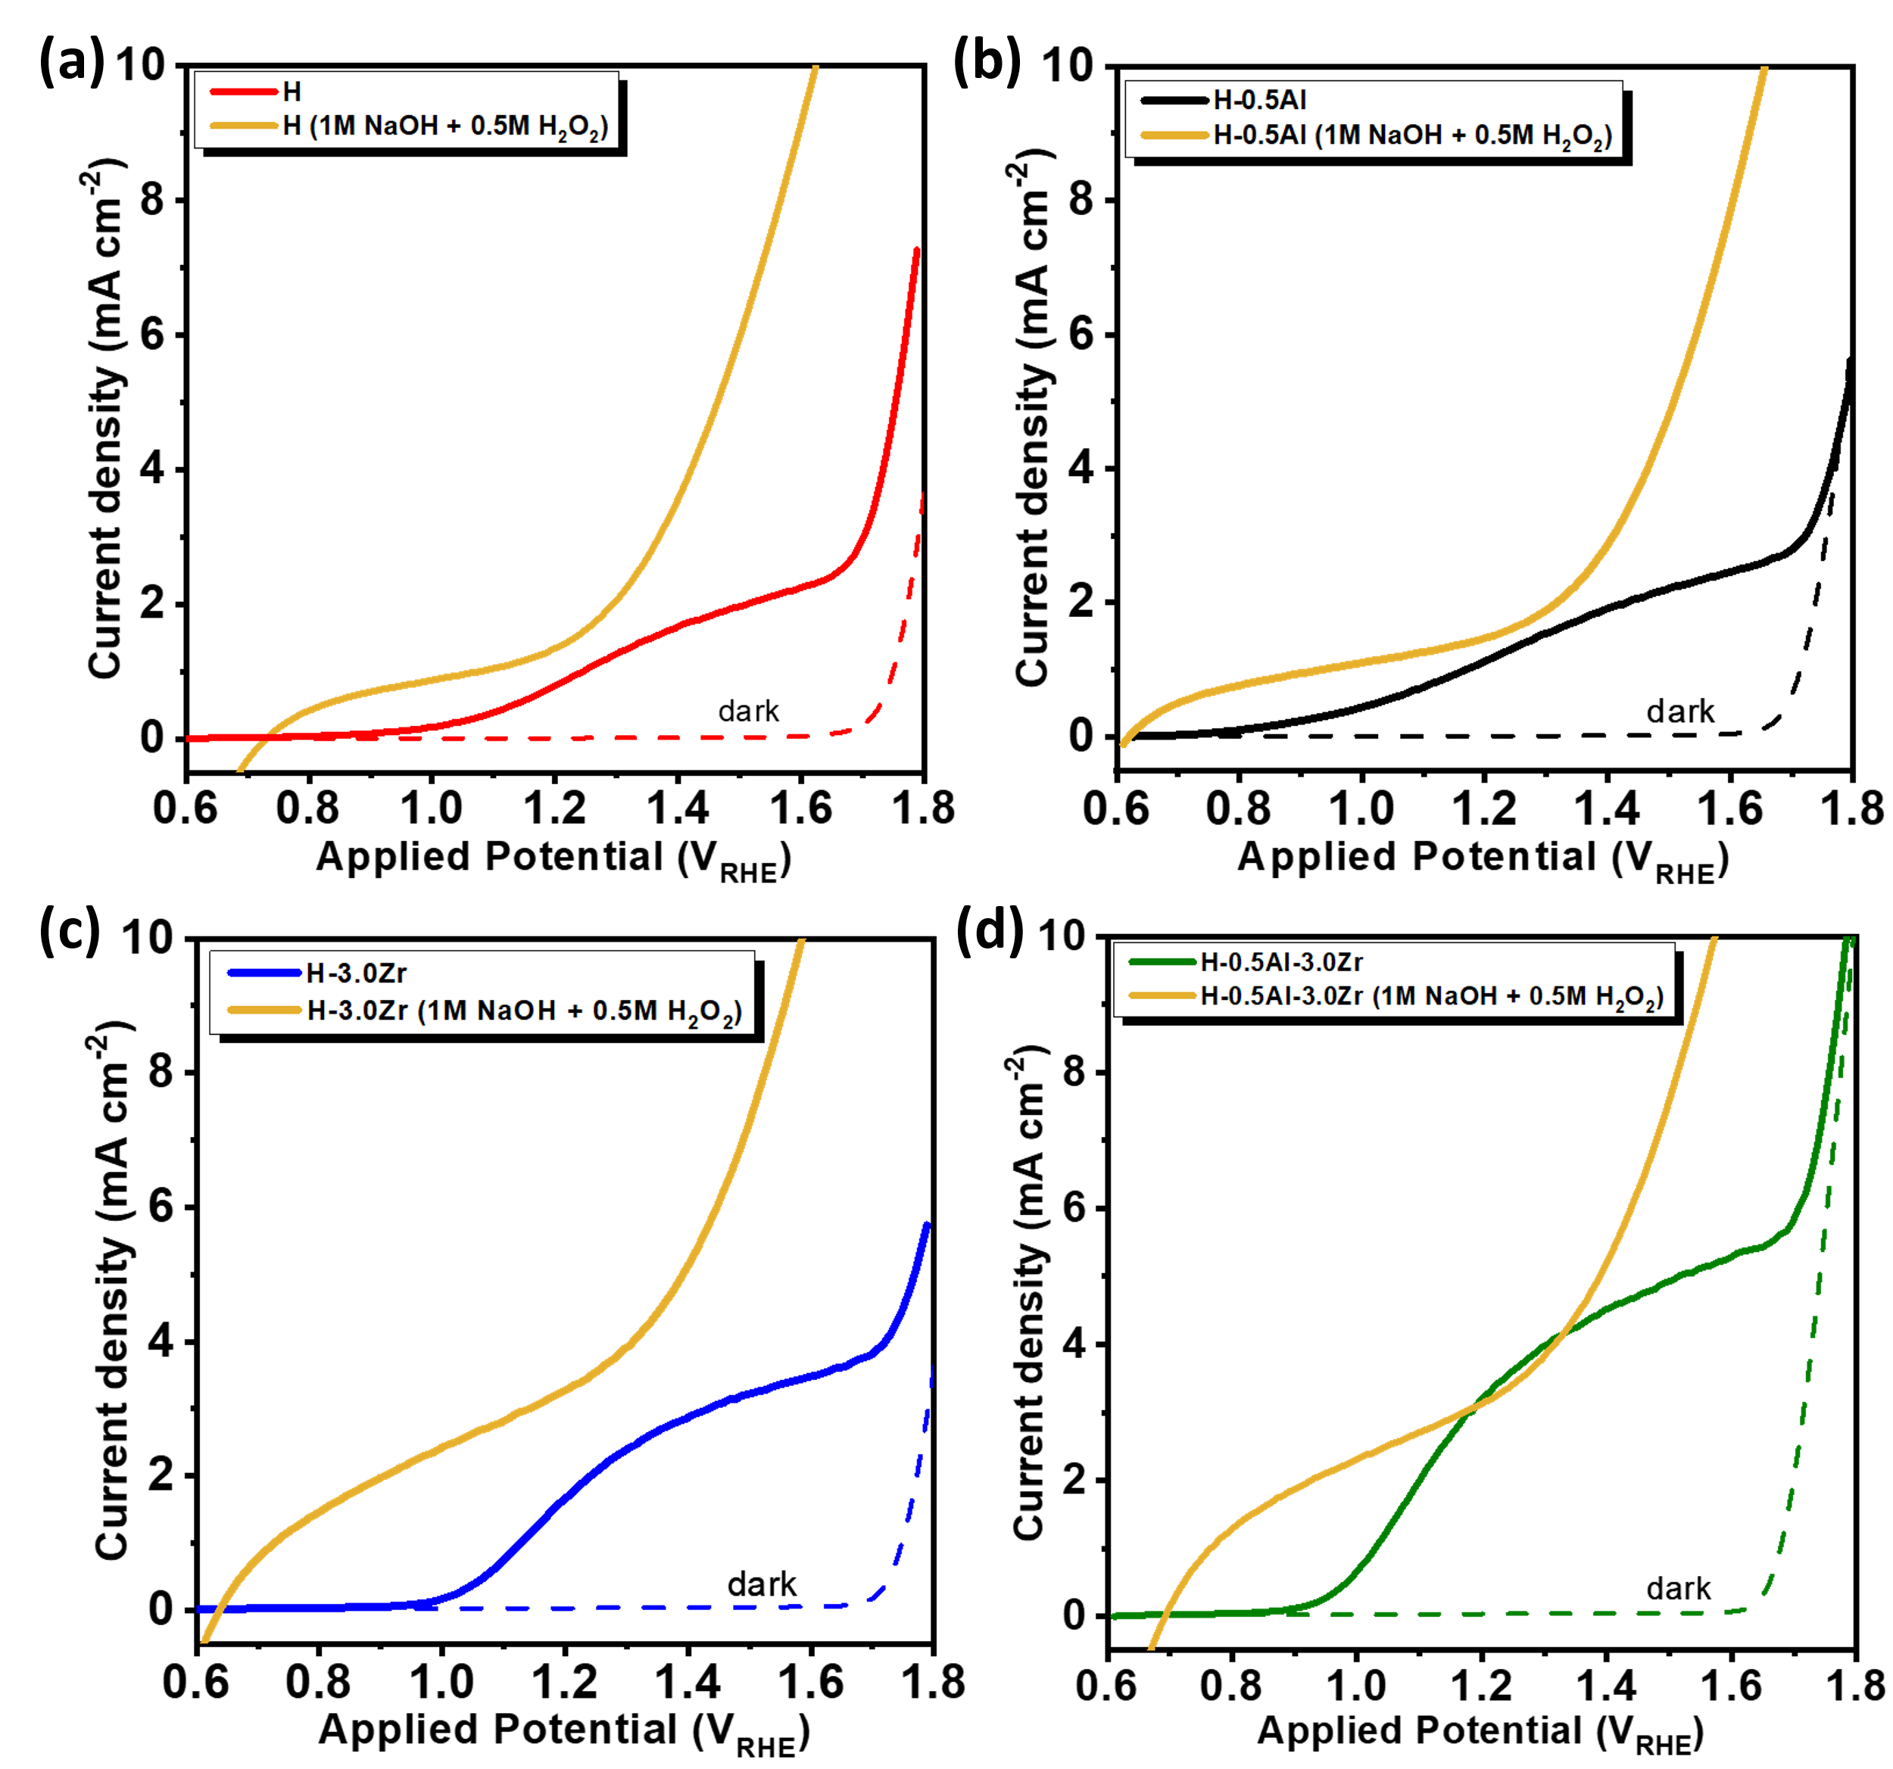
Figure S3. Linear voltammetry photocurrent density profiles of the photoanodes under AM1.5G 100 mW cm⁻² illumination in 1M NaOH (colorful curves) and 1M NaOH + 0.5M H₂O₂ (golden curves) electrolyte: (a) pristine hematite - H; (b) H-0.5Al, (c) H-3.0Zr, and (d) H-0.5Al-3.0Zr.

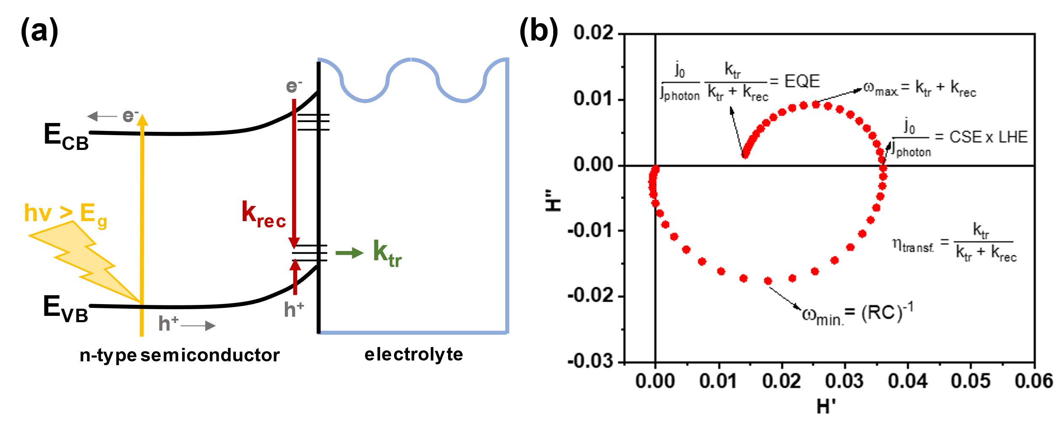
Figure S4. (a) Band diagram representing the photoelectrochemical processes considered in the IMPS general theory calculations in the presence of surface states. Photogenerated holes can be trapped at the surface and subsequently either recombine with electrons (k_{rec}) or be transferred to the electrolyte (k_{tr}). Majority carriers (e⁻) may also be trapped at the surface (k_{rec}). (b) IMPS Nyquist plot and calculations of IMPS parameters and efficiencies following the general theory, where j₀ is the amplitude of the modulated photocurrent (electrons cm⁻² s⁻¹), j_{𝑝ℎ𝑜𝑡𝑜𝑛} is the incident photon flux (photons cm⁻² s⁻¹), k_{𝑡𝑟} is the charge transfer rate constant, k_{𝑟𝑒𝑐} is the surface recombination rate constant, (RC)⁻¹ is the cell time constant, and ω_{min.} and ω_{max.} are the frequencies for minimum and maximum H’’ values of IMPS Nyquist plots.

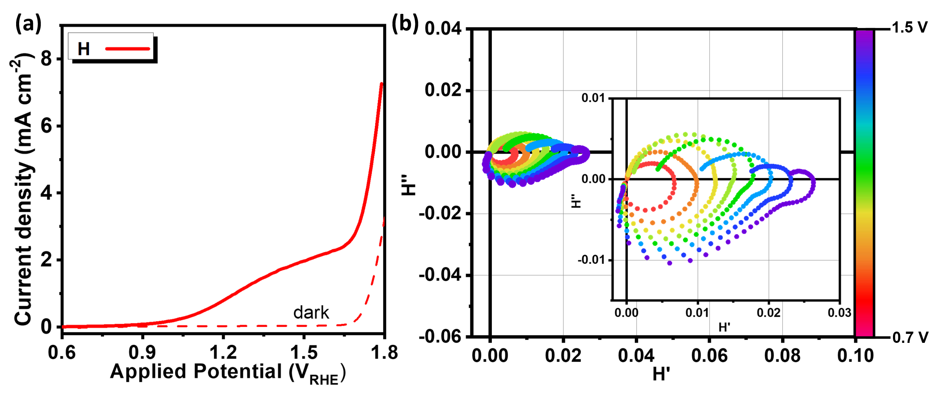
Figure S5. (a) Linear voltammetry photocurrent density profiles of H under AM1.5G 100 mW cm⁻² illumination in 1M NaOH electrolyte. (b) Intensity modulated photocurrent spectroscopy (IMPS) plots of H from 0.7 V to 1.4 V vs. RHE (step of 0.1 V), measured under 30 mW cm⁻² monochromatic (λ = 470 nm) illumination in 1M NaOH electrolyte. The inset is a zoom of pristine hematite (H) IMPS plots.

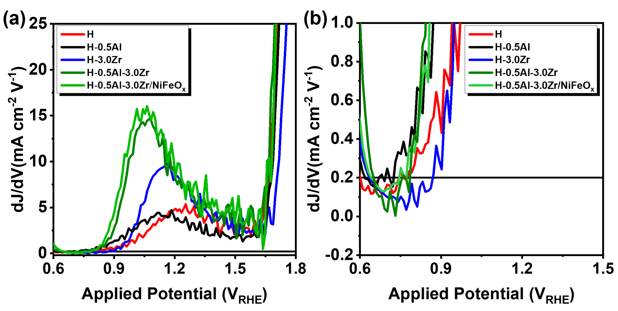
Figure S6. (a) First derivative curves of the current density as function of the potential applied (dJ/dV) for the photoanodes. (b) Zoom in the region of dJ/dV curves where the derivate changes its signal. The point of signal change is the onset potential (V_{onset}) of each photoanode. V_{onset} is 0.79 V for H, 0.71 V for H-0.5Al, 0.87 V for H-3.0Zr, 0.74 V for H-0.5Al-3.0Zr and 0.72 V for H-0.5Al-3.0Zr/NiFeO_{x}.

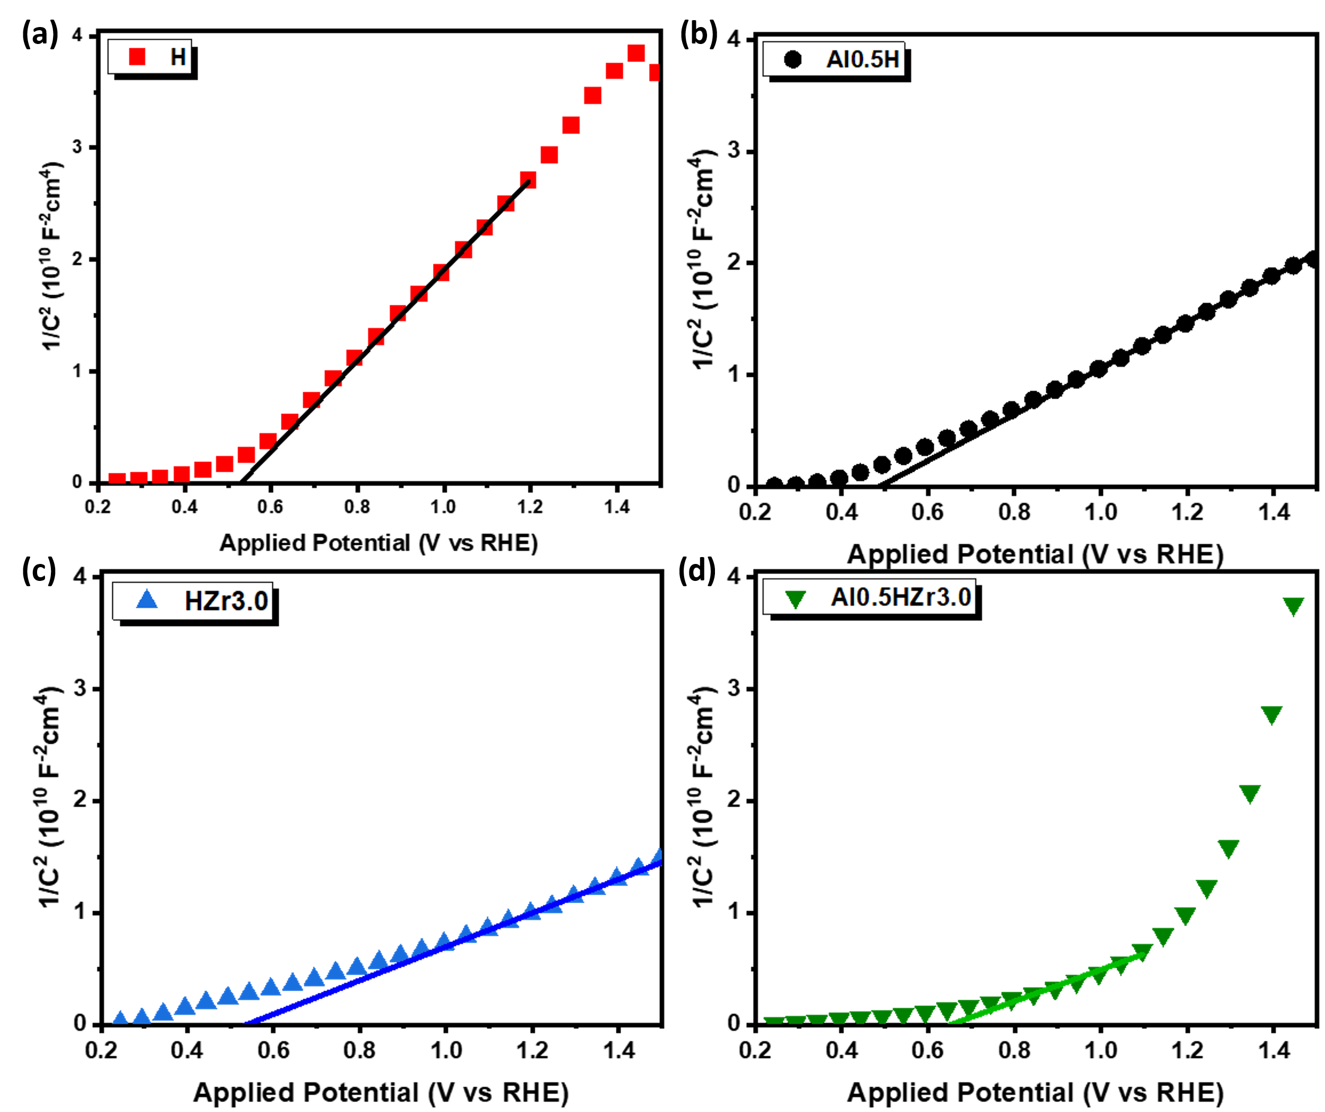
Figure S7. Mott-Schottky plots and linear fitting of (a) H, (b) H-0.5Al, (c) H-3.0Zr, and (d) H-0.5Al-3.0Zr photoanodes.

Table S1. Flat band potential (V_{fb}) and donor density (N_{D}) values extracted from Mott-Schottky analysis.
Sample | V_{fb} (V vs. RHE) | N_{D} (cm⁻³)
H | 0.48 | 4.87E+19
H-0.5Al | 0.46 | 8.53E+19
H-3.0Zr | 0.53 | 1.14E+20
H-0.5Al-3.0Zr | 0.63 | 1.25E+20

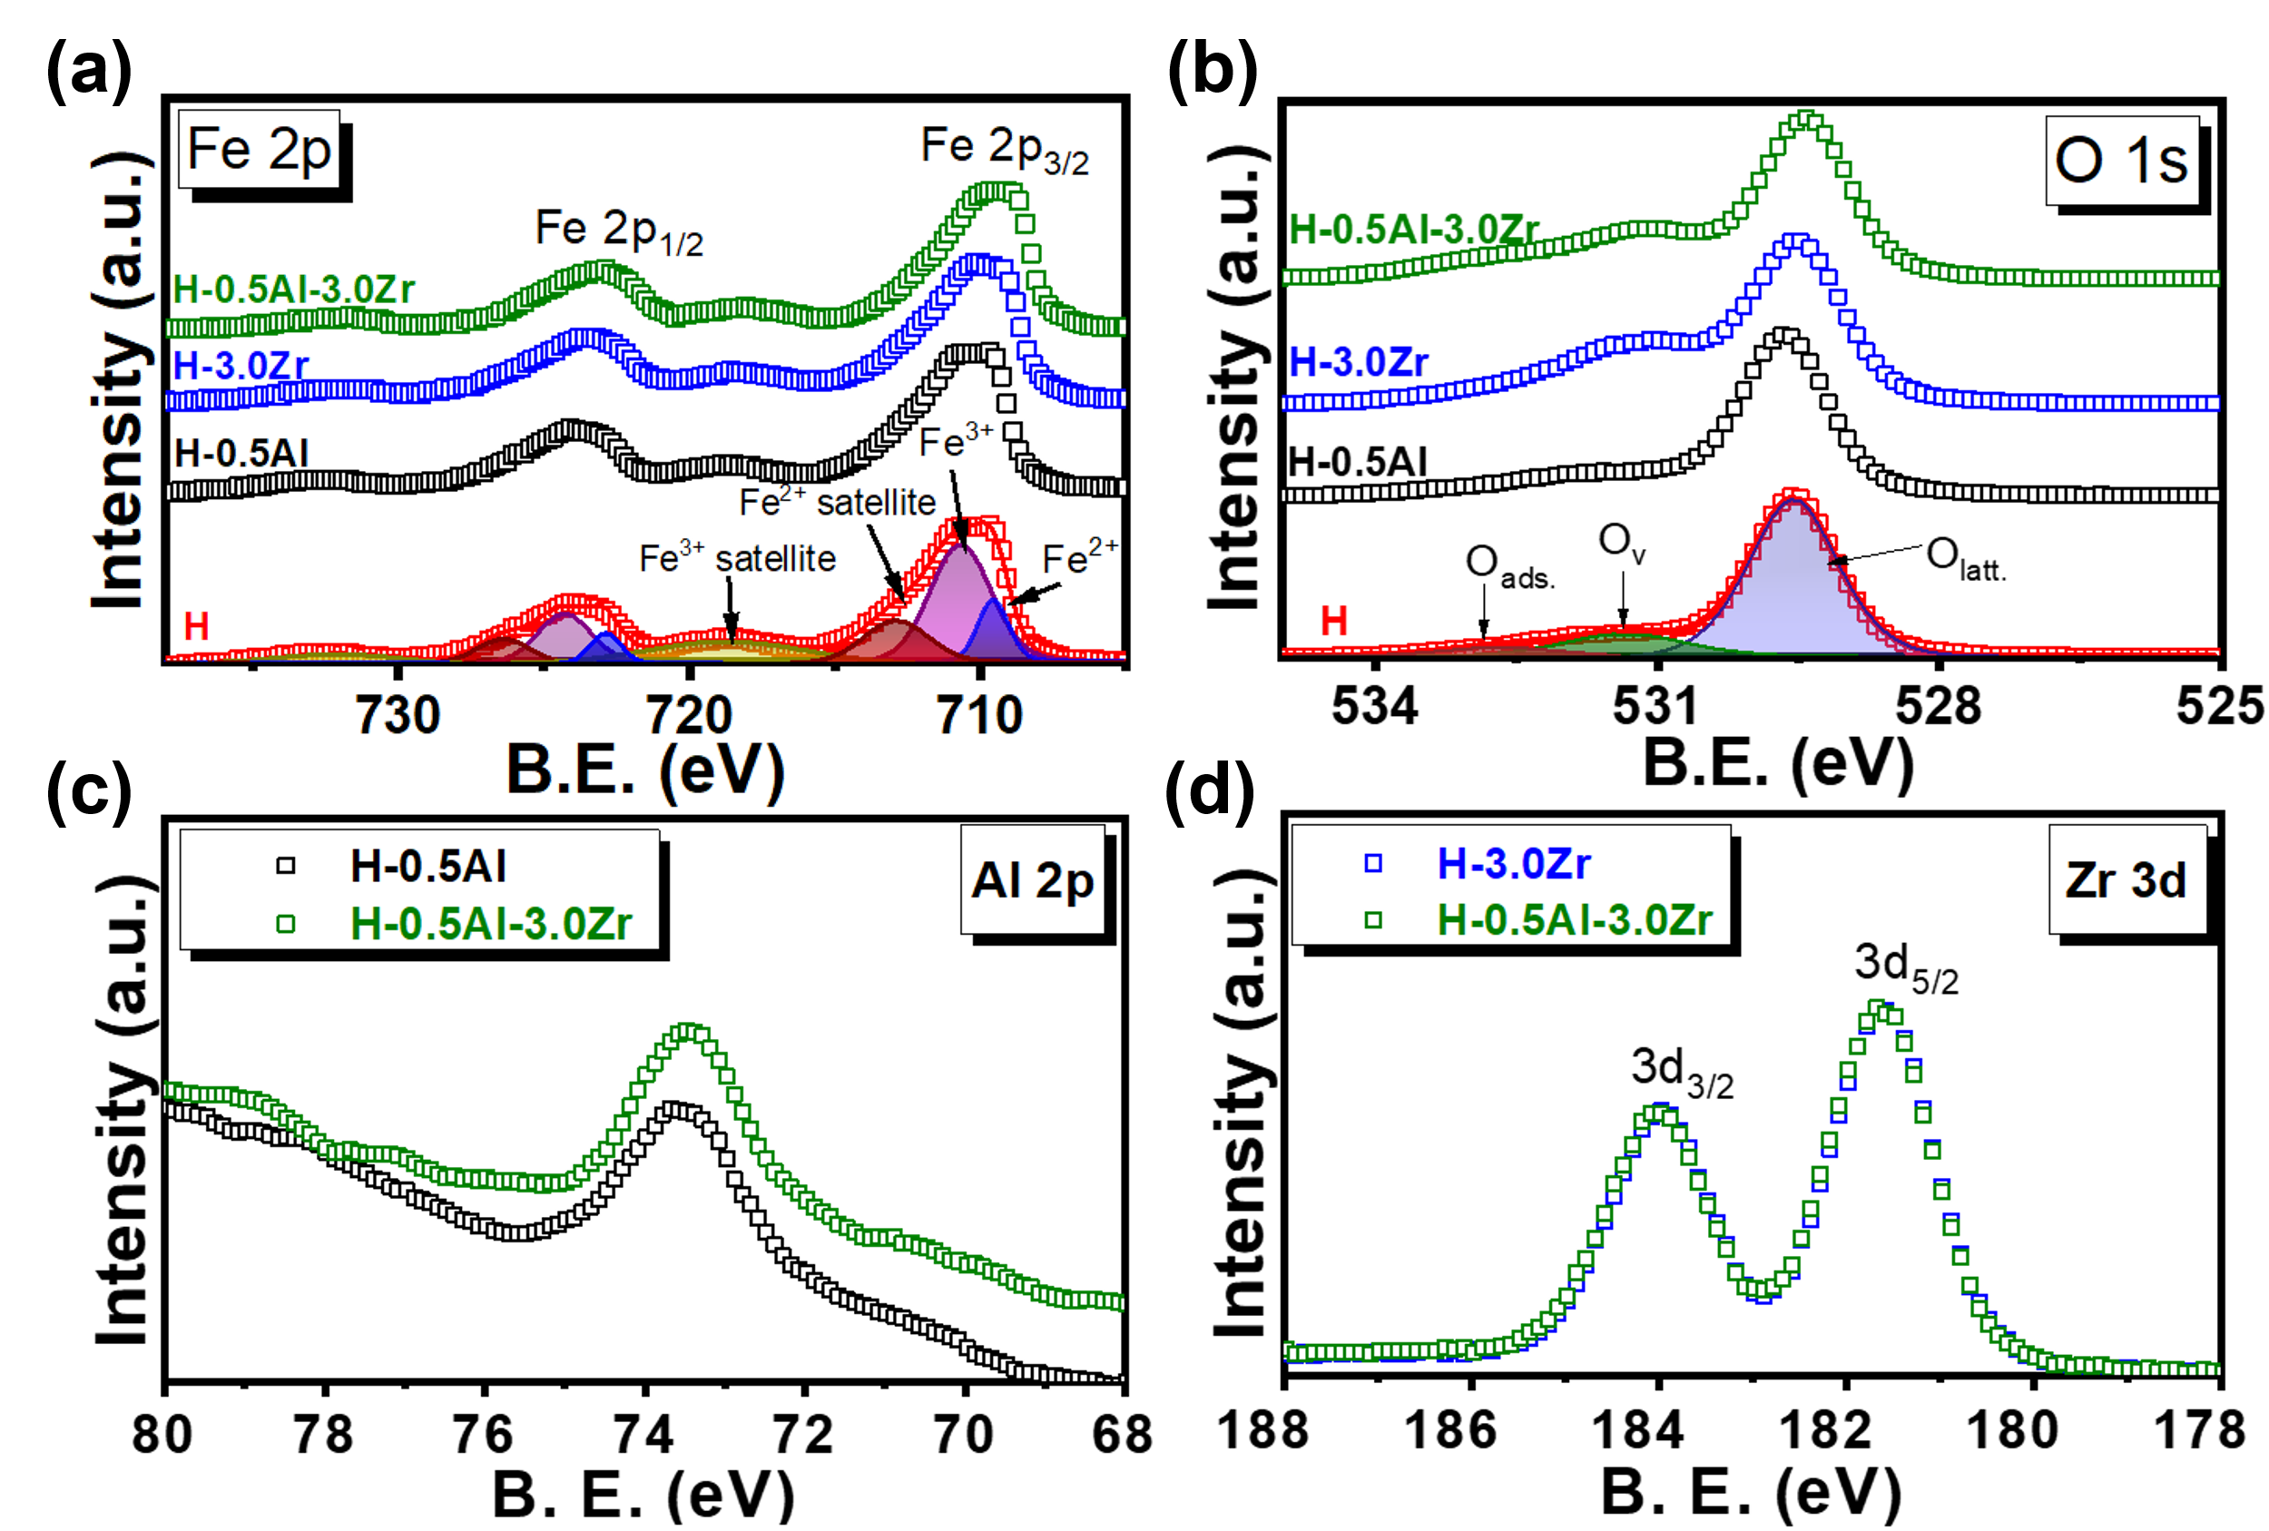
Figure S8. (a) Fe 2p high-resolution X-ray photoelectron spectroscopy (XPS) spectra of H, H-0.5Al, H-3.0Zr, and H-0.5Al-3.0Zr. (b) O 1s high-resolution XPS spectra of H, H-0.5Al, H-3.0Zr, and H-0.5Al-3.0Zr. (c) Al 2p high-resolution XPS spectra of H-0.5Al and H-0.5Al-3.0Zr. (d) Zr 3d high-resolution XPS spectra of H-3.0Zr and H-0.5Al-3.0Zr.

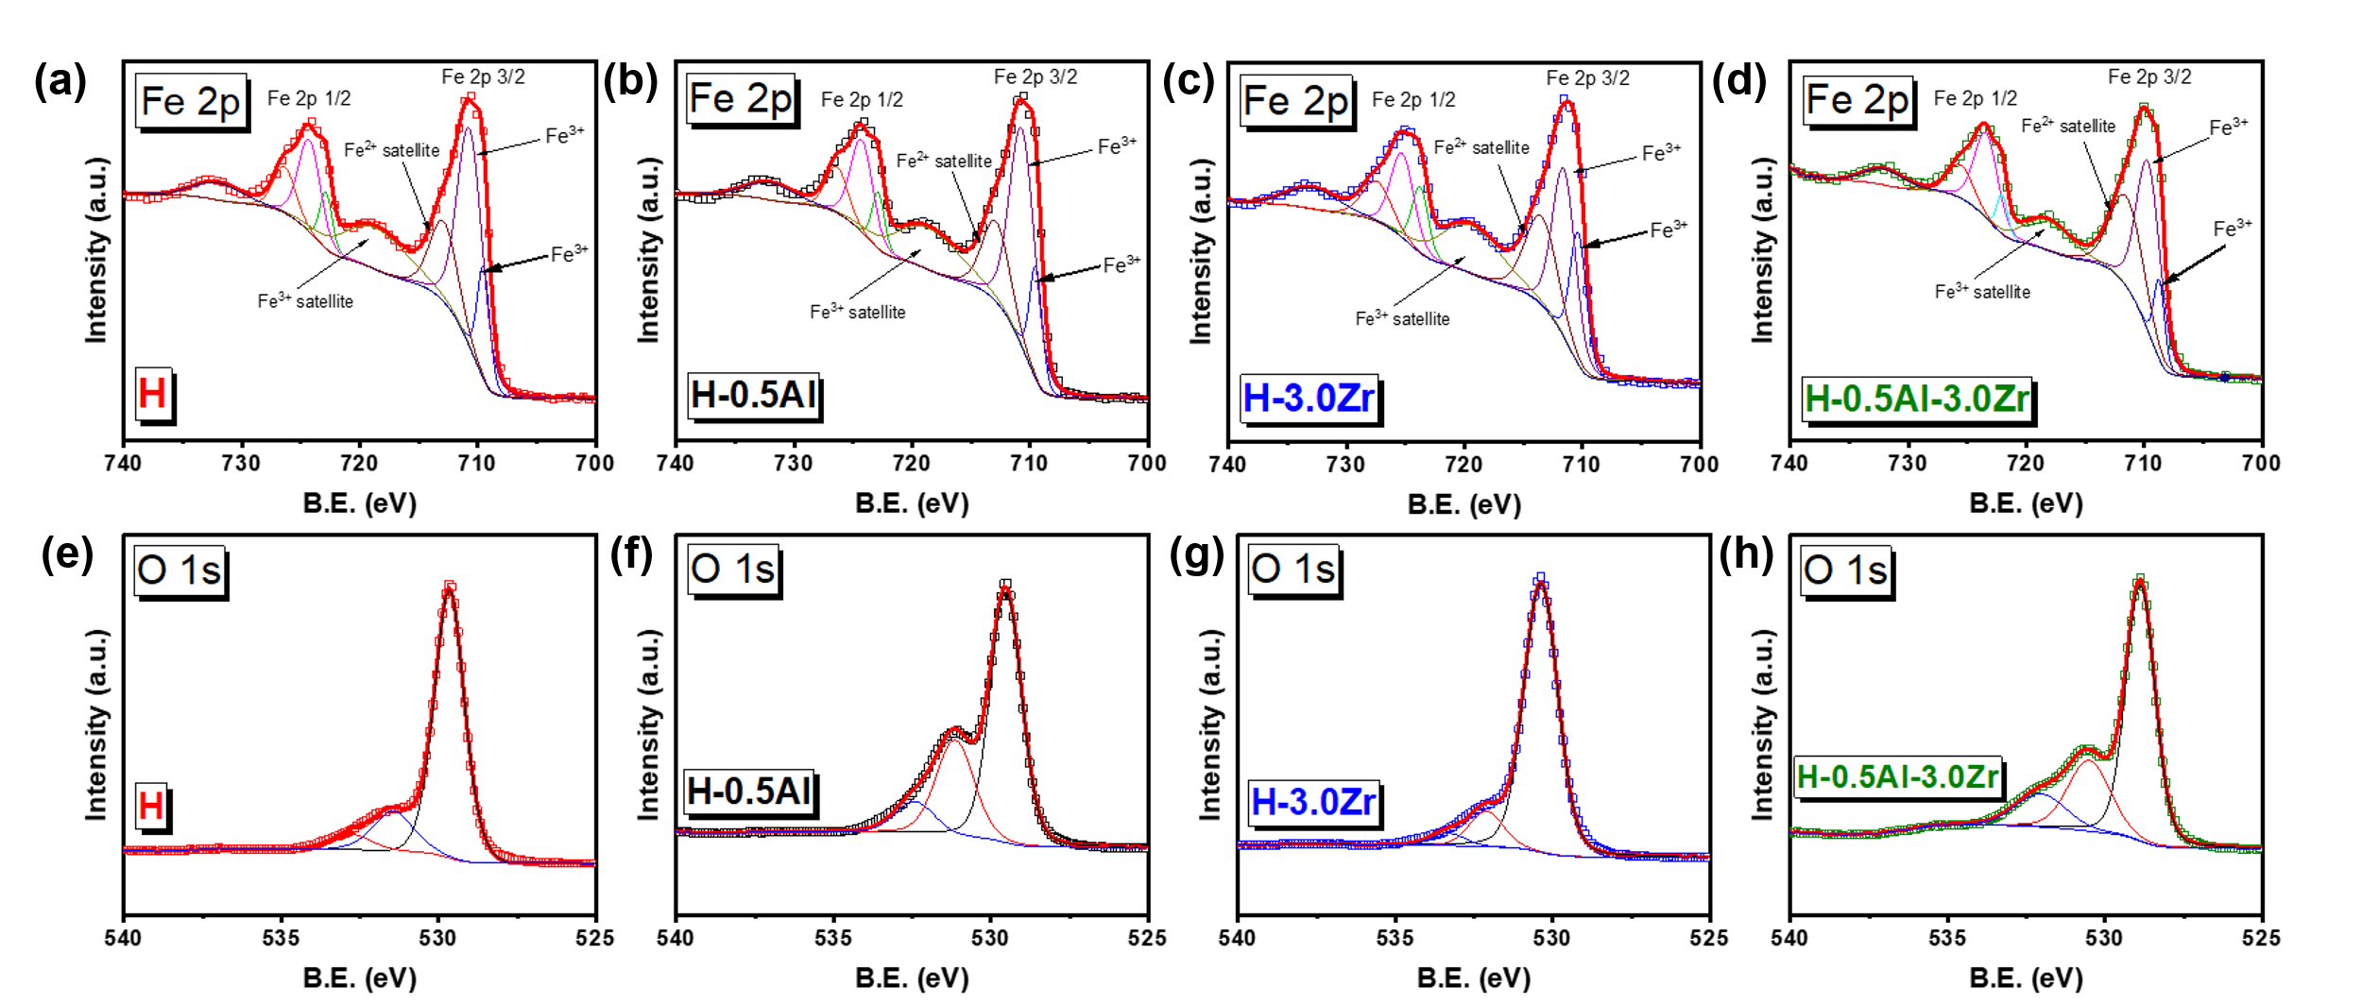
Figure S9. X-ray photoelectron spectroscopy (XPS) deconvoluted Fe 2p high-resolution spectrum of (a) pristine hematite, (b) H-0.5Al, (c) H-3.0Zr, and (d) H-0.5Al-3.0Zr. XPS deconvoluted O 1s high-resolution spectrum of (e) H, (f) H-0.5Al, (g) H-3.0Zr, and (h) H-0.5Al-3.0Zr.
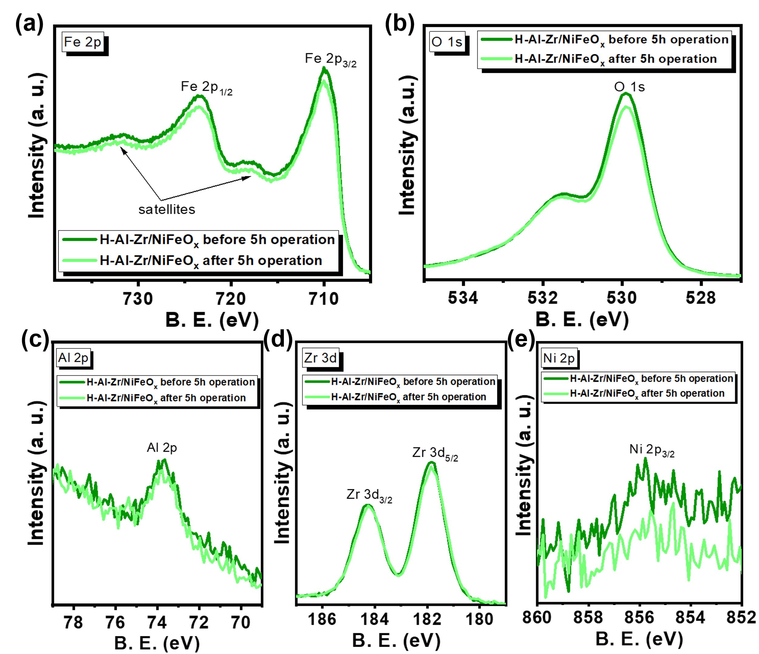
Figure S10. X-ray photoelectron spectroscopy (XPS) high-resolution spectra of (a) Fe 2p, (b) O 1s, (c) Al 2p, (d) Zr 3d, and (e) Ni 2p_{3/2} of H-0.5Al-3.0Zr/NiFeOx photoanode before and after 5h of photoelectrochemical operation.

Table S2. Surface composition of H-0.5Al-3.0Zr/NiFeO_{x} photoanode before and after 5h of photoelectrochemical operation.
H-Al-Zr/NiFeO_{x}
Content (at%) | Before 5h operation | After 5h operation
Fe 2p | 74.19 ±2 | 77.14 ±2
O 1s | 19.37 ±2 | 16.74 ±2
Al 2p | 0.8 ±0.3 | 0.77 ±0.3
Zr 3d | 5.37 ±0.3 | 5.12 ±0.3
*Ni 2p_{3/2} | 0.26 ±0.2 | 0.23 ±0.2
* Nickel at% was monitored only in the Ni 2p_{3/2} component because the other component was not distinguishable from instrumental noise. Ni²⁺ percentages reported were not reliably detected since its atomic percentage lies in the limit of detection of the equipment.

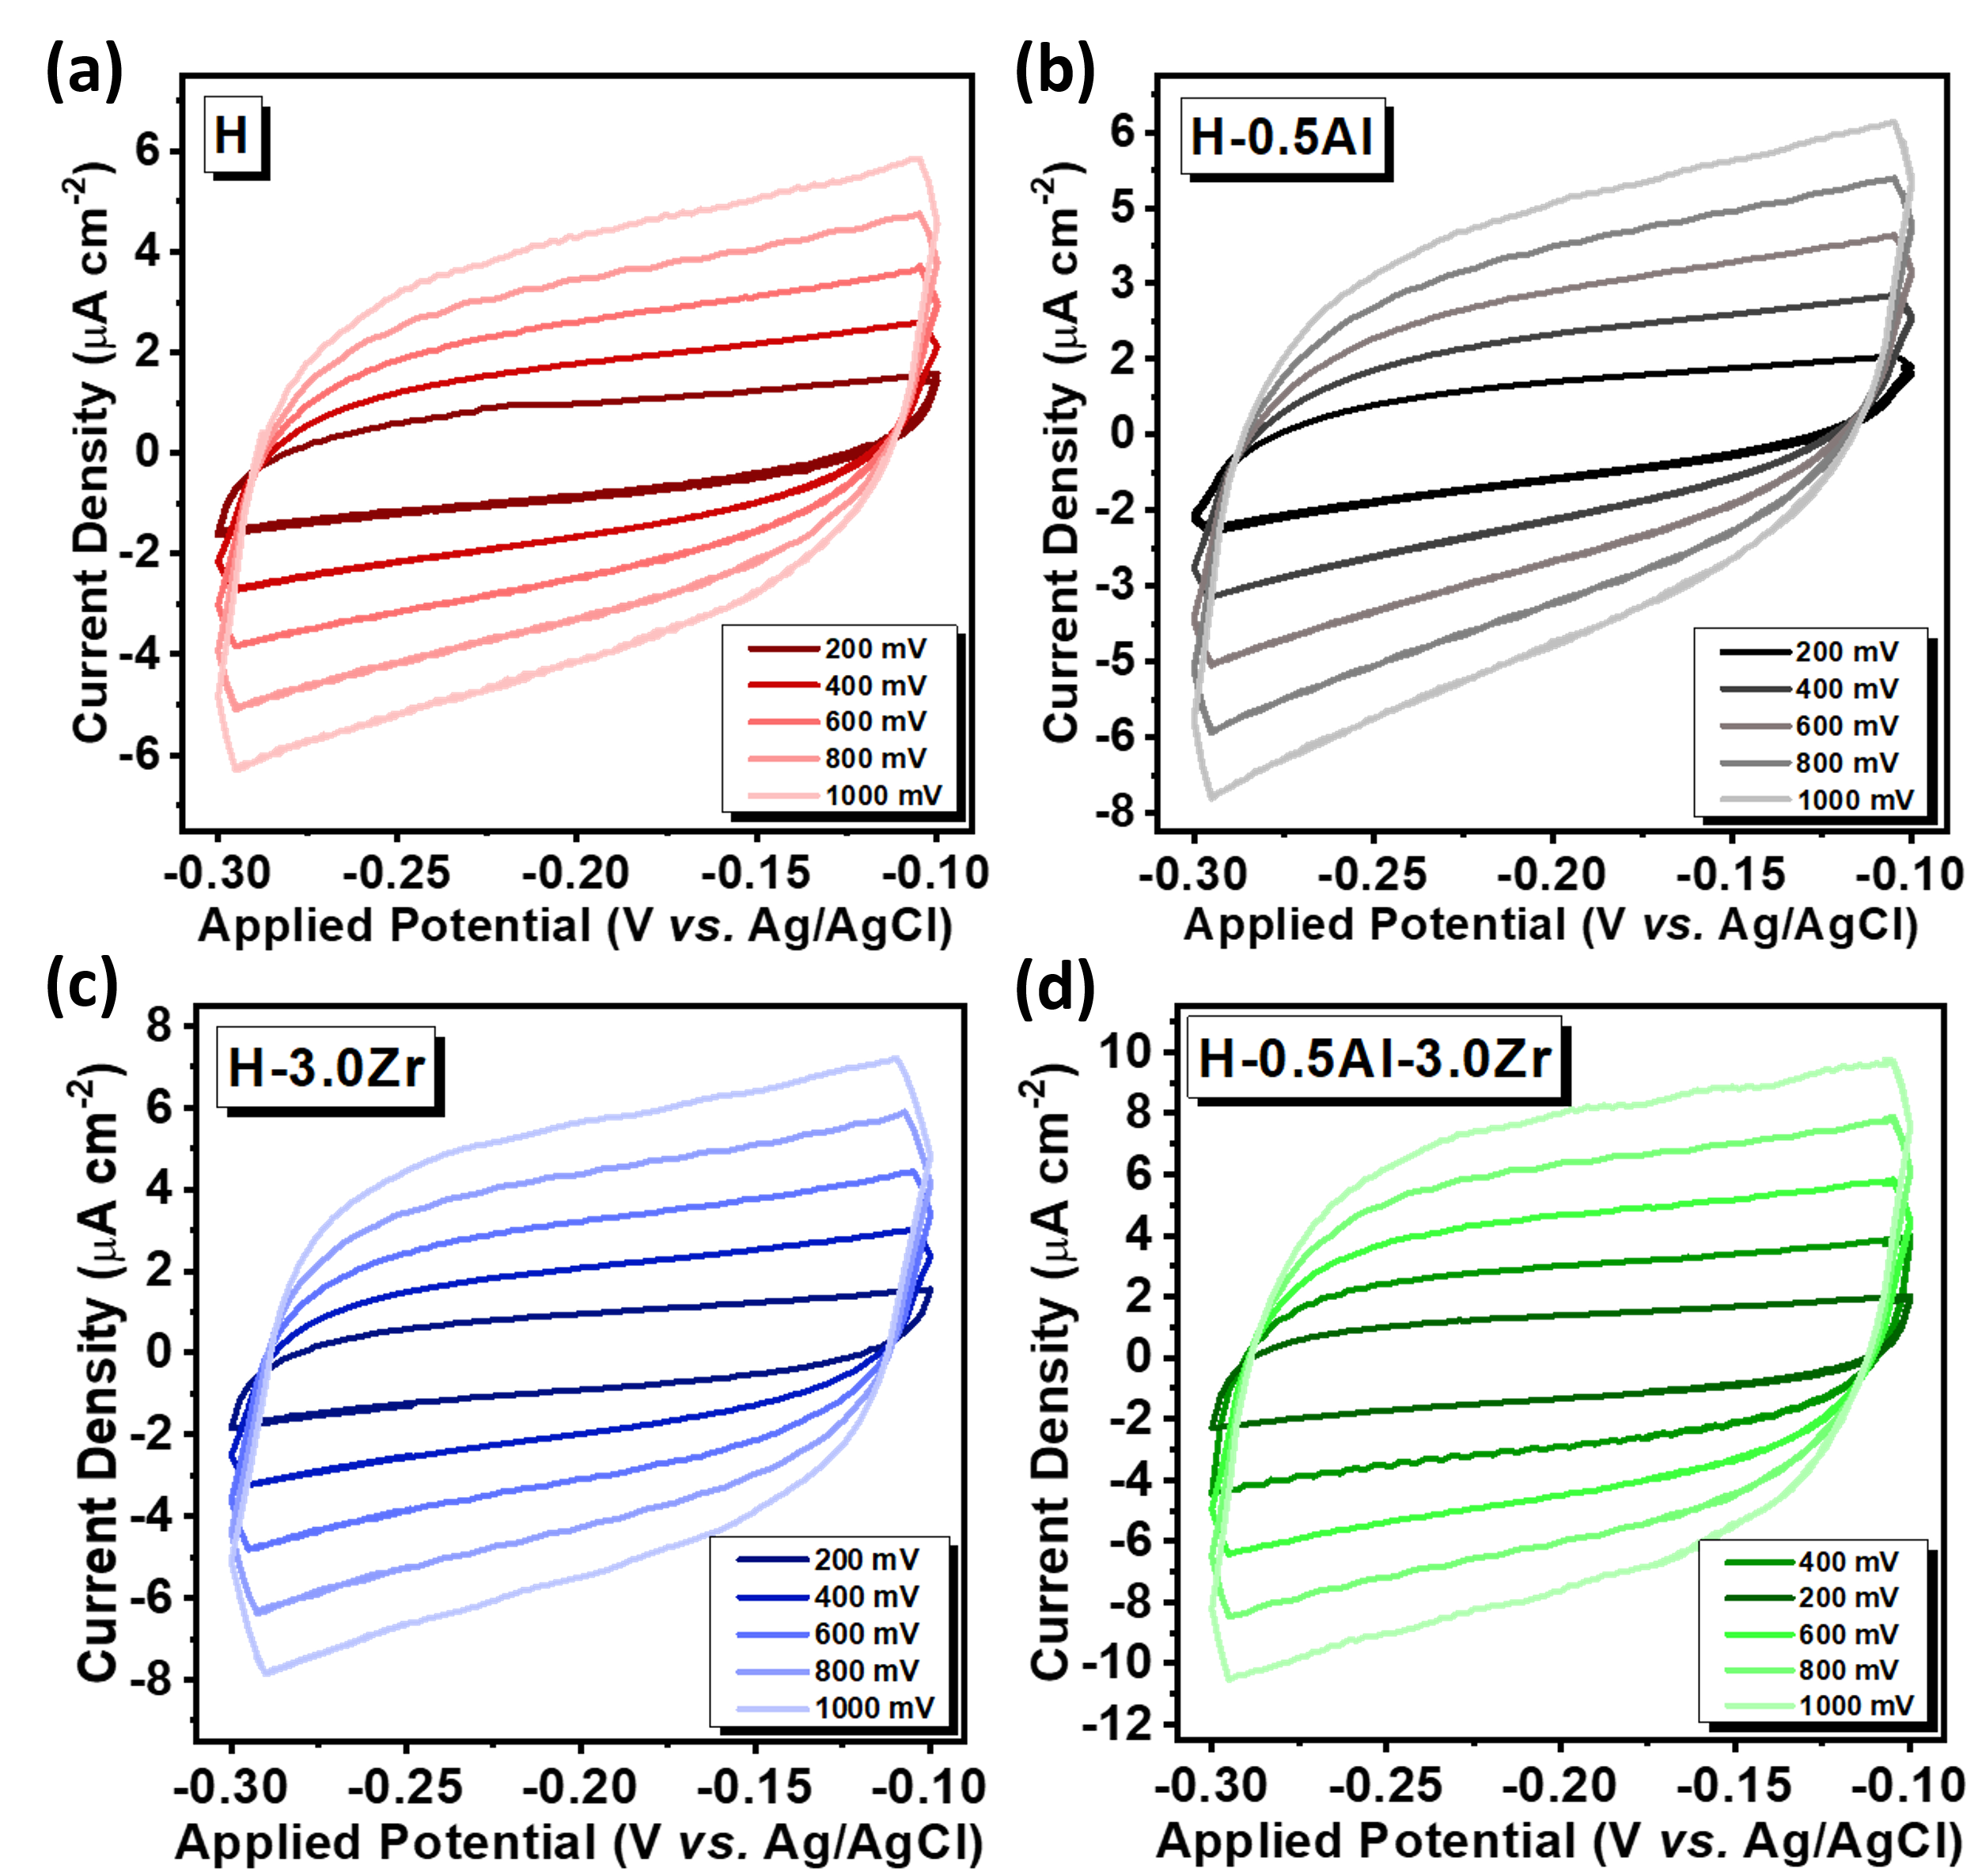
Figure S11. Cyclic voltammograms measured at non-faradaic regions (-0.3/-0.1 V vs. Ag/AgCl and -0.25/-0.15 V vs. Ag/AgCl) with different scan rates (200, 400, 600, 800, and 1000 mV s⁻¹) for (a) H, (b) H-0.5Al, (c) H-3.0Zr, and (d) H-0.5Al-3.0Zr photoanodes.

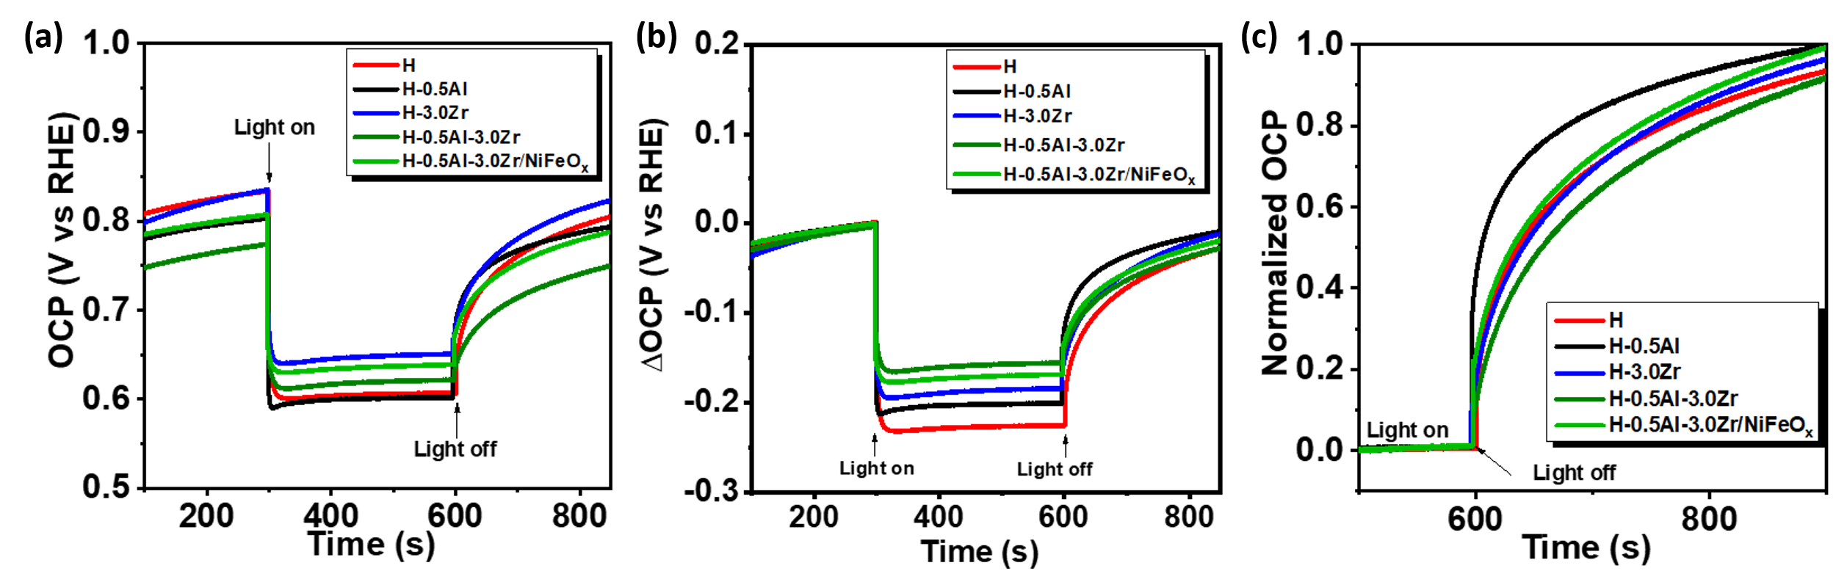
Figure S12. (a) Open circuit potential (OCP) curves measured for 900s, with light on and light off periods. (b) Values of OCP_{light} – OCP_{dark} (ΔOCP) plotted as function of time. (c) Normalized curves of OCP, highlighting the decay of OCP values when the illumination is interrupted.

Table S3. ΔOCP values of the photoanodes.
Sample | |ΔOCP| (V vs. RHE)
H | 0.23
H-0.5Al | 0.20
H-3.0Zr | 0.19
H-0.5Al-3.0Zr | 0.16
H-0.5Al-3.0Zr/NiFeO_{x} | 0.17

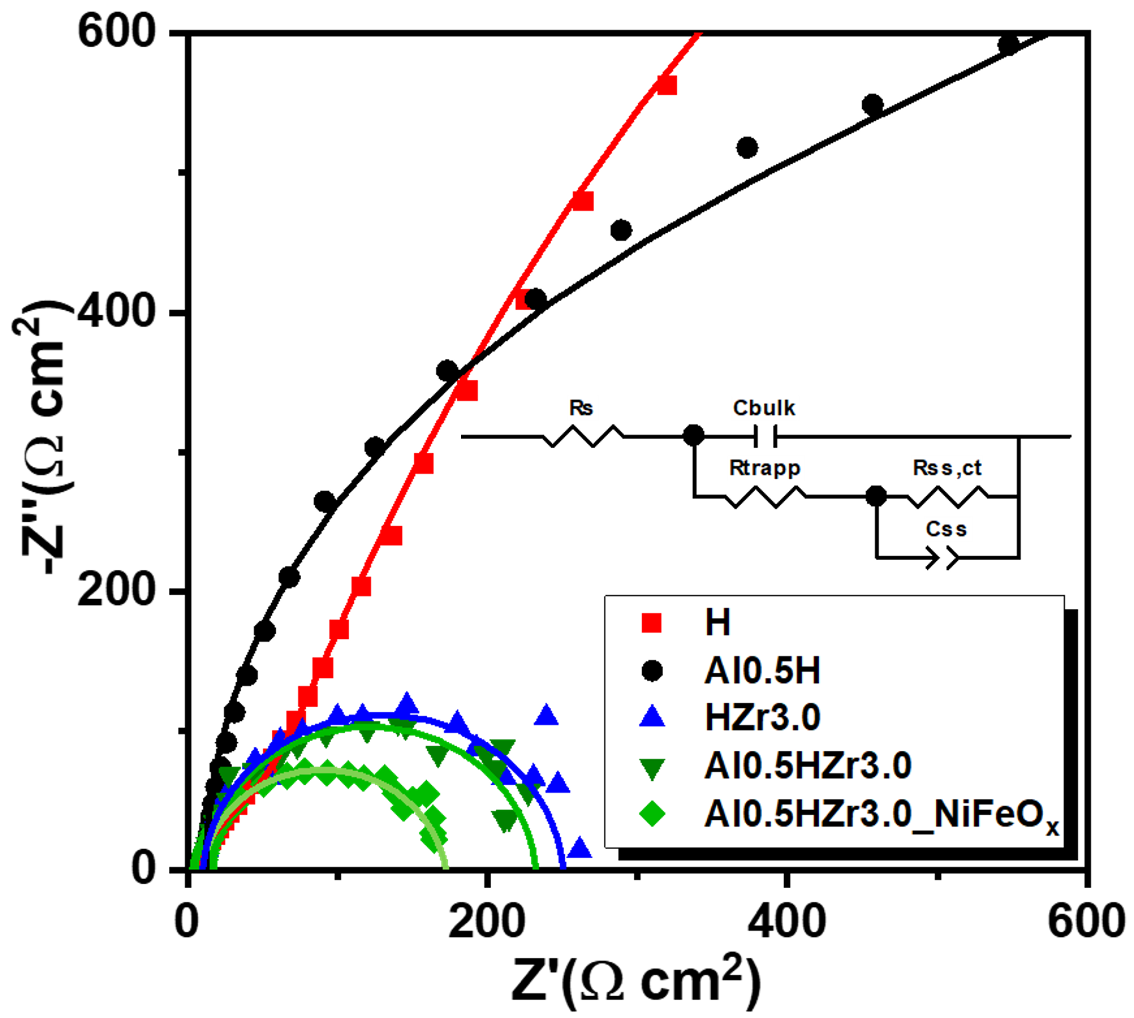
Figure S13. Electrochemical impedance spectroscopy (EIS) Nyquist plots of H, H-0.5Al, H-3.0Zr, H-0.5Al-3.0Zr, and H-0.5Al-3.0Zr/NiFeO_{x} photoanodes measured at 1.23 V_{RHE} under 100 mW cm⁻² illumination in 1M NaOH electrolyte. The model circuit employed to analyze the impedance parameters of the photoanodes is exhibited as an inset image in the graph.

Table S4. Impedance parameters of the model circuit employed to analyze H, H-0.5Al, H-3.0Zr, H-0.5Al-3.0Zr, and H-0.5Al-3.0Zr/NiFeO_{x} photoanodes. Electrochemical impedance spectroscopy (EIS) was measured at fixed potential of 1.23 V_{RHE} under 100 mW cm⁻² illumination in 1M NaOH electrolyte.
Sample | R_{s} | C_{bulk} | R_{trapp} | C_{ss} | CPE-P | R_{ss,ct}
H | 9.8 | 2.0E-05 | 83 | 1.4E-04 | 0.80 | 3429
H-0.5Al | 12.4 | 1.0E-05 | 813 | 7.6E-05 | 0.80 | 1659
H-3.0Zr | 9.4 | 1.9E-05 | 3.6 | 3.7E-05 | 0.92 | 238
H-0.5Al-3.0Zr | 10.1 | 2.2E-05 | 4.3 | 4.0E-05 | 0.91 | 219
H-0.5Al-3.0Zr/NiFeO_{x} | 10.3 | 3.1E-05 | 2.2 | 4.8E-05 | 0.80 | 160
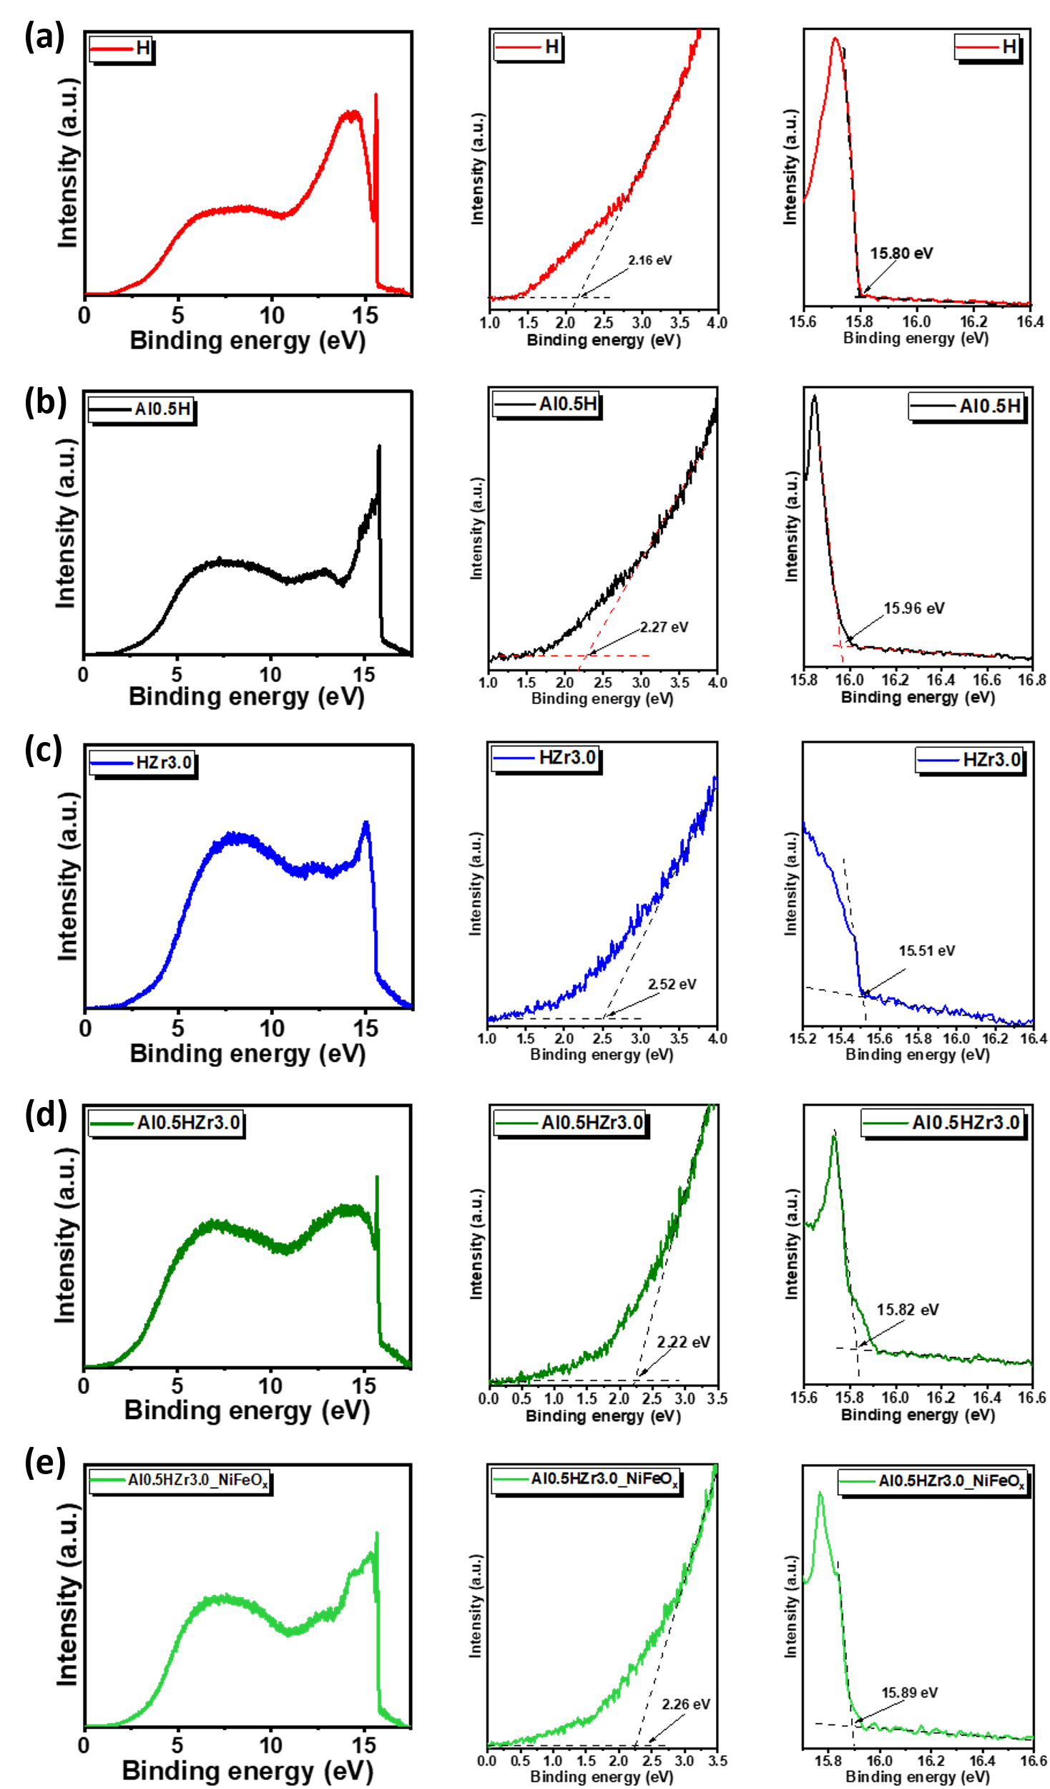
Figure S14. He I UPS spectra of (a) H, (b) H-0.5Al, (c) H-3.0Zr, (d) H-0.5Al-3.0Zr, and (e) H-0.5Al-3.0Zr/NiFeO_{x} obtained at 298 K. The plots to the right of each UPS spectrum represent the expansion of the region near the Fermi level and the determination of the secondary electron cutoff energy, respectively. The sample bias was -4 V relative to ground.
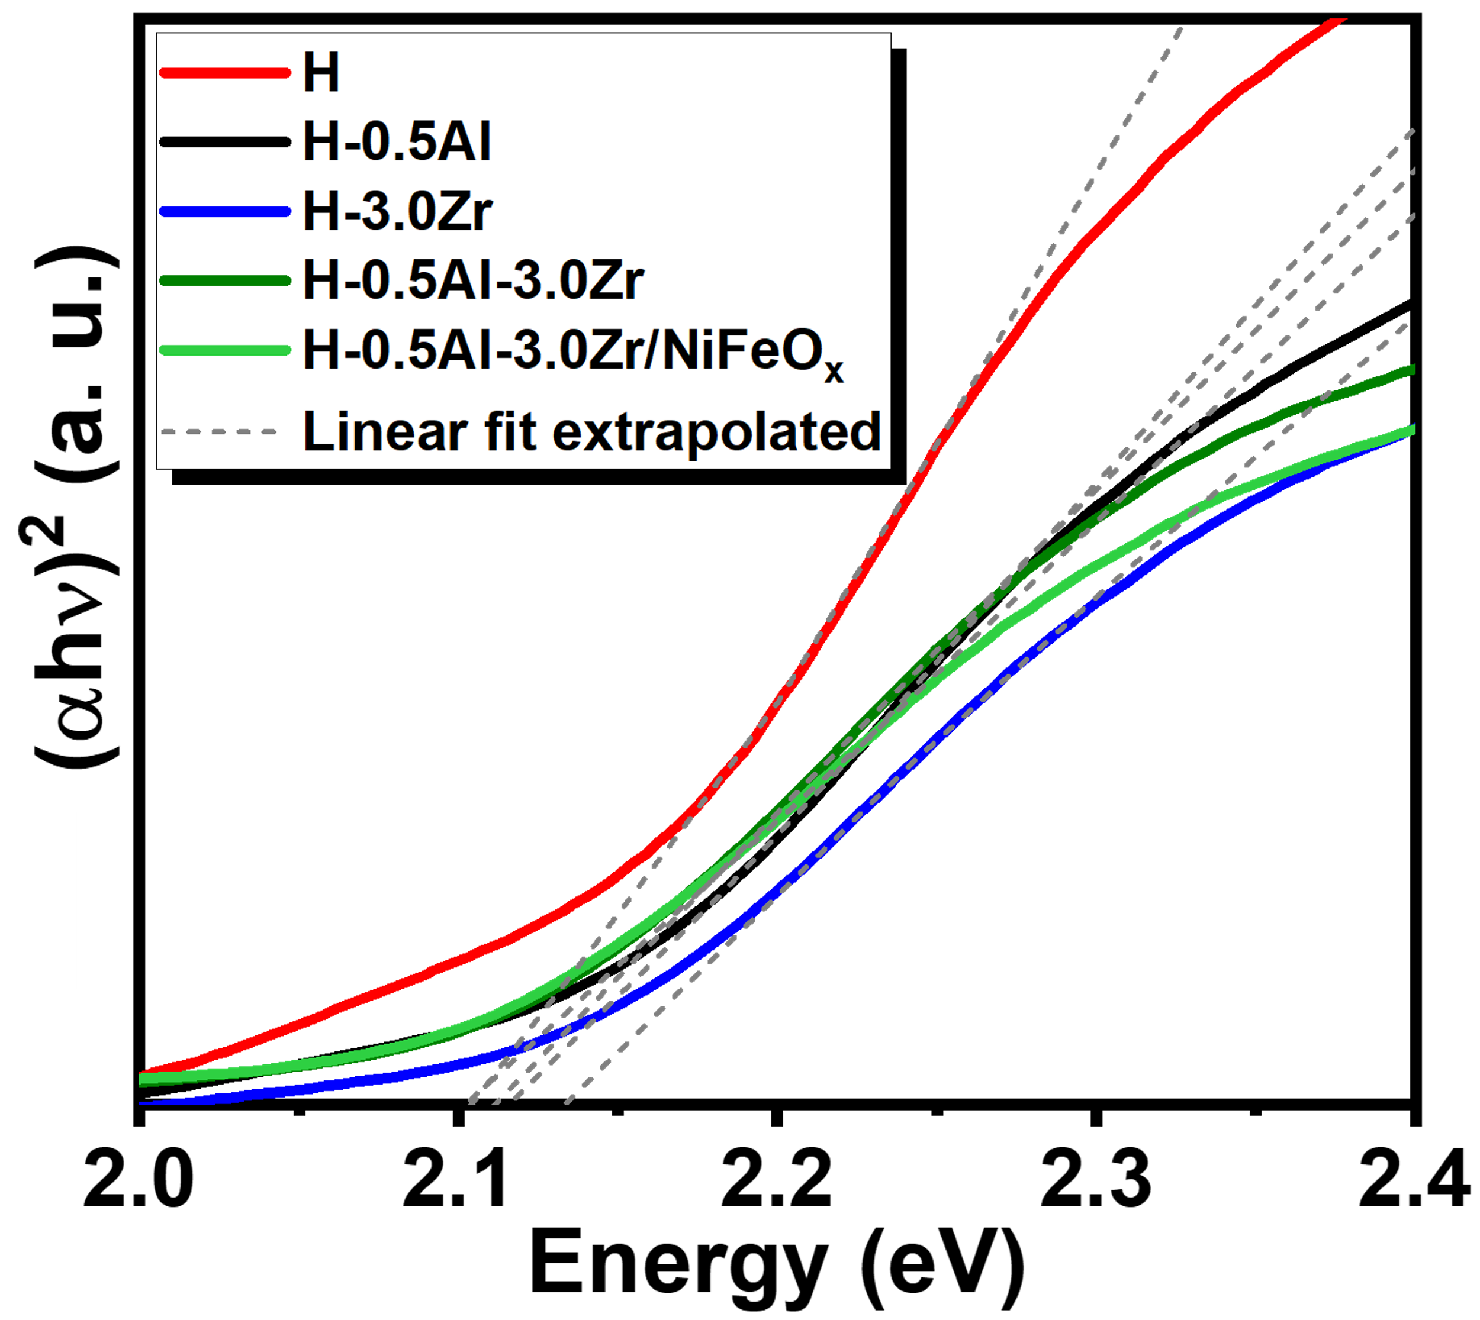
Figure S15. Tauc plots of H, H-0.5Al, H-3.0Zr, H-0.5Al-3.0Zr, and H-0.5Al-3.0Zr/NiFeO_{x} photoanodes with extrapolated linear fits. The intercepts of the linear fits at y = 0 indicate the estimated optical band gap values for the photoanodes.

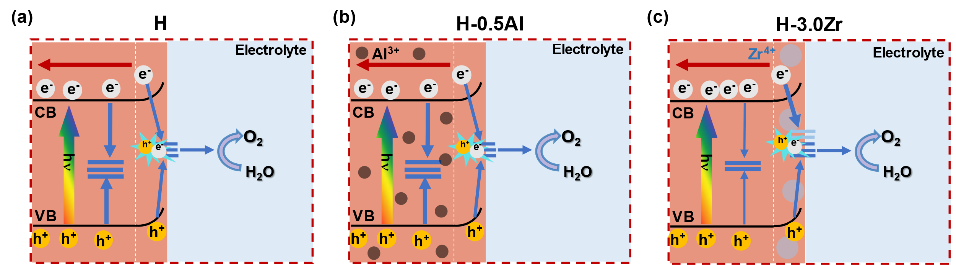
Figure S16. Schematic band diagrams of (a) pristine hematite, (b) H-0.5Al, and (c) H-3.0Zr photoanodes under PEC operation. Pristine hematite performance is strongly affected by bulk and surface recombination. H-0.5Al performance is enhanced by Al³⁺ bulk doping, which reduces small polaron effects and consequently improves intragrain electron mobility. Zr⁴⁺ segregation at the interfaces in H-3.0Zr photoanode improve charge separation efficiency by lowering Schottky’s energy barriers at the grain boundaries, but also creates surface states.
Table S5. Literature review of state-of-art hematite-based photoanodes compared to the water oxidation photocurrent obtained in this work (adapted from reference 10).
Photoanodes | Electrolyte solution | J_{ph} (mA cm⁻²) | Reference
H-0.5Al-3.0Zr/NiFeO_{x} | 1 M NaOH (pH 13.6) | 4.50 | This work
FH/TH/Co | 1 M NaOH (pH 13.6) | 6.00 | [9]
FeNiOOH-P-Hf-Fe₂O₃ (LV) | 1 M NaOH (pH 13.6) | 5.24 | [10]
Fe₂O₃ NS/Ag NPs/Co–Pi | 1 M NaOH (pH 13.6) | 4.68 | [11]
NiFeO_{x}@Ge-PH | 1 M NaOH (pH 13.6) | 4.60 | [12]
NH₂-CNTs :Ti-Fe₂O₃ | 1 M NaOH (pH 13.6) | 4.50 | [13]
Pt:Fe₂O₃ /CoPi | 1 M NaOH (pH 13.6) | 4.32 | [14]
NiFeO_{x}/Si:Ti-Fe₂O₃ | 1 M NaOH (pH 13.6) | 4.30 | [15]
PO₄³⁻-CoAl-LDHs/α-Fe₂O₃ | 1 M NaOH (pH 13.6) | 4.30 | [16]
Fe₂O₃ (Ti) MCs | 1 M NaOH (pH 13.6) | 4.30 | [17]
Ti:Fe₂O₃/SiO_{x}/Ti–FeOOH | 1 M NaOH (pH 13.6) | 4.06 | [18]
NiFeO_{x}/Ti:Si-Fe₂O₃ | 1 M NaOH (pH 13.6) | 4.00 | [19]
Co-Pi/Sn-Fe₂O₃ | 1 M NaOH (pH 13.6) | 3.90 | [20]
Fe₂O₃-MA-18 min | 1 M NaOH (pH 13.6) | 3.90 | [21]
IrO₂/Fe₂O₃ | 1 M NaOH (pH 13.6) | 3.75 | [22]
F/Sn: Fe₂O₃ | 1 M NaOH (pH 13.6) | 3.64 | [23]
CoP/SnO₂:Fe₂O₃ | 1 M NaOH (pH 13.6) | 3.54 | [24]
Co-Pi/Mn-Fe₂O₃ | 1 M NaOH (pH 13.6) | 3.50 | [25]
Ti-Fe₂O₃ MC/Co-Pi | 1 M NaOH (pH 13.6) | 3.50 | [26]
InO₂ layer / Fe₂O₃ | 1 M NaOH (pH 13.6) | 3.40 | [27]
CoPi-Ti/Au/ Fe₂O₃ | 1 M NaOH (pH 13.6) | 3.39 | [28]
Sn:Fe₂O₃ with V_{O} | 1 M NaOH (pH 13.6) | 3.30 | [29]
NiFe(OH)_{x}/Ta:Fe₂O₃@Fe₂O₃ | 1 M NaOH (pH 13.6) | 3.22 | [30]
FeGe1 | 1 M NaOH (pH 13.6) | 3.20 | [31]
Fe₂O₃/FeOOH/Au | 1 M KOH (pH 13.6) | 3.20 | [32]

REFERENCES
[1] Liardet, L. et al. An ultrathin cobalt–iron oxide catalyst for water oxidation on nanostructured hematite photoanodes. Journal of Materials Chemistry A 7, 6012–6020 (2019).
[2] Nogueira, A. E. et al. Discovering a selective semimetal element to increase hematite photoanode charge separation efficiency. Journal of Materials Chemistry A 7, 16992–16998 (2019).
[3] Hankin, A. et al. Flat band potential determination: avoiding the pitfalls. Journal of Materials Chemistry A 7, 26162-26176 (2019).
[4] Arumugam S., Toku, Y. & Ju, Y. Fabrication of γ-Fe₂O₃ Nanowires from Abundant and Low-cost Fe Plate for Highly Effective Electrocatalytic Water Splitting. Scientific Reports 10, 5407 (2020).
[5] Shimizu, K., Lasia, A. & Boily J.-F. Electrochemical Impedance Study of the Hematite/Water Interface. Langmuir 28, 7914–7920 (2012).
[6] Ibukun, O. & Jeong, H. K. Effects of Aqueous Electrolytes in Supercapacitors. New Phys.: Sae Mulli 69, 154–158 (2019).
[7] McCrory, C. C. L. et al. Benchmarking Hydrogen Evolving Reaction and Oxygen Evolving Reaction Electrocatalysts for Solar Water Splitting Devices. Journal of the American Chemical Society 137, 4347–4357 (2015).
[8] Makuła, P., Pacia, M. & Macyk, W. How To Correctly Determine the Band Gap Energy of Modified Semiconductor Photocatalysts Based on UV–Vis Spectra. Journal of Phyical. Chemistry Letters 9, 6814–6817 (2018).
[9] Jeon, T. H., Moon, G., Park, H. & Choi, W. Ultra-efficient and durable photoelectrochemical water oxidation using elaborately designed hematite nanorod arrays. Nano Energy 39, 211–218 (2017).

[10] Lu, C. et al. Hetero phase modulated hematite photoanodes for practical solar water splitting. Applied Catalysis B: Environmental 331, 122695 (2023).
[11] Peerakiatkhajohn, P. et al. Stable Hematite Nanosheet Photoanodes for Enhanced Photoelectrochemical Water Splitting. Advanced Materials 28, 6405–6410 (2016).

[12] Yoon, K. Y. et al. NiFeOx decorated Ge-hematite/perovskite for an efficient water splitting system. Nature Communications 12, 1–12 (2021).

[13] Liu, Y., Wang, D. P., Yu, Y. X. & Zhang, W. D. Preparation and photoelectrochemical properties of functional carbon nanotubes and Ti co-doped Fe 2O 3 thin films. International Journal of Hydrogen Energy 37, 9566–9575 (2012).

[14] Kim, J. Y. et al. Single-crystalline, wormlike hematite photoanodes for efficient solar water splitting. Scientific Reports 3, 1–8 (2013).

[15] Yoon, K. Y. et al. Unveiling the Role of the Ti Dopant and Viable Si Doping of Hematite for Practically Efficient Solar Water Splitting. ACS Catalysis 12, 5112–5122 (2022).

[16] Chong, R. et al. Anion engineering of exfoliated Co-Al layered double hydroxides on hematite photoanode toward highly efficient photoelectrochemical water splitting. Chemical Engineering Journal 366, 523–530 (2019).

[17] Zhang, Z., Nagashima, H. & Tachikawa, T. Ultra-Narrow Depletion Layers in a Hematite Mesocrystal-Based Photoanode for Boosting Multihole Water Oxidation. Angewandte Chemie - International Edition 59, 9047–9054 (2020).

[18] Yoon, K. Y. et al. A selectively decorated Ti-FeOOH co-catalyst for a highly efficient porous hematite-based water splitting system. Journal of Materials Chemistry A 4, 18730–18736 (2016).

[19] Park, J. et al. A highly transparent thin film hematite with multi-element dopability for an efficient unassisted water splitting system. Nano Energy 76, 105089 (2020).

[20] Gurudayal et al. Atomically Altered Hematite for Highly Efficient Perovskite Tandem Water-Splitting Devices. ChemSusChem 10, 2449–2456 (2017).

[21] Hou, Y., Zheng, C., Zhu, Z. & Wang, X. Microwave-assisted fabrication of porous hematite photoanodes for efficient solar water splitting. Chemical Communications 52, 6888–6891 (2016).

[22] Tilley, S. D., Cornuz, M., Sivula, K. & Grätzel, M. Light-induced water splitting with hematite: Improved nanostructure and iridium oxide catalysis. Angewandte Chemie - International Edition 49, 6405–6408 (2010).

[23] Quang, N. D. et al. Fluorine-surface-modified tin-doped hematite nanorod array photoelectrodes with enhanced water oxidation activity. Applied Surface Science 558, 149898 (2021).

[24] Quang, N. D. et al. Fe2O3 hierarchical tubular structure decorated with cobalt phosphide (CoP) nanoparticles for efficient photoelectrochemical water splitting. Chemical Engineering Journal 417, 129278 (2021).

[25] Gurudayal et al. Perovskite-Hematite Tandem Cells for Efficient Overall Solar Driven Water Splitting. Nano Letters 15, 3833–3839 (2015).

[26] Zhang, Z. et al. Interfacial oxygen vacancies yielding long-lived holes in hematite mesocrystal-based photoanodes. Nature Communications 10, 1–12 (2019).

[27] Yi, S. S. et al. Coupling effects of indium oxide layer on hematite enabling efficient photoelectrochemical water splitting. Applied Catalysis B: Environmental 283, 119649 (2021).

[28] Li, J. et al. A three-dimensional hexagonal fluorine-doped tin oxide nanocone array: A superior light harvesting electrode for high performance photoelectrochemical water splitting. Energy and Environmental Science 7, 3651–3658 (2014).

[29] Wang, J. J., Hu, Y., Toth, R., Fortunato, G. & Braun, A. A facile nonpolar organic solution process of a nanostructured hematite photoanode with high efficiency and stability for water splitting. Journal of Materials Chemistry A 4, 2821–2825 (2016).

[30] Zhang, H. et al. Gradient tantalum-doped hematite homojunction photoanode improves both photocurrents and turn-on voltage for solar water splitting. Nature Communications 11, 1–11 (2020).

[31] Rodrigues, M. H. M. et al. Ideal dopant to increase charge separation efficiency in hematite photoanodes: germanium. Journal of Materials Chemistry A 10, 13456–13466 (2022).

[32] Wang, L. et al. Plasmon-induced hole-depletion layer on hematite nanoflake photoanodes for highly efficient solar water splitting. Nano Energy 35, 171–178 (2017).

