Supplementary data
Flash flood dynamics in Doon Valley, NW Himalaya: Insights of hydrological and geological controls
Sumit Sagwal^{1,2}, Sandeep Panda¹*, Dipanwita Sengupta^{1,2}, Mohd Shahrukh^{1,2}, Sohan Kumar³, Anil Kumar^{1,2}, Som Dutt^{1,2}
¹Wadia Institute of Himalayan Geology, Dehradun 248001
²Academy of Scientific and Innovative Research, Ghaziabad 201002
³Department of Earth Sciences, Indian Institute of Technology, Roorkee 247667
* For correspondence - pandasandeep04@gmail.com

Supplementary table- 1 (Total Variance explained of Doon watershed)
Components | F1 | F2 | F3 | F4
Eigenvalue | 5.914 | 2.755 | 1.967 | 1.365
Variability (%) | 49.279 | 22.957 | 16.390 | 11.374
Cumulative % | 49.279 | 72.236 | 88.626 | 100.000

Supplementary table- 2 (Correlations between different variables and factors.)
Variable | F1 | F2 | F3 | F4
R_{b} | -0.129 | -0.462 | 0.877 | 0.011
R_{l} | 0.276 | 0.813 | 0.351 | -0.374
RHO | 0.295 | 0.899 | -0.020 | -0.324
F_{s} | 0.354 | -0.311 | 0.788 | -0.397
D_{d} | -0.834 | -0.059 | 0.053 | 0.546
T | 0.893 | -0.189 | 0.293 | 0.284
R_{e} | 0.956 | -0.263 | -0.127 | 0.026
R_{c} | 0.950 | -0.303 | -0.072 | 0.024
F_{f} | 0.929 | -0.313 | -0.152 | 0.122
ND | 0.748 | 0.505 | 0.104 | 0.418
FD | 0.777 | 0.472 | 0.086 | 0.407
FFI | 0.523 | -0.447 | -0.549 | -0.475
Variance | 5.914 | 2.755 | 1.967 | 1.365
% Var | 0.493 | 0.230 | 0.164 | 0.114

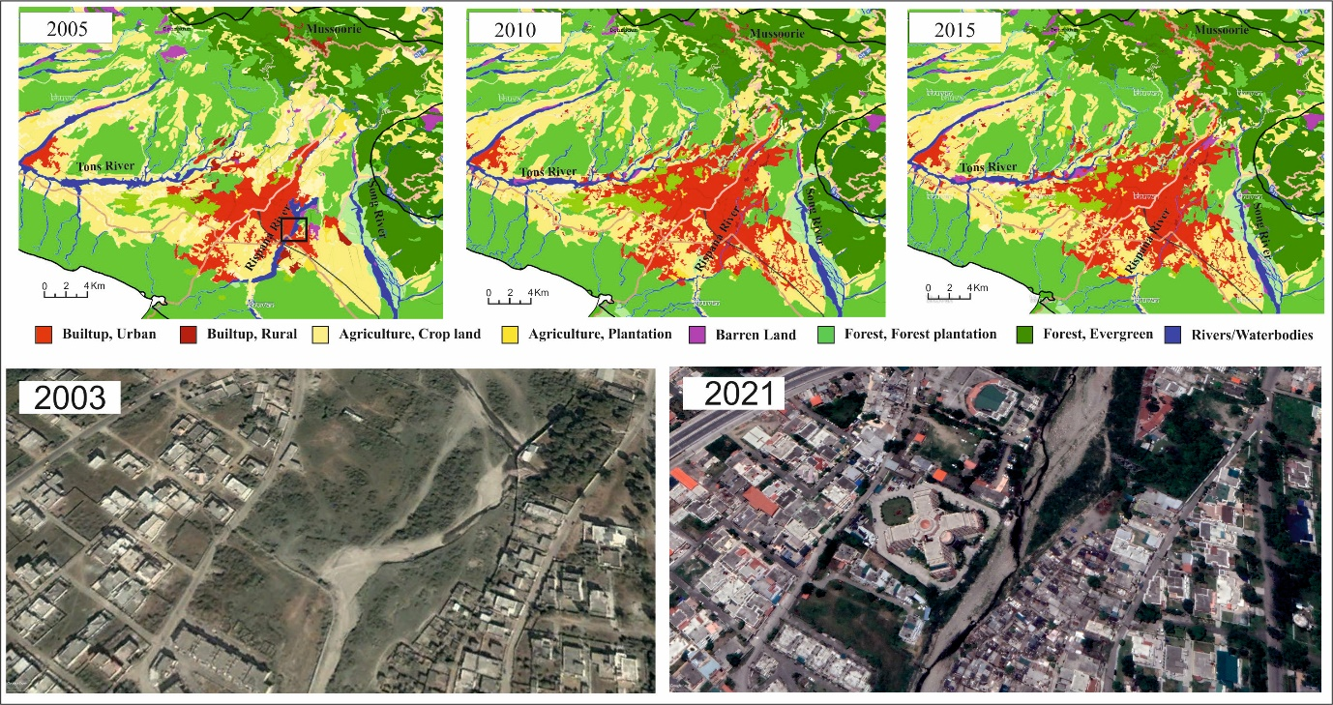
Supplementary figure 1: Change of Land use & Land Cover in Doon Valley since 2005 to 2015. The streams have narrowed down specially at Rispanna river. Vegetation cover has decreased. Google-earth images show the buildup activity of the flood plain of the river from 2003 to 2021.

