A Deep Learning Framework for Predicting the Heterogeneous Stiffness Map of Brain White Matter Tissue
Poorya Chavoshnejad*, Guangfa Li*, Akbar Solhtalab, Dehao Liu⁺, Mir Jalil Razavi⁺
Department of Mechanical Engineering, Binghamton University, State University of New York, New York 13902, USA
*These authors contributed equally to this work
⁺Corresponding Author: dehaoliu@binghamton.edu, mrazavi@binghamton.edu

Fig. S1 Mesh convergence analysis. Mesh size 0.3 mm was selected. Mesh sizes are in mm.

Table S1. Results of hyperparameter tuning for 3D Resnet
Session Number | Learning Rate  / ${10}^{-4}$ | Batch  Size | Stop  Epoch | Training  Time (s) | Training  Loss in MSE / ${10}^{-4}$ | Validation  Loss in MSE / ${10}^{-4}$ | Test  Loss in MSE / ${10}^{-4}$
1 | 0.1 | 20 | 200 | 4747.54 | 2.93794 | 8.4380 | 41.21
2 | 0.1 | 20 | 200 | 4680.37 | 2.80781 | 8.2375 | 39.13
3 | 50 | 40 | 200 | 5001.19 | 3.63063 | 4.7472 | 62.00
4 | 50 | 20 | 160 | 3808.41 | 3.05772 | 8.4857 | 53.39
5 | 5 | 5 | 5 | 175.22 | 4.13964 | 40.0425 | 49.65
6 | 1 | 10 | 5 | 134.94 | 5.48299 | 23.1335 | 56.88
7 | 1 | 20 | 160 | 3815.26 | 3.10635 | 8.6688 | 42.06
8 | 50 | 20 | 10 | 242.14 | 7.0572 | 13.2205 | 99.36
9 | 5 | 10 | 5 | 134.49 | 10.3208 | 31.6316 | 85.24
10 | 50 | 10 | 5 | 132.99 | 9.36417 | 29.9613 | 126.38
11 | 10 | 20 | 200 | 4697.58 | 3.00559 | 8.4660 | 42.00
12 | 0.1 | 5 | 5 | 174.30 | 3.41174 | 35.7407 | 44.46
13 | 10 | 40 | 200 | 5021.8 | 2.68132 | 4.0652 | 38.94
14 | 0.1 | 40 | 5 | 130.45 | 113.195 | 26.2405 | 269.53
15 | 0.1 | 40 | 10 | 255.01 | 22.0503 | 11.6037 | 115.10
16 | 10 | 5 | 5 | 173.66 | 5.71899 | 46.7321 | 59.02
17 | 10 | 10 | 5 | 132.14 | 9.08493 | 29.9427 | 82.90
18 | 0.1 | 40 | 5 | 130.72 | 111.717 | 26.0494 | 233.75
19 | 50 | 40 | 200 | 4970.87 | 3.62964 | 4.7215 | 130.39
20 | 5 | 5 | 5 | 173.47 | 5.24737 | 44.7515 | 56.05

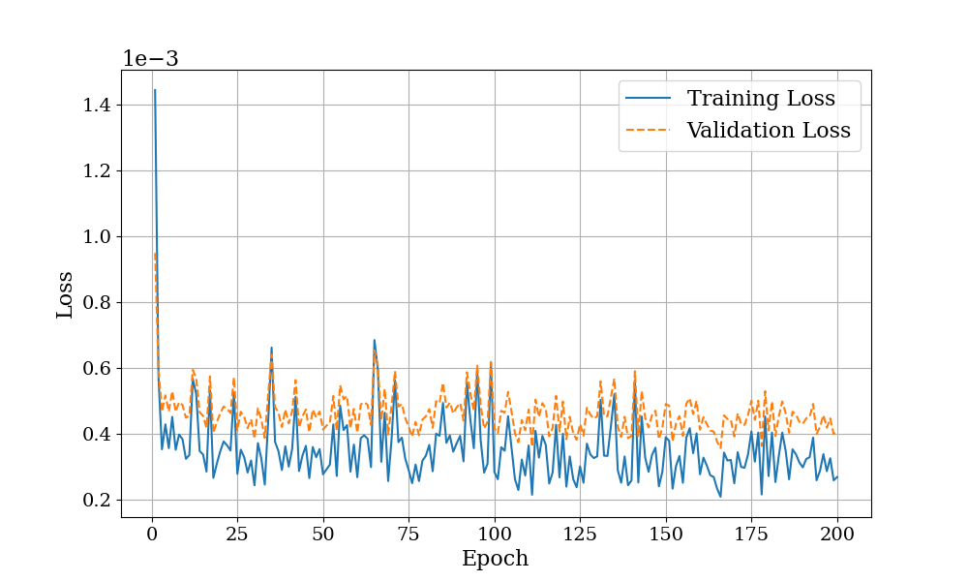
Fig. S2 Learning curve of the 3D Resnet

Table S2. The average RMSE of all the tested models in various conditions of loading, FVF, and dispersion.
 |  | Dispersion
 |  | Low (𝜅<0.2) |  | Medium (0.2<𝜅<0.26) |  | High (𝜅>0.26)
FVF (Fiber Volume Fraction) | High  (18%<FVF<30%) | Compression | 1.37 | Compression | 1.58 | Compression | 1.60
FVF (Fiber Volume Fraction) | High  (18%<FVF<30%) | Tension | 2.14 | Tension | 2.58 | Tension | 3.68
FVF (Fiber Volume Fraction) | Medium  (13%<FVF<18%) | Compression | 1.32 | Compression | 1.69 | Compression | 1.92
FVF (Fiber Volume Fraction) | Medium  (13%<FVF<18%) | Tension | 2.07 | Tension | 2.91 | Tension | 4.19
FVF (Fiber Volume Fraction) | Low  (FVF<13%) | Compression | 1.69 | Compression | 2.09 | Compression | 2.59
FVF (Fiber Volume Fraction) | Low  (FVF<13%) | Tension | 2.54 | Tension | 3.40 | Tension | 6.18

