Table 7. The morphological assessment of observed cyanobacteria in the shrimp farm water.
Labels, scale bar 100 µm | Cyanobacteria genus | Unicellular, colonial or filamentous | Cell shape | Mucilaginous sheath
 | Chroococcus | Forms a colony of 2, 4 or 8 cells | Small, round cell with jelly-like consistency. | Colourless sheath sticks together to form a biofilm
 | Pseudanabaena A | Filamentous and usually solitary. | Cylindrical, long cells. | Colourless.
 | Pseudanabaena B | Filamentous and usually solitary. | Cylindrical, long cells. | Colourless.
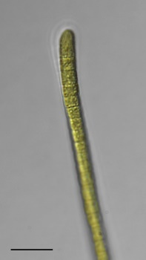 | Phormidium | Filamentous. | Almost uniform square stack of cells. | Colourless, thin but firm sheath.
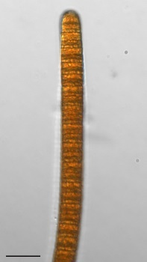 | Oscillatoria | Filamentous. | Wide stack of cells that with no visible gaps. | No distinctive sheath.
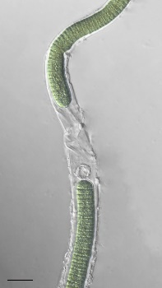 | Lyngbya | Filamentous. | Disc-like stack of cells that appear short and wide. | Sheath can be seen extending beyond the row of cells (trichome).

