Climate Dynamics

Supplementary Information for

Asymmetrical Responses of the ITCZ to Symmetrical Thermal Forcings at Different Latitudes
Xinyu Ma ¹, Weichong Huang ¹, Shuyun Zhao ^{1, 2*}, Hua Zhang ^{1, 2, 3}, Wuke Wang ¹, and Lunche Wang ⁴
¹ Department of Atmospheric Science, School of Environmental Studies, China University of Geosciences, Wuhan, China
² Key Laboratory of Meteorological Disaster, Ministry of Education/Collaborative Innovation Center on Forecast and Evaluation of Meteorological Disasters, Nanjing University of Information Science & Technology, Nanjing, China
³ State Key Laboratory of Severe Weather, Chinese Academy of Meteorological Sciences, China Meteorological Administration, Beijing, China
⁴ Department of Geography, School of Geography and Information Engineering, China University of Geosciences, Wuhan, China

*Corresponding author: Shuyun Zhao (zhaosy@cug.edu.cn)

Contents of this file
Table S1
Figures S1–S2

Table S1 Q-flux changes of the NH and SH in sensitive experiments (Unit: W m⁻²)
 | LowF1 | LowF2 | MidF1 | MidF2
NH | -2.36×10¹⁴ | 2.36×10¹⁴ | -2.34×10¹⁴ | 2.34×10¹⁴
SH | 2.36×10¹⁴ | -2.36×10¹⁴ | 2.34×10¹⁴ | -2.34×10¹⁴

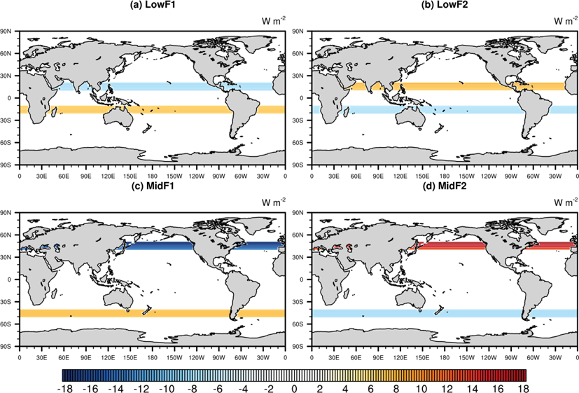
Fig. S1 Spatial distribution of Q-flux forcings (unit: W m⁻²) in (a) LowF1, (b) LowF2, (c) MidF1, and (d) MidF2. Q-flux forcing is defined to be downward positive

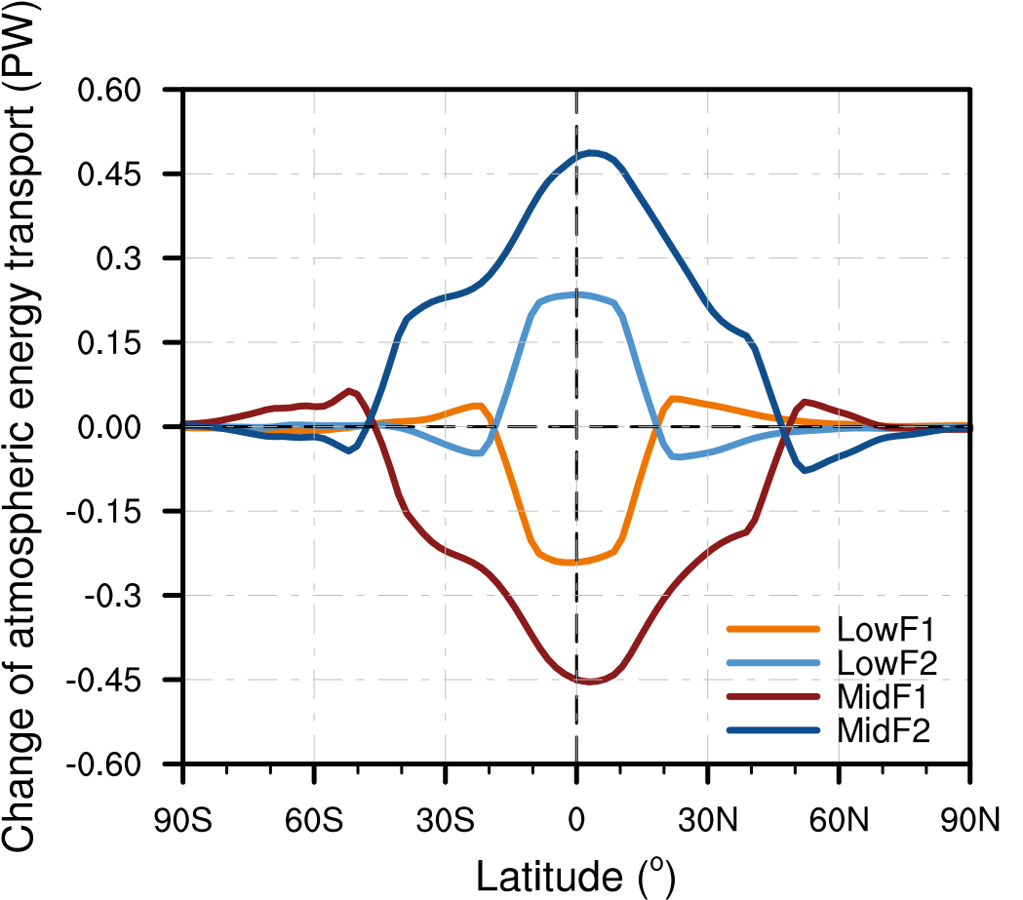
Fig. S2 Zonal distribution of changes in atmospheric energy transport (unit: PW) for all perturbed experiments

