SUPPLEMENTAL MATERIALS
RESULTS
Hoechst dye accumulation in E. coli clones harbouring MATE putative genes.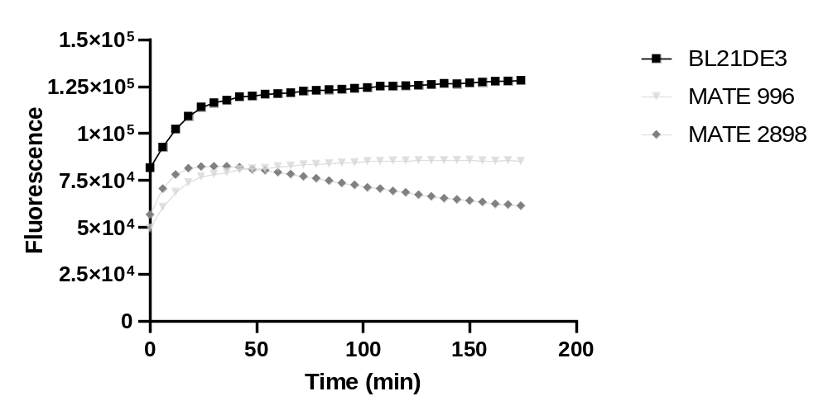
A.
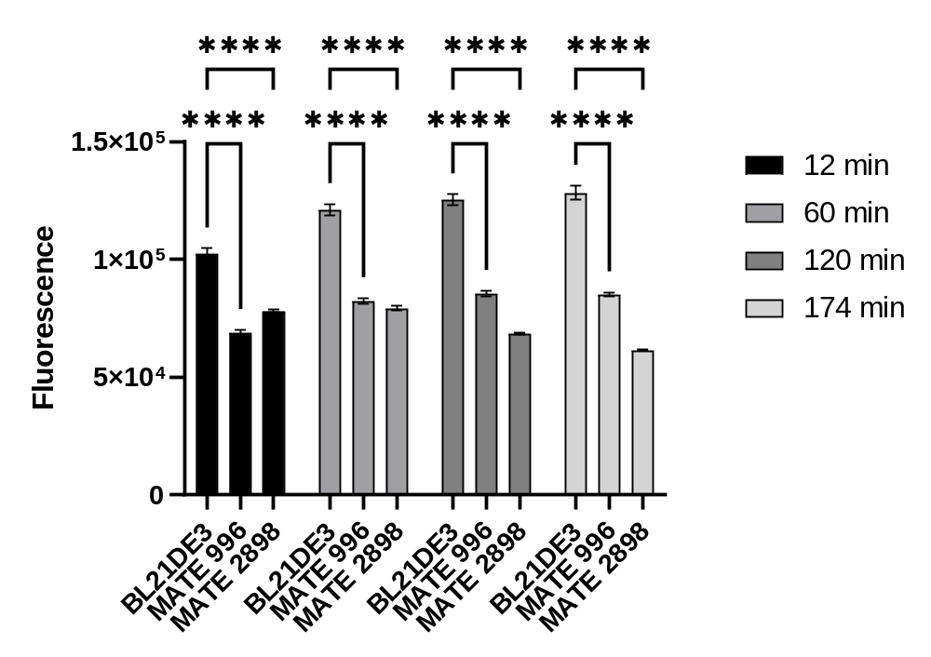
B.
FIG. S-1 A. Low accumulation of Hoechst dye in E. coli clones harboring MATE pump genes compared to BL21DE3 (control) over the 3 hours incubation time. B. The significant decrease in Hoechst dye accumulation in both MATE pump clones compared to BL21DE3 at 12, 60, 120 and 174 min.
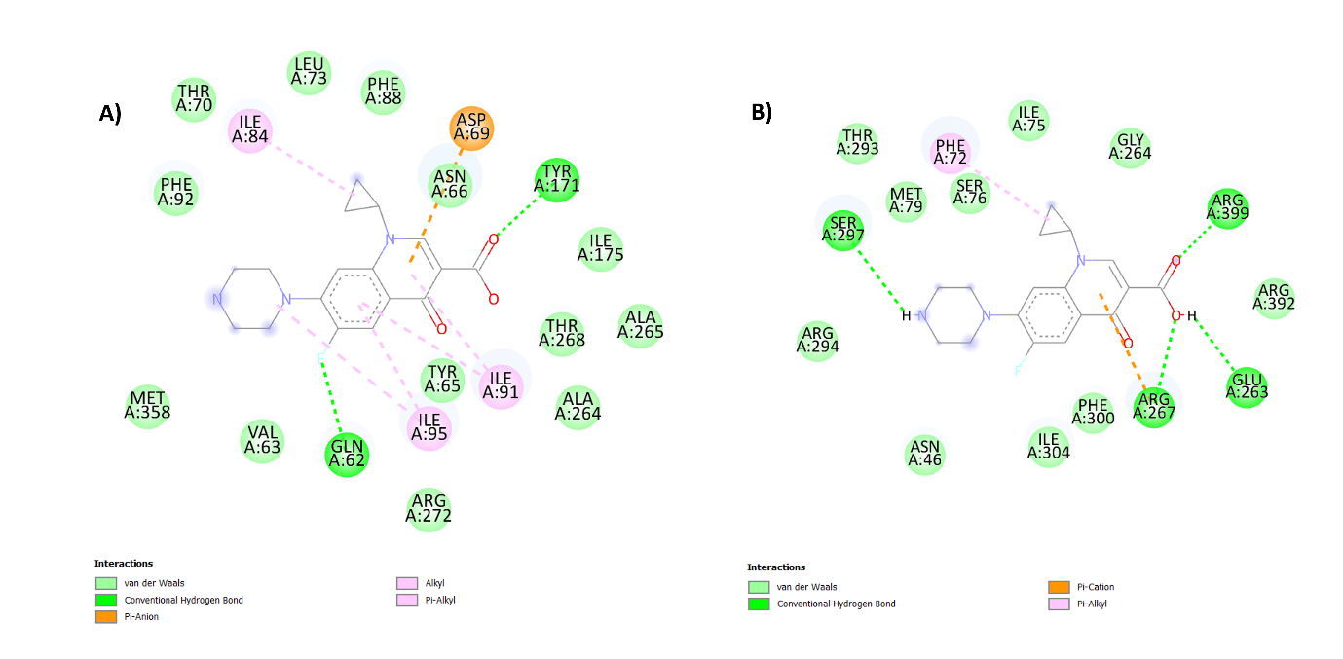
FIG. S-2 2D interactions map of ciprofloxacin with A) MATE996 and B) MATE2898 transporter.

MATERIALS AND METHODS
MATE gene cloning in E. coli BL21DE3 and culturing
The gene construct containing putative MATE genes were synthesised by GenScript (Netherlands). Synthesised pET28a(+) plasmid containing each gene of the MATE efflux pumps was cloned using BamHI and HindIII restriction sites, which was used to transform BL21DE3 cells. The transformation of BL21DE3 was also performed by GenScript (Netherlands).
The two E. coli clones and the control (untransformed E. coli BL21DE3) were cultured from frozen stock in lysogeny broth (LB) medium containing 50 µg/mL kanamycin and incubated at 37°C overnight. 1 mL of each culture was re-inoculated in 100 mL kanamycin-supplemented LB medium to mid-exponential phase (OD₅₈₀ of 0.4-0.6). Gene expression was induced with 0.8 mM Isopropyl β-D-1-thiogalactopyranoside at room temperature overnight.

