Supplementary data

(A) (B)

(C) (D)

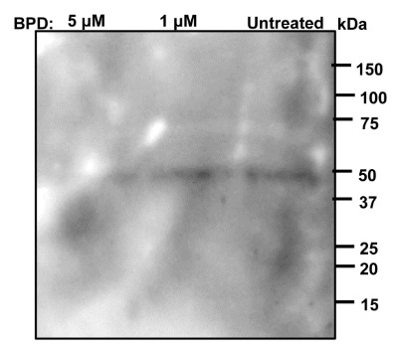

Fig. S1: Images representing the uncropped version of (A) Fig. 1F, (B) Fig. 3B, (C) Fig. 5D, and (D) Fig. 5E (i iii, & iv) of the main figures.

Fig. S2: Evaluation of antibody specificity generated against prefoldin subunits. Western blot analysis of PfPFD1, PfPFD2, PfPFD3, PfPFD4, PfPFD5 and PfPFD 6 in total parasite lysate using their specific antibodies. No band was detected in RBC cytosol and E. coli (DH5 alpha) pellet, depicting the specificity of anti-PFDs antibodies.

Fig. S3: Interaction studies of prefoldin subunits with α-tubulin-I. Purified recombinant PfPFD1 and PfPFD3 subunits (25 µM) were immobilized on gold sensor chip followed by titration with varying concentrations of α-tubulin-I. The net dissociation constant graph shows no affinity.

Fig. S4: Effect of BPD on cellular localization of NapL. Methanol fixed thin blood smears of treated and untreated Pf3D7 infected erythrocytes were stained with anti-NapL antisera (1:200) followed by incubation with Alexa Fluor conjugated secondary antibody (1: 200; Alexa Fluor 594, red color). DIC: differential interference contrast image, DAPI: nuclear staining using 4’,6-diamidino-2-phenylindole (blue); anti-NapL antibodies (red); merge: overlay of NapL with DAPI.

