Systematic Mendelian randomization using the human plasma proteome to identify therapeutic targets for lung adenocarcinoma

Supplementary Figure 1 Standard MR plots for proteins and risk of LUAD.
Supplementary Figure 2 Bidirectional MR analysis for LUAD on levels of nine potential causal proteins.
Supplementary Figure 3 Colocalization plots of pQTLs and genetic associations of LUAD.
Supplementary Figure 4 Protein-protein interaction network among the causal proteins and current lung adenocarcinoma medications targets.

(a)ALAD (b) FLT1
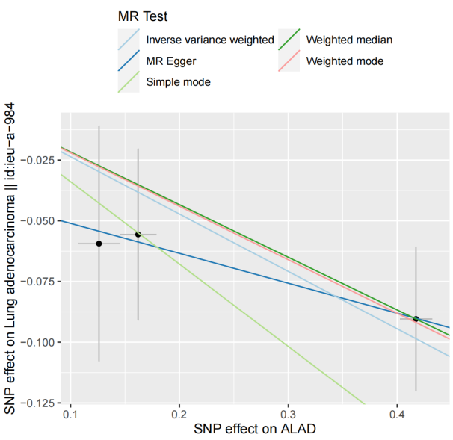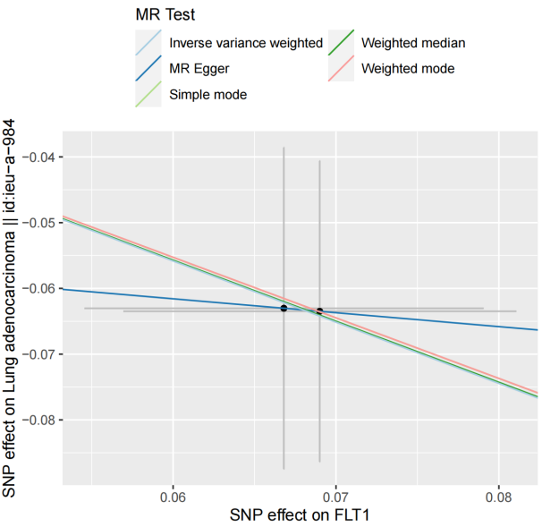

(c) ICAM5 (d) MDGA2
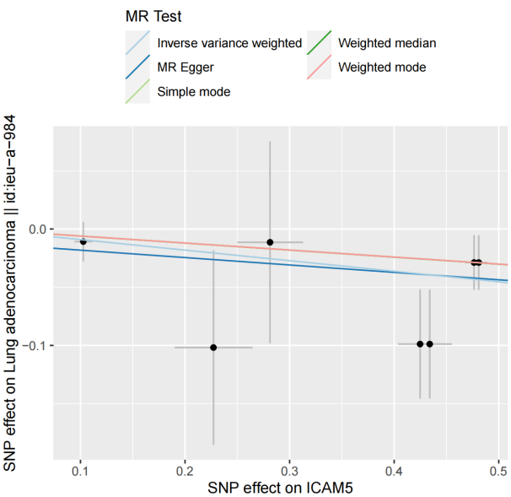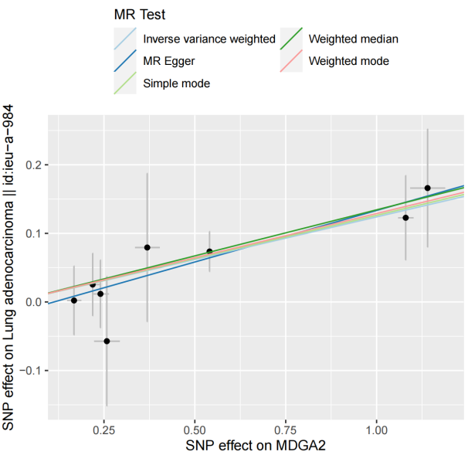

(e) NTM (f) PMM2
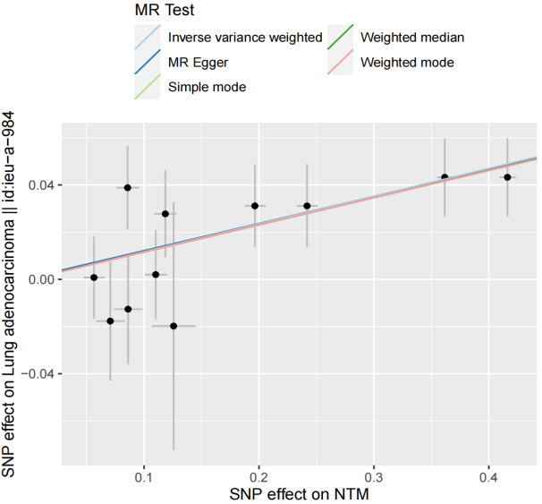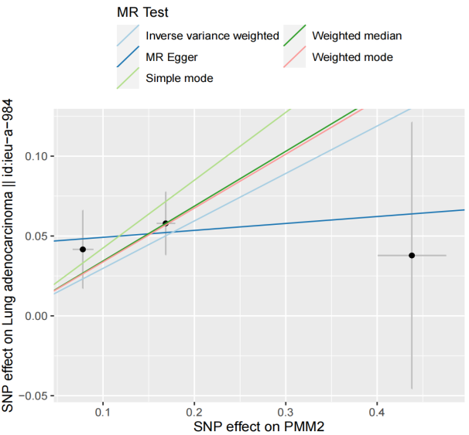

(g) RNASET2 (h)VWC2
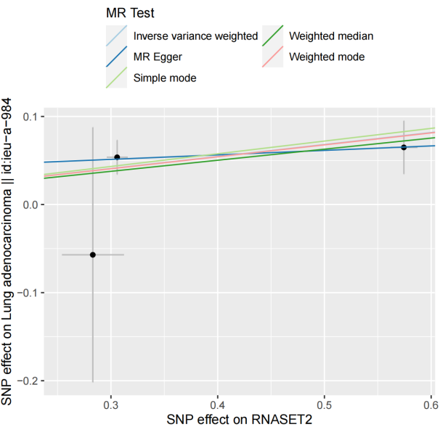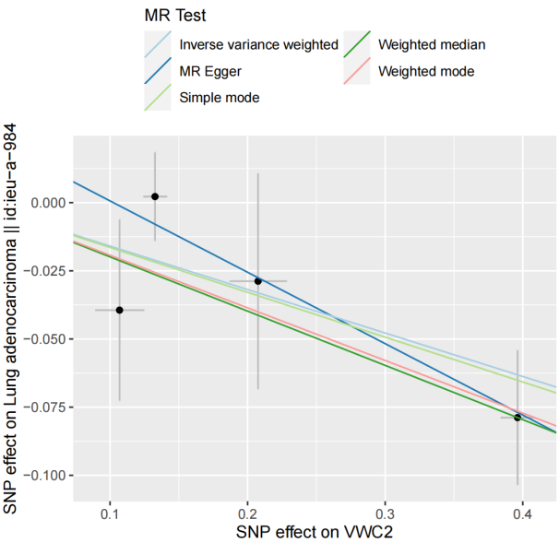

Supplementary Figure 1 Standard MR plots for proteins and risk of LUAD. The different regression lines indicated the effect sizes as calculated by different MR tests (Methods). MR analysis of plasma proteins for ALAD (a), FLT1 (b) , ICAM5 (c), MDGA2 (d), NTM (e), PMM2 (f), RNASET2 (g), and VWC2 (h), respectively. Abbreviations: ALAD = aminolevulinate dehydratase; FLT1 = Fms related receptor tyrosine kinase 1; ICAM5 = intercellular adhesion molecule 5; MDGA2 = MAM domain containing glycosylphosphatidylinositol anchor 2; NTM= neurotrimin; PMM2 = phosphomannomutase 2; RNASET2= ribonuclease T2; VWC2= von willebrand factor C domain containing 2.

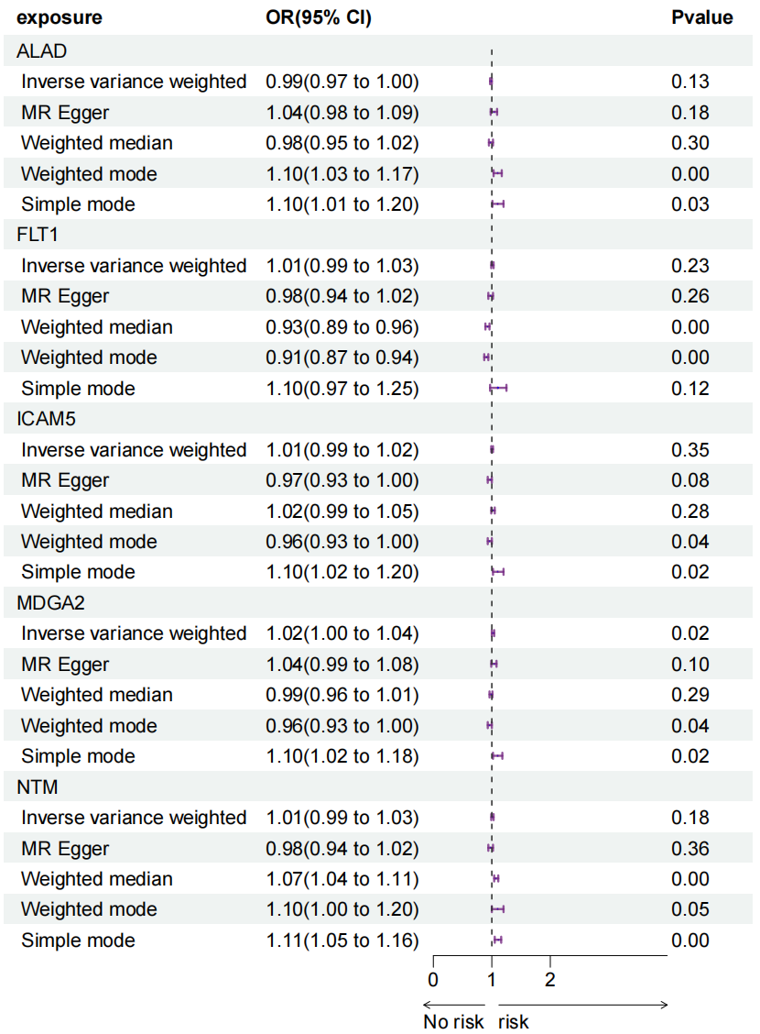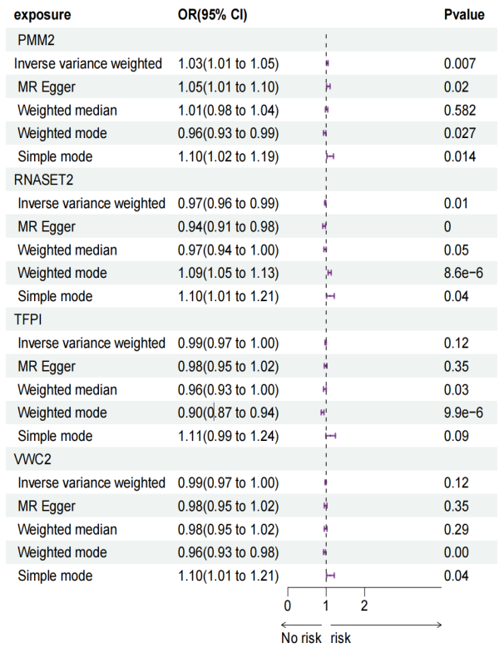

Supplementary Figure 2 Bidirectional MR analysis for LUAD on levels of nine potential causal proteins. OR stood for the odds ratios for per standard deviation (SD) increase in plasma protein levels as LUAD risk increased.

(a)ALAD (b) FLT1
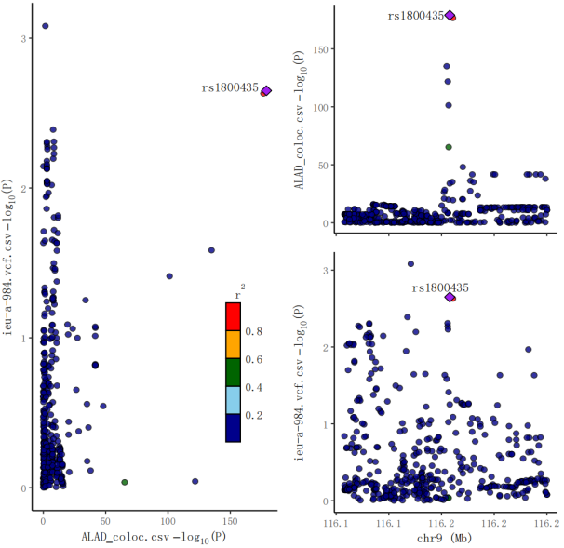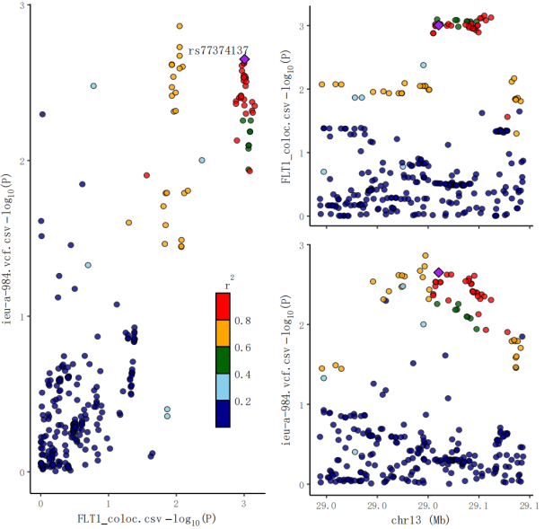

(c) ICAM5 (d) MDGA2
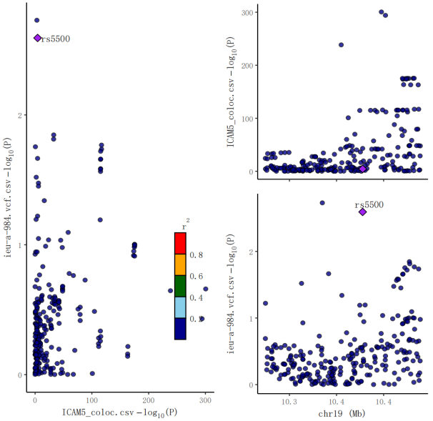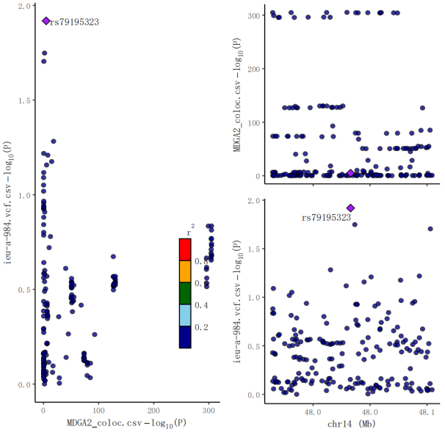

(e) NTM (f) PMM2
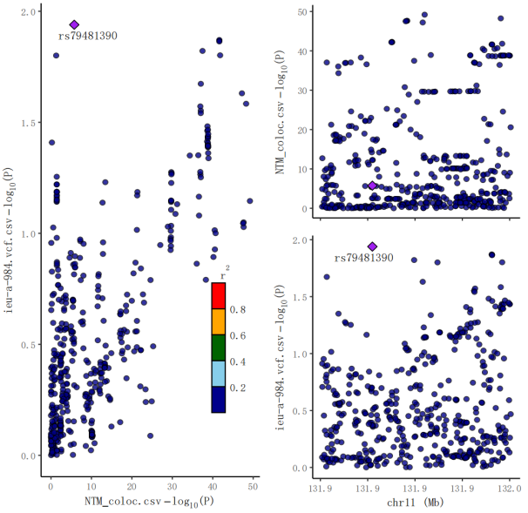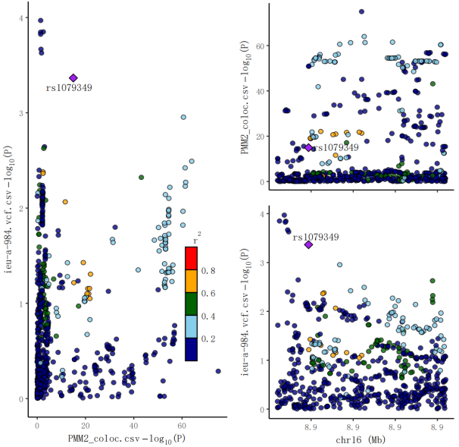
(g) RNASET2 (h) TFPI
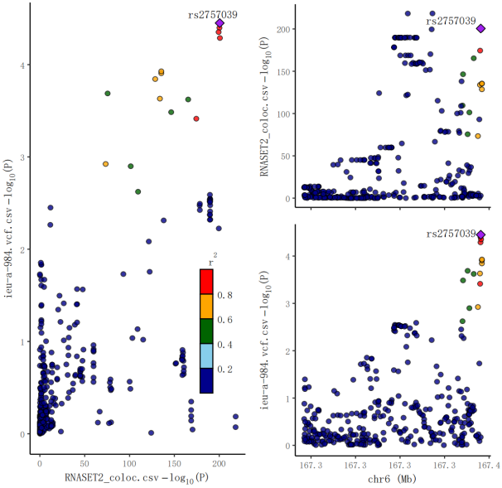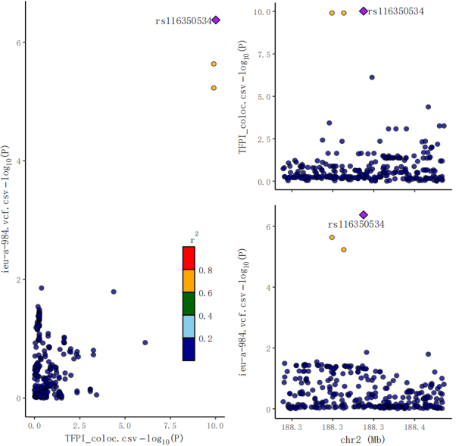

(i) VWC2
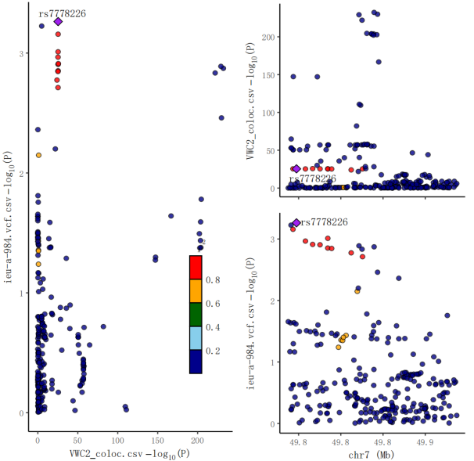

Supplementary Figure 3 Colocalization plots of pQTLs and genetic associations of LUAD. Colocalization analysis of plasma proteins for ALAD (a), FLT1 (b) , ICAM5 (c), MDGA2 (d), NTM (e), PMM2 (f), PTGFRN (g), TFPI (i), and VWC2 (j), respectively. Diamond purple points represented the SNP that with the minimal sum of P value in corresponded protein GWAS and lung adenocarcinoma GWAS.

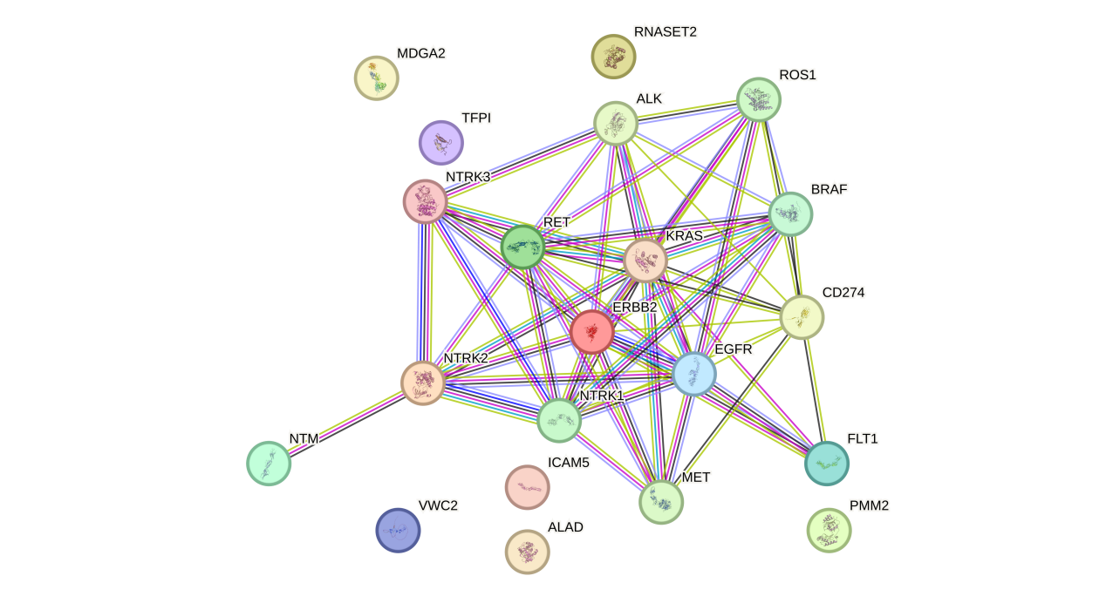

Supplementary Figure 4 Protein-protein interaction network among the causal proteins and current lung adenocarcinoma medications targets.

