Additional file 5: Map integration (consensus map) of populations 2.6-1 and 2.6-5 for genetic linkage groups 1 - 16

Linkage Group 1
LG1_BC2 2.6-1
LG1_Integrated
LG1a_BC2 2.6-5

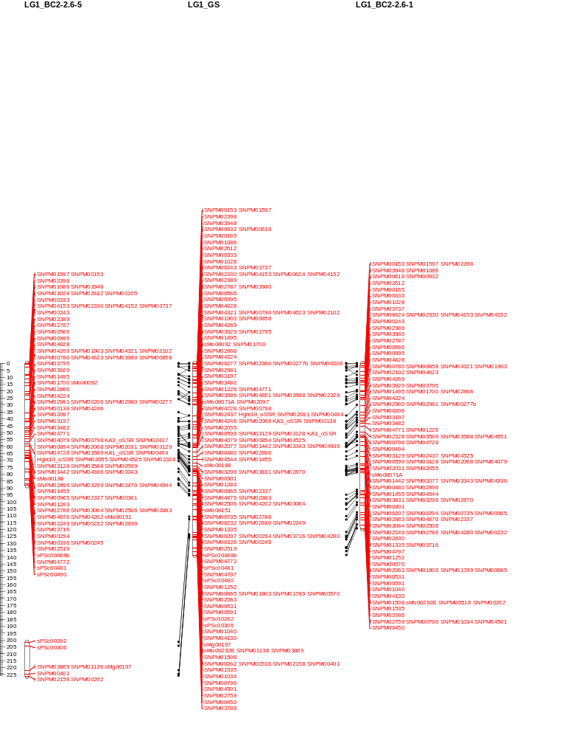
LG1b_BC2 2.6-5

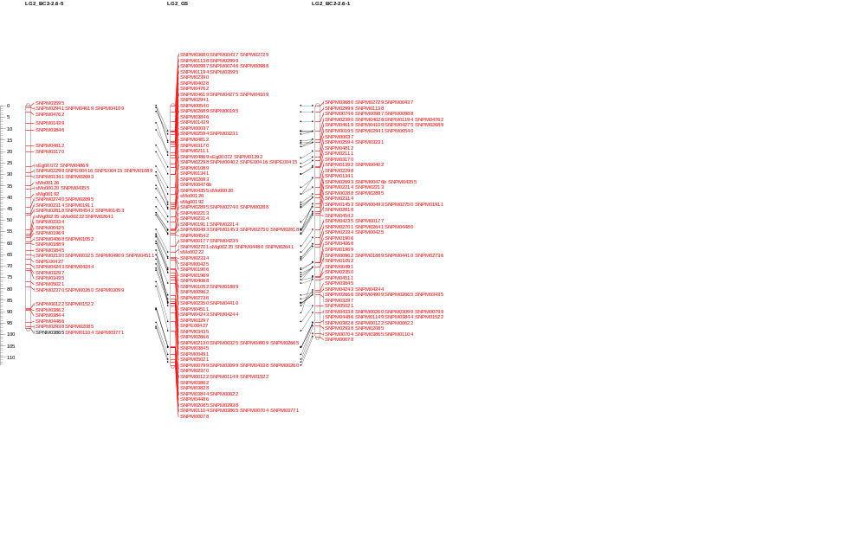
Linkage Group 2
LG2_Integrated
LG2_BC2 2.6-1
LG2_BC2 2.6-5

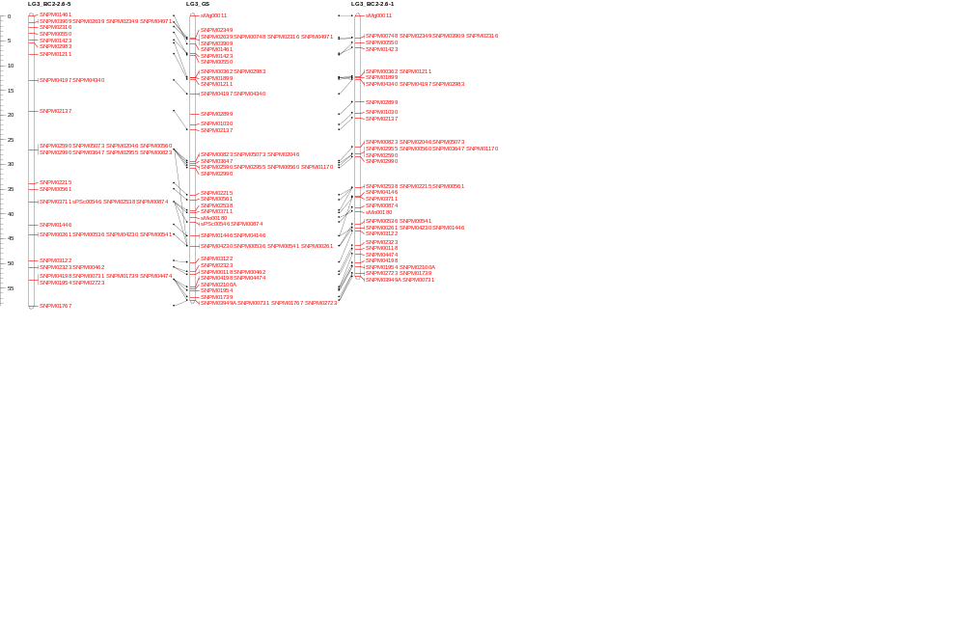
Linkage Group 3
LG3_BC2 2.6-1
LG3_Integrated
LG3_BC2 2.6-5

Linkage Group 4
LG4_BC2 2.6-1
LG4_Integrated
LG4_BC2 2.6-5
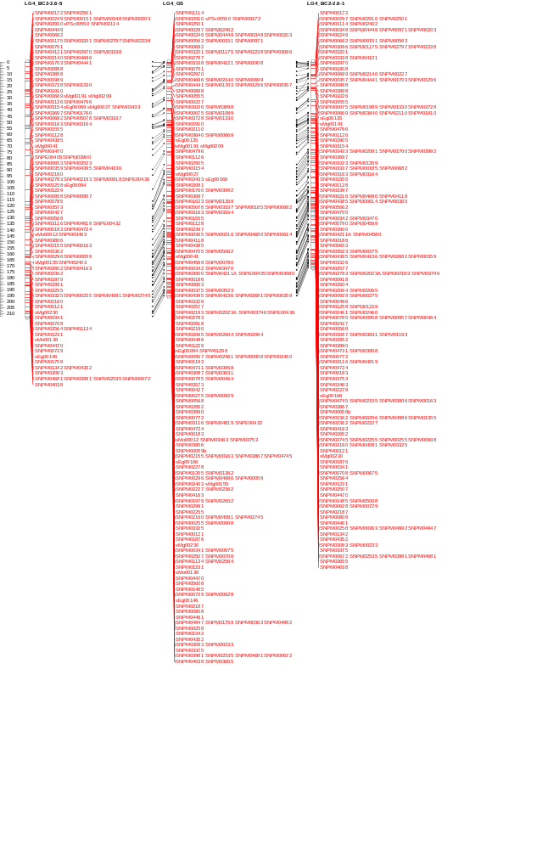

Linkage Group 5
LG5_BC2 2.6-1
LG5_Integrated
LG5_BC2 2.6-5
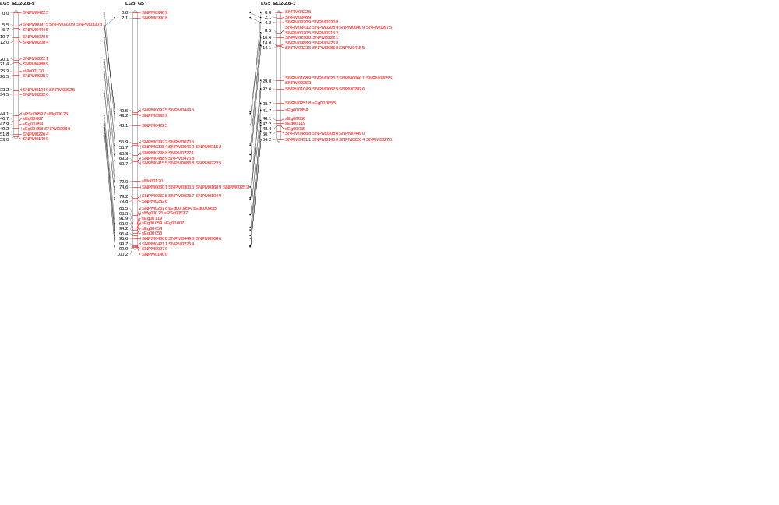

Linkage Group 6
LG6_BC2 2.6-1
LG6_Integrated
LG6_BC2 2.6-5
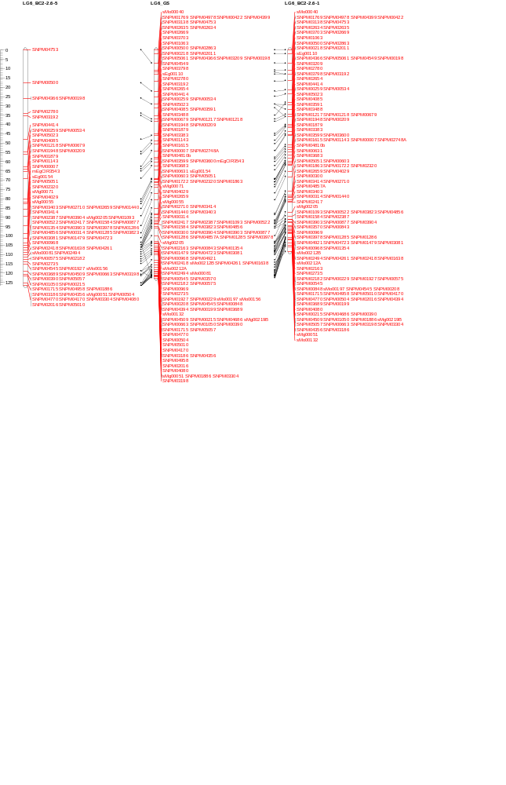

Linkage Group 7
LG7_BC2 2.6-1
LG7_Integrated
LG7_BC2 2.6-5
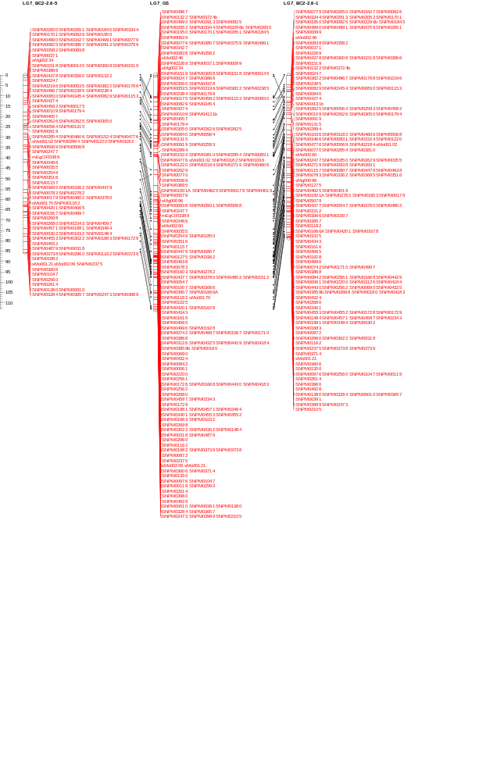

Linkage Group 8
LG8_BC2 2.6-1
LG8_Integrated
LG8_BC2 2.6-5
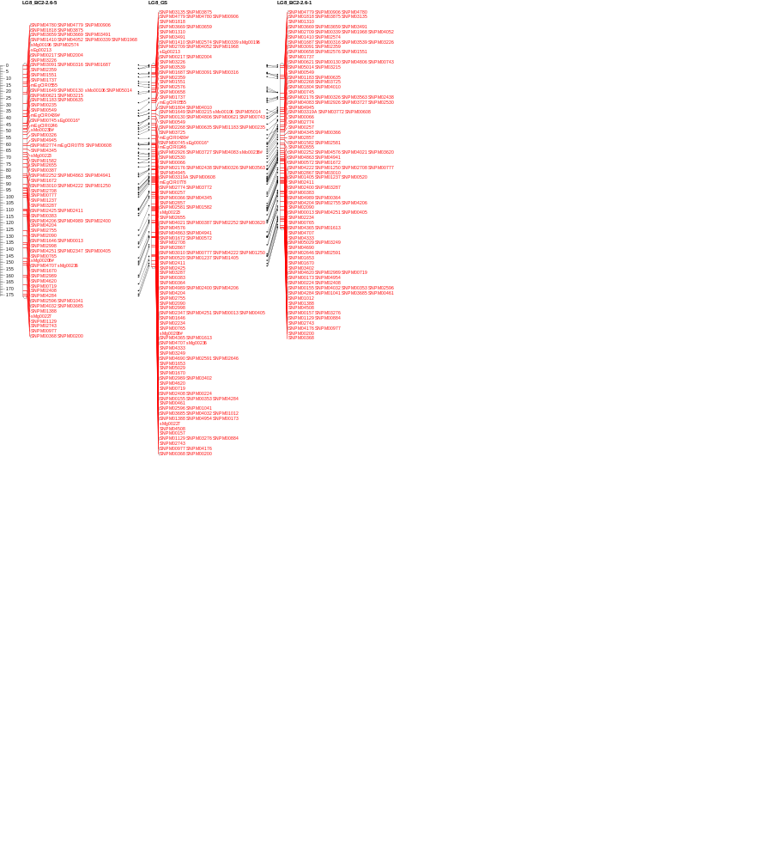

Linkage Group 9
LG9_Integrated
LG9_BC2 2.6-5
LG9_BC2 2.6-1

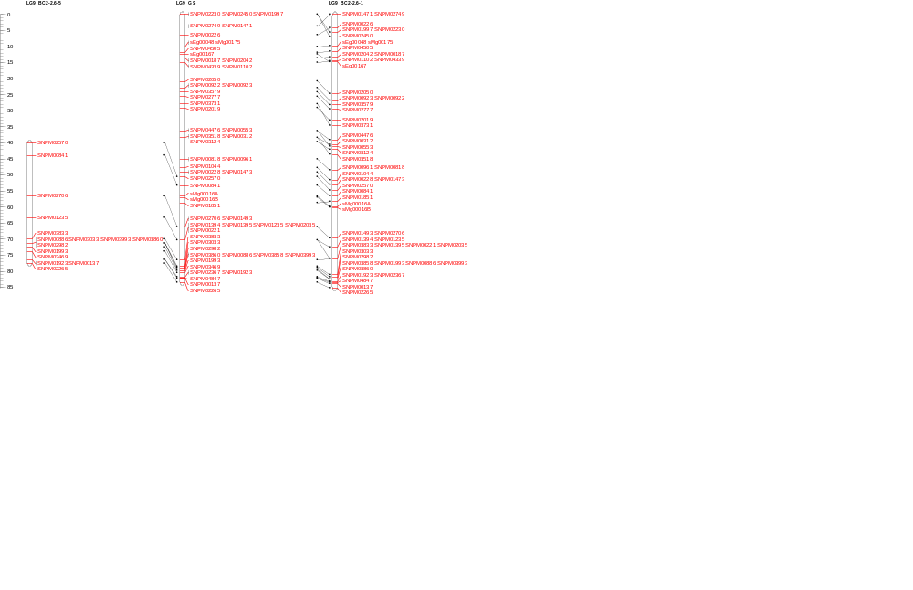

Linkage Group 10
LG10_Integrated
LG10_BC2 2.6-1
LG10_BC2 2.6-5
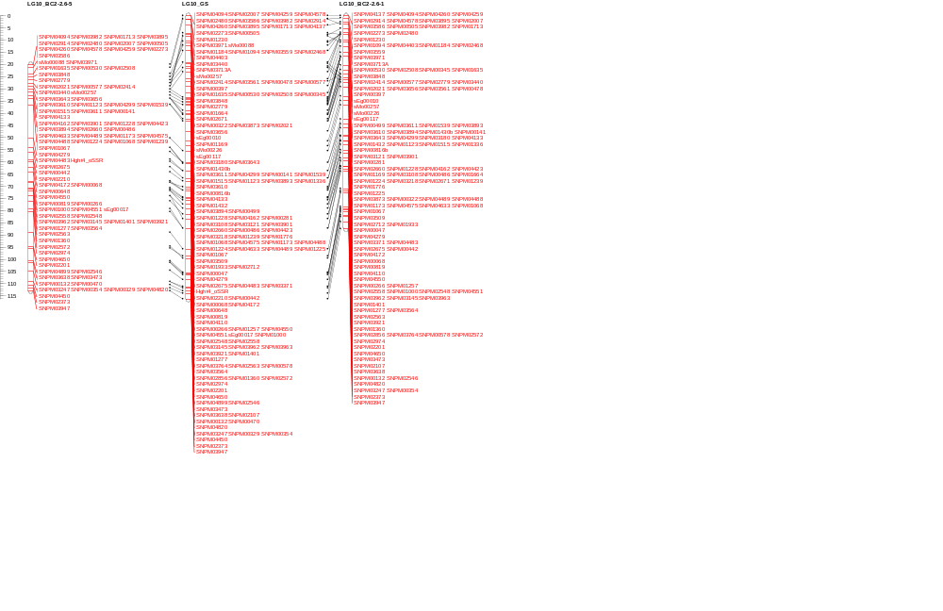

Linkage Group 11
LG11_Integrated
LG11_BC2 2.6-1
LG11_BC2 2.6-5
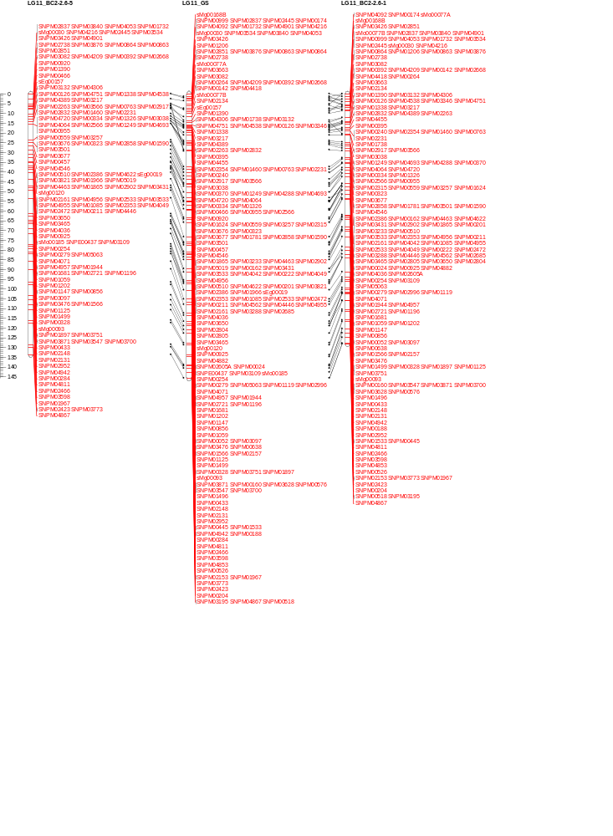

Linkage Group 12
LG12_Integrated
LG12_BC2 2.6-1
LG12_BC2 2.6-5
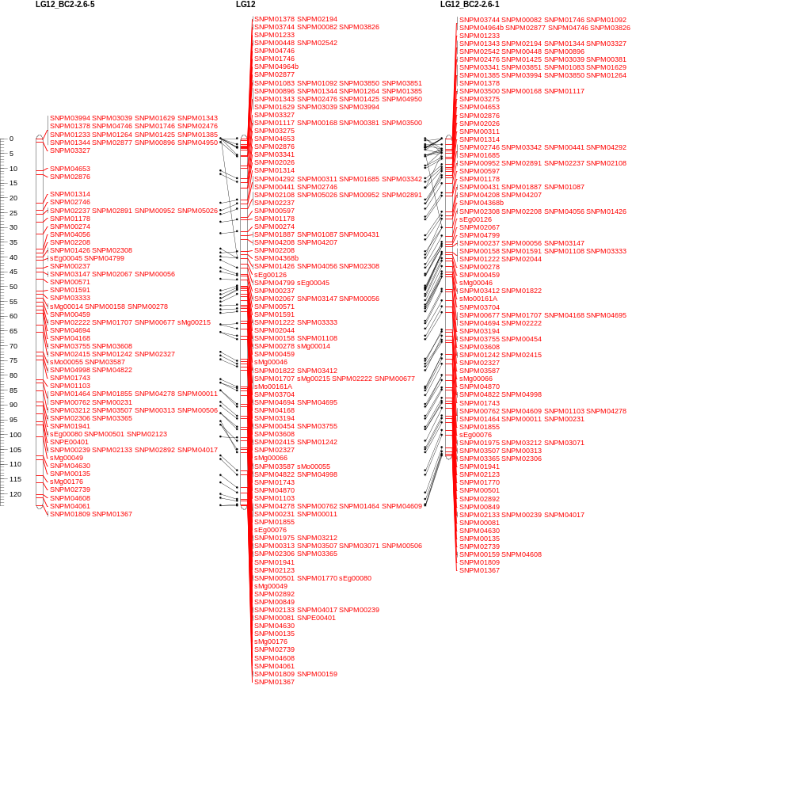

Linkage Group 13
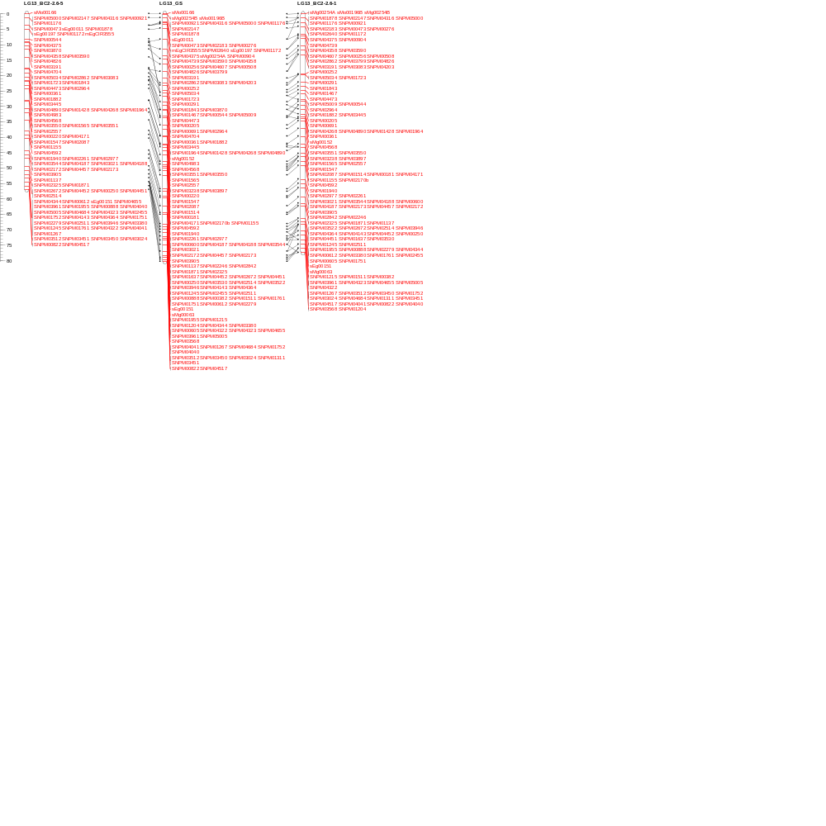
LG13_Integrated
LG13_BC2 2.6-1
LG13_BC2 2.6-5

Linkage Group 14
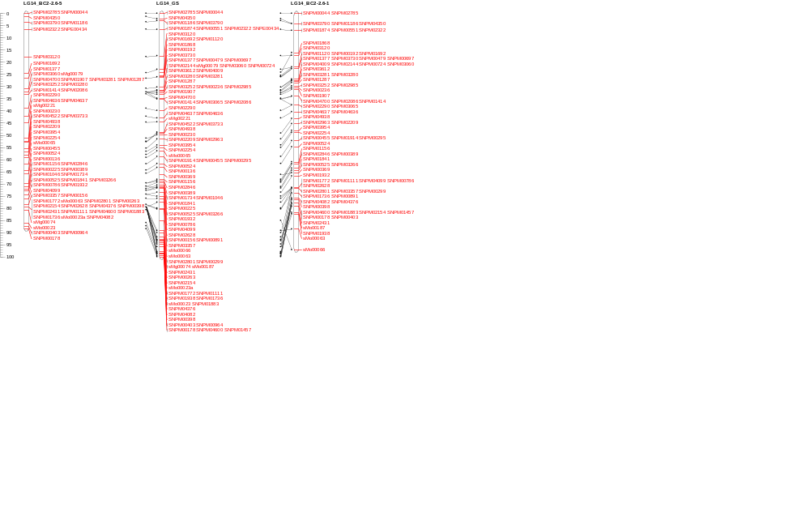
LG14_Integrated
LG14_BC2 2.6-1
LG14_BC2 2.6-5

Linkage Group 15

LG15_BC2 2.6-1
LG15_Integrated
LG15b_BC2 2.6-5

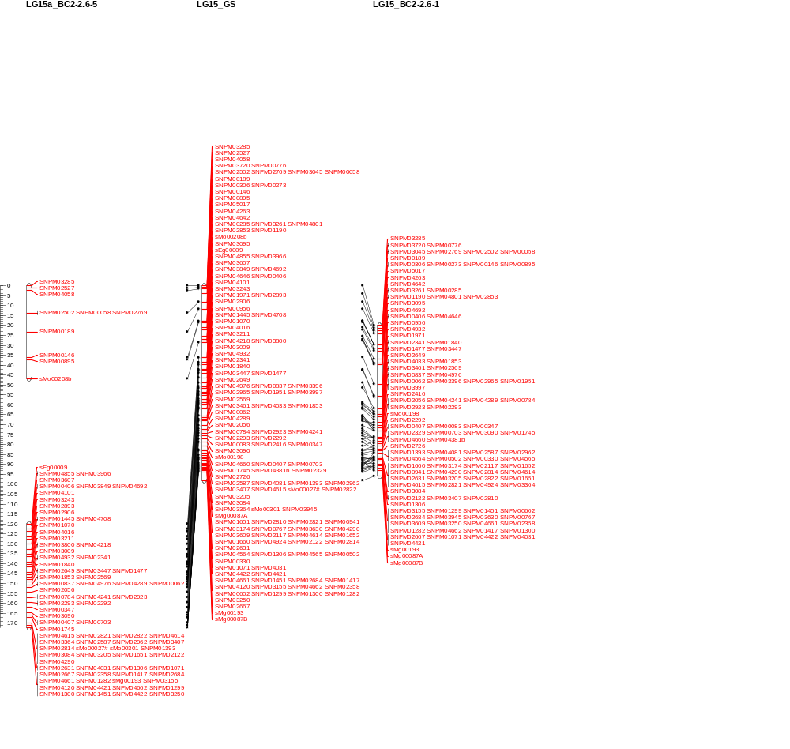
LG15a_BC2 2.6-5

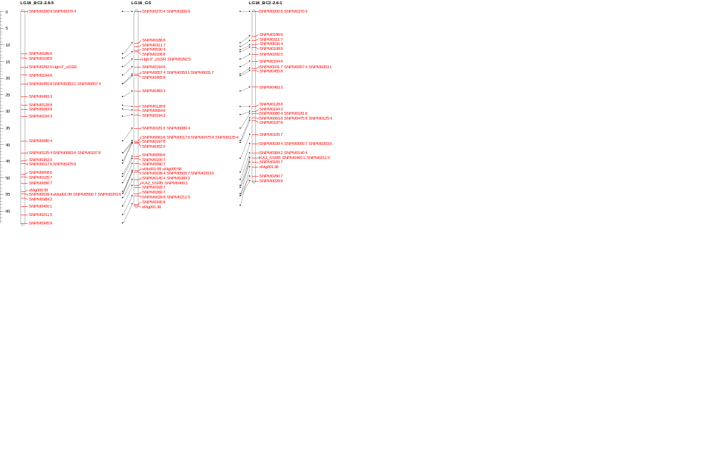
Linkage Group 16
LG16_Integrated
LG16_BC2 2.6-1
LG16_BC2 2.6-5

