(A) Rachis Length
(i) Population 2.6-1
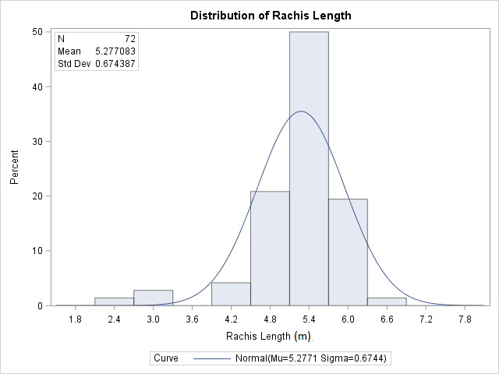

(ii) Population 2.6-5

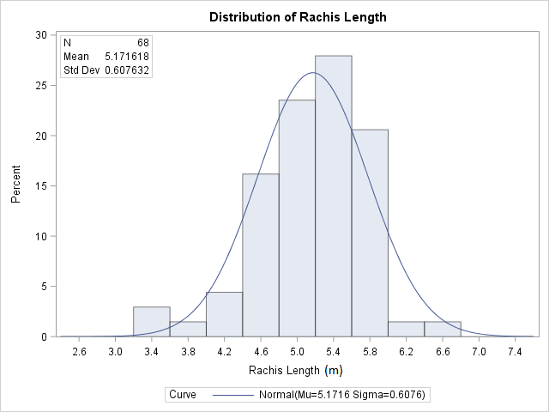

(B) Height Increment
(i) Population 2.6-1
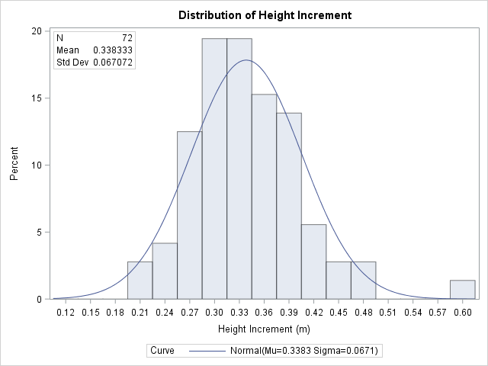

(ii) Population 2.6-5

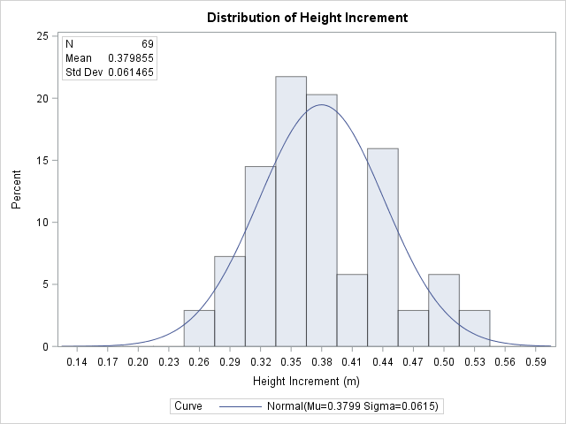

(C) Petiole Cross Section
(i) Population 2.6-1
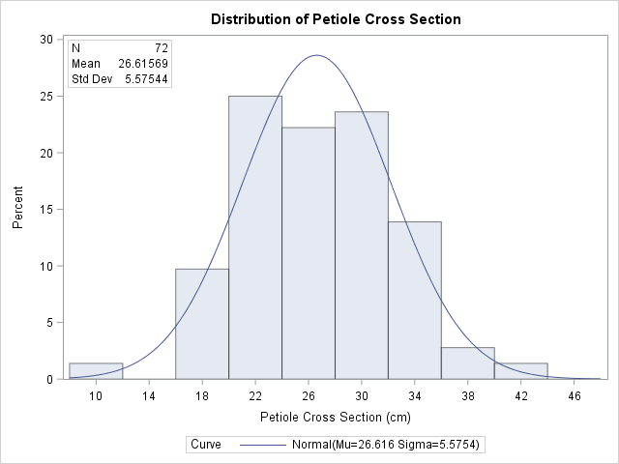

(ii) Population 2.6-5

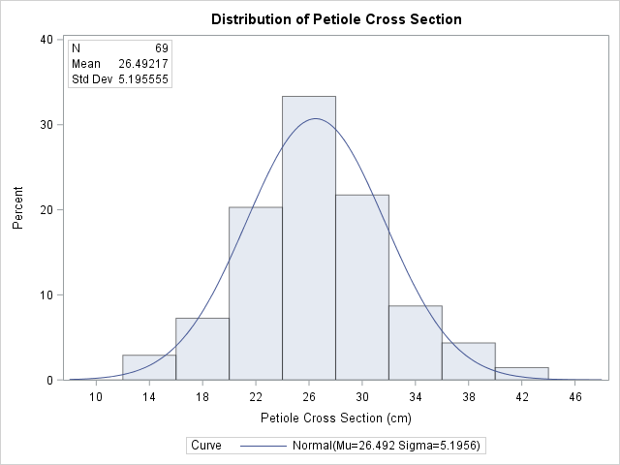

(D) C16:0 content
(i) Population 2.6-1
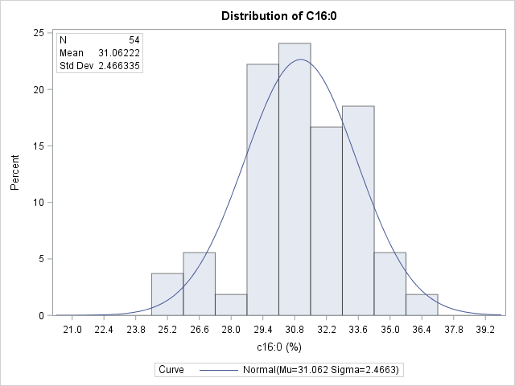

(ii) Population 2.6-5

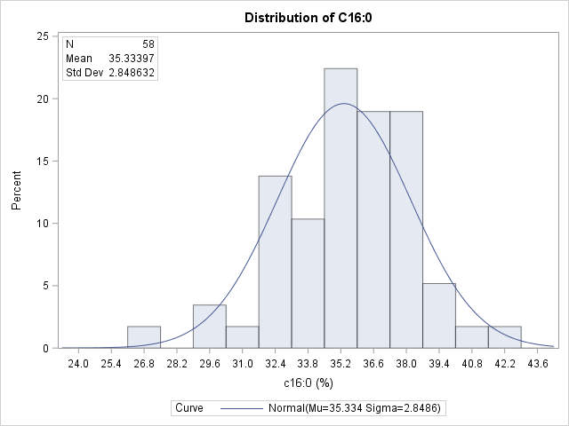

(E) C18:0 content
(i) Population 2.6-1
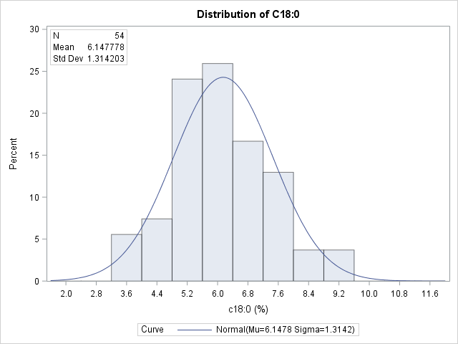

(ii) Population 2.6-5

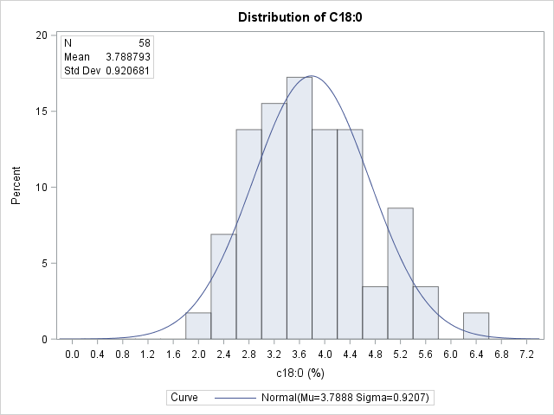

(F) C18:1 content
(i) Population 2.6-1
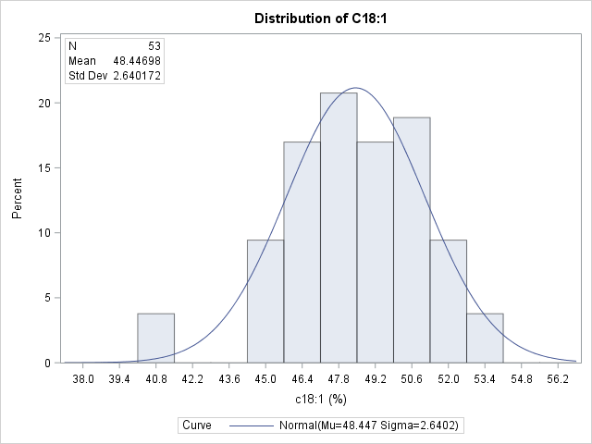

(ii) Population 2.6-5

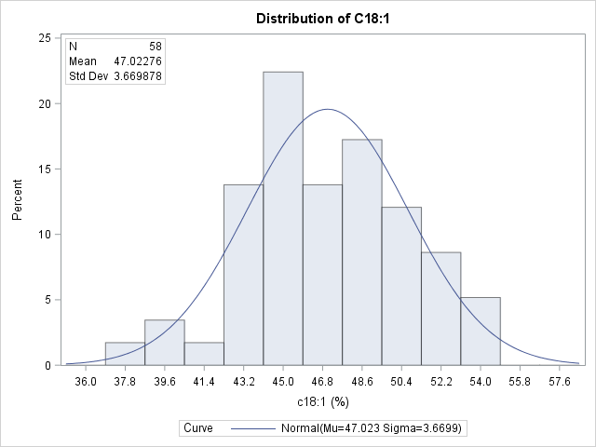

(G) C18:2 content
(i) Population 2.6-1
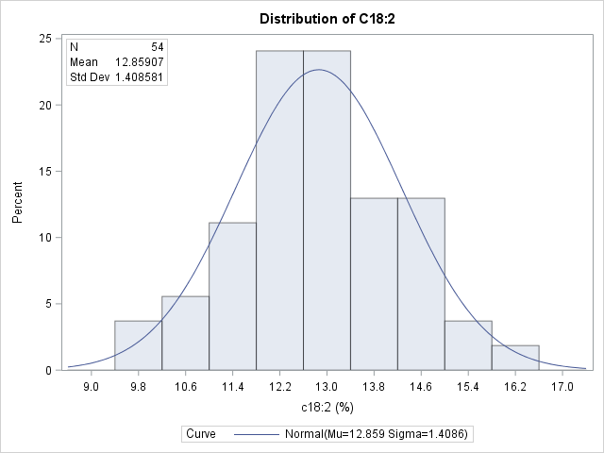

(ii) Population 2.6-5

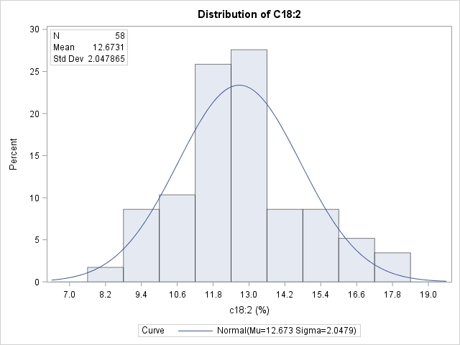
(H) Iodine Value
(i) Population 2.6-1
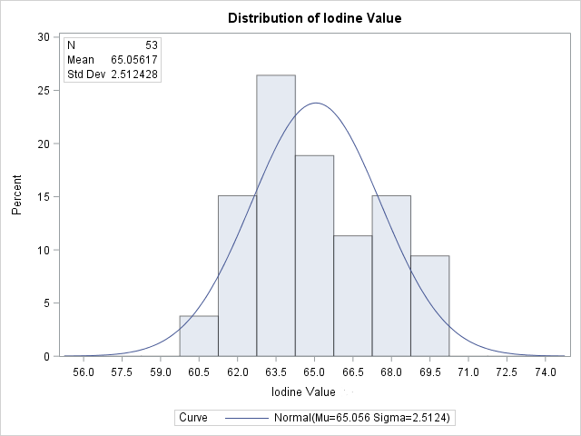

(ii) Population 2.6-5

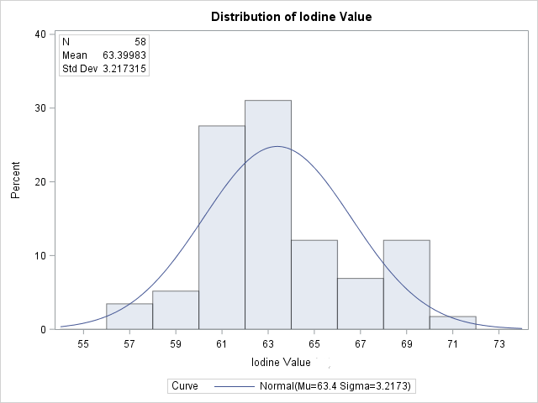
(I) Carotene Content
(i) Population 2.6-1
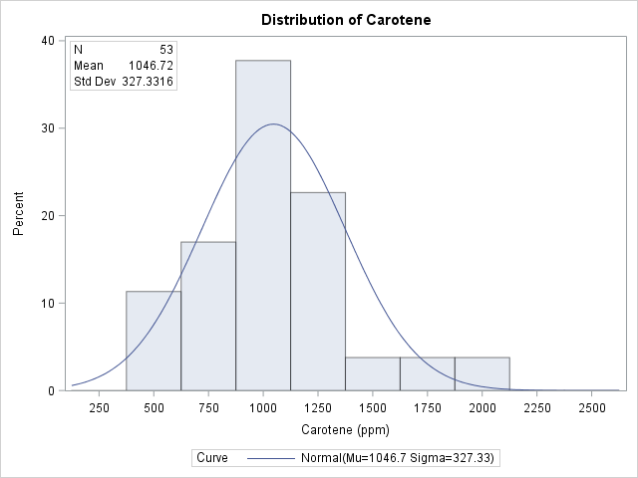

(ii) Population 2.6-5

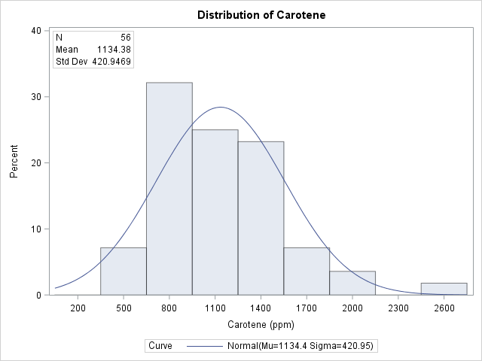

Additional File 1 : Histogram showing distribution of traits in 2.6-1 and 2.6-5 mapping populations: (A) Rachis Length, (B) Height Increment/year, (C) Petiole Cross Section, (D) C16:0 content, (E) C18:0 content, (F) C18:1 content, (G) C18:2 content, (H) Iodine Value (I) Carotene Content.

