Supplementary information for

Durable oxygen reduction catalysis of Cu-N-C sites boosted by adjacent main-group element for rechargeable Zn-air batteries with cycling over 5000 h

Contents:
Supplementary Notes 1-3
Supplementary Figures 1-35
Supplementary Tables 1-8
Supplementary Reference 1-56

Supplementary Notes
Supplementary Note 1.
In Raman spectra, there were two broad peaks at about 1350 and 1590 cm⁻¹ can be identified in pre-oxidated CSCC-PAN, pre-oxidated CuPc-PAN, CuNa-CF and CuPc-CF, corresponding to the D-band of disordered carbon and the G-band of ordered graphite (Supplementary Fig. 5)¹. The intensity I_{D}/I_{G} ratios of oxidated CSCC-PAN and oxidated CuPc-PAN were obvious higher than that of CuNa-CF catalyst and CuPc-CF catalyst, suggesting that the pre-oxidized metal complex-PAN membrane would form a relatively ordered graphite structure after annealing in the argon atmosphere. No characteristic peaks of metal precursors were observed in Raman spectra of pre-oxidized CSCC-PAN membrane and pre-oxidized CuPc-PAN membrane, indicating that CSCC complex and CuPc complex are highly dispersed in the PAN nanofibers of these two materials, which is helpful for the formation of single-atom sites after pyrolysis process.
X-ray photoelectron spectroscopy (XPS) was conducted to investigate the chemical composition and elemental state of CuNa-CF catalyst and Na-free CuPc-CF catalyst (Supplementary Fig. 6 and 7). The C 1s spectra of these two catalysts are similar, reveals the co-existence of C-C/C=C bond in aromatic rings (284.7 eV), sp² hybridized C bonded with N (285.6 eV, due to the carbonization of PAN and CSCC/CuPc metal precursor), C-O bond (286.6 eV) and O-C=O/C=O bond (288.8 eV, due to the pre-oxidation in air and carbonization in argon of CSCC-PAN/CuPc-PAN nanofibers)². It is worth noting that the area presented of C-O and O-C=O in C 1s spectrum exhibited in CuNa-CF catalyst is slightly larger than that in CuPc-CF, which is attributed to the partial retention of -COONa functional groups in CSCC complex during the pyrolysis process. The N 1s spectra in both two catalysts could be deconvoluted into four peaks: oxidized-N (401.8 eV), graphitic-N (400.8 eV), pyrrolic-N (399.4 eV) and pyridinic-N (398.2 eV)³. The O 1s spectra were also divided into four peaks, corresponding to C-O-C bond at 533.9 eV, C-OH at 533.3 eV, C=O at 532.4 eV and O-C=O at 531.2 eV⁴. Moreover, the binding energies of Cu 2p_{3/2} and Cu 2p_{1/2} peaks locate at 932.3 eV and 952.2 eV, respectively, indicating that the valence states of Cu atoms in both two catalysts are between 0 and +2⁵. Besides, there is an emission peak at around 1071.4 eV in CuNa-CF catalyst, which can be assigned to Na 1s spectrum, suggesting that Na atoms in CuNa-CF catalyst have oxidation states of +1 as same as in CSCC complex (Supplementary Fig. 8)⁶. The contents of C, N, O in these two catalysts were also discussed by analysing the XPS results (Supplementary Table 2), the N/C ratios in these two catalysts is not much different, but the O/C ratio of CuNa-CF is significantly higher than that of CuPc-CF. The high content of O in the CuNa-CF catalyst may be due to the retention of Na-bounded O in the CSCC complex after pyrolysis. These above XPS results indicated that the structure and composition of Cu precursors (CSCC complex and CuPc complex) are partially inherited in CuNa-CF and CuPc-CF catalysts.

Supplementary Note 2
In order to further confirm the unique electrocatalytic activation properties of Na atoms on Cu-N-C sites, except CuPc-CF catalyst, we also introduced NaCl in the synthesis of CuPc-CF catalyst process and prepared CuPc+NaCl-CF catalyst. It was found that the CuPc+NaCl-CF catalyst also showed a smooth surface and the well-distributed C, N, O, Cu, and Na elements in the nanofibers like CuNa-CF catalyst (Supplementary Fig. 5,14,15). As determined by ICP-MS, the metal contents of Cu and Na in CuPc+NaCl-CF catalyst were 1.93 wt% and 0.815 wt%, respectively, which were close to that in CuNa-CF catalyst (Supplementary Table 1). In addition, NaCl-CF catalyst (Cu free) and CF catalyst (Cu and Na free) were also synthesized by using same strategy for subsequent electrocatalytic performance comparison. Although the NaCl precursor in the NaCl-CF catalyst was added with a similar input as CuPc+NaCl-CF catalyst, the content of Na in the NaCl-CF catalyst was only 1.22 wt% recorded by ICP-MS (Supplementary Table 1). The loss content of Na probably due to some evaporation of Na during the catalyst carbonization process. The SEM, TEM, XRD, Raman and XPS were also performed to analysis the morphology and composition of above as-prepared catalysts (Supplementary Fig. 5, 16-19). It can be seen that the precursor adding would not obviously affect the structure and appearance of nanofibers. However, it has a non-negligible effect on the contents of C, N, O in as-prepared catalyst. As shown in Supplementary Table 2, the N/C ratios and O/C ratios have certain differences among as-prepared catalysts, the N/C ratios in CuNa-CF, CuPc-CF and CuPc+NaCl-CF are significantly higher than that in NaCl-CF and CF, which is due to the presence of N element in the metal complex precursors in these catalysts. At the same time, the O/C ratio to CuNa-CF is notably higher than that in other four samples, because of the retention of some -COONa functional groups in the CuNa-CF catalyst. The above results further indicate that the selection of metal precursor is of great significance for the structure and composition designing of catalysts.

Supplementary Note 3
In order to evaluate the possibility of applying CuNa-CF catalyst in Zn-air batteries, its activity and stability towards oxygen evolution reduction (OER) were also tested. As illustrated in Supplementary Fig. 24 and Supplementary Table 7, CuNa-CF catalyst delivered a current density of 10 mA cm⁻² (E_{J=10}) at the lowest potential of 1.58 V, compared with CuPc+NaCl-CF (1.59 V), CuPc-CF (1.63 V), NaCl-CF (1.70 V) and CF (1.73 V) catalysts. Although E_{J=10} of CuNa-CF is slightly higher than that in commercial IrO₂ catalyst (1.55 V), it outperforms IrO₂ catalyst at the higher current densities (above 95 mA cm⁻²). Also, CuNa-CF has the smallest Tafel slope (70 mV dec⁻¹) among all as-synthesized catalyst (Supplementary Fig. 25 and Supplementary Table 7), indicating its expedited mass transport and charge transfer ability. Equally importantly, an excellent OER stability is displayed in CuNa-CF catalyst. The potential of CuNa-CF catalyst at a constant current density of 10 mA cm⁻² almost unchanged after 10 h chronopotentiometry test, far exceeding the commercial IrO₂ catalyst (Supplementary Fig. 26).
Supplementary Figures

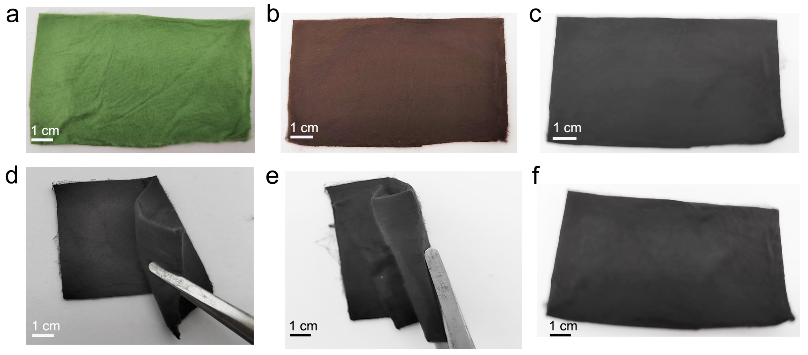
Supplementary Fig. 1. Digital photos of CuNa dual metal site catalyst (CuNa-CF) at different stages. a, Uniform dispersed chlorophyllin sodium copper complex-polyacrylonitrile membrane (CSCC-PAN) prepared by using solution blow spinning technology. b, Pre-oxidized CSCC-PAN membrane. c, CuNa-CF catalyst membrane. d,e, The bent state of CuNa-CF catalyst. f, CuNa-CF catalyst returning to a flat state after being bent.

Supplementary Fig. 2. Structures of metal precursors for different catalysts. a, The structure of CSCC precursor for CuNa-CF catalyst. b, The structure of CuPc precursor for CuPc-CF catalyst. In the structure of CuPc complex, the Cu atom coordinates with four N atoms which is similar with CSCC, but there is no Na atom in CuPc complex.

Supplementary Fig. 3. Structural characterization of CuNa-CF catalyst. a, Transmission electron microscopy (TEM) image of a CuNa-CF fiber. b, X-ray diffraction (XRD) patterns of CuNa-CF catalyst, pre-oxidized CSCC-PAN membrane and CSCC complex.

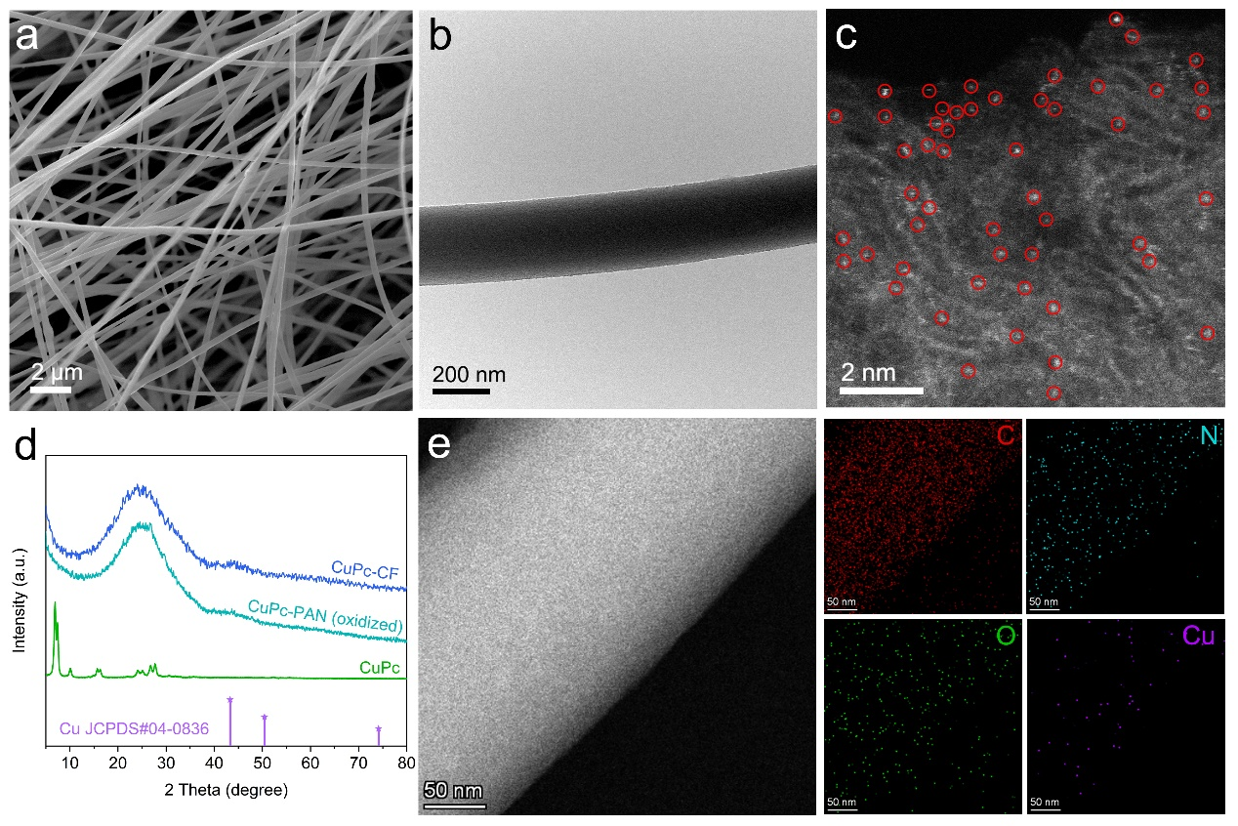
Supplementary Fig. 4. Structural characterization of CuPc-CF catalyst. a, Scanning electron microscope image (SEM) image. b, TEM image. c, Aberration-corrected high-angle annular dark-field scanning transmission electron microscopy (AC-HAADF-STEM) image, some of Cu atoms are marked by red circles. d, XRD patterns of CuPc-CF catalyst, pre-oxidized CuPc-PAN membrane and CuPc complex. e, HAADF-STEM image and the corresponding energy dispersive X-ray spectra elemental mappings for C (red), N (blue), O (green), and Cu (purple).

Supplementary Fig. 5. Raman spectra. a, Raman spectra of CSCC complex, CuPc complex, PAN nanofibers after pre-oxidation in the air, and different pre-oxidated metal precursor-carbon nanofibers (CSCC-PAN, CuPc+NaCl-PAN, CuPc-PAN, and NaCl-PAN). b, Raman spectra of CuNa-CF, CuPc+NaCl-CF, CuPc-CF, NaCl-CF, and CF catalysts. The typical graphite D band and G band can be identified clearly at 1350 and 1590 cm⁻¹ in different catalysts.

Supplementary Fig. 6. X-ray photoelectron spectroscopy (XPS) spectra of CuNa-CF catalyst for the C 1s (a), N 1s (b), O 1s (c), Cu 2p (d) and Na 1s (e) regions.

Supplementary Fig. 7. XPS spectra of CuPc-CF catalyst for the C 1s (a), N 1s (b), O 1s (c) and Cu 2p (d) regions.

Supplementary Fig. 8. XPS spectrum of CSCC complex for the Na 1s region.

Supplementary Fig. 9. The expanded pre-edge region of Cu K-edge X-ray absorption near-edge structure (XANES) spectra (CuNa-CF, CuPc-CF and reference samples (Cu Foil, CuO, CuPc and CSCC)).

Supplementary Fig. 10. Cu K-edge X-ray absorption near-edge structure spectra of CuNa-CF and other samples (Cu Foil, CuO, CuPc, CSCC and CuPc-CF).

Supplementary Fig. 11. Fourier transformed extended X-ray absorption fine structure (EXAFS) spectra at R space of CuNa-CF and other samples (Cu Foil, CuO, CuPc, CSCC and CuPc-CF).

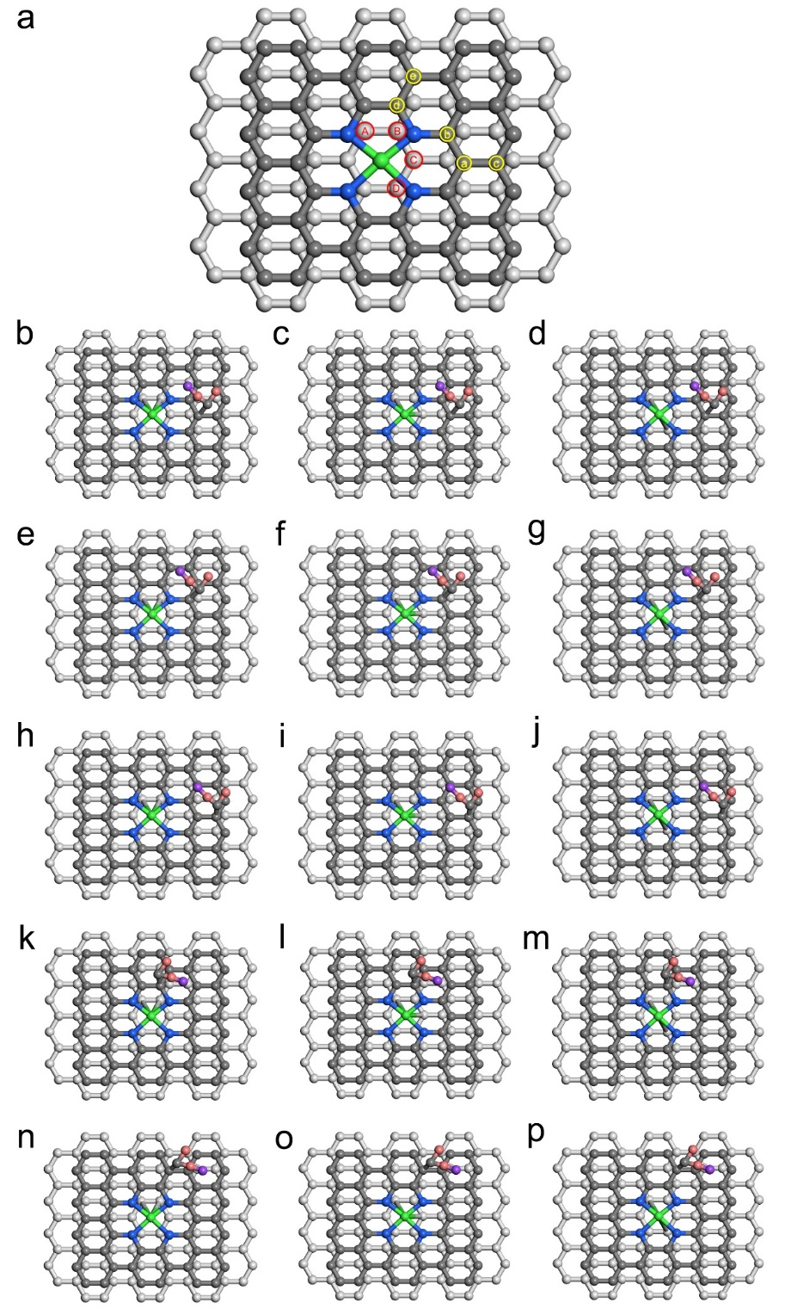
Supplementary Fig. 12. Atomistic structures of CuNa-CF catalyst. a, According to the Fourier transformed k2-weighted extended X-ray absorption fine structure (FT-EXAFS) spectra fitting, the Cu-N₄ site is embedded in the carbon matrix and each Cu atom is coordinated with two C atoms in the underlying carbon lattice matrix (bonded with two of the four C atoms numbered “A”, “B”, “C” and “D”). Also, one of three -COONa functional groups from CuNa complex is reserved during the pyrolysis process, the -COONa functional groups can bonded with one of five C atoms in the carbon matrix numbered “a”, “b”, “c”, “d”, and “e”. The optimized configuration of CuNa-CF is using density functional theory (DFT) to calculate the different energies of its possible structure, such as, the configuration of CuN₄ anchored on the ortho-, meta-, and para-C while the -COONa functional group anchored on different C atoms (Cu atom is green, Na atom is purple, O atoms are pink, N atoms are blue, C atoms in the layer where the Cu site is located are dark gray, C atoms in the layer below Cu site are light gray). b, The -COONa functional group anchored on C “a” atom and Cu atom bonded with the ortho-C (“A” and “B”). c, The -COONa functional group anchored on C “a” atom and Cu atom bonded with the meta-C (“A” and “C”). d, The -COONa functional group anchored on C “a” atom and Cu atom bonded with the para-C (“A” and “D”). e, The -COONa functional group anchored on C “b” atom and Cu atom bonded with the ortho-C (“A” and “B”). f, The -COONa functional group anchored on C “b” atom and Cu atom bonded with the meta-C (“A” and “C”). g, The -COONa functional group anchored on C “b” atom and Cu atom bonded with the para-C (“A” and “D”). h, The -COONa functional group anchored on C “c” atom and Cu atom bonded with the ortho-C (“A” and “B”). i, The -COONa functional group anchored on C “c” atom and Cu atom bonded with the meta-C (“A” and “C”). j, The -COONa functional group anchored on C “c” atom and Cu atom bonded with the para-C (“A” and “D”). k, The -COONa functional group anchored on C “d” atom and Cu atom bonded with the ortho-C (“A” and “B”). l, The -COONa functional group anchored on C “d” atom and Cu atom bonded with the meta-C (“A” and “C”). m, The -COONa functional group anchored on C “d” atom and Cu atom bonded with the para-C (“A” and “D”). n, The -COONa functional group anchored on C “e” atom and Cu atom bonded with the ortho-C (“A” and “B”). o, The -COONa functional group anchored on C “e” atom and Cu atom bonded with the meta-C (“A” and “C”). p, The -COONa functional group anchored on C “e” atom and Cu atom bonded with the para-C (“A” and “D”).
As a result, the Ortho-C in the underlying carbon lattice matrix serve as anchors for stabilizing the Cu and the C “a” atom in the carbon matrix was used to anchor -COONa functional group because of the existence of the strong coordination interaction.

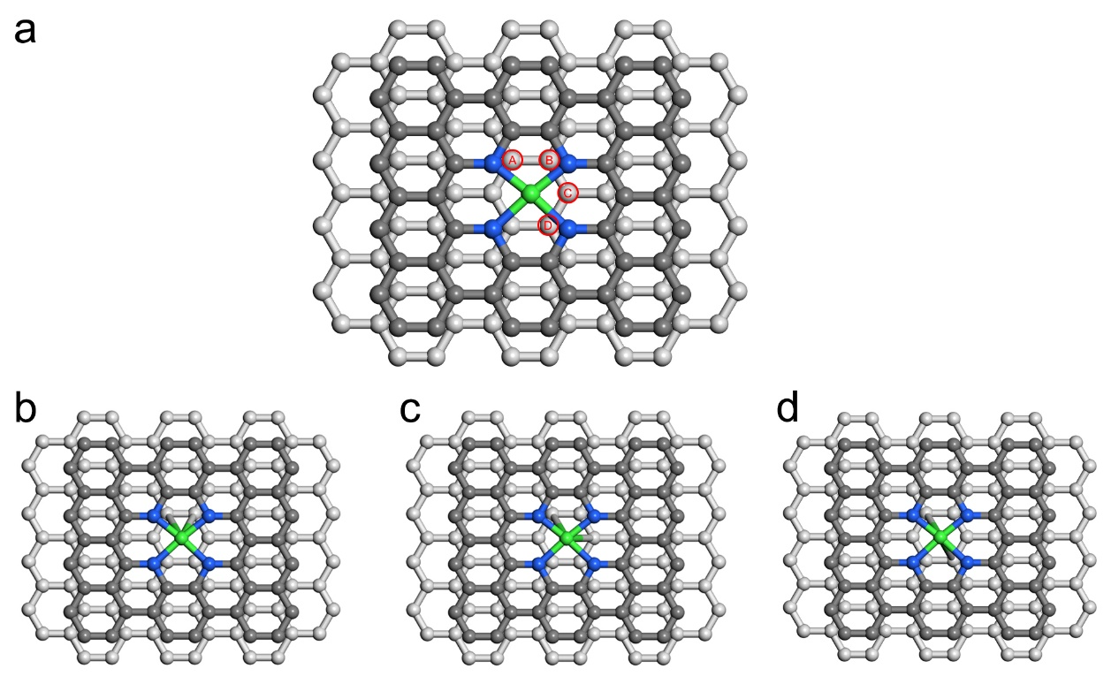
Supplementary Fig. 13. Atomistic structures of CuPc-CF catalyst. a, According to the FT-EXAFS fitting, the Cu-N₄ site is embedded in the carbon matrix and each Cu atom is coordinated with two C atoms in the underlying carbon lattice matrix (bonded with two of the four C atoms numbered “A”, “B”, “C” and “D”). The optimized configuration of CuPc-CF is using DFT to calculate the different energies of its possible structure, such as, CuN₄ anchored on ortho-C, meta-C, and para-C (Cu atom is green, N atoms are blue, C atoms in the layer where the Cu site is located are dark gray, C atoms in the layer below Cu site are light gray). b, The Cu atom in CuPc-CF catalyst is bonded with the ortho-C (“A” and “B”). c,The Cu atom in CuPc-CF catalyst is bonded with the meta-C (“A” and “C”). d, The Cu atom in CuPc-CF catalyst is bonded with the meta-C (“A” and “D”).
As a result, the Ortho-C in the underlying carbon lattice matrix serve anchors for stabilizing the Cu because of the existence of the strong coordination interaction.

Supplementary Fig. 14. Structural characterization of CuPc+NaCl-CF catalyst. a, SEM image. b, XRD patterns of CuPc+NaCl-CF catalyst, pre-oxidized CuPc+NaCl-PAN membrane and CuPc complex. c, TEM image and the corresponding EDS elemental mapping images for C (red), N (blue), O (green), Cu (purple), and Na (orange).

Supplementary Fig. 15. XPS spectra of CuPc+NaCl-CF catalyst for the C 1s (a), N 1s (b), O 1s (c), Cu 2p (d) and Na 1s (e) regions.

Supplementary Fig. 16. Structural characterization of NaCl-CF catalyst. a, SEM image. b, XRD patterns of NaCl-CF catalyst and pre-oxidized NaCl-PAN membrane. c, TEM image and the corresponding EDS elemental mapping images for C (red), N (blue), O (green), and Na (orange).
Supplementary Fig. 17. XPS spectra of NaCl-CF catalyst for the C 1s (a), N 1s (b), O 1s (c), and Na 1s (d) regions.

Supplementary Fig. 18. Structural characterization of CF catalyst. a, SEM image. b, XRD patterns of CF catalyst and pre-oxidized PAN membrane. c, TEM image and the corresponding EDS elemental mapping images for C (red), N (blue), and O (green).
Supplementary Fig. 19. XPS spectra of CF catalyst for the C 1s (a), N 1s (b), and O 1s (c) regions.

Supplementary Fig. 20. Tafel slopes for oxygen reduction reaction (ORR) of the CuNa-CF, CuPc+NaCl-CF, CuPc-CF, NaCl-CF, CF and commercial 20 wt% Pt/C catalysts.

Supplementary Fig. 21. Methanol tolerance tests of CuNa-CF and Pt/C at 0.68 V. The chronoamperometric responses of the two catalysts before and after adding 5 mL CH₃OH to the electrolyte solution.

Supplementary Fig. 22. Long-term ORR electrochemical stability of CuPc-CF catalyst in O₂-saturated 0.1 M KOH solution at 1600 rpm.

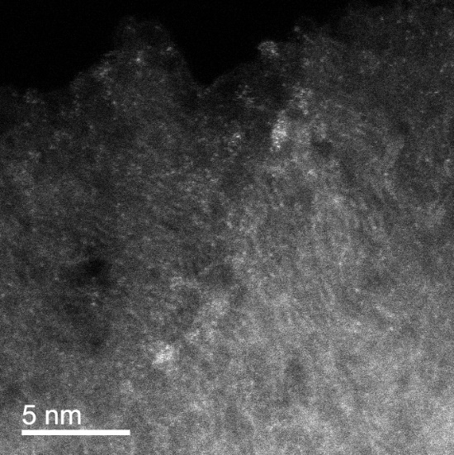
Supplementary Fig. 23. HAADF-STEM image of CuPc-CF after 10 h long-term electrochemical stability test.

Supplementary Fig. 24. Oxygen evolution reaction (OER) polarization curves of CuNa-CF, CuPc+NaCl-CF, CuPc-CF, NaCl-CF, CF and commercial IrO₂ catalysts in 1.0 M KOH solution.

Supplementary Fig. 25. Tafel slopes for OER of CuNa-CF, CuPc+NaCl-CF, CuPc-CF, NaCl-CF, CF and commercial IrO₂ catalysts.

Supplementary Fig. 26. Long-term electrochemical OER stability tests of CuNa-CF catalyst and commercial IrO₂ catalyst in 1.0 M KOH solution.

Supplementary Fig. 27. Energy density plots of zinc-air batteries with commercial Pt/C catalyst and CuNa-CF catalyst as air cathode.

Supplementary Fig. 28. Specific capacity of zinc-air batteries with commercial Pt/C catalyst and CuNa-CF catalyst as air cathode.

Supplementary Fig. 29. Discharging polarization curves and power density plots of zinc-air batteries with commercial Pt/C catalyst and CuNa-CF catalyst as air cathode.

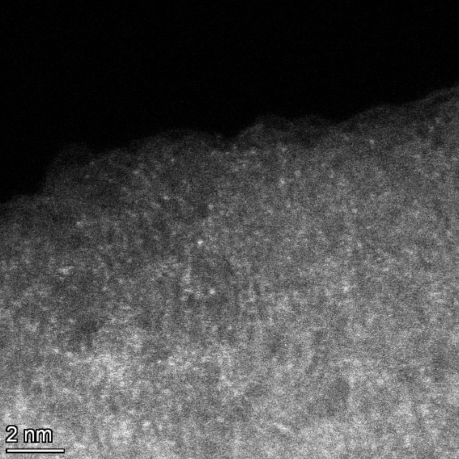
Supplementary Fig. 30. HAADF-STEM image of CuNa-CF after 5000 h ZAB operating stability test.

Supplementary Fig. 31. Long-term discharge/charge cycling stability of the liquid-state ZAB for CuNa-CF air cathode at 10 mA cm⁻².

Supplementary Fig. 32. Long-term discharge/charge cycling stability at 10 mA cm⁻² of commercial Pt/C as the air cathode of ZAB.

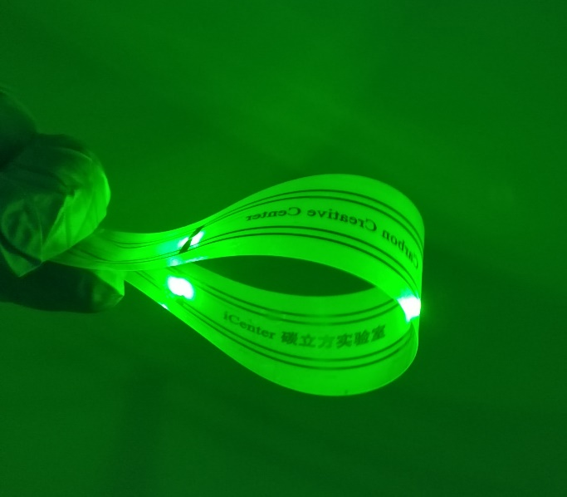
Supplementary Fig. 33. Photograph of a wristband with LED lamps powered by two series-connected solid-state ZABs.

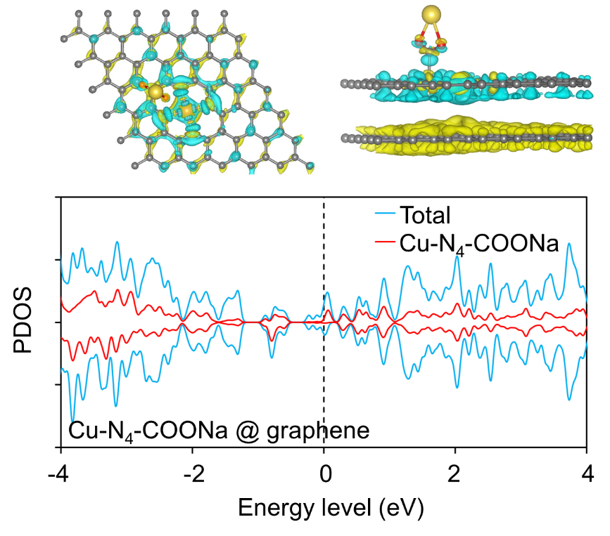
Supplementary Fig. 34. Charge density differences and projected density of state (PDOS) analysis of CuN₄-COONa and CuN₄-COONa@graphene. Where charge depletion and accumulation were depicted by cyan and yellow, respectively.

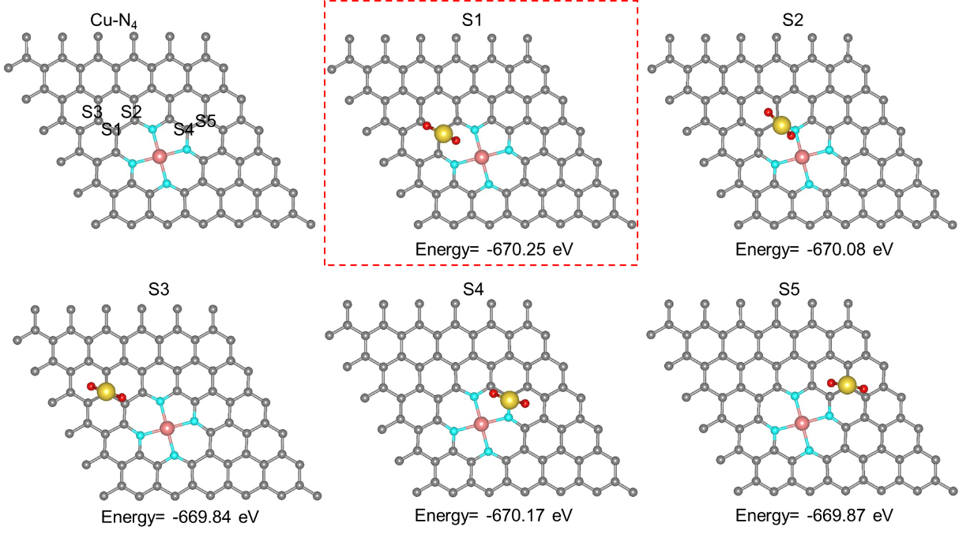
Supplementary Fig. 35. Atomistic structures of CuN₄-COONa (with -COONa on S1-S5 different adsorption sites).

Supplementary Tables

Supplementary Table 1. Inductively coupled plasma mass spectrometry (ICP-MS) analysis results of the as-prepared catalysts.
Catalyst | Cu (wt%) | Na (wt%)
CuNa-CF | 1.89 | 0.711
CuPc+NaCl-CF | 1.93 | 0.815
CuPc-CF | 2.60 | N/A
NaCl-CF | N/A | 1.22

Supplementary Table 2. Contents of C, N, O in as-prepared catalysts from XPS analysis.
Catalyst | C (at%) | N (at%) | O (at%) | N/C | O/C
CuNa-CF | 83.55 | 7.98 | 7.68 | 0.096 | 0.092
CuPc+NaCl-CF | 85.03 | 7.59 | 6.14 | 0.089 | 0.072
CuPc-CF | 84.70 | 8.35 | 6.50 | 0.099 | 0.077
NaCl-CF | 85.89 | 6.33 | 6.85 | 0.074 | 0.080
CF | 86.58 | 6.23 | 7.19 | 0.072 | 0.083

Supplementary Table 3. Extended X-ray absorption fine structure (EXAFS) fitting parameters for Cu foil, CuNa-CF catalyst, and CuPc-CF catalyst.
Sample | Bond Type | Coordination Number | Bond Length  R (Å) | Bond disorder  σ² (Å²) | ∆E₀ | R factor
Cu foil | Cu-Cu | 12 | 2.55 | 0.0093 | 4.9±0.6 | 0.0029
CuNa-CF | Cu-N | 4.1±0.3 | 1.91±0.02 | 0.0129 | 1.4±2.3 | 0.0118
CuNa-CF | Cu-C | 2.4±0.8 | 3.14±0.03 | 0.0016 | 1.4±2.3 | 0.0118
CuPc-CF | Cu-N | 3.9±0.3 | 1.94±0.02 | 0.0116 | 4.6±2.7 | 0.0175
CuPc-CF | Cu-C | 2.1±1.1 | 3.19±0.04 | 0.0020 | 4.6±2.7 | 0.0175

Supplementary Table 4. Summary of the onset potential (E_{onset}), half-wave potential (E_{1/2}), and J_{k} at 0.85 V of different catalysts.
Sample | E_{onset} Potential  (V, V versus RHE) | E_{1/2} Potential  (V, V versus RHE) | J_{k}  (mA cm⁻²)
CuNa-CF | 1.04 | 0.89 | 11.98
CuPc+NaCl-CF | 1.02 | 0.86 | 5.19
CuPc-CF | 0.94 | 0.80 | 1.72
NaCl-CF | 0.91 | 0.75 | 0.65
CF | 0.85 | 0.65 | 0.06
Pt/C | 1.01 | 0.85 | 4.26

Supplementary Table 5. Summary of Tafel slopes for ORR of the as-prepared catalysts.
 | CuNa-CF | CuPc+NaCl-CF | CuPc-CF | NaCl-CF | CF | Pt/C
Tafel Slope  (mV/dec) | 92 | 99 | 101 | 102 | 110 | 127

Supplementary Table 6. ORR electrocatalysis performance comparison of CuNa-CF with other state-of-the-art catalysts in 0.1 M KOH.
Catalyst | Loading Amount  (mg cm⁻²) | E_{onset} | E_{1/2} | Stability | Ref.
CuNa-CF | 0.2 | 1.04 | 0.89 | 99.91% after 36000 s | This Work
(101) copper phosphosulfide | 0.1 | - | 0.90 | E_{1/2} −11 mV after 30000 cycles | [7]  Nat. Energy 6, 592-604 (2021)
ZrN NPs | 0.125 | 0.89 | 0.80 | 95.6% after 36 h | [8]  Nat. Mater. 19, 282-286 (2020)
4.3% NiFe-MOF | 2.0 | 0.92 | 0.83 | 97% after 200 h | [9]  Nat. Energy 4, 115-122 (2019)
NFLGDY-900c | 0.6 | - | 0.87 | 92% after 10000 s | [10]  Nat. Chem. 10, 924-931 (2018)
Cu/Zn@NC | 0.4 | 0.98 | 0.83 | almost unchanged after 10000 cycles | [11]  Angew. Chem. Int. Ed. 60, 14005-14012 (2021)
90 %-AuCu | 25 μg metal | - | 0.85 | E_{1/2} −7mV after 10000 cycles | [12]  Angew. Chem. Int. Ed. 61, e202117834 (2022)
SA-CoCu@Cu/CoNP | 0.25 | 0.98 | 0.88 | 92.6% after 55 h | [13]  Adv. Energy Mater. 11, 2100303 (2021)
Cu-SAs@N-CNS | 0.255 | 1.01 | 0.90 | 87.8% after 60000 s | [14]  Adv. Funct. Mater. 31, 2104864 (2021)
HESACs (FeCoNiCuMn) | 0.18 | 0.999 | 0.887 | 93.33% after 25000 s | [15]  Nat. Commun. 13, 5071 (2022)
Cu-0.25 V/SNGF-0.4 | - | 0.961 | 0.862 | 98% after 20000 s | [16]  Appl. Catal. B 289, 120028 (2021)
Cu₃P/MoP@C | 0.4 | 1.03 | 0.90 | 98% after 40000 s | [17]  Appl. Catal. B 297, 120415 (2021)
CuCo@NC | 0.182 mg active materials | 0.96 | 0.884 | 94% after 30000 s | [18]  Adv. Energy Mater. 7, 1700193 (2017)
Co-TABQ@CNTs | 0.51 | 0.99 | 0.85 | 96.6% after 36000 s | [19]  Angew. Chem. Int. Ed. 60, 16937-16941 (2021)
Co-POP | 0.1 | - | 0.87 | 95% after 36000 s | [20]  Angew. Chem. Int. Ed. 134, e202201104 (2022)
FeCo-N-HCN | 0.102 | 0.98 | 0.86 | E_{1/2} no obvious deviation after 35000 s | [21]  Adv. Funct. Mater. 31, 2011289 (2021)
BFC-FeCo-0.2 | 0.25 | 1.03 | 0.90 | 85% after 20 h | [22]  Angew. Chem. Int. Ed. 59, 4793-4799 (2020)
Co SA-NDGs | 0.3 | 1.02 | - | E_{1/2} −11 mV after 5000 cycles | [23]  Nat. Commun. 13, 3689 (2022)
FeN₄-Te_{n} | 0.79 | 0.922 | 0.867 | 94% after 12 h | [24]  Adv. Mater. 34, 2202714 (2022)
TR-Z8-2-C | 0.153 | 0.90 | 0.77 | little degradation after 8 h | [25]  J. Am. Chem. Soc. 144, 17457-17467 (2022)
Fe SAA/NC | 0.4 | - | 0.892 | no decay after 5000 cycles | [26]  J. Am. Chem. Soc. 144, 15999-16005 (2022)
MNCSs | 0.126 | - | 0.82 | E_{1/2} −6mV after 5000 cycles | [27]  J. Am. Chem. Soc. 144, 11767-11777 (2022)
Co-Fe zeolitic imidazolate framework (S-CFZ) | 0.3 | - | 0.85 | 91% after 100 h | [28]  J. Am. Chem. Soc. 144, 4783-4791 (2022)
Fe-Co-Ni MOF | 0.28 | 0.82 | 0.75 | - | [29]  J. Am. Chem. Soc. 144, 3411-3428 (2022)
Fe/Meso-NC-1000 | 0.34 | 0.97 | 0.885 | 96.4% after 10000 s | [30]  Adv. Mater. 34, 2107291 (2022)
3DOM Fe/Co@NC-WO_{2−x} | - | 0.93 | 0.87 | E_{1/2} −3 mV after 5000 cycles | [31]  Adv. Sci. 9, 2104237 (2022)
Fe₁-NS_{1.3}C single atom catalyst | 0.2 | 0.97 | 0.86 | negligible reduction in E_{1/2} after 10000 cycles | [32]  Angew. Chem. Int. Ed. 60, 25404-25410 (2021)
Fe porphyrin1/CNT | 0.08 | 0.93 | 0.84 | 94% after 10 h | [33]  Angew. Chem. Int. Ed. 60, 7576-7581 (2021)
Sb₁/NG(O) | 0.255 | 1.03 | 0.86 | no obvious change E_{1/2} after 10000 cycles | [34]  Angew. Chem. Int. Ed. 61, e202202200 (2022)
Ru-SAS/SNC | 0.4 | 0.998 | 0.861 | E_{1/2} −24 mV after 30000 cycles | [35]  J. Am. Chem. Soc. 144, 2197–2207 ( 2022)
Mn-RuO₂ | 0.2 | - | 0.86 | 95.5% after 50 h | [36]  J. Am. Chem. Soc. 144, 2694−2704 (2022)
Pd metallene/C | 0.5μg Pd | 1.02 | 0.90 | 93.7% after 5 h  &  no obvious change E_{1/2} after 5000 cycles | [37]  Angew. Chem. Int. Ed. 60, 12027-12031 (2021)

Supplementary Table 7. Summary of the potential at a constant current density of 10 mA cm⁻² (E_{J=10}) and Tafel slopes for OER of the as-prepared catalysts.
 | CuNa-CF | CuPc+NaCl-CF | CuPc-CF | NaCl-CF | CF | IrO₂
E_{J=10} (V) | 1.58 | 1.59 | 1.63 | 1.70 | 1.73 | 1.55
Tafel Slope (mV/dec) | 70 | 71 | 141 | 201 | 211 | 67

Supplementary Table 8. The zinc-air batteries performance comparison of CuNa-CF with other state-of-the-art catalysts.
Catalyst | Loading Amount  (mg cm⁻²) | Cycling Stability  (h/cycles) | Current Density  (mA cm⁻²) | Ref.
CuNa-CF | 0.2 | 5000 h  (30000 cycles) | 1 | This work
CuNa-CF | 0.2 | 1200 h  (7200 cycles) | 10 | This work
HESA (FeMnCoNiCu) | 1.0 | 200 h | 2 | [38]  Nat. Sustain. 6, 816-826 (2023)
(101)-copper phosphosulfide | 15.0 | 800 h | 25 | [7]  Nat. Energy 6, 592-604 (2021)
ZrN nanoparticles | 1.0 | 100 h | 10 | [8]  Nat. Mater. 19, 282-286 (2020)
PdMo bimetallene/C | 1.0 | 500 h | 10 | [39]  Nature 574, 81-85 (2019)
FeCo-NCH | 1.0 | 100 h | 5 | [40]  Nat. Commun. 14, 1822 (2023)
Co SA-NDGs | 5.0 | 200 h | 2 | [23]  Nat. Commun. 13, 3689 (2022)
Fe,Mn/N-C | 0.5 | 81 h | 5 | [41]  Nat. Commun. 12, 1734 (2021)
Fe-Co-Ni MOF | 1.0 | 120 h | 5 | [29]  J. Am. Chem. Soc. 144, 3411-3428 ( 2022)
Ru SAS/SNC | 1.0 | 270 h | 5 | [35]  J. Am. Chem. Soc. 144, 2197-2207 ( 2022)
Pd arrays / NiO films | 1.0 | 300 cycles | 10 | [42]  Adv. Energy Mater. 11, 2102235 (2021)
VMoON@NC | 2.0 | 630 h | 10 | [43]  Adv. Mater. 35, 2302625 (2023)
CuCo₂O_{4-x}S_{x}/NC-2 | 6.0 | 300 h | 10 | [44]  Adv. Mater. 35, 2303488 (2023)
Cu-Co/NC | 1.0 | 510 h | 10 | [45]  Adv. Mater. 35, 2300905 (2023)
Fe_{0.5}Co@HOMNCP | 1.0 | 120 h | 2 | [46]  Adv. Mater. 34, 2109605 (2022)
Fe/SNCFs-NH₃ | 0.5 | 1000 h | 1 | [47]  Adv. Mater. 34, 2105410 (2022)
CoNC@LDH | 1.5 | 3630 cycles | 10 | [48]  Adv. Mater. 33, 2008606 (2021)
Asy-NiFe | 2.1 | 3400 cycles | 10 | [49]  Adv. Mater. 34, 2109407 (2022)
Co₂/Fe-N@CHC | 2.0 | 240 h | 5 | [50]  Adv. Mater. 33, 2104718 (2021)
Ru-Co/ELCO | 2.0 | 170 h | 5 | [51]  Angew. Chem. Int. Ed. 61, e202205946 (2022)
SMOx-SMO/CNTs | 8.0 | 200 h | 5 | [52]  Angew. Chem. Int. Ed. 133, 22214-22221 (2021)
Fe-N-GDY | 1.0 | 900 cycles | 2 | [53]  Angew. Chem. Int. Ed. 61, e202208238 (2022)
LD-Fe SAC | 0.5 | 550 cycles | 6 | [54]  Angew. Chem. Int. Ed. 60, 22722-22728 (2021)
Co₃O₄ NSs/CC | - | 500 cycles | 5 | [34]  Angew. Chem. Int. Ed. 61, e202202671 (2022)
OLC/Co-N-C | 0.5 | 100 h | 2 | [55]  Angew. Chem. Int. Ed. 60, 12759-12764 (2021)
MnCo₂O₄/NCNTs | 6.0 | 300 cycles | 5 | [56]  Angew. Chem. 134, e202114696 (2022)

Supplementary reference
[1] Liu, W. et al. Construction of ultra-sensitive surface-enhanced Raman scattering substrates based on 3D graphene oxide aerogels. Carbon 202, 389-397 (2023).
[2] Yao, Y., Li, W., Wang, S., Yan, D. & Chen, X. Polypeptide modification of multiwalled carbon nanotubes by a graft-from approach. Macromol. Rapid Commun. 27, 2019-2025 (2006).
[3] Peng, H. et al. Effect of transition metals on the structure and performance of the doped carbon catalysts derived from polyaniline and melamine for ORR application. ACS Catal. 4, 3797-3805 (2014).
[4] Al-Gaashani, R., Najjar, A., Zakaria, Y., Mansour, S. & Atieh, M.A. XPS and structural studies of high quality graphene oxide and reduced graphene oxide prepared by different chemical oxidation methods. Ceram. Int. 45, 14439-14448 (2019).
[5] Li, Y., Kong, M., Hu, J. & Zhou, J. Carbon-microcuboid-supported phosphorus-coordinated single atomic copper with ultrahigh content and its abnormal modification to Na storage behaviors. Adv. Energy Mater. 10, 2000400 (2020).
[6] Lai, H. et al. In situ generated composite gel polymer electrolyte with crosslinking structure for dendrite-free and high-performance sodium metal batteries. Energy Stor. Mater. 54, 478-487 (2023).
[7] Shinde, S. S. et al. Ampere-hour-scale zinc-air pouch cells. Nat. Energy 6, 592-604 (2021).
[8] Yuan, Y. et al. Zirconium nitride catalysts surpass platinum for oxygen reduction. Nat. Mater. 19, 282-286 (2020).
[9] Cheng, W. et al. Lattice-strained metal-organic-framework arrays for bifunctional oxygen electrocatalysis. Nat. Energy 4, 115-122 (2019).
[10] Zhao, Y. et al. Few-layer graphdiyne doped with sp-hybridized nitrogen atoms at acetylenic sites for oxygen reduction electrocatalysis. Nat. Chem. 10, 924-931 (2018).
[11] Tong, M. et al. Operando cooperated catalytic mechanism of atomically dispersed Cu-N₄ and Zn-N₄ for promoting oxygen reduction reaction. Angew. Chem. Int. Ed. 60, 14005-14012 (2021).
[12] Chen, H. Q. et al. Unmasking the critical role of the ordering degree of bimetallic nanocatalysts on oxygen reduction reaction by in situ Raman spectroscopy. Angew. Chem. Int. Ed. 61, e202117834 (2022).
[13] Zhang, Q. et al. Electronically modified atomic sites within a multicomponent Co/Cu composite for efficient oxygen electroreduction. Adv. Energy Mater. 11, 2100303 (2021).
[14] Zong, L. et al. Anchoring single copper atoms to microporous carbon spheres as high-performance electrocatalyst for oxygen reduction reaction. Adv. Funct. Mater. 31, 2104864 (2021).
[15] Rao, P. et al. Movable type printing method to synthesize high-entropy single-atom catalysts. Nat. Commun. 13, 5071 (2022).
[16] Xu, J. et al. Underpotential-deposition synthesis and in-line electrochemical analysis of single-atom copper electrocatalysts. Appl. Catal. B 289, 120028 (2021).
[17] Guo, M. et al. Electronic/mass transport increased hollow porous Cu₃P/MoP nanospheres with strong electronic interaction for promoting oxygen reduction in Zn-air batteries. Appl. Catal. B 297, 120415 (2021).
[18] Kuang, M., Wang, Q., Han, P., & Zheng, G. Cu, Co-embedded N-enriched mesoporous carbon for efficient oxygen reduction and hydrogen evolution reactions. Adv. Energy Mater. 7, 1700193 (2017).
[19] Ni, Y. et al. Regulating electrocatalytic oxygen reduction activity of a metal coordination polymer via d-π conjugation. Angew. Chem. Int. Ed. 60, 16937-16941 (2021).
[20] Lei, H. et al. Metal-corrole-based porous organic polymers for electrocatalytic oxygen reduction and evolution reactions. Angew. Chem. Int. Ed. 134, e202201104 (2022).
[21] Li, H. et al. Understanding of neighboring Fe-N₄-C and Co-N₄-C dual active centers for oxygen reduction reaction. Adv. Funct. Mater. 31, 2011289 (2021).
[22] Pei, Z. et al. A flexible rechargeable zinc-air battery with excellent low-temperature adaptability. Angew. Chem. Int. Ed. 59, 4793-4799 (2020).
[23] Wang, Q. et al. Quasi-solid-state Zn-air batteries with an atomically dispersed cobalt electrocatalyst and organohydrogel electrolyte. Nat. Commun. 13, 3689 (2022).
[24] Ji, B. et al. Metalloid-cluster ligands enabling stable and active FeN₄-Ten motifs for the oxygen reduction reaction. Adv. Mater. 34, 2202714 (2022).
[25] Song, Y. et al. Two-dimensional metal-organic framework superstructures from ice-templated self-assembly. J. Am. Chem. Soc. 144, 17457-17467 (2022).
[26] Wang, L. et al. Periodic one-dimensional single-atom arrays. J. Am. Chem. Soc. 144, 15999-16005 (2022).
[27] Zhao, Z. et al. Constructing unique mesoporous carbon superstructures via monomicelle interface confined assembly. J. Am. Chem. Soc. 144, 11767-11777 (2022).
[28] Jiang, Y. et al. Linker-compensated metal-organic framework with electron delocalized metal sites for bifunctional oxygen electrocatalysis. J. Am. Chem. Soc. 144, 4783-4791 (2022).
[29] Shahbazi F. F. et al. Trilayer metal-organic frameworks as multifunctional electrocatalysts for energy conversion and storage applications. J. Am. Chem. Soc. 144, 3411-3428 (2022).
[30] Zhao, S. N., Li, J. K., Wang, R., Cai, J., & Zang, S. Q. Electronically and geometrically modified single-atom Fe sites by adjacent Fe nanoparticles for enhanced oxygen reduction. Adv. Mater. 34, 2107291 (2022).
[31] Han, Q. et al. Synergistic binary Fe-Co nanocluster supported on defective tungsten oxide as efficient oxygen reduction electrocatalyst in zinc-air battery. Adv. Sci. 9, 2104237 (2022).
[32] Chen, Z. et al. Unraveling the origin of sulfur-doped Fe‐N‐C single-atom catalyst for enhanced oxygen reduction activity: effect of iron spin-state tuning. Angew. Chem. Int. Ed. 60, 25404-25410 (2021).
[33] Xie, L. et al. Enzyme‐inspired iron porphyrins for improved electrocatalytic oxygen reduction and evolution reactions. Angew. Chem. Int. Ed. 60, 7576-7581 (2021).
[34] Gu, Y., Xi, B. J., Zhang, H., Ma, Y. C., & Xiong, S. L. Activation of main-group antimony atomic sites for oxygen reduction catalysis. Angew. Chem. Int. Ed. 61, e202202200 (2022).
[35] Qin, J. et al. Altering ligand fields in single-atom sites through second-shell anion modulation boosts the oxygen reduction reaction. J. Am. Chem. Soc. 144, 2197-2207 ( 2022).
[36] Zhou, C. et al. Superdurable bifunctional oxygen electrocatalyst for high-performance zinc-air batteries. J. Am. Chem. Soc. 144, 2694-2704 (2022).
[37] Yu, H. et al. Defect-rich porous palladium metallene for enhanced alkaline oxygen reduction electrocatalysis. Angew. Chem. Int. Ed. 60, 12027-12031 (2021).
[38] Lei, X. et al. High-entropy single-atom activated carbon catalysts for sustainable oxygen electrocatalysis. Nat. Sustain. 6, 816-826 (2023).
[39] Luo, M. et al. PdMo bimetallene for oxygen reduction catalysis. Nature 574, 81-85 (2019).
[40] Jiang, Z. et al. Interfacial assembly of binary atomic metal-Nx sites for high-performance energy devices. Nat. Commun. 14, 1822 (2023).
[41] Yang, G. et al. Regulating Fe-spin state by atomically dispersed Mn-N in Fe-NC catalysts with high oxygen reduction activity. Nat. Commun. 12, 1734 (2021).
[42] Lu, X. et al. Atomic heterointerface boosts the catalytic activity toward oxygen reduction/evolution reaction. Adv. Energy Mater. 11, 2102235 (2021).
[43] Wang, Q. et al. Electrolyte tuned robust interface toward fast-charging Zn-air battery with atomic Mo site catalyst. Adv. Mater. 35, 2302625 (2023).
[44] Cai, J. et al. Hetero-anionic structure activated Co-S bonds promote oxygen electrocatalytic activity for high-efficiency zinc-air batteries. Adv. Mater. 35, 2303488 (2023).
[45] Li, Z. et al. Geometric and electronic engineering of atomically dispersed copper-cobalt diatomic sites for synergistic promotion of bifunctional oxygen electrocatalysis in zinc-air batteries. Adv. Mater. 35, 2300905 (2023).
[46] Li, W. et al. Alloying Co species into ordered and interconnected macroporous carbon polyhedra for efficient oxygen reduction reaction in rechargeable zinc-air batteries. Adv. Mater. 34, 2109605 (2022).
[47] Yang, L. et al. Atomic Fe-N₄/C in flexible carbon fiber membrane as binder-free air cathode for Zn-air batteries with stable cycling over 1000 h. Adv. Mater. 34, 2105410 (2021).
[48] Zhao, C. X. et al. A ΔE=0.63 V bifunctional oxygen electrocatalyst enables high-rate and long-cycling zinc-air batteries. Adv. Mater. 33, 2008606 (2021).
[49] Liu, J. N. et al. Preconstructing asymmetric interface in air cathodes for high-performance rechargeable Zn-air batteries. Adv. Mater. 34, 2109407 (2022).
[50] Wang, Z. et al. Atomically dispersed Co₂-N₆ and Fe-N₄ costructures boost oxygen reduction reaction in both alkaline and acidic media. Adv. Mater. 33, 2104718 (2021).
[51] Zheng, X. et al. Ru-Co pair sites catalyst boosts the energetics for the oxygen evolution reaction. Angew. Chem. Int. Ed. 61, e202205946 (2022).
[52] Chen, C. et al. Epitaxially grown heterostructured SrMn₃O₆-x-SrMnO₃ with high-valence Mn³⁺/⁴⁺ for improved oxygen reduction catalysis. Angew. Chem. Int. Ed. 133, 22214-22221 (2021).
[53] Li, M., Lv, Q., Si, W., Hou, Z., & Huang, C. Sp-hybridized nitrogen as new anchoring sites of iron single atoms to boost the oxygen reduction reaction. Angew. Chem. Int. Ed. 61, e202208238 (2022).
[54] Yang, J. et al. Compressive strain modulation of single iron sites on helical carbon support boosts electrocatalytic oxygen reduction. Angew. Chem. Int. Ed. 60, 22722-22728 (2021).
[55] Liang, Z. et al. Highly curved nanostructure‐coated Co, N-doped carbon materials for oxygen electrocatalysis. Angew. Chem. Int. Ed. 60, 12759-12764 (2021).
[56] Wang, Z. et al. Cation-tuning induced d-band center modulation on Co-based spinel oxide for oxygen reduction/evolution reaction. Angew. Chem. Int. Ed.134, e202114696 (2022).

