Supplementary material

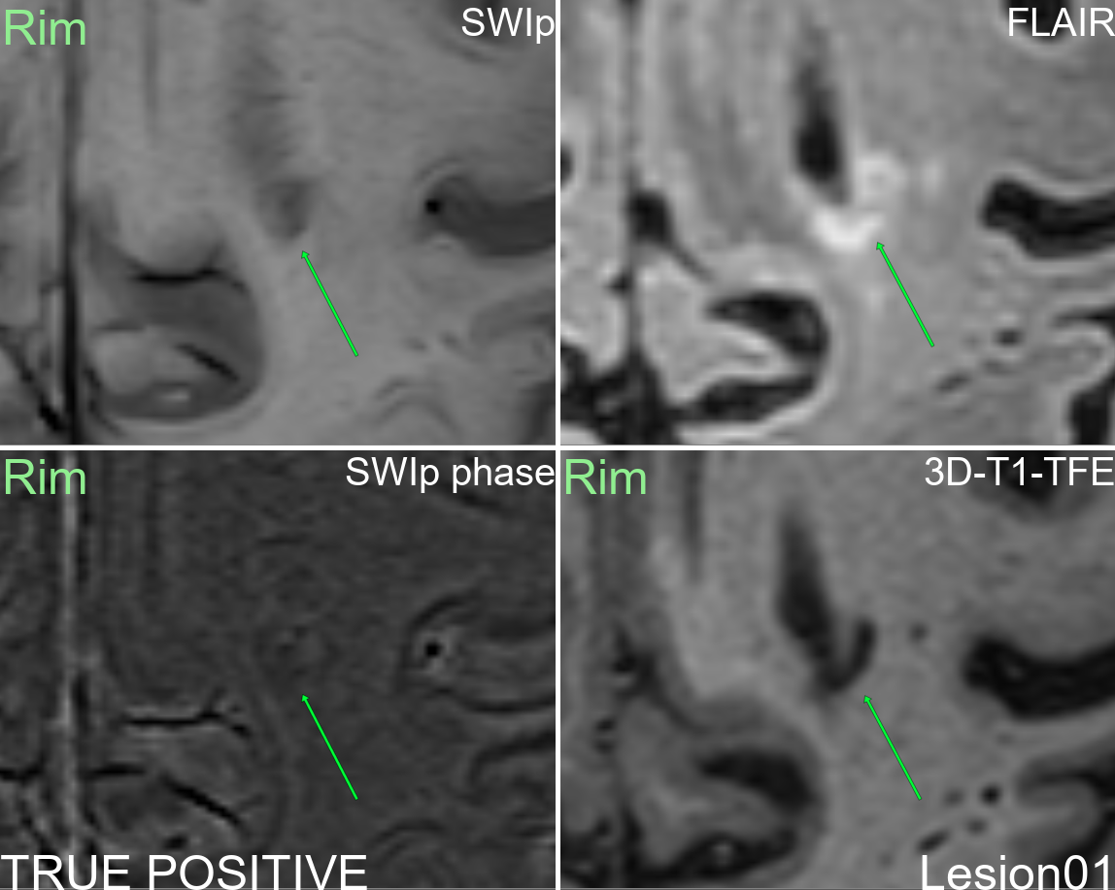
Supplementary figure 1: Multi-modal display of lesion 1.
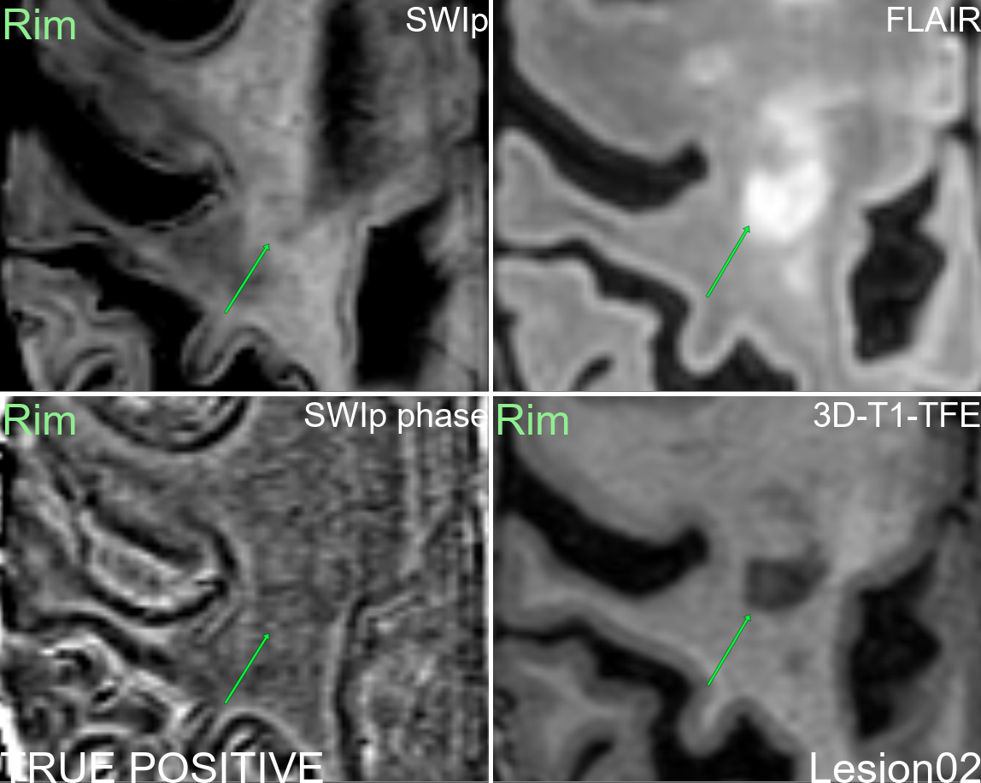
Supplementary figure 2: Multi-modal display of lesion 2.
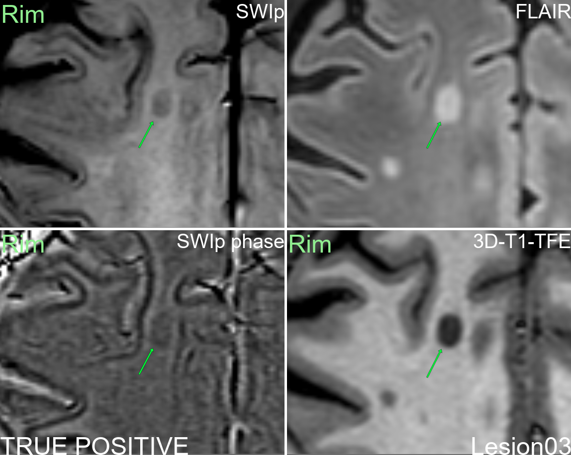
Supplementary figure 3: Multi-modal display of lesion 3.
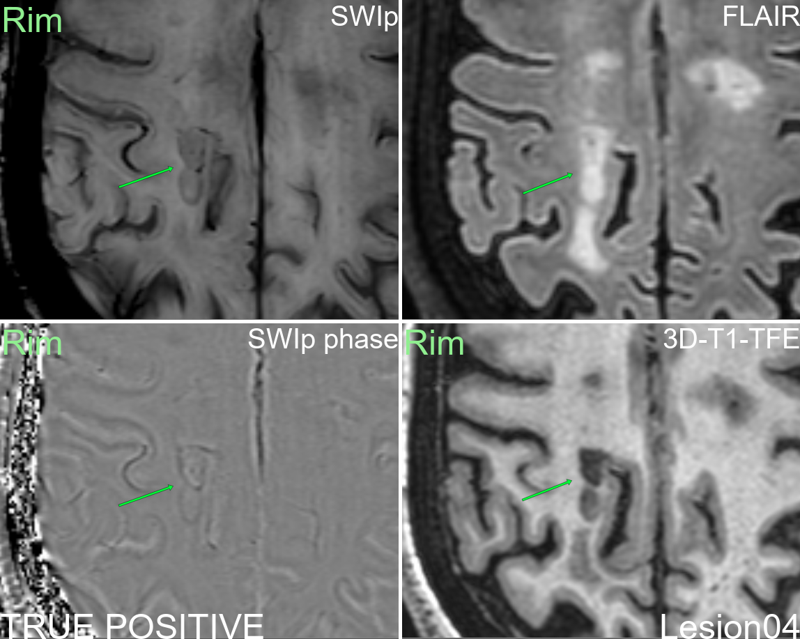
Supplementary figure 4: Multi-modal display of lesion 4.
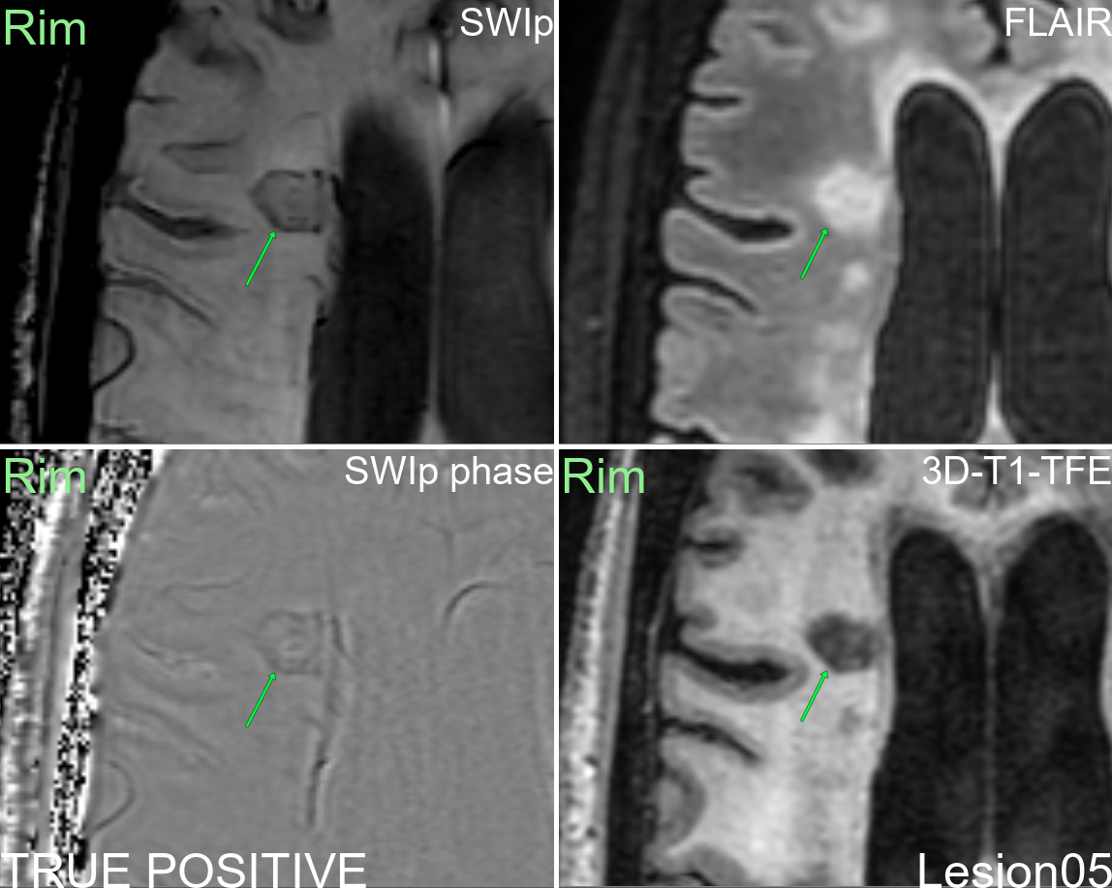
Supplementary figure 5: Multi-modal display of lesion 5.
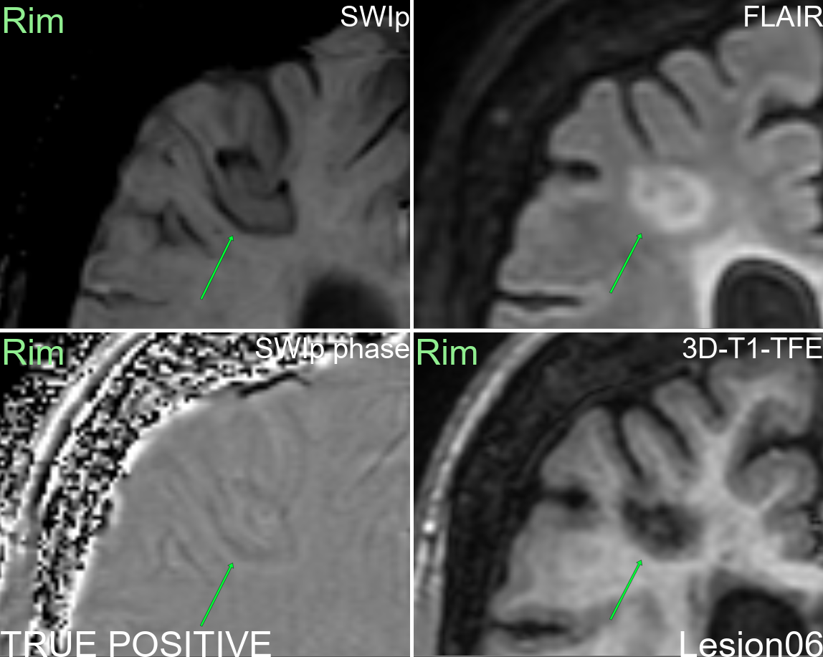
Supplementary figure 6: Multi-modal display of lesion 6.
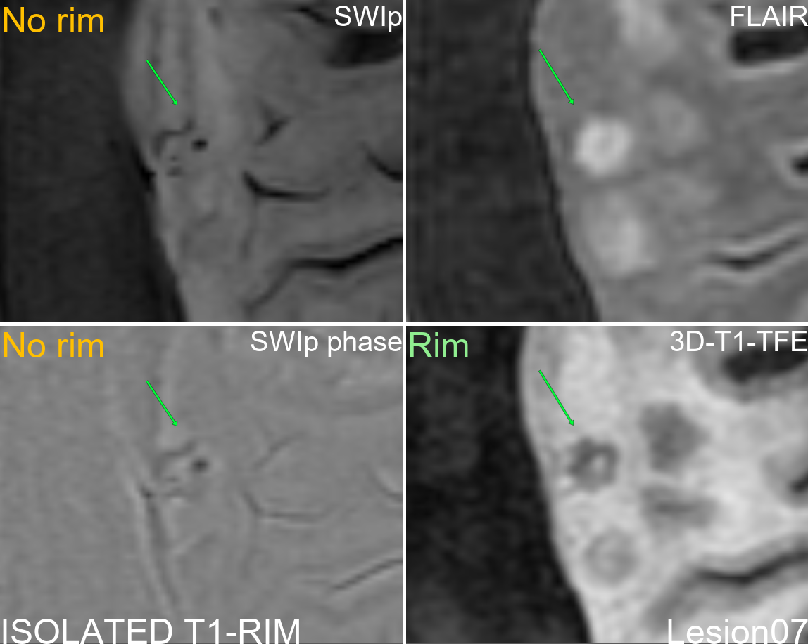
Supplementary figure 7: Multi-modal display of lesion 7.
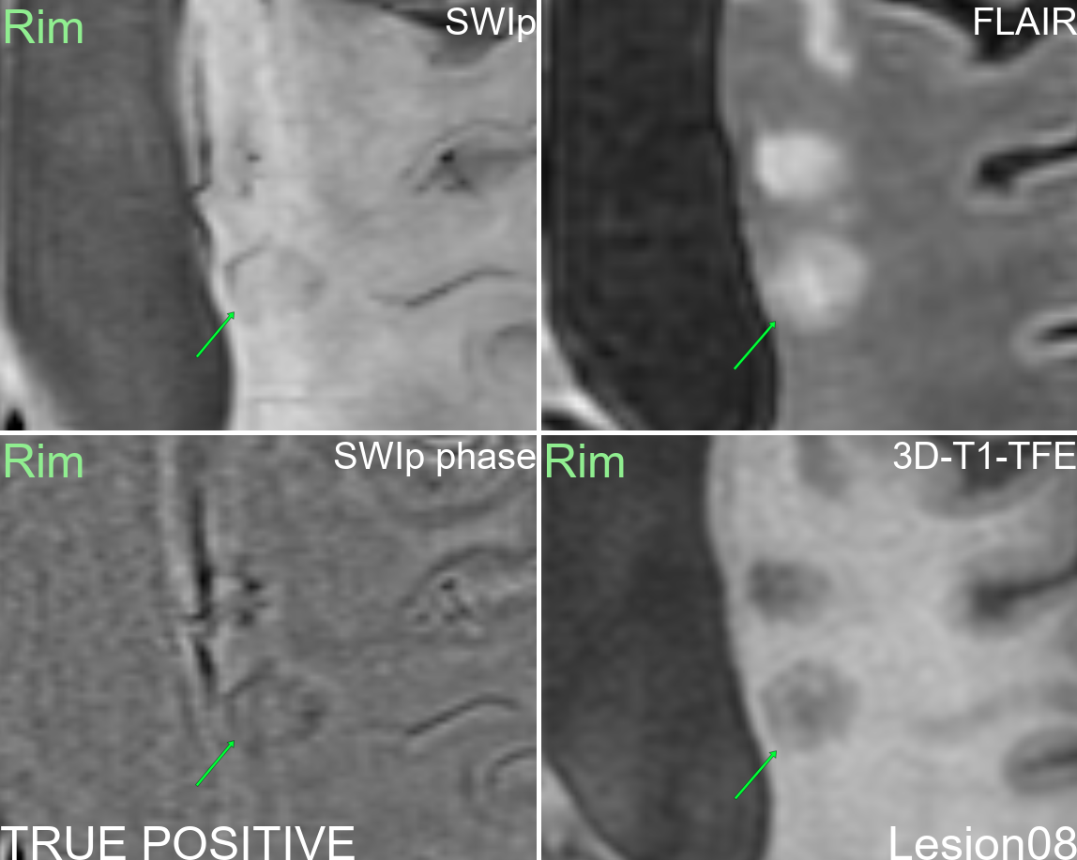
Supplementary figure 8: Multi-modal display of lesion 8.
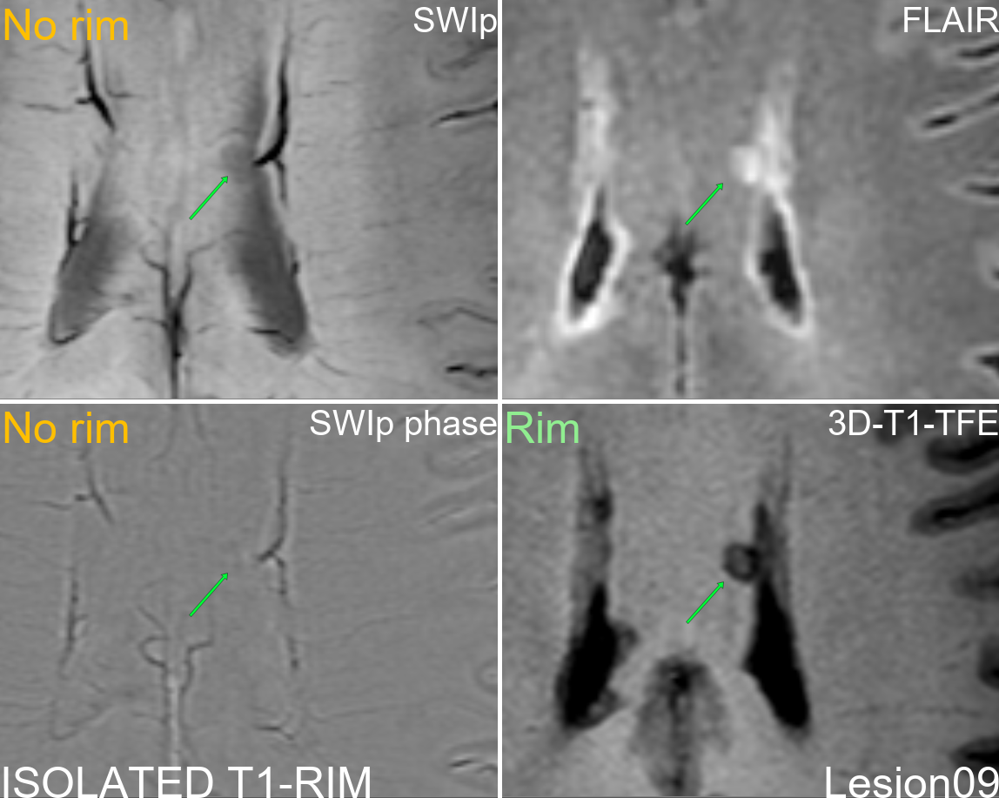
Supplementary figure 9: Multi-modal display of lesion 9.
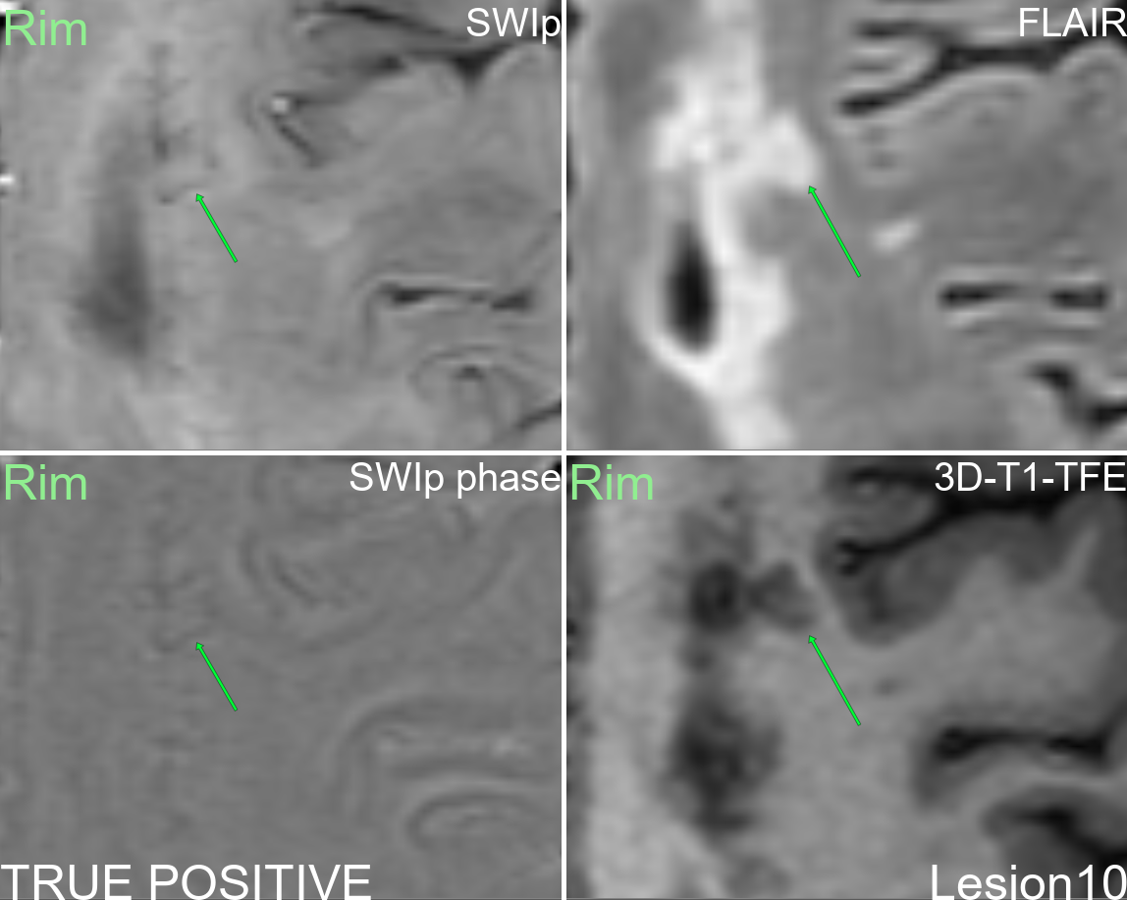
Supplementary figure 10: Multi-modal display of lesion 10.
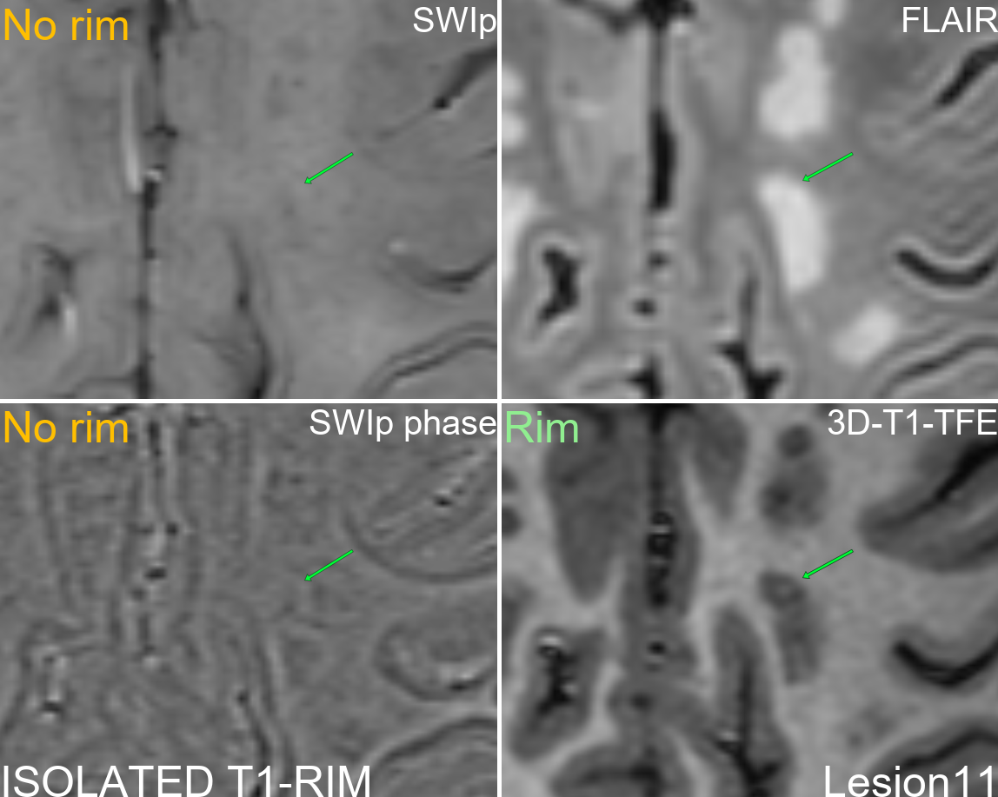
Supplementary figure 11: Multi-modal display of lesion 11.
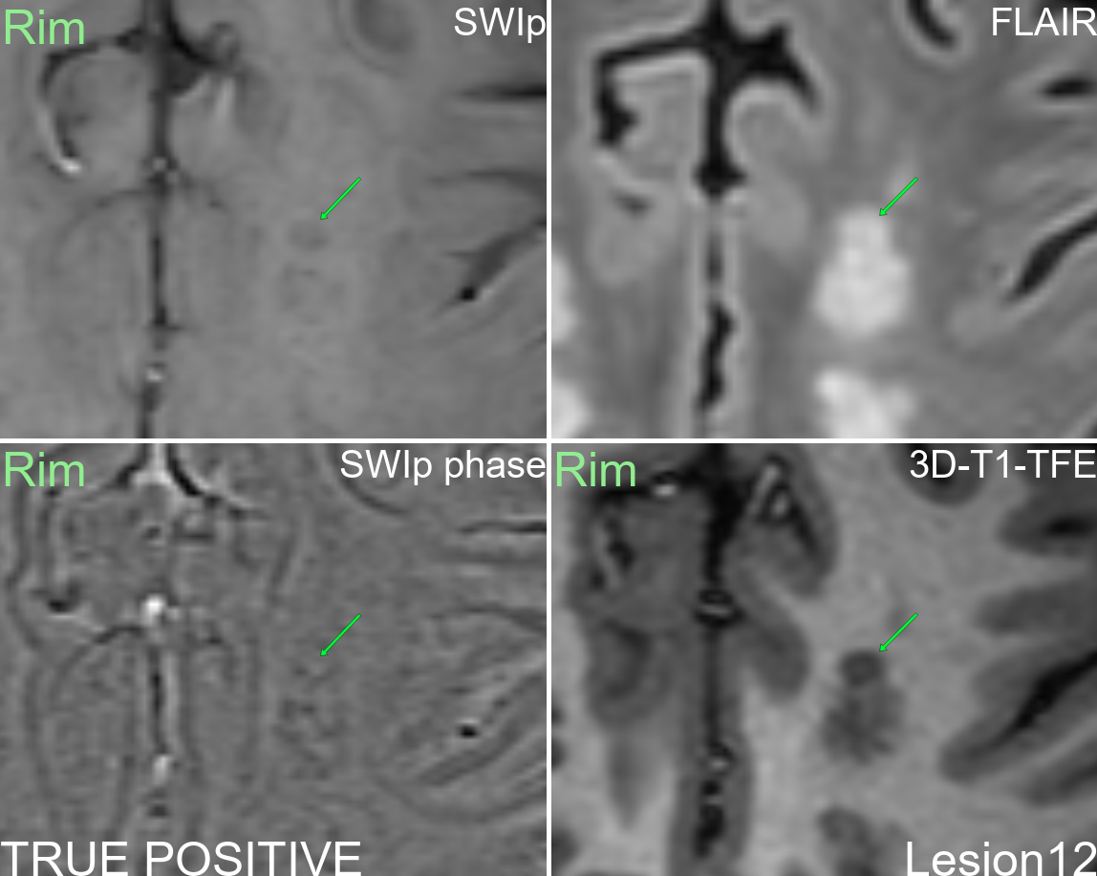
Supplementary figure 12: Multi-modal display of lesion 12.
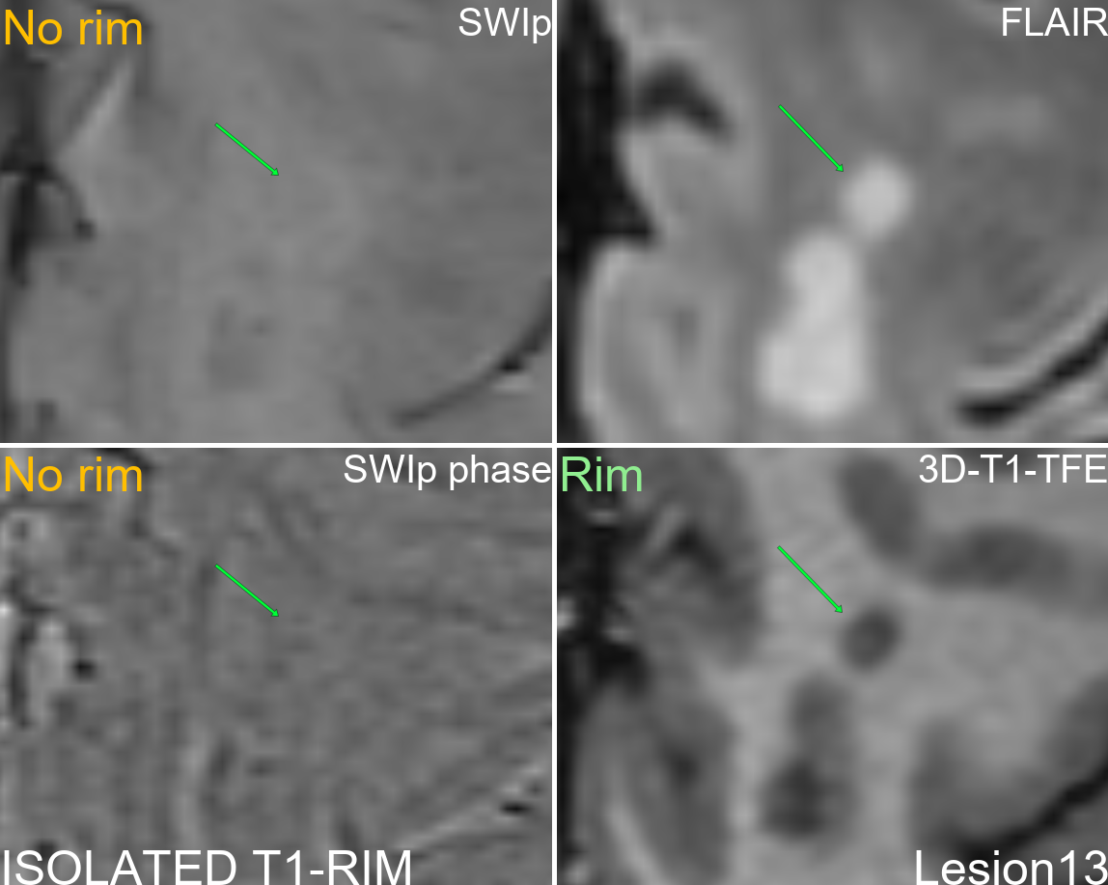
Supplementary figure 13: Multi-modal display of lesion 13.
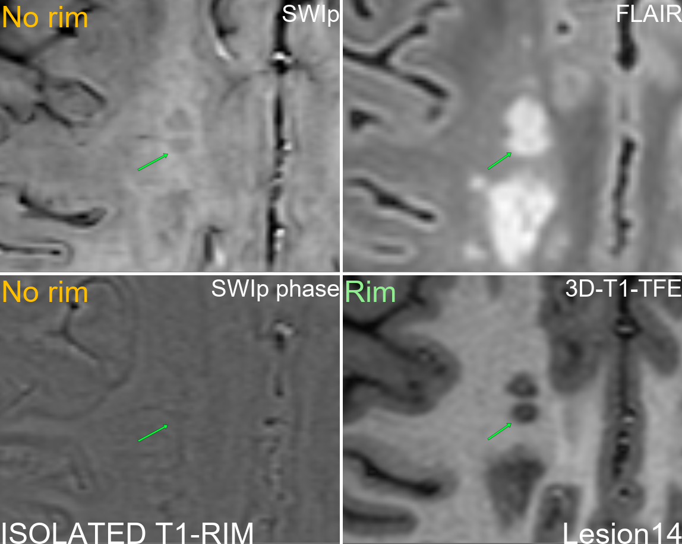
Supplementary figure 14: Multi-modal display of lesion 14.
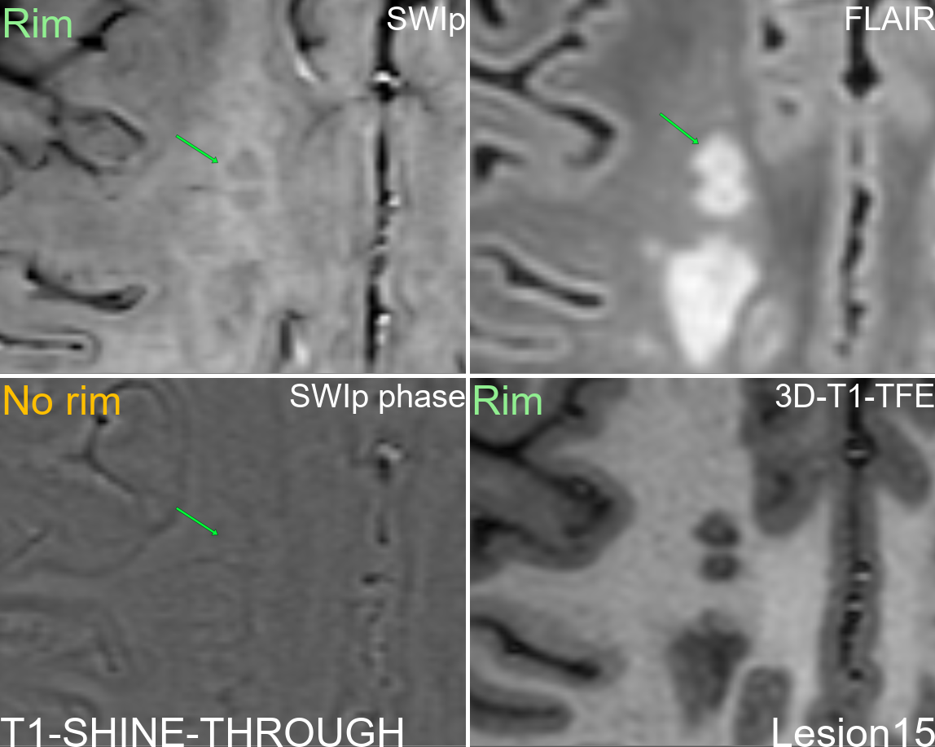
Supplementary figure 15: Multi-modal display of lesion 15.
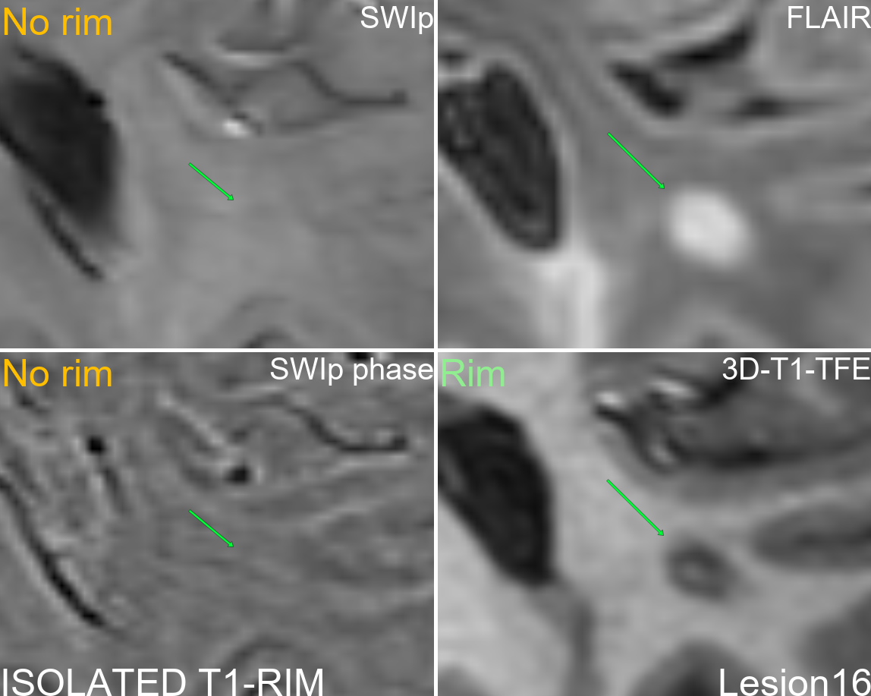
Supplementary figure 16: Multi-modal display of lesion 16.
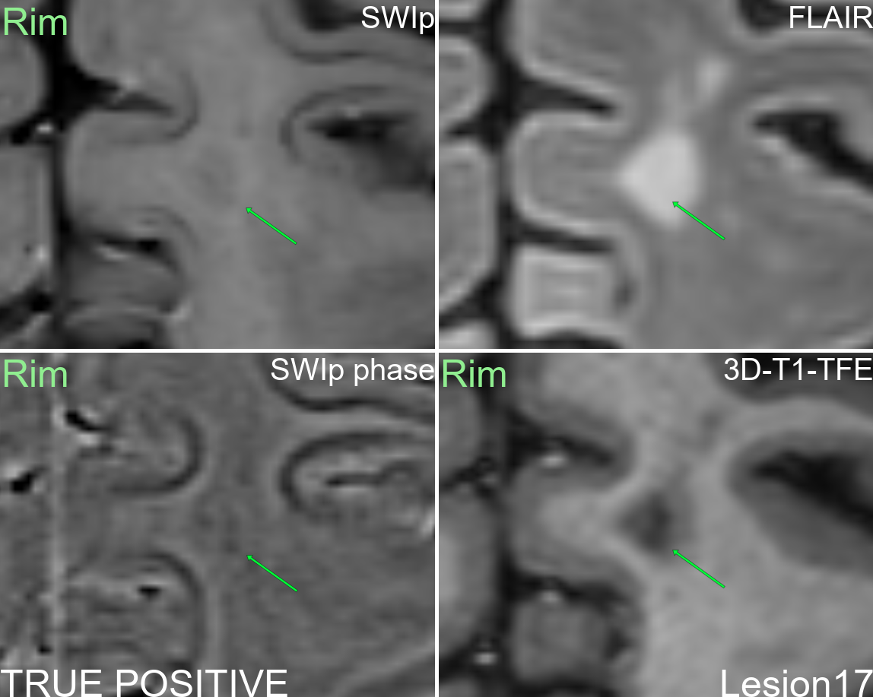
Supplementary figure 17: Multi-modal display of lesion 17.
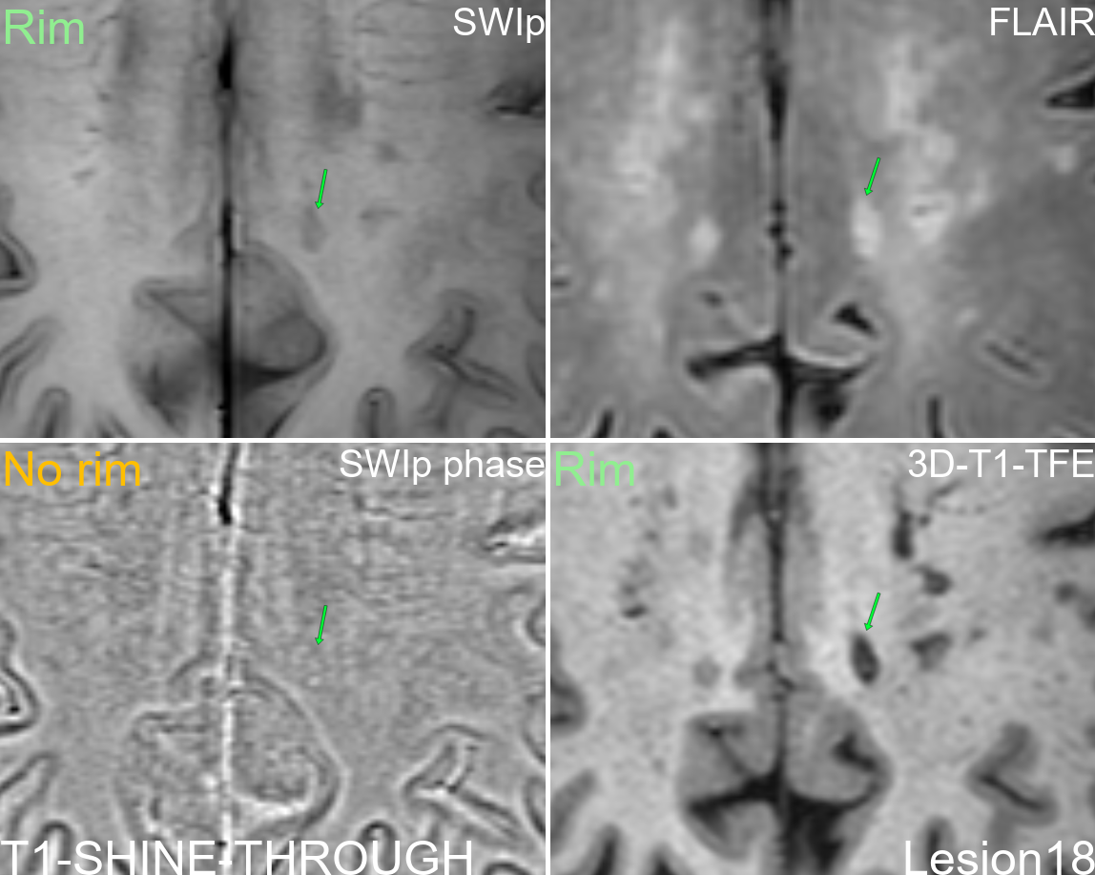
Supplementary figure 18: Multi-modal display of lesion 18.
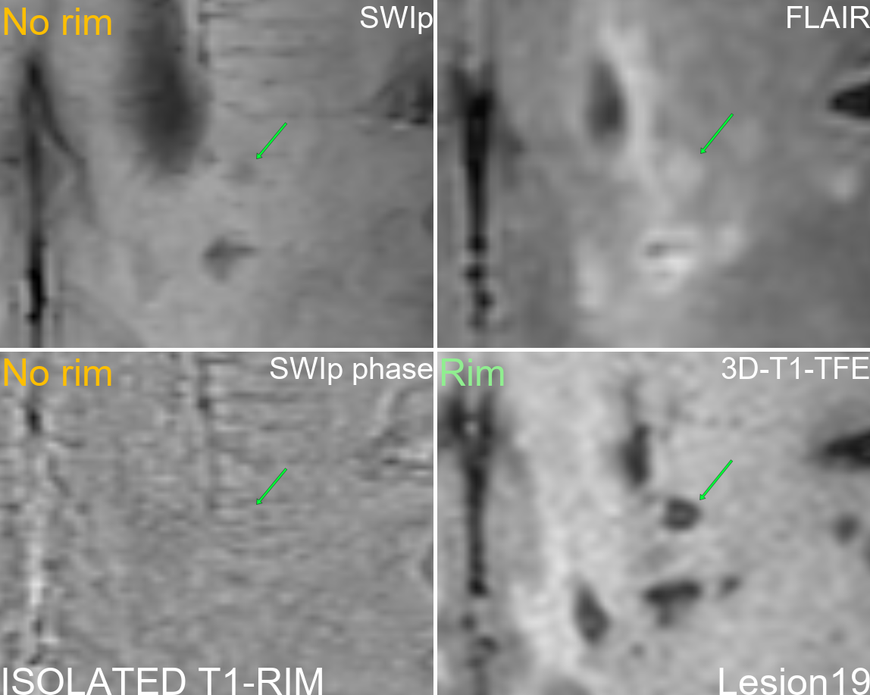
Supplementary figure 19: Multi-modal display of lesion 19.
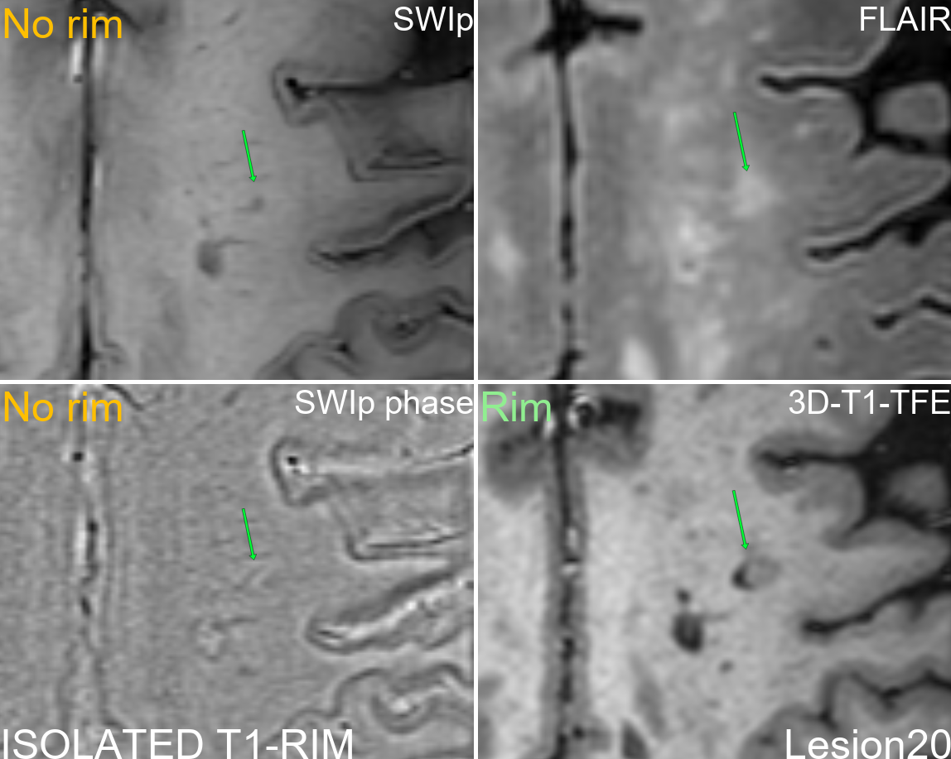
Supplementary figure 20: Multi-modal display of lesion 20.
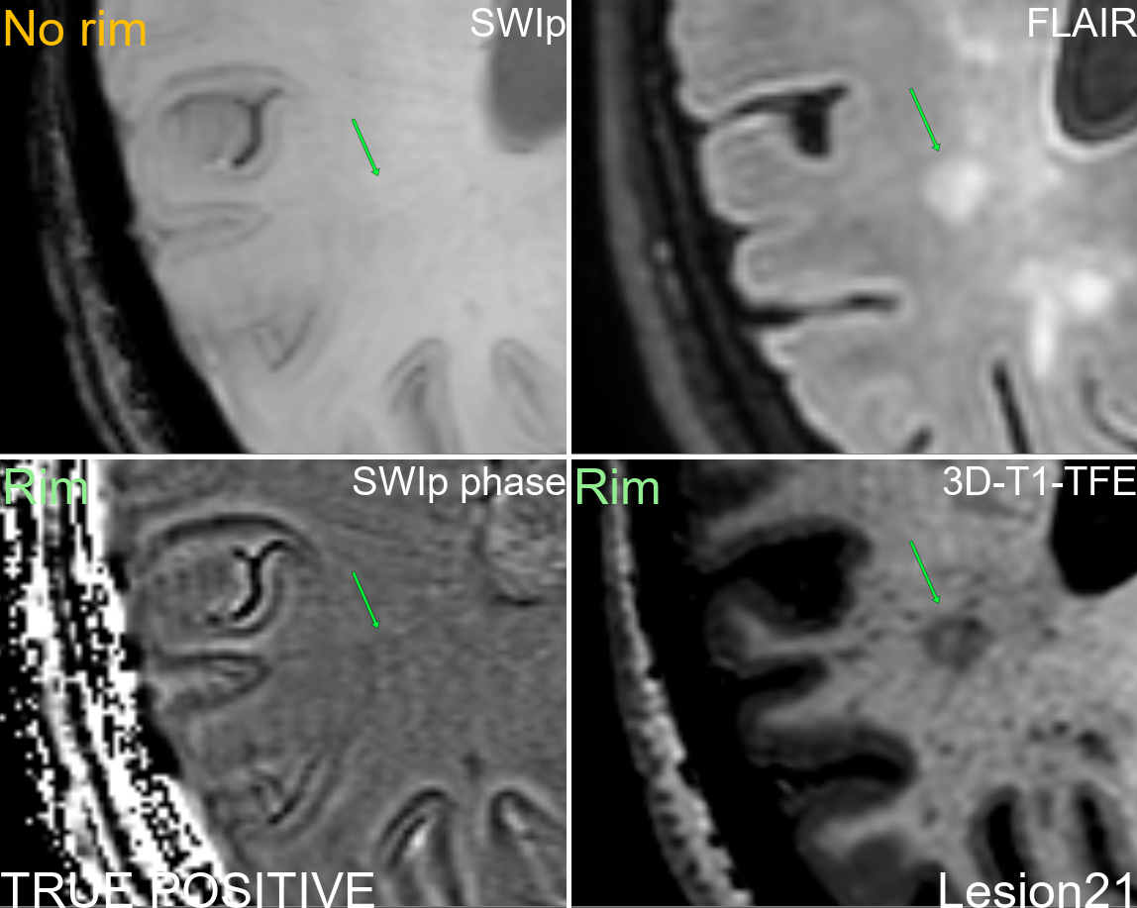
Supplementary figure 21: Multi-modal display of lesion 21.
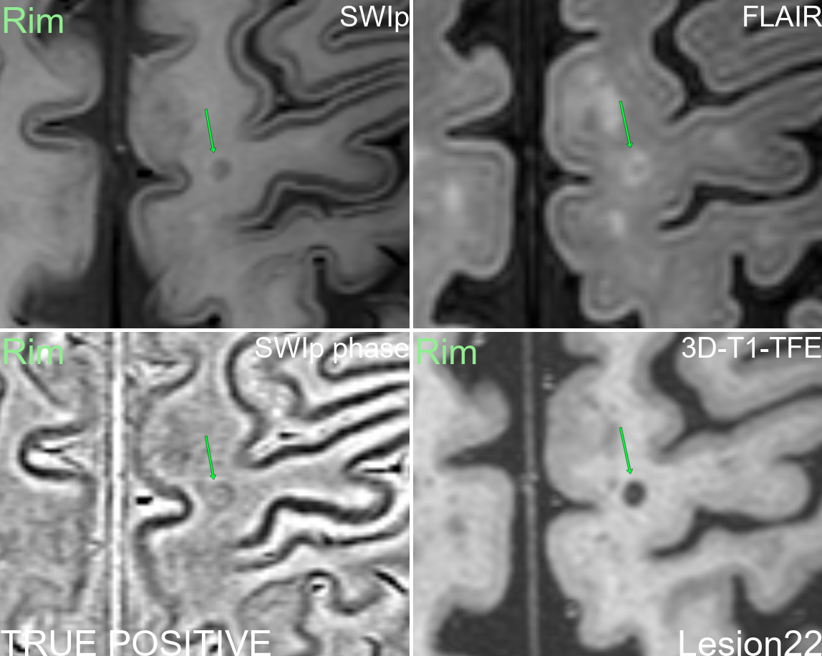
Supplementary figure 22: Multi-modal display of lesion 22.
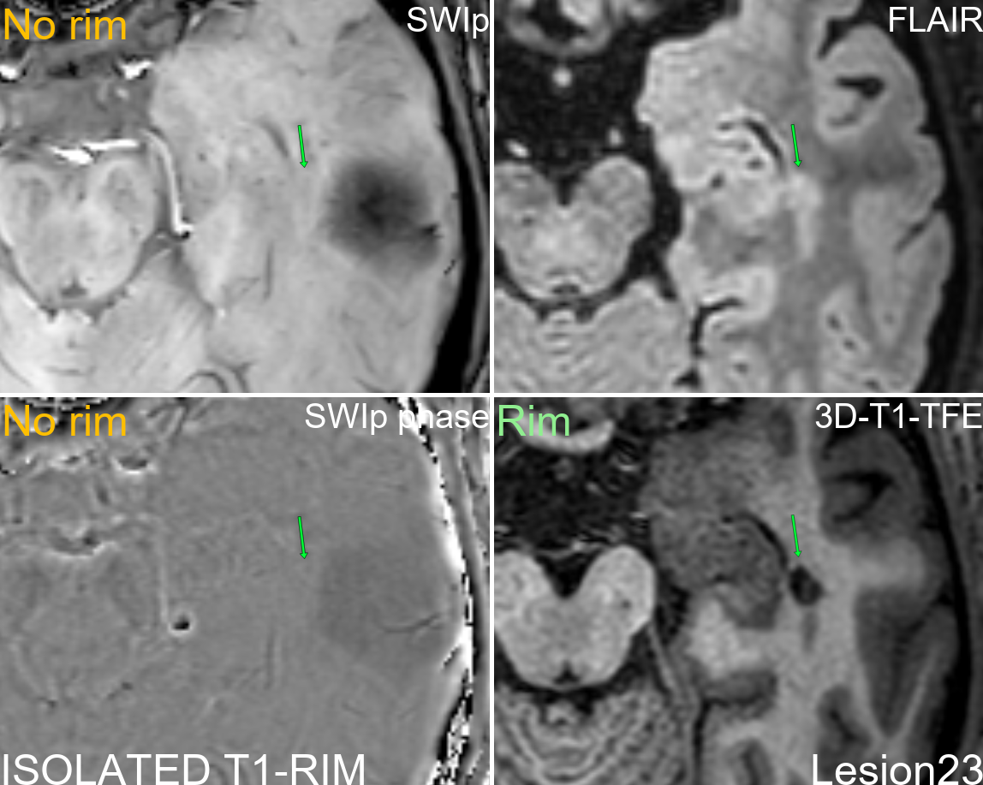
Supplementary figure 23: Multi-modal display of lesion 23.
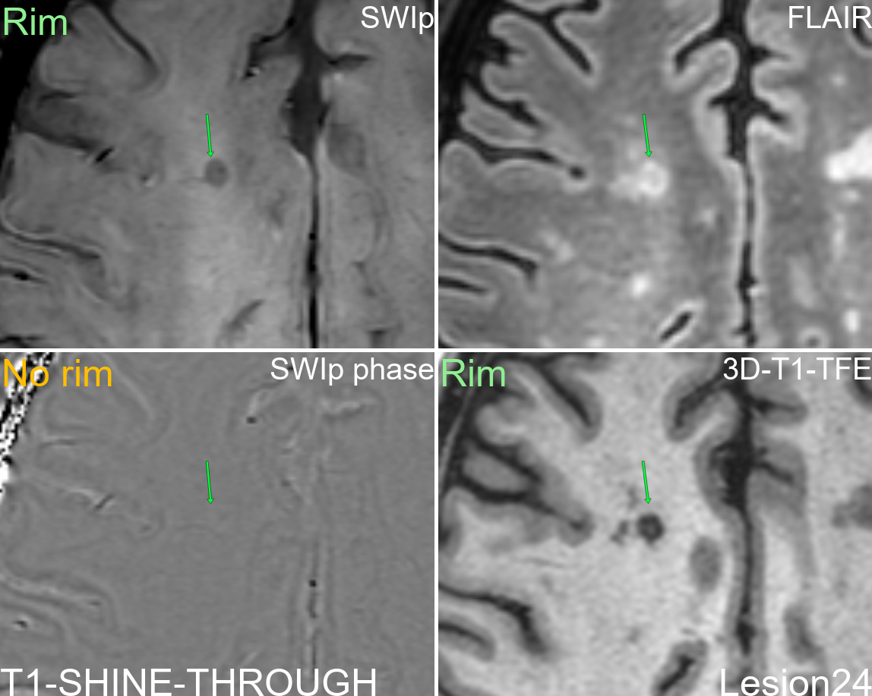
Supplementary figure 24: Multi-modal display of lesion 24.
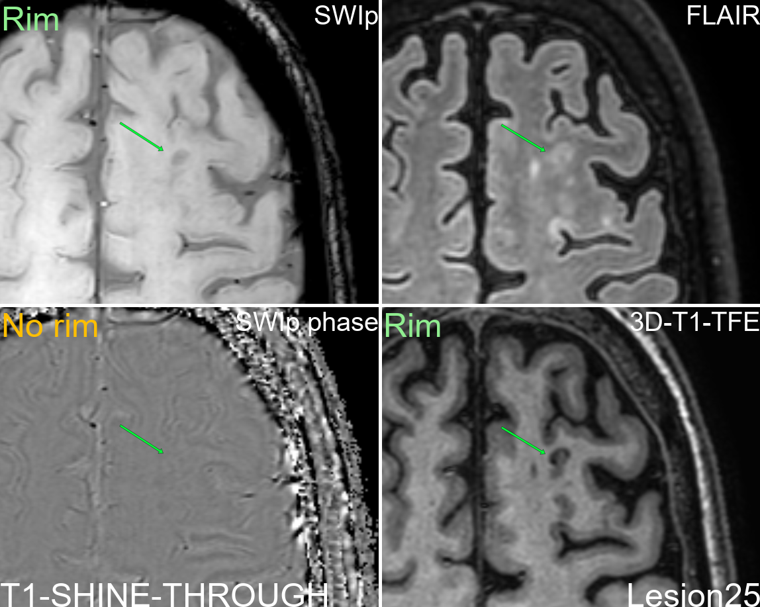
Supplementary figure 25: Multi-modal display of lesion 25.
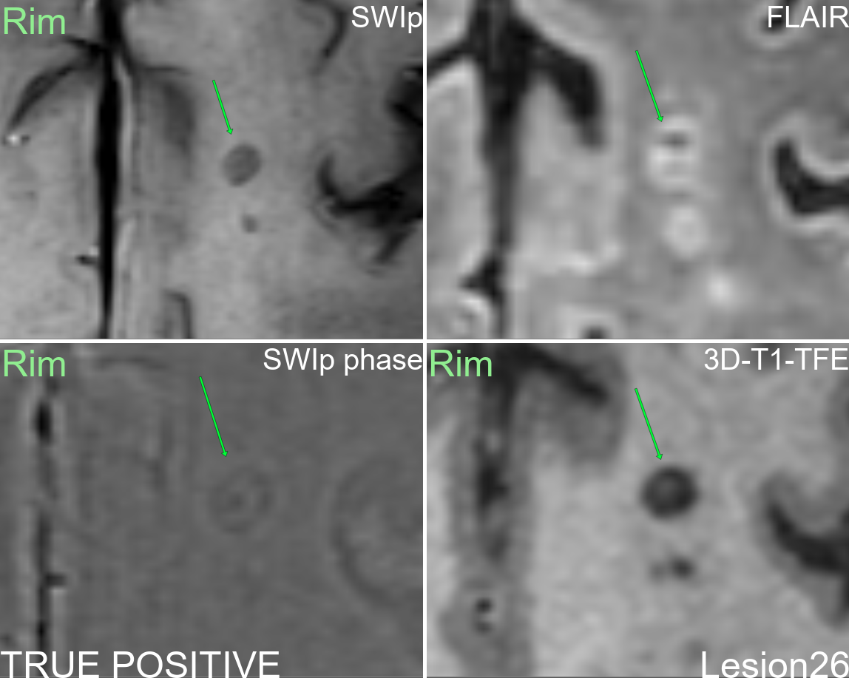
Supplementary figure 26: Multi-modal display of lesion 26.
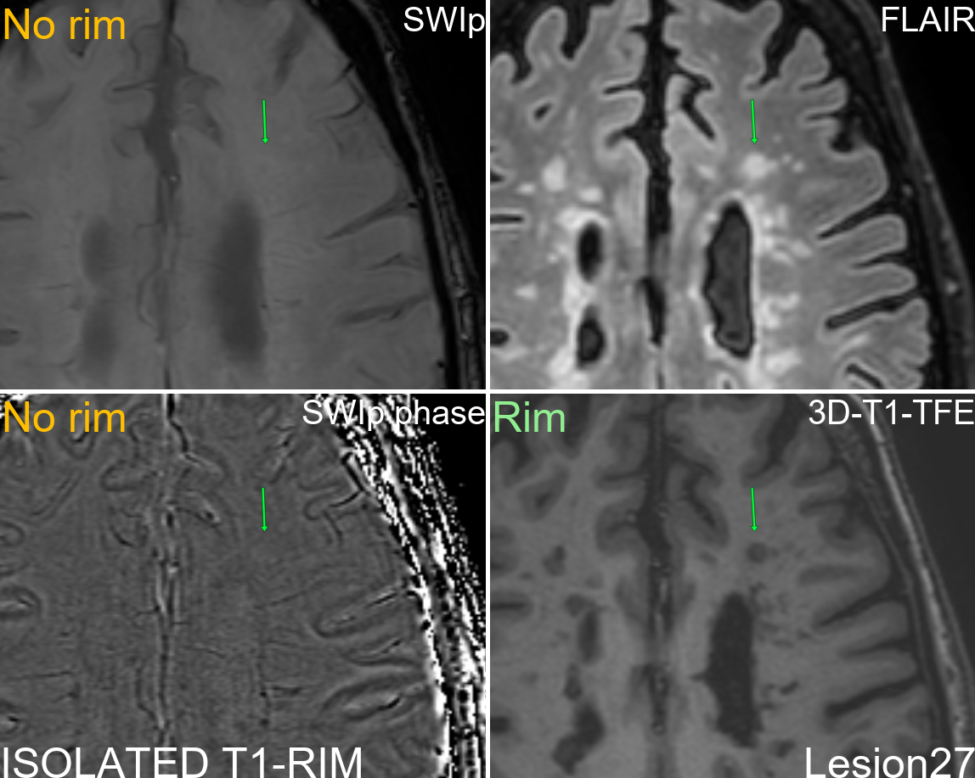
Supplementary figure 27: Multi-modal display of lesion 27.
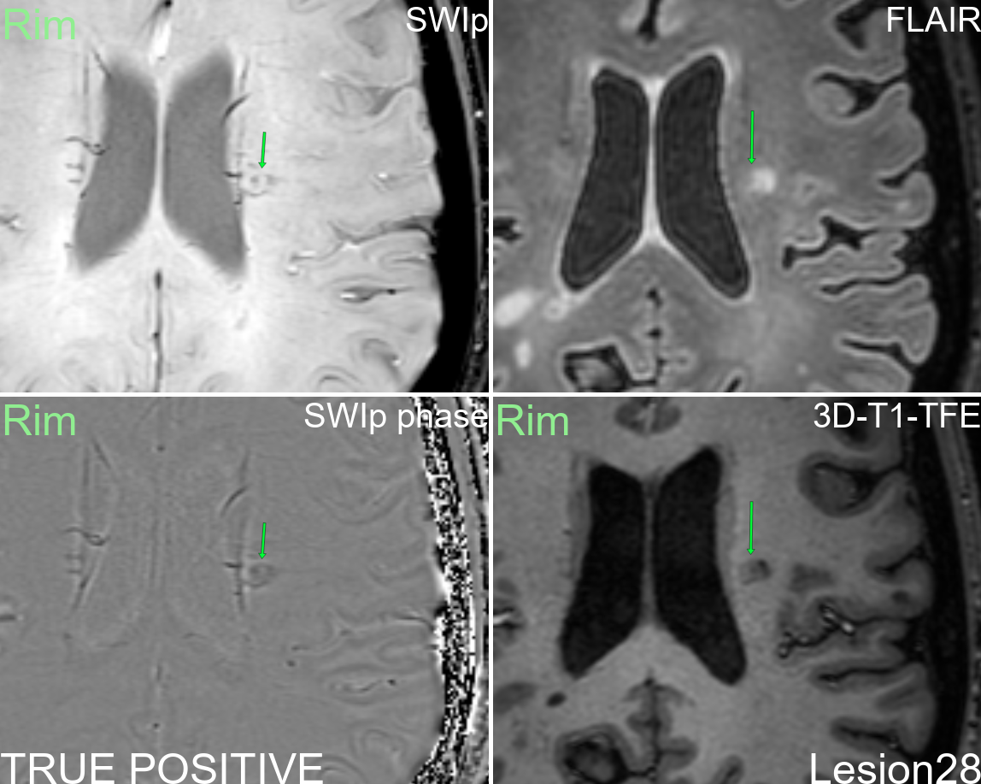
Supplementary figure 28: Multi-modal display of lesion 28.
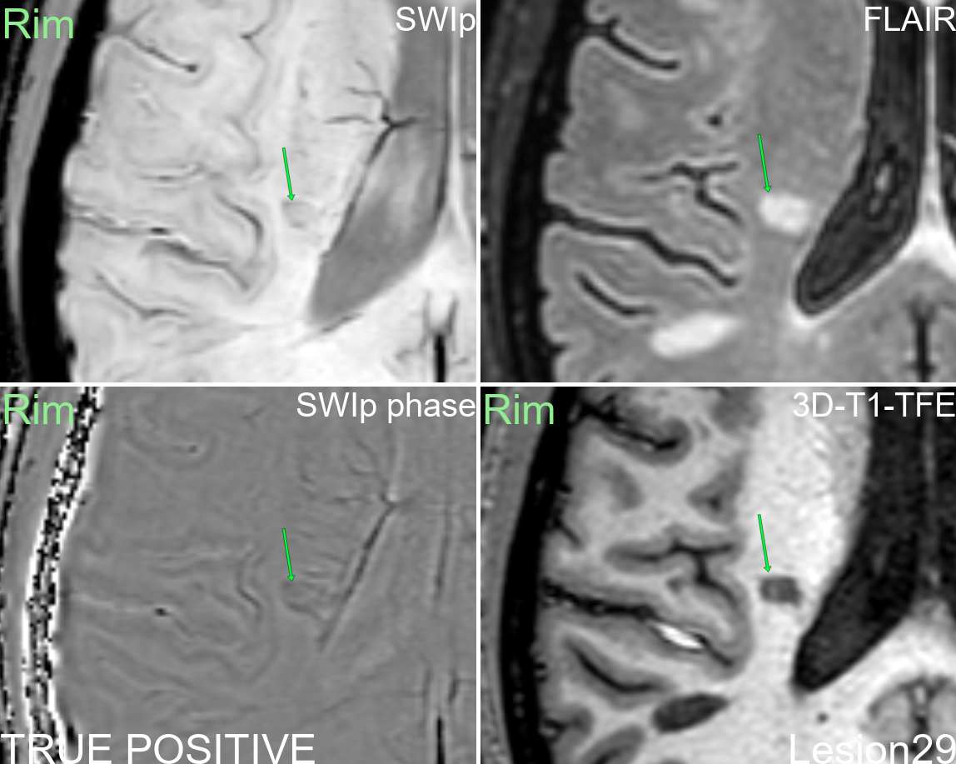
Supplementary figure 29: Multi-modal display of lesion 29.
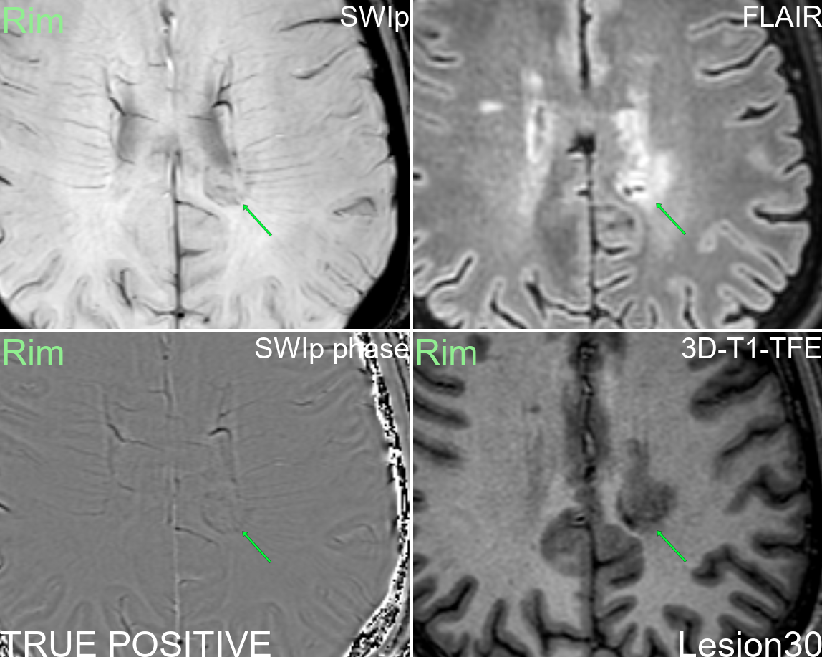
Supplementary figure 30: Multi-modal display of lesion 30.
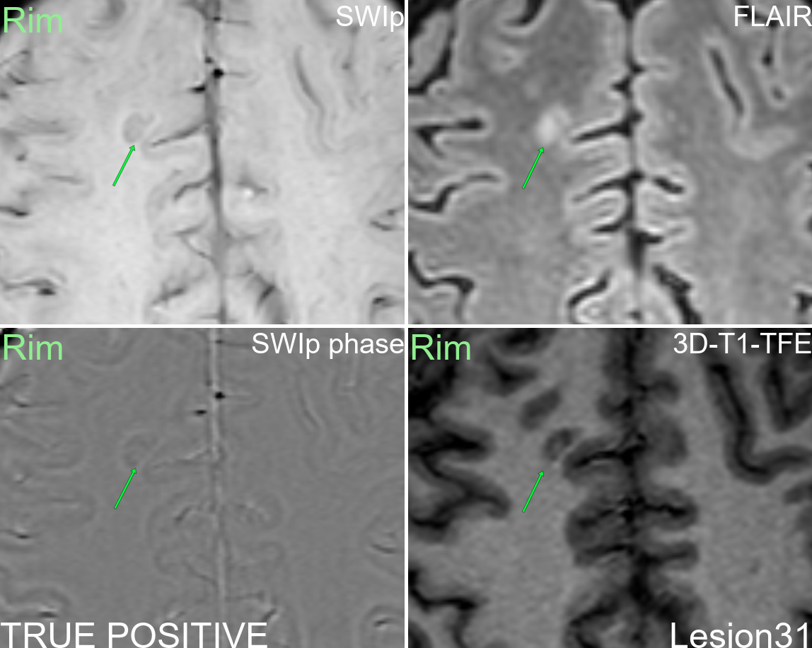
Supplementary figure 31: Multi-modal display of lesion 31.
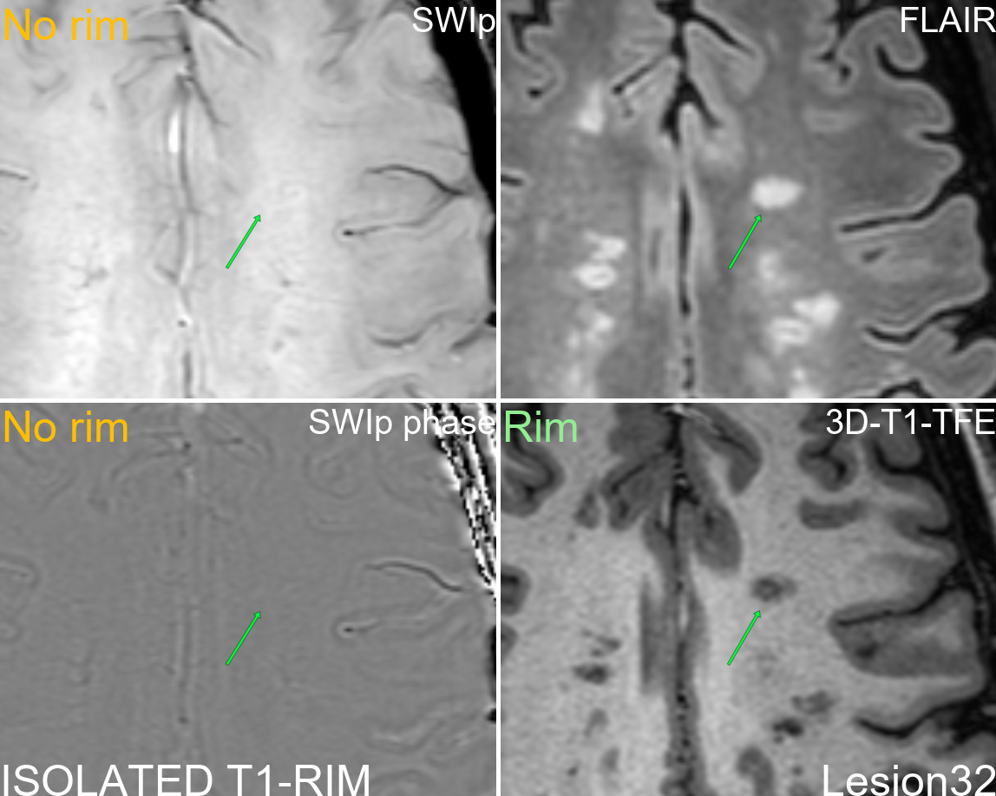
Supplementary figure 32: Multi-modal display of lesion 32.
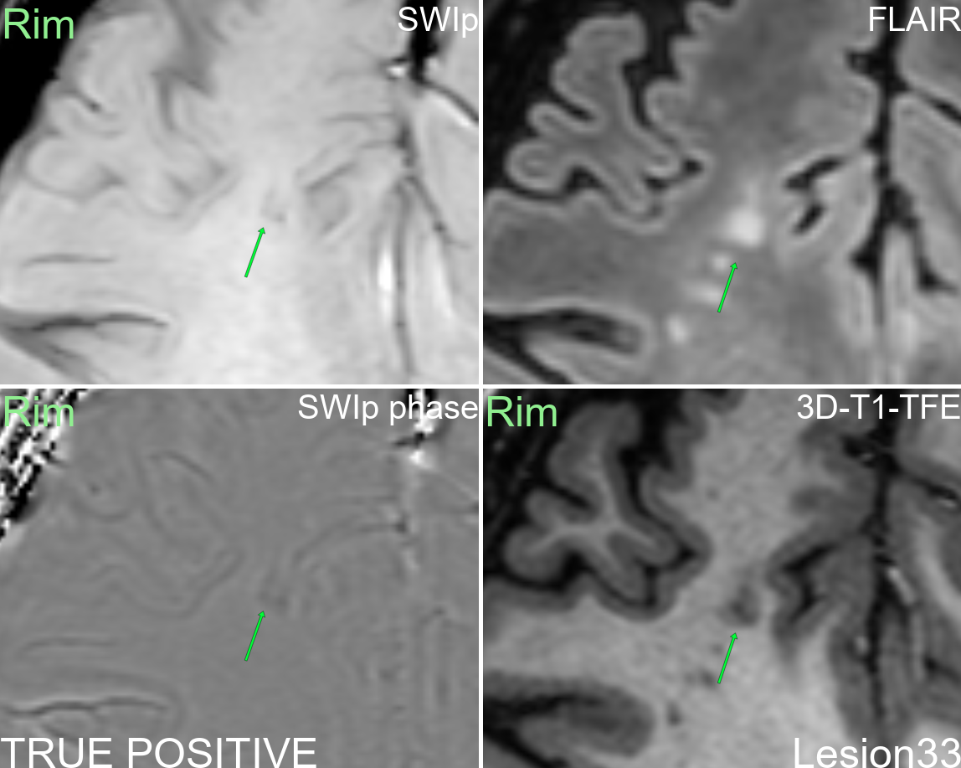
Supplementary figure 33: Multi-modal display of lesion 33.
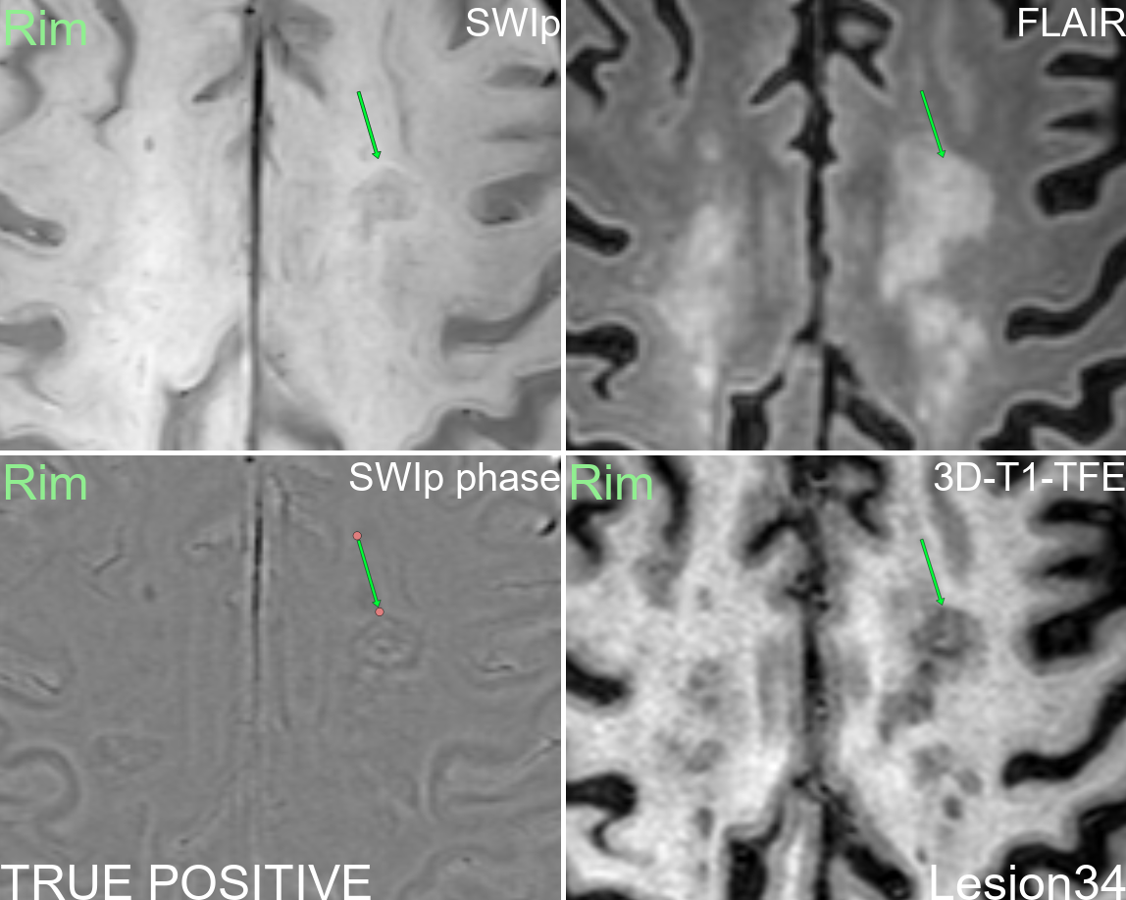
Supplementary figure 34: Multi-modal display of lesion 34.
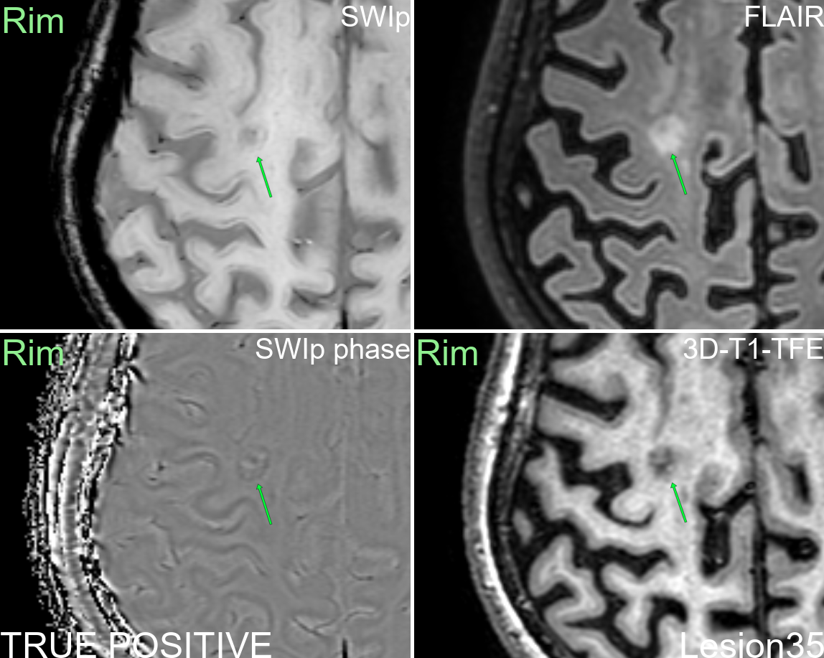
Supplementary figure 35: Multi-modal display of lesion 35.
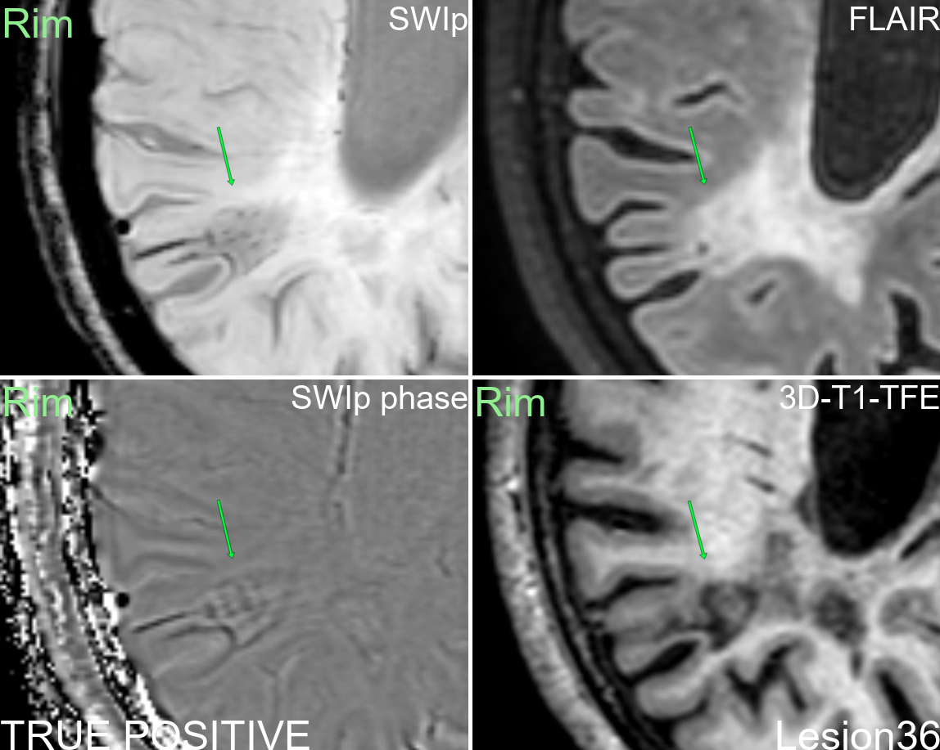
Supplementary figure 36: Multi-modal display of lesion 36.
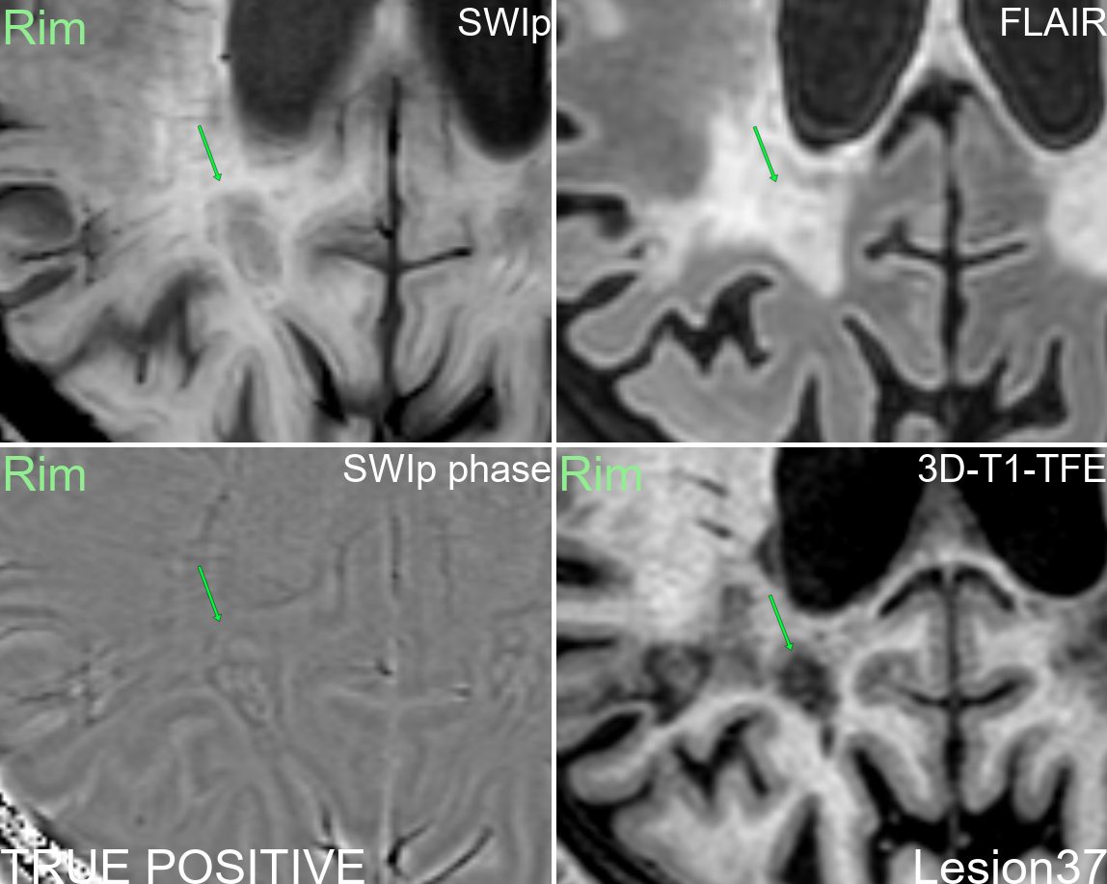
Supplementary figure 37: Multi-modal display of lesion 37.
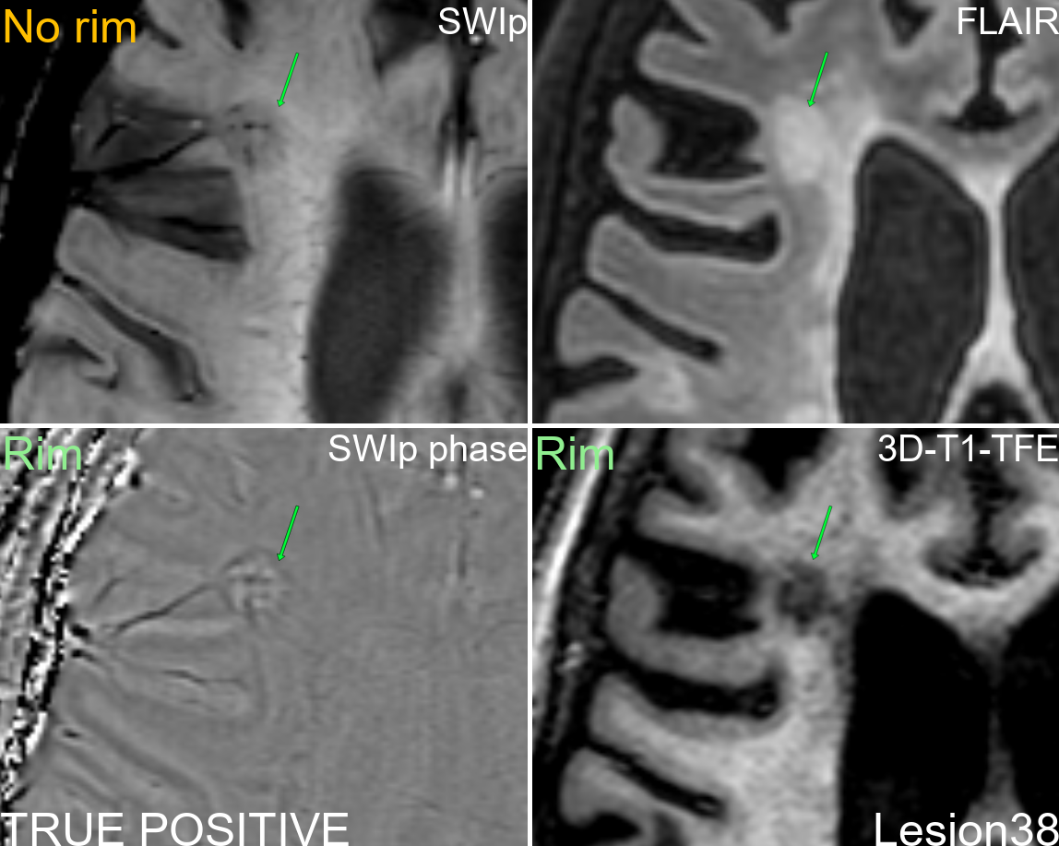
Supplementary figure 38: Multi-modal display of lesion 38.
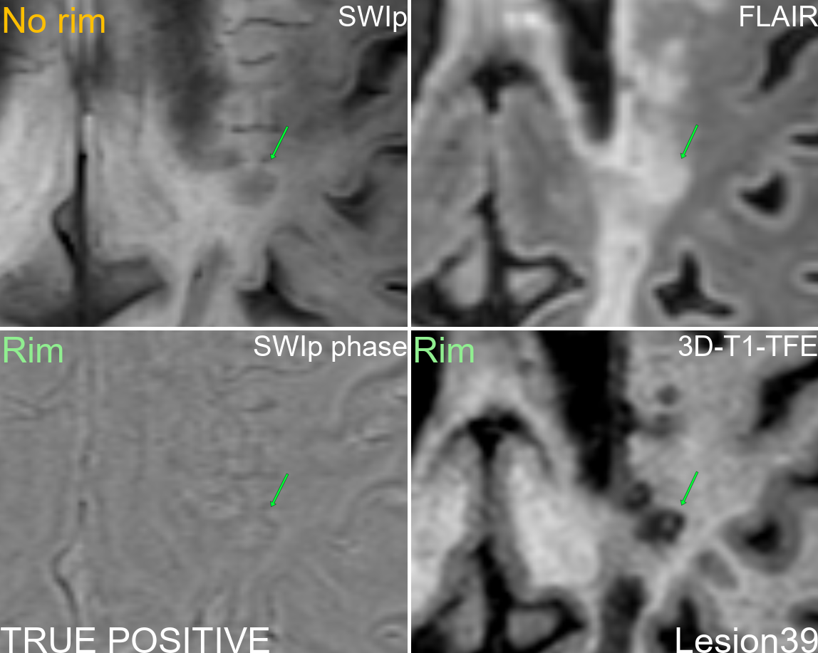
Supplementary figure 39: Multi-modal display of lesion 39.
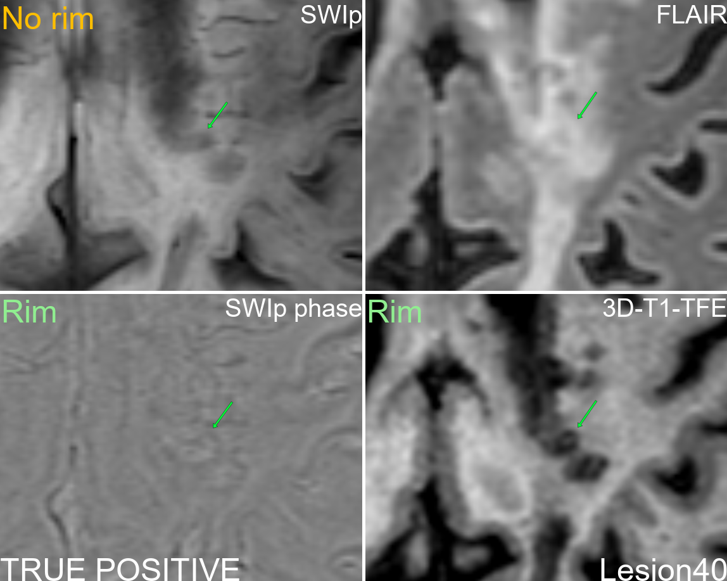
Supplementary figure 40: Multi-modal display of lesion 40.
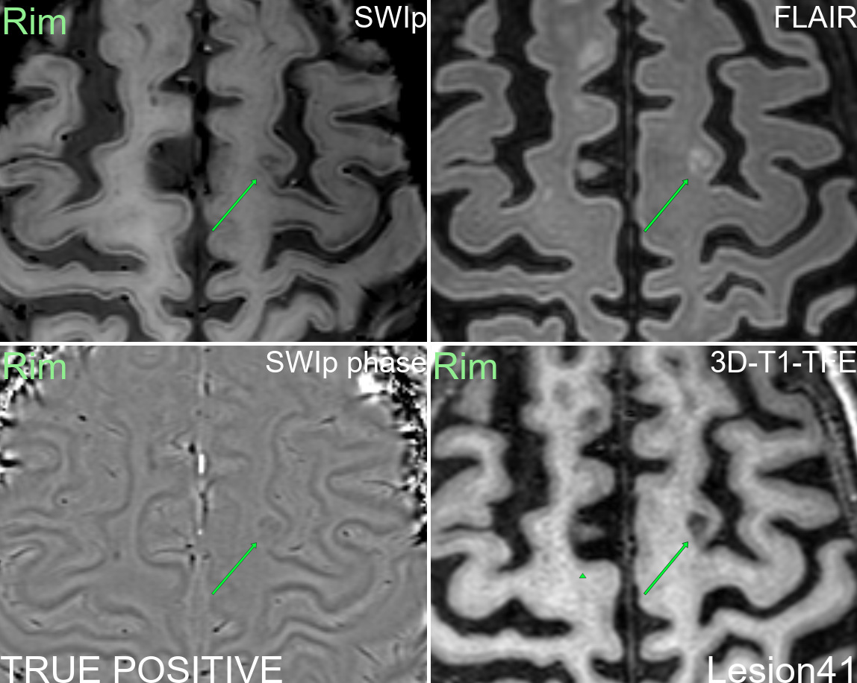
Supplementary figure 41: Multi-modal display of lesion 41.
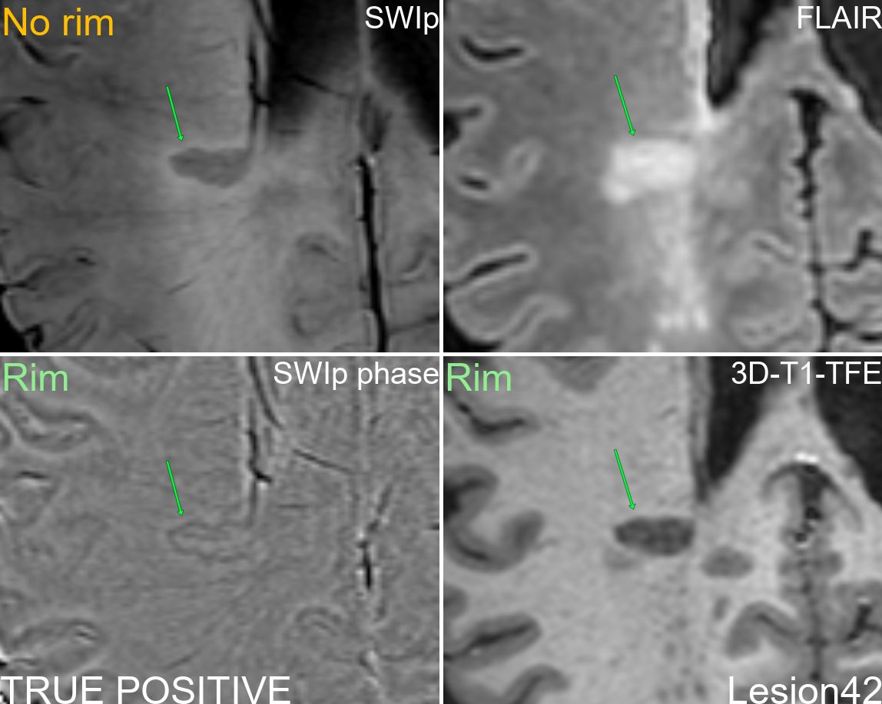
Supplementary figure 42: Multi-modal display of lesion 42.
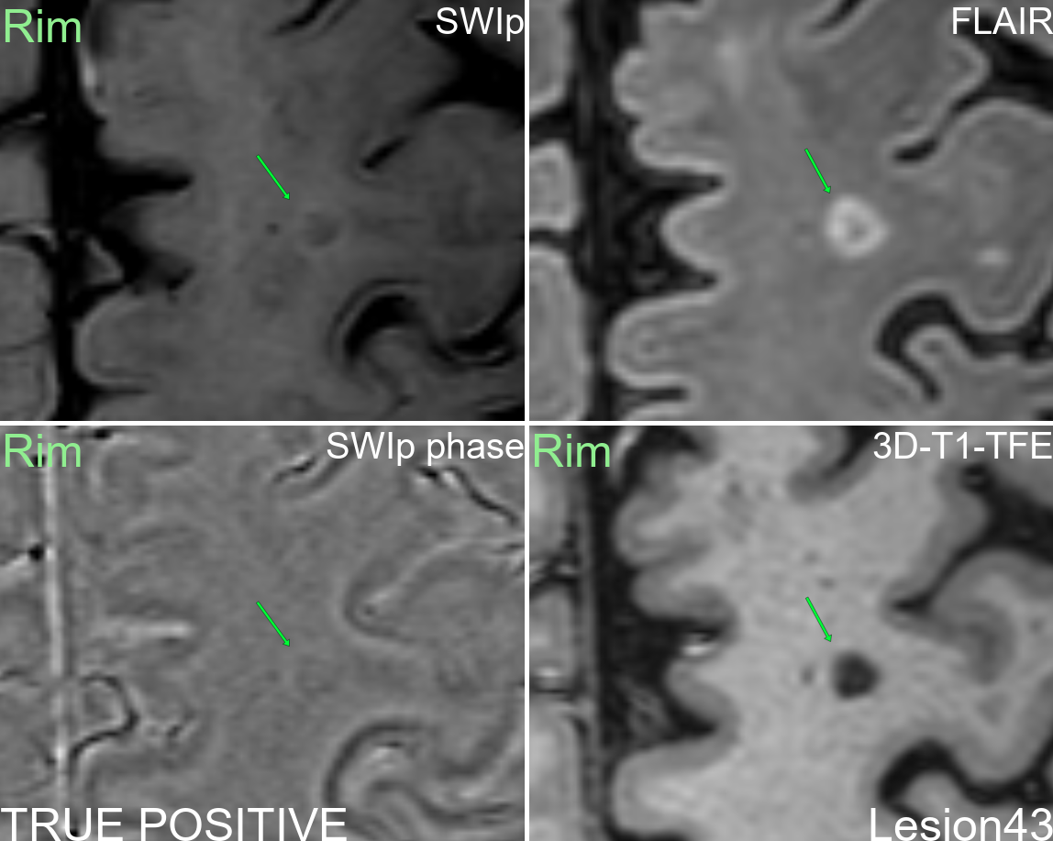
Supplementary figure 43: Multi-modal display of lesion 43.
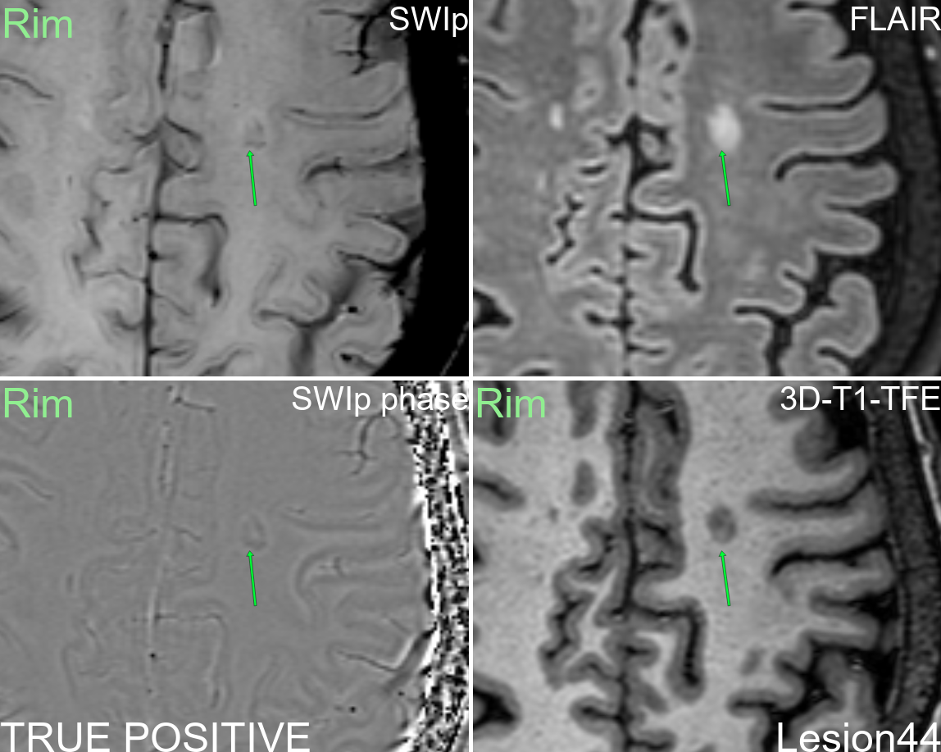
Supplementary figure 44: Multi-modal display of lesion 44.
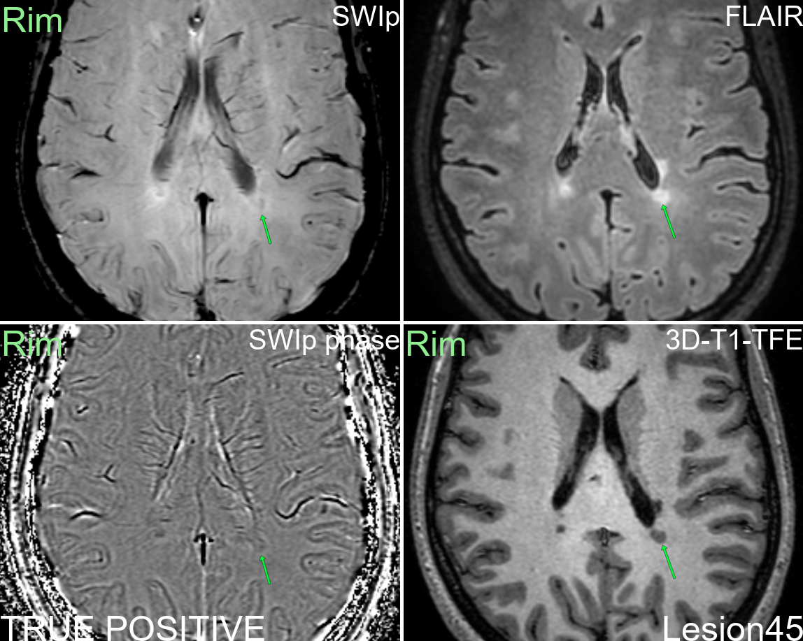
Supplementary figure 45: Multi-modal display of lesion 45.
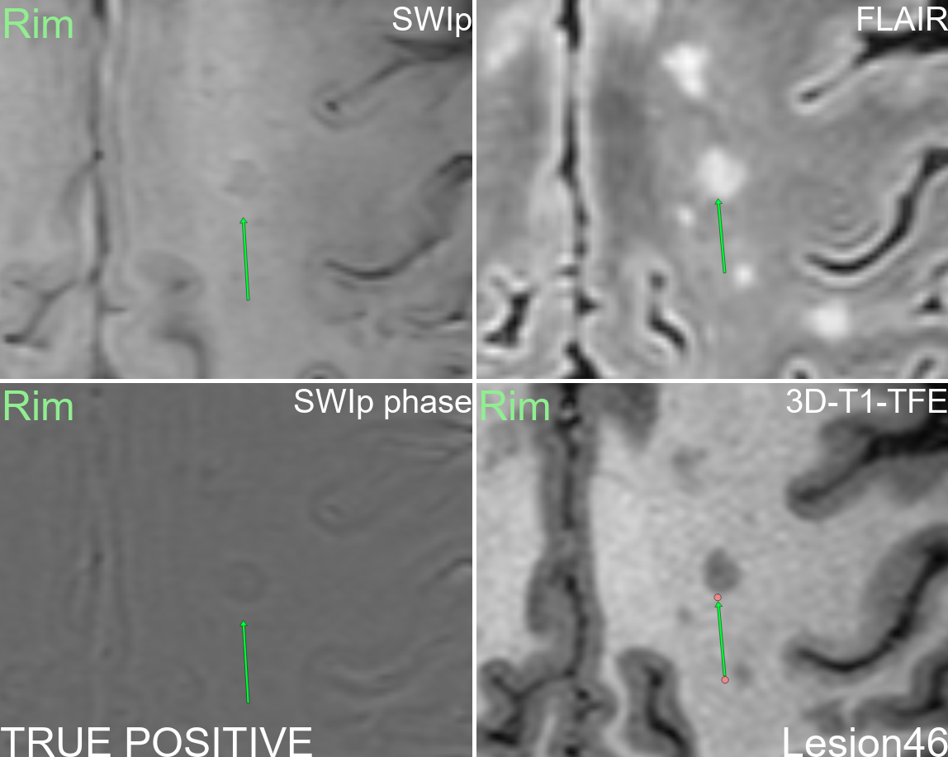
Supplementary figure 46: Multi-modal display of lesion 46.
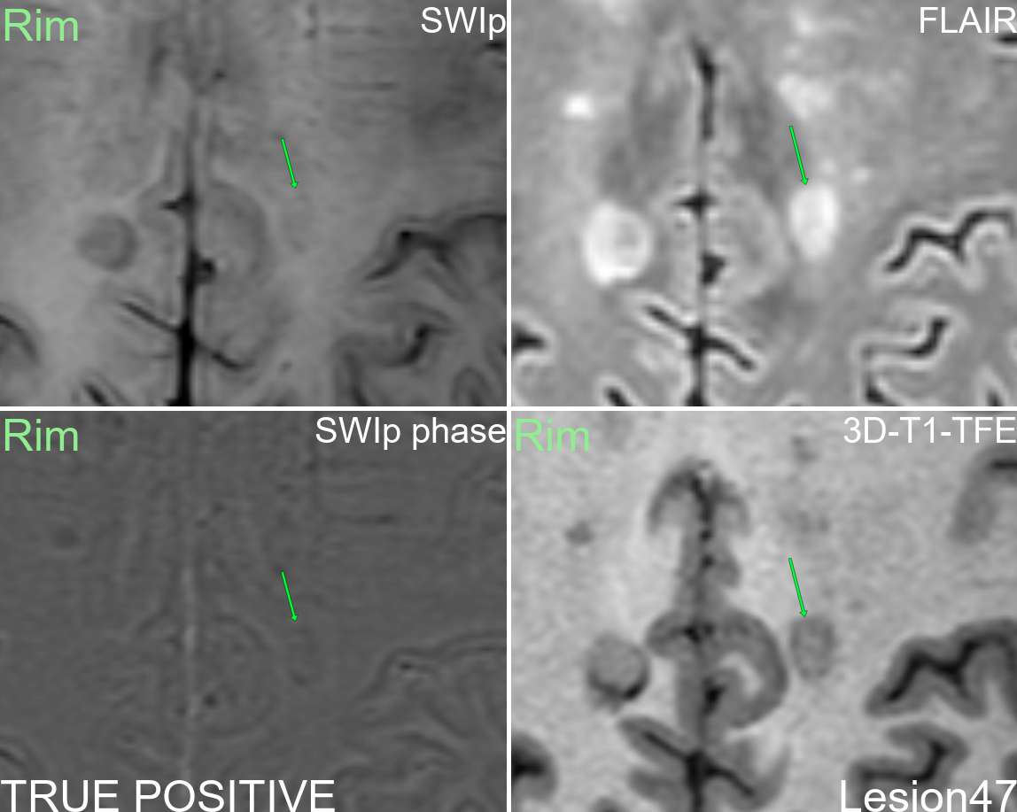
Supplementary figure 47: Multi-modal display of lesion 47.
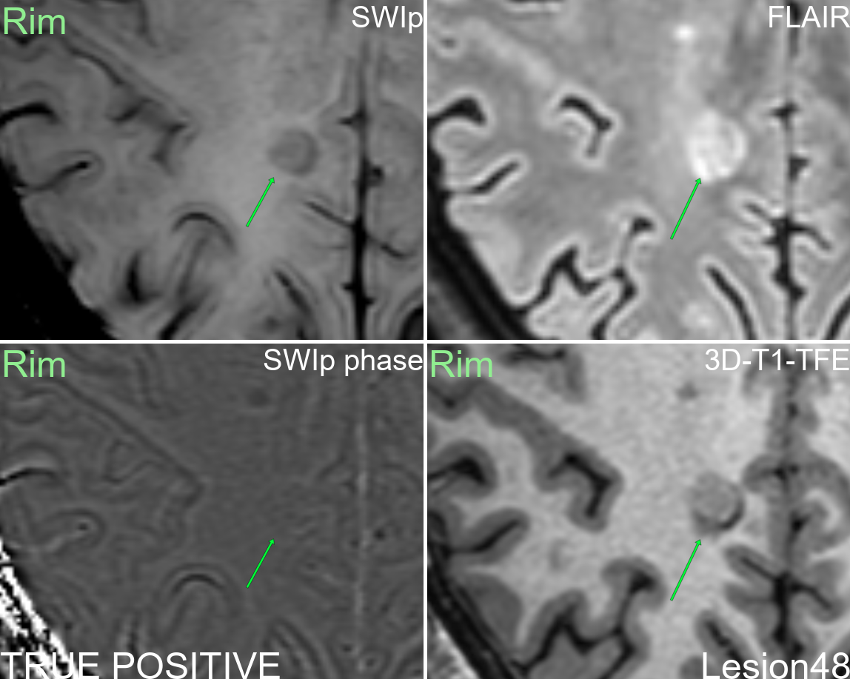
Supplementary figure 48: Multi-modal display of lesion 48.
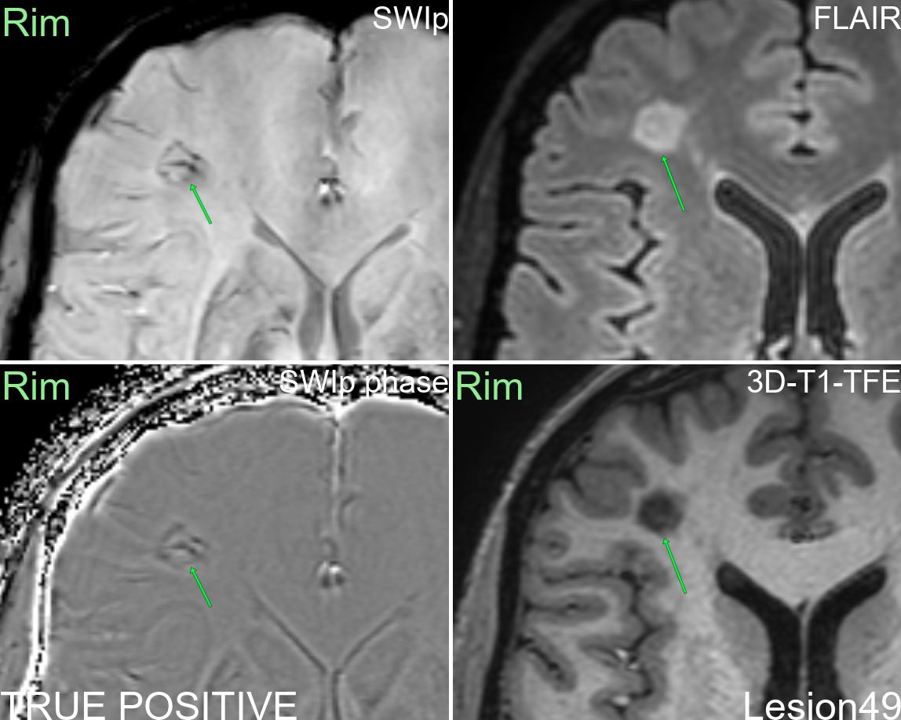
Supplementary figure 49: Multi-modal display of lesion 49.
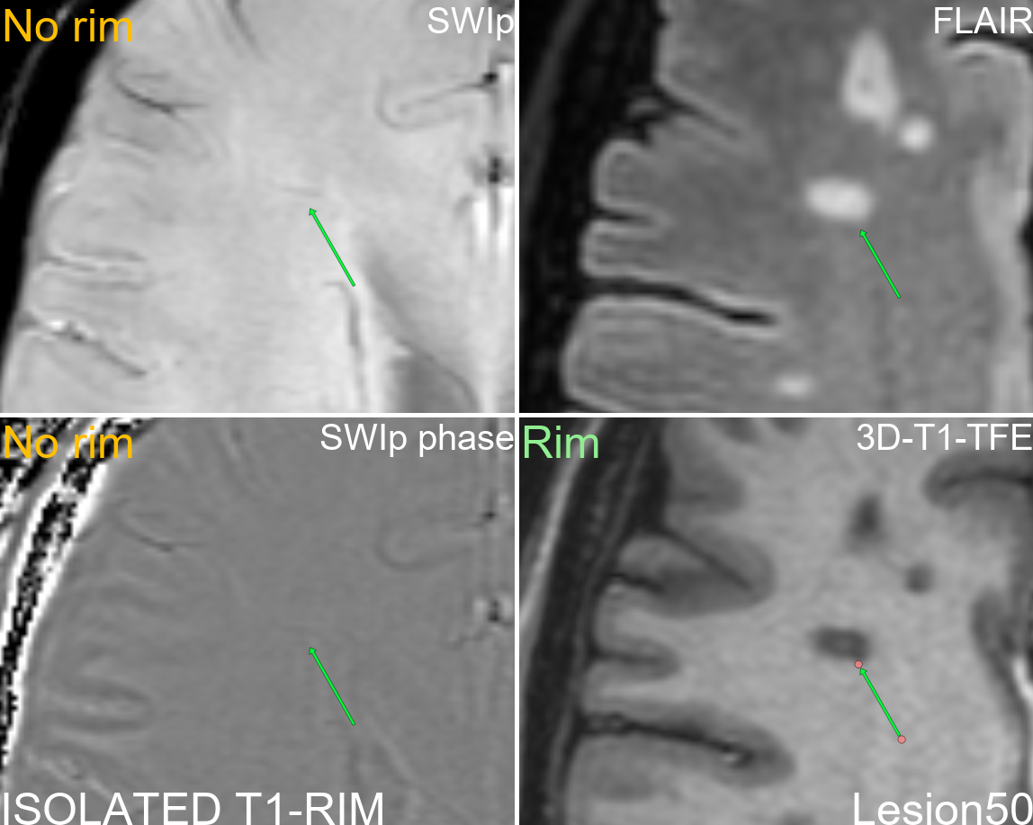
Supplementary figure 50: Multi-modal display of lesion 50.
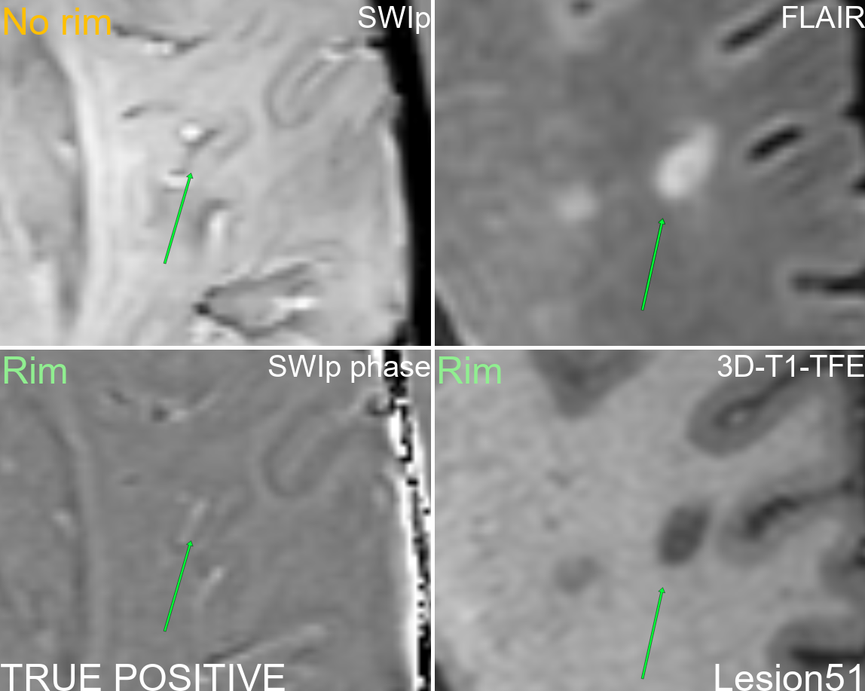
Supplementary figure 51: Multi-modal display of lesion 51.
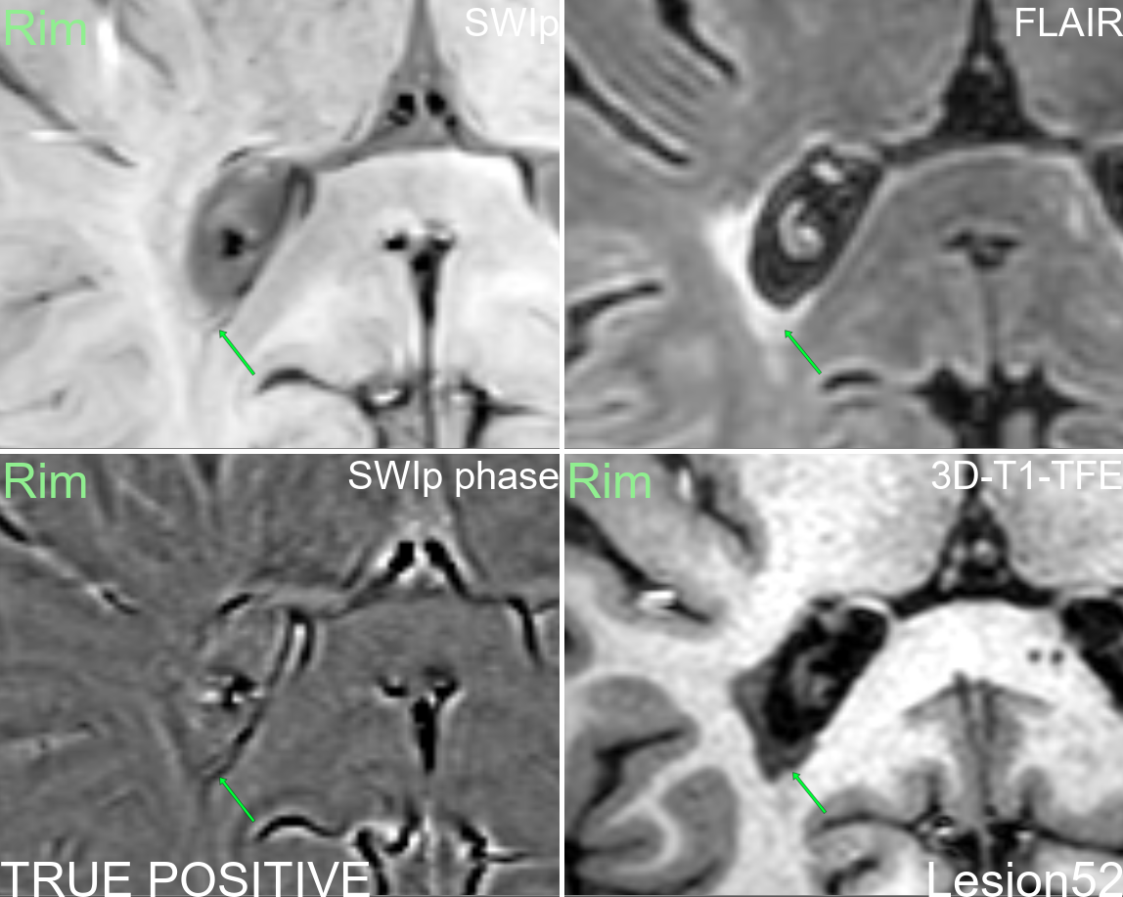
Supplementary figure 52: Multi-modal display of lesion 52.
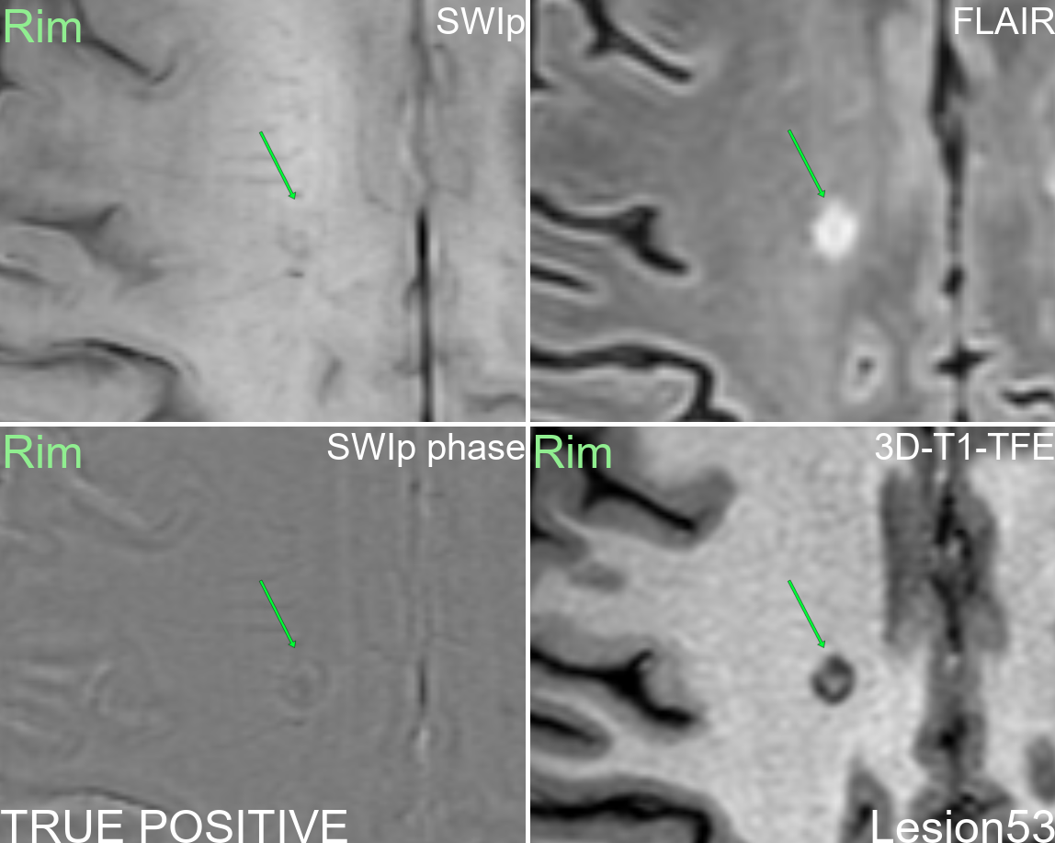
Supplementary figure 53: Multi-modal display of lesion 53.
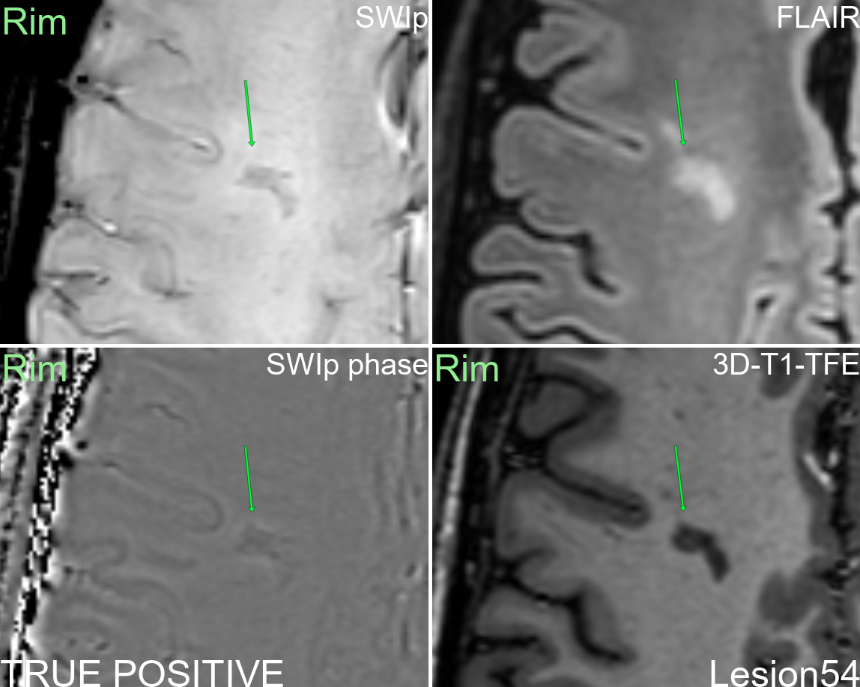
Supplementary figure 54: Multi-modal display of lesion 54.
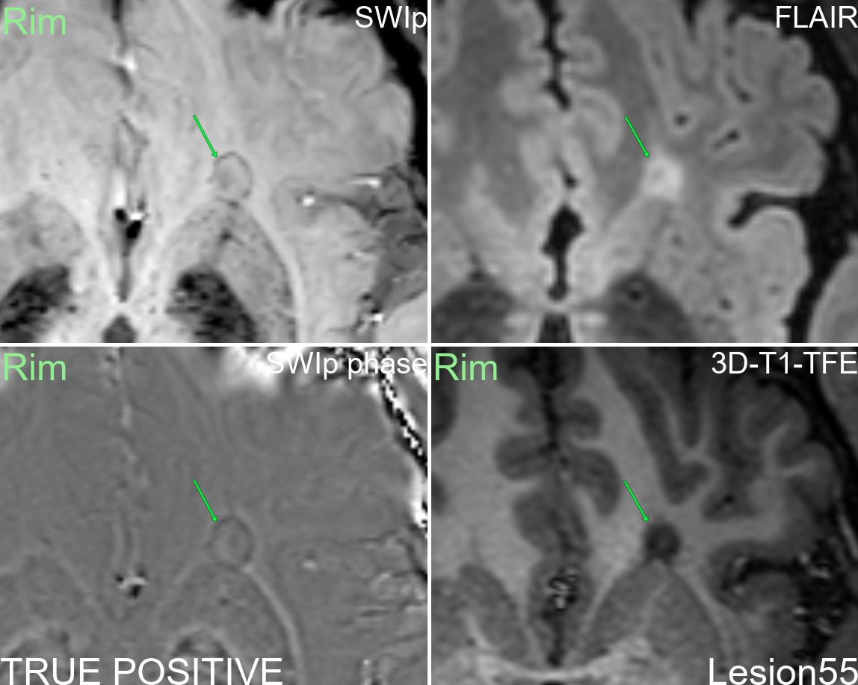
Supplementary figure 55: Multi-modal display of lesion 55.
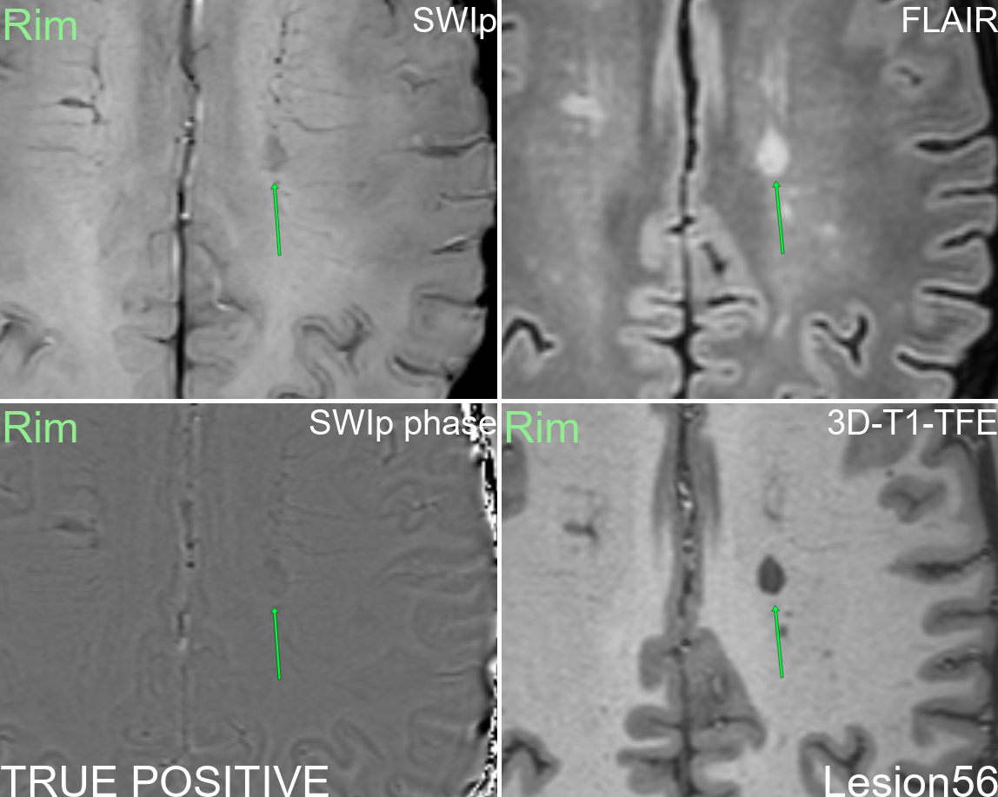
Supplementary figure 56: Multi-modal display of lesion 56.
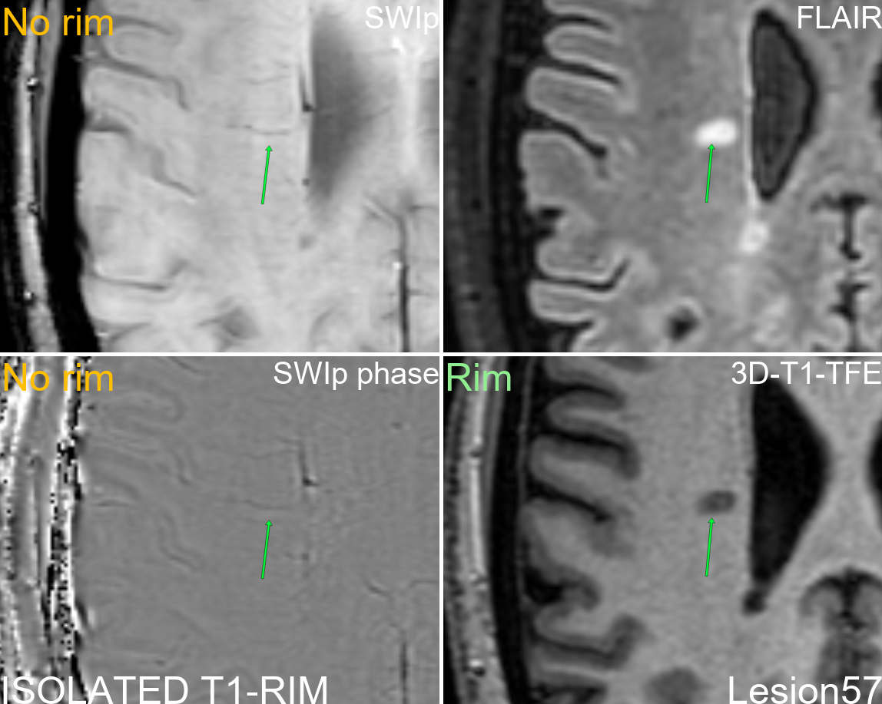
Supplementary figure 57: Multi-modal display of lesion 57.
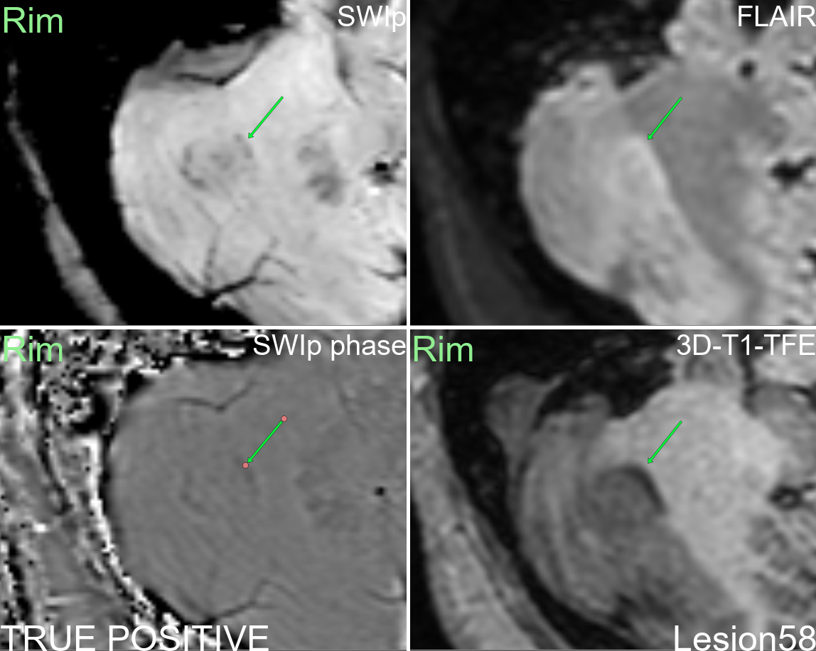
Supplementary figure 58: Multi-modal display of lesion 58.
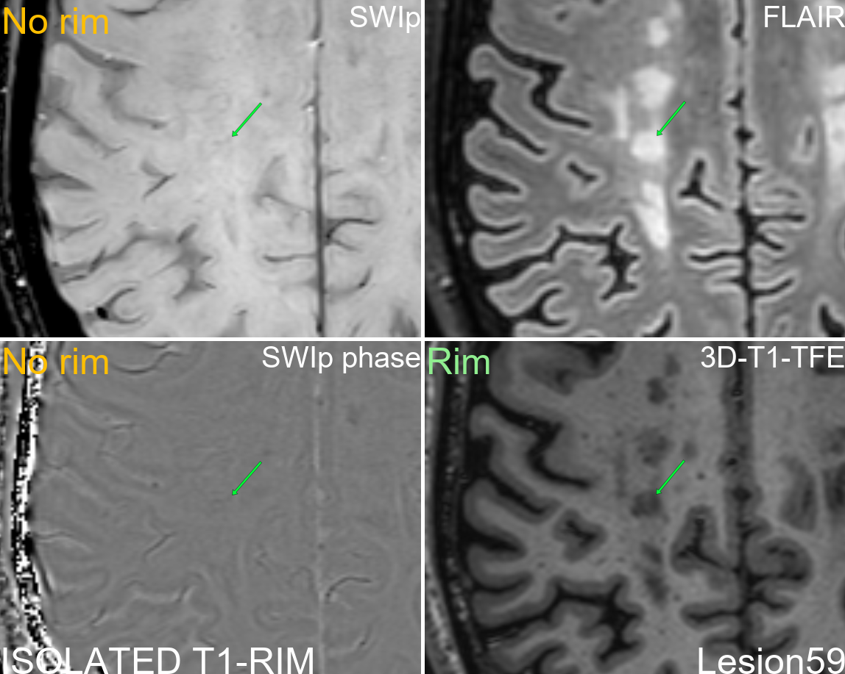
Supplementary figure 59: Multi-modal display of lesion 59.
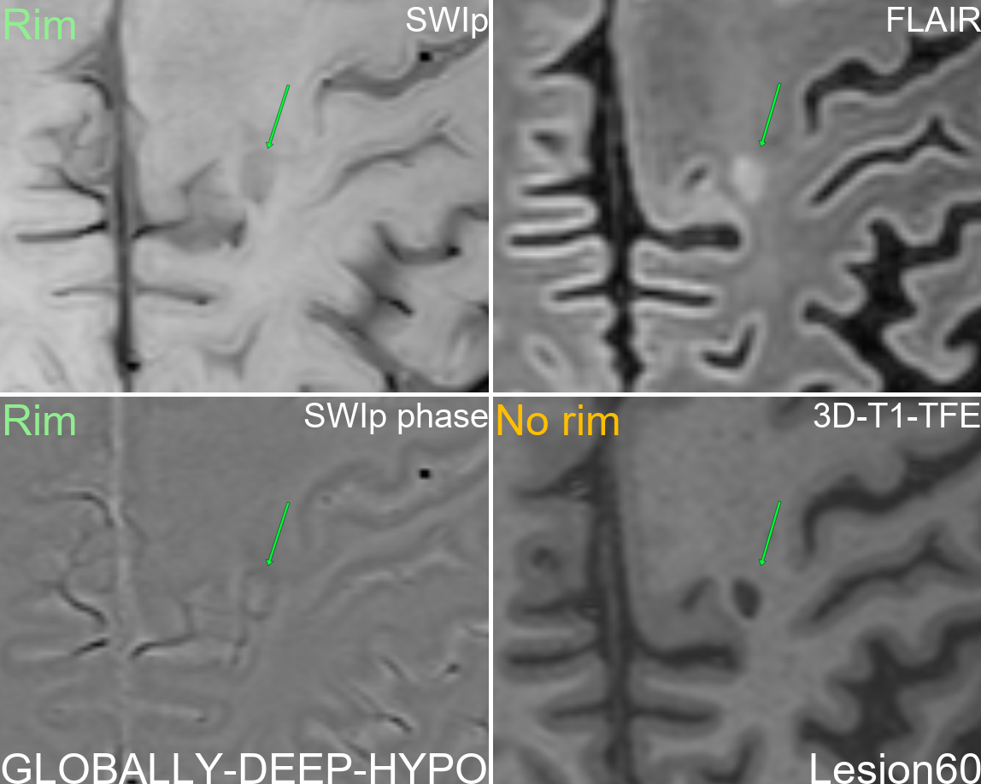
Supplementary figure 60: Multi-modal display of lesion 60.
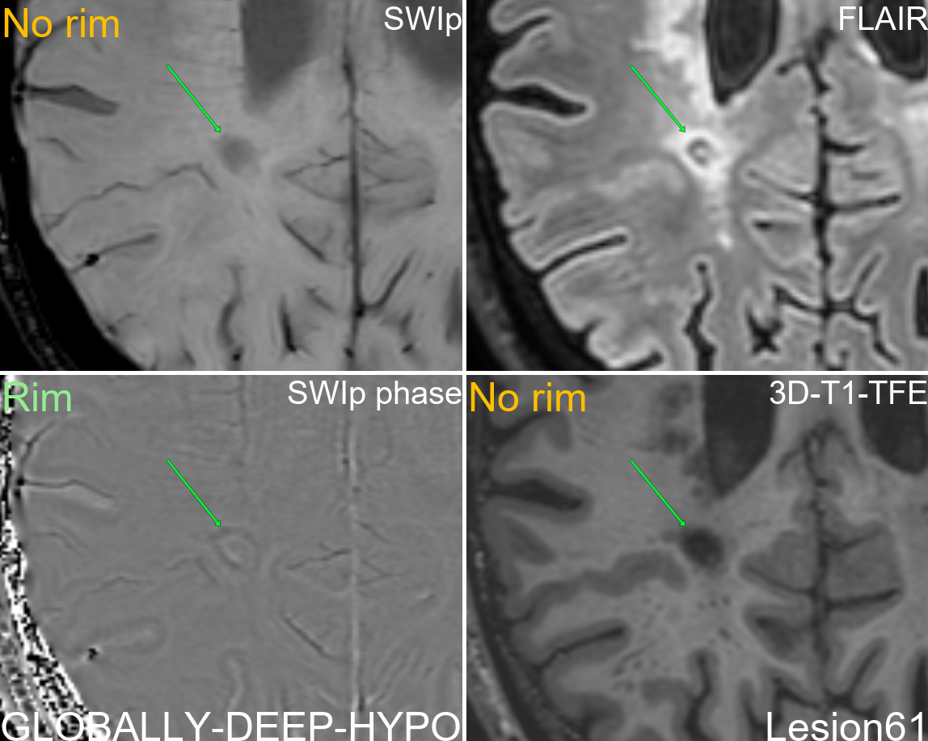
Supplementary figure 61: Multi-modal display of lesion 61.
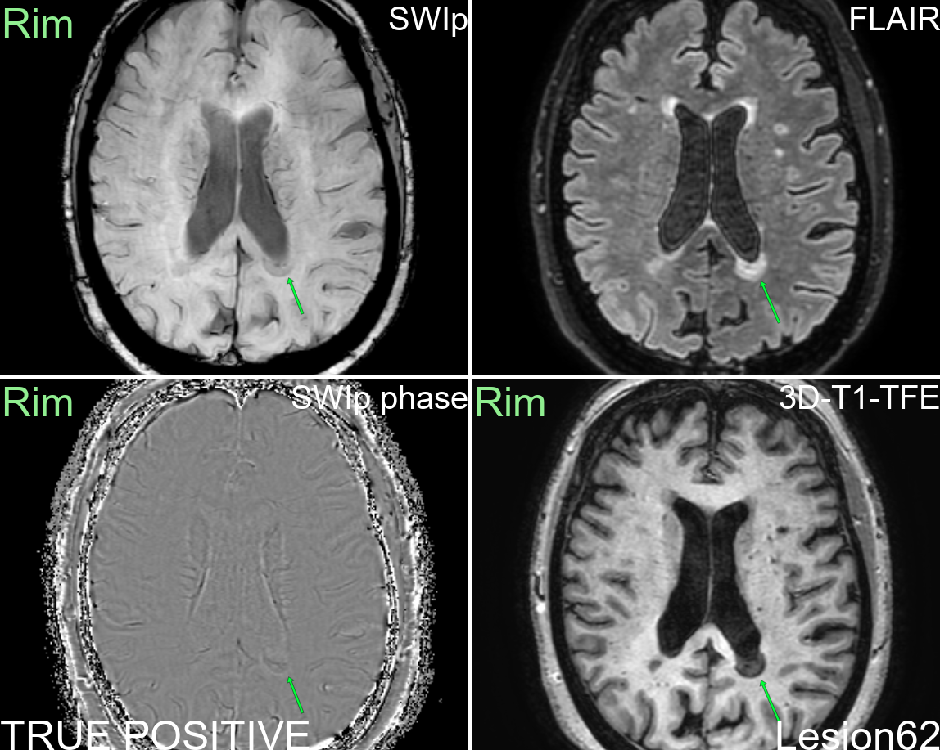
Supplementary figure 62: Multi-modal display of lesion 62.
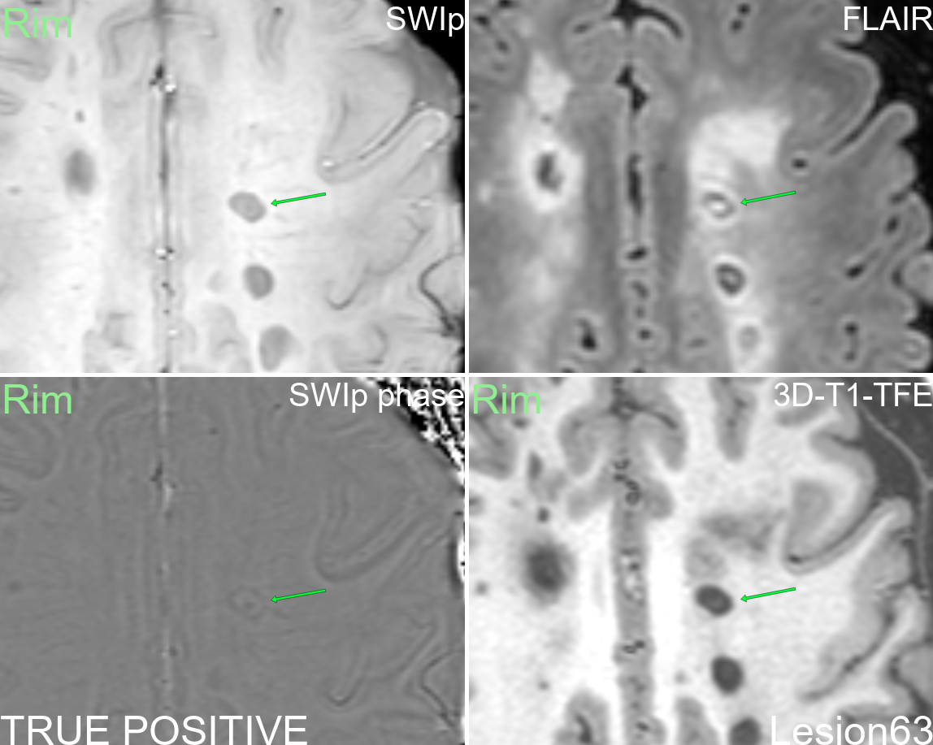
Supplementary figure 63: Multi-modal display of lesion 63.
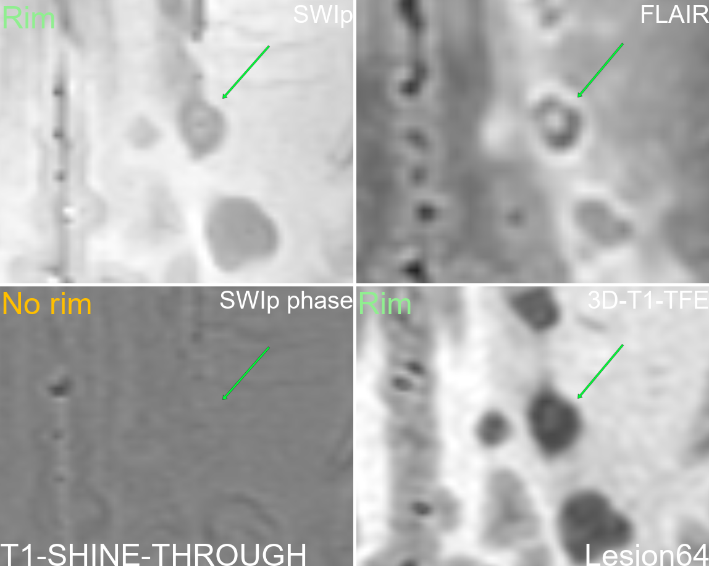
Supplementary figure 64: Multi-modal display of lesion 64.
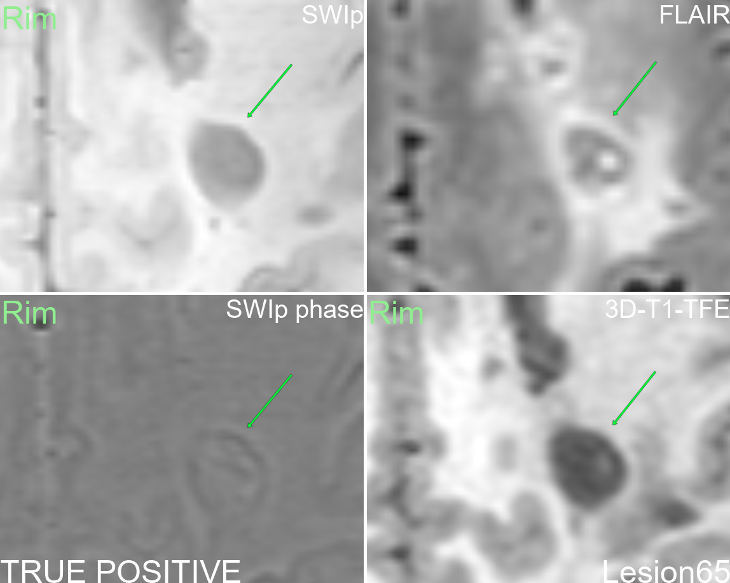
Supplementary figure 65: Multi-modal display of lesion 65.
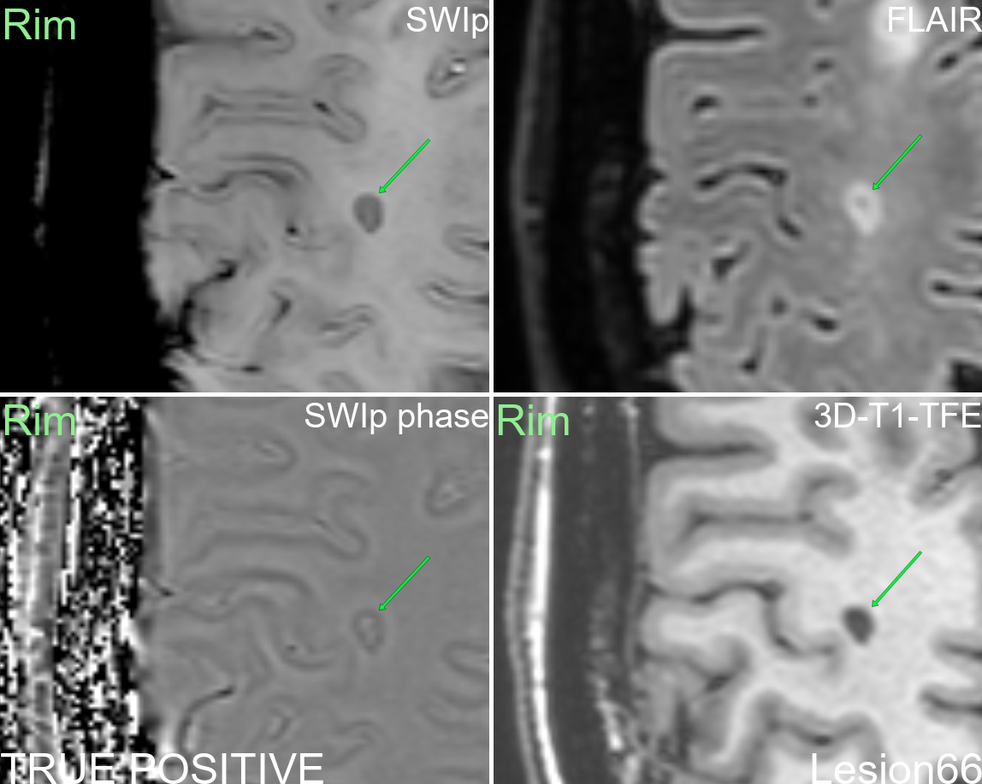
Supplementary figure 66: Multi-modal display of lesion 66.
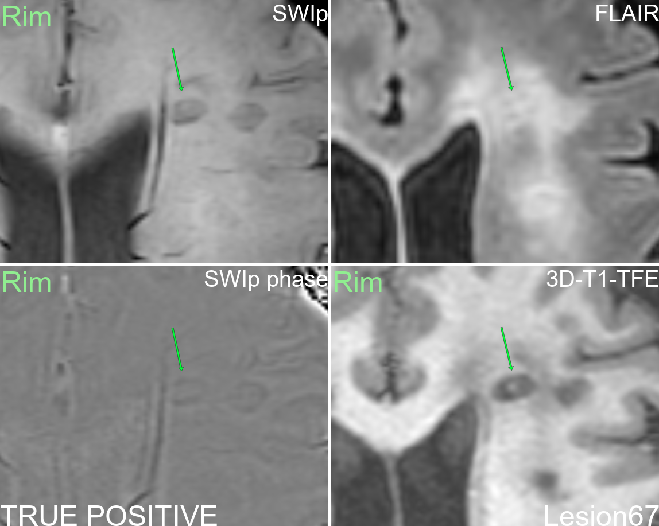
Supplementary figure 67: Multi-modal display of lesion 67.
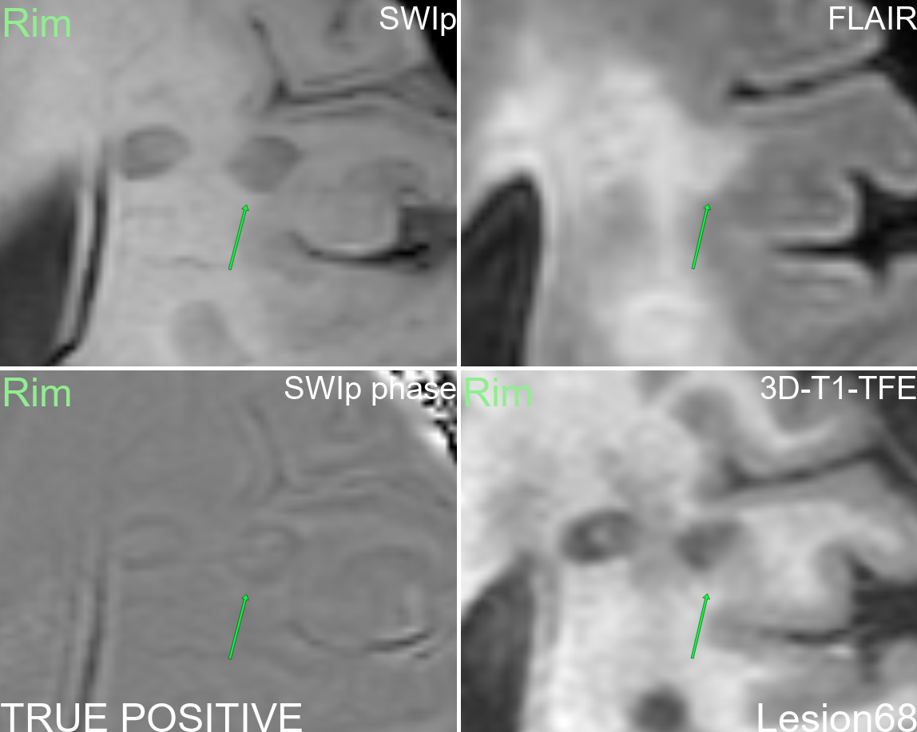
Supplementary figure 68: Multi-modal display of lesion 68.
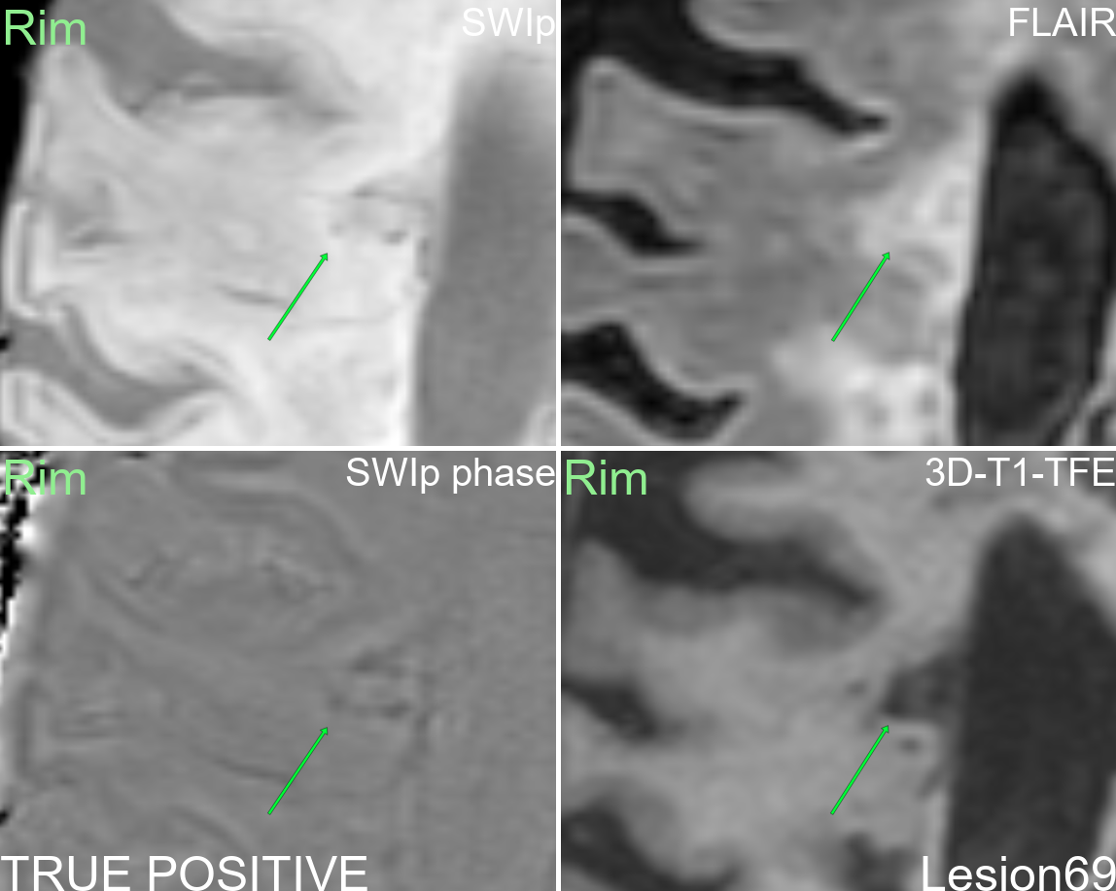
Supplementary figure 69: Multi-modal display of lesion 69.
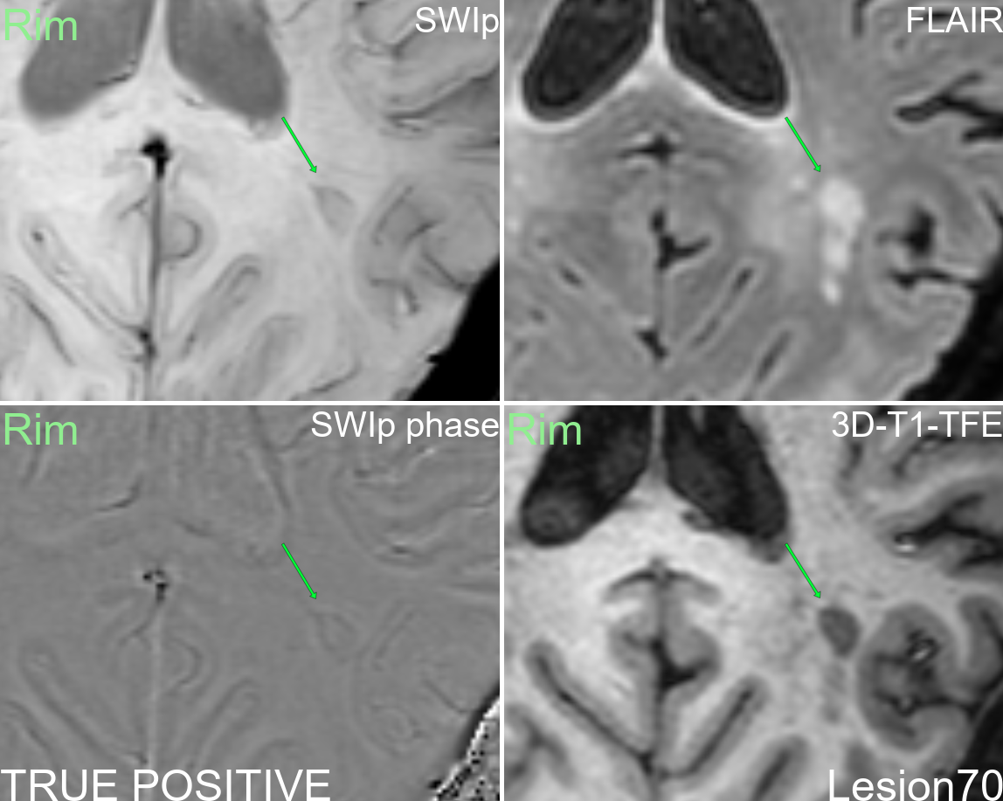
Supplementary figure 70: Multi-modal display of lesion 70.
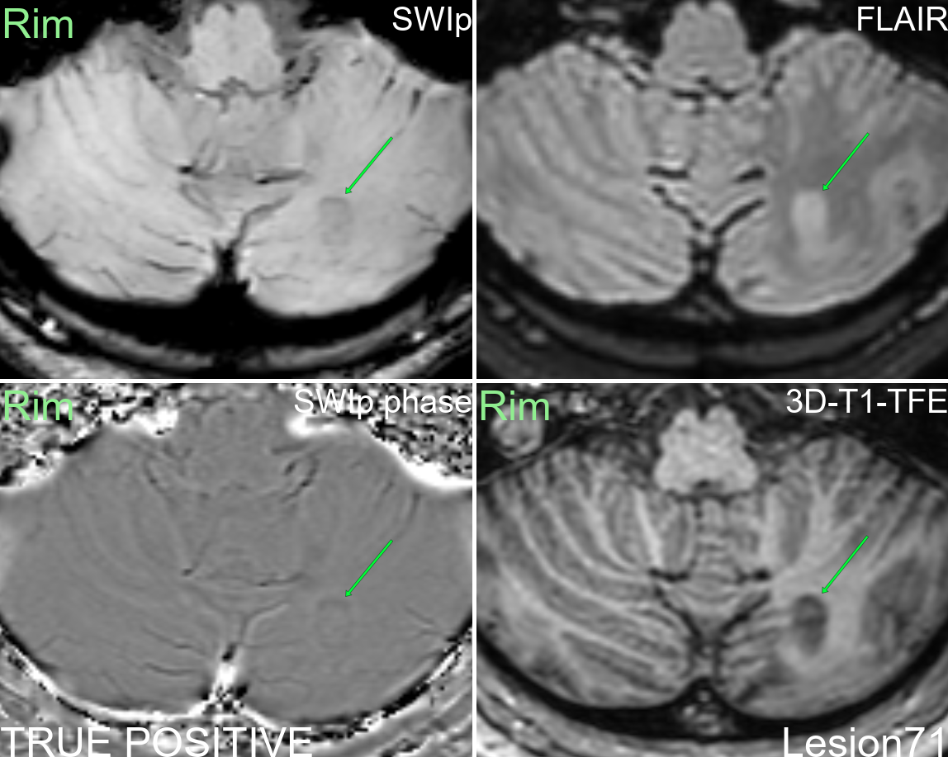
Supplementary figure 71: Multi-modal display of lesion 71.
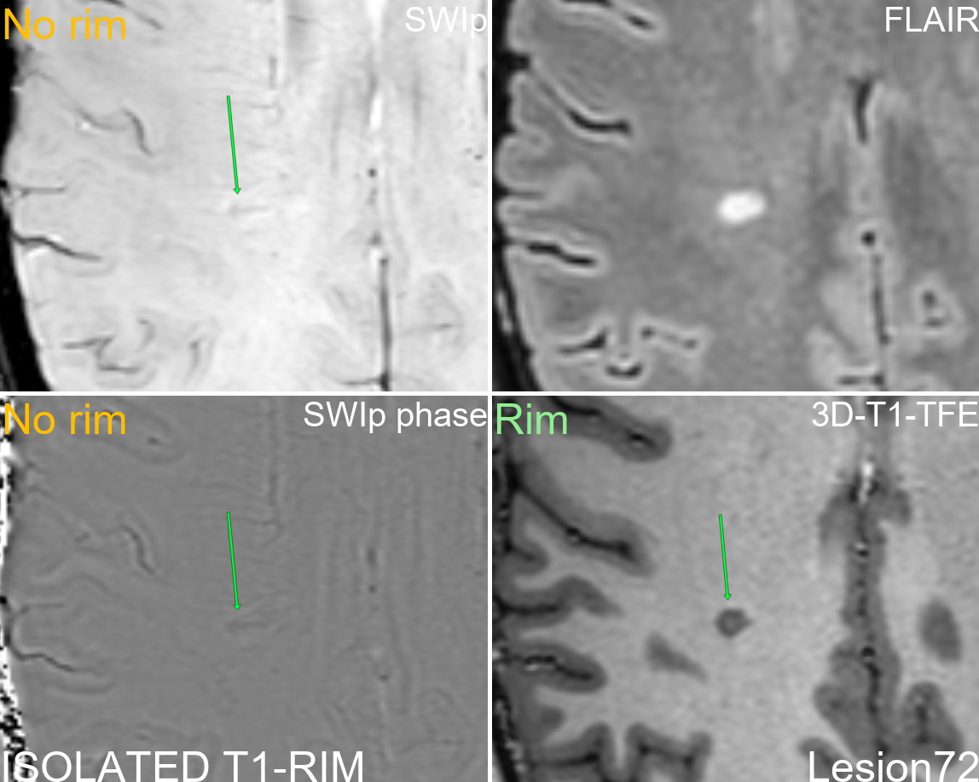
Supplementary figure 72: Multi-modal display of lesion 72.
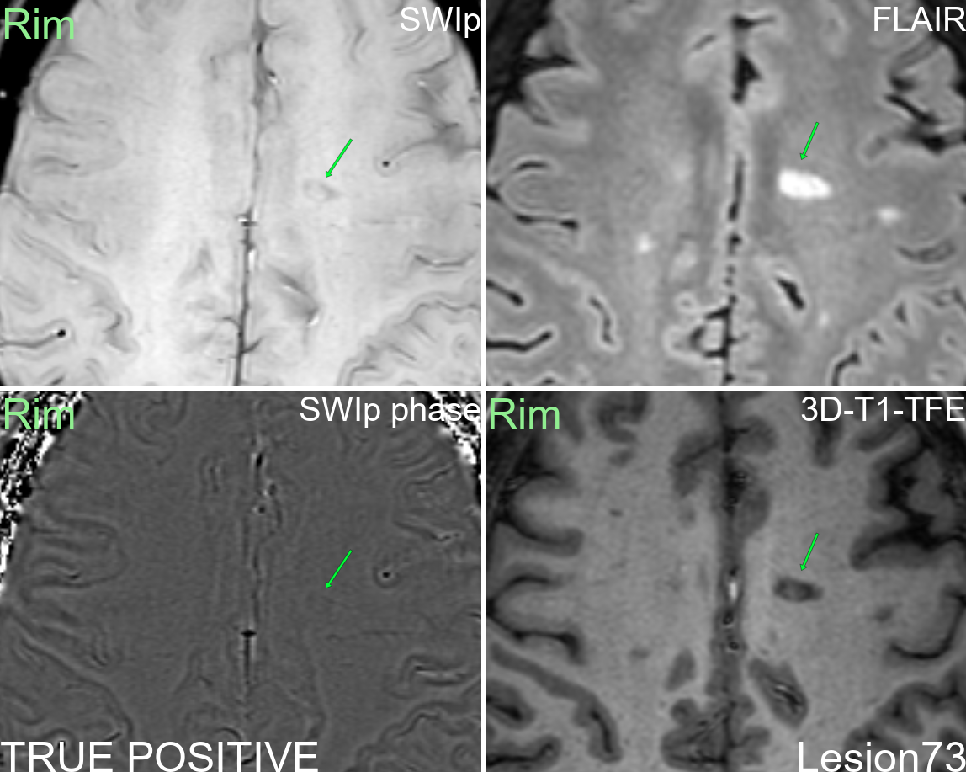
Supplementary figure 73: Multi-modal display of lesion 73.
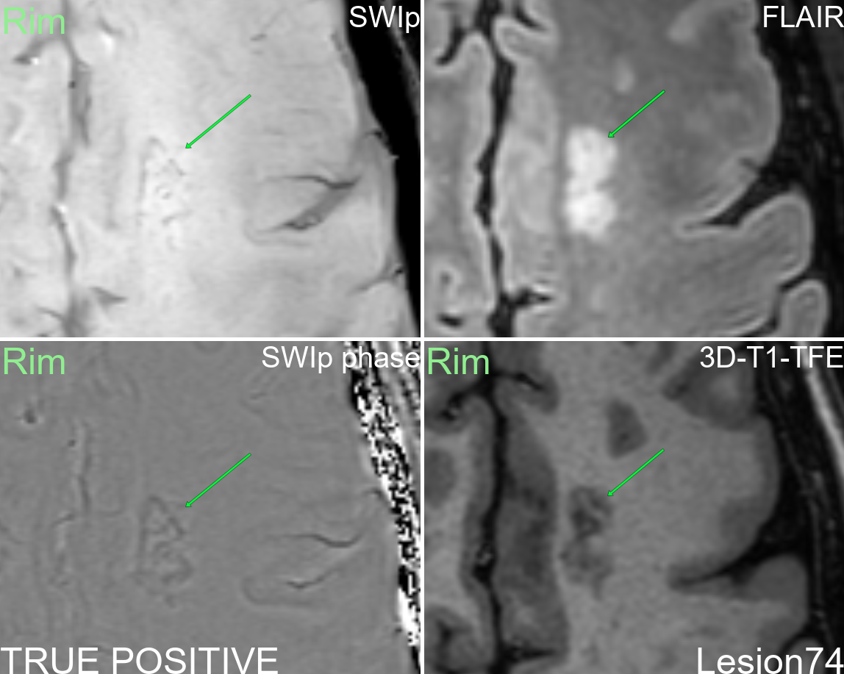
Supplementary figure 74: Multi-modal display of lesion 74.
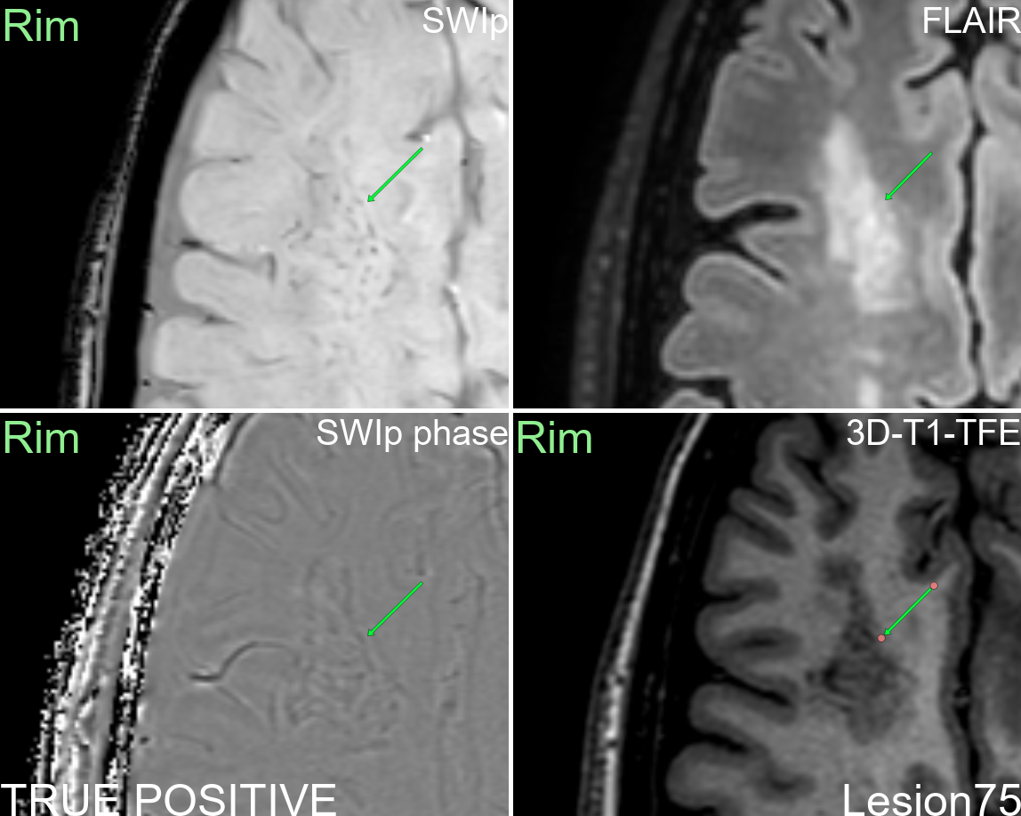
Supplementary figure 75: Multi-modal display of lesion 75.
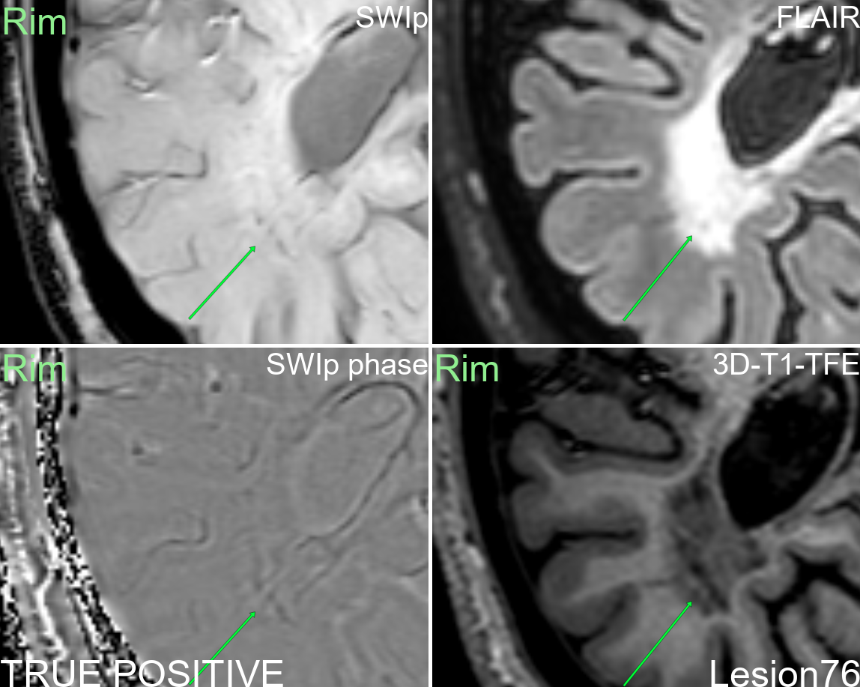
Supplementary figure 76: Multi-modal display of lesion 76.
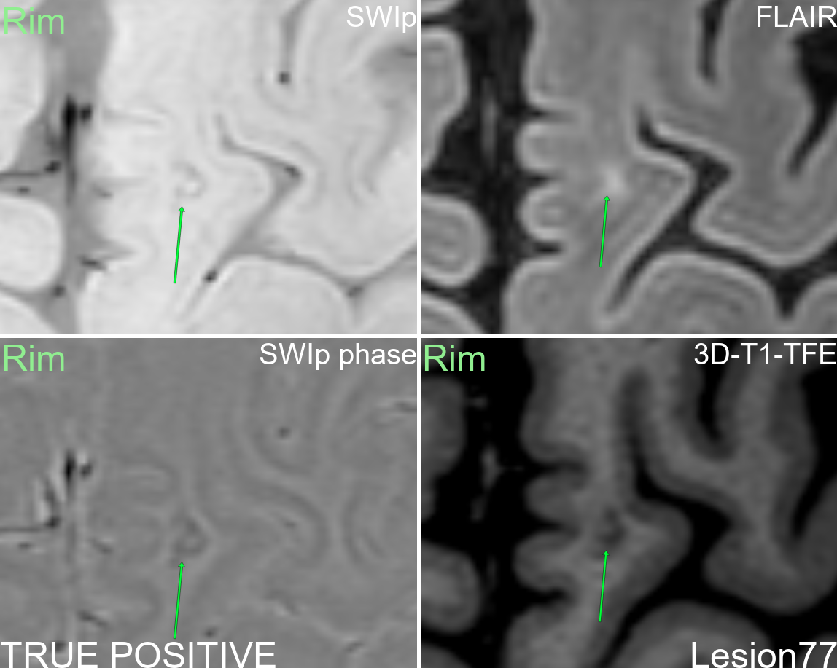
Supplementary figure 77: Multi-modal display of lesion 77.
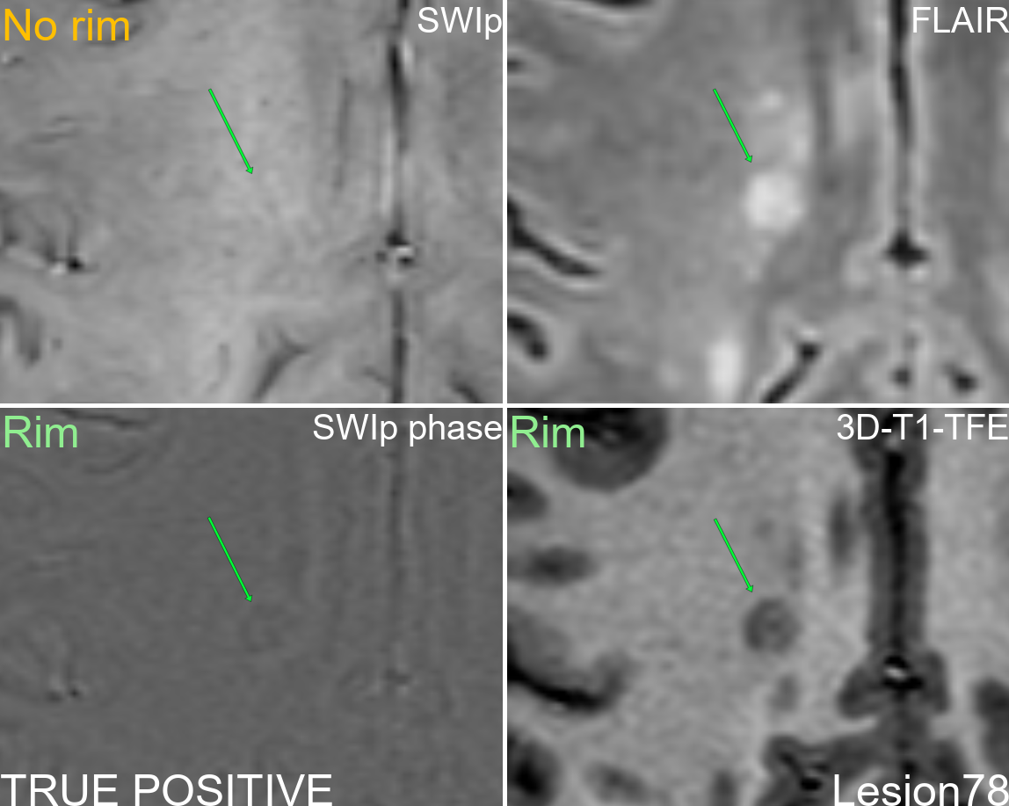
Supplementary figure 78: Multi-modal display of lesion 78.
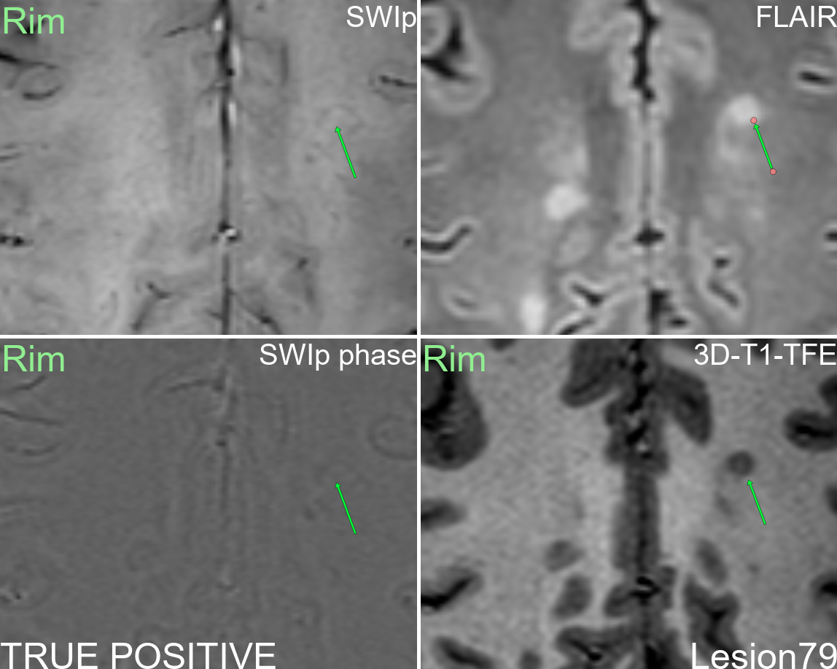
Supplementary figure 79: Multi-modal display of lesion 79.
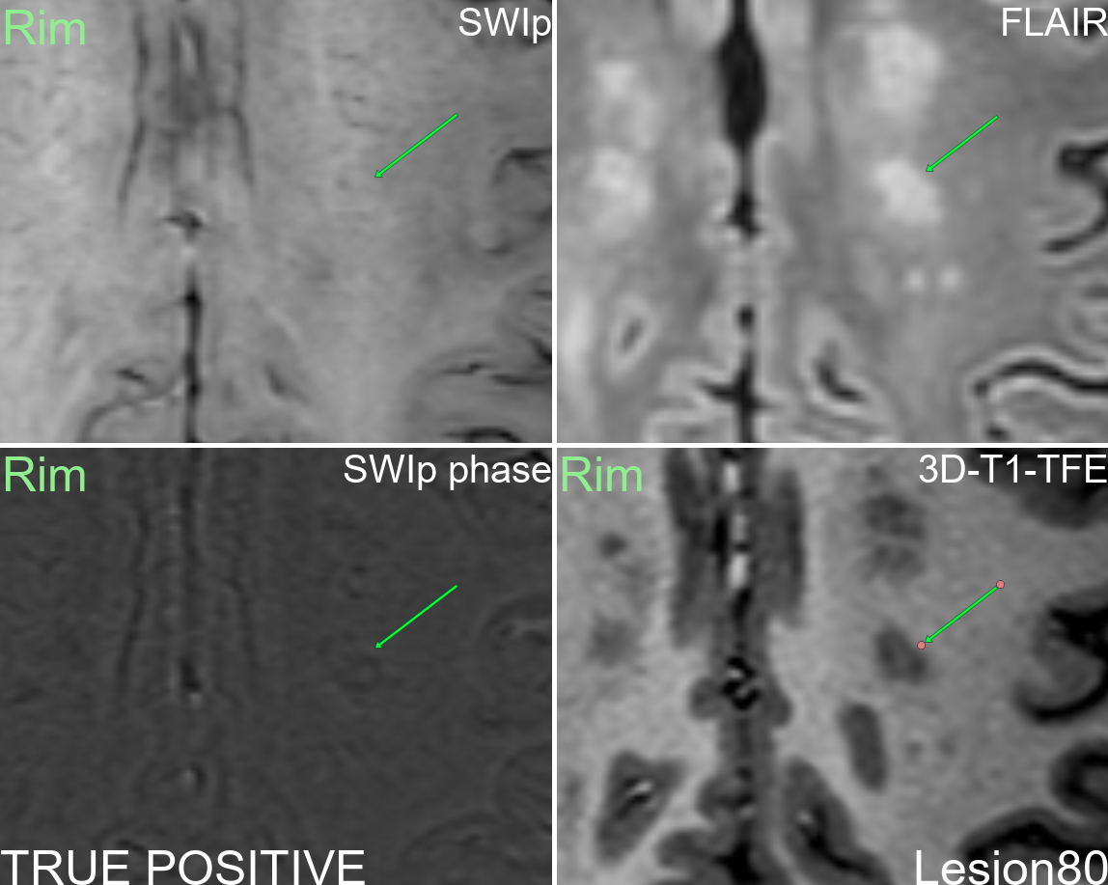
Supplementary figure 80: Multi-modal display of lesion 80.

