Supplementary information

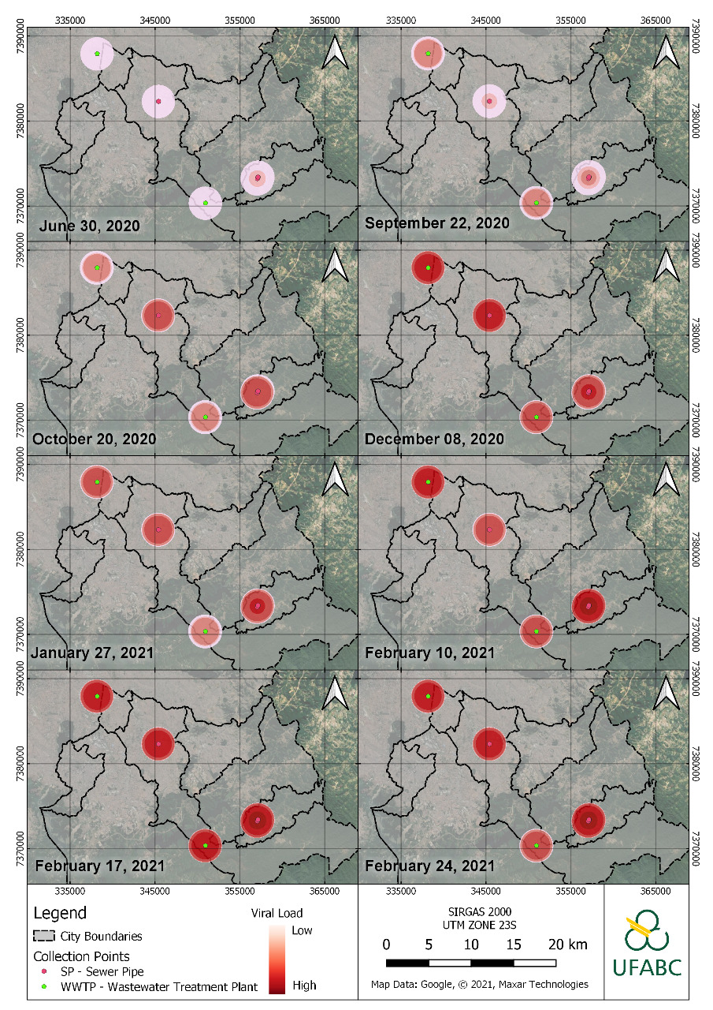
Supplementary Fig. 1. Heat maps of the progress of SARS-CoV-2 viral load (N1 assay) in the ABC region. The heat maps were made using QGIS software. The color scale ranged from the highest (red color) to the lowest (white color) SARS-CoV-2 RNA concentration, considering the period analyzed.
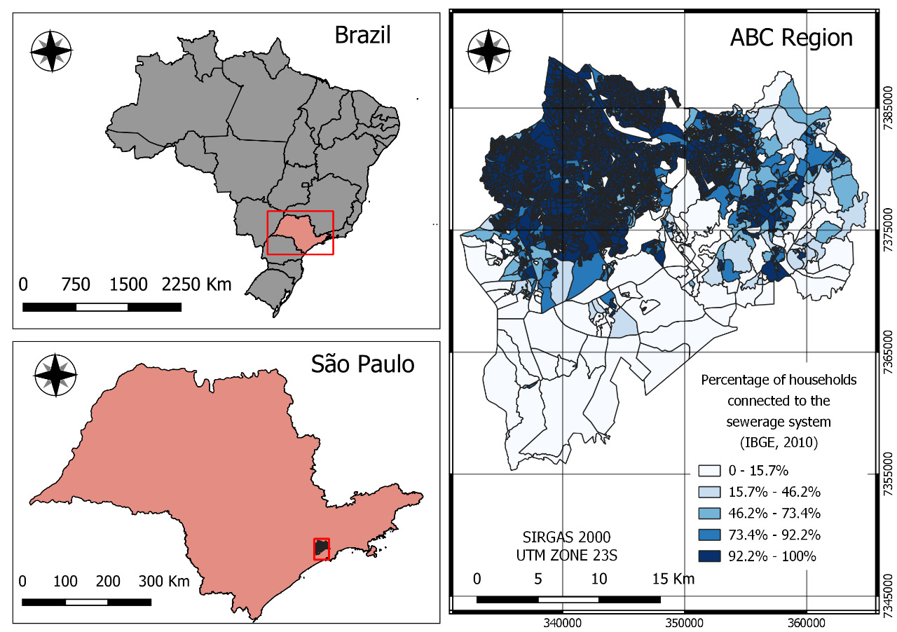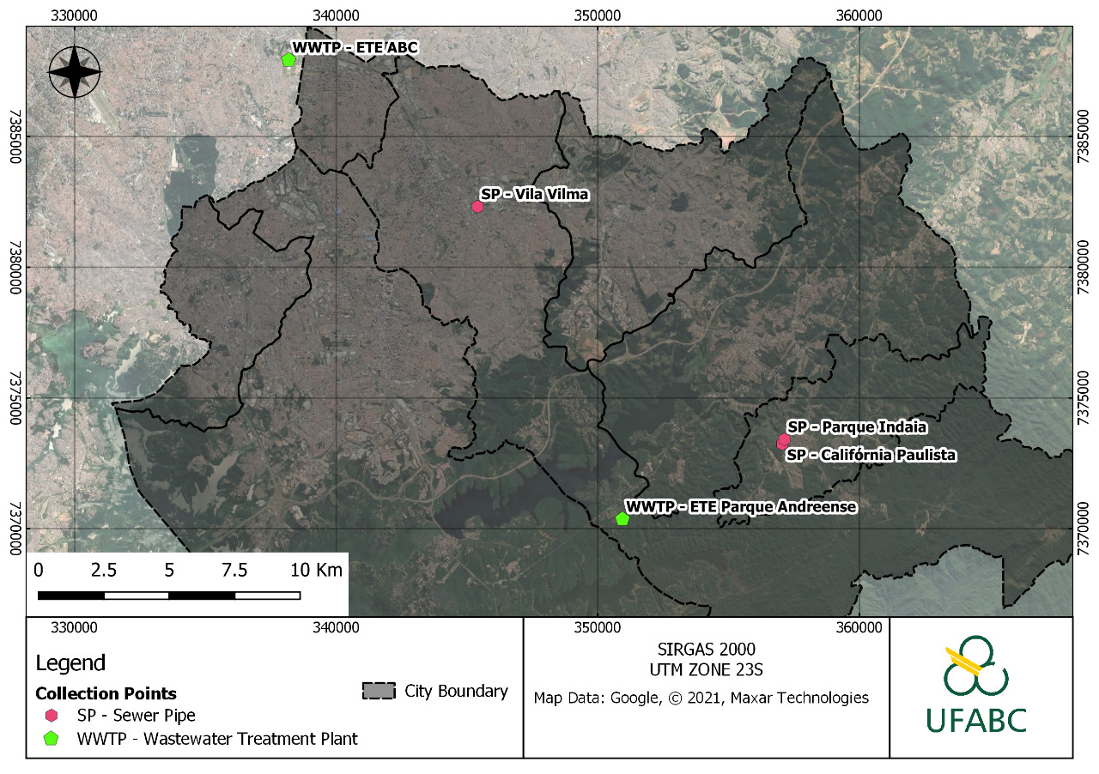
Supplementary Fig. 2. Maps of the sampling location.

Supplementary Tab. 1. Sampling points characteristics.
Sampling point | Site category | Contributing population | Wastewater flow rate (L.s⁻¹)
Point 1:  WWTP ABC | WWTP | 1,400,000 | 3,000.0ª
Point 2:  Vila Vilma | Sewerage system (sewer pipe) | 2,636 | 4.5^{b}
Point 3:  Califórnia Paulista | Sewerage system (sewer pipe) | 10,972 | 18.0^{b}
Point 4:  Parque Indaiá | Sewerage system (sewer pipe) | 456 | 1.0^{b}
Point 5:  WTTP Parque Andreense | WWTP | 2,320 | 2.0ª
ªMeasured (average value).
^{b}Estimated (from population data and per capita wastewater generation).

Supplementary Tab. 2. Monte-Carlo simulation parameters/input.
Parameter/Input | Unit | Distribution  (Value)
SARS-CoV-2 RNA concentration in in wastewater samples (C_{RNA}) | genome copies.L⁻¹ | Point  (Mean = Measured)
Wastewater volumetric flow rate (F) | L.d⁻¹ | Point  (Mean = Table 1)
Fecal load (α) | g.person⁻¹.d⁻¹ | Normal  (Mean = 149, SD = 95)ª
SARS-CoV-2 shedding rate (β) | genome copies.g⁻¹ | Uniform  (Min = 6.3x10⁵, Max = 1.3x10⁸)^{b}
ªAccording to Rose et al. (2015)⁴¹.
^{b}According to Kitajima et al. (2020)³ and Gholipour et al. (2021)⁴².

