Probiotic properties and antioxidant activities of Lactiplantibacillus plantarum HY7720 and its fermentation characteristics in plant-based materials
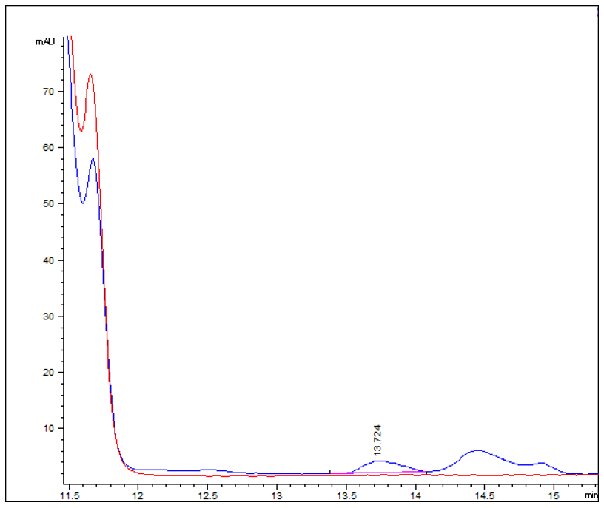
Supplementary Fig. 1 HPLC chromatogram of extracellular B₁₂ produced by HY7720. The red and blue lines correspond to the results obtained before and after culture, respectively.

