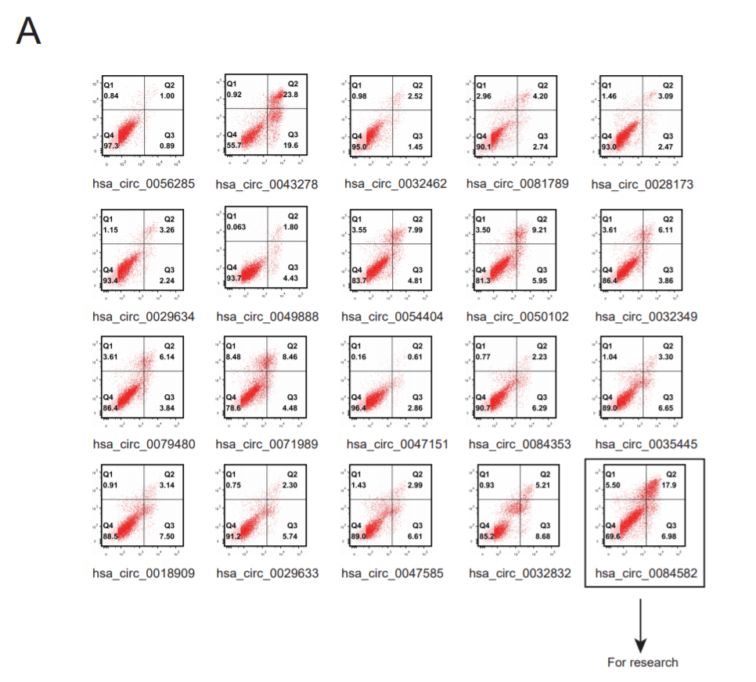
Figure 1A The rate of apoptosis of 143B cells were tested after transfected with relevant small interfering RNA in 143B cell. (n = 3, P<0.05)

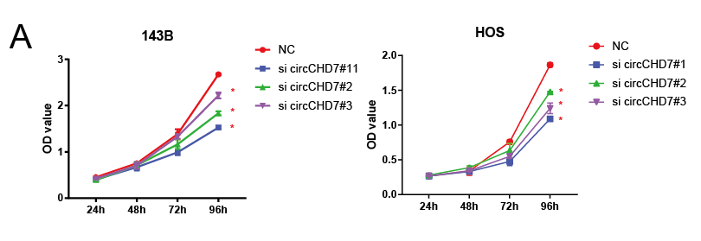
Figure 3A CCK-8 assay were used to detect proliferation ability of the 143B and HOS after transfected with si-circCHD7 at a final concentration of 20nM. Data represent the mean ± SEM (n = 3; *= p<0.05)

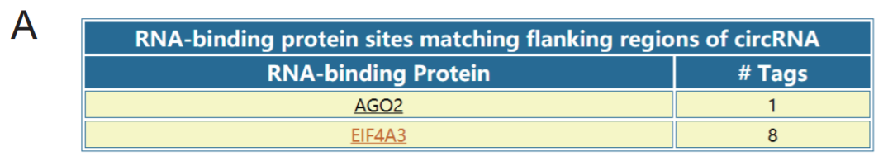
Figure 4A the CircInteractome website predicts the combination of the circCHD7 and AGO2. (https://circinteractome.nia.nih.gov/)

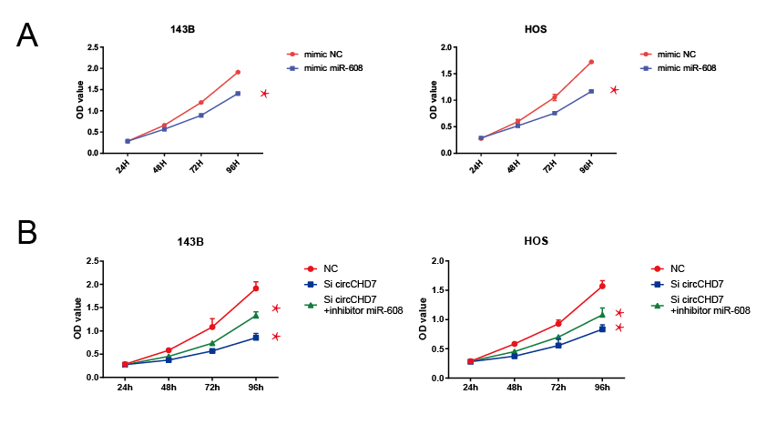
Figure 5A The proliferation ability of 143B and HOS were measured by CCK-8 assay after transfected with miR-608 mimics at a final concentration of 20nM. Data represent the mean ± SEM (n = 3; *= p<0.05) 5B The proliferation ability of 143B and HOS were measured by CCK-8 assay after co-transfected with Si-circCHD7 and miR-608 inhibitors. Data represent the mean ± SEM (n = 3; *= p<0.05)

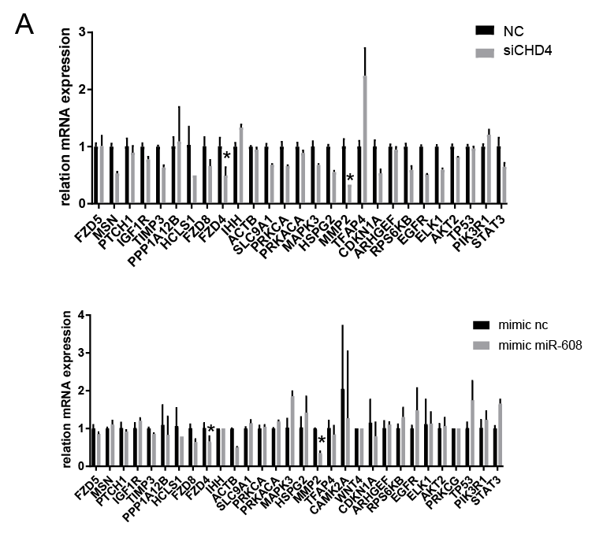
Figure 6A The expression of genes in proteoglycans in cancer pathway after transfected with miR-608 or Si-circCHD7 in 143B cells. Data represent the mean ± SEM (n = 3; *= p<0.05)

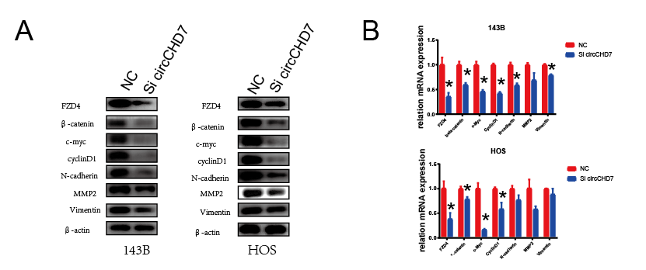
Figure 7A and 7B The protein and mRNA expression of FZD4, β-catenin, c-Myc, cyclinD1, N-cadherin, MMP2, Vimentin of 143B and HOS after transfected with miR-608 or Si-circCHD7. Data represent the mean ± SEM (n = 3; *= p<0.05)

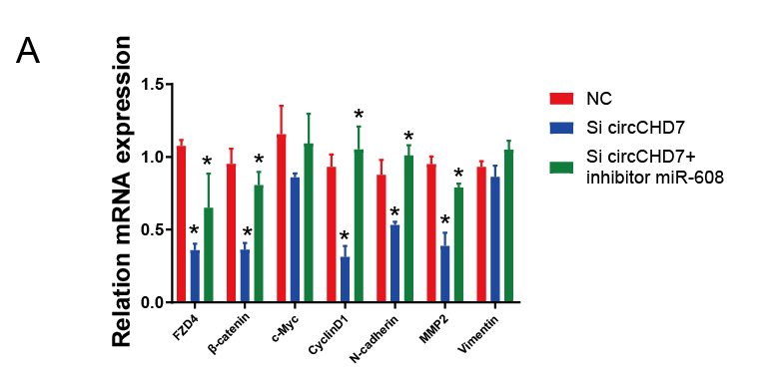
Figure 8A qRT-PCR was used to measure the expression of the FZD4, β-catenin, c-Myc, CyclinD1, N-cadherin, MMP2, Vimentin in tumor tissue. Data represent the mean ± SEM (n = 5, *=p<0.05).

