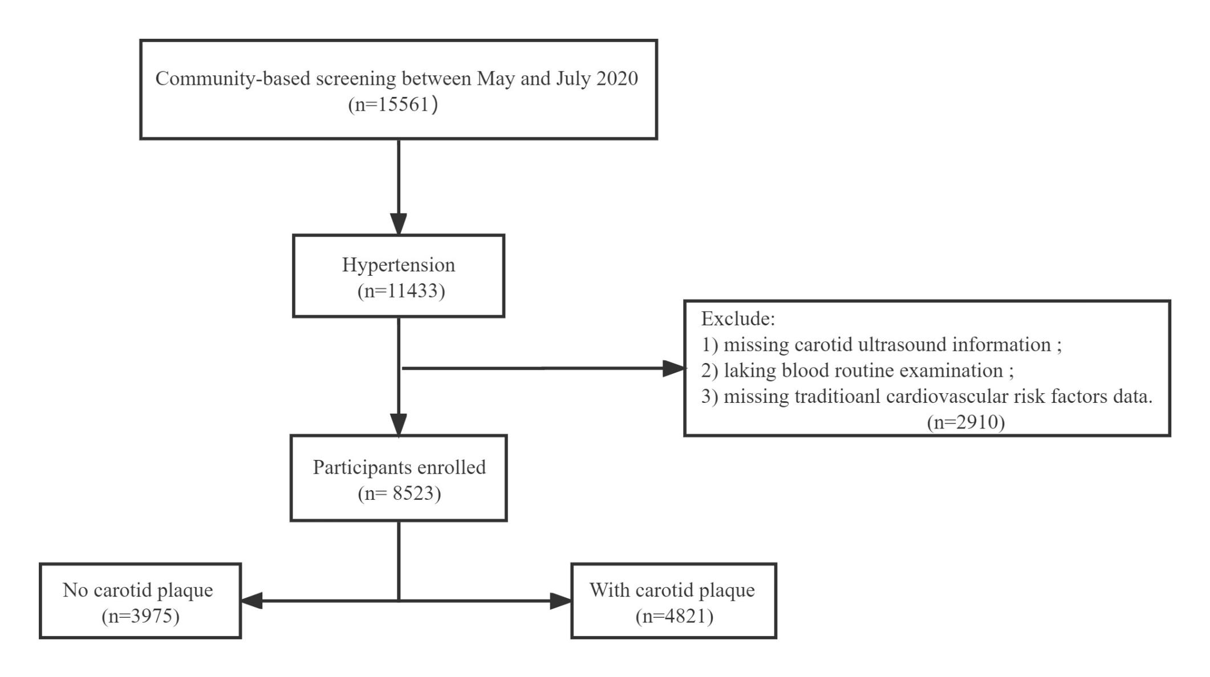
Supplemental figure 1. Flowchart of the study.

Supplemental Table 1 Lipid values by carotid plaque.
 | Without carotid plaque | With carotid plaque | P-value
TC, mmol/L | 4.67±1.09 | 4.87±1.08 | < 0.001
Triglycerides, mmol/L | 1.77±1.29 | 1.89±1.44 | < 0.001
HDLC, mmol/L | 1.42±0.36 | 1.39±0.35 | <0.001
LDLC, mmol/L | 2.56±0.85 | 2.68±0.78 | < 0.001
RC, mmol/L | 0.69±0.50 | 0.81±0.60 | <0.001
RC & LDLC groups |  |  | <0.001
RC ≤ 0.78 mmol/mL & LDLC ≤ 2.59 mmol/mL | 1518 (41.00) | 1395 (28.94)
RC > 0.78 mmol/mL & LDLC ≤ 2.59 mmol/mL | 498 (13.45) | 857 (17.78)
RC ≤ 0.78 mmol/mL & LDLC > 2.59 mmol/mL | 1062 (28.69) | 1433 (29.72)
RC > 0.78 mmol/mL & LDLC > 2.59 mmol/mL | 624 (16.86) | 1136 (23.56)
Data were shown as mean ± SD or n (%). Abbreviations were same as in Table1.

Supplemental table2 Associated factors with remnant cholesterol form multivariable linear regression model
Variables | β coefficient | P-value
Smoking | -0.512 | <0.001
Regular exercise | -0.123 | 0.261
stroke | -0.243 | 0.259
TIA | -0.247 | 0.269
Atrial fibrillation /valvular heart disease | -0.374 | 0.020
Diabetes | -0.329 | 0.031
Family history of stroke | -0.105 | 0.515
Blood glucose | -0.032 | 0.443
Triglycerides | 2.006 | <0.001
HDLC | -0.992 | <0.001
LDLC | 0.402 | <0.001
eGFR | 0.000 | 0.803
BMI | -0.047 | 0.019
SBP | -0.017 | <0.001
DBP | 0.015 | 0.023
Antihypertensive drugs | -0.160 | 0.722
Lipid-lowering drugs | -0.812 | 0.236
β coefficients and p values estimated with linear regression model adjusted for all other characteristics. Abbreviations were same as in Table1.

Supplemental table 3 Sensitivity analysis for association between remnant cholesterol and risk of carotid plaque
 | Model 1 |  | Model 2 |  | Model 3
 | OR (95% CI) |  | OR (95% CI) |  | OR (95% CI)
Remnant cholesterol (per 0.1mmol/L increase) | 1.052 (1.052–1.062) |  | 1.042 (1.032–1.052) |  | 1.043 (1.030–1.055)
Remnant cholesterol (quartiles)
Q2 vs. Q1 | 1.555 (1.378–1.754) |  | 1.489 (1.318–1.683) |  | 1.487 (1.315–1.681)
Q3 vs. Q1 | 1.838 (1.628–2.075) |  | 1.722 (1.522–1.949) |  | 1.717 (1.512–1.949)
Q4 vs. Q1 | 2.157 (1.908–2.439) |  | 1.934 (1.706–2.192) |  | 1.919 (1.665–2.212)
Model 1 adjusted none; Model 2 adjusted for sex and age; Model 3 adjusted for sex, age and a propensity score. OR odds ratio; CI, confidence interval.

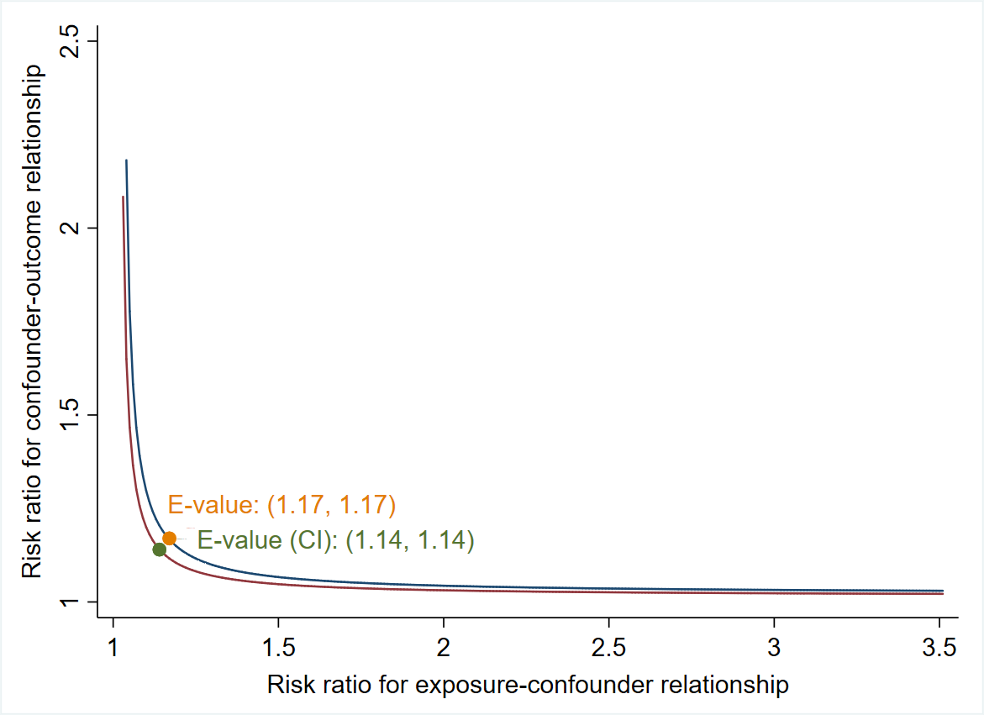

Supplemental figure 2. Curves of the sensitivity analysis for unobserved confounders with E-value. Curve depicting the range of joint relationships (RC per 0.1mmol/L increase-confounder and confounder-caroid plaque) that may explain away the estimated effect and its confidence interval for the multivariable logistic regression model to predict caroid plaque. A larger E-value indicates greater robustness of the research conclusion and makes it more difficult for confounding factors to explain or overturn the results.

