Table 1 Measurement point settings in Huanglongxian Village
Site name | Space type | Environmental parameters | SVF | Elevation | Fisheye photos
A1 | Courtyard space | Underlying surface: brick and stone  Building orientation: 180 ° | 0.928 | 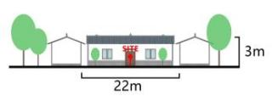 | 
A2 | Courtyard space | Underlying surface: brick and stone  Building orientation: 210 ° | 0.817 | 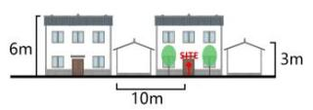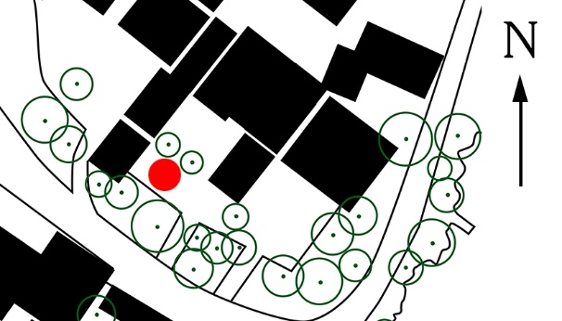 | 
A3 | Alleyway street space | Underlying surface: brick and stone  Street width: 12m | 0.934 | 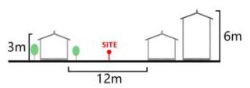 | 
A4 | Alleyway street space | Underlying surface: brick and stone  Street width: 8m | 0.643 | 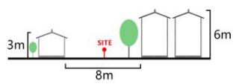 | 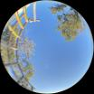
A5 | Square space | Underlying surface: brick and stone  Square area: 200m² | 0.89 | 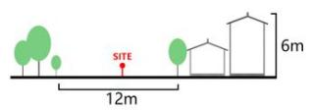 | 
A6 | Square space | Underlying surface: brick and stone  Square area: 300m² | 0.802 | 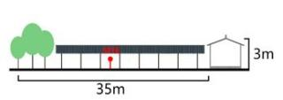 | 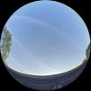
A7 | Waterfront space | Underlying surface: anticorrosive wood  Water area: 0.1hm² | 0.714 | 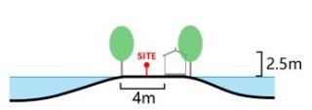 | 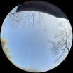
A8 | Waterfront space | Underlying surface: anticorrosive wood  Water area: 2hm² | 0.775 | 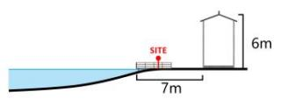 | 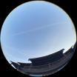

Table 2 Measurement point settings in Shishanxia Village
Site name | Space type | Environmental parameters | SVF | Elevation | Fisheye photos
B1 | Courtyard space | Underlying surface: brick and stone  Building orientation: 135° | 0.611 | 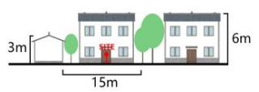 | 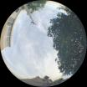
B2 | Courtyard space | Underlying surface: brick and stone  Building orientation: 90° | 0.801 | 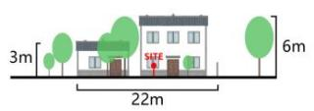 | 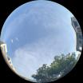
B3 | Alleyway street space | Underlying surface: brick and stone  Street width: 6m | 0.484 | 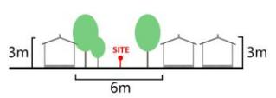 | 
B4 | Alleyway street space | Underlying surface: brick and stone  Street width: 8m | 0.575 | 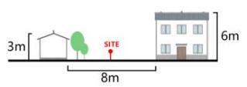 | 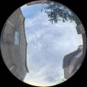
B5 | Square space | Underlying surface: brick and stone  Square area:1150m² | 0.745 | 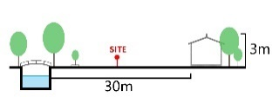 | 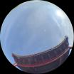
B6 | Square space | Underlying surface: anticorrosive wood  Square area:300m² | 0.802 | 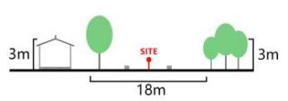 | 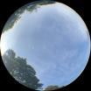
B7 | Waterfront space | Underlying surface: anticorrosive wood  Water area:1hm² | 0.823 |  | 
B8 | Waterfront space | Underlying surface: brick and stone  Water area:0.4hm² | 0.523 | 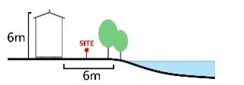 | 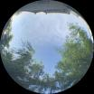

Table 3 Measurement point settings in Huashu Village
Site name | Space type | Environmental parameters | SVF | Elevation | Fisheye photos
C1 | Courtyard space | Underlying surface: brick and stone  Building orientation:330° | 0.461 | 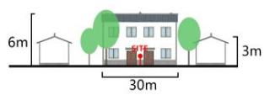 | 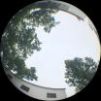
C2 | Courtyard space | Underlying surface: brick and stone  Building orientation:150° | 0.768 | 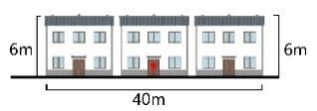 | 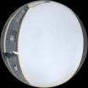
C3 | Alleyway street space | Underlying surface: brick and stone  Street width: 7m | 0.747 | 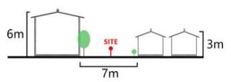 | 
C4 | Alleyway street space | Underlying surface: brick and stone  Street width: 5m | 0.752 | 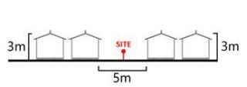 | 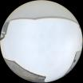
C5 | Square space | Underlying surface: brick and stone  Square area:1200m² | 0.603 | 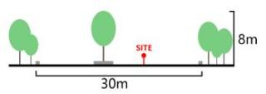 | 
C6 | Square space | Underlying surface: brick and stone  Square area:300m² | 0.959 | 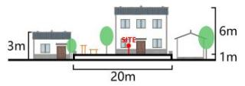 | 
C7 | Waterfront space | Underlying surface: anticorrosive wood  Water area:2.5hm² | 0.701 | 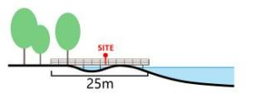 | 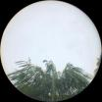
C8 | Waterfront space | Underlying surface: brick and stone  Water area:0.4hm² | 0.894 | 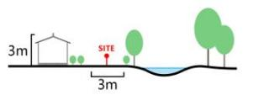 | 

