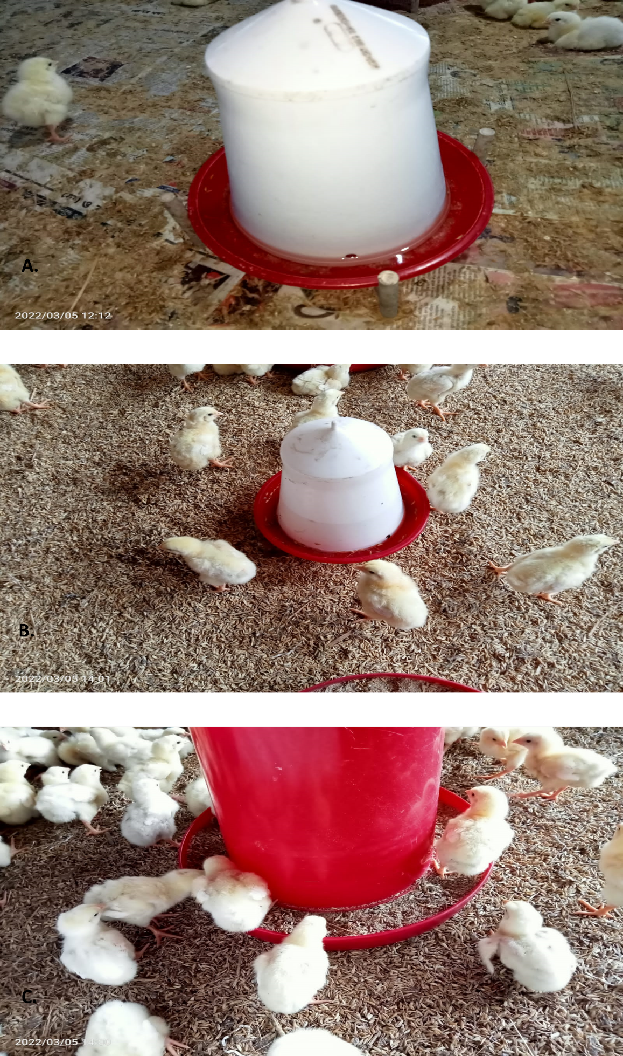

Supplementary Figure 1: Poultry Farm Drinking System
A. Drinker Placement: Placement of drinkers within the poultry farm, emphasizing their positioning on the floor, rather than being suspended.
B. Birds' Proximity: Birds are observed in close proximity to the drinkers, showcasing their direct interaction with the water source.
C. Contaminated Drinker: The image depicts a drinker in a later stage, contaminated with litter, highlighting the potential for ESBL contamination due to direct contact between birds and the water source. This observation underscores the importance of hygiene and management practices in preventing antimicrobial resistance in poultry production systems.

