Supporting Information
Spectral, Density functional theory calculations, molecular docking studies, antimicrobial, antioxidant, antidiabetic activities of the novel (E)-2-(3-(5-(3-nitrophenyl)furan-2-yl)acryloyl)-3,4-dihydronaphthalen-1(2H)-one

J. Irshad Ahamed ^{1,*}, S.I.Davis Presley², Venkatadri Babu³, Jayachitra.S⁴

ª Department of Chemistry, Theivanai Ammal College for Women (Autonomous), Affiliated to the Annamalai University, Chennai – Trichy Trunk Road, Villupuram, Tamil Nadu – 605401.
^{b}epartment of Chemistry, Sri Sivasubramaniya Nadar College of Engineering. Kalavakkam-603110.
^{c} Department of Life Sciences, The National Institute for Biotechnology in the Negev, Ben-Gurion University of the Negev, Beer-Sheva 84105, Israel
^{d}Department of Chemistry, S.A.Engineering College, Poonamallee, Avadi Road Veeraraghavapuram, Thiruverkadu, Tamil Nadu 600077

Corresponding Author

J. Irshad Ahamed ^{1,*}
Department of Chemistry, Theivanai Ammal College for Women (Autonomous),
Affiliated to the Annamalai University,
Chennai – Trichy Trunk Road, Villupuram, Tamil Nadu – 605401.
irshad@loyolacollege.edu (Dr. J. Irshad Ahamed^{1,*})
https://orcid.org/0000-0002-8436-9803.

Table S1 Calculated Bond lengths (Å) of the ENFADH molecule with DFT theory employing 6-311G++(d,p) basis set values are shown below
Bond length (Å) | B3LYP | Bond length (Å) | B3LYP
(C1-C2) | 1.534 | (C16-C17) | 1.467
(C1-C6) | 1.537 | (C16-O18) | 1.252
(C1-C16) | 1.548 | (C17-C19) | 1.357
(C1-H46) | 1.100 | (C17-H21) | 1.085
(C2-C3) | 1.480 | (C19-H20) | 1.088
(C2-O15) | 1.252 | (C19-C31) | 1.429
(C3-C4) | 1.415 | (C26-C28) | 1.422
(C3-C8) | 1.410 | (C26-H29) | 1.079
(C4-C5) | 1.514 | (C26-C31) | 1.384
(C4-C9) | 1.404 | (C27-C28) | 1.382
(C5-C6) | 1.539 | (C27-O32) | 1.392
(C5-H22) | 1.098 | (C27-C33) | 1.452
(C5-H23) | 1.097 | (C28-H30) | 1.079
(C6-H24) | 1.098 | (C31-O32) | 1.407
(C6-H25) | 1.095 | (C33-C34) | 1.412
(H7-C8) | 1.084 | (C33-C35) | 1.406
(C8-C11) | 1.391 | (C34-C36) | 1.397
(C9-C10) | 1.397 | (C34-H37) | 1.083
(C9-H12) | 1.086 | (C35-C38) | 1.392
(C10-C11) | 1.403 | (C35-H39) | 1.082
(C10-H13) | 1.086 | (C36-C40) | 1.397
(C11-H14) | 1.085 | (C36-H41) | 1.084
 |  | (C38-C40) | 1.398
 |  | (C38-N43) | 1.468
 |  | (C40-H42) | 1.081
 |  | (C43-O44) | 1.265
 |  | (C43-O45) | 1.264

Table S2 Calculated Bond angles (˚) of the ENFADH molecule with DFT theory employing 6-311G++(d,p) basis set
Bond angle (0) | B3LYP | Bond angle (0) | B3LYP
(C2-C1-C16) | 111.0 | (C17-C19-C20) | 118.2
(C2-C1-C6) | 112.3
(C2-C1-H46) | 105.0 | (C17-C19-C31) | 125.6
(C1-C2-C3) | 118.6 | (H20-C19-C31) | 116.2
(C1-C2-O15) | 119.7 | (C19-C31C-26) | 135.7
(C6-C1-C16) | 112.4 | (C19-C31-O32) | 116.3
(C6-C1-H46) | 110.3 | (C28-C26-H29) | 126.4
(C1-C6-C5) | 111.7 | (C28-C26-C31) | 107.8
(C1-C6-H24) | 108.7 | (C26-C28-C27) | 107.6
(C1-C6-H25) | 109.3 | (C26-2C8-H30) | 126.1
(C16-C1-H46) | 105.5 | (H29-26C-C31) | 125.8
(C1-C16-C17) | 117.1 | (C26-C31-O32) | 108.0
(C1-C16-O18) | 120.2 | (C28-C27-O32) | 108.7
(C3-C2-O15) | 121.7 | (C28-C27-C33) | 134.0
(C2-C3-C4) | 121.5 | (C27-C28-H30) | 126.3
(C2-C3-C8) | 118.3 | (O32-C27-C33) | 117.3
(C4-C3-C8) | 120.2 | (C27-O32-C31) | 107.9
(C3-C4-C5) | 120.7 | (C27-C33-C34) | 120.8
(C3-C4-C9) | 118.5 | (C27-C33-C35) | 120.3
(C3-C8-H7) | 118.1 | (C34-C33-C35) | 118.9
(C3-C8-C11) | 120.6 | (C33-C34-C36) | 120.7
(C5-C4-C9) | 120.9 | (C33-C34-H37) | 119.0
(C4-C5-C6) | 112.2 | (C33-C35-C38) | 119.2
(C4-C5-H22) | 109.8 | (C33-C35-C39) | 121.8
(C4-C5-H23) | 109.6 | (C36-C34-H37) | 120.3
(C4-C9-C10) | 121.0 | (C34-C36-C40) | 120.7
(C4-C9-C12) | 119.1 | (C34-C36-H41) | 119.7
(C6-C5-H22) | 108.5 | (C38-C35-H39) | 119.0
(C6-C5-H23) | 110.1 | (C35-C38-C40) | 122.6
(C5-C6-H24) | 109.5 | (C35-C38-C43) | 118.5
(C5-C6-H25) | 109.7 | (C40-C36-H41) | 119.6
(H22-C-5-H23) | 106.5 | (C36-C40-C38) | 118.0
(H24-C6-H25) | 107.8 | (C36-C40-H42) | 122.2
(H7-C8-C11) | 121.4 | (C40-C38-N43) | 118.9
(C8-C11-C10) | 119.5 | (C38-C40-H42) | 119.8
(C8-C11-H14) | 120.3 | (C38-C43-O44) | 118.1
(C10-C9-H12) | 119.8 | (C38-C43-O45) | 118.0
(C9-C10-C11) | 120.3 | (O44-C43-O45) | 123.9
(C9-C10-H13) | 119.7
(C11-C10-H13) | 120.0
(C10-C11-H14) | 120.2
(C17-C16-O18) | 122.7
(C16-C17-C19) | 120.6
(C16-C17-H21) | 117.2
(C19-C17-H21) | 122.2

Table S3 Mulliken atomic charges of the ENFADH

Atoms | Mulliken atomic charge | Atoms | Mulliken atomic charge
C1 | -0.262 | H20 | 0.189
C2 | 0.278 | H21 | 0.174
C3 | 0.027 | H22 | 0.196
C4 | 0.114 | H23 | 0.142
C5 | -0.332 | H24 | 0.129
C6 | -0.245 | H25 | 0.153
H7 | 0.164 | C26 | -0.148
C8 | -0.127 | C27 | 0.204
C9 | -0.180 | C28 | -0.133
C10 | -0.103 | H29 | 0.171
C11 | -0.133 | H30 | 0.166
H12 | 0.137 | C31 | 0.262
H13 | 0.144 | O32 | -0.557
H14 | 0.138 | C33 | 0.042
O15 | -0.446 | C34 | -0.105
C16 | 0.317 | C35 | -0.105
C17 | -0.138 | C36 | -0.149
O18 | -0.443 | H37 | 0.179
C19 | -0.097 | C38 | 0.292
 |  | H39 | 0.186
 |  | C40 | -0.100
 |  | H41 | 0.157
 |  | H42 | 0.193
 |  | N43 | 0.052
 |  | O44 | -0.294
 |  | O45 | -0.285
 |  | H46 | 0.177

Table S4 Comparison of the bands observed in the experimental and simulated vibrational assignment of ENFADH
Mode no | Experimental Wave Number | Calculated Wave Number (scaled) DFT/B3LYP/6-311G ++(d,p) FTIR(cm¹) | IR intensity^{b} | Vibrational Assignments along with % of (PED)ª
Mode no | FT-IR (cm⁻¹) |  | IR intensity^{b} | Vibrational Assignments along with % of (PED)ª
1 |  | 3304 | 0.6417 | υ C-H (50)
2 |  | 3289 | 5.6552 | υ C-H (48)
3 |  | 3268 | 5.8164 | υ C-H (24)
4 |  | 3261 | 3.855 | υ C-H (29)
5 |  | 3249 | 1.8022 | υ C-H (15)
6 |  | 3235 | 16.310 | υ C-H (63)
7 |  | 3224 | 15.361 | υ C-H (19)
8 |  | 3222 | 12.550 | υ C-H (48)
9 | 3212 | 3219 | 24.376 | υ C-H (18)
10 |  | 3205 | 16.378 | υ C-H (24)
11 |  | 3198 | 0.2757 | υ C-H (18)
12 |  | 3191 | 3.5893 | υ C-H (28)
13 | 3102 | 3121 | 17.030 | υ C-H (84)
14 |  | 3090 | 38.448 | υ C-H (36)
15 |  | 3055 | 23.775 | υ C-H (11)
16 |  | 3050 | 10.989 | υ C-H (28)
17 | 3041 | 3038 | 27.588 | υ C-H (44)
18 | 1704 | 1701 | 250.33 | υ C=O (18)
19 |  | 1673 | 49.588 | υ C=O (19)
20 |  | 1670 | 12.815 | υ C=C (47)
21 |  | 1645 | 109.27 | υ C=C (11)
22 |  | 1635 | 70.807 | υ C=C (13)
23 |  | 1627 | 93.893 | υ C=C (10)
24 |  | 1625 | 3.9831 | υ C=C (12)
25 | 1608 | 1621 | 569.62 | υ C= O (35)
26 |  | 1576 | 2.5006 | υ C=C (23)
27 |  | 1544 | 8.263 | β HCC (29)
28 |  | 1531 | 35.604 | β HCH (75)
29 |  | 1525 | 6.3015 | β HCC (15)
30 | 1519 | 1524 | 152.52 | β HCC (22)
31 |  | 1509 | 29.461 | β HCC (44)
32 |  | 1504 | 31.859 | β HCC (34)
33 | 1450 | 1459 | 60.828 | υ N=O (71)
34 |  | 1423 | 4.6495 | β HCC (13)
35 |  | 1415 | 61.607 | υ N=O (14)
36 |  | 1400 | 3.6598 | β CCO (20)
37 |  | 1386 | 76.769 | υ C=C (15)
38 | 1368 | 1378 | 100.00 | υ C=C (25)
39 |  | 1372 | 18.903 | β HCC (22)
40 |  | 1350 | 53.166 | β HCC (13)
41 |  | 1349 | 18.507 | β HCC (16)
42 |  | 1348 | 4.9585 | β HCC (22)
43 |  | 1337 | 96.254 | τ HCCC (20)
44 | 1328 | 1325 | 177.77 | β HCC (13)
45 |  | 1305 | 15.049 | β HCC (32)
46 | 1285 | 1288 | 39.202 | υ CN (14)
47 | 1289 | 1287 | 342.21 | υ N=O (66)
48 |  | 1267 | 6.6924 | β HCC (10)
49 |  | 1245 | 3.0598 | β HCC (11)
50 |  | 1235 | 9.7096 | υ C=C (14)
51 |  | 1229 | 29.644 | υ C=C (10)
52 |  | 1223 | 5.2798 | β HCC (51)
53 |  | 1219 | 31.436 | β HCC (38)
54 |  | 1197 | 1.5247 | β HCC (22)
55 | 1163 | 1160 | 42.046 | β CCC (10)
56 |  | 1151 | 221.72 | υ C=C (20)
57 |  | 1135 | 8.8904 | υ C=C (16)
58 |  | 1130 | 11.233 | υ C=C (16)
59 |  | 1108 | 36.405 | υ C=C (45)
60 | 1098 | 1100 | 300.02 | υ C=C (29)
61 |  | 1086 | 2.7994 | γ CCCC (12)
62 |  | 1076 | 7.6807 | β HCC (17)
63 |  | 1069 | 59.310 | γ CCCC (35)
64 |  | 1051 | 47.541 | υ C=C (10)
65 |  | 1047 | 46.724 | γ HCCC (44)
66 |  | 1040 | 0.8552 | γ HCCC (10)
67 |  | 1039 | 0.316 | γ HCCC (12)
68 |  | 1033 | 0.4245 | β HCC (10)
69 | 1006 | 1008 | 3.2667 | γ HCCC (49)
70 |  | 993 | 6.0533 | β CCO (10)
71 |  | 985 | 2.5932 | γ HCCC (40)
72 |  | 961 | 0.7664 | γ HCCC (53)
73 |  | 961 | 16.873 | γ HCCC (29)
74 |  | 953 | 5.8015 | γ HCCC (23)
75 |  | 945 | 15.522 | γ HCCC (34)
76 |  | 928 | 37.937 | τ HCCC (10)
77 |  | 923 | 0.2244 | τ HCCC (36)
78 |  | 917 | 16.785 | τ HCCC (11)
79 |  | 904 | 49.046 | τ HCCN (14)
80 |  | 858 | 2.5679 | β CCC (16)
81 |  | 855 | 9.6278 | β CCC (12)
82 | 854 | 850 | 0.8145 | τ HCCC (13)
83 |  | 835 | 82.807 | τ HCCC (31)
84 |  | 833 | 7.7882 | τ HCCC (35)
85 |  | 795 | 42.027 | τ HCCC (24)
86 |  | 774 | 23.505 | τ HCCC (18)
87 |  | 756 | 49.036 | γ COCC (13)
88 |  | 742 | 29.533 | γ COCC (14)
89 |  | 734 | 4.604 | γ COCC (13)
90 | 726 | 718 | 1.7488 | τ CCOC (18)
91 |  | 707 | 25.488 | τ CCOC (10)
92 |  | 689 | 9.384 | β CCC (19)
93 |  | 683 | 4.4265 | β CCC (17)
94 |  | 682 | 0.1541 | β CCC (25)
95 |  | 669 | 11.583 | γ OCCC (18)
96 | 639 | 643 | 15.683 | γ OCCC (23)
97 |  | 609 | 1.3484 | γ OCCC (18)
98 |  | 570 | 2.5534 | γ OCOC (12)
99 |  | 554 | 4.7887 | γ NCCC (21)
100 |  | 535 | 0.5681 | γ NCCC (11)
101 |  | 530 | 1.8953 | γ ONCC (26)
102 |  | 511 | 5.703 | γ ONCC (11)
103 |  | 506 | 10.903 | γ ONCC (12)
104 |  | 475 | 12.687 | γ NCCC (11)
105 |  | 445 | 2.0545 | τ NCCC (14)
106 |  | 441 | 0.0366 | τ NCCC (12)
107 |  | 436 | 1.0361 | τ OCCC (31)
108 |  | 420 | 2.4511 | β CCC (22)
109 |  | 403 | 0.3942 | β HCC (26)
110 |  | 347 | 0.9659 | γ CCOC (20)
111 |  | 342 | 1.5562 | γ CCOC (43)
112 |  | 330 | 14.490 | β CCC (27)
113 |  | 313 | 17.978 | β OCC (12)
114 |  | 283 | 3.7205 | τ CCCC (19)
115 |  | 282 | 2.5914 | τ CCOC (10)
116 |  | 258 | 4.5658 | τ CCOC (34)
117 |  | 224 | 2.1779 | β CCC (11)
118 |  | 217 | 2.0342 | β CCC (18)
119 |  | 185 | 1.3374 | γ NCCC (21)
120 |  | 163 | 1.3232 | τ CCCC (16)
121 |  | 156 | 3.245 | τ CCCC (13)
122 |  | 125 | 0.0459 | β CCC (28)
123 |  | 120 | 2.2318 | β CCC (21)
124 |  | 111 | 1.5855 | β CCC (10)
125 |  | 91 | 0.8741 | γ CCOC (18)
126 |  | 76 | 4.8783 | τ ONCC (12)
127 |  | 56 | 0.2127 | τ ONCC (67)
128 |  | 51 | 3.6774 | τ CCCC (19)
129 |  | 31 | 0.0885 | τ CCCC (23)
130 |  | 27 | 2.5271 | τ CCCC (10)
131 |  | 16 | 0.9563 | τ COCC (19)
132 |  | 12 | 0.123 | τ COCC (35)
ªυ - stretching, β - bending, γ – out of plane bending, τ – torsion
vw – very weak, w – weak, m – medium, s – strong.
^{b}Relative absorption intensities normalized with highest peak absorption equal to 132.

Table S5 The electronic transition of ENFADH
Calculated at TD-DFT B3LYP/6-311++G(d,p) | Assignment | Oscillator strength | TD-DFT/gas phase (eV/nm) | Experimental (nm) | Transition
Excited State 1
101 ->102 | HOMO -> LUMO (93%) | f=0.0131 | 2.6504 / 467.80 | 482 | n–π*
Excited State 2
97 ->103 | HOMO-4 -> LUMO+1 (12%)
100 ->102 | HOMO-1 -> LUMO (7%) | f=0.0422 | 3.1136 / 398.20 | 382 | n–π*
100 ->103 | HOMO-1 -> LUMO +1 (63%)
100 ->105 | HOMO-1 -> LUMO+3 (2%)
101 ->103 | HOMO -> LUMO +1 (2%)
Excited State 3
97 ->103 | HOMO-4 -> LUMO+1 (5%)
99 ->103 | HOMO-2 -> LUMO+1 (3%)
99 ->104 | HOMO-2 -> LUMO+2 (2%)
100 ->104 | HOMO-1 -> LUMO+2 (4%) | f=0.9236 | 3.3557 / 369.47 | 370 | n–π*
101 ->103 | HOMO -> LUMO+1 (59%)
101 ->104 | HOMO -> LUMO +2 (3%)

Table S6 The ligand- receptor residue interaction between ENFADH and with 1HD2 protein
S.NO | Pub chem.  Id | Ligand  Name | Residue Interaction | Type of bond | Distance (Å)
1 | 1HD2 | ENFADH | A: ARG86:H21-:UNK0:O | Hydrogen | 2.55
1 | 1HD2 | ENFADH | A: ARG86:H-:UNK0:O | Hydrogen | 2.68
1 | 1HD2 | ENFADH | AGLU16:O2-:UNK0 | Electrostatic | 3.54
1 | 1HD2 | ENFADH | :UNKO-A:ARG95 | Hydrophobic | 5.44
1 | 1HD2 | ENFADH | :UNKO-A:VAL69 | Hydrophobic | 5.33
1 | 1HD2 | ENFADH | :UNKO-A:VAL69 | Hydrophobic | 4.64
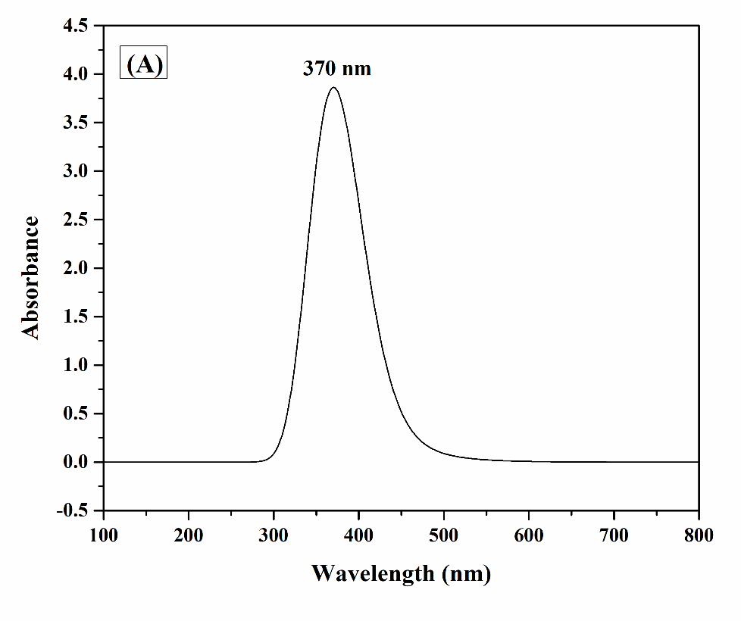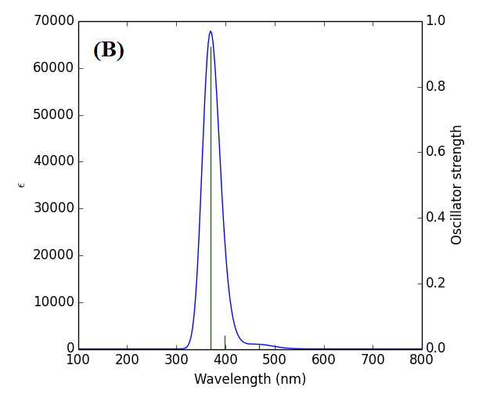
Fig. S1 UV–Vis spectra of ENFADH experimental (a) and theoretical (b) (GAS phase))

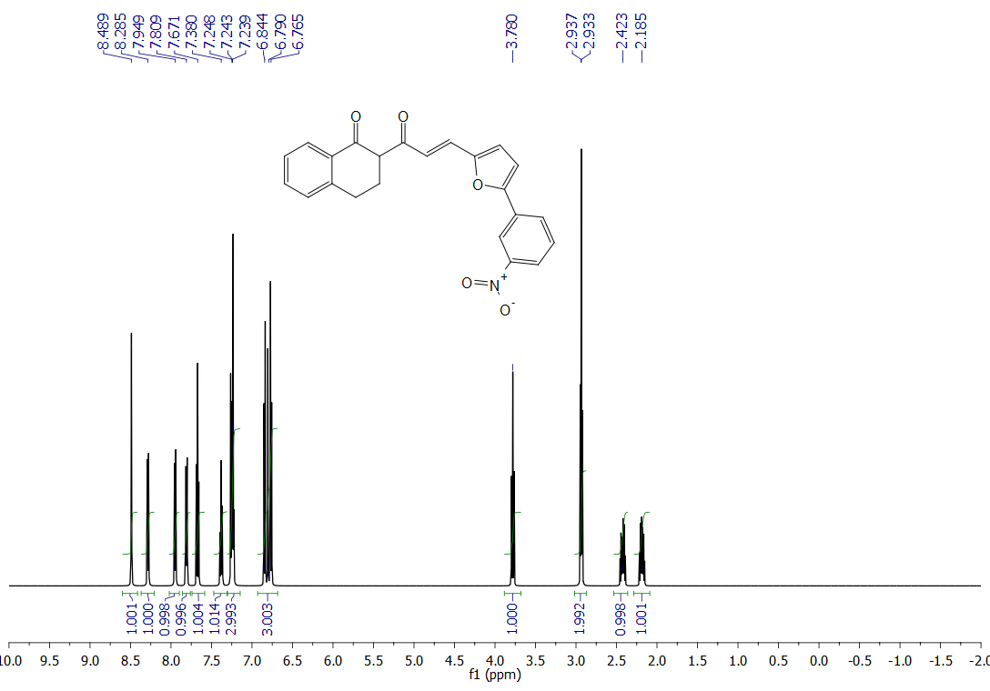

Fig. S2 ¹H Spectrum of Compound in CDCl₃ Solvent ENFADH

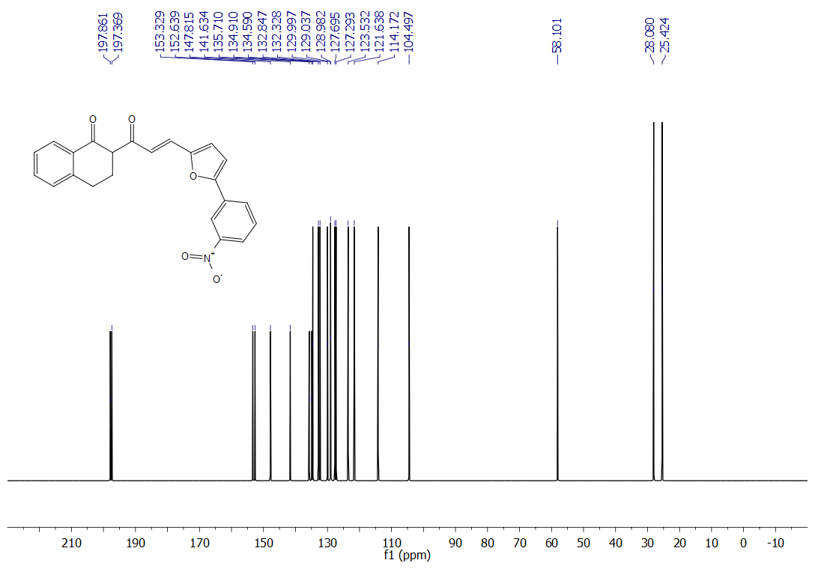
Fig. S3 ¹³ C Spectrum of Compound in CDCl₃ Solvent ENFADH

