Appendix S1: Flowering periods
The flowering overlap was examined in the B3, B4, and B7 sites where the dominances of each species were greatest (the B4 and B7 sites) or similar (the B3 site) (see Figure 3ab). The number of flowers of R. groenlandicum was counted in the 1-m2 quadrates in the B3 and B7 sites, and one of R. tomentosum was counted in the B3 and B4 sites every week from the end of May to the beginning of July 2023.
To compare the flowering phenology between the species, a GLMM was performed. The number of flowers was employed as a response variable; species, day of the year in 2023 (both linear and quadratic terms), and their interactions were employed as fixed effects; and the site was employed as a random effect. We assumed that the number of flowers followed the Poisson distribution. AIC was also used to select the best-fit model.
All variables of species, day of the year, and their interactions were significantly selected based on AIC. The peaks of flowering periods were one week earlier in R. tomentosum (around 15th July) than in R. groenlandicum (around 23rd July), but the flowering periods overlapped (Figure S7).

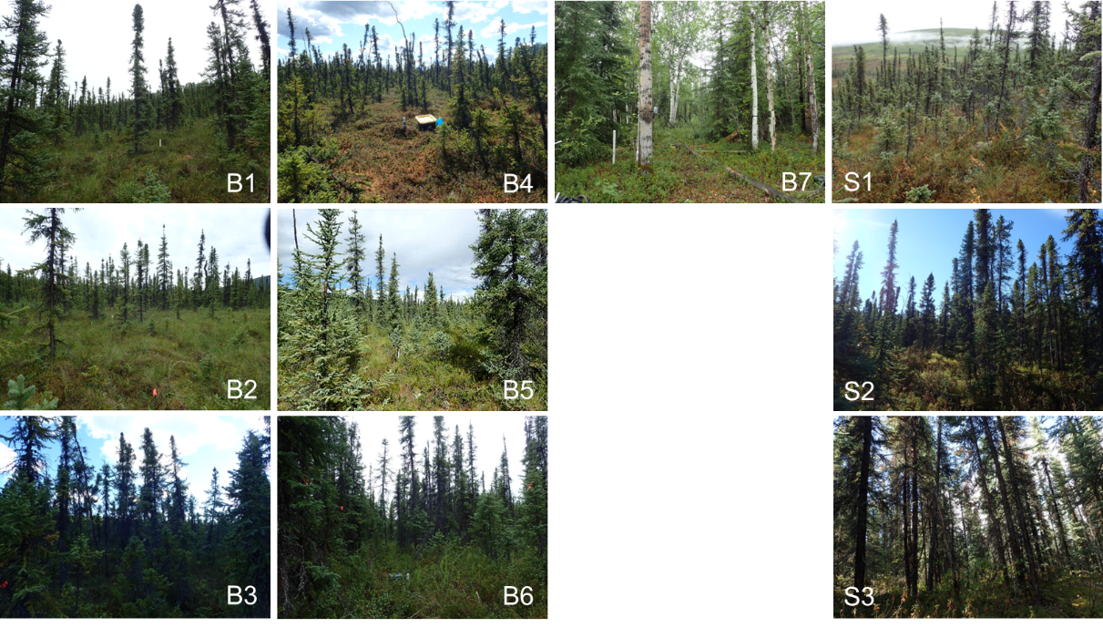

Fig. S1 Photographs of the study sites.

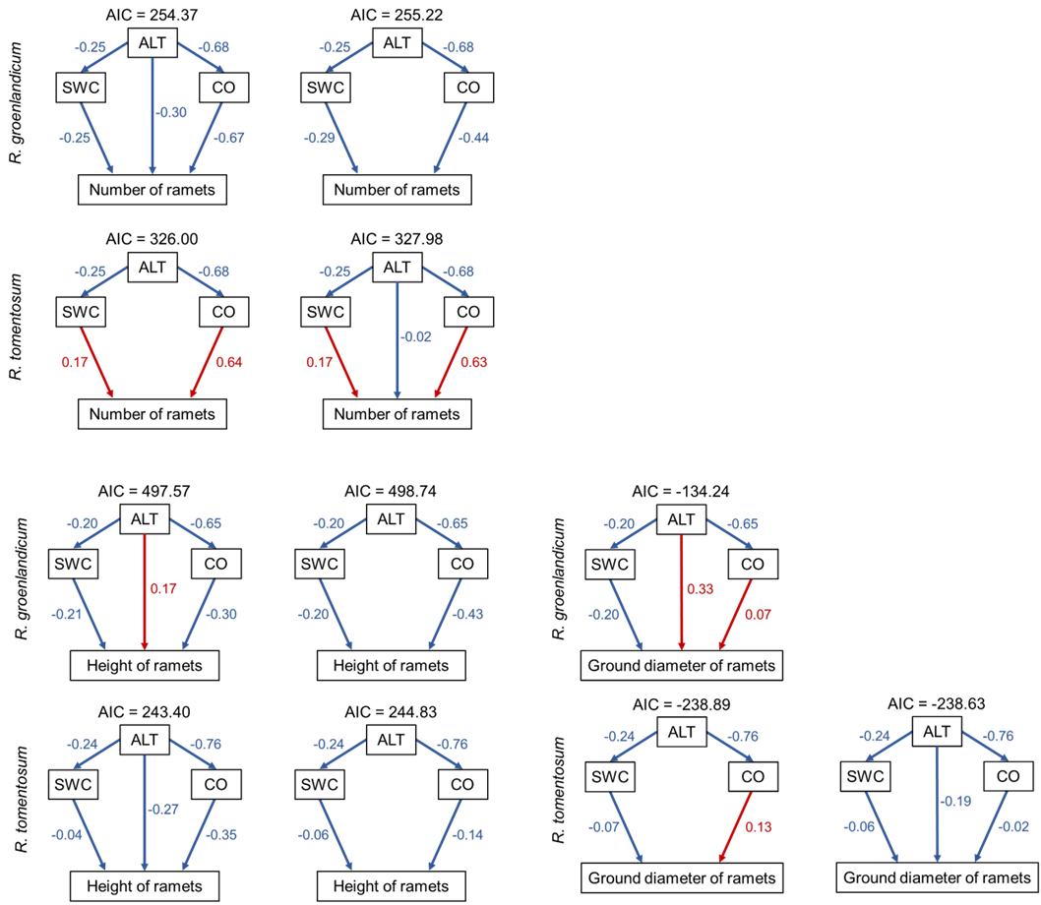

Fig. S2 Associations of environmental variables with the numbers, heights, or ground diameters of ramets in each species with ΔAIC < 2.00. Red and blue arrows indicate positive and negative associations, respectively, and the numbers close to the arrows indicate standardized coefficients of each association.

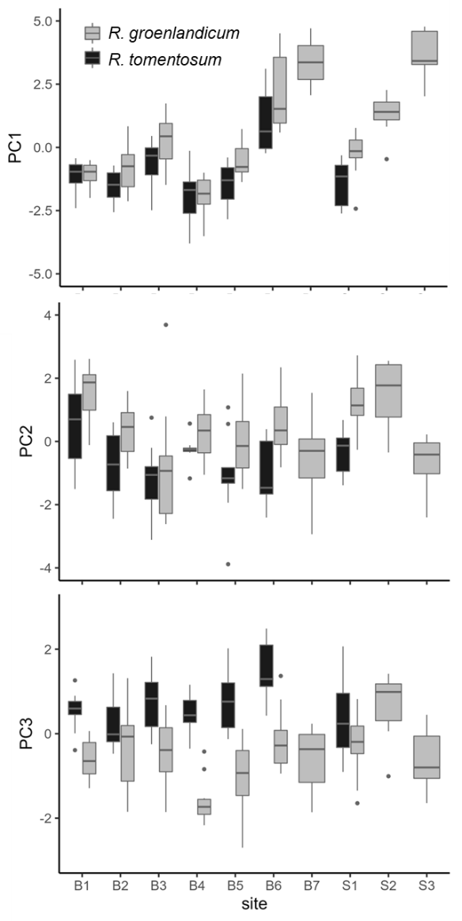

Fig. S3 PC scores of R. groenlandicum and R. tomentosum among the study sites.

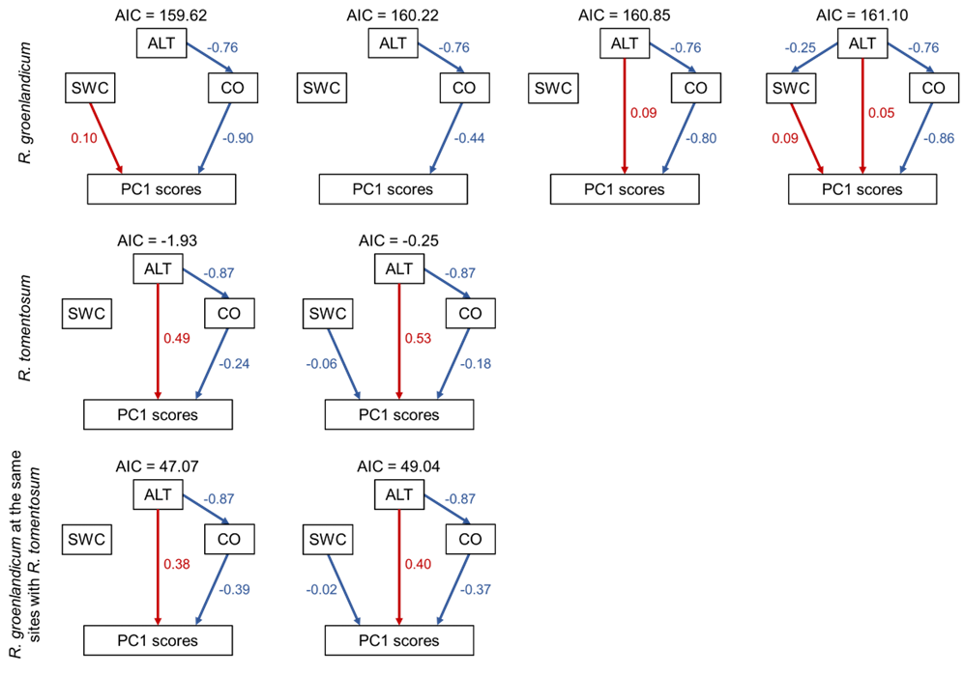
Fig. S4 Associations of environmental variables with PC1 scores in each species with ΔAIC < 2.00. Red and blue arrows indicate positive and negative associations, respectively, and the numbers close to the arrows indicate standardized coefficients of each association.

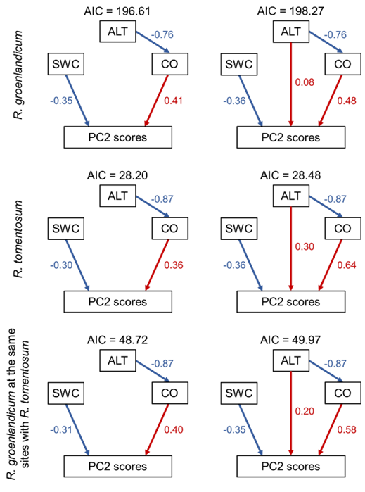

Fig. S5 Associations of environmental variables with PC2 scores in each species with ΔAIC < 2.00. Red and blue arrows indicate positive and negative associations, respectively, and the numbers close to the arrows indicate standardized coefficients of each association.

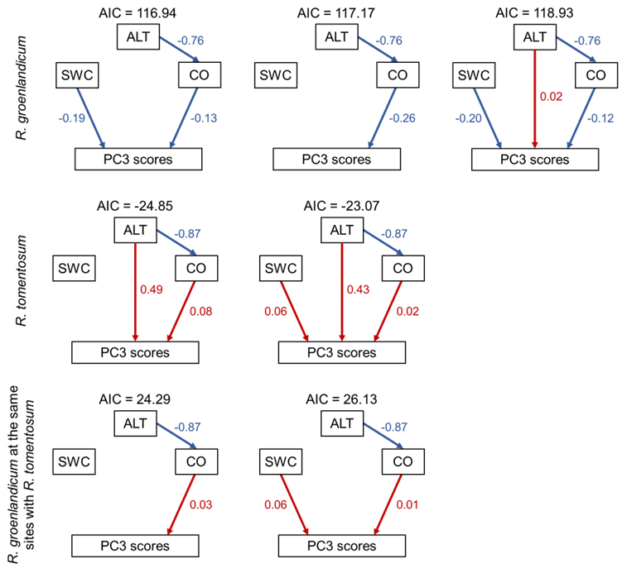

Fig. S6 Associations of environmental variables with PC3 scores in each species with ΔAIC < 2.00. Red and blue arrows indicate positive and negative associations, respectively, and the numbers close to the arrows indicate standardized coefficients of each association.

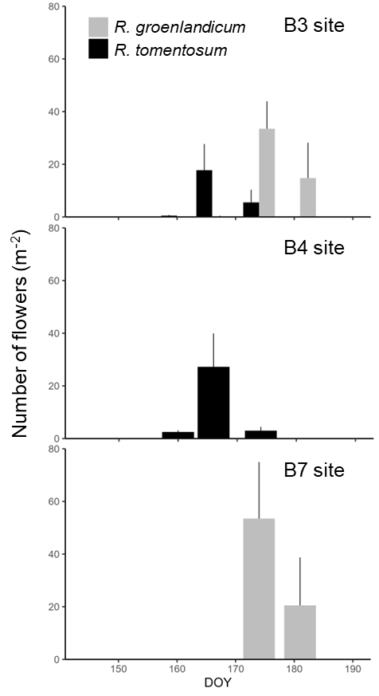
Fig. S7 The number of flowers of R. groenlandicum and R. tomentosum in the B3, B4, and B7 sites. In the GLMM, all terms of species, day of the year (both linear and quadratic terms), and their interactions were significantly selected based on AIC. The peaks of flowering periods were one week earlier in R. tomentosum than R. groenlandicum but the flowering periods overlapped to some extent.

Table S1 Standardized coefficients of the selected models (ΔAIC < 2.00) for the associations of environmental variables with the numbers, heights, or ground diameters of ramets in each species. I-V indicate the pathways in Figure 2. The best-fit models (ΔAIC = 0.00; grey line) are illustrated in Fig. 4. All models are illustrated in Figure S2. RG: R. groenlandicum, RT: R. tomentosum.

Objective variables | Species | I | II | III | IV | V | ΔAIC
Number | RG | -0.25 | -0.68 | -0.30 | -0.25 | -0.67 | 0.00
 |  | -0.25 | -0.68 | — | -0.29 | -0.44 | 0.85
 | RT | -0.25 | -0.68 | — | 0.17 | 0.64 | 0.00
 |  | -0.25 | -0.68 | -0.02 | 0.17 | 0.63 | 1.98
Height | RG | -0.20 | -0.65 | 0.17 | -0.21 | -0.30 | 0.00
 |  | -0.20 | -0.65 | — | -0.20 | -0.43 | 1.17
 | RT | -0.24 | -0.76 | -0.27 | -0.04 | -0.35 | 0.00
 |  | -0.24 | -0.76 | — | -0.06 | -0.14 | 1.43
Diameter | RG | -0.20 | -0.65 | 0.33 | -0.20 | 0.07 | 0.00
 | RT | -0.24 | -0.76 | — | -0.07 | 0.13 | 0.00
 |  | -0.24 | -0.76 | -0.19 | -0.06 | -0.02 | 0.26

Table S2 Standardized coefficients of the selected models (ΔAIC < 2.00) for the associations of environmental variables with the numbers of ramets in each species based on the GLMM analyses. The best-fit models (ΔAIC = 0.00; grey line) are illustrated in Figure 5. Selected negative quadratic terms (ALT2, SWC2, and CO2) mean that the number of ramets have a unimodal distribution across each environmental range. RG: R. groenlandicum, RT: R. tomentosum.

Species | ALT | ALT² | SWC | SWC² | CO | CO² | Intercept | ΔAIC
RG | — | — | -0.36 | — | -1.20 | -0.77 | 3.76 | 0.00
 | — | — | -0.33 | -0.14 | -1.19 | -0.74 | 3.86 | 0.42
 | -0.21 | — | -0.30 | -0.16 | -1.33 | -0.71 | 3.85 | 1.29
 | -0.16 | — | -0.33 | — | -1.31 | -0.75 | 3.74 | 1.33
 | — | — | — | -0.17 | -1.37 | -0.80 | 3.95 | 1.55
 | — | -0.06 | -0.35 | — | -1.24 | -0.75 | 3.79 | 1.75
 | — | — | — | — | -1.40 | -0.85 | 3.84 | 1.75
 | — | -0.09 | -0.31 | -0.16 | -1.25 | -0.70 | 3.91 | 1.82
 | -0.26 | — | — | -0.19 | -1.52 | -0.76 | 3.93 | 1.90
RT | — | — | 0.51 | — | 2.14 | -1.40 | 4.06 | 0.00
 | — | — | 0.82 | -0.31 | 2.09 | -1.46 | 4.37 | 0.36
 | — | — | — | — | 2.41 | -1.19 | 3.88 | 0.41
 | 0.41 | — | 0.49 | — | 2.47 | -1.54 | 4.14 | 1.23
 | 0.48 | — | — | — | 2.79 | -1.35 | 3.98 | 1.41
 | — | 0.14 | 0.52 | — | 2.26 | -1.51 | 4.00 | 1.74
 | 0.34 | — | 0.79 | -0.29 | 2.37 | -1.58 | 4.43 | 1.81

Table S3 Standardized coefficients of the selected models (ΔAIC < 2.00) for the associations of environmental variables with the PC scores of leaf traits in each species. I-V indicate the pathways in Figure 2. The best-fit models (ΔAIC = 0.00; grey line) are illustrated in Figure 8. All models are illustrated in Fig. S4-6. RG: R. groenlandicum in all sites, RGlimit: R. groenlandicum in the sites where R. tomentosum was found (i.e., B1-6 and S1; see Figure 3), RT: R. tomentosum.

Objective variables | Species | I | II | III | IV | V | ΔAIC
PC1 | RG_{all} | — | -0.76 | — | 0.10 | -0.90 | 0.00
 |  | — | -0.76 | — | — | -0.44 | 0.60
 |  | — | -0.76 | 0.09 | — | -0.80 | 1.23
 |  | -0.25 | -0.76 | 0.05 | 0.09 | -0.86 | 1.48
 | RG_{limit} | — | -0.87 | 0.38 | — | -0.39 | 0.00
 |  | — | -0.87 | 0.40 | -0.02 | -0.37 | 1.97
 | RT | — | -0.87 | 0.49 | — | -0.24 | 0.00
 |  | — | -0.87 | 0.53 | -0.06 | -0.18 | 1.68
PC2 | RG_{all} | — | -0.76 | — | -0.35 | 0.41 | 0.00
 |  | — | -0.76 | 0.08 | -0.36 | 0.48 | 1.66
 | RG_{limit} | — | -0.87 | — | -0.31 | 0.40 | 0.00
 |  | — | -0.87 | 0.20 | -0.35 | 0.58 | 1.25
 | RT | — | -0.87 | — | -0.30 | 0.36 | 0.00
 |  | — | -0.87 | 0.30 | -0.36 | 0.64 | 0.28
PC3 | RG_{all} | — | -0.76 | — | -0.19 | -0.13 | 0.00
 |  | — | -0.76 | — | — | -0.26 | 0.23
 |  | — | -0.76 | 0.02 | -0.20 | -0.12 | 1.99
 | RG_{limit} | — | -0.87 | — | — | 0.03 | 0.00
 |  | — | -0.87 | — | 0.06 | 0.01 | 1.84
 | RT | — | -0.87 | 0.49 | — | 0.08 | 0.00
 |  | — | -0.87 | 0.43 | 0.06 | 0.02 | 1.84

