SUPPLEMENTARY INFORMATION

Recent increasing eastern Siberian wildfires linked to
rapid summer Russian Arctic sea-ice loss

Binhe Luo¹⁾, Dehai Luo²⁾, Aiguo Dai³⁾, Cunde Xiao¹⁾, Ian Simmonds⁴⁾, Edward Hanna⁵⁾, James Overland⁶⁾, Yao Yao²⁾, Jiaqi Shi²⁾, Wansuo Duan²⁾, Yimin Liu²⁾, Qiang Zhang⁷⁾, Xiyan Xu²⁾, Yina Diao⁸⁾, Zhina Jiang⁹⁾ and Tingting Gong¹⁰⁾
- State Key Laboratory of Earth Surface Processes and Resource Ecology, Beijing Normal University, Beijing, China
- Institute of Atmospheric Physics, Chinese Academy of Science, Beijing, China, 100029 and University of Chinese Academy of Sciences, Beijing, China
- Department of Atmospheric and Environmental Sciences, State University of New York, Albany, NY, USA
- School of Geography, Earth and Atmospheric Sciences, University of Melbourne, Melbourne, Australia
- Department of Geography, School of Life and Environmental Sciences, University of Lincoln, UK
- NOAA/Pacific Marine Environmental Laboratory, Seattle, Washington, USA
- Department of Earth system Science, Tsinghua University
- College of Oceanic and Atmospheric Sciences, Ocean University of China, Qingdao, China
- Institute of Arctic and Global change, Chinese Academy of Meteorological Sciences, Beijing, China
- Institute of Oceanography, Chinese Academy of Science, Qingdao, China

This PDF file includes:

Supplementary Extended Data Figures 1 to 8

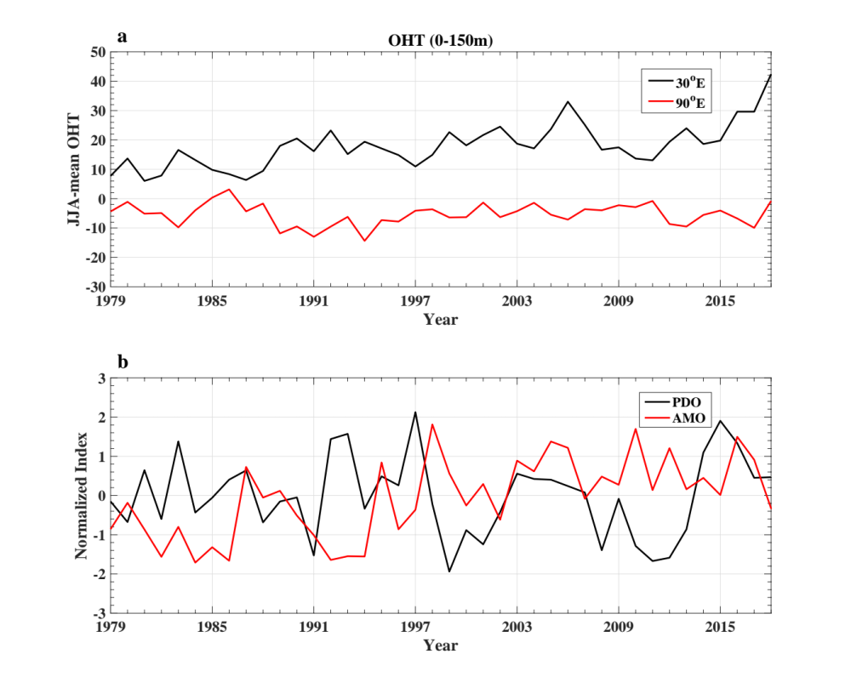

Extended Data Figure 1. Temporal variations of summer (JJA) mean upper ocean heat transport (OHT) in the Arctic regions, Atlantic Multidecadal Oscillation (AMO) and Pacific Decadal Oscillation (PDO) indices.
a-b, Time series of summer (June to August, JJA) mean (a) ocean heat transport averaged from the surface to the depth at 150 m (0-150m) at the two Arctic regions: 30ºE, 65º- 85ºN near the Barents Sea Opening (black line) and 90ºE, 65º- 85ºN near Laptev Sea (red line), and (b) Atlantic Multidecadal Oscillation (AMO) (red line) and Pacific Decadal Oscillation (PDO) (black line) indices.

Extended Data Figure 2. The lead-lag correlation coefficient of the summer upper ocean heat transport (OHT) with the summer AMO and PDO index
a-b, Lead-lag correlation coefficients between the summer upper ocean heat transports (OHTs) at the longitudinal locations (a) 30ºE and (b) 90ºE along the latitude belt (65º-85ºN) with the summer AMO (blue line) and PDO (red line) indices during 1979-2018.

Extended Data Figure 3. Scatter diagram of Arctic warming over East Siberia against Russian Arctic SIC anomaly.
Scatter diagram of the normalized summer mean surface air temperature (SAT) anomaly averaged over east Siberia (90º-150ºE, 60º-75ºN) against the normalized Russian Arctic anomaly averaged over the region (30ºE-130ºE; 65ºN-85ºN) during 1979-2021 for non-detrended data. The slope rate of -0.63 is significant at the 95% confidence level.

Extended Data Figure 4. Temporal variation of summer precipitation anomaly over east Siberia and its trend patterns over 1979-2003 and 2004-2021.
a, Normalized time series of summer (JJA) mean precipitation anomaly averaged over east Siberia (90º-150ºE, 60º-75ºN) during 1979-2021 with the slope rates of the linear trends over 1979-2003 (dashed blue line) and 2004-2021 (dashed red line). b-c, Linear trend patterns of the summer mean precipitation anomalies over (b) 1979-2003 and (c) 2004-2021, where the dot represents the significant region with a 95% confidence level for a two-sided student t-test.

Extended Data Figure 5. Variation of composite atmospheric precipitation anomaly fields during Siberian blocking episodes with the sea-ice cover (SIC) extent over Russian Arctic.
a-b, Time-mean composite daily precipitation anomalies averaged from lag -10 to 10 days of Siberian blocking (SB) events during 1979-2021 for (a) low and (b) high SIC summers, where lag 0 denotes the peak day of SB, the blue (red) shading denotes the negative (positive) precipitation anomaly and the dot represents the region being significant at the 95% confidence level based on a two-sided student t-test.

Extended Data Figure 6. Spatial patterns of time-mean composite daily wildfire fractions associated with Siberian blocking (SB) events averaged the blocking period based on the satellite data during 2003-2021.
a-d, Time-mean fields of composite daily wildfire fraction (WF, color shading, unit: non-dimensional) anomalies averaged from lag-10 to 10 days of Siberian blocking (SB) events for (a) low and (b) high sea-ice cover (SIC) summers during 2003-2021. (c, d) Time-longitude evolutions of the composite daily wildfire fraction (WF, color shading, unit: non-dimensional) anomalies averaged over 60ºN-80ºN and 55ºN-75ºN during the life cycle from lag-10 to 10 days of Siberia blocking (SB) events for (c) low and (d) high SIC summers during 2003-2021. The color shading denotes the region being significant at the 95% confidence level based on a two-side Student t-test.

Extended Data Figure 7. Spatial patterns of composite atmospheric fields related to Siberian blocking (SB) events.

a-d, Time-mean fields of composite daily (a, b) 500-hPa geopotential height (Z500, contour interval=10 gmp) and surface air temperature (SAT, color shading, unit: K) and (c, d) fire weather index (FWI, color shading; unit: non-dimensional) anomalies averaged from lag-10 to 10 days of Siberia blocking (SB) events for (a, c) low and (b, d) high SIC summers during 2003-2021, where lag 0 denotes the peak day of the SB. The color shading anomalies represents the region being significant for the 95% confidence level based on a two-side Student t-test.

Extended Data Figure 8. The variations of atmospheric background fields with the Russian Arctic sea-ice cover (SIC) extent.
a-f, JJA-mean (a, b) 500 hPa zonal wind and (d, e) meridional potential vorticity gradient (PV_{y}) anomalies without Siberian blocking events for which the daily fields of the blocking life cycle are removed for (a, d) low and (b, d) high SIC summers as well as (c, f) low minus high differences during 1979-2021. The dot represents the region being significant at the 95% confidence level based on a two-sided student t-test.

