Supplementary materials
Materials and methods
Literature search and data abstraction
Two researchers (YJ and MX) independently conducted the literature retrieval from the PubMed (http://www.ncbi.nlm.nih.gov/) and Web of Science (https://webofknowledge.com/) databases for papers published before June 26, 2023 without restriction to regions, publication, types or languages. We used the following key words to search for suitable studies: ("voxel-based morphometry" OR "VBM" OR "morphometry" OR "gray matter" OR "grey matter") AND ("parkinson disease" OR ("parkinson" AND "disease") OR "parkinson disease" OR "parkinson s disease" OR "PD"). For completeness, we did not limit disease subtype comparisons in the retrieval process but rather restricted them in the subsequent artificial screening process. In addition, we manually searched the reference lists of the selected articles and PD-related meta-analyses for additional qualifying studies. Moreover, the meta-analysis was pre-registered on PROSPERO (https://www.crd.york.ac.uk/PROSPERO/,NO: CRD42023439786).
Study screening was performed separately by two authors (YJ and MX). Any disagreement was resolved by the adjudicating senior investigator (FX). All studies were included according to the following criteria: (i) studies explored GMV changes in patients with Parkinson’s disease; (ii) patients diagnosed as Parkinson’s disease according to the criteria of the UK Bank; (iii) comparisons Brain were performed between patients and controls; (iv) voxel-wise comparisons were carried out within whole-brain gray matter rather than regions of interest; (v) statistical results were reported in a stereotactic space (Montreal Neurological Institute [MNI] or Talairach coordinates). Exclusion criteria were as follows: (i) studies were not original papers (e.g., editorials, letters to the editor, review articles, and meta-analyses); (ii) studies were case reports; (iii) studies involved animal experiments; (iv) data could not be obtained from the published investigations or after contacting the authors. We also excluded studies whose data overlapped those of other studies (e.g., from the same institution or authors), with most recent or the most complete report included in our meta-analysis.
The data were independently extracted by two reviewers (YJ and MX). The following data were abstracted from the included papers: first author, sample size, sex, mean age, education, illness duration, UPDRSⅢ scores, software used for voxel-based morphometry (VBM), and magnetic resonance imaging (MRI) scanner. To ensure comprehensive and transparent reporting of methods and results, the research was conducted in line with the Preferred Reporting Items for Systematic Reviews and Meta-analyses guidelines¹.
Sensitivity and heterogeneity analyses of meta-analysis
Several supplementary analyses were pursued to test the robustness and reliability of our meta-analysis results. First, to assess the replicability of the results, a whole-brain voxel-based jackknife sensitivity analysis was performed by iteratively repeating meta-analyses, discarding one study each time. The results that remain significant in all or most of the combinations of studies are considered highly replicable. Second, potential publication bias was assessed by two tests for small-study effect and excess significance, respectively. Finally, I² statistic was calculated to describe which percentage of the variability between studies might be due to between-study heterogeneity, with I² > 50% commonly indicating serious heterogeneity ².
Participants in the independent dataset
Forty-eight PD patients attending the PD Clinic at the Affiliated Wuxi People’s Hospital of Nanjing Medical University were prospectively and consecutively recruited into this study between August 2021 and April 2023, as they were diagnosed with idiopathic PD according to the UK Parkinson’s Disease Brain Bank criteria ³. Twenty-six healthy people matched for age and sex were also enrolled as controls. PD patients were included if they (1) were coincident with the PD diagnosis standard according to the UK Parkinson’s Disease Brain Bank criteria ³; (2) were aged 40–80 years old; (3) were right-handers; (4) were able to perform MRI scans and finish the neurological and psychological assessment; (5) had no cognitive impairment; and (6) were willing to take part in this research. PD patients were extra excluded if: (1) inability to cooperate with clinical assessment or MRI examination; (2) max head motion ≥ 2.5mm or 2.5◦; (3) Mini-Mental State Examination (MMSE) score <24; and (4) history of severe neurological or cerebrovascular diseases besides PD. The ethics committee’s approval of the Affiliated Wuxi People’s Hospital of Nanjing Medical University was acquired, and written informed consent was obtained from all participants according to the Declaration of Helsinki. All dopaminergic therapy was withheld for at least 12h before the MRI scan to alleviate the impact of drugs.
MRI data acquisition in the independent dataset
Magnetic resonance images were obtained on 3.0T MRI equipment (Magnetom 3T Siemens, Prisma, Germany) with the 20-channel head coil in the morning. When shifting lying positions, we used a foam pad to minimize head motion and earplugs to reduce scanner noise. In addition, all the participants were instructed to stay awake, close their eyes, and try not to think about anything during the examination ^{4,5}. We obtained T1-weighted anatomical data using a volumetric 3D-magnetization prepared rapid acquisition gradient echo (3DT1WI MP-RAGE) sequence with the following parameters: repetition time (TR) = 2300 ms, echo time (TE) = 2.98 ms, inversion time (TI) = 900 ms, flip angle (FA) = 9◦, slice thickness = 1 mm, slices per slab = 192, the field of view (FOV) = 256 × 256 mm², matrix size = 256 × 256, and voxel size = 1 × 1 × 1 mm³. The 3D-T1WI MP-RAGE scanning duration was 5 min and 30 s.
GMV analysis in the independent dataset
We applied the Statistical Parametric Mapping program (SPM12) to run the VBM analysis on the MATLAB R2018b platform to explore structural differences among the two groups ⁶. The VBM analysis consists of the following three steps: (1) segmenting the 3D-T1WI MP-RAGE data of each participant into the cerebrospinal fluid, white matter, and gray matter; (2) spatially normalizing and transforming the gray matter images into MNI space; (3) spatial smoothing at 8 × 8 × 8 mm³ FWHM Gaussian kernel.
Brain gene expression data processing
Brain gene expression data was extracted from the open AHBA dataset. (http://www.brain-map.org) ^{7,8}. The dataset was collected from six human postmortem donors (Table S1). The original expression data of over 20 000 genes via 3702 spatially separate brain tissue samples was analyzed relying on a newly suggested pipeline ⁹. Using the Re-Annotator package, we particularly first updated the most probe-to-gene annotations based on the up-to-date information from the National Center for Biotechnology Information (NCBI) ¹⁰. We eliminated probes that did not outperform the background noise in at least 50% of samples from all donors using intensity-based filtering. We further applied RNA-seq data as a reference to pick probes since multiple probes were used to quantify the expression level of a single gene. We calculated the correlations between microarray and RNA-seq expression measures for the remaining genes after removing genes whose expression patterns do not overlap across RNA-seq and microarray datasets. After eliminating probes with low correlations (r < 0.2), a representative probe for a gene was chosen on the basis of the strongest correlation to the RNA-seq data. Only tissue samples in the left cerebral cortex were used in this study. For one thing, all six donors had expression data in the left hemisphere, while only two had samples in the right. Another issue is that the inclusion of subcortical samples may generate biases due to the large disparities in gene expression between cortical and subcortical regions ⁷. To account for both potential between-sample differences and donor-specific effects in gene expression, we applied the scaled robust sigmoid normalization approach to perform within-sample cross-gene and within-gene cross-sample normalization. Differential stability (DS) is an indicator that measures the consistency of regional variance among donor brains. Previous study has found that genes with high DS scores exhibit more consistent spatial expression patterns among donors ⁸. We only picked genes with relatively more conserved expression patterns for analysis since gene expression conservation across subjects is necessary for the transcription-neuroimaging spatial correlations. In order to manage, we ranked the genes according to their DS values and selected the top 50% with the highest DS values for the primary analysis. Furthermore, we performed sensitivity analyses using two additional DS cutoff thresholds (top 40% and 60%) in order to assess the impact of various DS threshold selections. Fig. S1 in the Supplementary materials displays the number of remaining probes and genes at each processing step.
Spatially-constrained permutation test
In order to confirm the significance of our findings, a spatially-constrained permutation test was carried out to evaluate if the number of our discovered genes was significantly higher than the random level. The standard non-parametric null (i.e., randomly shuffling the sample labels) is strongly violated by the spatial autocorrelation of brain maps given that transcriptional data are spatially autocorrelated, i.e., nearby anatomical regions tend to have more similar patterns of gene expression than spatially distant regions, resulting in greater family-wise error rates ¹¹. To deal with this issue, we conducted the permutation test using a spatially constrained null model suggested by Burt et al. ¹². This method is implemented in an open-access, Python-based software package, BrainSMASH: Brain Surrogate Maps with Autocorrelated Spatial Heterogeneity (https://github.com/murraylab/brainsmash). It can simulate volumetric surrogate brain maps which utilize three-dimensional Euclidean distance between regions to preserve spatial autocorrelation. We applied this approach to produce spatial autocorrelation-preserving surrogate maps for each gene to correct the spatial autocorrelation in transcriptional data. Using exactly the same procedure as described above, these surrogate maps were utilized to re-identify genes linked to GMV variations in PD patients. Then, the number of genes discovered in each test was recorded as we performed this process 5000 times to create a null distribution. Finally, to test whether our results varied from randomness, we compared the number of genes obtained through the real data with this null distribution.
Behavioral relevance analysis
We investigated their interactions with behavioral domains from the Neurosynth (https://neurosynth.org/), a well-validated and publicly available platform for meta-analysis of neuroimaging literature, to capture the behavioral relevance of the genes connected to GMV variations in PD patients ¹³. Nearly all aspects of human behavior are covered by the activation maps of 1335 behavioral terms contained in the Neurosynth database. Cross-sample correlation analysis between activation levels and gene expression measures was performed for each term, yielding a set of correlation coefficients corresponding to the genes. We averaged the absolute values of these correlation coefficients (|r | mean) to measure the degree to which these genes were associated with each term, given that high positive and negative correlation coefficients both show that a gene contributes to a behavioral term. Finally, the behavioral terms were ranked by |r | mean, and the terms with the highest |r | mean were chosen to represent the behavioral relevance of the genes associated with GMV changes in PD patients. For visualization and interpretation, a criterion of |r | mean > 0.2 was employed in this case. Using the same analytic pipeline applied to the Neurosynth, we also tested the associations of gene expression with 63 behavioral domains via the BrainMap (http://brainmap.org/) ¹⁴.

Supplementary Figures
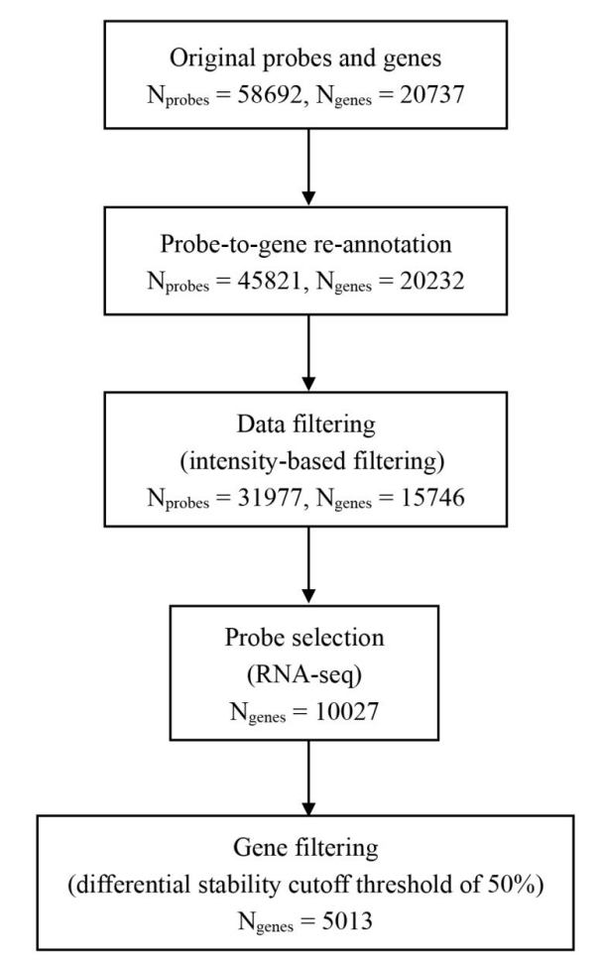
Figure S1. The remaining probes and genes at each processing step.

Figure S2. The study selection process of the meta-analysis.

Figure S3. The tests for small-study effect and excess significance.
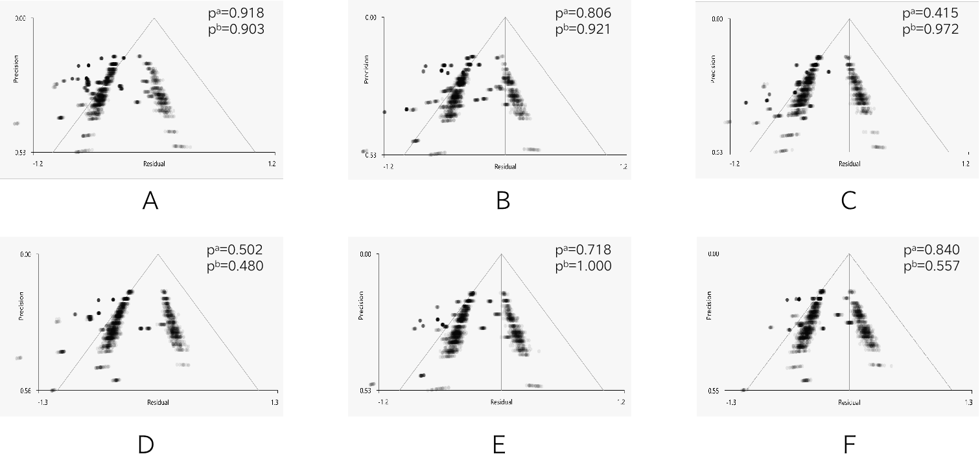
Funnel plots of six significant clusters showing gray matter atrophy between PD and HC. (A)Right superior temporal gyrus (B) Left superior temporal gyrus (C) Right angular gyrus (D)Right inferior parietal (E)Left superior frontal gyrus (F)Left inferior parietal
Abbreviations: PD, patients with Parkinson’s disease; HC, healthy controls.
ª A test for small-study effect.
^{b} A test for excess significance.

Figure S4. The results of the 5000 spatially-constrained permutation test.
The horizontal axis represents the number of genes obtained from a 5,000-time spatially constrained permutation test using BrainSMASH and the vertical axis represents the frequency, indicating that our results were by no means random.

Fig. S5 Functional enrichment of the identified genes related to gray matter atrophy in PD patients.
For the circle figure, each color represents a distinct biological process and pathway category from the GO and pathway databases. From Outer to Inner Circles, GO and pathway ID, the Gene Ontology and pathway identifier associated with each biological process; Enriched Gene Count, the number of genes enriched in each respective biological process, the color intensity represents the -log10(q) enrichment score for each GO term. GO name, the name or description of each biological process corresponding to the GO ID; Rich Factor, refers to the ratio of the number of the significant genes annotated to the item to the number of all genes annotated to the item. BP, biological process; CC, cellular component; GO, gene ontology; MF, molecular function; PD, Parkinson disease; PW, pathway.
Supplementary Tables
Table S1. Demographic information of the six adult donors in the AHBA
Donor | Age (years) | Gender | Ethnicity | Hemisphere | Post-mortem interval (h)
H0351.2001 | 24 | Male | African American | Both | 23
H0351.2002 | 39 | Male | African American | Both | 10
H0351.1009 | 57 | Male | Caucasian | Left | 25.5
H0351.1012 | 31 | Male | Caucasian | Left | 17.5
H0351.1015 | 49 | Female | Hispanic | Left | 30
H0351.1016 | 55 | Male | Caucasian | Left | 18
Abbreviation: AHBA, Allen Human Brain Atlas.
Table S2. Demographic and clinical characteristics of the 44 studies in the meta-analysis.
Study | Comparison | Number (female) |  | Age (years) |  | Education (years) |  | Illness duration (years) | UPDRS III |  | MRI scanner
Study |  | HC | PD | HC | PD | HC | PD | Illness duration (years) | UPDRS III | Software | MRI scanner
Agosta, F., et al. (2013) | HC>Moderate + severe PD | 42/17 | 26/12 | 64.0±7.0 | NA | 13.0±3.0 | NA | NA | NA | SPM8 | 1.5T Siemens
Alzahrani, H., et al. (2016) | HC>PD with apathy | 65/NA | 25/NA | 62.79±9.77 | 68.7 ± 8.4 | 12.21±5.49 | 10.9±4.5 | 10.3 ±5.98 | NA | SPM8 | 1.5 T Philips
 | HC>PD without NPSS | 65/NA | 40/NA | 62.79±9.77 | 66.1±8.5 | 12.21±5.49 | 11.2±4.7 | 7.9 ±4.5 | NA
Baagil, H., et al. (2023) | HC>PDICB+ | 61/19 | 36/12 | 64.1±7.6 | 65.7±9.0 | 16.5±2.9 | 15.7±3.4 | 4.3±0.7 | 20.3±14.1 | SPM12 | 3.0T Siemens
Beyer, M. K., et al. (2007) | HC>PDD | 20/10 | 16/6 | 73.3±6.3 | 73.5±6.5 | 12.1±4.3 | 10.2±3.6 | 12.1±4.3 | NA | SPM2 | 1.5T Siemens
Biundo, R., et al. (2011) | HC>PD | 22/17 | 59/26 | NA | NA | NA | NA | NA | NA | SPM8 | 1.5 T Philips
Borroni, B., et al. (2015). | HC>PDD | 10/7 | 10/4 | 62.2±8.0 | 74.5±4.6 | 8.2±3.5 | 6.2±3.1 | 10.9±6.0 | 27.9±10.5 | SPM8 | 1.5T Siemens
Burton,E.J.,etal. (2004) | HC>PDD | 36/16 | 26/10 | 75.1±6.6 | 72.3 ±5.2 | NA | NA | 6.83±5.05 | 36.4±10.5 | NA | 1.5T GE
 | HC>PD | 36/16 | 31/8 | 75.1±6.6 | 75.2±5.2 | NA | NA | 3.63±2.85 | 25.8±11.1
Camicioli, R., et al. (2009) | HC>PD | 43/19 | 43/19 | 71.0±4.5 | 70.7±4.0 | 15.0±3.5 | 14.2±3.0 | 8.3±4.5 | 16.7±8.1 | SPM5 | 1.5T Siemens
Chang, Y. T., et al. (2017). | HC> PD-MCI-ND | 27/13 | 42/22 | 63.4±8.1 | 65.8±9.8 | 9.6±2.7 | 8.6±4.0 | NA | 30.8±20.0 | SPM8 | 3.0T GE
 | HC> PD-MCI-D | 27/13 | 35/14 | 63.4±8.1 | 62.7±11.8 | 9.6±2.7 | 9.3±4.3 | NA | 27.1±14.7
Chen, B., et al. (2017) | HC>PD-NC | 21/13 | 11/6 | 61.1±8.43 | 59.18±5.12 | 10.86±2.44 | 11.64±2.58 | 3.74±2.20 | 16±7.09 | SPM8 | 3.0T GE
 | HC>PD-MCI | 21/13 | 21/9 | 61.1±8.43 | 63.57 ±11.16 | 10.86±2.44 | 10.19±2.44 | 4.23±3.21 | 16.93±5.42
Chen, M. H., et al. (2016) | HC>PD | 15/10 | 23/17 | 56.00±8.95 | 61.04±6.79 | NA | NA | 4.47±4.80 | 28.65±14.45 | SPM8 | 1.5T Siemens
Chen, Y. S., et al. (2019). | HC>PD | 59/37 | 61/37 | 60.9±6.3 | 62.61±8.59 | NA | NA | 3.04±2.97 | 23.66±13.97 | SPM8 | 3.0T GE
Cheng, K. L., et al. (2020) | HC>all PDD | 37/27 | 35/27 | 63.1±5.34 | 64.0±5.85 | 9.95±4.73 | 6.14±4.45 | NA | 31.8±16.6 | SPM12 | 3.0T GE
Chou, K. H., et al. (2015). | HC>PD | 30/14 | 48/27 | 59.1±5.9 | 61.7±11.3 | 7.71±4.81 | 9.20±3.11 | NA | 28.8±17.0 | SPM8 | 3.0T GE
Compta, Y., et al. (2012). | HC > PDD | 12/8 | 15/10 | 71.5 | 73 | 8.5 | 8 | 9 | 32 | SPM5 | 3.0T Siemens
 | HC > PDND | 12/8 | 18/6 | 71.5 | 69 | 8.5 | 8 | 10 | 28.5
Cordato, N. J., et al. (2005). | HC>PD | 23/9 | 17/4 | 71.5±7.2 | 67.7±6.7 | 11.7±2.8 | 11.3±3.3 | 7.86±2.96 | 32.3±7.4 | SPM99 | 1.5T Siemens
Droby, A., et al. (2021) | HC>FOG | 20/11 | 16/5 | 64±13.5 | 72±3 | NA | NA | NA | 27.91±16.27 | SPM12 | 1.5T GE
Fioravanti,V., et al. (2015) | HC>PD at baseline | 15/7 | 20/8 | 64.6±4.8 | 60.5±7.7 | 11.3±3.19 | 9.75±3.76 | 5.17±4.14 | 26.6±7.12 | SPM | 3.0T Philips
Gao, Y., et al. (2017) | HC>PD-CN | 21/13 | 23/8 | 63.76±5.42 | 62.35±7.73 | 12.29±3.84 | 11.22±3.97 | 2.81 ±2.43 | 23.63±13.43 | SPM8 | 3.0T GE
 | HC>PD-MCI | 21/13 | 23/13 | 63.76±5.42 | 65.09±8.71 | 12.29±3.84 | 9.34±4.03 | 5.83±8.17 | 37.59±16.09
Gerrits, N.J., et al. (2014). | HC>PD | 46/18 | 93/32 | 61±8 | 63±10 | NA | 5 | NA | 24.5±10.3 | SPM8 | 3.0T GE
Huang, L. C., et al. (2019) | HC>PD | 7/3 | 9/2 | 56.14±8.07 | 57.78±9.05 | NA | NA | 12.89±9.711 | NA | SPM12 | 1.5T GE
Jia, X., et al. (2019). | HC>PD-NC | 61/25 | 61/26 | 62.21±6.43 | 61.8±7.7 | 16.16±2.25 | 15.26±3.38 | 7.03±7.41 | 19.11±8.21 | SPM12 | 1.5T &3.0TGE
 | HC>PD-MCI | 61/25 | 61/24 | 62.21±6.43 | 64.11±7.08 | 16.16±2.25 | 14.93±3.14 | 7.03±7.23 | 22.75±9.28
Kobayakawa, M., et al. (2017) | HC>PD | 37/21 | 20/10 | 70.9±4.8 | 70.1±8.7 | 12.9±2.3 | 13.5±2.7 | 6.3±3.4 | NA | SPM8 | 3.0T Siemens
Kostic, V. S., et al. (2010). | HC>PD | 26/12 | 40/19 | 63 | 66 | NA | NA | NA | NA | SPM5 | 1.5T Siemens
Lee, E. Y., et al. (2013). | HC>PD | 40/21 | 40/19 | 58.2±6.8 | 58.5±7.2 | 15.6±3 | 15.1±3 | 3.0±3.1 | 17.7±10.7 | FSL | 3.0T Siemens
Li, L., et al. (2022) | HC>PD with MCI | 23/13 | 23/11 | 62.04±3.81 | 64.3±6.68 | 7.39±1.47 | 6.65±1.53 | 6.3±2.46 | 29.65±3.41 | SPM12 | 3.0T Siemens
Li, Y., et al. (2016) | HC>PD | 20/9 | 23/12 | 65.3±7.0 | 63.0±7.1 | 12.5±3.8 | 14.5±3.2 | 7±3.3 | 38±18.6 | SPM5 | 3.0T Siemens
Lim, J. S., et al. (2016) | HC>PD-nRBD | 25/12 | 14/6 | 68.5±6.6 | 69.7±7.2 | NA | NA | 4.4±3.7 | 22.4±10.6 | SPM8 | 3.0T Philips
 | HC>PD-RBD | 25/12 | 24/12 | 68.5±6.6 | 69.8±6.4 | NA | NA | 6.2±2.9 | 12.4±2.5
Lin, W.-C., et al. (2015). | HC>PD | 25/14 | 27/16 | 50.88±10.51 | 54.59±9.32 | 11.76±4.27 | 9.22±4.91 | NA | 23.48±12.64 | SPM8 | 3.0T GE
Meppelink, A. M., et al. (2011). | HC>PD | 14 | 24 | NA | NA | NA | NA | NA | NA | SPM5 | 3.0T Philips
Nagano-Saito, A., et al. (2005). | HC>PD advanced | 31 | 19 | 63.5±8.8 | 62.6±7.9 | NA | NA | 4.9±4.3 | 37.4±15.3 | NA | 1.5 T Toshiba
Pagonabarraga, J., et al. (2014). | HC>PD-mH | 15 | 15 | 66.8±8 | 64.1±9 | 10.1±5 | 11.1±6 | 9.8±7 | 21.7±8 | SPM5 | 1.5T GE
 | HC>PD-NH | 15 | 27 | 66.8±8 | 66.3±8 | 10.1±5 | 9.2±5 | 7.3±4 | 18.6±8
Pereira, J. B., et al. (2012). | HC>PD | 20/6 | 20/7 | 59.1±10.9 | 64±9.53 | NA | NA | 6.8±5.8 | 24.9±15.5 | SPM8 | 3.0T Siemens
Potgieser, A. R., et al. (2014). | HC>PD | 87/37 | 77/31 | 60.1±7.2 | 63.0±10.5 | NA | NA | 8.0±5.1 | 24.3±7.5 | SPM8 | 3.0T Philips
Rahayel, S., et al. (2019). | HC>PD-RBD | 41/16 | 15/5 | 63.3±8.1 | 66.7±7.6 | 14.6±4.1 | 14.2±3.6 | 3.9±2.9 | 24.1±10 | SPM12 | 3.0T Siemens
 | HC>PD-nRBD | 41/16 | 15/10 | 63.3±8.1 | 63.1±8.9 | 14.6±4.1 | 15.7±3.9 | 3.7±2.6 | 17.6±8.5 |  | 3.0T Siemens
Ramirez-Ruiz, B., et al. (2007). | HC>PD + VH | 21/12 | 18/11 | NA | NA | 7.9±4.6 | 7.6±3.7 | 12.6±5.6 | 3.2±1.0 | SPM2 | 1.5T GE
 | HC>PD without VH | 21/12 | 20/12 | NA | NA | 7.9±4.6 | 7.5±3.4 | 10.6±4.3 | 24.5±14.0
Sanchez-Castaneda, C., et al. (2009). | HC>PDD | 16/8 | 16/5 | 71.8±7.6 | 71.1±7.2 | 7.7±6.5 | 6.1±6 | 4.4±2.32 | 35.5±13.5 | SPM5 | 1.5T Philips
Santos, M. C. A., et al. (2016) | HC>LDO | 80/49 | 36/12 | 57.1±9.47 | 58.71±9.38 | NA | NA | 8.68±5.50 | 36.82±17.63 | SPM8 | 3.0T Philips
 | HC>RDO | 80/49 | 24/5 | 57.1±9.47 | 56.77±11.42 | NA | NA | 6.61±7.93 | 33.73±19.67
Wu, Y. N., et al. (2020). | HC>PD | 15/11 | 30/20 | 62.6±4.85 | 64.9±10.08 | NA | NA | 1.13±1.36 | 19.13±11.73 | SPM12 | 3.0T GE
Xia, J., et al. (2013). | HC>PD | 25/11 | 32/15 | 66.88±7.57 | 69.97±9.44 | 8.80±4.08 | 8.63±3.55 | NA | NA | SPM5 | 3.0T GE
Yoneyama, N., et al. (2018). | HC > PD-SH | 15/8 | 15/8 | 63.3±5.2 | 70.7±4.8 | NA | NA | 5.9±3.7 | 19.3±7.9 | SPM8 | 3.0T Siemens
Zhang, J., et al. (2015). | HC>PD | 20/10 | 35/16 | 59.36±6.36 | 61.86±8.98 | 9.50±2.74 | 8.54±3.25 | 4.81±3.43 | NA | SPM5 | 3.0T GE
Zheng, J. H., et al. (2022). | HC>PD | 58/26 | 180/71 | 61.8±7.0 | 62.1±6.9 | NA | NA | 6.6±4.2 | 17.9±8.3 | SPM12 | 3.0T Siemens
Zhong, M., et al. (2022). | HC>PD-mH | 31/19 | 23/17 | 60.35±7.68 | 60.57±8.88 | 8.55±2.90 | 10.35±3.77 | 7.08±5.12 | 32.78±13.28 | SPM8 | 3.0T Siemens
 | HC>PD-NH | 31/19 | 35/22 | 60.35±7.68 | 61.06±8.35 | 8.55±2.90 | 8.63±4.26 | 5.06±4.11 | 30.97±13.74
Abbreviation: FOG,PD with freezing of gait; HC, healthy controls; LDO, left-sided disease onset; MRI, Magnetic resonance imaging; NA, not applicable; NPSS, neuropsychiatric symptoms; PD, patient with Parkinson's disease; PD-CN, PD with normal cognition; PDD, PD with dementia; PDICB+, PD with impulse control behaviors; PD-MCI, PD with mild cognitive impairment; PD-MCI-D, PD-MCI with depression; PD-MCI-ND, PD-MCI without depression; PD-NC, PD with normal cognitive function; PD-mH, PD with minor hallucinations; PDND, PD with no dementia; PD-NH, PD without hallucinations; PD-nRBD, PD without rapid eye movement sleep behavior disorders; PD-RBD, PD with rapid eye movement sleep behavior disorders; RDO, right-sided disease onset; SH, severe hyposmia; SPM, Statistical Parametric Mapping program; UDPRS, Unified Parkinson’s Disease Rating Scale; VH, visual hallucinations.
Supplementary Reference
1 Moher, D., Liberati, A., Tetzlaff, J. & Altman, D. G. Preferred reporting items for systematic reviews and meta-analyses: the PRISMA statement. BMJ 339, b2535, doi:10.1136/bmj.b2535 (2009).
2 Higgins, J. P. T. & Thompson, S. G. Quantifying heterogeneity in a meta-analysis. Stat Med 21, 1539-1558 (2002).
3 Hughes, A. J., Daniel, S. E., Kilford, L. & Lees, A. J. Accuracy of clinical diagnosis of idiopathic Parkinson's disease: a clinico-pathological study of 100 cases. J Neurol Neurosurg Psychiatry 55, 181-184 (1992).
4 Fox, M. D. et al. The human brain is intrinsically organized into dynamic, anticorrelated functional networks. Proc Natl Acad Sci U S A 102, 9673-9678 (2005).
5 Fransson, P. Spontaneous low-frequency BOLD signal fluctuations: an fMRI investigation of the resting-state default mode of brain function hypothesis. Hum Brain Mapp 26, 15-29 (2005).
6 Kurth, F., Gaser, C. & Luders, E. A 12-step user guide for analyzing voxel-wise gray matter asymmetries in statistical parametric mapping (SPM). Nat Protoc 10, 293-304, doi:10.1038/nprot.2015.014 (2015).
7 Hawrylycz, M. J. et al. An anatomically comprehensive atlas of the adult human brain transcriptome. Nature 489, 391-399, doi:10.1038/nature11405 (2012).
8 Hawrylycz, M. et al. Canonical genetic signatures of the adult human brain. Nat Neurosci 18, 1832-1844, doi:10.1038/nn.4171 (2015).
9 Arnatkeviciute, A., Fulcher, B. D. & Fornito, A. A practical guide to linking brain-wide gene expression and neuroimaging data. Neuroimage 189, 353-367, doi:10.1016/j.neuroimage.2019.01.011 (2019).
10 Arloth, J., Bader, D. M., Röh, S. & Altmann, A. Re-Annotator: Annotation Pipeline for Microarray Probe Sequences. PLoS One 10, e0139516, doi:10.1371/journal.pone.0139516 (2015).
11 Markello, R. D. & Misic, B. Comparing spatial null models for brain maps. Neuroimage 236, 118052, doi:10.1016/j.neuroimage.2021.118052 (2021).
12 Burt, J. B., Helmer, M., Shinn, M., Anticevic, A. & Murray, J. D. Generative modeling of brain maps with spatial autocorrelation. Neuroimage 220, 117038, doi:10.1016/j.neuroimage.2020.117038 (2020).
13 Yarkoni, T., Poldrack, R. A., Nichols, T. E., Van Essen, D. C. & Wager, T. D. Large-scale automated synthesis of human functional neuroimaging data. Nat Methods 8, 665-670, doi:10.1038/nmeth.1635 (2011).
14 Lancaster, J. L. et al. Automated regional behavioral analysis for human brain images. Front Neuroinform 6, 23, doi:10.3389/fninf.2012.00023 (2012).

