Supplementary Materials
Contents
1. Summary statistics 1
2. Google search trends. 1
3. Water risk exposure by region 2
4. Interpretation of water risk premium and scenario analysis 4

- Summary statistics
Supplementary Table 1. Summary statistics for water municipal bonds between 2009-2019
 | Mean | Std.Dev | Min | Max | Observation
Coastal Flood Risk Score | 0.41 | 0.66 | 0.00 | 3.89 | 23183
Drought Risk Score | 1.94 | 0.31 | 0.65 | 2.38 | 23183
Issuance Spread (bps) | 47.50 | 46.06 | -22.80 | 254.60 | 21593
Coupon Rate (%) | 3.42 | 1.22 | 0.00 | 7.50 | 23178
Municipal Maturity Size ($) | 927002.85 | 4214408.64 | 5000.00 | 2.45e+08 | 23183
Time to Maturity (Year) | 4.92 | 2.56 | 0.08 | 21.52 | 23183
1(Insured) | 0.37 | 0.48 | 0.00 | 1.00 | 23183
1(Federal Taxable) | 0.02 | 0.13 | 0.00 | 1.00 | 23183
1(General Obligation) | 0.25 | 0.44 | 0.00 | 1.00 | 23183
Unemployment Rate (%) | 3.76 | 0.81 | 2.10 | 8.20 | 23183
Median Household Income ($) | 77884.35 | 18962.69 | 38567.00 | 153716.00 | 23183
Investor Belief (%) | 62.22 | 5.13 | 43.35 | 76.36 | 23183
Average Water Bill ($) | 43.25 | 15.87 | 20.00 | 77.00 | 23138
Total Water Withdrawal (Mgal/d) | 410.12 | 446.75 | 0.05 | 2189.34 | 23183
Notes: Observations are at the bond level, not issuing agency level.

- Google search trends.
We analyzed Google search trends for the terms 'flood' and 'drought' across the United States from 2009 to 2019, utilizing data from trends.google.com. This search volume encompasses queries made through various Google services, including web search, YouTube, image search, Google News, and Google Shopping.
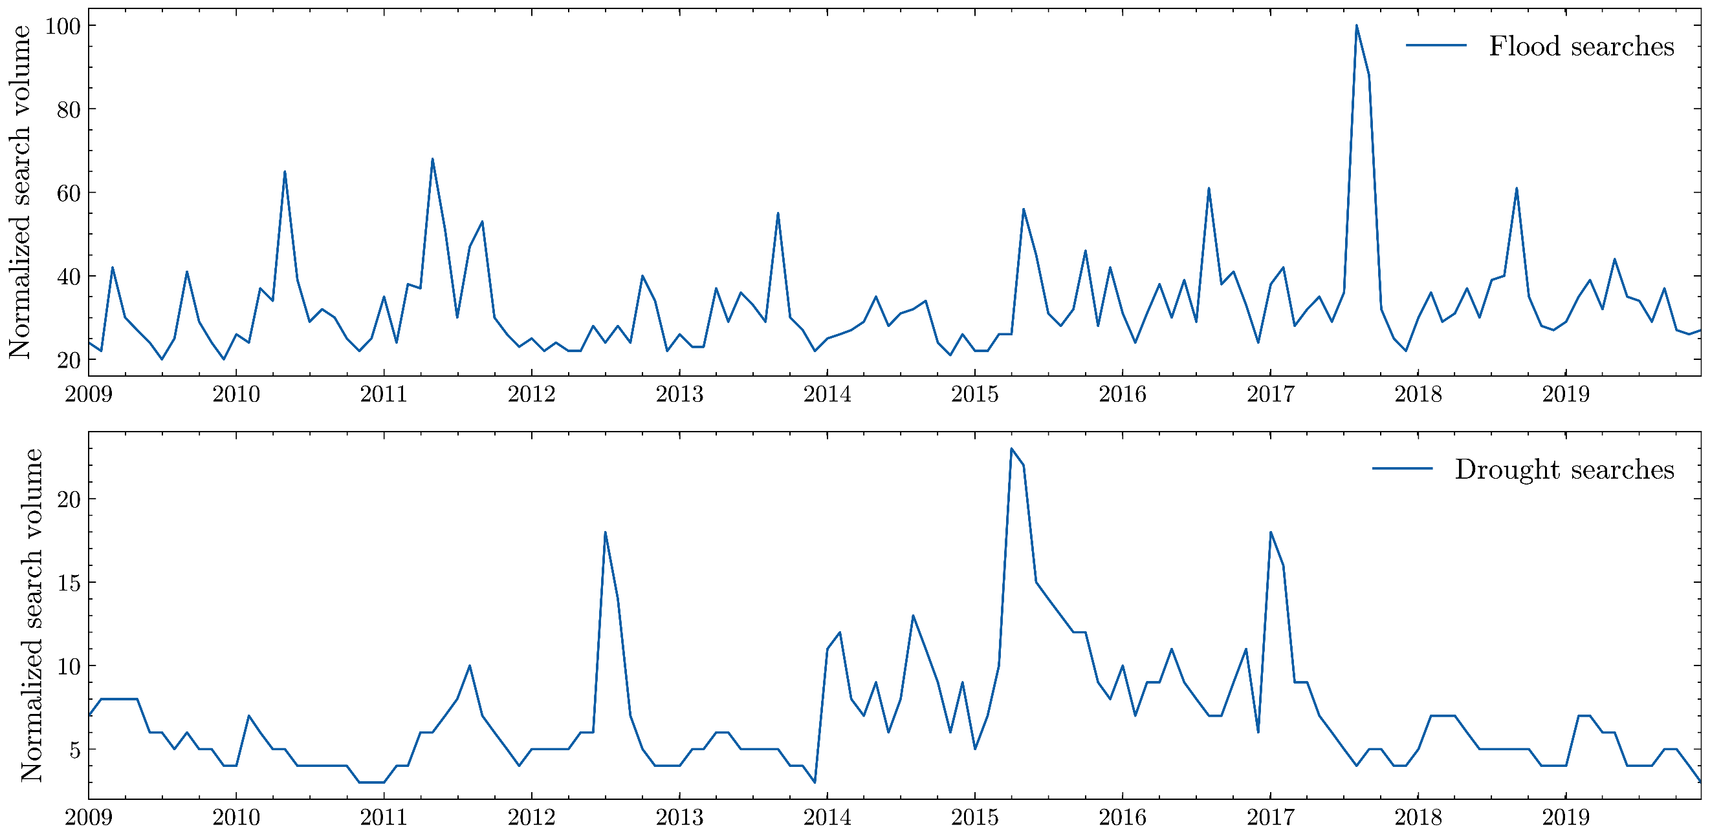Supplementary Figure 1. Google search trends for ‘flood’ and ‘drought’ as keywords.

- Water risk exposure by region
Due to the localized nature of flood and drought risk, we partitioned the sample into subregions, namely the western, southern, and northeastern regions (with no representation from the midwestern region due to absence of coastal flood risk data) based on the U.S. Census Bureau Regions and Division Map⁴⁴. Supplementary Table 2 presents estimates of impact of water risk exposure on municipal bond spreads over the 2009 to 2019 sample period in the sub-region in the U.S., using the same mixed effect regressions as discussed in the Method. Supplementary Figure 2 illustrates how flood and drought impacts on the cost of bonds have evolved over time across different regions.
Notably, approximately 61% of the water bond universe is situated within the southern region as these counties comprise the majority of bond issuers to finance water infrastructure. Among the western states, including Arizona, California, Oregon, and Washington, the impact of coastal flood risk on bond spreads after 2013 is notably significant in both magnitude and level of significance. The premium observed in the full sample is primarily driven by bonds issued in these western states. In contrast, bonds issued by municipalities in the northeast have not priced any flood risk into bond yields, as indicated by their predominantly negative coefficients. Supplementary Table 2 also suggests that the significance of the premium is temporally dynamic as not all regions are significant each year of issuance, or at the same time. Over the past decade, the most substantial coastal floods have been concentrated in the Mississippi River and the southern region, as depicted in Supplementary Figure 3 (a). However, the actual bond premium reflects investors' perception of flood risk rather than the realized damage cost.
Supplementary Table 2. Annual impact of costal flood risk and drought risk on bond spreads by region
 | Costal flood risk |  |  | Drought risk
 | Northeast | West | South | Northeast | West | South
WaterRisk exposure (Year 2009) | 6.13  (4.35) | -2.91  (4.41) | -19.59***  (4.44) | 19.12  (14.30) | 0.17  (25.70) | 49.27**  (17.60)
WaterRisk exposure (Year 2010) | -3.72  (4.52) | 9.90**  (4.45) | -0.55  (2.78) | 82.59***  (14.10) | -72.86**  (26.5) | 42.53**  (16.90)
WaterRisk exposure (Year 2011) | -3.55  (4.30) | -17.03***  (4.33) | -5.73**  (2.85) | 63.77***  (14.50) | 85.49***  (25.90) | -18.97  (18.40)
WaterRisk exposure (Year 2012) | -3.82  (4.32) | -12.92**  (4.93) | -10.47***  (2.78) | 65.24***  (14.40) | 20.55  (28.80) | 17.23  (17.10)
WaterRisk exposure (Year 2013) | -9.41**  (4.16) | -7.79*  (4.70) | 4.16  (3.72) | 31.73**  (13.50) | 56.48**  (27.80) | 1.28  (17.10)
WaterRisk exposure (Year 2014) | -2.81  (4.13) | 17.57***  (5.24) | 6.27**  (2.62) | 24.59*  (13.50) | -82.88**  (40.20) | 4.09  (18.10)
WaterRisk exposure (Year 2015) | -4.18  (4.10) | 3.03  (4.95) | 5.49**  (2.53) | 21.66  (13.30) | -10.51  (30.20) | 2.76  (17.20)
WaterRisk exposure (Year 2016) | -7.92*  (4.12) | 9.03*  (4.92) | -4.49  (2.92) | 9.68  (13.50) | -14.48  (27.00) | 37.01**  (17.30)
WaterRisk exposure (Year 2017) | -3.18  (4.14) | 5.08  (4.92) | 6.13*  (3.32) | 8.39  (13.40) | -4.14  (35.20) | -59.98**  (18.90)
WaterRisk exposure (Year 2018) | -6.71  (4.11) | 14.23**  (5.78) | 2.21  (2.88) | -1.08  (13.40) | -6.51  (30.20) | 8.74  (18.00)
WaterRisk exposure (Year 2019) | -5.83  (4.09) | 20.13***  (5.1) | 6.58**  (2.65) | 9.43  (13.40) | -46.30 (28.90) | 8.04  (17.10)
R2 | 0.64 | 0.42 | 0.73 | 0.65 | 0.42 | 0.73
R2-marginal | 0.25 | 0.29 | 0.33 | 0.28 | 0.29 | 0.33
Observations | 4828 | 3326 | 15019 | 4828 | 3326 | 15019
The baseline period for the fixed effects is 2009. Standard errors are reported in parentheses. The control, Year-Month FE and county RE is based on model 3 from Table 2. R2 accounts for both the fixed and random effects in the model, while R2-marginal represents the variance explained by the fixed factors alone. *p <.1; **p <.05; ***p <.01.
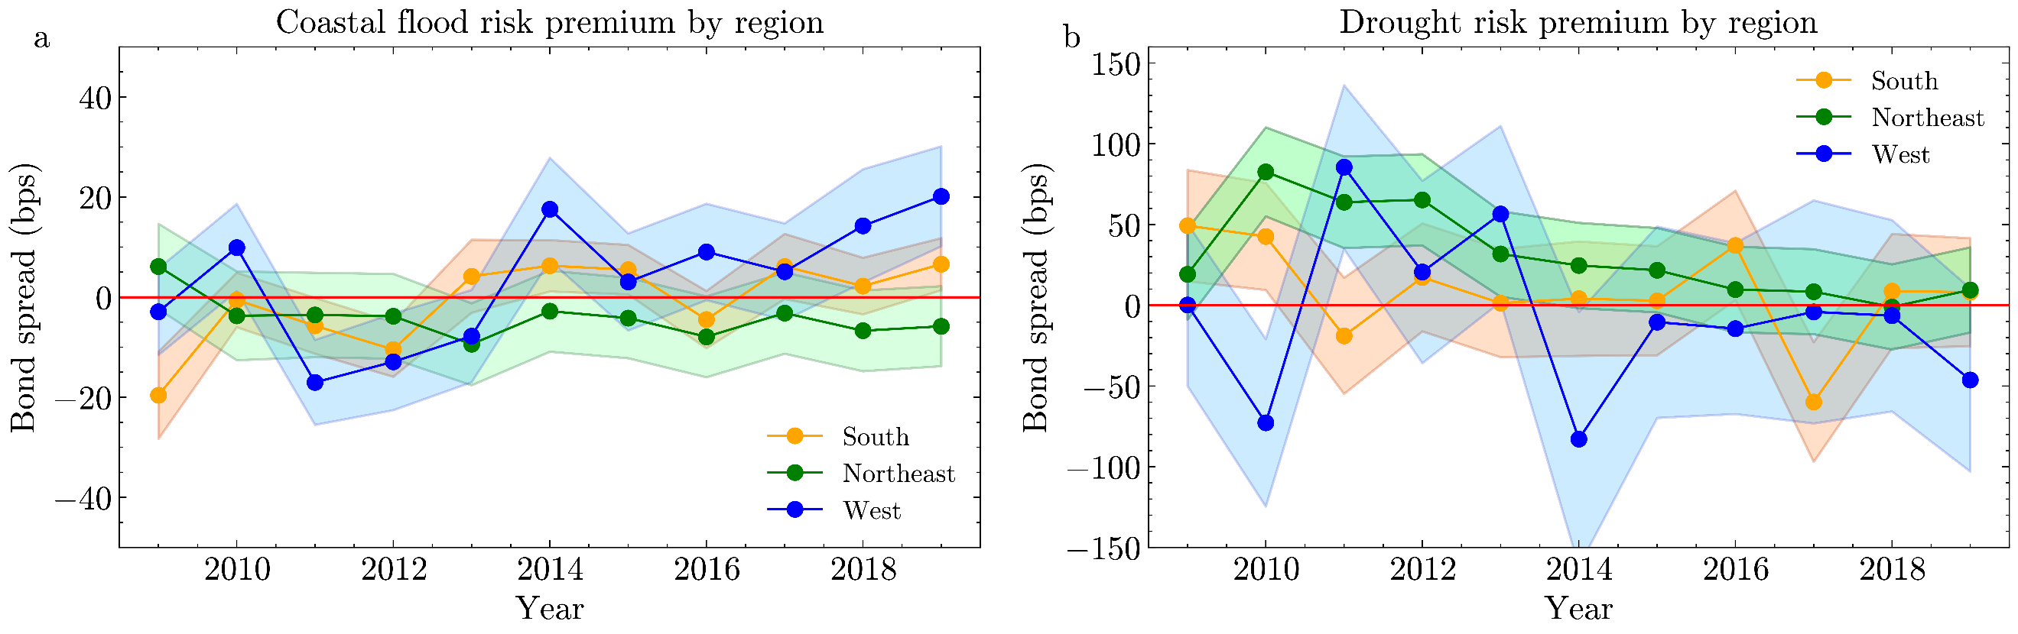Supplementary Figure 2. Visualization of annual effect of bond spread premium by region based on Supplementary Table 2 for (a) flood risk and (b) drought risk scores. Shaded areas delineated the confidence intervals.

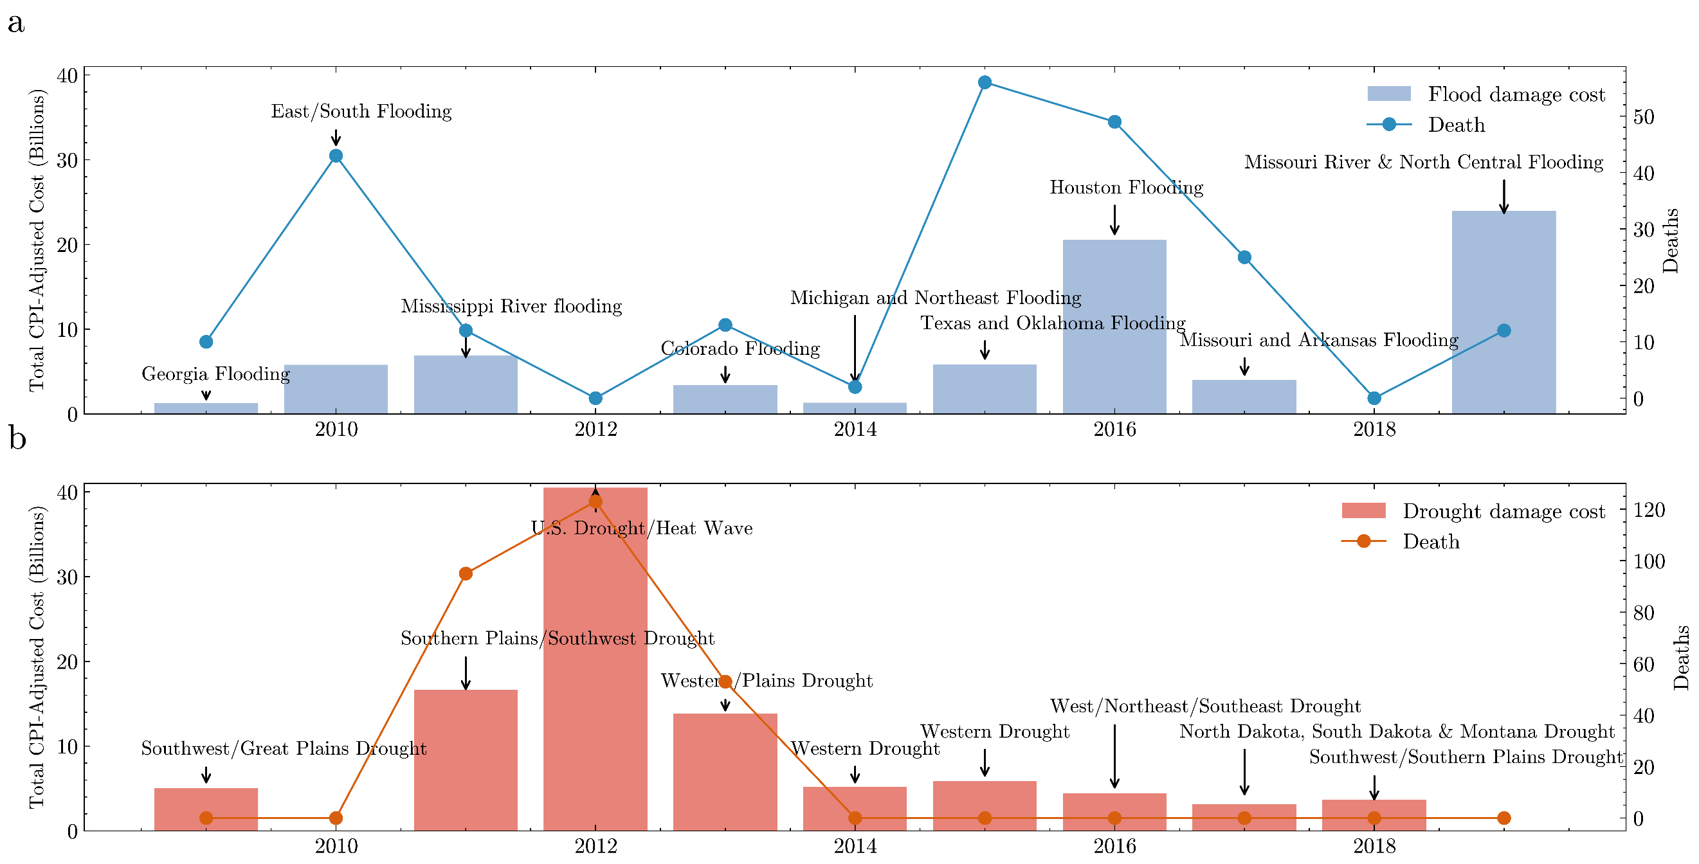
Supplementary Figure 3. CPI-adjusted flood damage cost and deaths for billion-dollar disaster in the U.S. from 2009 to 2019 for (a) flood, (b) drought. Labels represents the most significant damage events in each year based on the CPI adjusted cost³⁰.
Regarding the influence of drought risk exposure, our findings suggest that the drought risk premium is primarily influenced by bonds within the northeast and western regions. In these areas, higher drought risk scores correlate positively with increased bond spreads, as evidenced in Supplementary Table 2 and Figure 2 (b). The results are particularly consistent and robust for the northeast, while the bond premium in the western region is more volatile, as evidenced by its wider confidence interval. The impact of droughts on premiums in the southern region, however, is negligible. These regional disparities in water risk premiums underscore the need for caution in interpreting the bond pricing effects of climate risks. The temporal trend of drought risk's impact on bond spreads follows a pattern similar to the depicted damage costs of drought events in Supplementary Figure 3 (b).
- Interpretation of water risk premium and scenario analysis
This section analyzes the channels for the flood and drought risk premium based on a theoretical model of bond credit risk, to support inferring economic implications of the empirical evidence presented. Based on the definition of a climate risk premium¹⁸ and the Merton³¹ model, the increased cost of municipal water bond financing due to flood and drought risk can be attributed to two potential factors based on equation (1) in Methods. The premium may stem from a decrease in the underlying asset values due to climate risk. Alternatively, it could be attributed to heightened asset volatility, primarily driven by uncertainties in future cash flows related to user fees, which can impact the asset's value over time. An illustrative instance of a parameter underpinning volatility is the investor's perception of climate change ramifications on the valuation and financial risk of the water utility and the bonds it issues.
The Merton model³¹ is a mathematical model used to understand the structural credit risk of an entity, in this case a municipality. It assumes that the market value of the entity V follows a geometric Brownian motion in the risk neutral space with volatility parameter σ and risk-free rate r, respectively:
$ⅆ\ln{V_{t}}=\left(r-\frac{1}{2}σ^{2}\right)ⅆt+σⅆw_{t}^{Q}$ (2)
Consider a scenario where a municipality holds a zero-coupon water bond, which means it doesn't pay periodic interest but has a face value k and matures at time T. This bond is the sole form of debt for the municipality. A coupon-paying bond can be converted to equivalent zero-coupon bond by discounting all its future coupon payments to determine its fair value at the time of issuance. The value of the bond, D, represents the total worth of the utilities, minus what is owned by the public holders (the equity value). When the bond matures, the equity holders receive the remaining portion after paying off the debt holder, as bondholders have priority for repayment. Consequently, we can conceptualize the value of equity as resembling a European call option on the entire asset. The actual value of the bond D is:
$D=V-\left[VN\left(d_{1}\right)-kⅇ^{-rT}N\left(d_{2}\right)\right]$ (3)
where
$$d_{1}=\frac{\ln\left(V∕k\right)+\left(r+\frac{1}{2}σ^{2}\right)T}{σ\sqrt{T}}, d_{2}=d_{1}-σ\sqrt{T}$$

To simplify equation (3), we can estimate the bond value D using the market value of the water utility V, the face value of the bond k, the volatility of the asset σ, time T, and risk-free rate r:
$D=f\left(V, k,σ, T,r\right)$(4)
In the domain of climate risk premiums concerning bonds, the determinants of notable significance appear to be confined to V and σ¹⁸. In contrast, variations in k, T, and r are not the focal point within the context of sustainable finance modeling. The outcome variable in our study, yield spread, is the difference between the yield of a given bond and that of its benchmark counterpart, where yield can be expressed by $y=\frac{1}{T}\ln\left(\frac{k}{D}\right)$.
We calibrated the yield change for the water bonds based on a change in asset value or volatility. The average time to maturity in our sample is 4.92 years, the average spreads of 47.5 bps for all bond observations and the average risk-free rate in our sample period is 0.71%. As illustrated in Supplementary Figure 4, utilizing the summary statistics of our sample, a 5-basis point premium can be decomposed into either a 25% reduction in underlying asset values when volatility is set at 0.25, or an increase in asset volatility (uncertainty of future cash flows) by 0.501 when the debt-to-asset ratio (k/V) equals 0.5, or a composite effect of both factors.

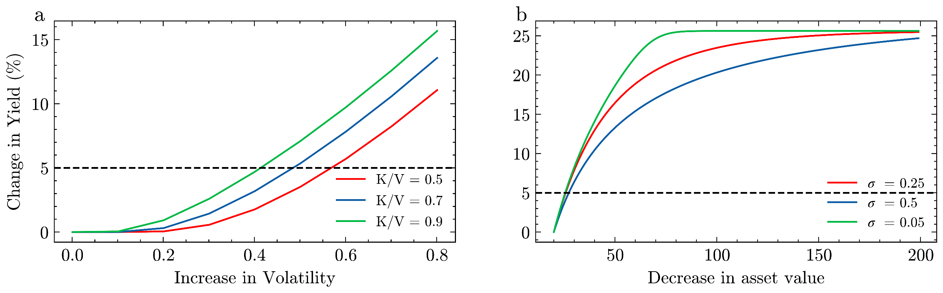Supplementary Figure 4. Decomposition of flood or drought risk bond premium based on Merton model to (a) increase in volatiltiy of future cash flow, (b) decrease in value of underlying asset.
The model shows that the inferred relationship between flood or drought risk exposure and municipal bond spreads may arise from either an asset depreciation due to decrease of future cash flows, or an increase in the uncertainty regarding the volatility of those cash flows. In empirical terms, untangling the intricacies of these dual pathways poses challenges, as identifying a definitive proxy for climate impacts on asset value or uncertainty remain are ongoing¹⁸.
To enhance practical applicability, we conducted an illustrative analysis by leveraging empirical evidence and simulation results to demonstrate potential water bond issuance costs. Table 8 shows the possible fluctuations in bond yields under different financial conditions as scenario 1 to 8, with scenario 0 serving as the baseline for the simulation.
Supplementary Table 3. Scenario testing of the key inputs for Merton model on bond yield
No. | Scenario No. | V ($) | Corresponding k/V ratio | σ | Yield (%) |  | Spread (bps)
0 | Baseline | 200 | 0.5 | 0.3 | 10.305
1 | High leverage | 100 | 1 | 0.3 | 11.157 | 85.2
2 | Low leverage | 400 | 0.25 | 0.3 | 10.054 | -25.1
3 | Low volatility | 200 | 0.5 | 0.15 | 10.000 | -30.5
4 | High volatility | 200 | 0.5 | 0.6 | 14.217 | 391.2
5 | High leverage, low volatility | 100 | 1 | 0.15 | 10.048 | -25.7
6 | High leverage, high volatility | 100 | 1 | 0.6 | 16.406 | 610.1
7 | Low leverage, low volatility | 400 | 0.25 | 0.15 | 10.000 | -30.5
8 | low leverage, high volatility | 400 | 0.25 | 0.6 | 12.612 | 230.7
Note that the input for the simulation model comprises k = 100, T = 10, and r = 0.1, as utilized in equation (2). The asset in the k/V ratio represents the assets of the issuing agency that serve as collateral for the debt⁴⁵.
In the 1st scenario characterized by high leverage, where the municipality's assets all stem from debt obligations, the bond yield stands at 11.16%, in contrast to the baseline yield of 10.30%. Conversely, within a low leverage ratio context of 0.25, the model projects an estimated yield of 10.05% indicating a spread premium of 25.1 bps. Further examination involved assessing the sensitivity of bond yield in relation to volatility, with values set at 0.15 and 0.6. The findings revealed that, for an equivalent percentage alteration in asset value and volatility, bond yield displayed greater responsiveness to changes in volatility. Scenarios 5 through 8 encompassed the combined manipulation of these two key inputs.
Municipal bond yields have exhibited a pattern of being consistently low and stable. During much of the mid-twentieth century, interest rates on water and sewer municipal bonds were consistently below those of US Treasuries⁴⁶. This trend was fueled by the perception of low risk within this bond sector, combined with high federal taxes during that era. However, a transformation took place due to various factors, including the introduction of lower federal tax rates, primarily stemming from the Tax Reform Act of 1986⁴⁷. Furthermore, an uptick in the availability of taxable municipal bonds and a decline in credit quality for specific issuers played roles in driving this shift. Consequently, the projected scenario may only materialize under extreme circumstances and should be approached with careful consideration.
The Merton model overlooks aspects like insurance and various macroeconomic factors such as dynamic interest rates in bond valuation. As a result, its valuations might deviate from market-observed prices. For instance, some municipalities exhibit negative equity value—indicating more liabilities than assets—which could imply insolvency. However, the involvement of government-provided insurance introduces complexity, potentially leading to mispricing of bond values⁴⁸, as market participants factor in implicit insurance when valuing bonds.

