SUPPLEMENTARY FIGURES
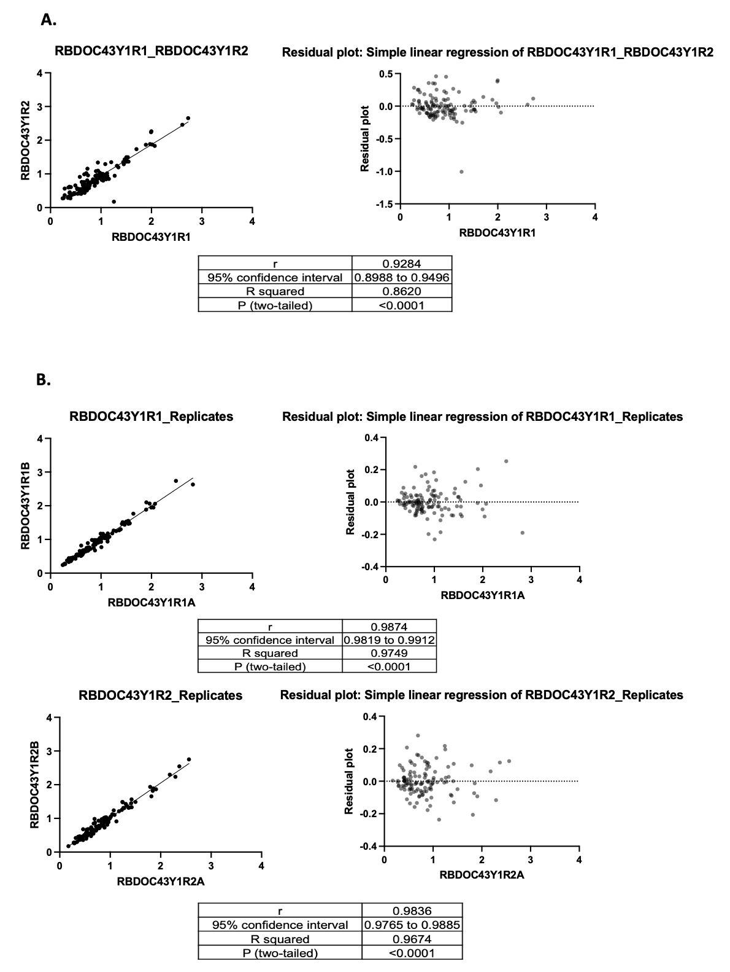
Fig. S1. Example ELISA reproducibility. Scatterplots, residual plots, and correlation coefficients comparing ELISA OD values (A) between experiments or (B) for replicates within a given experiment.

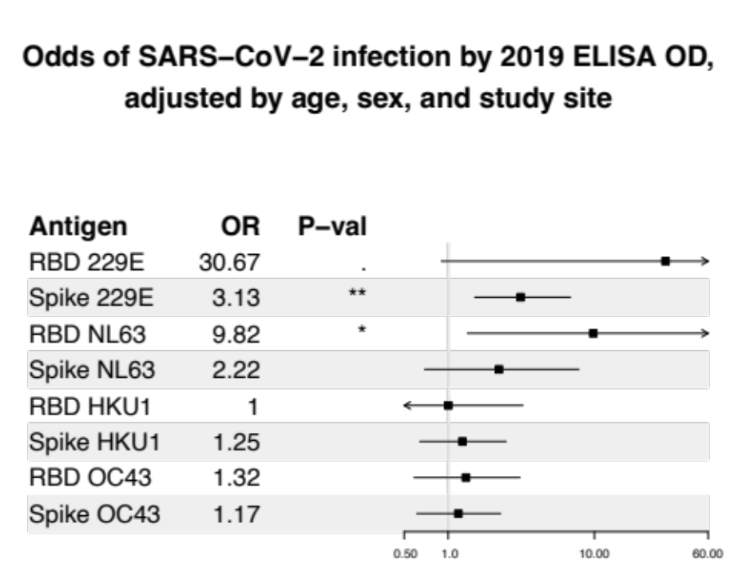
Fig. S2. Odd ratios of SARS-CoV-2 infection by each endemic hCoV ELISA OD prior to the COVID-19 pandemic, estimated using logistic regression with models adjusted for age, sex, and study site.

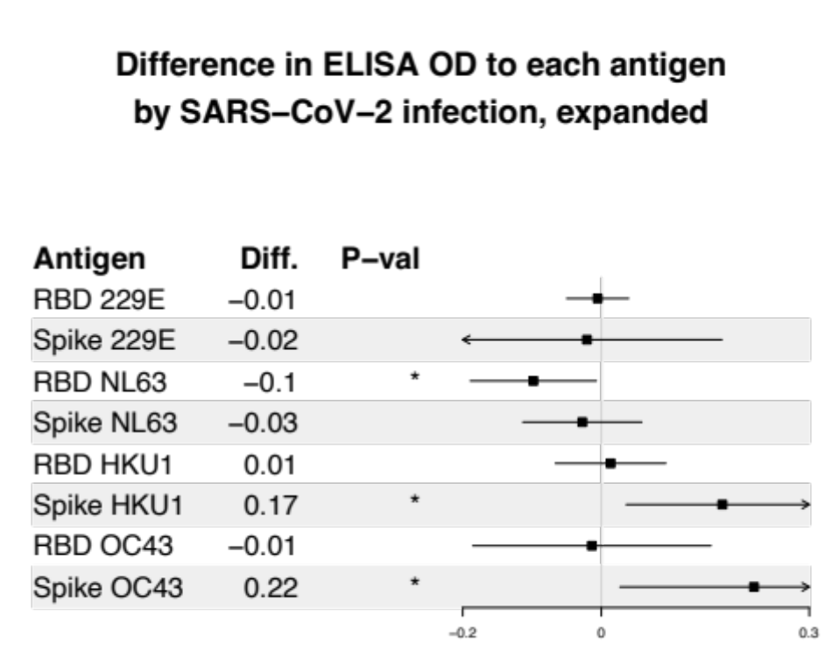
Fig. S3. Changes in antibodies to RBDs and spikes of endemic hCoVs between 2019 and 2021 in those with vs. without SARS-CoV-2 infection, defined to include n=10 infections for those with large boosts in SARS-CoV-2 spike antibodies (>0.6). Magnitude of change in ELISA OD to each antigen by SARS-CoV-2 infection. Differences were estimated using linear regression, with ELISA ODs in 2021 modeled as a function of SARS-CoV-2 infection and ELISA ODs in 2019.

