Supplementary document in
Cortical and white matter substrates supporting visuospatial working memory

Riyo Ueda $; Kazuki Sakakura $; Takumi Mitsuhashi ; Masaki Sonoda ;
Ethan Firestone ; Naoto Kuroda ; Yu Kitazawa ; Hiroshi Uda ; Aimee F. Luat ;
Elizabeth L. Johnson ; Noa Ofen ; Eishi Asano
$: Equal contribution.

This document includes:
Tables S1-S2;
Figures S1-S18;
Supplementary descriptions related to post-hoc mixed model analyses;
Legends for Videos S1-S5.

Region of interests | Electrodes | Patients
PreCG: precentral gyrus | 97 | 10
STG: superior-temporal gyrus | 80 | 10
SMG: supramarginal gyrus | 73 | 9
MTG: middle-temporal gyrus | 64 | 8
PoCG: postcentral gyrus | 63 | 10
FG: fusiform gyrus | 61 | 10
OrbF: orbitofrontal region (BA 11, 12 and 47) | 57 | 8
SFG: superior frontal gyrus | 51 | 6
ITG: inferior-temporal gyrus | 47 | 10
aMFG: anterior middle-frontal gyrus | 41 | 7
pMFG: posterior middle-frontal gyrus | 37 | 9
LOG: lateral occipital gyrus | 37 | 8
IPL: inferior parietal lobule | 32 | 8
pIFG: posterior inferior-frontal gyrus (BA 44 and 45) | 32 | 7
MedTG: medial temporal gyrus (entorhinal and parahippocampal gyri) | 29 | 9
MOG: medial occipital gyrus (lingual and cuneus gyri) | 29 | 8
SPL: superior parietal lobule | 16 | 3
pCG: posterior cingulate gyrus (posterior and isthmus cingulate) | 14 | 4
PCun: precuneus | 9 | 3
PCL: paracentral lobule | 5 | 2
FP: frontal pole | 2 | 1
Total | 876 | 10

Table S1. The number of artifact-free, nonepileptic electrode sites used for region of interest (ROI)-based analysis. A total of 16 ROIs contained at least 20 eligible electrode sites and were included in the group-level statistical analysis.

 |  | Delta | Theta | Alpha | Sigma | Beta | Low gamma | Very high-gamma
 |  | 2-4 Hz | 4-8 Hz | 8-12 Hz | 12-16 Hz | 16-30 Hz | 30-50 Hz | 130-150 Hz
PreCG | Mean rho | -0.06 | -0.10 | -0.16 | -0.21 | -0.16 | 0.001 | 0.4
 | 95% CI | -0.12 to 0.01 | -0.17 to -0.02 | -0.23 to -0.09 | -0.27 to -0.15 | -0.23 to -0.10 | -0.07 to 0.07 | 0.33 to 0.46
STG | Mean rho | -0.06 | -0.10 | -0.07 | -0.05 | 0.05 | 0.30 | 0.43
 | 95% CI | -0.14 to 0.02 | -0.16 to -0.02 | -0.14 to 0.002 | -0.12 to 0.02 | -0.04 to 0.13 | 0.23 to 0.37 | 0.37 to 0.49
SMG | Mean rho | -0.19 | -0.20 | -0.10 | -0.06 | 0.13 | 0.33 | 0.44
 | 95% CI | -0.26 to -0.11 | -0.27 to -0.12 | -0.18 to -0.02 | -0.14 to 0.03 | 0.04 to 0.21 | 0.26 to 0.40 | 0.37 to 0.51
MTG | Mean rho | -0.10 | -0.08 | -0.04 | 0.002 | 0.18 | 0.40 | 0.41
 | 95% CI | -0.19 to -0.01 | -0.16 to 0.01 | -0.12 to 0.04 | -0.08 to 0.08 | 0.12 to 0.25 | 0.34 to 0.46 | 0.34 to 0.47
PoCG | Mean rho | -0.01 | -0.10 | -0.17 | -0.15 | -0.16 | 0.09 | 0.39
 | 95% CI | -0.10 to 0.08 | -0.21 to -0.004 | -0.27 to -0.08 | -0.24 to -0.06 | -0.25 to -0.07 | 0.001 to 0.17 | 0.32 to 0.46
FG | Mean rho | -0.01 | -0.04 | -0.11 | -0.11 | 0.10 | 0.40 | 0.53
 | 95% CI | -0.10 to 0.07 | -0.13 to 0.05 | -0.19 to -0.03 | -0.20 to -0.03 | 0.002 to 0.19 | 0.31 to 0.48 | 0.44 to 0.62
OrbF | Mean rho | -0.11 | -0.14 | -0.08 | 0.05 | 0.27 | 0.39 | 0.35
 | 95% CI | -0.19 to -0.03 | -0.22 to -0.04 | -0.15 to 0.01 | -0.02 to 0.12 | 0.19 to 0.34 | 0.33 to 0.47 | 0.27 to 0.43
SFG | Mean rho | -0.04 | -0.04 | -0.04 | -0.03 | 0.08 | 0.10 | 0.37
 | 95% CI | -0.12 to 0.05 | -0.14 to 0.05 | -0.12 to 0.06 | 0.12 to 0.07 | -0.01 to 0.17 | -0.004 to 0.20 | 0.29 to 0.45
ITG | Mean rho | -0.14 | -0.08 | -0.11 | -0.02 | 0.11 | 0.32 | 0.43
 | 95% CI | -0.24 to -0.06 | -0.18 to 0.03 | -0.20 to -0.01 | -0.11 to 0.07 | 0.01 to 0.21 | 0.24 to 0.41 | 0.33 to 0.52
aMFG | Mean rho | -0.20 | -0.18 | -0.08 | 0.03 | 0.37 | 0.43 | 0.39
 | 95% CI | -0.30 to -0.10 | -0.31 to -0.06 | -0.19 to 0.03 | -0.08 to 0.14 | 0.26 to 0.49 | 0.33 to 0.53 | 0.30 to 0.48
pMFG | Mean rho | -0.04 | -0.05 | -0.04 | -0.10 | 0.08 | 0.20 | 0.31
 | 95% CI | -0.16 to 0.07 | -0.15 to 0.05 | -0.14 to 0.06 | -0.20 to -0.01 | -0.02 to 0.16 | 0.11 to 0.30 | 0.21 to 0.41
LOG | Mean rho | -0.02 | 0.003 | -0.06 | -0.11 | -0.05 | 0.28 | 0.70
 | 95% CI | -0.19 to 0.15 | -0.12 to 0.13 | -0.17 to 0.04 | -0.20 to -0.01 | -0.16 to 0.06 | 0.14 to 0.40 | 0.62 to 0.77
IPL | Mean rho | -0.16 | -0.14 | -0.06 | -0.05 | 0.09 | 0.36 | 0.45
 | 95% CI | -0.28 to -0.04 | -0.24 to -0.03 | -0.19 to 0.06 | -0.16 to 0.05 | -0.03 to 0.22 | 0.26 to 0.45 | 0.36 to 0.55
pIFG | Mean rho | -0.07 | -0.17 | -0.14 | -0.02 | 0.22 | 0.39 | 0.43
 | 95% CI | -0.18 to 0.04 | -0.28 to -0.06 | -0.24 to -0.05 | -0.13 to 0.12 | 0.09 to 0.33 | 0.27 to 0.49 | 0.32 to 0.54
MedTG | Mean rho | 0.04 | 0.04 | 0.03 | 0.08 | 0.16 | 0.27 | 0.36
 | 95% CI | -0.07 to 0.15 | -0.07 to 0.15 | -0.07 to 0.12 | -0.02 to 0.16 | 0.07 to 0.26 | 0.18 to 0.36 | 0.21 to 0.49
MOG | Mean rho | -0.06 | -0.01 | -0.06 | -0.04 | 0.07 | 0.42 | 0.75
 | 95% CI | -0.21 to 0.09 | -0.15 to 0.14 | -0.21 to 0.06 | -0.18 to 0.10 | -0.06 to 0.21 | 0.31 to 0.53 | 0.69 to 0.81

Table S2. Correlation between task-related high-gamma and other frequency band amplitudes. The table provides the Bootstrap mean of Spearman’s rho, its 95% confidence interval (95%CI), and the p-value to showcase the degree of correlation between the high-gamma amplitude and each of the following frequency band amplitudes: delta at 2-4 Hz, theta at 4-8 Hz, alpha at 8-12 Hz, sigma at 12-16 Hz, beta at 16-30 Hz, low-gamma at 30-50 Hz, and very high-gamma at 130-150 Hz. Refer to Table S1 for the definitions of the abbreviations used in this table.

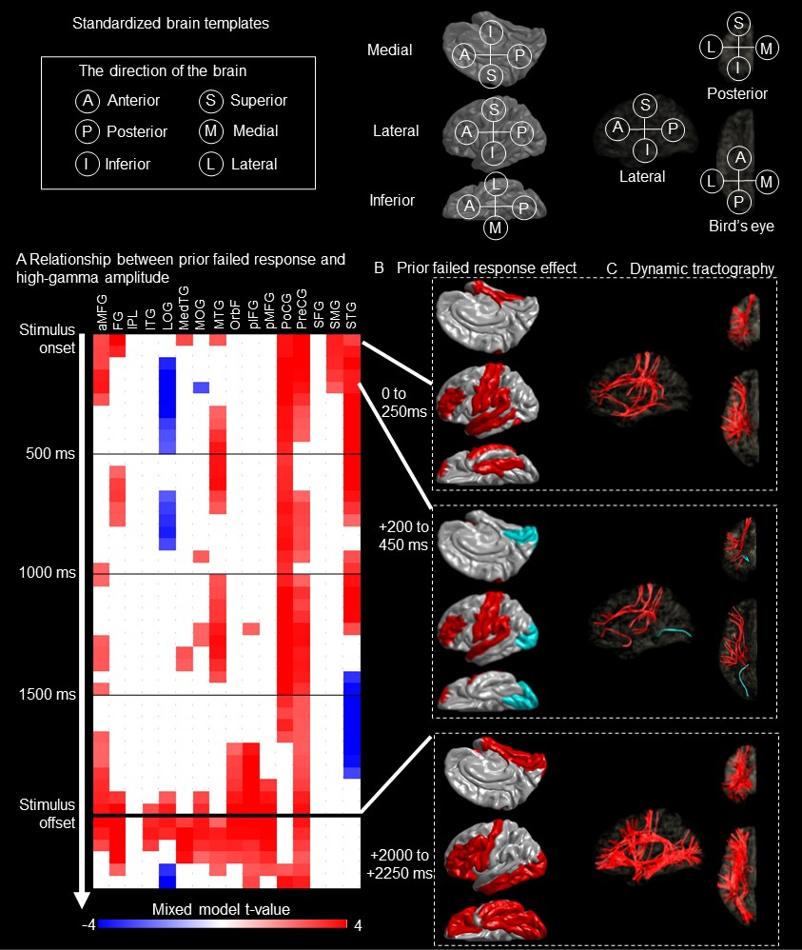
Figure S1. Prior failed response-related high-gamma amplitude modulations and white matter substrates. (A) Spatiotemporal characteristics of the relationship between the prior failed response and high-gamma amplitude. The red cells indicate mixed model t-values at regions of interest (ROIs) and corresponding 250-ms time windows where the failed response in an immediately preceding trial was significantly associated with increased high-gamma amplitudes. The blue cells indicate time windows where the prior failed response was significantly associated with decreased high-gamma amplitudes. (B) Snapshots of high-gamma modulations correlated to the prior failed response. Color-coded ROIs indicate that the failed response in an immediately preceding trial was significantly associated with increased (red) or decreased (blue) high-gamma amplitudes based on the mixed model analysis. (C) Snapshots of white matter tracts underlying functional connectivity modulations related to the failed response in an immediately prior trial. Color-coded streamlines indicate functional connectivity enhancement (red) and diminution (blue) between ROIs. 0 ms: a 250-ms time window post-stimulus onset.

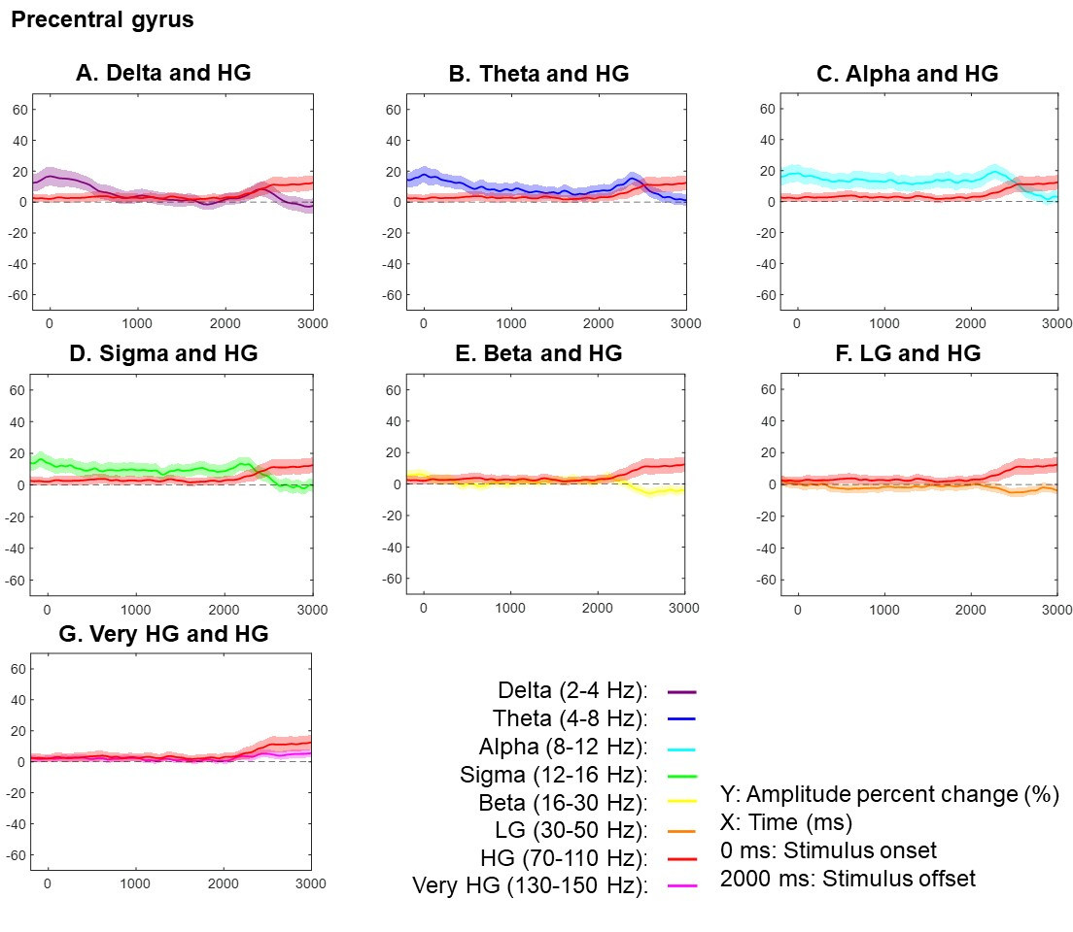

Figure S2. Task-related amplitude modulations at the precentral gyrus. Each plot presents the temporal changes of high-gamma (HG) and one of the following frequency band amplitudes: (A) delta at 2-4 Hz, (B) theta at 4-8 Hz, (C) alpha at 8-12 Hz, (D) sigma at 12-16 Hz, (E) beta at 16-30 Hz, (F) low-gamma (LG) at 30-50 Hz, and (G) very HG at 130-150 Hz. Mean amplitude changes from the baseline mean are presented with a 95% confidence interval bar.

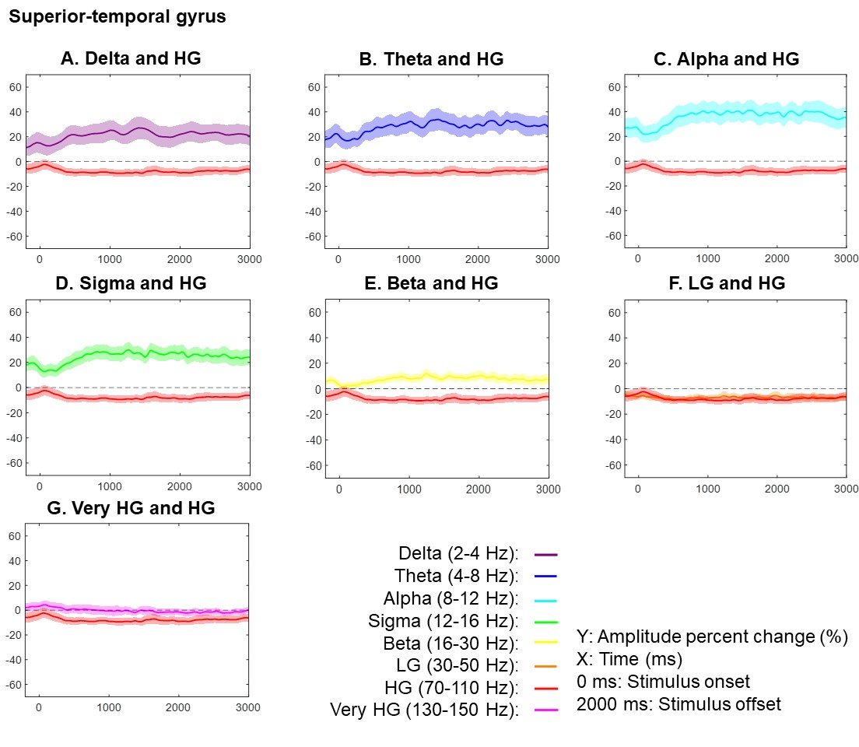
Figure S3. Task-related amplitude modulations at the superior-temporal gyrus. Each plot presents the temporal changes of high-gamma (HG) and one of the following frequency band amplitudes: (A) delta at 2-4 Hz, (B) theta at 4-8 Hz, (C) alpha at 8-12 Hz, (D) sigma at 12-16 Hz, (E) beta at 16-30 Hz, (F) low-gamma (LG) at 30-50 Hz, and (G) very HG at 130-150 Hz. Mean amplitude changes from the baseline mean are presented with a 95% confidence interval bar.

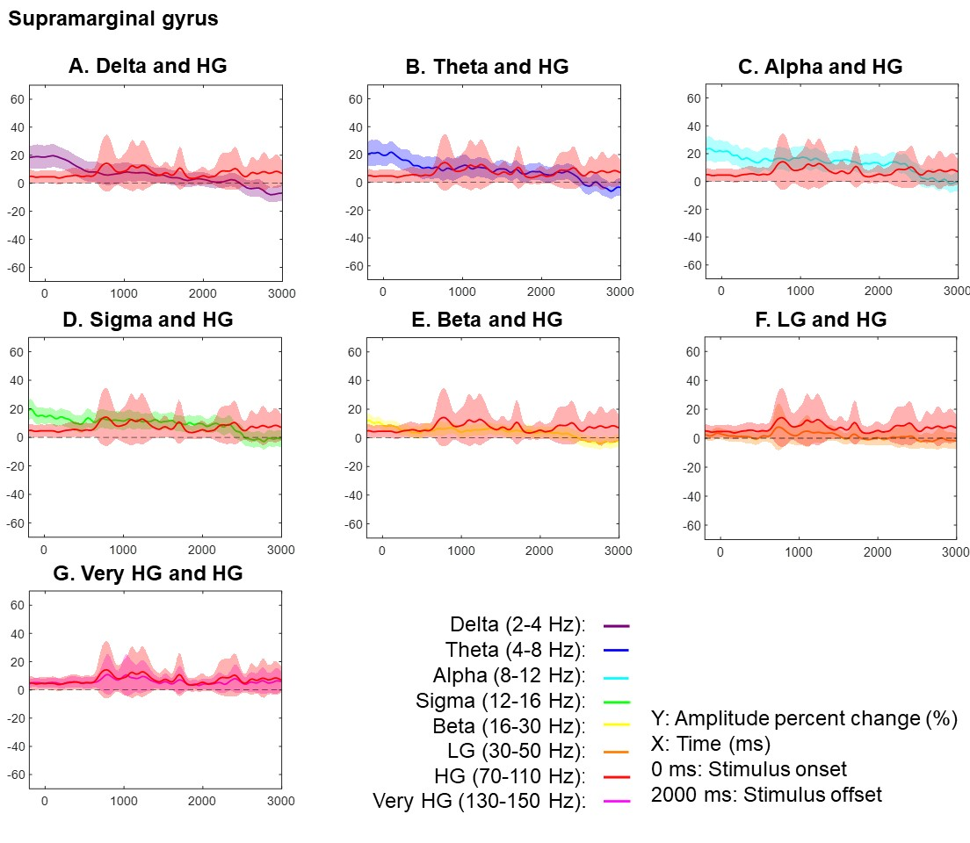
Figure S4. Task-related amplitude modulations at the supramarginal gyrus. Each plot presents the temporal changes of high-gamma (HG) and one of the following frequency band amplitudes: (A) delta at 2-4 Hz, (B) theta at 4-8 Hz, (C) alpha at 8-12 Hz, (D) sigma at 12-16 Hz, (E) beta at 16-30 Hz, (F) low-gamma (LG) at 30-50 Hz, and (G) very HG at 130-150 Hz. Mean amplitude changes from the baseline mean are presented with a 95% confidence interval bar.

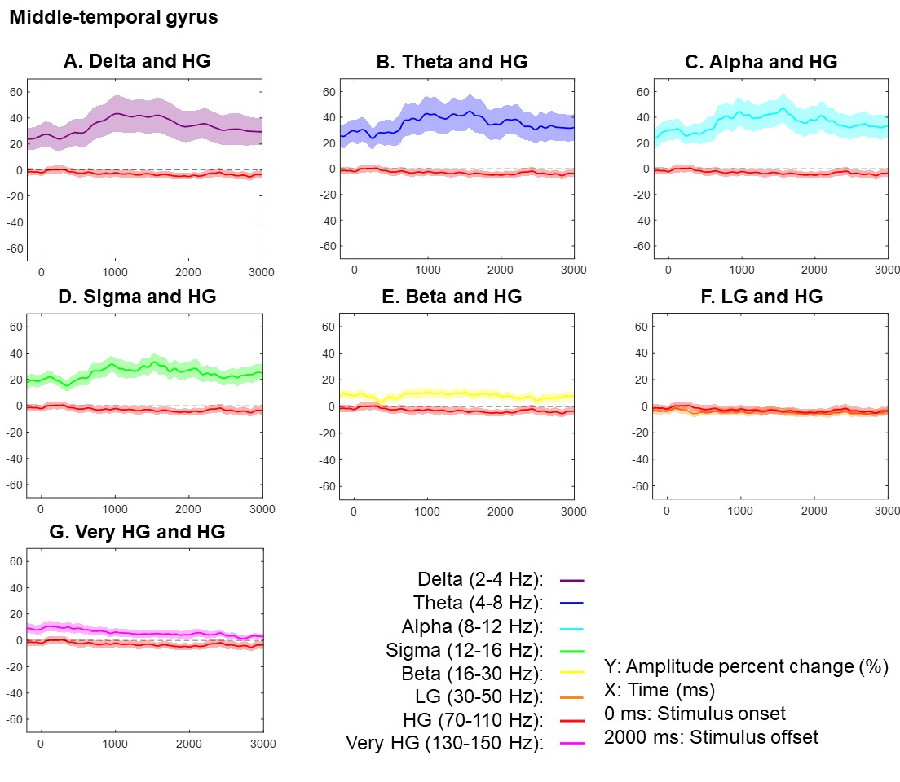
Figure S5. Task-related amplitude modulations at the middle-temporal gyrus. Each plot presents the temporal changes of high-gamma (HG) and one of the following frequency band amplitudes: (A) delta at 2-4 Hz, (B) theta at 4-8 Hz, (C) alpha at 8-12 Hz, (D) sigma at 12-16 Hz, (E) beta at 16-30 Hz, (F) low-gamma (LG) at 30-50 Hz, and (G) very HG at 130-150 Hz. Mean amplitude changes from the baseline mean are presented with a 95% confidence interval bar.

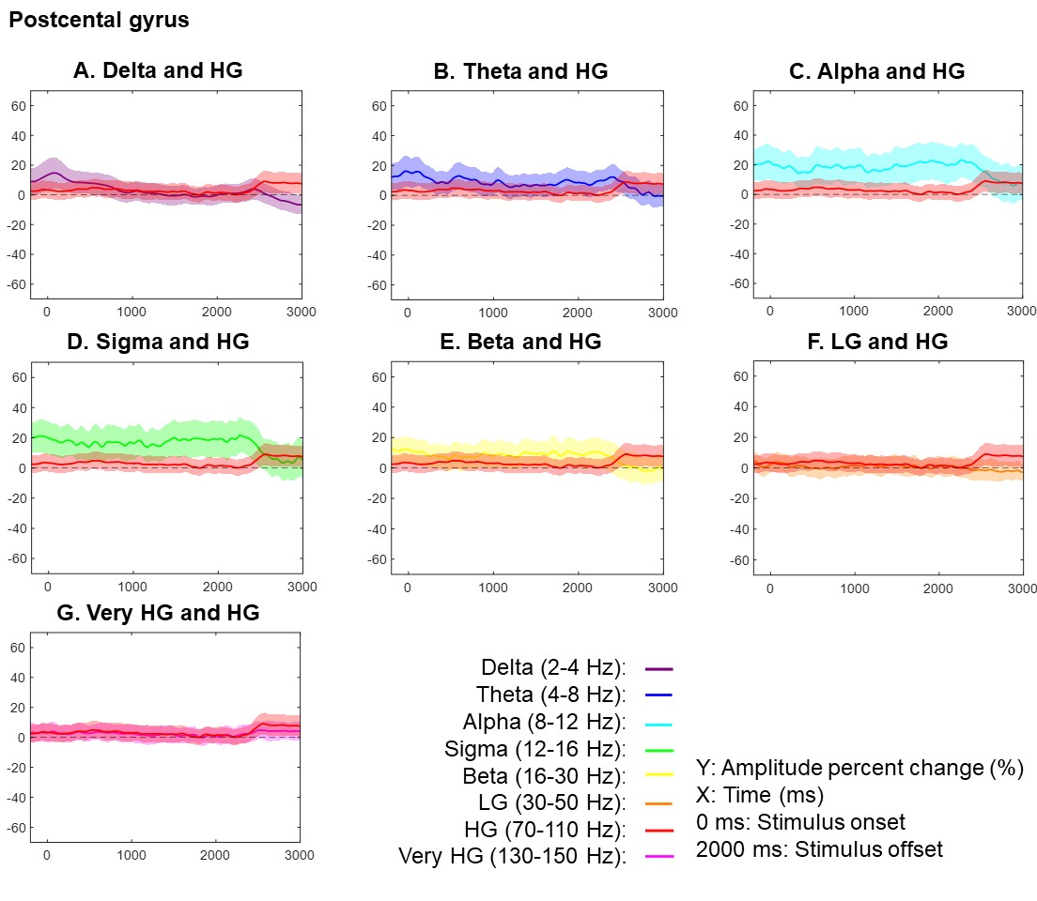
Figure S6. Task-related amplitude modulations at the postcentral gyrus. Each plot presents the temporal changes of high-gamma (HG) and one of the following frequency band amplitudes: (A) delta at 2-4 Hz, (B) theta at 4-8 Hz, (C) alpha at 8-12 Hz, (D) sigma at 12-16 Hz, (E) beta at 16-30 Hz, (F) low-gamma (LG) at 30-50 Hz, and (G) very HG at 130-150 Hz. Mean amplitude changes from the baseline mean are presented with a 95% confidence interval bar.

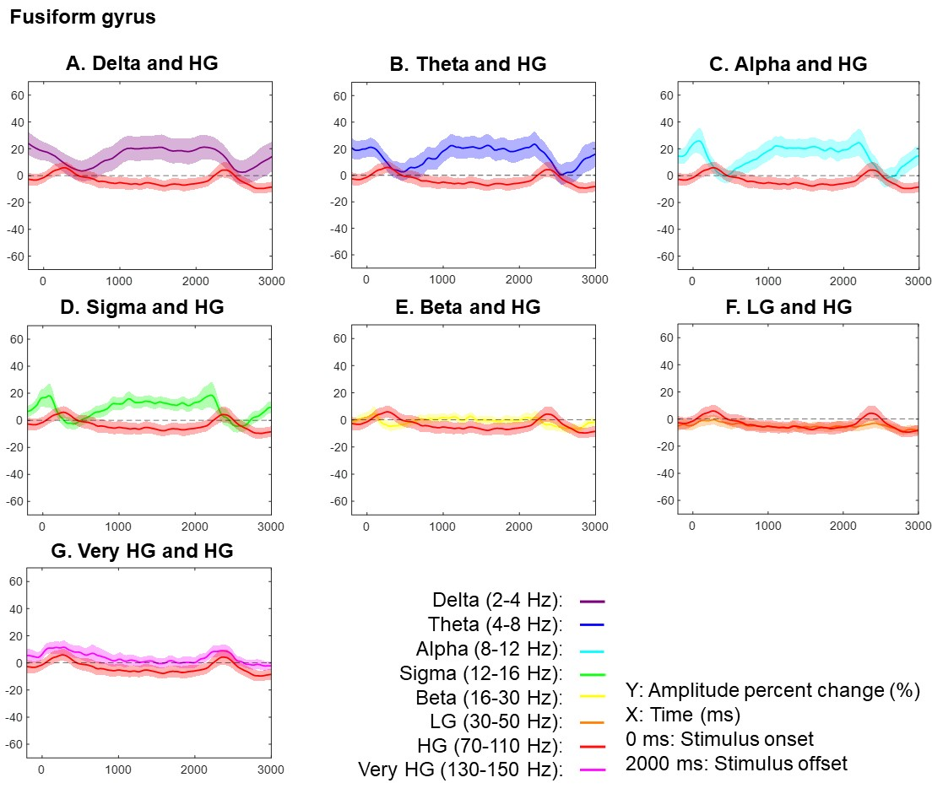
Figure S7. Task-related amplitude modulations at the fusiform gyrus. Each plot presents the temporal changes of high-gamma (HG) and one of the following frequency band amplitudes: (A) delta at 2-4 Hz, (B) theta at 4-8 Hz, (C) alpha at 8-12 Hz, (D) sigma at 12-16 Hz, (E) beta at 16-30 Hz, (F) low-gamma (LG) at 30-50 Hz, and (G) very HG at 130-150 Hz. Mean amplitude changes from the baseline mean are presented with a 95% confidence interval bar.

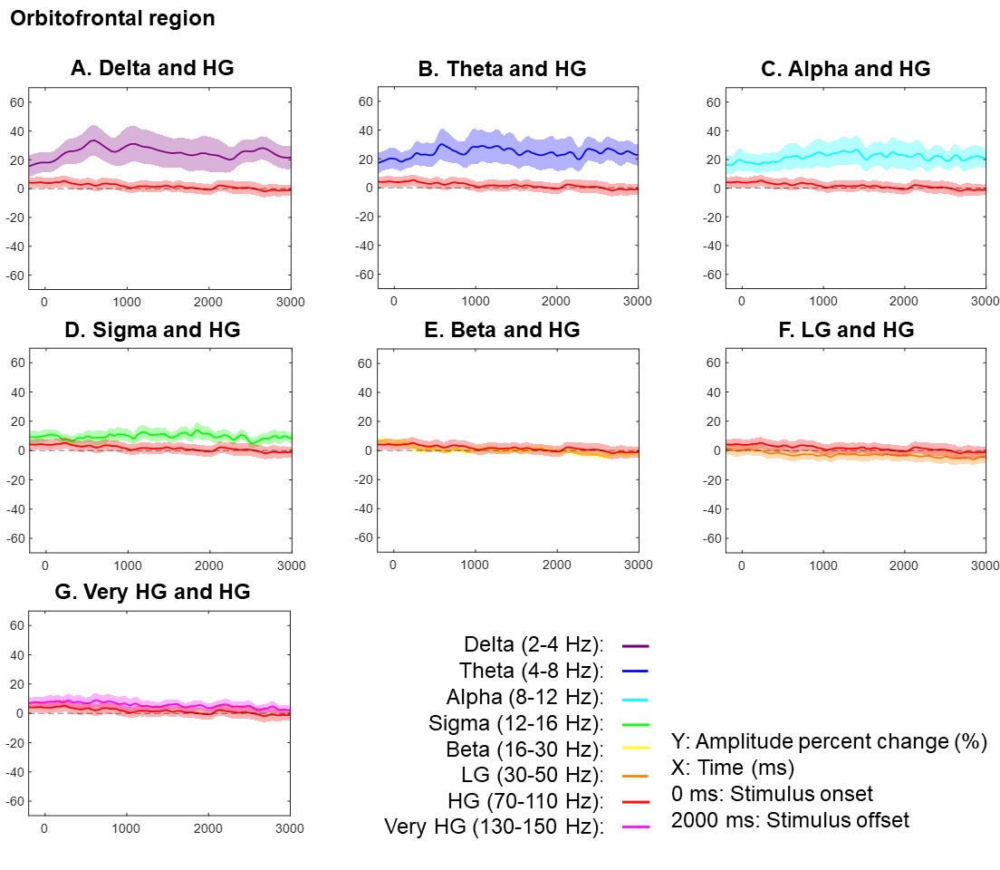
Figure S8. Task-related amplitude modulations at the orbitofrontal gyrus. Each plot presents the temporal changes of high-gamma (HG) and one of the following frequency band amplitudes: (A) delta at 2-4 Hz, (B) theta at 4-8 Hz, (C) alpha at 8-12 Hz, (D) sigma at 12-16 Hz, (E) beta at 16-30 Hz, (F) low-gamma (LG) at 30-50 Hz, and (G) very HG at 130-150 Hz. Mean amplitude changes from the baseline mean are presented with a 95% confidence interval bar.

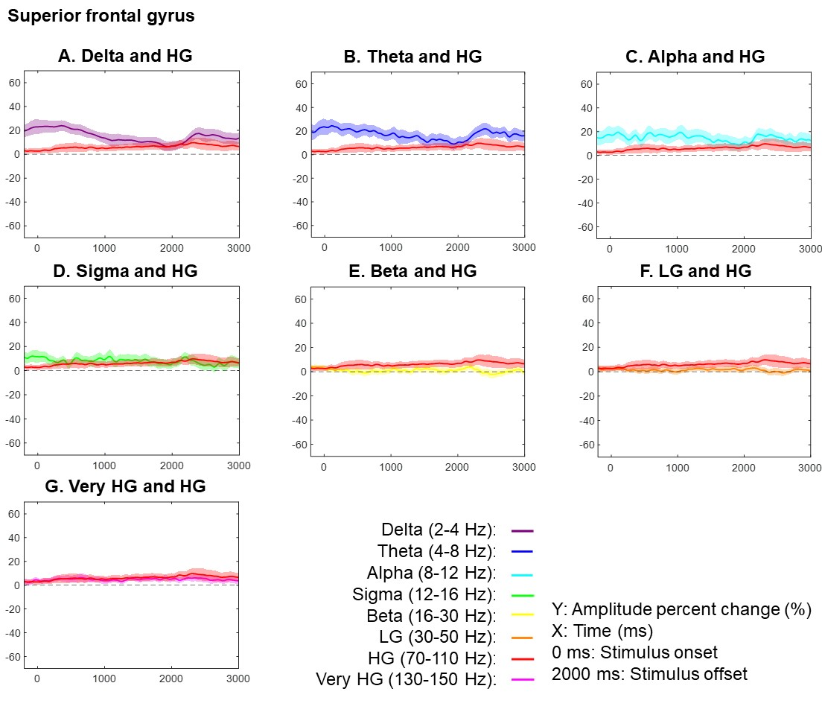
Figure S9. Task-related amplitude modulations at the superior frontal gyrus. Each plot presents the temporal changes of high-gamma (HG) and one of the following frequency band amplitudes: (A) delta at 2-4 Hz, (B) theta at 4-8 Hz, (C) alpha at 8-12 Hz, (D) sigma at 12-16 Hz, € beta at 16-30 Hz, (F) low-gamma (LG) at 30-50 Hz, and (G) very HG at 130-150 Hz. Mean amplitude changes from the baseline mean are presented with a 95% confidence interval bar.
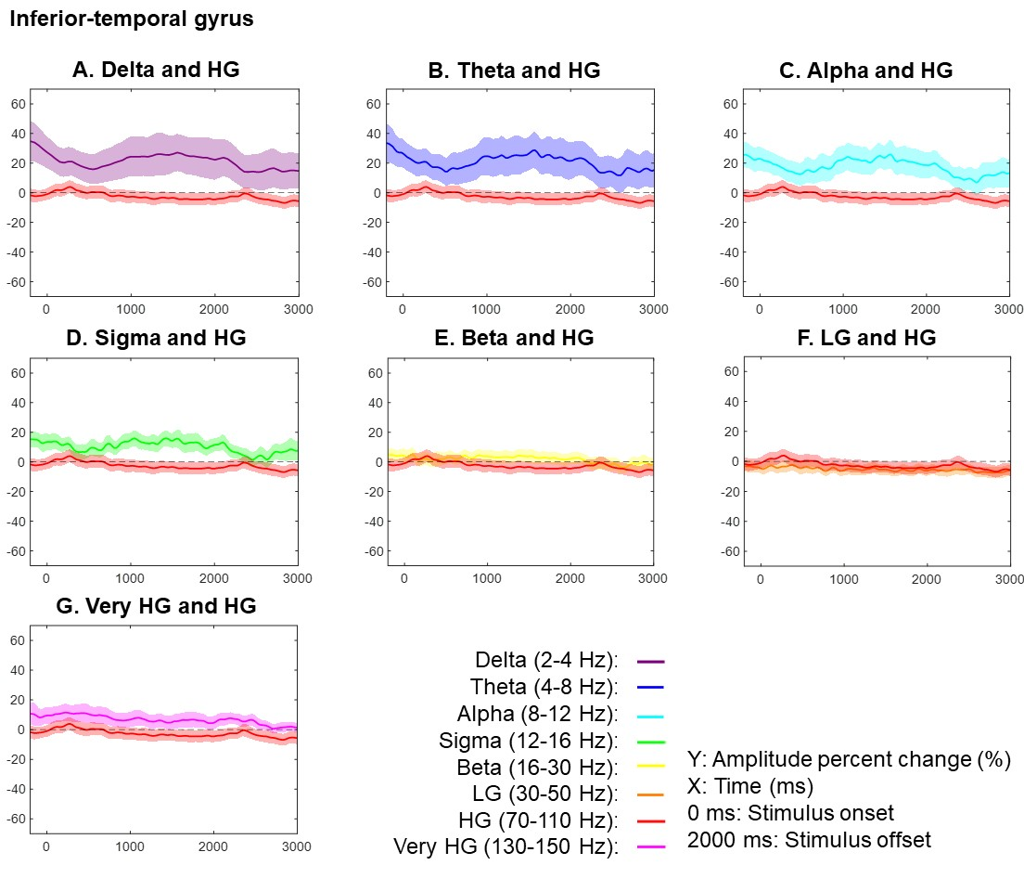
Figure S10. Task-related amplitude modulations at the inferior-temporal gyrus. Each plot presents the temporal changes of high-gamma (HG) and one of the following frequency band amplitudes: (A) delta at 2-4 Hz, (B) theta at 4-8 Hz, (C) alpha at 8-12 Hz, (D) sigma at 12-16 Hz, € beta at 16-30 Hz, (F) low-gamma (LG) at 30-50 Hz, and (G) very HG at 130-150 Hz. Mean amplitude changes from the baseline mean are presented with a 95% confidence interval bar.
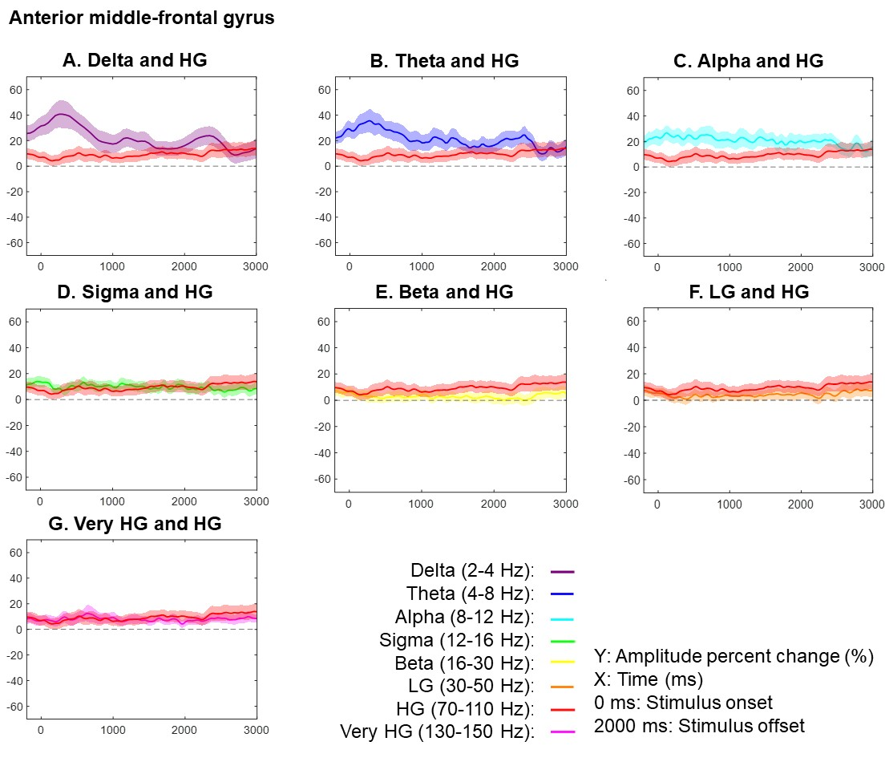
Figure S11. Task-related amplitude modulations at the anterior middle-frontal gyrus. Each plot presents the temporal changes of high-gamma (HG) and one of the following frequency band amplitudes: (A) delta at 2-4 Hz, (B) theta at 4-8 Hz, (C) alpha at 8-12 Hz, (D) sigma at 12-16 Hz, € beta at 16-30 Hz, (F) low-gamma (LG) at 30-50 Hz, and (G) very HG at 130-150 Hz. Mean amplitude changes from the baseline mean are presented with a 95% confidence interval bar.

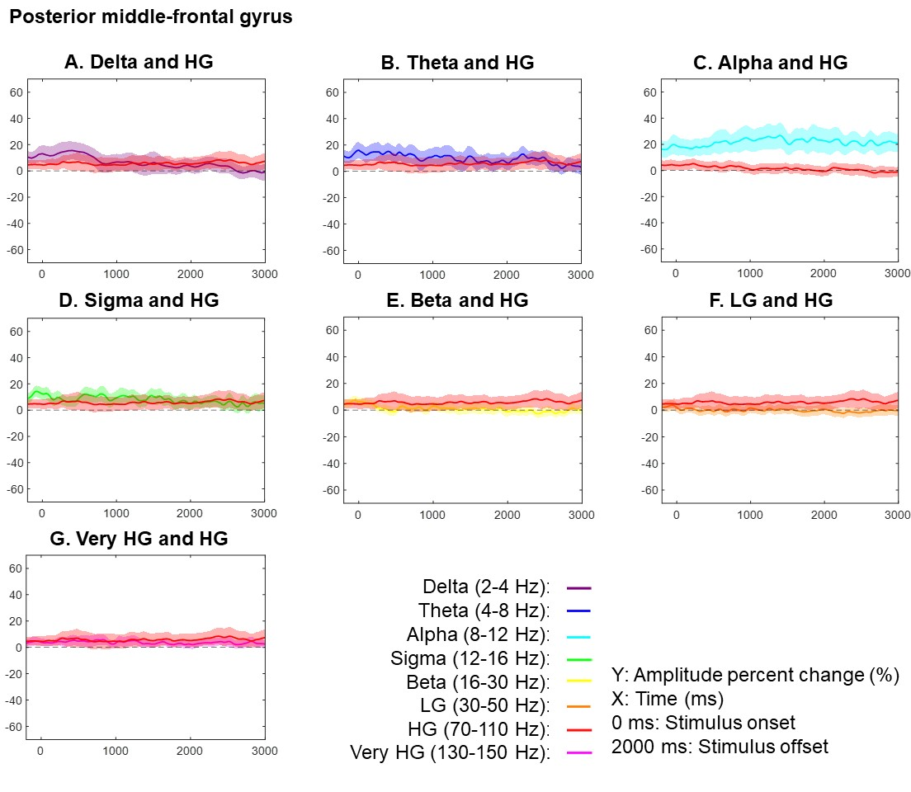
Figure S12. Task-related amplitude modulations at the posterior middle-frontal gyrus. Each plot presents the temporal changes of high-gamma (HG) and one of the following frequency band amplitudes: (A) delta at 2-4 Hz, (B) theta at 4-8 Hz, (C) alpha at 8-12 Hz, (D) sigma at 12-16 Hz, (E) beta at 16-30 Hz, (F) low-gamma (LG) at 30-50 Hz, and (G) very HG at 130-150 Hz. Mean amplitude changes from the baseline mean are presented with a 95% confidence interval bar.
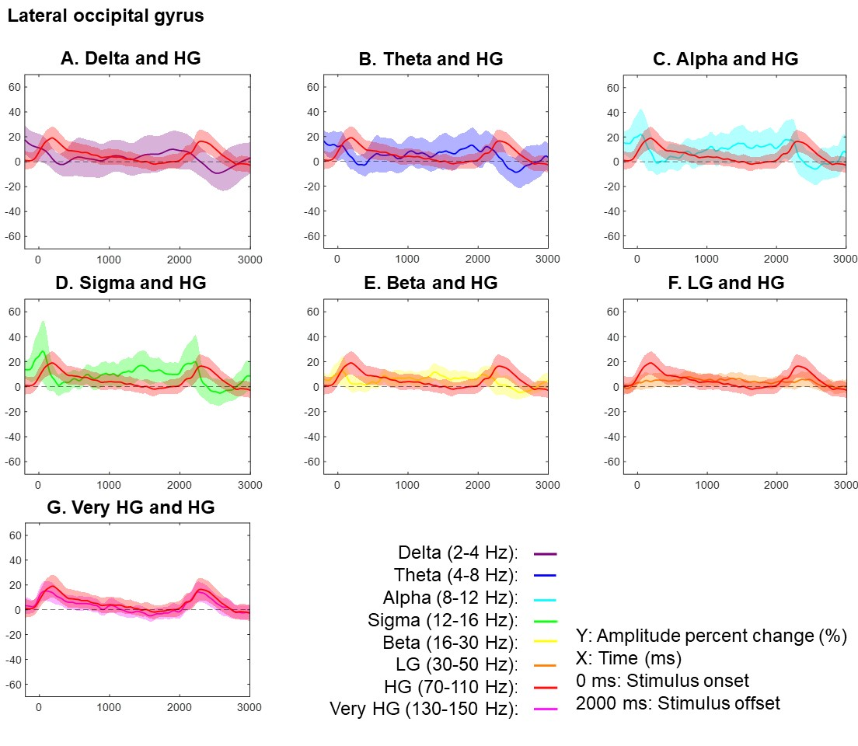
Figure S13. Task-related amplitude modulations at the lateral occipital gyrus. Each plot presents the temporal changes of high-gamma (HG) and one of the following frequency band amplitudes: (A) delta at 2-4 Hz, (B) theta at 4-8 Hz, (C) alpha at 8-12 Hz, (D) sigma at 12-16 Hz, (E) beta at 16-30 Hz, (F) low-gamma (LG) at 30-50 Hz, and (G) very HG at 130-150 Hz. Mean amplitude changes from the baseline mean are presented with a 95% confidence interval bar.
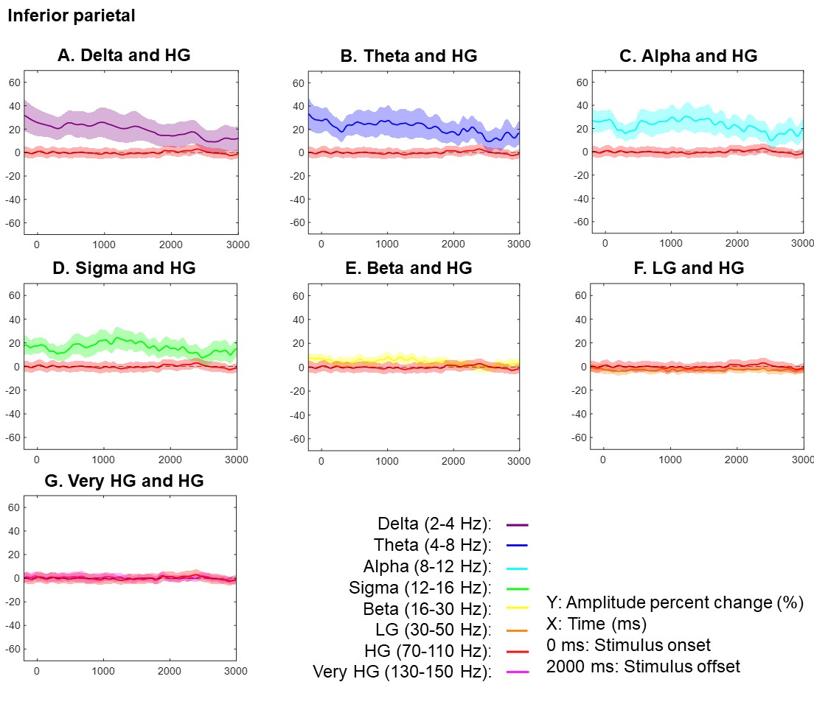
Figure S14. Task-related amplitude modulations at the inferior parietal gyrus. Each plot presents the temporal changes of high-gamma (HG) and one of the following frequency band amplitudes: (A) delta at 2-4 Hz, (B) theta at 4-8 Hz, (C) alpha at 8-12 Hz, (D) sigma at 12-16 Hz, (E) beta at 16-30 Hz, (F) low-gamma (LG) at 30-50 Hz, and (G) very HG at 130-150 Hz. Mean amplitude changes from the baseline mean are presented with a 95% confidence interval bar.
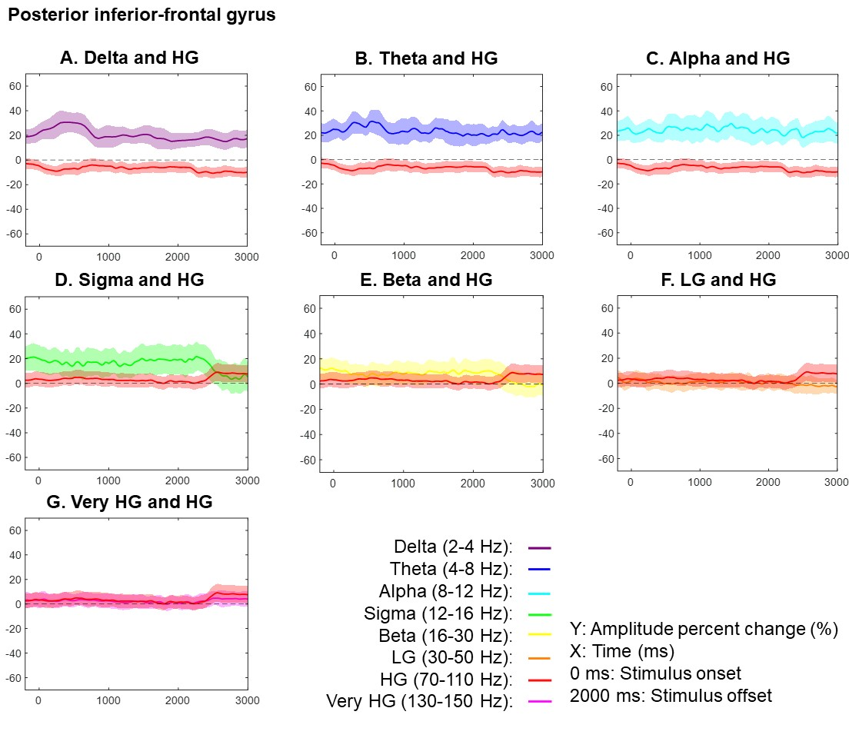
Figure S15. Task-related amplitude modulations at the posterior inferior-frontal gyrus. Each plot presents the temporal changes of high-gamma (HG) and one of the following frequency band amplitudes: (A) delta at 2-4 Hz, (B) theta at 4-8 Hz, (C) alpha at 8-12 Hz, (D) sigma at 12-16 Hz, (E) beta at 16-30 Hz, (F) low-gamma (LG) at 30-50 Hz, and (G) very HG at 130-150 Hz. Mean amplitude changes from the baseline mean are presented with a 95% confidence interval bar.
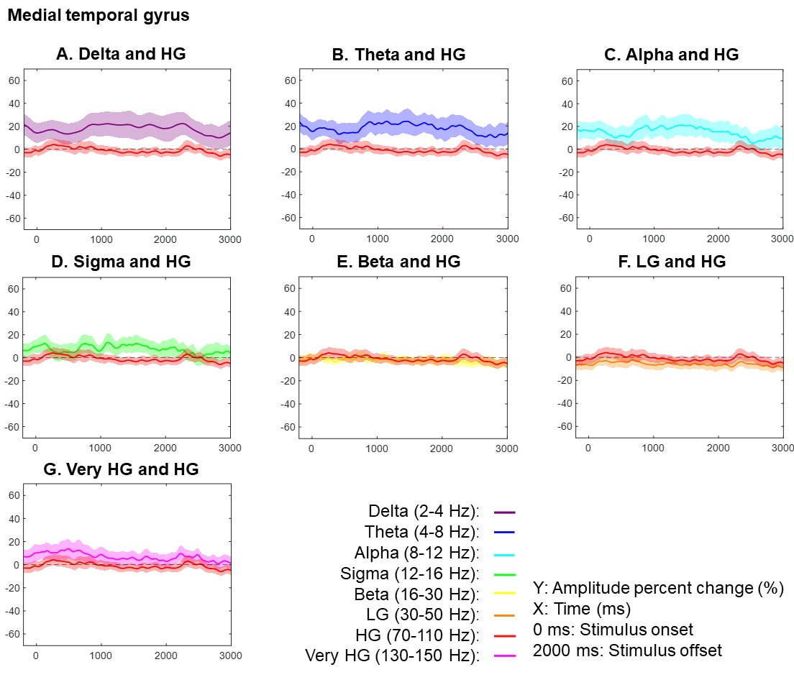
Figure S16. Task-related amplitude modulations at the medial temporal gyrus. Each plot presents the temporal changes of high-gamma (HG) and one of the following frequency band amplitudes: (A) delta at 2-4 Hz, (B) theta at 4-8 Hz, (C) alpha at 8-12 Hz, (D) sigma at 12-16 Hz, (E) beta at 16-30 Hz, (F) low-gamma (LG) at 30-50 Hz, and (G) very HG at 130-150 Hz. Mean amplitude changes from the baseline mean are presented with a 95% confidence interval bar.

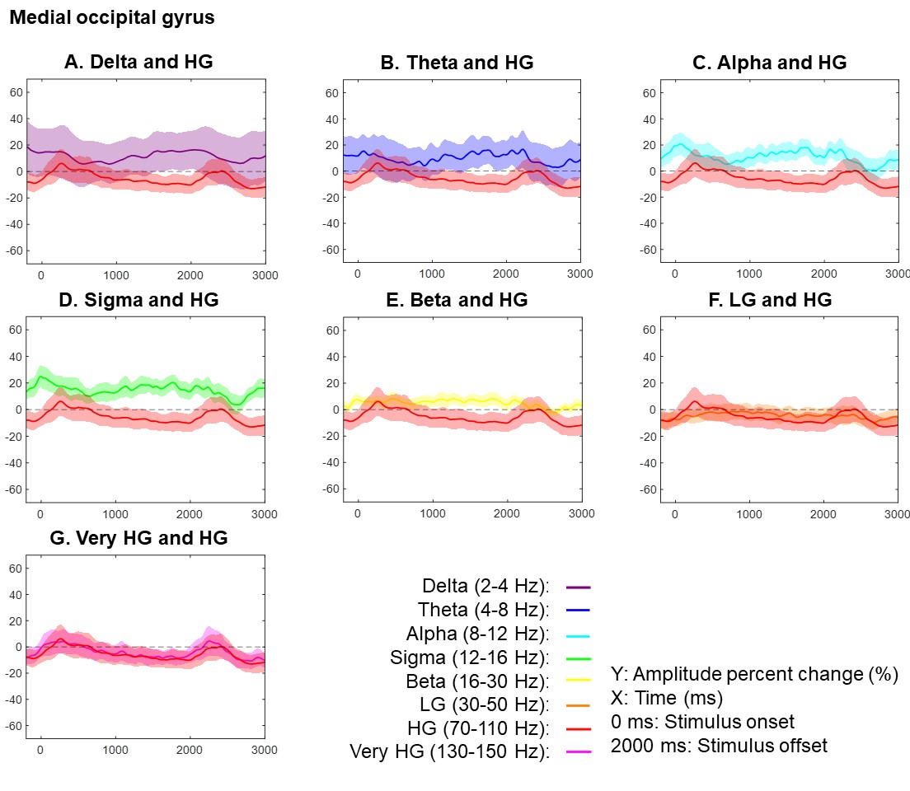
Figure S17. Task-related amplitude modulations at the medial occipital gyrus. Each plot presents the temporal changes of high-gamma (HG) and one of the following frequency band amplitudes: (A) delta at 2-4 Hz, (B) theta at 4-8 Hz, (C) alpha at 8-12 Hz, (D) sigma at 12-16 Hz, (E) beta at 16-30 Hz, (F) low-gamma (LG) at 30-50 Hz, and (G) very HG at 130-150 Hz. Mean amplitude changes from the baseline mean are presented with a 95% confidence interval bar.

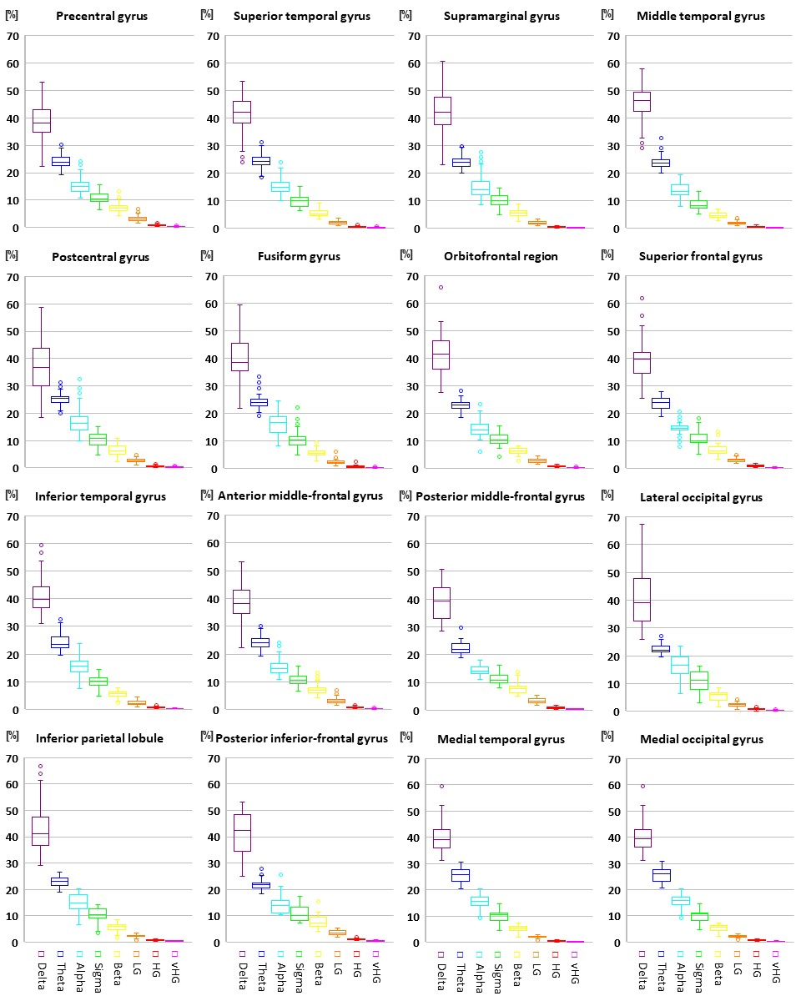
Figure S18. Baseline spectral amplitudes at given regions of interest (ROIs). Each box plot presents the proportion (%) of (A) delta_{2-4 Hz}, (B) theta_{4-8 Hz}, (C) alpha_{8-12 Hz}, (D) sigma_{12-16 Hz}, (E) beta_{16-30 Hz}, (F) low-gamma (LG)_{30-50 Hz}, and (G) high-gamma (HG)_{70-110 Hz}, and (H) very HG_{130-150 Hz} amplitudes during the baseline period prior to the gameplay. The boxplot presents the median, the 25th and 75th percentiles, and the highest and lowest proportion values.

Post-hoc mixed model analyses
We performed a post-hoc mixed model analysis to determine whether the difference in inverse correlation between high-gamma and low-frequency band amplitudes across ROIs (Figure 7) could be attributed to the characteristics of low-frequency band amplitudes during the baseline period (Figure S18). We tested the hypothesis that the baseline period would be characterized by prominent alpha and sigma activities in the sensorimotor/visual areas and prominent theta and delta activities in the association cortices. To address this hypothesis, we designed a mixed model with the dependent variable being the ratio of “8-16 Hz” amplitude to “2-8 Hz” amplitude, and the fixed effect variable was the anatomical location (with a value of 1 indicating that a given electrode site was within the sensorimotor/visual cortices defined as precentral, postcentral, lateral occipital, medial occipital, and fusiform regions). Patient and intercept were treated as random factor variables. The analysis revealed that the ratio of “8-16 Hz” amplitude to “2-8 Hz” amplitude was greater in the sensorimotor/visual areas as compared to the association cortices (t-value: 7.088; mixed model coefficient: 0.052 [95%CI: 0.037 to 0.066]; p-value: 2.930E-12; DF: 821.55).

Video S1. Visuospatial working memory task. The first author (R.U.) demonstrates how to play 'Memory Matrix', a visuospatial working memory game on the Lumosity platform.

Video S2. Intracranial EEG (iEEG) amplitude modulations. The video showcases the percentage changes of task-related high- gamma_{70-110 Hz} and alpha_{8-12 Hz} amplitudes in comparison to the baseline mean.

Timeline:
00:00-00:52. A period of 2,500 ms after stimulus onset.
00:52-01:38. A period of 2,000 ms between 1,500 ms before and 500 ms after the initial tap response.

Video S3. Memory load-dependent high-gamma amplitude modulations and white matter substrates. Left: Memory load-dependent cortical high-gamma_{70-110 Hz} modulations. Color-coded ROIs indicate that increased tile number was significantly associated with increased (red) or decreased (blue) high-gamma amplitude, as determined by the mixed model analysis. Right: White matter tracts underlying memory load-dependent functional connectivity modulations. Color-coded streamlines indicate functional connectivity enhancement (red) and diminution (blue) between ROIs. 0 ms: a 250-ms time window immediately after stimulus onset.

Video S4. Task familiarity-dependent high-gamma amplitude modulations and white matter substrates. Left: Task familiarity-dependent cortical high-gamma_{70-110 Hz} modulations. Color-coded ROIs indicate that increased trial number was significantly associated with increased (red) or decreased (blue) high-gamma amplitude, as determined by the mixed model analysis. Right: White matter tracts underlying task familiarity-dependent functional connectivity modulations. Color-coded streamlines indicate functional connectivity enhancement (red) and diminution (blue) between ROIs. 0 ms: a 250-ms time window immediately after stimulus onset.

Video S5. Prior failed response-related high-gamma amplitude modulations and white matter substrates. Left: Prior failed response-related cortical high-gamma_{70-110 Hz} modulations. Color-coded ROIs indicate that the failed response in an immediately preceding trial was significantly associated with increased (red) or decreased (blue) high-gamma amplitude, as determined by the mixed model analysis. Right: White matter tracts underlying prior failed response-related functional connectivity modulations. Color-coded streamlines indicate functional connectivity enhancement (red) and diminution (blue) between ROIs. 0 ms: a 250-ms time window immediately after stimulus onset.

