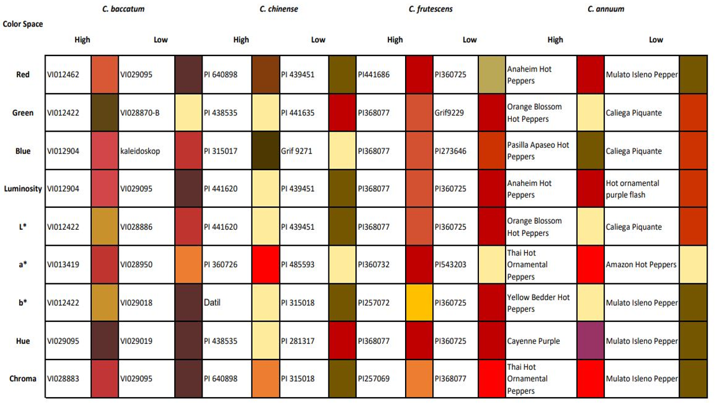
Figure S1. Phenotypic diversity of 9 color spaces across Capsicum species indicating the accession name with high and low color values for each specie.

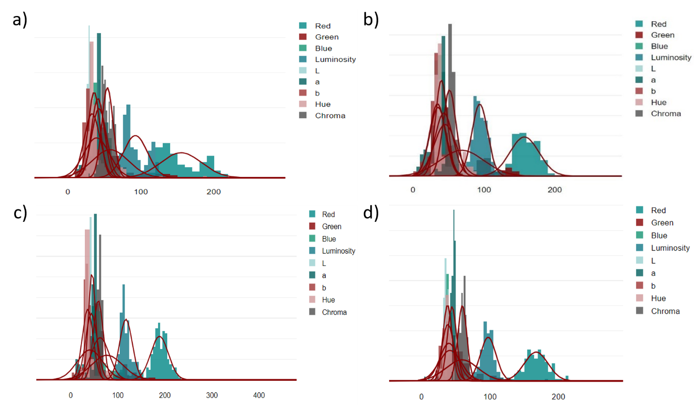
Figure S2. Color frequency distribution of a) C. baccatum, b) C. chinense, c) C. frutescens, and d) C. annuum accessions grown in field conditions from 2015 to 2021. Y-axis displays the frequency percentage of accessions, and the X-axis indicates the color fruit trait.
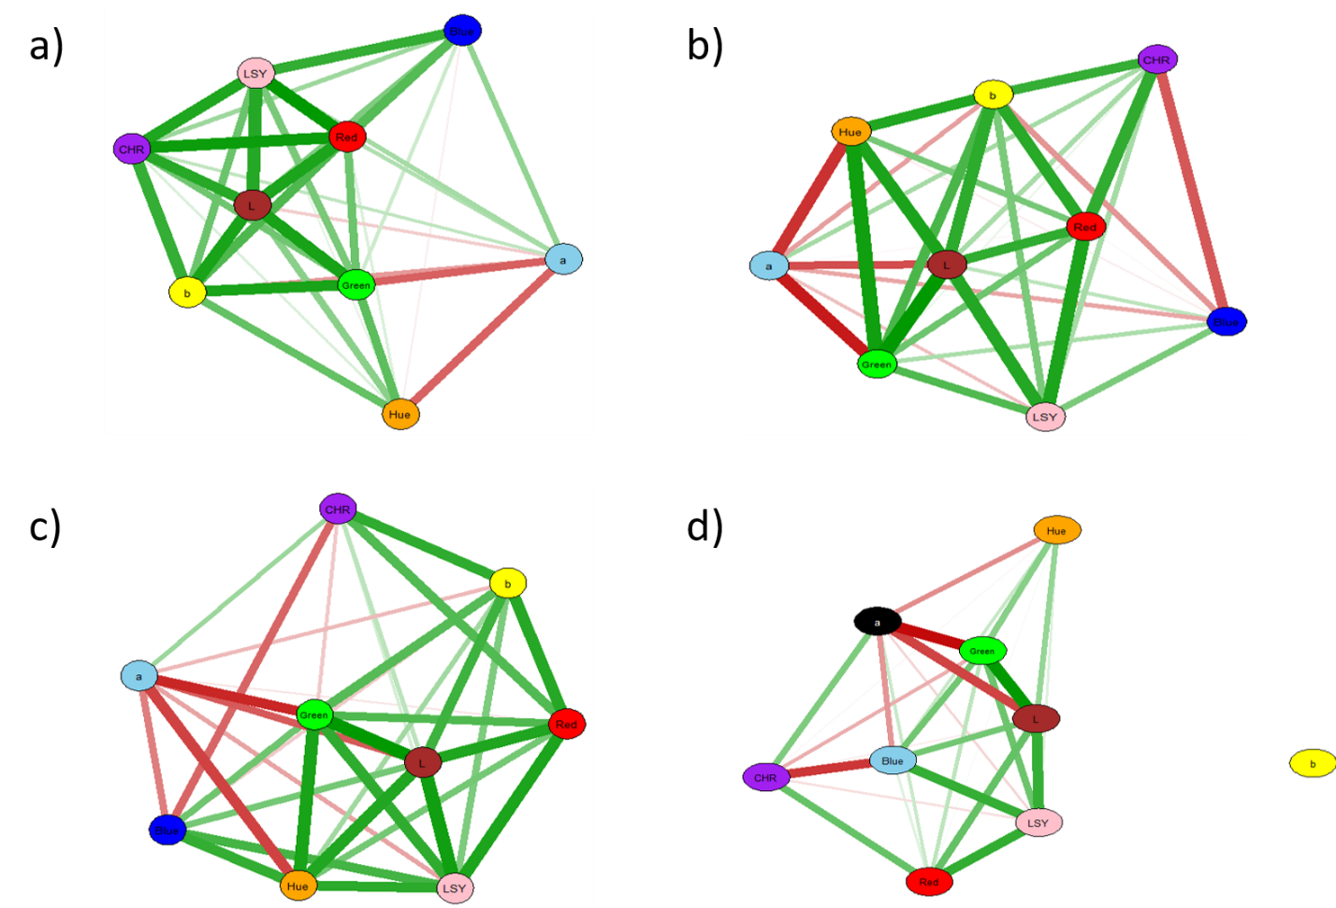
Figure S3. Correlation network plots illustrate the associations among different 9 color spaces across Capsicum Species a) C. baccatum, b) C. chinense, c) C. frutescens, and d) C. annuum. Each node represents a color space, and green and red edges between nodes indicate positive and negative correlation, respectively. The thickness of each edge relates to the strength of the association. (LSY-Luminosity; CHR- Chroma).

