SUPPLEMENTARY DATA

Supplementary Fig 1. Body weight at different times in septic and healthy groups pretreated or no-pretreated with A. faecalis A12C.
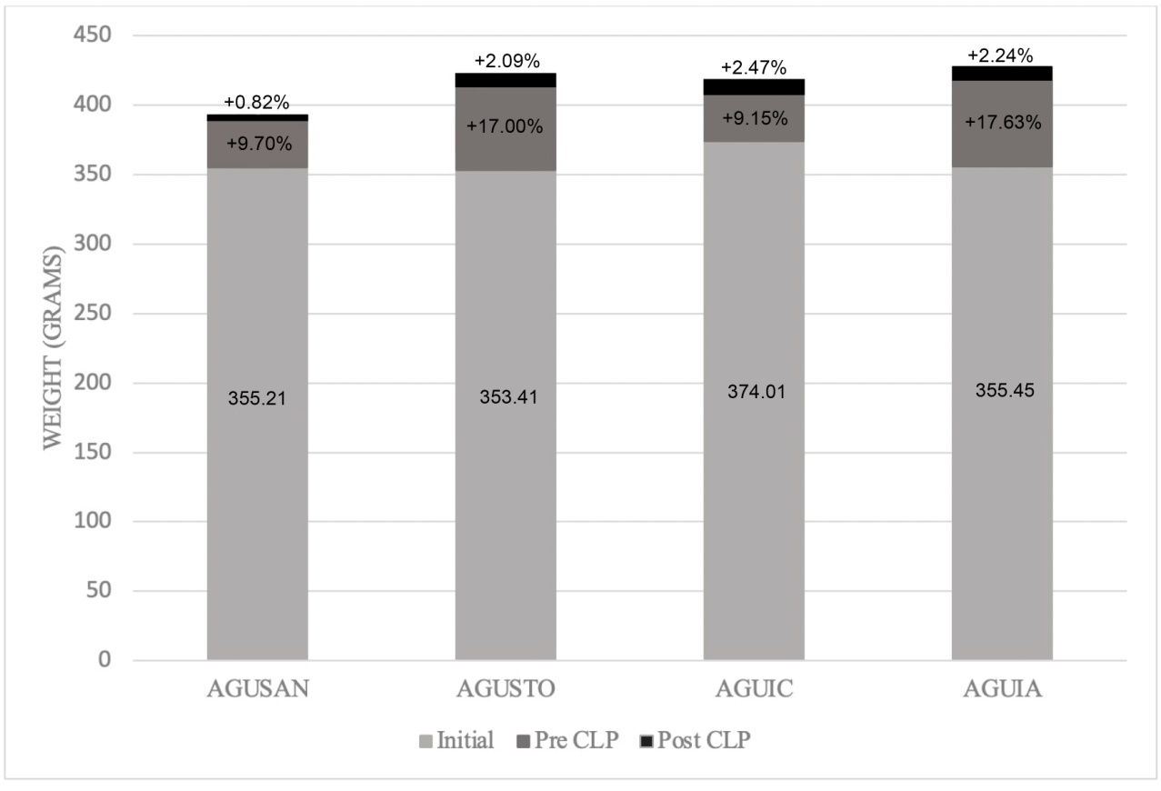
The results are expressed as the body weight mean in grams and % of weight gained, assessed at 0 days, 30 days, and 20h post CLP (AGUIC and AGUIA) or immediately before euthanasia (without CLP) in the case of healthy animals (AGUSAN and AGUSTO).

