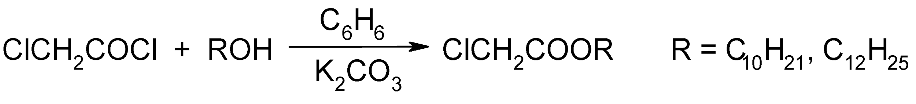

Scheme 1 Synthesis of long-chain alkyl chloroacetates

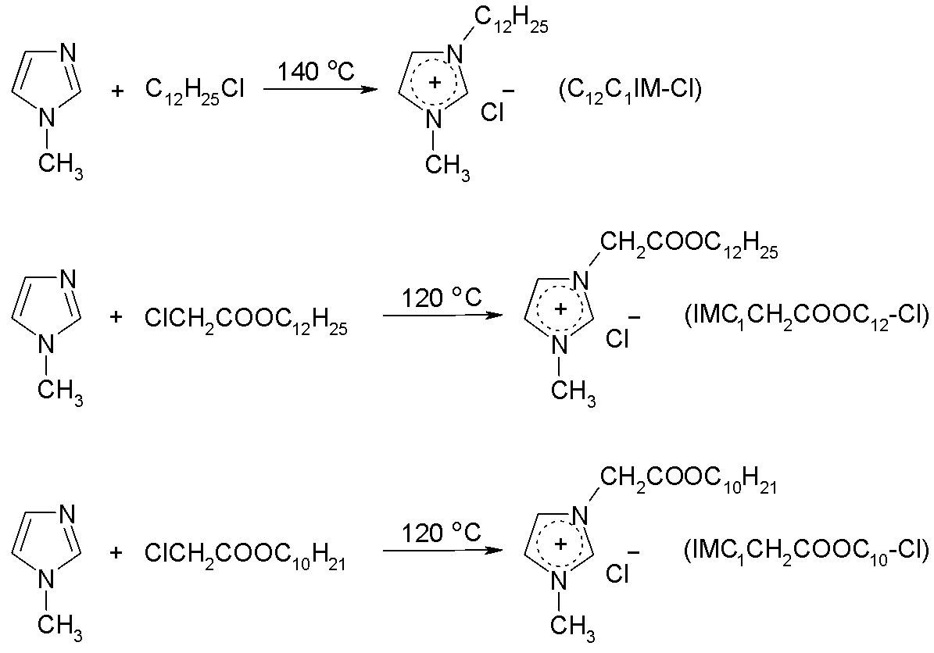

Scheme 2 Synthesis of imidazolium-based ILs

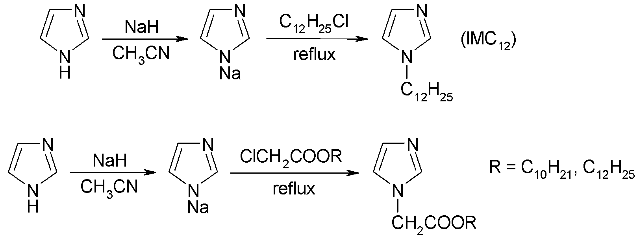

Scheme 3. Synthesis of imidazolium-based lysosomotropic detergents

