Supplementary Material
Anticancer activity features of imidazole-based ionic liquids and lysosomotropic detergents: in silico and in vitro studies

Anastasiia Gryniukova^{1,3} Petro Borysko³, Iryna Myziuk³, Diana Alieksieieva³, Diana Hodyna ¹, Ivan Semenyuta ¹, Vasyl Kovalishyn ¹, Larysa Metelytsia ¹, Sergiy Rogalsky², Sergiy Tcherniuk^{4,5}

¹ Department of Medical and Biological Researches, V.P. Kukhar Institute of Bioorganic Chemistry and Petrochemistry, National Academy of Science of Ukraine, 1 Academician Kukhar Str., Kyiv, 02094, Ukraine

² Laboratory of Modification of Polymers, V.P. Kukhar Institute of Bioorganic Chemistry and Petrochemistry, National Academy of Science of Ukraine, 50 Kharkivske shose, Kyiv, 02160, Ukraine
³Bienta/Enamine Ltd., 78 Winston Churchill Str., 02094, Kyiv, Ukraine

⁴IdeSip, 4 Rue Pierre Fontaine, 91058 Évry-Courcouronnes, France,

⁵Department of Biological Sciences, Youth Academy of Sciences, 2 Nemyrovych-Danchenko Str., Kiev, 01011, Ukraine

- OCHEM web platform

The model development was done using the On-line Chemical Database and Modeling Environment (OCHEM), which supports the calculation of different descriptors and machine learning techniques [].

  - Machine learning techniques (MLT)

Transformer Convolutional Neural Network (Trans-CNN). Trans-CNN method models biological activity or physicochemical properties using the internal representation of the molecules based on the information from their SMILES notation []. The network architecture usually requires a few tens iterations to converge for new tasks. The method predicts an aim value using the average individual prediction for a batch of augmented SMILES belonging to the same molecule. The deviation within the batch can serve as a measure of the prediction confidence interval, while the ability to canonize SMILES can be used to determine the areas of applicability of the models.

Convolutional Neural Fingerprint (CNF). Convolutional Neural Fingerprint model is based on the convolutional graph introduced by Duvenaud et al. []. The key ideas behind the convolutional graph are the hierarchical convolutional layers and a matrix multiplication which acts as a hash function []. CNF model is realized on the SMILES representation of a molecule. The CNF model applies to the one-hot encoding of SMILES convolutional layers followed by matrix multiplications. The idea behind applying convolutional layers is to obtain neighboring atoms in a chemical structure and multiplication can be interpreted as an embedding on a latent space An advantage of the CNF model is that it maps a sparse matrix, the one-hot encoding of a SMILES, into a dense vector, the neural ﬁngerprint. The latter can be plugged directly into standard machine learning algorithms such as neural network, support vector machine and random forest [4]. The very high prediction accuracy of the CNF has achieved thanks to the augmentation technique, which was originally proposed in computer vision and was newly introduced to QSAR studies []. Transformer Convolutional Neural Fingerprint resembles Trans-CNN, but instead of the convolutional neural network, it uses a CNF for processing the latent representation of the neural network. A ﬁngerprint is a numerical representation that encodes molecular information. It also uses the augmentation technique, which was first proposed in computer vision and was recently introduced to QSAR studies [].

Random Forest Regression (RFR). Random Forests (RF) consist of many individual trees devised to operate quickly over large data sets. The underlying algorithm presents a number of attractive features, such as an internal procedure for descriptor selection. RF is not affected by correlated descriptors since it uses random samples to build each tree in the forest. The final forecast is made by most of the votes of the individual trees [].

Message Passing Neural Networks (MPNN). The main idea of this framework consists of message, update, and readout functions that operate on different node (atom) features and edge (bond) features in the graph. MPNN operates in two phases: the message passing phase, which transmits information across the molecule to build a neural representation of the molecule, and the readout phase, which uses the final representation of the molecule to predict the properties of interest [].

Deep Learning Consensus Architecture (DLCA). DLCA is a consensus approach inside the single neural network. It combines three separate deep learning neural networks built based on three types of ﬁngerprints by averaging their outputs inside the single neural net and improving the consensus results. In this case, during training, the neural network calculates the best weights for each specific output and for averaging them. As a result, the network provides multitask outputs for each type of ﬁngerprint and a consensus output [].

1.2 Molecular descriptors software packages
OCHEM supports many commonly used software packages for calculation of vast collections of molecular descriptors. In OCHEM, the descriptors are grouped by the name of the software name that calculates them:
E-State indices. Calculation of electro-topological state indices is based on the chemical graph theory. The E-state indices are 2D-descriptors that combine together both electronic and topological characteristics of the analyzed compounds [].
ALogPS. The program calculates two 2D descriptors, namely the 1-octanol-water partition coefficient and the aqueous solubility ].
CDK 2.3. The Chemistry Development Kit (CDK) is a set of module Java libraries for processing chemical information. CDK 2.3 calculates 256 molecular descriptors such as geometrical, topological, constitutional, electronic, and hybrid descriptors [].

2. Computational Machine Learning results

Regression models from Table 1

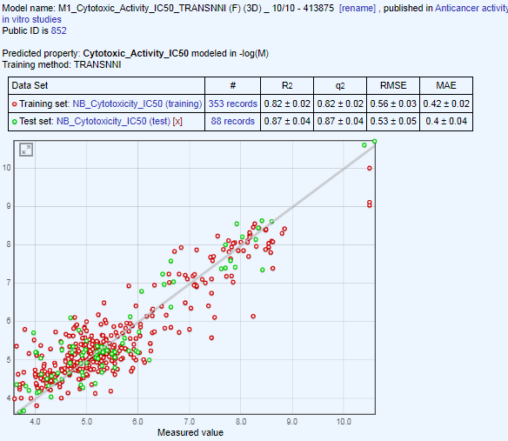
a)
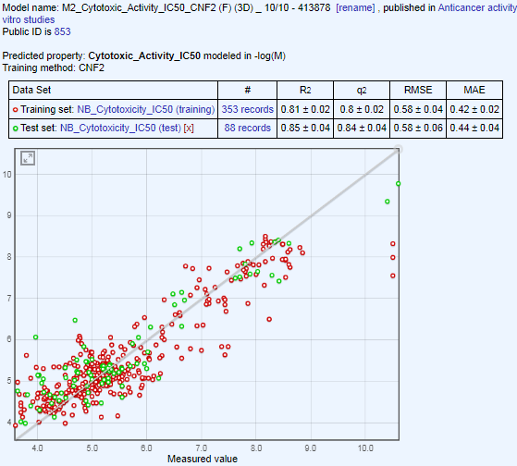
b)

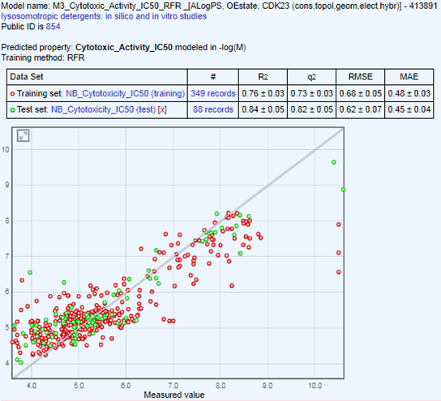
c)
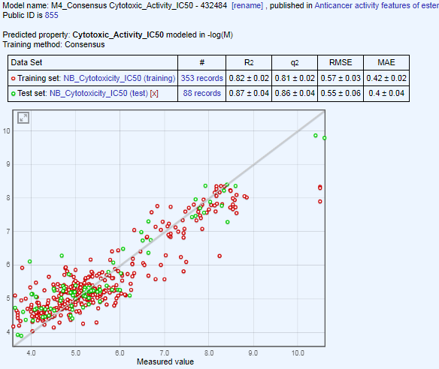
d)

Fig. 1S. QSAR models calculated by a different MLT on the OCHEM server; a-с) Statistical coefficients calculated for regression models by the Trans-CNN, Transformer CNF and RFR; d) Consensus model calculated by averaging the previous three models.
Regression models from Table 2

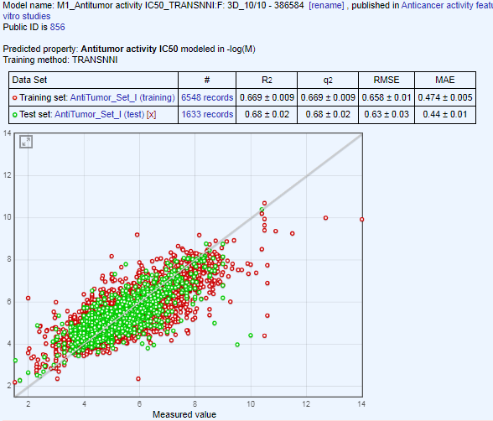
a)
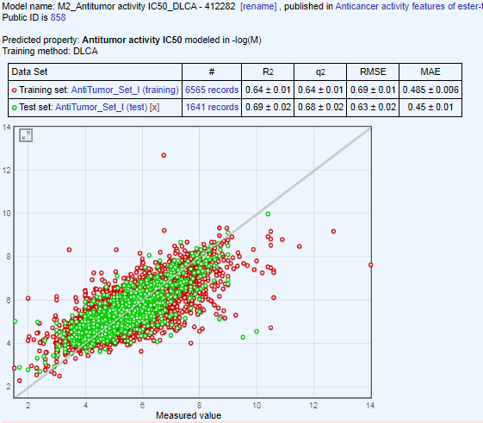
b)
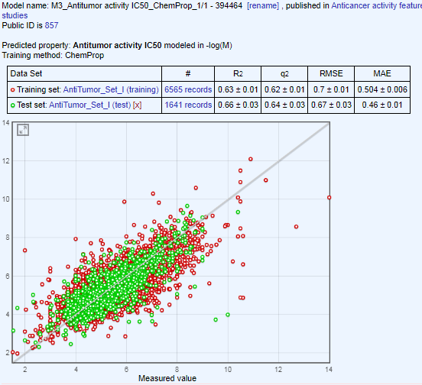
c)

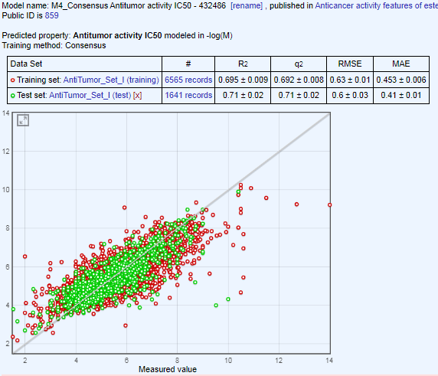
d)

Fig. 2S. QSAR models calculated by a different MLT on the OCHEM server; a-c) Statistical coefficients calculated for regression models by the Trans-CNN, DLCA and MPNN; d) Consensus model calculated by averaging of the previous models.

3. Predicted activity of new compounds

Table 1S. Structures of the 20 compounds analyzed in this work.
Compound No | Chemical Structure | Weight | Chemical Name
1 | 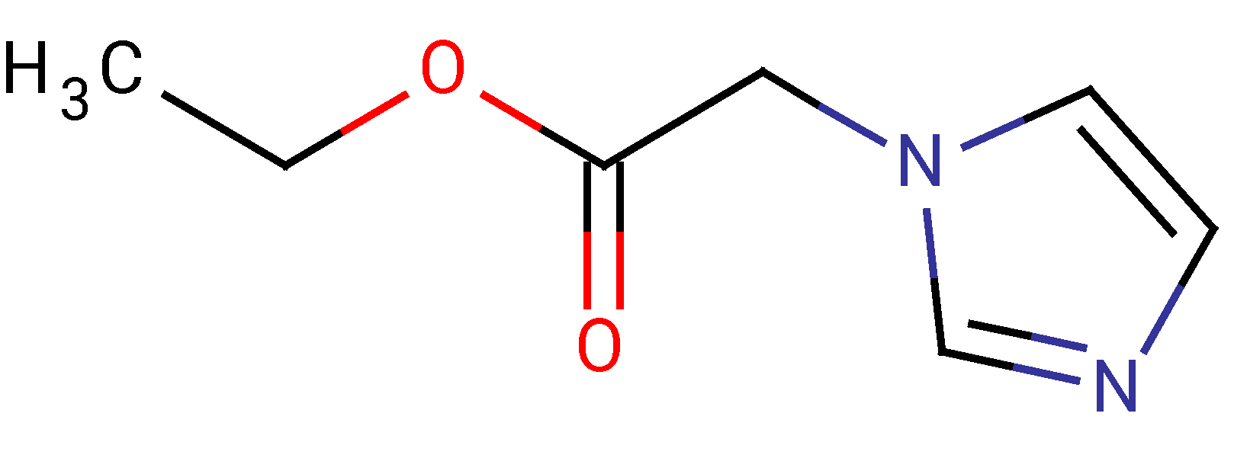 | 154.17 | 1-ethyloxycarbonylmethyl-imidazole
2ª | 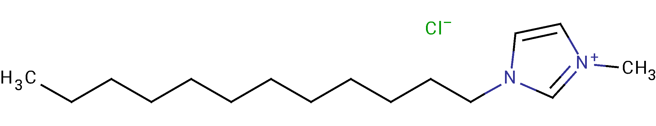 | 222.37 | 1-dodecyl-3-methyl-imidazolium chloride
3ª | 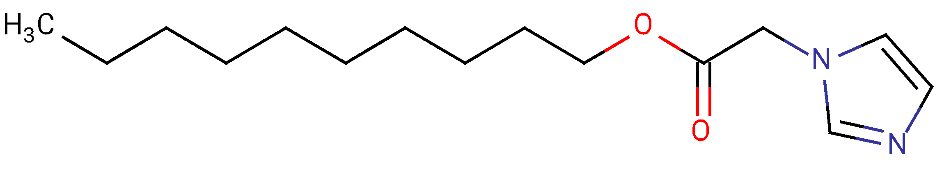 | 266.38 | 1-decyloxycarbonylmethyl-imidazole
4ª | 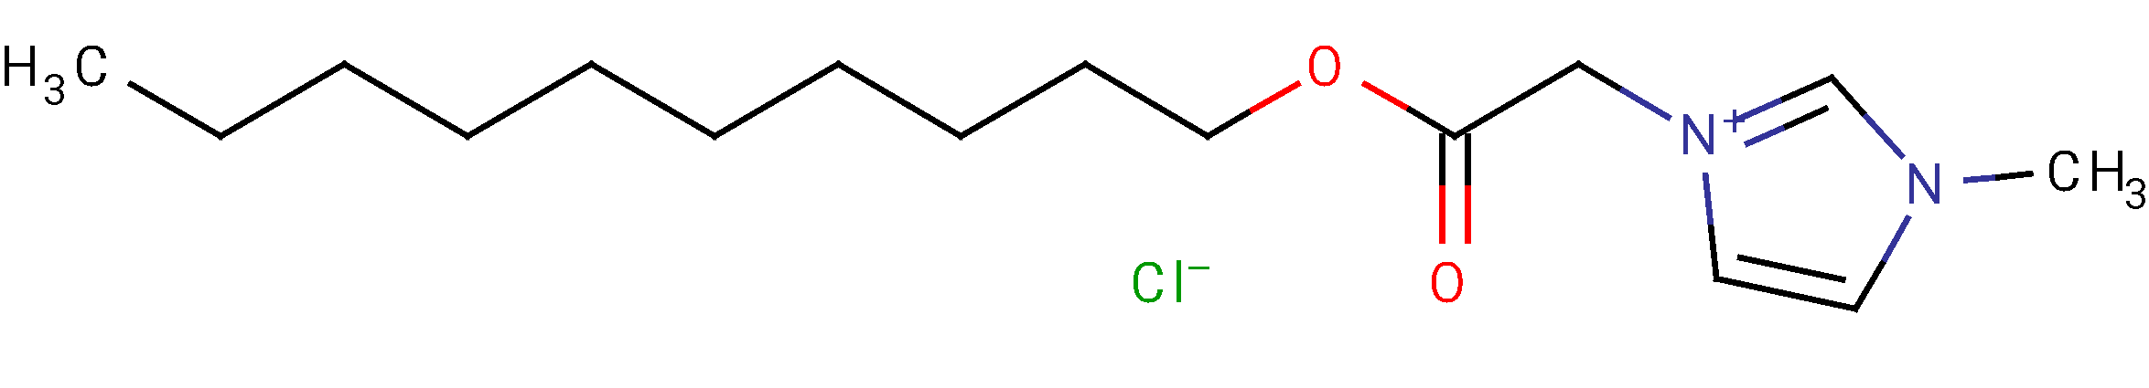 | 316.87 | 1-decyloxycarbonylmethyl-  3-methylimidazolium chloride
5 | 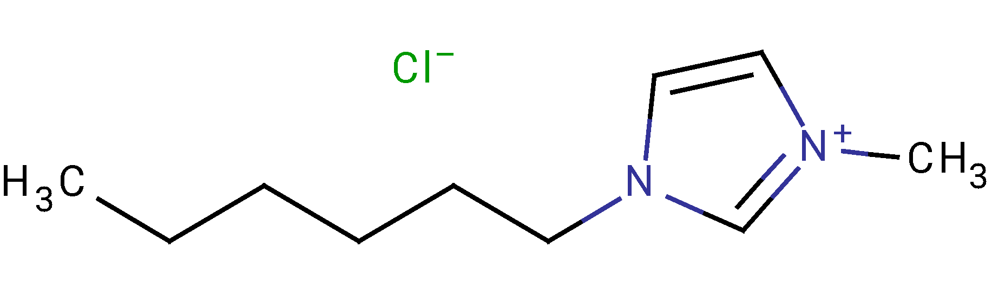 | 202.72 | 1-hexyl-3-methylimidazolium chloride
6 | 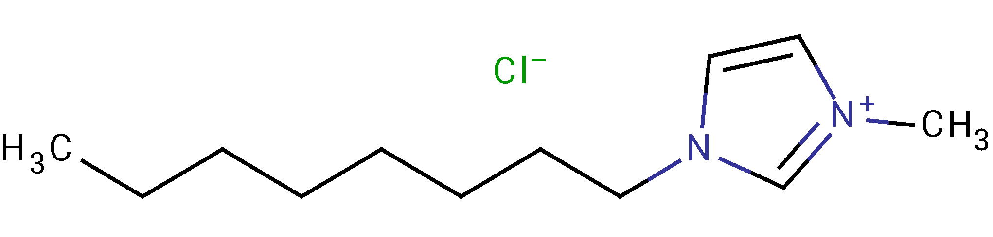 | 230.78 | 1-octyl-3-methylimidazolium chloride
7ª | 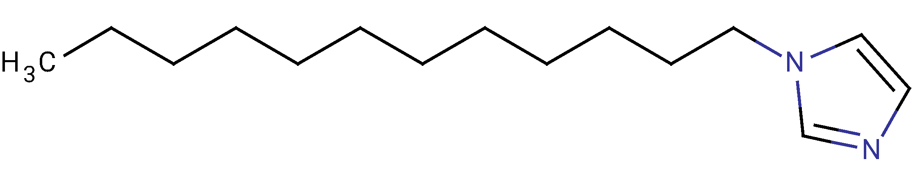 | 236.39 | 1-dodecylimidazole
8ª | 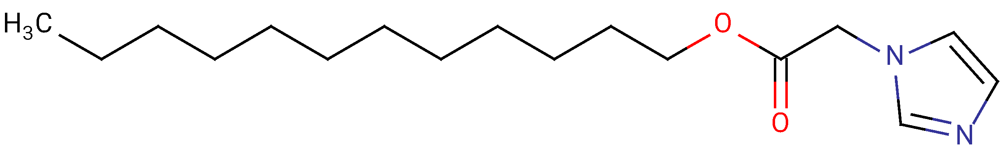 | 294.43 | 1-dodecyloxycarbonylmethyl-imidazole
9ª | 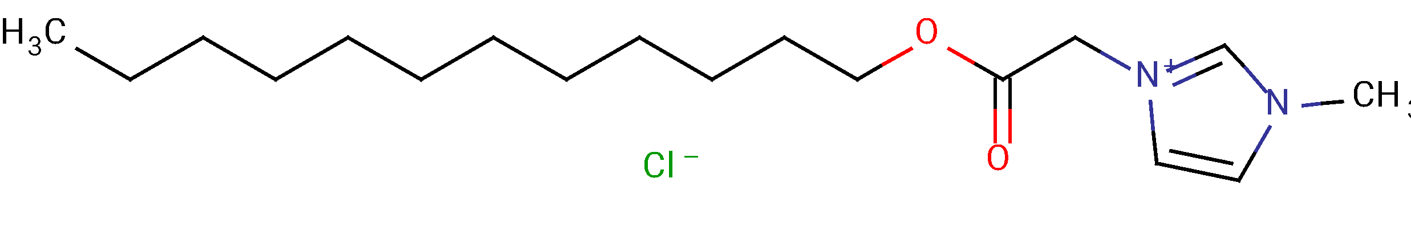 | 344.92 | 1-dodecyloxycarbonylmethyl-3-methylimidazolium chloride
10 | 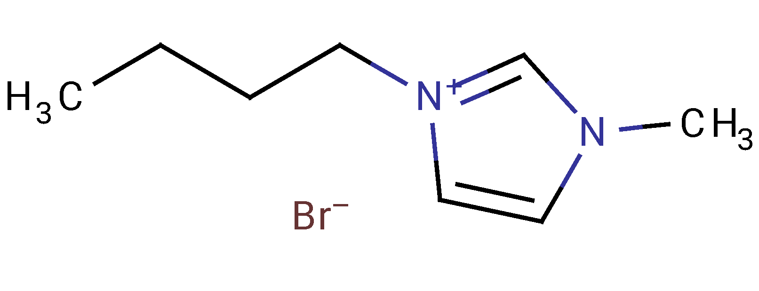 | 219.12 | 1-butyl-3-methylimidazolium bromide
11 | 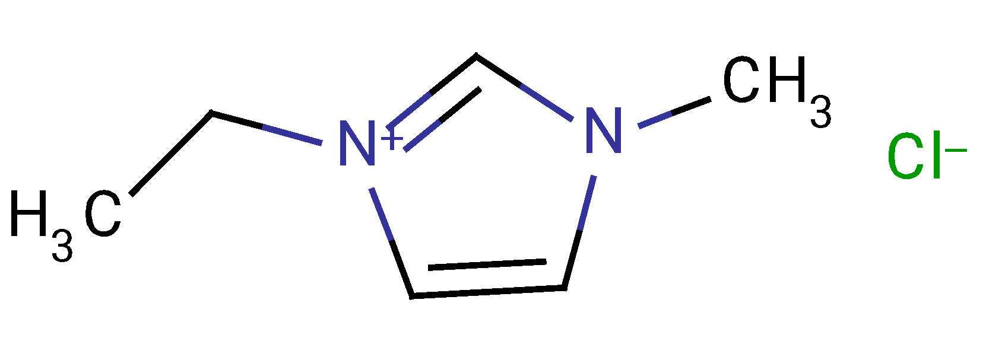 | 146.62 | 1-ethyl-3-methylimidazolium chloride
12 | 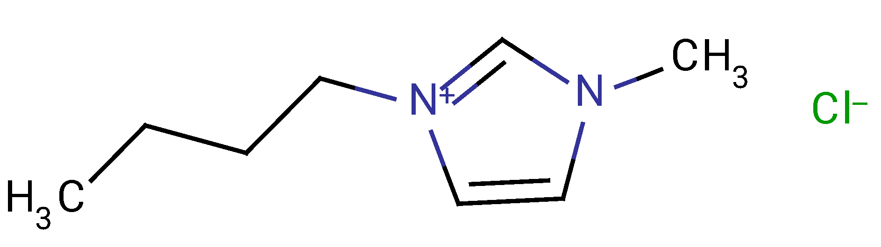 | 174.67 | 1-butyl-3-methylimidazolium chloride
13 | 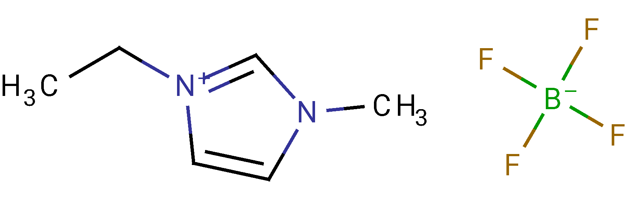 | 197.97 | 1-ethyl-3-methylimidazolium tetrafluoroborate
14 | 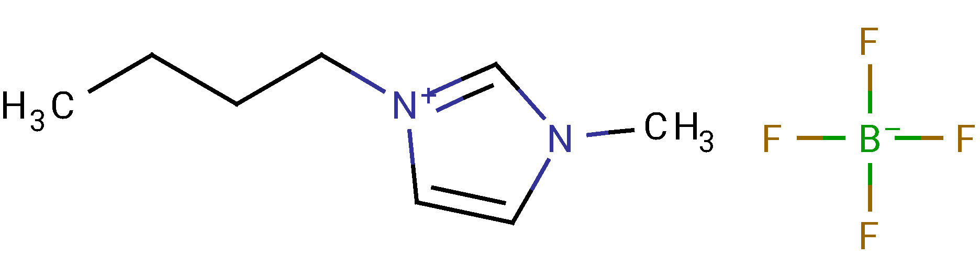 | 226.02 | 1-butyl-3-methylimidazolium tetrafluoroborate
15 | 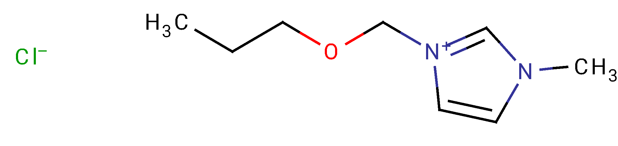 | 190.67 | 1-(propyloxymethyl)-3-methylimidazolium chloride
16 | 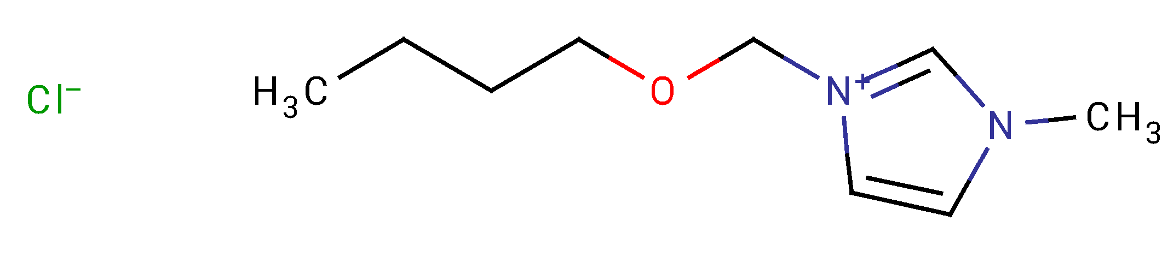 | 204.68 | 1-(butoxymethyl)-3-methylimidazolium chloride
17 | 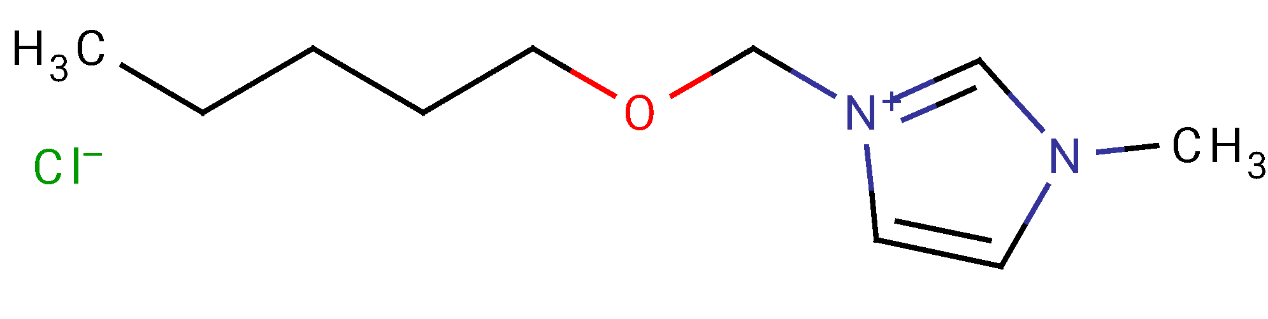 | 218.72 | 1-(pentyloxymethyl)-3-methylimidazolium chloride
18 | 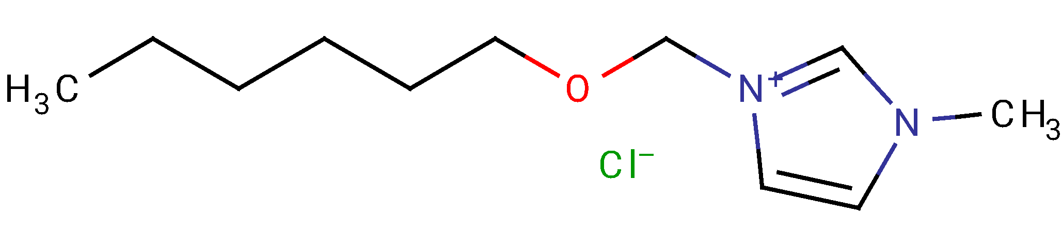 | 232.75 | 1-(hexyloxymethyl)-3-methylimidazolium chloride
19 | 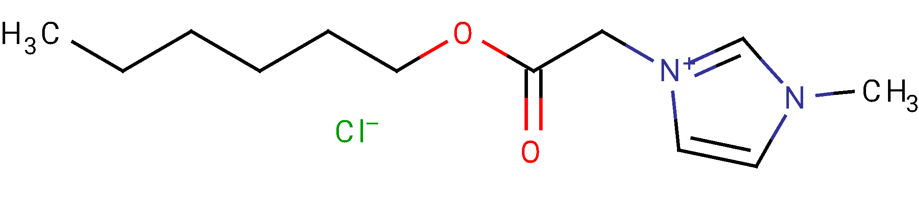 | 260.76 | 1-hexyloxycarbonylmethyl-3-methylimidazolium chloride
20 | 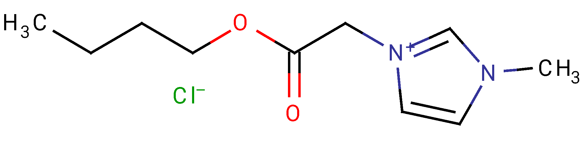 | 232.71 | 1-butyloxycarbonylmethyl-3-methylimidazolium chloride
ªFinal set compounds are represented in bold.

Table 2S. Statistical coefficients calculated by using consensus regression models for 20 ILs

No. | Neuroblastoma |  |  |  | Leukemia
No. | log(1/IC₅) | CONSENSUS-STD | RMSE | AD | log(1/IC₅) | CONSENSUS-STD | RMSE | AD
1ª | 4.93 | 0.12 | 0.42 | TRUE | 3.87 | 0.32 | 0.83 | TRUE
2^{a,b} | 5.13 | 0.35 | 0.69 | TRUE | 4.33 | 0.31 | 0.83 | TRUE
3^{a,b} | 5.1 | 0.1 | 0.42 | TRUE | 3.97 | 0.25 | 0.53 | TRUE
4 ^{a,b} | 4.8 | 0.26 | 0.69 | TRUE | 4.1 | 0.2 | 0.53 | TRUE
5 | 4.77 | 0.67 | 0.85 | FALSE | 4.13 | 0.15 | 0.53 | TRUE
6 | 4.9 | 0.6 | 0.85 | FALSE | 4.07 | 0.23 | 0.53 | TRUE
7 ^{a,b} | 5.53 | 0.31 | 0.69 | TRUE | 4.33 | 0.15 | 0.53 | TRUE
8 ^{a,b} | 5.03 | 0.21 | 0.67 | TRUE | 4.03 | 0.31 | 0.83 | TRUE
9 ^{a,b} | 4.83 | 0.32 | 0.69 | TRUE | 4.2 | 0.26 | 0.61 | TRUE
10 | 4.53 | 0.4 | 0.85 | TRUE | 4.23 | 0.47 | 0.83 | TRUE
11 | 4.43 | 0.51 | 0.85 | FALSE | 4.3 | 1.1 | 0.83 | FALSE
12 | 4.53 | 0.4 | 0.85 | TRUE | 4.23 | 0.47 | 0.83 | TRUE
13 | 4.43 | 0.51 | 0.85 | FALSE | 4.3 | 1.1 | 0.83 | FALSE
14 | 4.53 | 0.4 | 0.85 | TRUE | 4.23 | 0.47 | 0.83 | TRUE
15 | 4.53 | 0.4 | 0.85 | TRUE | 4.07 | 0.49 | 0.83 | TRUE
16 | 4.53 | 0.35 | 0.69 | TRUE | 4.07 | 0.32 | 0.83 | TRUE
17 | 4.57 | 0.35 | 0.69 | TRUE | 4.13 | 0.47 | 0.83 | TRUE
18 | 4.6 | 0.3 | 0.69 | TRUE | 4.13 | 0.31 | 0.83 | TRUE
19ª | 4.7 | 0.3 | 0.69 | TRUE | 4.07 | 0.21 | 0.53 | TRUE
20ª | 4.7 | 0.3 | 0.69 | TRUE | 4.07 | 0.21 | 0.53 | TRUE

ªSet of compounds selected at the first stage of screening. ^{b}Final set compounds are represented in bold. IC₅₀ - half maximal inhibitory concentration; CONSENSUS-STD – the standard deviation of the predictions, obtained from an ensemble of models; RMSE - root mean square error; AD –applicability domain

Table 3S. dTmD in C° values for tested compounds against SIRT1, BRD4 and Carbonic Anhydrase A.

Compound | Concentration,  μM | SIRT1 | BRD4 | Carbonic Anhydrase A
2 | 0.78 | -0.1 | -0.15 | -0.05
2 | 1.56 | -0.1 | -0.15 | -0.05
2 | 3.12 | -0.15 | -0.05 | 0.05
2 | 6.25 | -0.15 | -0.1 | 0.05
2 | 12.5 | -0.2 | -0.1 | 0.05
2 | 25 | -0.25 | -0.05 | -0.05
2 | 50 | -0.5 | 0.05 | -0.15
2 | 100 | -1.5 | -0.2 | -0.4
3 | 0.78 | -0.1 | -0.2 | 0
3 | 1.56 | -0.15 | -0.1 | 0
3 | 3.12 | -0.2 | -0.25 | 0
3 | 6.25 | -0.2 | -0.2 | 0.05
3 | 12.5 | -0.25 | -0.2 | 0
3 | 25 | -0.3 | -0.2 | 0
3 | 50 | -0.45 | -0.25 | 0
3 | 100 | -0.75 | -0.15 | -0.05
4 | 0.78 | -0.1 | -0.15 | 0.1
4 | 1.56 | -0.2 | -0.25 | 0.1
4 | 3.12 | -0.2 | -0.2 | 0.05
4 | 6.25 | -0.3 | -0.2 | 0.05
4 | 12.5 | -0.3 | -0.15 | 0.1
4 | 25 | -0.25 | -0.3 | 0
4 | 50 | -0.35 | -0.3 | 0
4 | 100 | -0.85 | -0.15 | -0.02
7 | 0.78 | -0.15 | -0.25 | 0.1
7 | 1.56 | -0.2 | -0.25 | 0.05
7 | 3.12 | -0.2 | -0.2 | 0.1
7 | 6.25 | -0.15 | -0.2 | 0
7 | 12.5 | -0.25 | -0.1 | 0.05
7 | 25 | -0.3 | -0.3 | 0.05
7 | 50 | -0.4 | -0.25 | 0.05
7 | 100 | -1.45 | -2.05 | -0.2
8 | 0.78 | -0.2 | -0.2 | 0
8 | 1.56 | -0.2 | -0.25 | 0
8 | 3.12 | -0.15 | -0.2 | 0
8 | 6.25 | -0.25 | -0.2 | -0.05
8 | 12.5 | -0.25 | -0.1 | -0.05
8 | 25 | -0.25 | -0.1 | 0
8 | 50 | -0.3 | -0.3 | -0.05
8 | 100 | -0.35 | -0.1 | 0.1
9 | 0.78 | -0.25 | -0.25 | 0.05
9 | 1.56 | -0.3 | -0.25 | 0
9 | 3.12 | -0.2 | -0.25 | 0
9 | 6.25 | -0.35 | -0.25 | -0.1
9 | 12.5 | -0.45 | -0.25 | -0.1
9 | 25 | -0.65 | -0.5 | 0
9 | 50 | -0.9 | -0.4 | -0.1
9 | 100 | -5.05 | -1.85 | -0.7

. Sushko, I.; Novotarskyi, S.; Korner, R.; Pandey, A.K.; Rupp, M.; Teetz, W.; Brandmaier, S.; Abdelaziz, A.; Prokopenko, V.V.; Tanchuk, V.Y.; et al. Online chemical modeling environment (OCHEM): Web platform for data storage, model development and publishing of chemical information. J. Comput. Aided. Mol. Des. 2011, 25, 533–554, doi:10.1007/s10822-011-9440-2.
. Karpov, P.; Godin, G.; Tetko, I.V. Transformer-CNN: Swiss knife for QSAR modeling and interpretation. J. Cheminform. 2020, 12, 17, doi:10.1186/s13321-020-00423-w.
Duvenaud, D., Maclaurin, D., Aguilera-Iparraguirre, J., Gуmez-Bombarelli, R., Hirzel, T., Aspuru-Guzik, A. and Adams, R. P. (2015) Convolutional Networks on Graphs for Learning Molecular Fingerprints. ArXiv e-prints.
. Kimber, T.B., Engelke, S., Tetko, I.V., Bruno, E., Godin, G.: Synergy effect between convolutional neural networks and the multiplicity of SMILES for improvement of molecular prediction. eprint. arXiv:1812.04439 (2018).
. Tetko I.V., Karpov P., Bruno E., Kimber T.B., Godin G. (2019) Augmentation Is What You Need!. In: Tetko I., Kůrková V., Karpov P., Theis F. (eds) Artificial Neural Networks and Machine Learning – ICANN 2019: Workshop and Special Sessions. ICANN 2019. Lecture Notes in Computer Science, vol 11731. Springer, Cham. https://doi.org/10.1007/978-3-030-30493-5_79;
. Tetko, I.V., Karpov, P., Bruno, E., Kimber, T.B., & Godin, G. (2019). Augmentation Is What You Need! In Lecture Notes in Computer Science, vol. 11731, (Tetko, I., Kůrková, V., Karpov, P., Theis, F., eds), Springer, Cham, pp. 831–835. https://doi.org/10.1007/978-3-030-30493-5_79
. Breiman, L. Random forests. Machine Learn. 2001, 45, 5–32, doi:10.1023/A:1010933404324.
. Kevin Yang, Kyle Swanson, Wengong Jin, Connor Coley, Philipp Eiden, Hua Gao, Angel Guzman-Perez, Timothy Hopper, Brian Kelley, Miriam Mathea, Andrew Palmer, Volker Settels, Tommi Jaakkola, Klavs Jensen, and Regina Barzilay. Analyzing Learned Molecular Representations for Property Prediction. Journal of Chemical Information and Modelin. 2019, 59 (8), 3370-3388 ; doi: 10.1021/acs.jcim.9b00237
. Zakharov, A.V. Zhao, T., Nguyen, D.T., Peryea, T., Sheils, T., Yasgar, A.; Huang, R.; Southall, N; Simeonov, A. Novel consensus architecture to improve performance of large-scale multitask deep learning QSAR Models. J Chem Inf Model. 2019; 59(11):4613-4624, doi:10.1021/acs.jcim.9b00526
. Hall, L.H.; Kier, L.B. Electrotopological State Indexes for Atom Types—A Novel Combination of Electronic, Topological, and Valence State Information. J. Chem. Inf. Comput. Sci. 1995, 35, 1039–1045, doi:10.1021/Ci00028a014.
. Tetko, I.V.; Tanchuk, V.Y. Application of associative neural networks for prediction of lipophilicity in ALOGPS 2.1 program. J. Chem. Inf. Comput. Sci. 2002, 42, 1136–1145, doi:10.1021/ci025515j.
. Willighagen, E.L.; Mayfield, J.W.; Alvarsson, J.; Berg, A.; Carlsson, L.; Jeliazkova, N.; Kuhn, S.; Pluskal, T.; Rojas-Cherto, M.; Spjuth, O.; et al. The Chemistry Development Kit (CDK) v2.0: Atom typing, depiction, molecular formulas, and substructure searching. J. Cheminform. 2017, 9, 33, doi:10.1186/s13321-017-0220-4.

