Additional file 1. Regression without regrets
Mark Baillie
Georg Heinze
Marianne Huebner
2023-11-04
Table of contents
Preface 2
1. Bacteremia study 2
1.1 Bacteremia study overview 2
1.2 Where to access the data? 3
2. IDA plan 3
2.1 Prerequisites for the IDA plan 3
2.2 IDA data derivations 4
2.3 IDA planned analyses 5
3. Analysis ready data for IDA 7
3.1 Analysis ready dataset 7
4. Results of IDA: Missing values 9
4.1 M1: Participant missingness 10
4.2 M2: Variable missingness 10
4.3 M3: Complete cases 10
4.4 M4: Patterns of missing values 11
5. Univariate distribution checks 12
5.1 U1: Categorical variables 13
5.2 Continuous variables 13
6. Multivariate analyses 20
6.1 V1: Association with structural variables 20
6.2 V2: Correlation coefficients between all predictors 22
7. Final Analysis ready data 30
7.1 Final dervivations and transformations 30
7.2 Save final analysis ready data sets 31
References 31
Appendix A — Pseudo-log transformations 32
A.1 Introduction 32
A.2 Impact of choice of $σ$ 32
A.3 Finding a parameter that best achieves normality 37
Appendix B — Supplementary Example 48
B.1 Overview 48
B.2 Example 1: to transform or not to transform 51
B.3 Example 2: Interpretation of regression coefficient ‘size’ 54
B.4 Example 3: the support of a model determines what it can explain 56
B.5 Example 4: the limits of mulitiple imputation 57
B.6 Example 5: Plot of functional form should focus on areas with high density 59
Appendix C — Source data 61
C.1 Data dictionary 61
Appendix D — Results of IDA: Missing values Appendix 64
D.1 M2: Variable missingness for remaining predictors 64
Appendix E — Univariate distribution checks 65
E.1 U2: Descriptive summaries 65
Appendix F — Multivariate analyses 76
F.1 V1: Association with structural variables 76
F.2 VE3: Redundancy 78

Preface
The focus of this report is to provide guidance on conducting initial data analysis in a reproducible manner in the context of intended regression analyses.

1. Bacteremia study

1.1 Bacteremia study overview
We will exemplify our proposed systematic approach to data screening by means of a diagnostic study with the primary aim of using age, sex and 49 laboratory variables to fit a diagnostic prediction model for the bacteremia status (= presence of bacteria in the blood stream) of a blood sample. A secondary aim of the study is to describe the functional form of each predictor in the model. Between January 2006 and December 2010, patients with the clinical suspicion to suffer from bacteremia were included if blood culture analysis was requested by the responsible physician and blood was sampled for assessment of hematology and biochemistry. An analysis of this study can be found in Ratzinger et al. (2014).
The data consists of 14,691 observations from different patients and 51 potential predictors. To protect data privacy our version of this data was slightly modified compared to the original, and this modified version was cleared by the Medical University of Vienna for public use (DC 2019-0054). Compared to the official results given in (Ratzinger et al. 2014), our results may differ to a negligible degree.

1.2 Where to access the data?
We refer to the source data as the raw data set available in this repository (DC 2019-0054). The data set is published on Zenodo with the following doi: https://doi.org/10.5281/zenodo.7554815.
For simplicity, we have also stored the source data and accompanying materials such as the data dictionary the data-raw directory. The data dictionary provides an overview of the collected source data - see Appendix C.1 for further details. Within the appendix, we also display a short snapshot of source data set from the data-raw folder of the project directory. The snapshot provides a glimpse of the data and the data dictionary for more context. However, we refer you to the Zenodo page for an interactive overview of the source data.

2. IDA plan
This document exemplifies the pre-specified plan for initial data analysis (IDA plan) for the bacteremia study.

2.1 Prerequisites for the IDA plan

2.1.1 PRE1: Research aims
We assume that the aims of the study are to fit a diagnostic prediction model for bacteremia based on 51 potential predictors and to describe the functional form of each predictor.

2.1.2 PRE2: Analysis strategy
The aims are addressed by fitting a logistic regression model with bacteremia status as the dependent variable. Based on domain expertise, the predictors are grouped by their assumed importance to predict bacteremia. Variables with known strong associations with bacteremia are age (AGE), leukocytes (WBC), blood urea neutrogen (BUN), creatinine (CREA), thrombocytes (PLT), and neutrophiles (NEU) and these predictors will be included in the model as key predictors. Predictors of medium importance are potassium (POTASS), and some acute-phase related parameters such as fibrinogen (FIB), C-reactive protein (CRP), aspartate transaminase (ASAT), alanine transaminase (ALAT), and gamma-glutamyl transpeptidase (GGT). All other predictors are of minor importance.
Continuous predictors should be modelled by allowing for flexible functional forms, where for all key predictors four degrees of freedom will be spent, and for predictors of medium and minor importance, three or two degrees of freedom should be foreseen at maximum, respectively. The decision on whether to use only key predictors, or to consider predictors also from the predictor sets of medium or minor importance depends on results of data screening, but will be made before uncovering the association of predictors with the outcome variable.
An adequate strategy to cope with missing values will also be chosen after screening the data. Candidate strategies are omission of predictors with abundant missing values, complete case analysis, single value imputation or multiple imputation with chained equations.

2.1.3 PRE3: Analysis Ready Data dictionary
The source data dictionary of the bacteremia data set consists of columns for variable names, variable labels, scale of measurement (continuous or categorical), units, plausibility limits, and remarks. See Appendix C.
An additional analysis ready data dictionary will be created to capture additional derivation, transformations and metadata relevant to the research question.

2.1.4 PRE4: Domain expertise
The demographic variables age and sex are are chosen as the structural variables in this analysis for illustration purposes, since they are commonly considered important for describing a cohort in health studies. Key predictors and predictors of medium importance are as defined above. Laboratory analyses always bear the risk of machine failures, and hence missing values are a frequent challenge. This may differ between laboratory variables, but no a priori estimate about the expected proportion of missing values can be assumed. As most predictors measure concentrations of chemical compounds or cell counts, skewed distributions are expected. Some predictors describe related types of cells or chemical compounds, and hence some correlation between them is to be expected. For example, leukocytes consist of five different types of blood cells (BASO, EOS, NEU, LYM and MONO), and the sum of the concentration of these types approximately (but not exactly) gives the leukocyte count, which is recorded in the variable WBC. Moreover, these variables are given as absolute counts and as percentages of the sum of the five variables, which creates some correlation. Some laboratory variables differ by sex and age, but the special selection of patients for this study (suspicion of bacteremia) may distort or alter the expected correlations with sex and age.

2.2 IDA data derivations
Based on the prerequisites the following data derivations will be performed on the source data to form an analysis ready data set stored in the data folder.
The outcome variable from the source data BC will be renamed to BACTEREMIA to be more informative. A numeric variable BACTEREMIAN will also be derived to enable modelling with the following coding, 0: no, 1: yes.
For the purpose of stratifying IDA results by age, AGE will be categorized into the following three groups: [16, 50], (50, 65], (65, 101], both with numeric (AGEGR01) and character coding (AGEGR01C).
Predictors will be grouped by importance to the research question. Indicator flags for the predictor grouping will be derived:
- KEY_PRED_FL01 will indicate the key predictors: AGE, WBC, BUN, CREA, PLT, and NEU
- MED_PRED_FL01 will indicate the medium importance predictors: POTASS, FIB, CRP, ASAT, ALAT, GGT
- REM_PRED_FL01 will indicator all remaining predictors not defined as key or medium importance.
Note that depending on the consequences of IDA, additional flags may be defined and derived to track the changes to the original analysis plan. For example, an addition to the key predictors can be handled by creating a new flag KEY_PRED_FL02, with an increment the index to indicate that a change has occurred. This provides traceability to the consumer of the analysis data.
An additional metadata flag PARCAT01 will de derived to indicate the blood cell variables which form the Leukocytes predictor (WBC): BASO, EOS, NEU, LYM and MONO.

2.3 IDA planned analyses
The following sections detail the IDA planned analyses.

2.3.1 M1: Participant missingness
As the data was obtained from the registry of the laboratory, and only performed laboratory analyses were included, participant missingness cannot be evaluated.

2.3.2 M2: Variable missingness
Numbers and proportions of missing values will be reported for each predictor separately. Type of missingness has not been recorded.

2.3.3 M3: Complete cases
The number of available complete cases (outcome and predictors) will be reported when considering:
- the outcome variable (BACTEREMIA)
- outcome and structural variables (BACTEREMIA, AGE, SEX)
- outcome and key predictors only (BACTEREMIA, AGE, WBC, BUN, CREA, PLT, NEU)
- outcome, key predictors and predictors of medium importance (BACTEREMIA, AGE, WBC, BUN, CREA, PLT, NEU, POTASS, FIB, CRP, ASAT, ALAT, GGT)
- outcome and all predictors.

2.3.4 M4: Patterns of missing values
Patterns of missing values will be investigated by:
- computing a table of complete cases (for the three predictor sets described above) for strata defined by the structural variables age and sex,
- constructing a dendrogram of missing values to explore which predictors tend to be missing together.

2.3.5 U1: Univariate descriptions: categorical variables
For sex and bacteremia status, the frequency and proportion of each category will be described numerically.

2.3.6 U2: Univariate descriptions: continuous variables
For all continuous predictors, combo plots consisting of high-resolution histograms, boxplots and dotplots will be created. Because of the expected skew distribution, combo plots will also be created for log-transformed predictors.
As numerical summaries, minimum and maximum values, main quantiles (5th, 10th, 25th, 50th, 75th, 90th, 95th), and the first four moments (mean, standard deviation, skewness, curtosis) will be reported. The number of distinct values and the five most frequent values will be given, as well as the concentration ratio (ratio of frequency of most frequent value and mean frequency of each unique value).
Graphical and parametric multivariate analyses of the predictor space such as cluster analyses or the computation of variance inflation factors are heavily influenced by the distribution of the predictors. In order to make this set of analyses more robust to highly influential points or areas of the predictor support, some predictors may need transformation (e.g. logarithmic). We will compute the correlation of the untransformed and log-transformed predictors with normal deviates. Since some predictors may have values at or close to 0, we will consider the pseudolog transformation $f\left(x;σ\right)=sinh^{-1}\left(x/2σ\right)/log10$ (Johnson 1949) which provides a smooth transition from linear (close to 0) to logarithmic (further away from 0). The transformation has a parameter $σ$ which we will optimize separately for each predictor in order to achieve an optimal approximation to a normal distribution monitored via the correlation of normal deviates with the transformed predictor. For those predictors for which the pseudolog-transformation increases correlation with normal deviates by at least 0.2 units of the correlation coefficient, the pseudolog-transformed predictor will be used in multivariate IDA instead of the respective original predictor. For those predictors, histograms and boxplots will be provided on both the original and the transformed scale.

2.3.7 V1: Multivariate descriptions: associations of predictors with structural variables
A scatterplot of each predictor with age, with different panels for males and females will be constructed. Associated Spearman correlation coefficients will be computed.

2.3.8 V2: Multivariate descriptions: correlation analyses
A matrix of Spearman correlation coefficients between all pairs of predictors will be computed and described numerically as well as by means of a heatmap.

2.3.9 VE1: Multivariate descriptions: comparing nonparametric and parametric predictor correlation
A matrix of Pearson correlation coefficients will be computed. Predictor pairs for which Spearman and Pearson correlation coefficients differ by more than 0.1 correlation units will be depicted in scatterplots.

2.3.10 VE2: Variable clustering
A variable clustering analysis will be performed to evaluate which predictors are closely associated. A dendrogram groups predictors by their correlation. Scatterplots of pairs of predictors with Spearman correlation coefficients greater than 0.8 will be created.

2.3.11 VE3: Redundancy
Variance inflation factors will be computed between the candidate predictors. This will be done for the three possible candidate models, and using all complete cases in the respective candidate predictor sets. Redundancy will further be explored by computing parametric additive models for each predictor in the three candidate models.

3. Analysis ready data for IDA
Based on the IDA plan, this section prepares the source data to be analysis ready: read, clean, tidy and transform. This section focuses on the steps prior to IDA (data screening) and the required additions to the source data in order to prepare the data. The aim is to produce an analysis ready data set for the research objective.

3.1 Analysis ready dataset
The aim of this section and the remaining chapters of the report are to document the steps taken towards transforming the source data set to an analysis ready data set. These are the steps prior to the IDA analysis plan being executed.
The steps taken in this section are guided by the data set specification for the analysis ready data set, which is based on review of the IDA and analysis strategy.
For example, additional meta-data, data derivations and indicator flags are added to the source data set.
To support IDA, it is important that we keep track of the changes to the source data including all new modifications, data derivations and transformations. Therefore, we store references to the source data in the data folder after adding additional meta-data for all variables.
The format of the analysis ready data set follows that of the analysis ready CDISC data model.

3.1.1 Data set transformations
Important meta-data is added to the data set from the data dictionary. At the stage we could select the variables of interest to take in to the IDA phase by dropping variables we do not check in IDA.
First the source data set and corresponding data dictionary are loaded. The variable names are normalized.
A new variable is created called PARAMCD which stores the abbreviated variable name as a reference. This provides a link between the dictionary and source data.
The source data is then transform in to a long format to store the lab specific measurements called ADLB. A long format enables efficient data processing and also allows new transformed variables to be added during the course of IDA. Structural and demographic variables will be stored in a wide format in a separate data set named ADSL.

3.1.2 Add lab variable meta-data
The lab parameter variable information such as labels and units on to the transformed data are added directly from the data dictionary.
At this point, additional variables and metadata are derived per the analysis plan including:
- Units
- Variable type
- Categories for sex
- rename outcome to be more informative

3.1.3 Reorder variables
Select and re-order the variables as per the data set specification.

3.1.4 Add informative variable meta-data
Add variable metadata as label attributes.

3.1.5 Visual check outcome is correct
Visual check we have not introduced any errors with the outcome variable. First display marginal distribution from source data variable.
BloodCulture | n
no | 675550
yes | 59000
Second, display marginal distribution from transformed data variable.
Blood culture result for bacteremia (Character coding) | n
no | 675550
yes | 59000

3.1.6 Derive indicator flags
The next step is to dervive indicator flags for predictors as per the IDA plan (see Section 2.2):
- age (AGE), leukocytes (WBC), blood urea neutrogen (BUN), creatinine (CREA), thrombocytes (PLT), and neutrophiles (NEU) and these predictors will be included in the model as key predictors
- Predictors of medium importance are potassium (POTASS), and some acute-phase related parameters such as fibrinogen (FIB), C-reactive protein (CRP), aspartate transaminase (ASAT), alanine transaminase (ALAT), and gamma-glutamyl transpeptidase (GGT).
Next step, add metadata flags to indicate relationship between blood cell parameters. See Section 2.2.

3.1.7 Data dervivations
Now, derive age groups. For the purpose of stratifying IDA results by age, age will be categorized into the following three groups (Section 2.2):
- [16, 50],
- (50, 65],
- (65, 101].

3.1.8 Save analysis ready data for IDA
Save the analysis data sets in to two linked data sets following a structure similar to the CDISC ADaM data standard. Individual patient measurements are stored in a data set called ADSL. The lab specific data sets are stored in ADLB (a long format data set).
Saving ADSL into an intermediate location DATA/IDA/ADSL_01.rds prior to IDA.
Saving ADLB into an intermediate location DATA/IDA/ADLB_01.rds prior to IDA.
Note: At this stage of IDA, both ADSL and ADLB are intermediate files that will be used for further IDA. Findings in IDA may require updates to either data set.

4. Results of IDA: Missing values
THis seciton reports the IDA analyses for missing data. The Section headers (i.e. M2) correspond to the IDA analysis plan in Chapter 2.

4.1 M1: Participant missingness
As the data was obtained from the registry of the laboratory, and only performed laboratory analyses were included, participant missingness cannot be evaluated.

4.2 M2: Variable missingness
Number and percentage of missingness for each predictor, sorted by descending missingness proportion.

4.2.1 Outcome and Structural variables
Table S1: Summary of missing values for outcome and structural predictors
Variable | Missing (count) | Missing (%)
BACTEREMIA | 0 | 0.0
AGE | 0 | 0.0
SEX | 0 | 0.0

4.2.2 Lab parameters
Missingness patterns for key and medium importance predictors are reported here. The remaining predictors are reported in Appendix Section D.1 .
Table S2: Summary of missing values for key predictors
Predictor | Description | Missing (count) | Missing (%)
NEU | Neutrophiles (G/L) | 728 | 5.0
WBC | White blood count (G/L) | 462 | 3.1
BUN | Blood urea nitrogen (mg/dl) | 172 | 1.2
CREA | Creatinine (mg/dl) | 159 | 1.1
PLT | Blood platelets (G/L) | 42 | 0.3
AGE | Patient Age (years) | 0 | 0.0
Table S3: Summary of missing values for medium importance predictors
Predictor | Description | Missing (count) | Missing (%)
FIB | Fibrinogen (mg/dl) | 2567 | 17.5
POTASS | Potassium (mmol/L) | 2008 | 13.7
GGT | Gamma-glutamyl transpeptidase (G/L) | 1262 | 8.6
ASAT | Aspartate transaminase (U/L) | 1154 | 7.9
ALAT | Alanin transaminase (U/L) | 987 | 6.7
CRP | C-reactive protein (mg/dl) | 155 | 1.1

4.3 M3: Complete cases
Number of available complete cases (outcome and predictors):
Table S4: Summary of complete cases by sets of predictors
Set | Complete (count) | Complete (%)
Outcome | 14691 | 100.0
Outcome and structural variables | 14691 | 100.0
Outcome and key predictors only | 13793 | 93.9
Outcome key predictors and predictors of medium importance | 9389 | 63.9
Outcome and all predictors | 3979 | 27.1

4.4 M4: Patterns of missing values

4.4.1 Complete cases by strata defined by structural variables
Table S5: Summary of complete cases by sets of predictors
Set | # patients | Complete (count) | Complete (%)
female - [16, 50]
All predictors | 2462 | 604 | 24.5
Key predictors | 2462 | 2309 | 93.8
Medium importance predictors | 2462 | 1656 | 67.3
female - (50, 65]
All predictors | 1579 | 411 | 26.0
Key predictors | 1579 | 1468 | 93.0
Medium importance predictors | 1579 | 1075 | 68.1
female - (65, 101]
All predictors | 2114 | 545 | 25.8
Key predictors | 2114 | 1975 | 93.4
Medium importance predictors | 2114 | 1389 | 65.7
male - [16, 50]
All predictors | 2903 | 805 | 27.7
Key predictors | 2903 | 2744 | 94.5
Medium importance predictors | 2903 | 1993 | 68.7
male - (50, 65]
All predictors | 2671 | 771 | 28.9
Key predictors | 2671 | 2504 | 93.7
Medium importance predictors | 2671 | 1862 | 69.7
male - (65, 101]
All predictors | 2962 | 843 | 28.5
Key predictors | 2962 | 2793 | 94.3
Medium importance predictors | 2962 | 2014 | 68.0

4.4.2 Dendrogram of missingness indicators
The dendrogram depicts the results of a cluster analysis using the complete linkage method based on the percentage of discordant missing indicators. (This percentage was computed via the squared Euclidian distance of missingness indicators between predictors.) The horizontal axis shows the distance between two clusters, which is given by the maximum distance between any element of the first and the second clusters. For example, if two clusters are merged at a height of 25 it means that in 25% of the observations the missingness indicators of the most discordant predictors contained in the two clusters are discordant.
The numbers in brackets are the percentages of missing observations for each predictor.
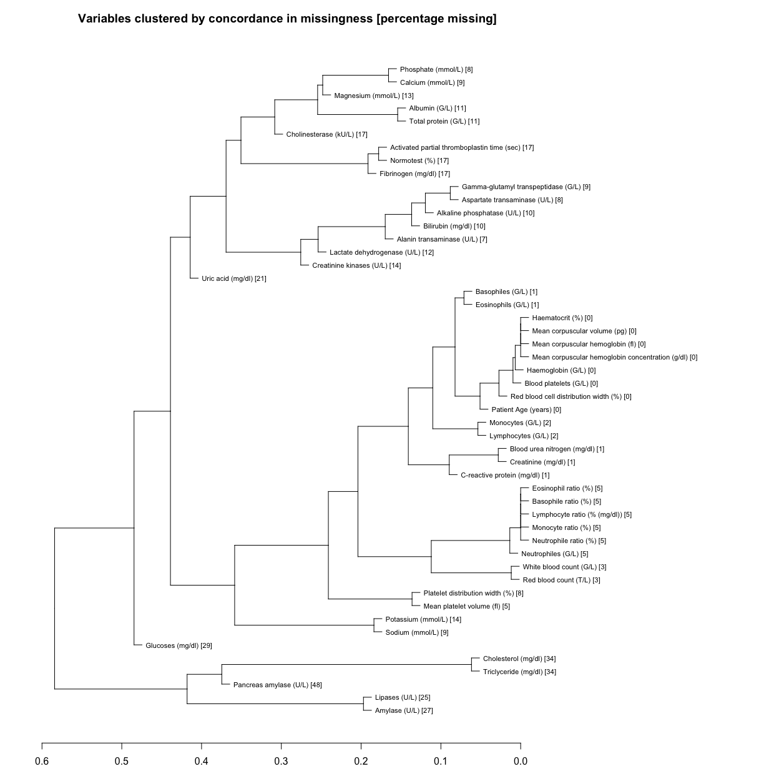

5. Univariate distribution checks
This section reports a series of univariate summary checks of the bacteremia dataset.

5.1 U1: Categorical variables
Age group, sex and bacteremia status are described by frequencies and proportions in each category.
Category | Count | Proportion
Age group
[16, 50] | 5365 | 0.37
(65, 101] | 5076 | 0.35
(50, 65] | 4250 | 0.29
Sex
male | 8536 | 0.58
female | 6155 | 0.42
Presence of bacteremia
no | 13511 | 0.92
yes | 1180 | 0.08
Also plot the categories as simple bar charts.
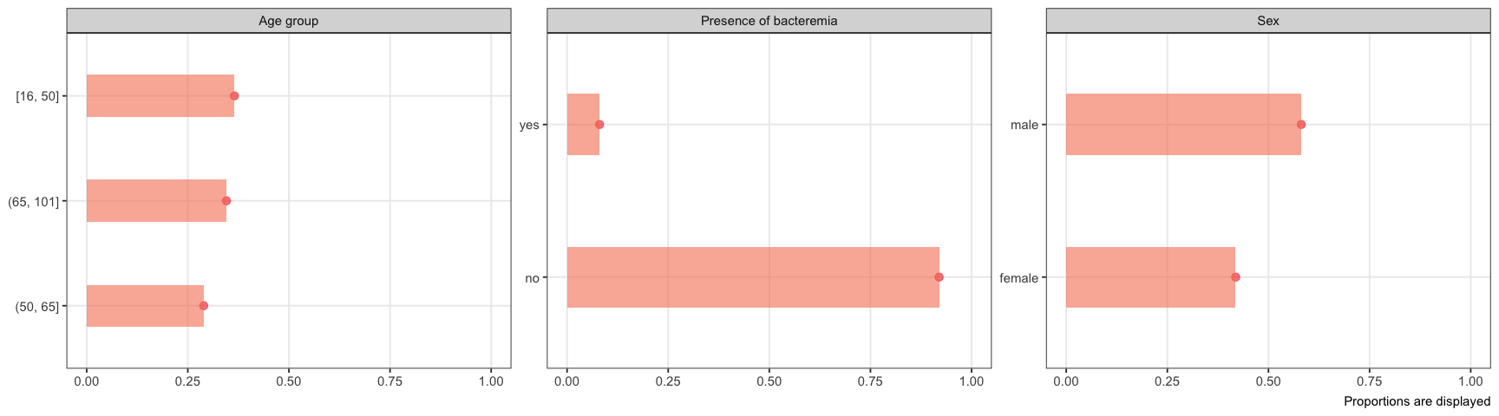
Summary of categorical variables including outcome

5.2 Continuous variables

5.2.1 U2: Univariate distributions of continuous variables

5.2.1.1 U2: Structural variables
The only structural continuous variable is AGE. This variable is also a key predictor and reported in the following section (see below).

5.2.1.2 U2: Key predictors
Distribution of key predictors. Lines indicate the 5-number summary including reported numerical values (where possible).
The remaining predictors are reported in the appendix Section E.1.1.
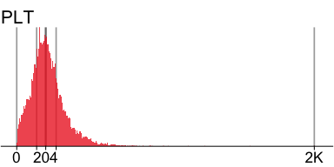 | 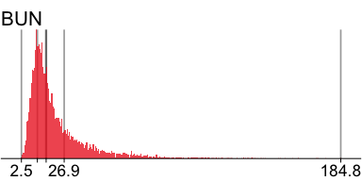 | 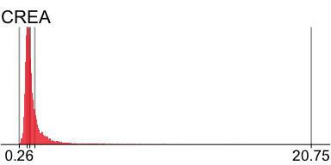

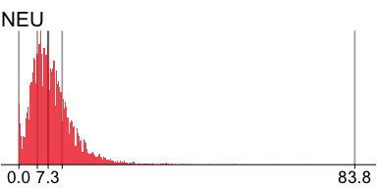 | 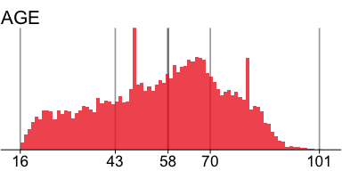 | 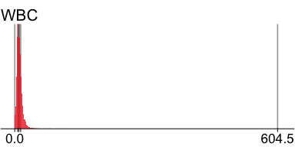

5.2.1.3 U2: Predictors of medium importance
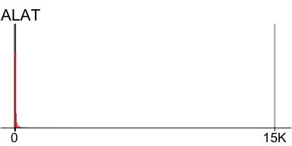 | 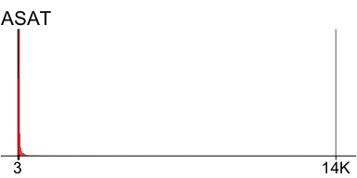 | 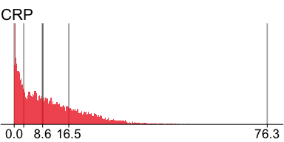

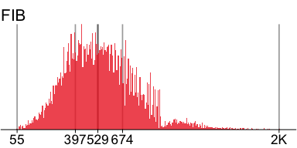 | 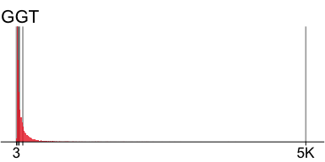 | 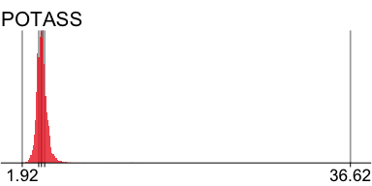

5.2.2 Numerical summaries

5.2.2.1 Key predictors
n | missing | distinct | Info | Mean | Gmd | .05 | .10 | .25 | .50 | .75 | .90 | .95
14649 | 42 | 718 | 1 | 220 | 130.1 | 50 | 81 | 140 | 204 | 277 | 369 | 445
lowest : 0 1 2 3 4 , highest: 1068 1211 1321 1639 2092

CREA: Parameter analysis value (Numeric)
n | missing | distinct | Info | Mean | Gmd | .05 | .10 | .25 | .50 | .75 | .90 | .95
14532 | 159 | 674 | 1 | 1.329 | 0.8518 | 0.620 | 0.690 | 0.810 | 1.000 | 1.350 | 2.160 | 3.144
lowest : 0.26 0.27 0.28 0.29 0.3 , highest: 15.24 15.4 15.67 16.64 20.75

BUN: Parameter analysis value (Numeric)
n | missing | distinct | Info | Mean | Gmd | .05 | .10 | .25 | .50 | .75 | .90 | .95
14519 | 172 | 947 | 1 | 22.66 | 16.92 | 7.1 | 8.6 | 11.6 | 16.6 | 26.9 | 44.8 | 60.8
lowest : 2.5 2.7 2.8 2.9 3 , highest: 160.6 171.3 171.9 176 184.8

NEU: Parameter analysis value (Numeric)
n | missing | distinct | Info | Mean | Gmd | .05 | .10 | .25 | .50 | .75 | .90 | .95
13963 | 728 | 374 | 1 | 8.367 | 5.776 | 1.60 | 2.70 | 4.60 | 7.30 | 10.80 | 15.08 | 18.40
lowest : 0 0.1 0.2 0.3 0.4 , highest: 54 56.4 63.7 71.6 83.8

WBC: Parameter analysis value (Numeric)
n | missing | distinct | Info | Mean | Gmd | .05 | .10 | .25 | .50 | .75 | .90 | .95
14229 | 462 | 2710 | 1 | 11.23 | 7.602 | 2.66 | 4.26 | 6.63 | 9.60 | 13.53 | 18.22 | 22.27
lowest : 0 0.01 0.02 0.03 0.04 , highest: 365.3 383.74 387.73 433.83 604.47

AGE: Parameter analysis value (Numeric)
n | missing | distinct | Info | Mean | Gmd | .05 | .10 | .25 | .50 | .75 | .90 | .95
14691 | 0 | 85 | 1 | 56.17 | 20.78 | 24 | 29 | 43 | 58 | 70 | 79 | 84

5.2.2.2 Predictors of medium importance
n | missing | distinct | Info | Mean | Gmd | .05 | .10 | .25 | .50 | .75 | .90 | .95
12124 | 2567 | 1084 | 1 | 547.4 | 231 | 247 | 301 | 397 | 529 | 674 | 816 | 892
lowest : 55 60 66 67 69 , highest: 1506 1508 1529 1537 1593

POTASS: Parameter analysis value (Numeric)
n | missing | distinct | Info | Mean | Gmd | .05 | .10 | .25 | .50 | .75 | .90 | .95
12683 | 2008 | 408 | 1 | 4.003 | 0.6004 | 3.20 | 3.39 | 3.66 | 3.95 | 4.29 | 4.67 | 4.92
lowest : 1.92 2.07 2.11 2.12 2.21 , highest: 8.57 11.34 13.55 14.6 36.62

ASAT: Parameter analysis value (Numeric)
n | missing | distinct | Info | Mean | Gmd | .05 | .10 | .25 | .50 | .75 | .90 | .95
13537 | 1154 | 650 | 1 | 86.9 | 115.6 | 15 | 17 | 22 | 31 | 56 | 121 | 218
lowest : 3 5 6 7 8 , highest: 10845 11928 12079 12380 13991

ALAT: Parameter analysis value (Numeric)
n | missing | distinct | Info | Mean | Gmd | .05 | .10 | .25 | .50 | .75 | .90 | .95
13704 | 987 | 578 | 1 | 67.66 | 90.07 | 9 | 11 | 16 | 26 | 48 | 101 | 175
lowest : 0 1 2 3 4 , highest: 7109 9136 9314 12329 15059

GGT: Parameter analysis value (Numeric)
n | missing | distinct | Info | Mean | Gmd | .05 | .10 | .25 | .50 | .75 | .90 | .95
13429 | 1262 | 858 | 1 | 115.1 | 141.3 | 13.0 | 16.0 | 25.0 | 49.0 | 117.0 | 262.2 | 429.0
lowest : 3 5 6 7 8 , highest: 2932 3303 3782 3919 5171

CRP: Parameter analysis value (Numeric)
n | missing | distinct | Info | Mean | Gmd | .05 | .10 | .25 | .50 | .75 | .90 | .95
14536 | 155 | 3328 | 1 | 10.92 | 10.39 | 0.29 | 0.77 | 2.87 | 8.57 | 16.45 | 24.49 | 29.61

5.2.3 Suggested transformations
Next we investigate whether a pseudolog transformation of continuous variables may substantially symmetrize the univariate distributions of the continuous variables, and may hence be useful for multivariate summaries. We employ a function ida_trans for this purpose, which optimises the parameter sigma of the pseudo-logarithm for that purpose. The optimization targets the best possible linear correlation of the transformed values with normal deviates. If no better transformation can be found, or if the improvement in correlation is less than 0.2 correlation units, no transformation is suggested.
Display the proposed variable transformations and the new parameter codes.
PARAMCD | n
ALAT_T | 14691
AMY_T | 14691
AP_T | 14691
ASAT_T | 14691
BASO_T | 14691
CK_T | 14691
CREA_T | 14691
EOS_T | 14691
GBIL_T | 14691
GGT_T | 14691
LDH_T | 14691
LIP_T | 14691
LYM_T | 14691
PAMY_T | 14691
WBC_T | 14691
Register transformed variables in the data set. The updated data set with suggested log transformed data sets is saved at data/IDA/ADLB_02.rds.
The IDA analysis plan and specifications are updated with the proposed variable transformations. A new flag is derived to indicate the categorization of predictors now including transformations.

5.2.4 Comparison of univariate distributions with and without pseudo-log transformation
The comparison is only shown for variables where a transformation is suggested. Note, all observed values, and the distribution min, max and interquartile range as reference lines, are displayed.
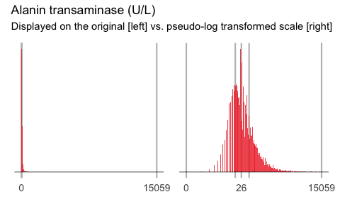 | 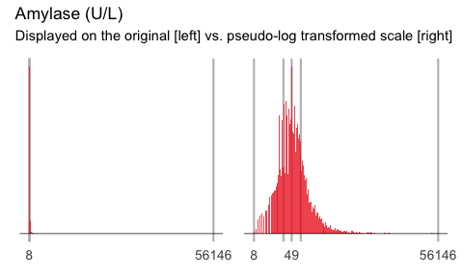

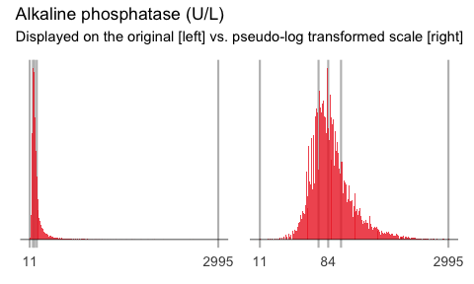 | 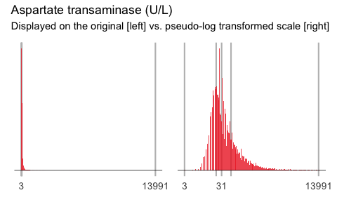

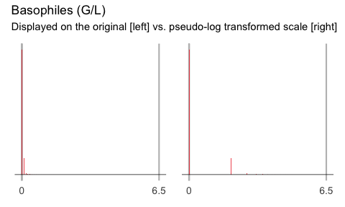 | 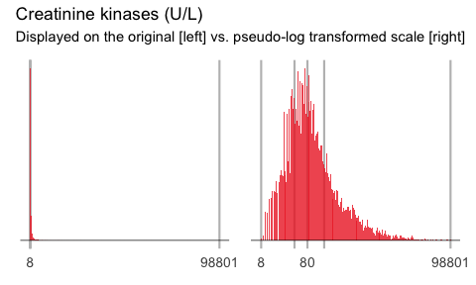

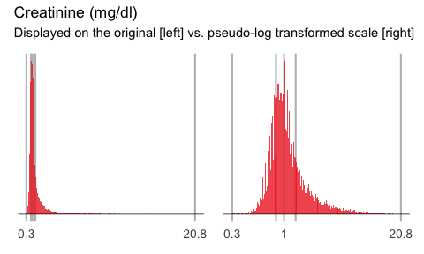 | 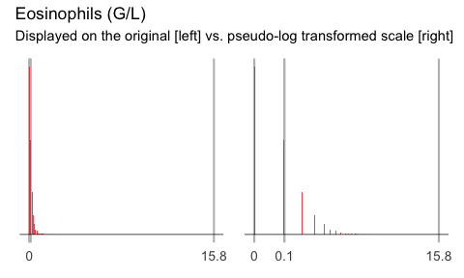

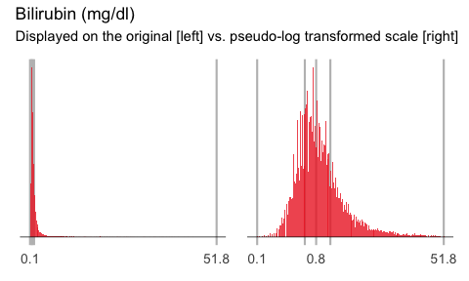 | 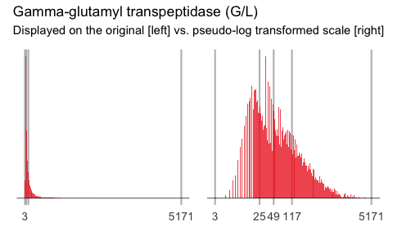

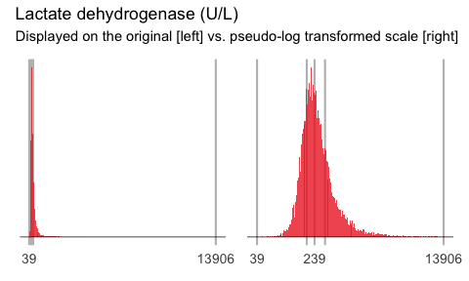 | 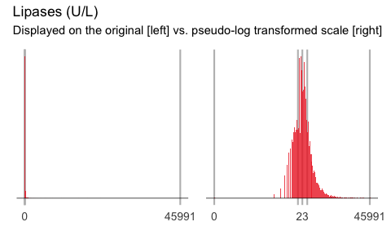

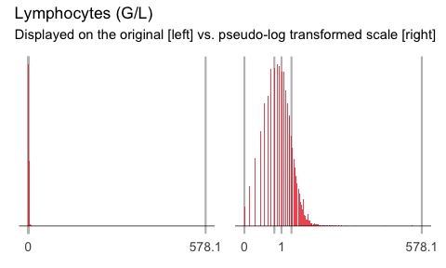 | 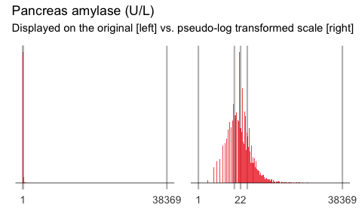

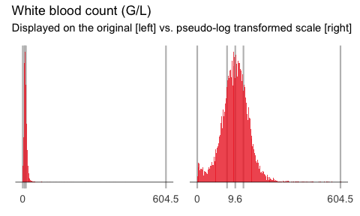

6. Multivariate analyses
First load the required packages and data. Note that from the univariate analyses the analysis data set for the lab parameters has been updated to include transformed variables. Therefore, we load the second iteration of the data data/ADLB_02.rds.

6.1 V1: Association with structural variables
Attached the required structural variables to the lab data.
A scatterplot of each predictor with age, with different panels for males and females have been constructed. Associated Spearman correlation coefficients have been computed.
The remaining predictors are reported in appendix Section F.1.

6.1.1 Key predictors
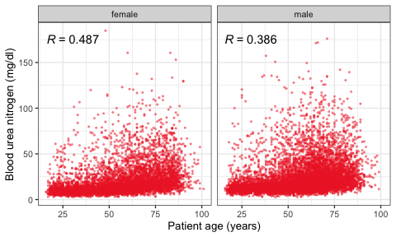 | 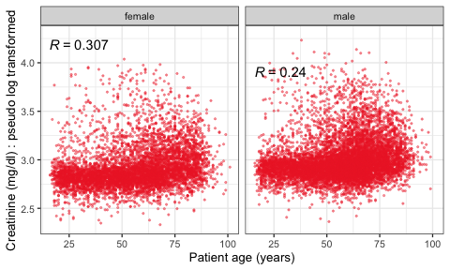

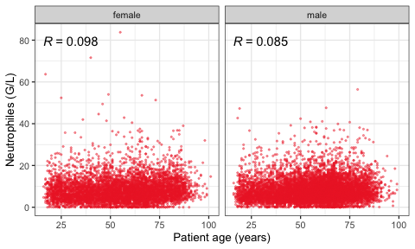 | 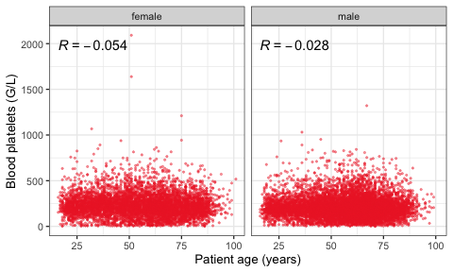

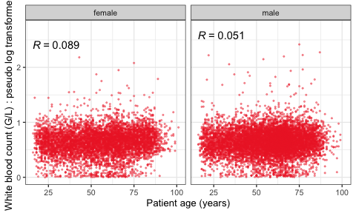

6.1.2 Predictors of medium importance
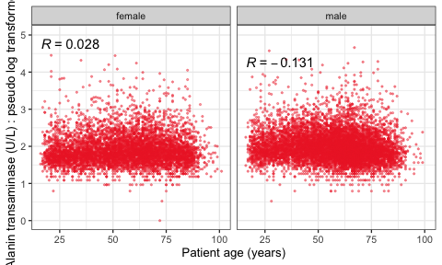 | 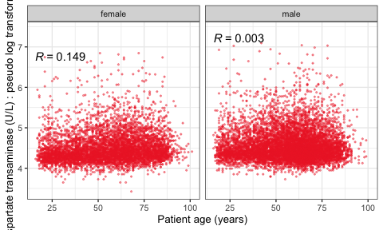

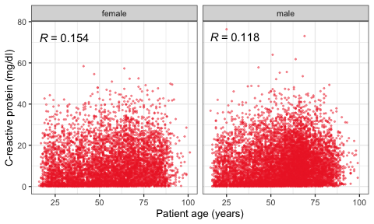 | 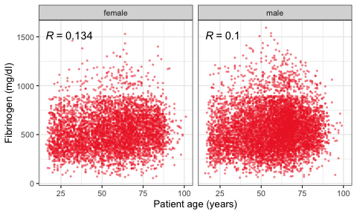

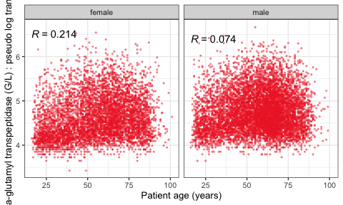 | 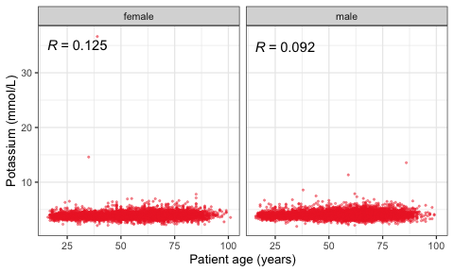

6.2 V2: Correlation coefficients between all predictors
Calculate correlation matrix using Spearman correlation coefficient.
The Spearman correlation coefficients are depicted in a quadratic heat map:
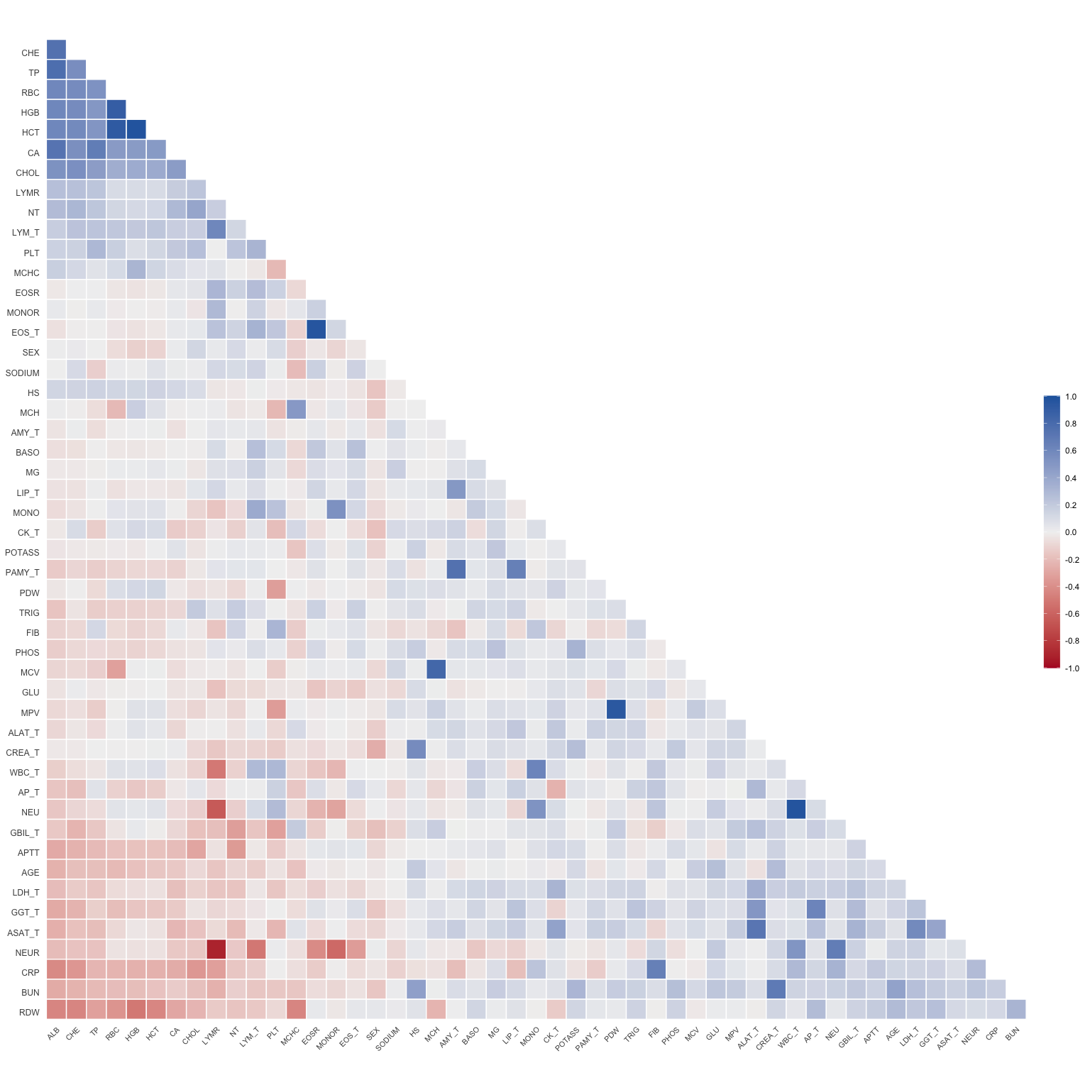

6.2.1 VE1: Comparing nonparametric and parametric predictor correlation
Plot the difference matrix.
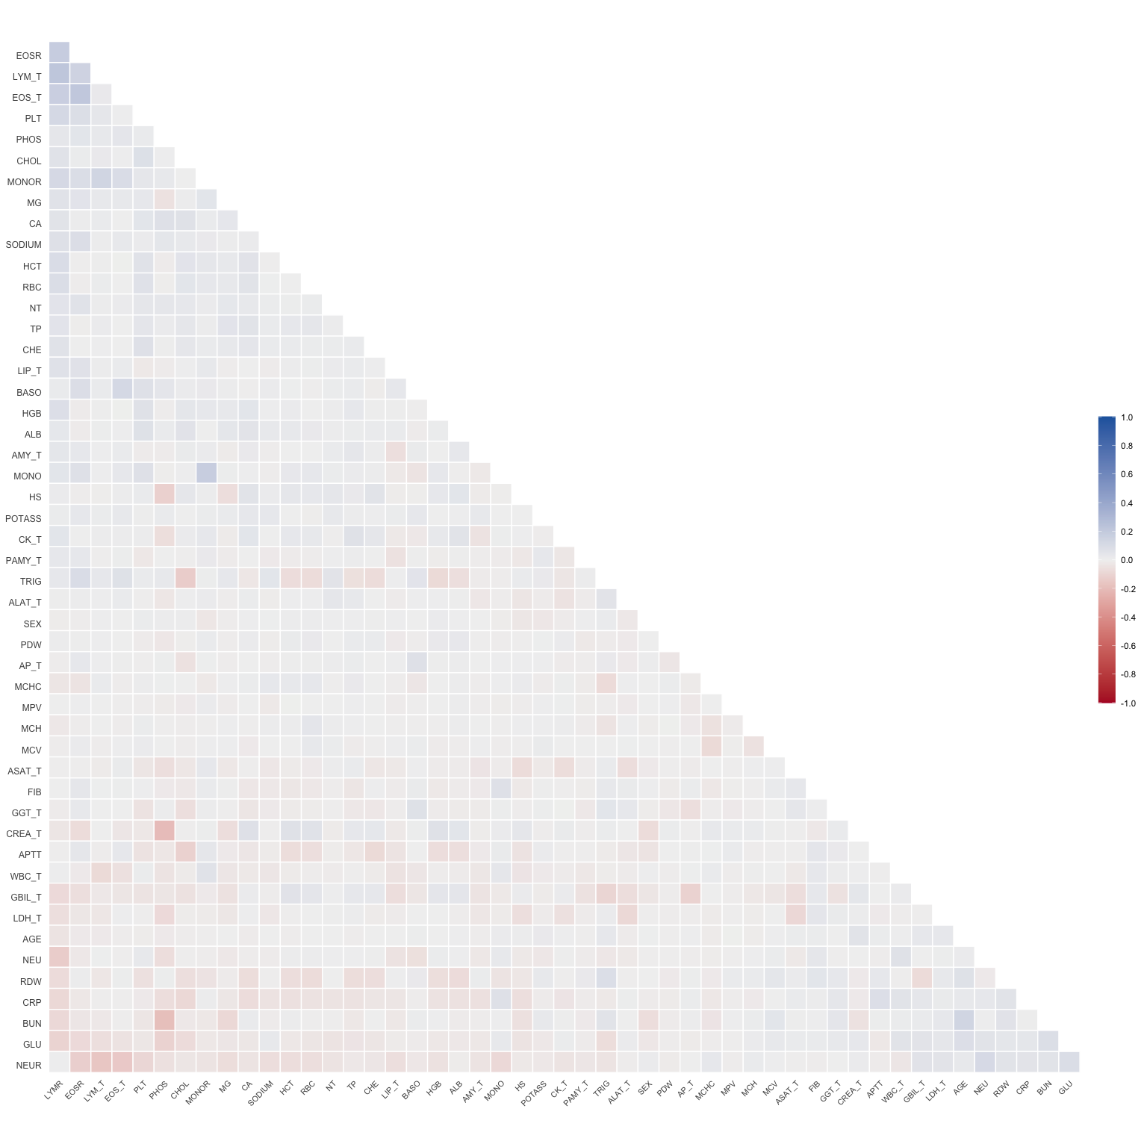
Plot the matrix but suppress differences less then 0.1.
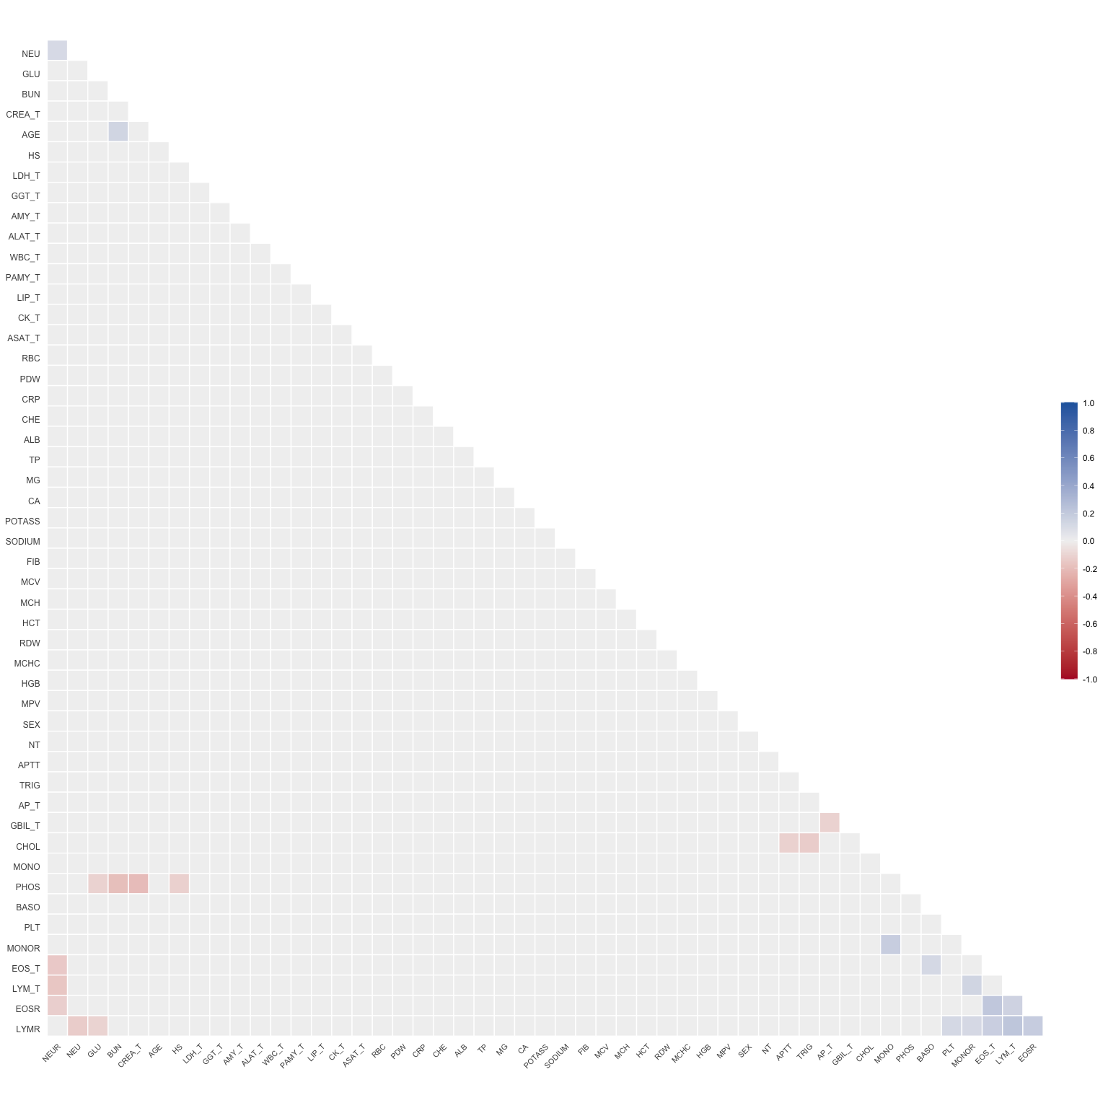
Predictor pairs for which Spearman and Pearson correlation coefficients differ by more than 0.1 correlation units will be depicted in scatterplots. First report the table of predictor parirs where r is greater than 0.1.
x | y | r
PLT | LYMR | 0.12
MONO | MONOR | 0.18
BASO | EOS_T | 0.12
BUN | AGE | 0.13
EOSR | LYMR | 0.18
EOSR | EOS_T | 0.21
EOSR | LYM_T | 0.14
LYMR | MONOR | 0.11
LYMR | EOS_T | 0.17
LYMR | LYM_T | 0.22
MONOR | LYM_T | 0.13
NEU | NEUR | 0.11
Then plot the scatter plots.
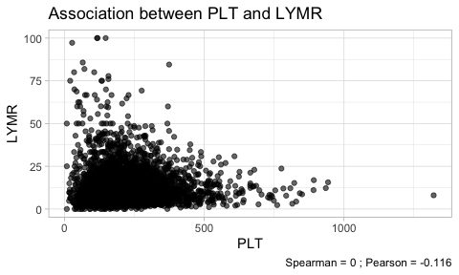 | 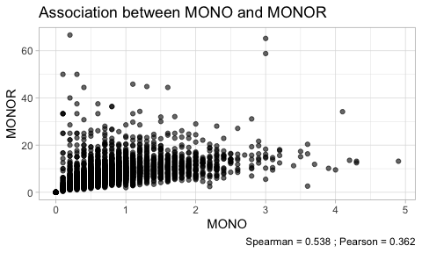 | 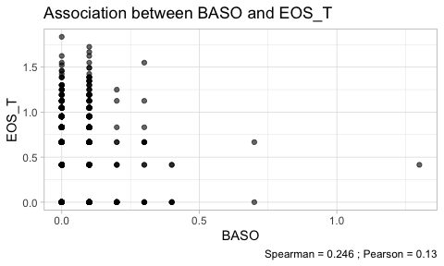

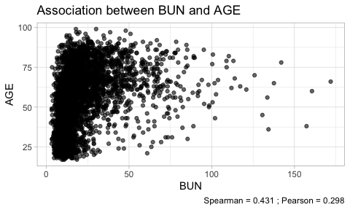 | 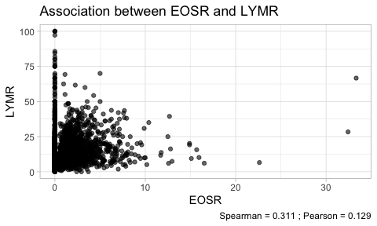 | 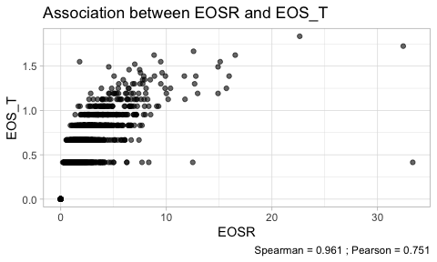

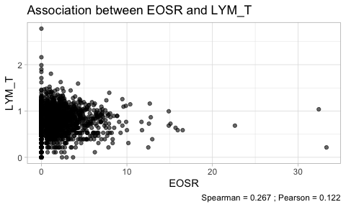 | 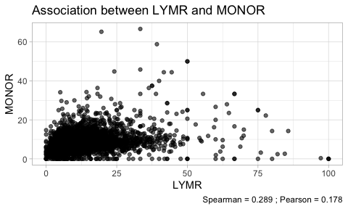 | 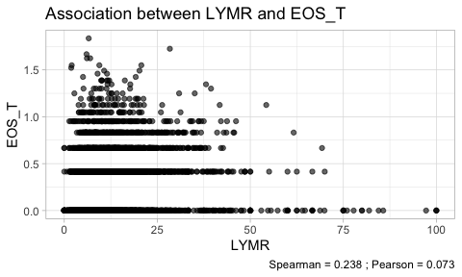

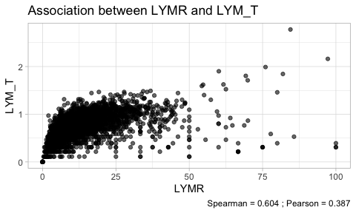 | 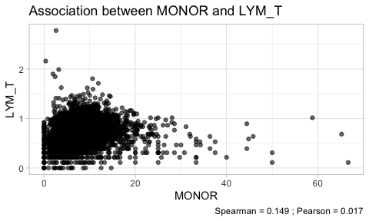 | 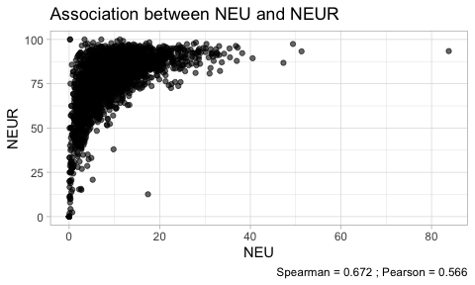

6.2.2 VE2: Variable clustering
A variable clustering analysis has been performed to evaluate which predictors are closely associated. The dendrogram groups predictors by their correlation.
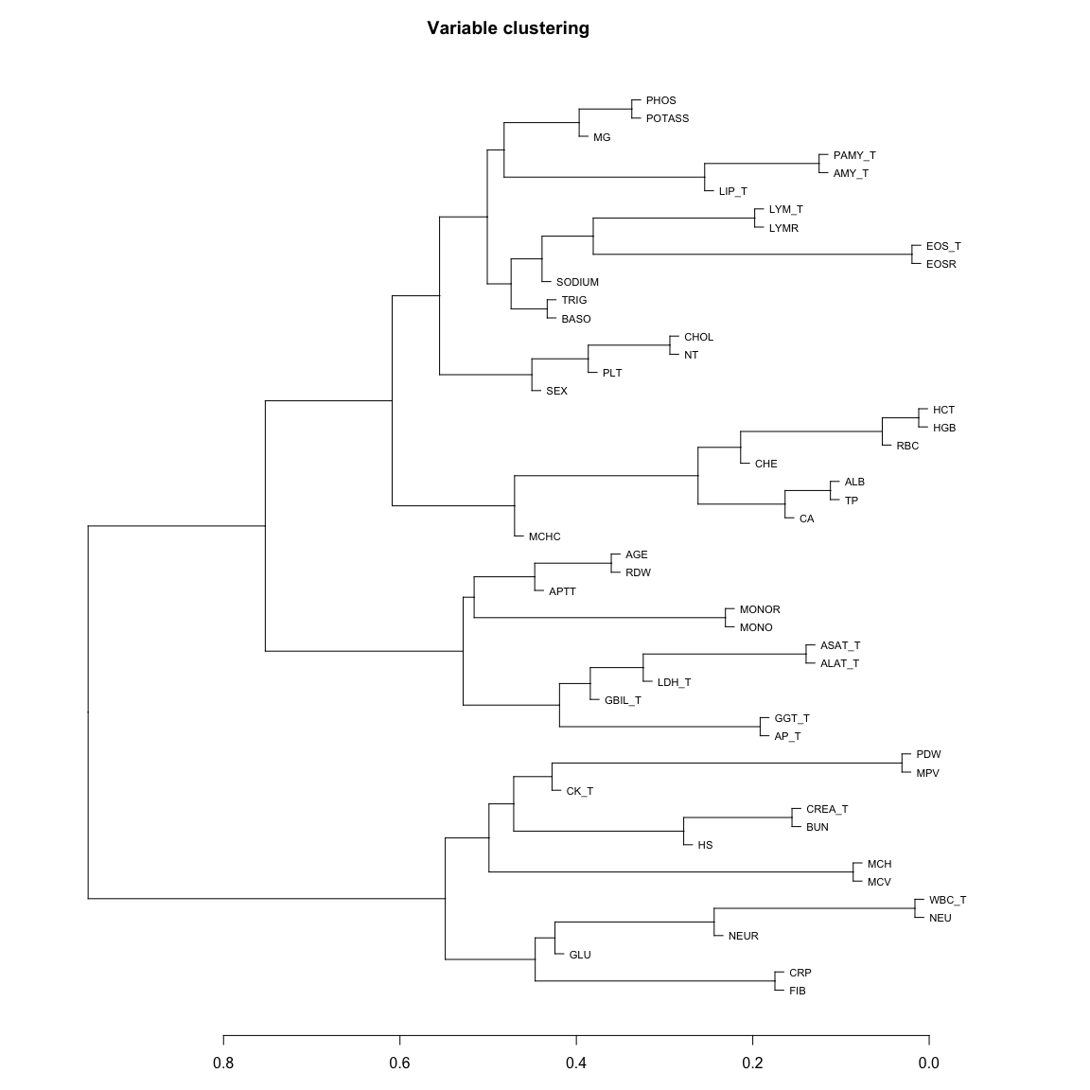
This can also be displayed as a network plot
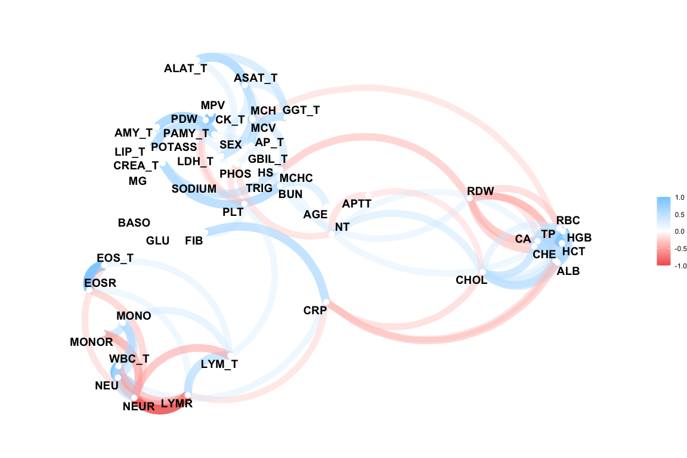
In the following scatterplots we show predictor pairs with Spearman correlation coefficients greater than 0.8:
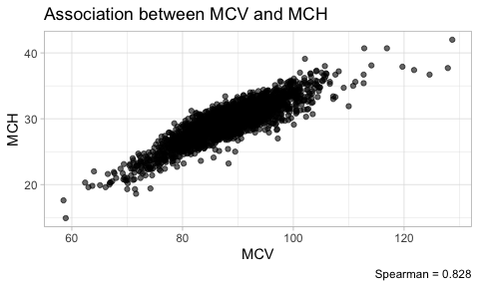 | 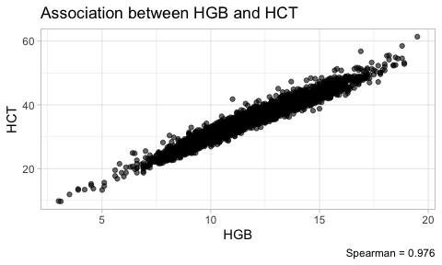

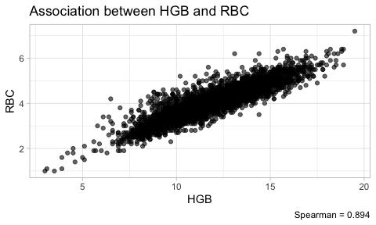 | 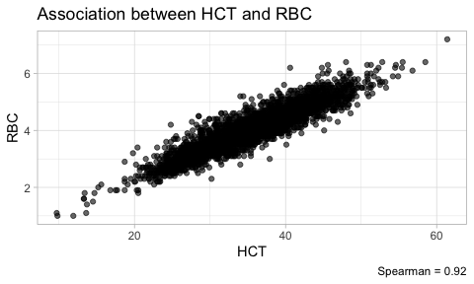

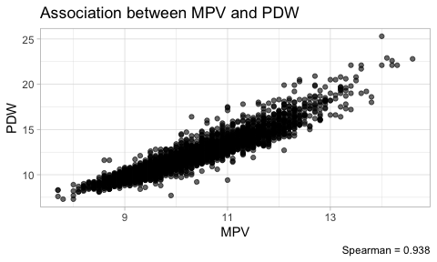 | 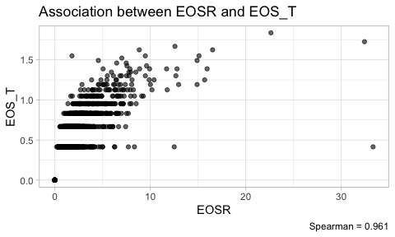

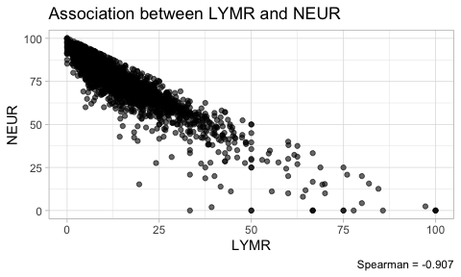 | 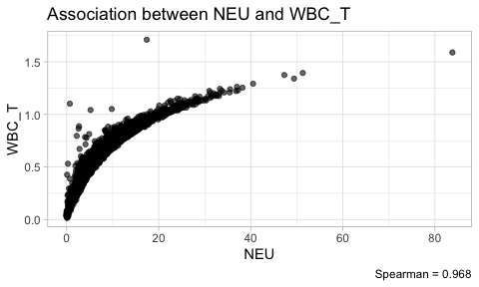

6.2.3 VE3: Redundancy
Variance inflation factors (VIF) will be computed between the candidate predictors. This will be done for the three possible candidate models, and using all complete cases in the respective candidate predictor sets. Since $VIF={\left(1-R^{2}\right)}^{-1}$, we also report the multiple R-squared values.
Redundancy was further explored by computing parametric additive models for each predictor in the key predictor model and the extended predictor model. VIFs and multiple $R^{2}$ are reported from those models, again for the three predictor sets.
Note, the all predictor model is reported in appendix Section F.2.

6.2.3.1 VIF for key predictor model
The available sample size is 13793 (1.44 %).
Parameter code | Variance inflation factor | Multiple R-squared
SEX | 1.1 | 0.05
PLT | 1.2 | 0.15
BUN | 2.4 | 0.58
NEU | 5.4 | 0.82
AGE | 1.1 | 0.09
CREA_T | 2.3 | 0.56
WBC_T | 5.6 | 0.82

6.2.3.2 VIF for model with key predictors and predictors of medium importance
The available sample size is 9389 (0.98 %).
Parameter code | Variance inflation factor | Multiple R-squared
SEX | 1.1 | 0.09
PLT | 1.4 | 0.30
FIB | 2.3 | 0.56
POTASS | 1.1 | 0.10
BUN | 2.6 | 0.61
CRP | 2.2 | 0.54
NEU | 5.9 | 0.83
AGE | 1.2 | 0.15
ALAT_T | 3.3 | 0.69
ASAT_T | 3.2 | 0.69
CREA_T | 2.4 | 0.58
GGT_T | 1.4 | 0.30
WBC_T | 6.0 | 0.83

6.2.3.3 VIF for all predictor model
See appendix Section F.2.

6.2.3.4 Redundancy by parametric additive model: key predictor model
The available sample size is 13793 (1.44 %).
Parameter code | Variance inflation factor | Multiple R-squared
SEX | 1.1 | 0.11
PLT | 1.2 | 0.16
BUN | 2.6 | 0.61
NEU | 11.5 | 0.91
AGE | 1.3 | 0.21
CREA_T | 2.4 | 0.58
WBC_T | 13.7 | 0.93

6.2.3.5 Redundancy by parametric additive model: key predictors and predictors of medium importance
The available sample size is 9389 (0.98 %).
Parameter code | Variance inflation factor | Multiple R-squared
SEX | 1.2 | 0.15
PLT | 1.5 | 0.32
FIB | 2.4 | 0.58
POTASS | 1.1 | 0.11
BUN | 2.8 | 0.65
CRP | 2.3 | 0.56
NEU | 14.1 | 0.93
AGE | 1.4 | 0.29
ALAT_T | 3.4 | 0.70
ASAT_T | 3.5 | 0.71
CREA_T | 2.5 | 0.60
GGT_T | 1.5 | 0.35
WBC_T | 16.4 | 0.94

7. Final Analysis ready data

7.1 Final dervivations and transformations
From the IDA exercise a decision was made to derive a new variable based on White Blood Count in the absence of Neutrophiles:
- WBC_NEU: WBC - NEU
The new derivation will also be checked as a candidate for pseudo-log transformation.
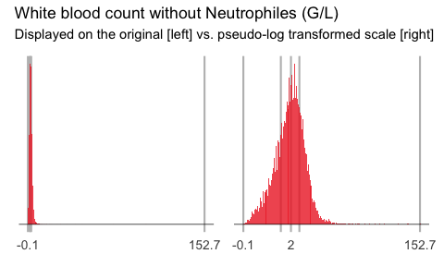
A visual check confirms that a psuedo-log transformation is appropriate for the newly derived variable.
The new derivation and transformation is added to the analysis ready data, setting the correct indicator flags to enable final analyses and modelling.
Visual check of indicator flag and new derviation added to the analysis data set.
[1] "c(\"PLT\", \"CREA\", \"BUN\", \"NEU\", \"AGE\", \"WBC_noNEU\")"

7.2 Save final analysis ready data sets
The final analysis ready data sets are then stored in data/Analysis.

References
Johnson, N. L. 1949. “Systems of Frequency Curves Generated by Methods of Translation.” Biometrika 36 (1/2): 149–76. http://www.jstor.org/stable/2332539.
Ratzinger, Franz, Michel Dedeyan, Matthias Rammerstorfer, Thomas Perkmann, Heinz Burgmann, Athanasios Makristathis, Georg Dorffner, Felix Lötsch, Alexander Blacky, and Michael Ramharter. 2014. “A Risk Prediction Model for Screening Bacteremic Patients: A Cross Sectional Study.” PLOS ONE 9 (9): 1–10. https://doi.org/10.1371/journal.pone.0106765.

Appendix A — Pseudo-log transformations

A.1 Introduction
This supplemental section illustrates how pseudo-log transformations can be used to transform skewed distributions towards normality.
The transformation $f\left(x\right)=sinh^{-}1\left(x/2σ\right)/log\left(10\right)$ is a pseudo-logarithmic transformation mentioned by (Johnson 1949). It has the following advantages over ordinary logarithmic transformations:
- it is defined also for $x=$ as $f\left(0\right)=0$
- it is a signed logarithmic transformation, and is defined also for negative values as $f\left(-\left|x\right|\right)=-f\left(\left|x\right|\right)$
Of course, this comes at the cost of deviation from the logarithmic transformation in terms of interpretability.
The parameter $σ$ may be used to adapt the transformation to a specific range of an empirical distribution.
We define the pseudo-logarithmic transformation in R as:
pseudo_log <-
function(x, sigma = 1, base = 10)
asinh(x / (2 * sigma)) / log(base)
inv_pseudo_log <-
function(x, sigma = 1, base = 10)
2 * sigma * sinh(x * log(base))

A.2 Impact of choice of $σ$
Next, we investigate how the parameter $σ$ impacts the result of the transformation. We assume that $x$ follows a log-normal distribution, and we will show results of $f\left(x\right)$ with different choices of $σ$. We center and scale $f\left(x\right)$ before plotting.
p <- seq(0.001, 0.999, 0.001)
x <- exp(qnorm(p, mean = 0, sd = 1))
hist(x)
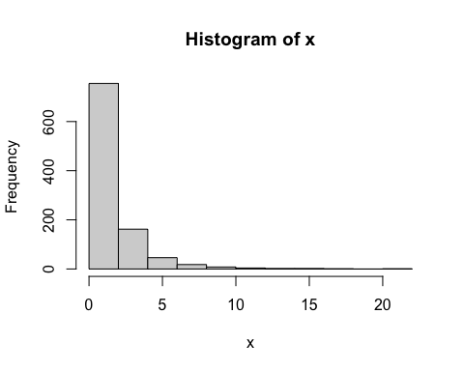
y <-
cbind(
log(x),
scale(pseudo_log(x, 1)),
scale(pseudo_log(x, 0.5)),
scale(pseudo_log(x, 2)),
scale(pseudo_log(x, 0.05))
)
plot(x,
y[, 2],
type = "l",
ylab = "f(x)",
ylim = range(y))
lines(x, y[, 1], col = "red")
lines(x, y[, 3], type = "l", lty = 2)
lines(x, y[, 4], type = "l", lty = 3)
lines(x, y[, 5], type = "l", lty = 4)
legend(
"topleft",
lty = c(1, 1, 2, 3, 4),
col = c("red", "black", "black", "black", "black"),
legend = c("log", "sigma=1", "sigma=0.5", "sigma=2", "sigma=0.05")
)
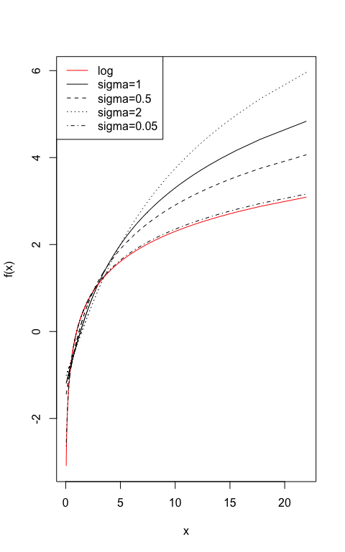
In the next code chunk, we multiply by 10 and repeat the exercise. We learn that the transformations become more similar and the choice of $σ$ less relevant.
x <- x * 10
y <-
cbind(
scale(log(x)),
scale(pseudo_log(x, 1)),
scale(pseudo_log(x, 0.5)),
scale(pseudo_log(x, 2)),
scale(pseudo_log(x, 0.05))
)
plot(x, y[, 2], type = "l", ylab = "f(x)")
lines(x, y[, 1], col = "red")
lines(x, y[, 3], type = "l", lty = 2)
lines(x, y[, 4], type = "l", lty = 3)
lines(x, y[, 5], type = "l", lty = 4)
legend(
"bottomright",
lty = c(1, 1, 2, 3, 4),
col = c("red", "black", "black", "black", "black"),
legend = c("log", "sigma=1", "sigma=0.5", "sigma=2", "sigma=0.05")
)
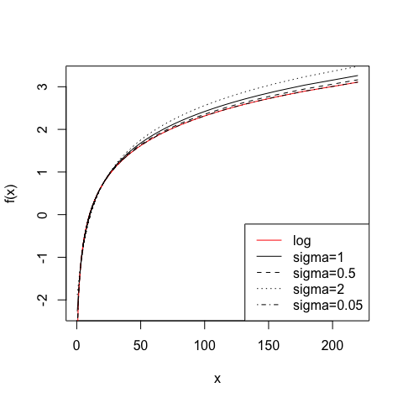
Finally, we apply the pseudo-logarithmic transformation to the original normal deviates. We learn that a higher value for the parameter $σ$ makes the distribution ‘slimmer’ while a lower value makes it ‘fatter’, and it is even possible to induce bimodality with low values of sigma:
z <- qnorm(p, mean = 0, sd = 1)
hist(z)
hist(pseudo_log(z, sigma = 1))
hist(pseudo_log(z, sigma = 2))
hist(pseudo_log(z, sigma = 0.5))
hist(pseudo_log(z, sigma = 0.05))
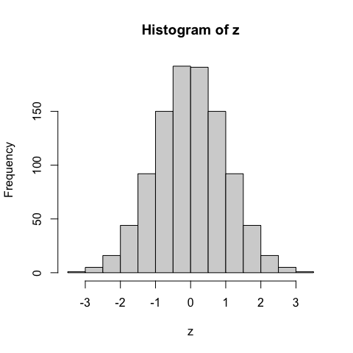 | 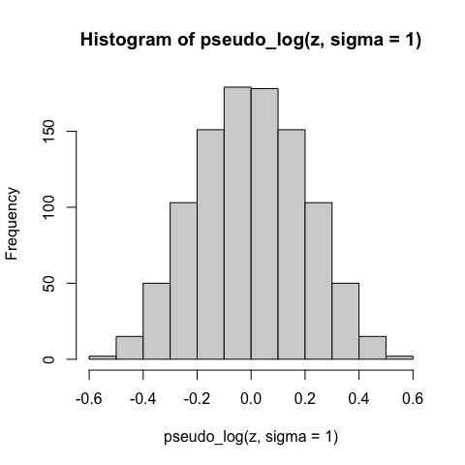 | 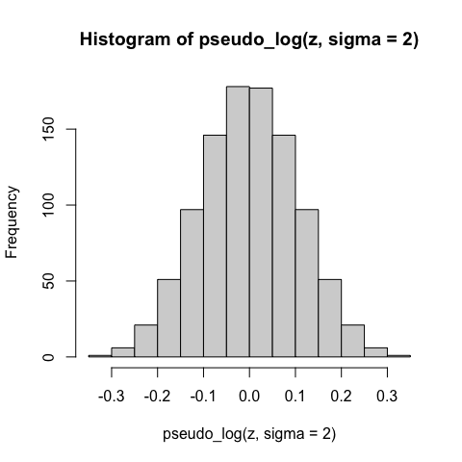

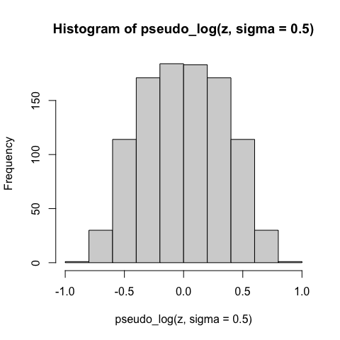 | 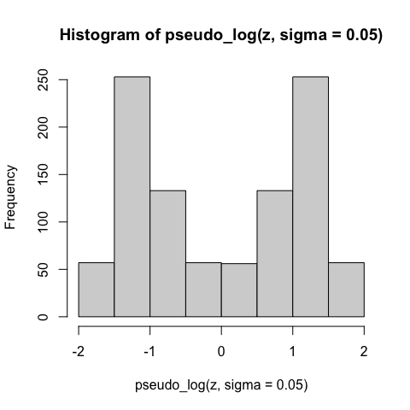

A.3 Finding a parameter that best achieves normality
Any test statistic for testing normality could be chosen to find a suitable value of $σ$ that induces normality into the transformed values. Here we use the (Pearson) correlation coefficient to compare the empirical distribution with normal deviates.

A.3.1 Deviates from log normal distribution
We simulate from a shifted log normal distribution and evaluate the value of $σ$ that optimizes agreement with a normal distribution:
x <- sort(exp(rnorm(1000) + 3))
hist(x)
sigmas <- 2 ** seq(-10, 10, 1)
origcor <- cor(qnorm((1:length(x) - 0.5) / length(x)), x)
ncorx <-
sapply(sigmas, function(X)
cor(qnorm((1:length(
x
) - 0.5) / length(x)), pseudo_log(x, X)))
cat("Optimal sigma: ")
(optsigma <- sigmas[ncorx == max(ncorx)])
plot(log2(sigmas), ncorx, ylab = "Correlation with normal deviates", ylim =
c(0, 1))
points(log2(sigmas)[ncorx == max(ncorx)], max(ncorx), pch = 19)
abline(h = origcor)
legend(
"bottomright",
lty = c(1, NA, NA),
pch = c(NA, 1, 19),
legend = c("Original", "Pseudo-log", "Pseudo-log with optimal sigma")
)
box()
hist(pseudo_log(x, optsigma))
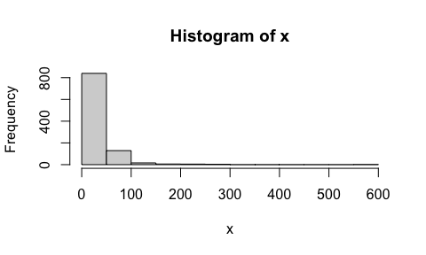 | Optimal sigma:

[1] 1 | 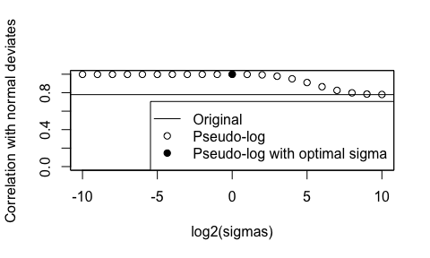

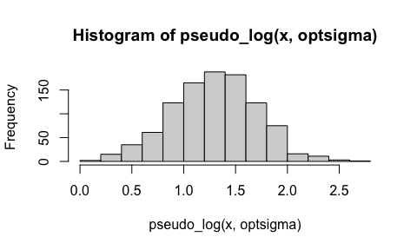

A.3.2 Deviates from exponential distribution
Also with an exponential distribution, the pseudo-logarithm may achieve a better agreement with a normal:
x <- sort(exp(rnorm(1000) + 3))
hist(x)
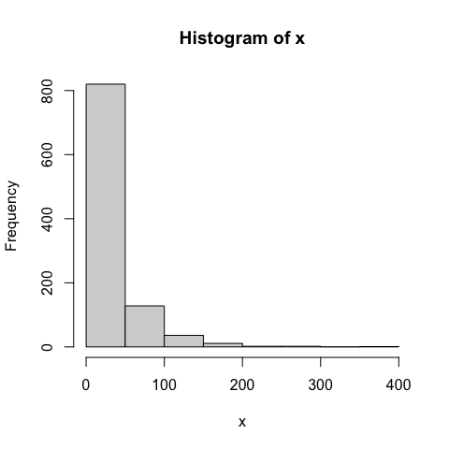
sigmas <- 2 ** seq(-10, 10, 1)
origcor <- cor(qnorm((1:length(x) - 0.5) / length(x)), x)
ncorx <-
sapply(sigmas, function(X)
cor(qnorm((1:length(
x
) - 0.5) / length(x)), pseudo_log(x, X)))
cat("Optimal sigma: ")
Optimal sigma:
(optsigma <- sigmas[ncorx == max(ncorx)])
[1] 0.5
plot(log2(sigmas), ncorx, ylab = "Correlation with normal deviates", ylim =
c(0, 1))
points(log2(sigmas)[ncorx == max(ncorx)], max(ncorx), pch = 19)
abline(h = origcor)
legend(
"bottomright",
lty = c(1, NA, NA),
pch = c(NA, 1, 19),
legend = c("Original", "Pseudo-log", "Pseudo-log with optimal sigma")
)
box()
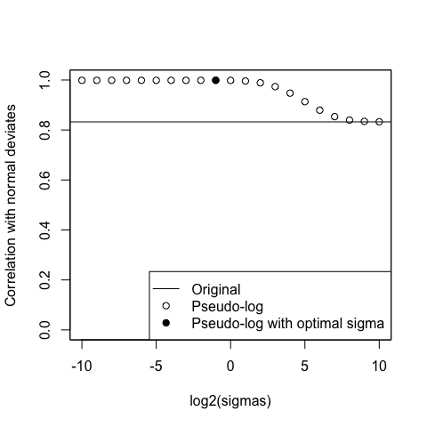
hist(pseudo_log(x, optsigma))
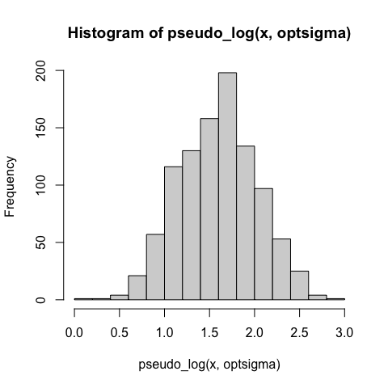

A.3.3 Deviates from mixture distribution
Now we mix a normal, lognormal and exponential distribution:
x1 <- scale(rnorm(1000))
x2 <- scale(rexp(1000))
x3 <- scale(exp(rnorm(1000)))
p1 <- rbinom(1000, 1, 0.33)
p2 <- rbinom(1000, 1, 0.5)
x <- p1 * x1 + (1 - p1) * (p2 * x2 + (1 - p2) * x3)
x <- x - min(x)
x <- sort(x)
hist(x)
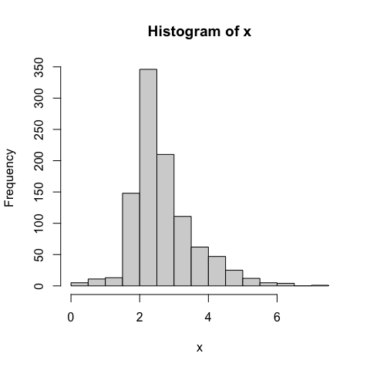
sigmas <- 2 ** seq(-10, 10, 1)
origcor <- cor(qnorm((1:length(x) - 0.5) / length(x)), x)
ncorx <-
sapply(sigmas, function(X)
cor(qnorm((1:length(
x
) - 0.5) / length(x)), pseudo_log(x, X)))
cat("Optimal sigma: ")
Optimal sigma:
(optsigma <- sigmas[ncorx == max(ncorx)])
[1] 1
plot(log2(sigmas), ncorx, ylab = "Correlation with normal deviates", ylim =
c(0, 1))
points(log2(sigmas)[ncorx == max(ncorx)], max(ncorx), pch = 19)
abline(h = origcor)
legend(
"bottomright",
lty = c(1, NA, NA),
pch = c(NA, 1, 19),
legend = c("Original", "Pseudo-log", "Pseudo-log with optimal sigma")
)
box()
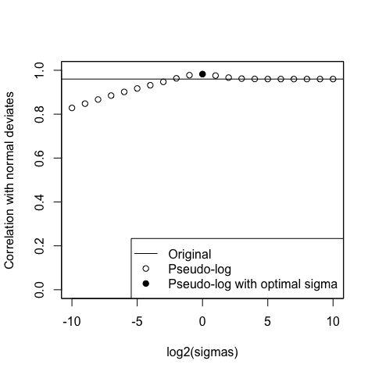
hist(pseudo_log(x, optsigma))
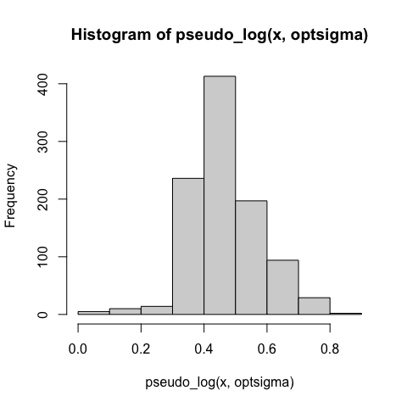

A.3.4 Normal deviates
With simulated normal deviates, the pseudo-logarithm cannot improve the already perfect normality.
x <- sort(rnorm(1000))
hist(x)
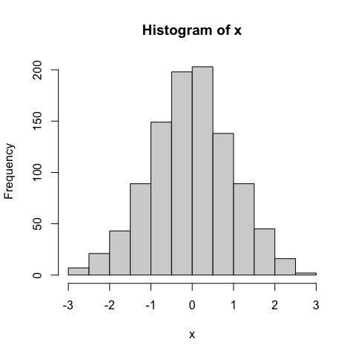
sigmas <- 2 ** seq(-10, 10, 1)
origcor <- cor(qnorm((1:length(x) - 0.5) / length(x)), x)
ncorx <-
sapply(sigmas, function(X)
cor(qnorm((1:length(
x
) - 0.5) / length(x)), pseudo_log(x, X)))
cat("Optimal sigma: ")
Optimal sigma:
(optsigma <- sigmas[ncorx == max(ncorx)])
[1] 1024
plot(log2(sigmas), ncorx, ylab = "Correlation with normal deviates", ylim =
c(0, 1))
points(log2(sigmas)[ncorx == max(ncorx)], max(ncorx), pch = 19)
legend(
"bottomright",
lty = c(1, NA, NA),
pch = c(NA, 1, 19),
legend = c("Original", "Pseudo-log", "Pseudo-log with optimal sigma")
)
abline(h = origcor)
box()
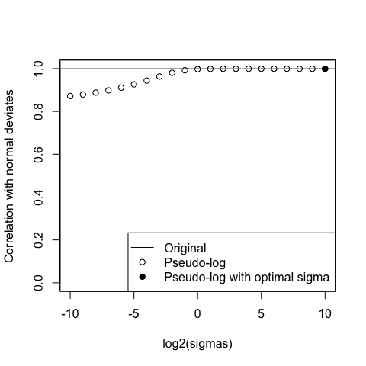
hist(pseudo_log(x, optsigma))
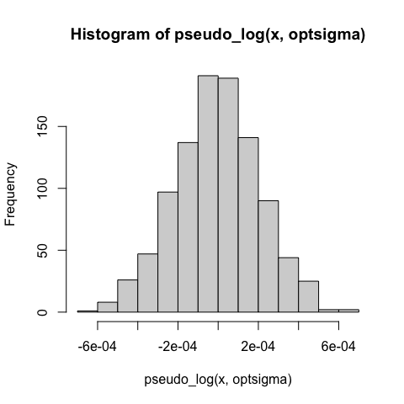

Appendix B — Supplementary Example
We now perform an example research project on the final analysis ready data which is stored at data/analysis.

B.1 Overview
In the following examples we use the Bacteremia data with complete observations regarding the key predictors PLT, BUN, NEU, AGE, CREA_T, WBC_noNEU_T, which represent 93.9% of the dataset w.r.t key predictors. We will fit a global logistic regression model with the outcome BACTEREMIAN (i.e. presence of bacteremia) and the key predictors as covariates. We will use pseudo-log transformations as suggested in the IDA. Within the model, all key predictors will be transformed by fractional polynomials of order 1 (df = 2).
The aim of the examples is to showcase how decisions derived from IDA influence the results of the fitted model.

B.1.1 Global Model
The global model will be fitted by the mfp function. If not indicated otherwise, we will use the fp-transformations of the key predictors determined in global model in all consecutive models. For all models we report McFaddens’s R² and the AUC, i.e. the area under the ROC curve, and boxplots comparing “BACTEREMIAN” predictions with outcomes.
To put the results of the global model into context, we will first review the histograms of the original and the transformed predictors:
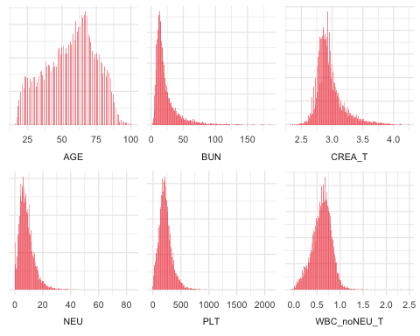

B.1.2 Model Summary
The global model is specified as print(global_formula, quote = TRUE). The model is fit to the complete cases data on the transformed scale stored in the data set data_model_trans.
Report the global model fit.
Table S6: global model - including transformed variables
term | estimate | std.error | statistic | p.value
(Intercept) | -2.689 | 0.588 | -4.57 | 4.78 × 10^-6
I((WBC_noNEU_T + 0.1)^0.5) | -5.192 | 0.253 | -20.53 | 1.25 × 10^-93
I(((NEU + 0.1)/10)^0.5) | 1.526 | 0.117 | 13.10 | 3.46 × 10^-39
I((AGE/100)^1) | 1.690 | 0.199 | 8.49 | 2.05 × 10^-17
I(CREA_T^1) | 0.713 | 0.198 | 3.60 | 3.19 × 10^-4
I(((PLT + 1)/100)^1) | -0.082 | 0.032 | -2.57 | 1.03 × 10^-2
I((BUN/10)^1) | 0.010 | 0.024 | 0.43 | 6.68 × 10^-1
Plot predictions by outcome and report the model AUC.
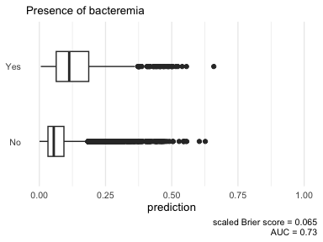
Global model - including covariates on the transformed psuedo log scale

B.1.3 Functional forms of global model
We now take a look at the functional forms of the covariates in the global model, which are determined by the fp algorithm. Besides scaling factors, only for WBC_noNEU_T the fp algorithm chose a non-linear transformation (note the ‘^0.5’ in the term column). This means all other covariates enter the model in a linear fashion. In the following effect plots, each variable is adjusted to the median of the other variables in the model.
  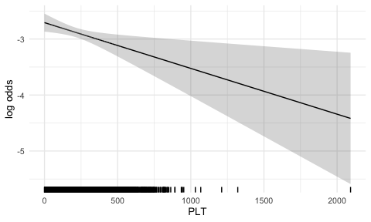
  (a)
  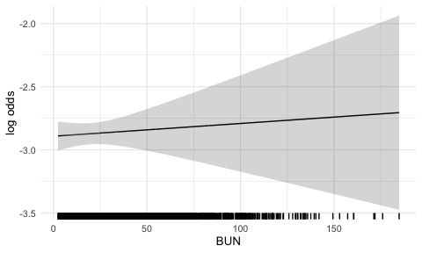
  (b)

  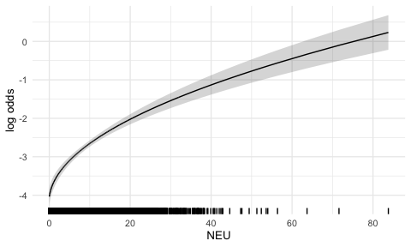
  (c)
  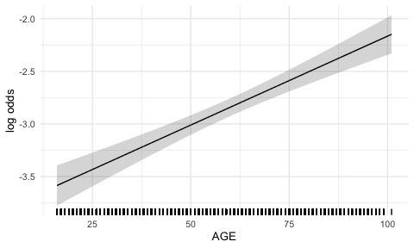
  (d)

  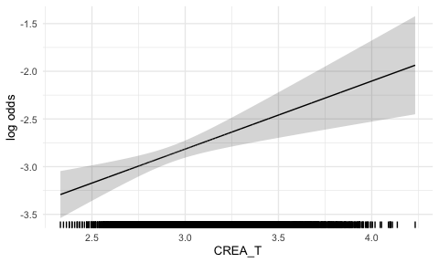
  (e)
  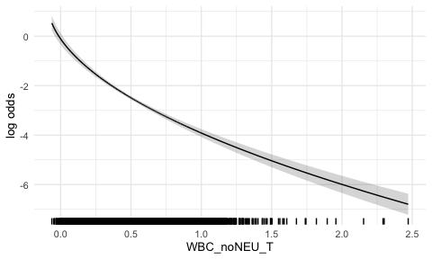
  (f)
Figure B.1: Functional forms of global model - repeats over plots

B.2 Example 1: to transform or not to transform
Only for one out of the six key predictors did the fp algorithm chose a non-linear transformation. But out of those six variables, four were pseudo-log transformed before entering the model. In the first example we want to compare the global model to a model using the key predictors on their original scale.
Table S7: Global model without pseudo-log tranformations
term | estimate | std.error | statistic | p.value
(Intercept) | -3.18 | 0.28 | -11.17 | 5.48 × 10^-29
log((WBC_noNEU + 0.2)) | -1.25 | 0.06 | -20.22 | 5.92 × 10^-91
I(((NEU + 0.1)/10)^0.5) | 1.52 | 0.12 | 12.99 | 1.34 × 10^-38
I((AGE/100)^1) | 1.64 | 0.20 | 8.26 | 1.51 × 10^-16
I(((PLT + 1)/100)^1) | -0.08 | 0.03 | -2.53 | 1.13 × 10^-2
I((BUN/10)^1) | 0.02 | 0.02 | 0.68 | 5.00 × 10^-1
I(CREA^-0.5) | -0.77 | 0.21 | -3.69 | 2.20 × 10^-4
Note the different fp-transformation arising when the key predictors are not pseudo-log transformed. On the original scale, three covariates instead of one now enter the model via a non-linear fp-transformation. This suggests that a transformation prior to the regression model ‘outsources’ the need for transformations within the model. Now let us compare the model performances.
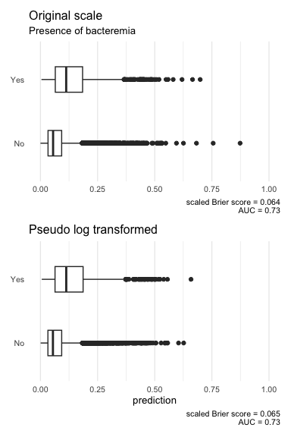
Global model(s) with covariates on original and transformed scale.

With regards to McFadden’s R² and the AUC, the differences between the two approaches is marginal.
Next we will compare the differences of the functional forms in the two models for those covariates where a pseudo-log transformation was suggested in IDA. We will look at the log odds for bacteremia by each covariate on the original and the transformed scale, and compare the global model using the original and the pseudo-log transformed covariates. Each variable is adjusted for the median of all other variables used.
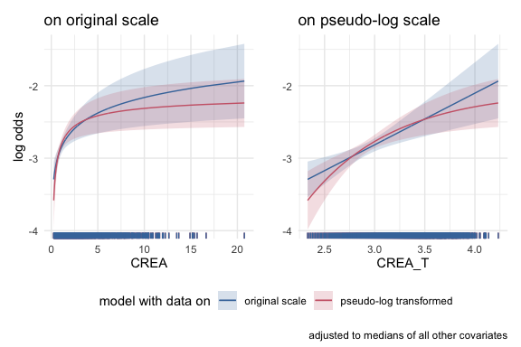

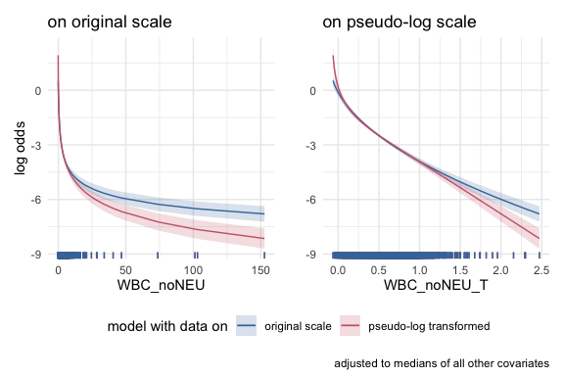

Comparing functional form of both global models.

B.3 Example 2: Interpretation of regression coefficient ‘size’
As a result of IDA, it turned out that the key predictor WBC_noNEU should be transformed for further analyses because of its extreme skewness. As a consequence, the original variable WBC_noNEU and the pseudo-logged variable WBC_noNEU_T are now on two very different scales:
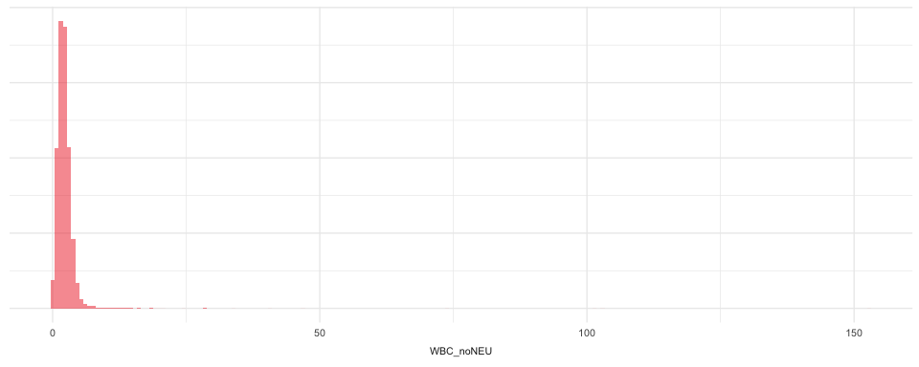
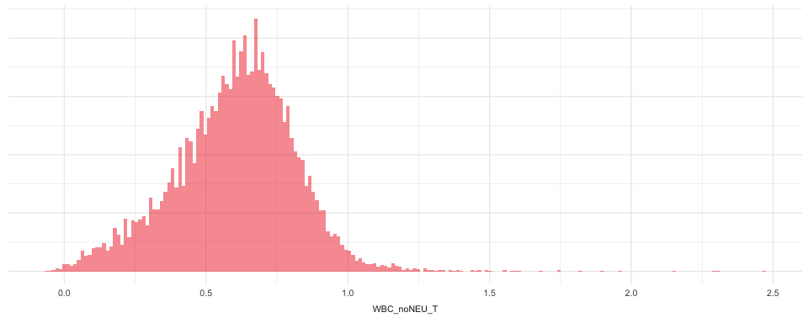
To illustrate that the scale of the original variable determines the size of the regression coefficient, let us consider two logistic regression models with WBC_noNEU and t_WBC_noNEU as single covariate, respectively.
Table S8: Comparing original and transformed scale
term | estimate | std.error | statistic
WBC_noNEU | -0.557 | 0.035 | -15.731
WBC_noNEU_T | -2.851 | 0.150 | -18.985
Even if the model with transformed WBC has a slightly better prediction performance as revealed by the summary plots below, this is not the reason for the difference. The estimates -0.56 and -2.85 indicate the difference in log odds for the outcome when the ‘term’ variable differs by 1 unit, but cannot be compared directly. A $1$ unit difference is only a small step on the original scale, where WBC_noNEU covers values from -0.15 up to 152.74. In comparison, WBC_noNEU_T lies between -0.06 up to 2.47, so a difference of $1$ unit cover almost half the range of the variable.
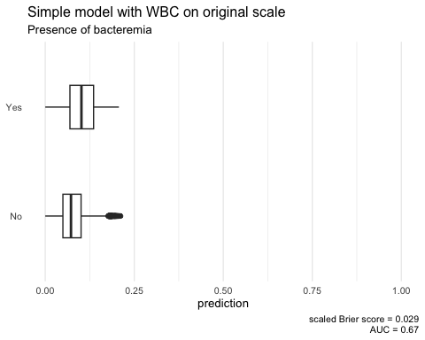
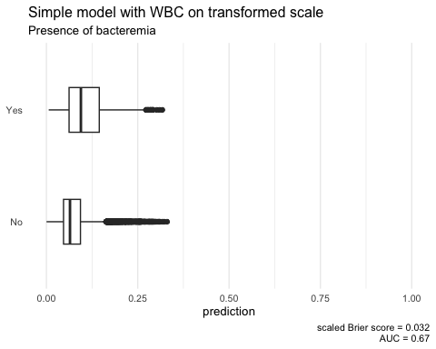

B.4 Example 3: the support of a model determines what it can explain
Next we compare the global model to a model were for an important variable, in our case we chose age, the variable support is reduced to the central 50% of the data (i.e. data within the 25% and 75% quantiles), and for comparison we also generate a scenario where we randomly sample 50% of the data.
When evaluating the apparent predictive performance in terms of the AUC and the scaled Brier score, we see that the model fitted on the participants with age between the first and third quartiles performs worse than the global model and the model where 50% were randomly sampled.
data | AUC | scaled Brier score
complete | 0.731 | 0.065
central 50% of age distribution | 0.723 | 0.053
randomly sampled 50% | 0.738 | 0.065
Plot the model predictions based on different missing data scenarios
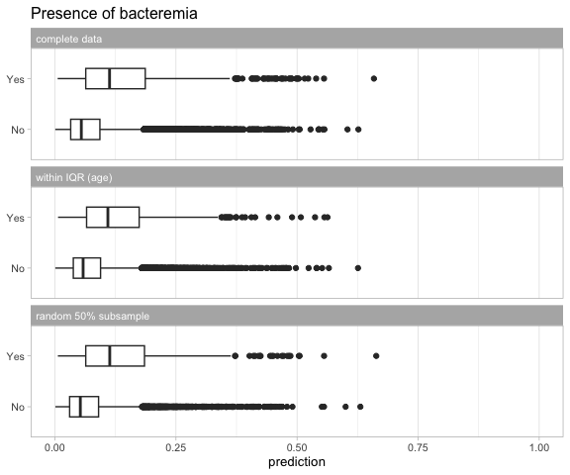
Model predictions based on different missing data scenarios.

B.5 Example 4: the limits of mulitiple imputation
To show the effect of multiple imputation if the number of missing values is high, we construct a dataset with 50% artificially generated missing values in one variable. First, recall the output of the complete model, relying on the Bacteremia data with complete cases regarding the key predictors.
Table S9: global model
term | estimate | std.error | statistic | p.value
(Intercept) | -2.69 | 0.59 | -4.57 | 4.78 × 10^-6
I((WBC_noNEU_T + 0.1)^0.5) | -5.19 | 0.25 | -20.53 | 1.25 × 10^-93
I(((NEU + 0.1)/10)^0.5) | 1.53 | 0.12 | 13.10 | 3.46 × 10^-39
I((AGE/100)^1) | 1.69 | 0.20 | 8.49 | 2.05 × 10^-17
I(CREA_T^1) | 0.71 | 0.20 | 3.60 | 3.19 × 10^-4
I(((PLT + 1)/100)^1) | -0.08 | 0.03 | -2.57 | 1.03 × 10^-2
I((BUN/10)^1) | 0.01 | 0.02 | 0.43 | 6.68 × 10^-1
Creatinine (‘CREA’) is significant at a level that might not survive substantial missingness. We thus create a dataset were we artificially introduce 50% missing creatinine values, missing completely at random.
Next we fit a ‘complete case’ model in the case of missing creatinine data, using the fp-transformations from the global model.
Now we impute the missing creatinine data using MICE with 50 imputations, fit the model using the fp-transformations from the global model and pool the results.
We now can compare the outputs of the complete model, the complete model with missing data (i.e. only half of the original complete data is used), and the imputed model.
Table S10: Comparison of the model with no missing data, with complete cases, and with imputed data
term | model | estimate | std.error | statistic | p.value
(Intercept) | missing, complete cases | -3.888 | 0.822 | -4.731 | 2.23 × 10^-6
 | missing, imputed | -3.973 | 0.798 | -4.975 | 1.42 × 10^-6
 | no missing data | -2.689 | 0.588 | -4.574 | 4.78 × 10^-6
I(((NEU + 0.1)/10)^0.5) | missing, complete cases | 1.612 | 0.166 | 9.703 | 2.92 × 10^-22
 | missing, imputed | 1.546 | 0.117 | 13.195 | 1.63 × 10^-39
 | no missing data | 1.526 | 0.117 | 13.096 | 3.46 × 10^-39
I(((PLT + 1)/100)^1) | missing, complete cases | -0.070 | 0.046 | -1.532 | 1.25 × 10^-1
 | missing, imputed | -0.077 | 0.032 | -2.416 | 1.57 × 10^-2
 | no missing data | -0.082 | 0.032 | -2.567 | 1.03 × 10^-2
I((AGE/100)^1) | missing, complete cases | 1.898 | 0.287 | 6.606 | 3.95 × 10^-11
 | missing, imputed | 1.671 | 0.200 | 8.371 | 6.26 × 10^-17
 | no missing data | 1.690 | 0.199 | 8.491 | 2.05 × 10^-17
I((BUN/10)^1) | missing, complete cases | -0.024 | 0.033 | -0.721 | 4.71 × 10^-1
 | missing, imputed | -0.030 | 0.030 | -1.019 | 3.09 × 10^-1
 | no missing data | 0.010 | 0.024 | 0.429 | 6.68 × 10^-1
I((WBC_noNEU_T + 0.1)^0.5) | missing, complete cases | -5.340 | 0.363 | -14.714 | 5.25 × 10^-49
 | missing, imputed | -5.246 | 0.255 | -20.602 | 7.20 × 10^-93
 | no missing data | -5.192 | 0.253 | -20.526 | 1.25 × 10^-93
I(CREA_T^1) | missing, complete cases | 1.094 | 0.276 | 3.972 | 7.13 × 10^-5
 | missing, imputed | 1.183 | 0.280 | 4.229 | 3.83 × 10^-5
 | no missing data | 0.713 | 0.198 | 3.599 | 3.19 × 10^-4
When half of the data is missing, the standard errors of the coefficients increase by a factor of approximately $\sqrt{2}$. Multiple imputation is able to recreate standard errors very close to those of the model with no missing data in most variables, but not in the one that was being imputed, namely creatinine. Its relative importance in the model is higher in the complete cases model than in the imputed model.

B.6 Example 5: Plot of functional form should focus on areas with high density
The functional forms have wide confidence intervals when the data is sparse. In presentations of the effects, plots of the functional forms should focus on areas with high density. In this analysis, PLT was very sparse above ~800 [UNITS], which is reflected in a large confidence interval for high PLT values. In the effect plot PLT values could be limited to values <800 [UNITS].
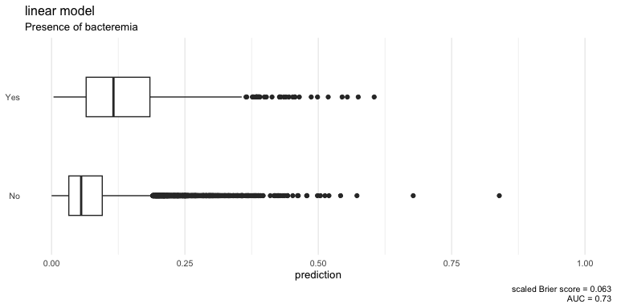
Model predictions

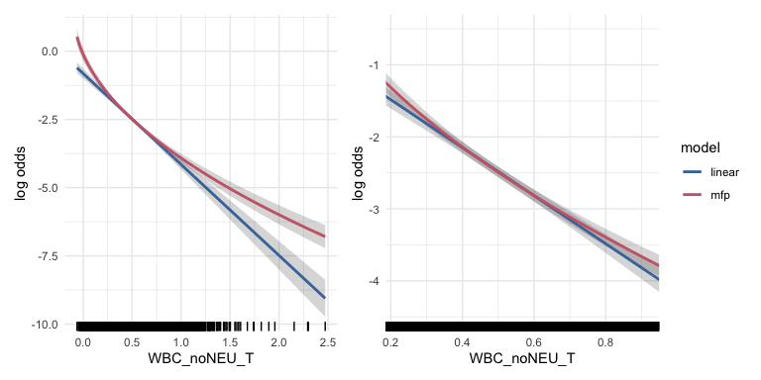
WBC_noNEU comparison

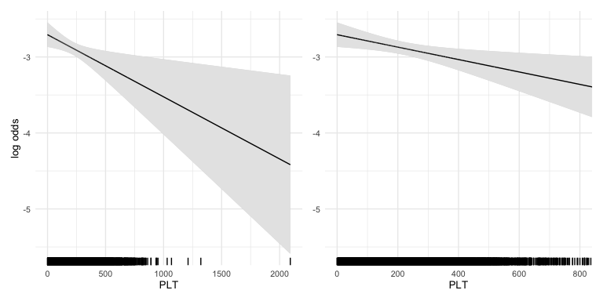
PLT comparison

Appendix C — Source data
The source data available in this repository (DC 2019-0054) can be located in the data-raw folder. For persistance, the data set is also published on Zenodo with the following doi: https://doi.org/10.5281/zenodo.7554815.
The following sections provide a short overview of the data dictionary which accompanies the source data, and a short description of the data.

C.1 Data dictionary
The data dictionary provides an overview of the collected data. First, we read and display the data dictionary below providing an overview of the collected measurements.
The variable name and label are displayed alongside the measurement scale and units as well as remarks and relevant study information from_paper.
variable | label | scale_of_measurement | units
ID | Patient Identification | nominal | 1-14691
SEX | Patient sex | nominal | 1=male, 2=female
AGE | Patient Age | continuous | years
MCV | Mean corpuscular volume | continuous | pg
HGB | Haemoglobin | continuous | G/L
HCT | Haematocrit | continuous | %
PLT | Blood platelets | continuous | G/L
MCH | Mean corpuscular hemoglobin | continuous | fl
MCHC | Mean corpuscular hemoglobin concentration | continuous | g/dl
RDW | Red blood cell distribution width | continuous | %
MPV | Mean platelet volume | continuous | fl
LYM | Lymphocytes | continuous | G/L
MONO | Monocytes | continuous | G/L
EOS | Eosinophils | continuous | G/L
BASO | Basophiles | continuous | G/L
NT | Normotest | continuous | %
APTT | Activated partial thromboplastin time | continuous | sec
FIB | Fibrinogen | continuous | mg/dl
SODIUM | Sodium | continuous | mmol/L
POTASS | Potassium | continuous | mmol/L
CA | Calcium | continuous | mmol/L
PHOS | Phosphate | continuous | mmol/L
MG | Magnesium | continuous | mmol/L
CREA | Creatinine | continuous | mg/dl
BUN | Blood urea nitrogen | continuous | mg/dl
HS | Uric acid | continuous | mg/dl
GBIL | Bilirubin | continuous | mg/dl
TP | Total protein | continuous | G/L
ALB | Albumin | continuous | G/L
AMY | Amylase | continuous | U/L
PAMY | Pancreas amylase | continuous | U/L
LIP | Lipases | continuous | U/L
CHE | Cholinesterase | continuous | kU/L
AP | Alkaline phosphatase | continuous | U/L
ASAT | Aspartate transaminase | continuous | U/L
ALAT | Alanin transaminase | continuous | U/L
GGT | Gamma-glutamyl transpeptidase | continuous | G/L
LDH | Lactate dehydrogenase | continuous | U/L
CK | Creatinine kinases | continuous | U/L
GLU | Glucoses | continuous | mg/dl
TRIG | Triclyceride | continuous | mg/dl
CHOL | Cholesterol | continuous | mg/dl
CRP | C-reactive protein | continuous | mg/dl
BASOR | Basophile ratio | continuous | %
EOSR | Eosinophil ratio | continuous | %
LYMR | Lymphocyte ratio | continuous | % (mg/dl)
MONOR | Monocyte ratio | continuous | %
NEU | Neutrophiles | continuous | G/L
NEUR | Neutrophile ratio | continuous | %
PDW | Platelet distribution width | continuous | %
RBC | Red blood count | continuous | T/L
WBC | White blood count | continuous | G/L
BloodCulture | Blood culture result for bacteremia | nominal | no, yes
We do not display all observations measured as it is too wide and long to fit reasonably in to the report. However, we refer you to the Zenodo page for an interactive overview of the source data.

Appendix D — Results of IDA: Missing values Appendix

D.1 M2: Variable missingness for remaining predictors
Table S11: Summary of missing values for remaining predictors
Predictor | Description | Missing (count) | Missing (%)
PAMY | Pancreas amylase (U/L) | 7114 | 48.4
TRIG | Triclyceride (mg/dl) | 5061 | 34.4
CHOL | Cholesterol (mg/dl) | 5045 | 34.3
GLU | Glucoses (mg/dl) | 4192 | 28.5
AMY | Amylase (U/L) | 3913 | 26.6
LIP | Lipases (U/L) | 3699 | 25.2
HS | Uric acid (mg/dl) | 3061 | 20.8
APTT | Activated partial thromboplastin time (sec) | 2549 | 17.4
NT | Normotest (%) | 2467 | 16.8
CHE | Cholinesterase (kU/L) | 2447 | 16.7
CK | Creatinine kinases (U/L) | 2080 | 14.2
MG | Magnesium (mmol/L) | 1869 | 12.7
LDH | Lactate dehydrogenase (U/L) | 1714 | 11.7
ALB | Albumin (G/L) | 1676 | 11.4
TP | Total protein (G/L) | 1583 | 10.8
GBIL | Bilirubin (mg/dl) | 1441 | 9.8
AP | Alkaline phosphatase (U/L) | 1400 | 9.5
SODIUM | Sodium (mmol/L) | 1282 | 8.7
CA | Calcium (mmol/L) | 1276 | 8.7
PHOS | Phosphate (mmol/L) | 1242 | 8.5
PDW | Platelet distribution width (%) | 1102 | 7.5
BASOR | Basophile ratio (%) | 732 | 5.0
EOSR | Eosinophil ratio (%) | 732 | 5.0
LYMR | Lymphocyte ratio (% (mg/dl)) | 732 | 5.0
MONOR | Monocyte ratio (%) | 732 | 5.0
NEUR | Neutrophile ratio (%) | 732 | 5.0
MPV | Mean platelet volume (fl) | 702 | 4.8
RBC | Red blood count (T/L) | 461 | 3.1
LYM | Lymphocytes (G/L) | 262 | 1.8
MONO | Monocytes (G/L) | 246 | 1.7
BASO | Basophiles (G/L) | 146 | 1.0
EOS | Eosinophils (G/L) | 135 | 0.9
RDW | Red blood cell distribution width (%) | 56 | 0.4
MCV | Mean corpuscular volume (pg) | 42 | 0.3
HCT | Haematocrit (%) | 42 | 0.3
MCH | Mean corpuscular hemoglobin (fl) | 42 | 0.3
MCHC | Mean corpuscular hemoglobin concentration (g/dl) | 42 | 0.3
HGB | Haemoglobin (G/L) | 41 | 0.3

Appendix E — Univariate distribution checks
This section reports a series of univariate summary checks of the bacteremia dataset.

E.1 U2: Descriptive summaries

E.1.1 U2: Remaining predictors
We present a visual summary.
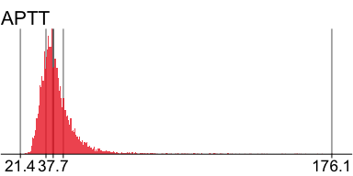 | 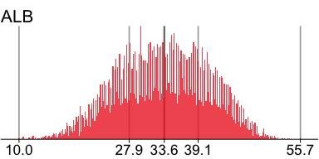 | 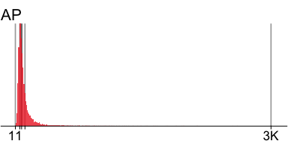

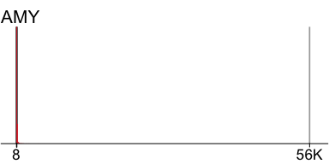 | 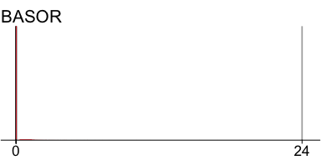 | 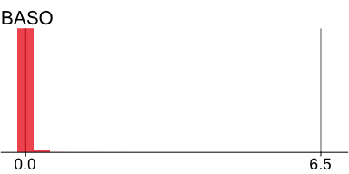

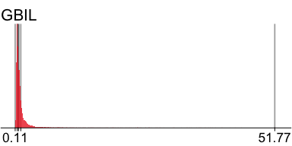 | 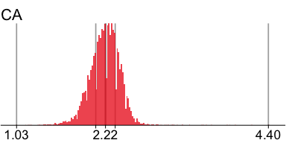 | 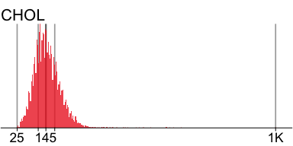

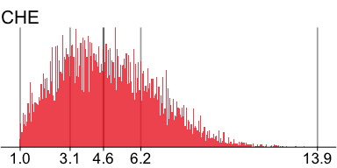 | 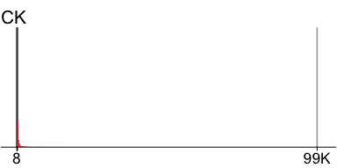 | 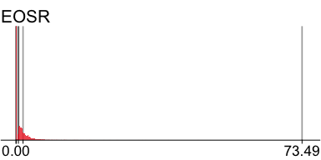

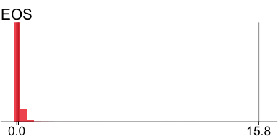 | 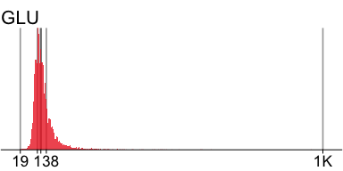 | 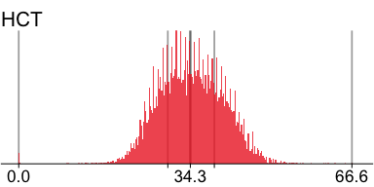

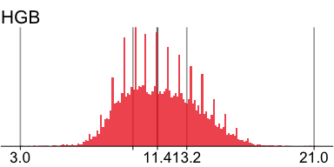 | 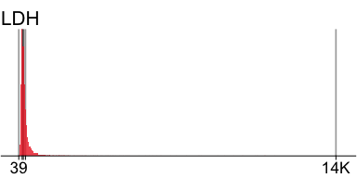 | 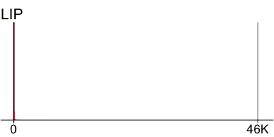

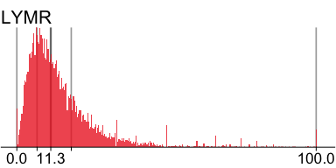 | 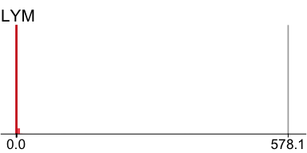 | 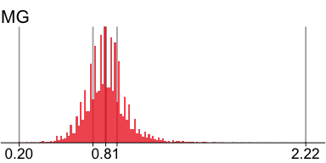

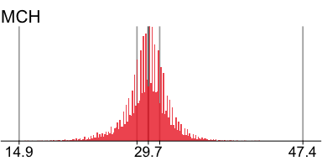 | 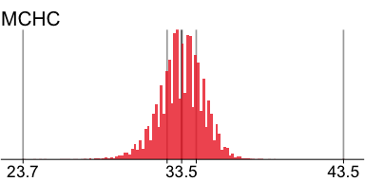 | 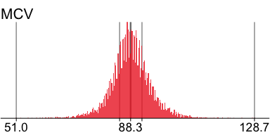

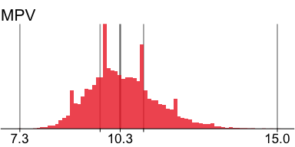 | 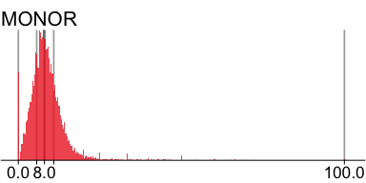 | 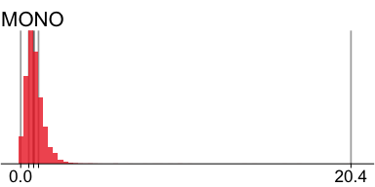

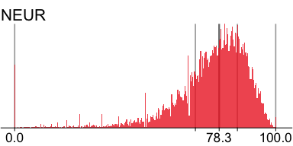 | 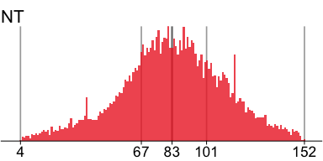 | 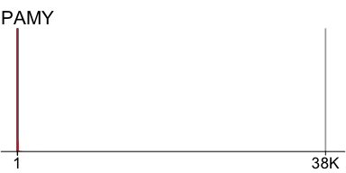

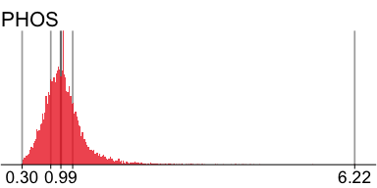 | 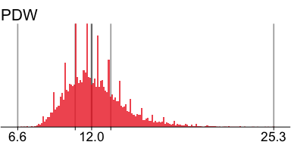 | 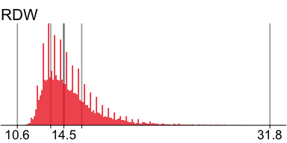

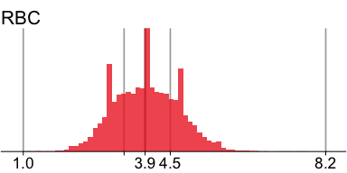 | 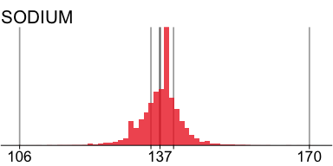 | 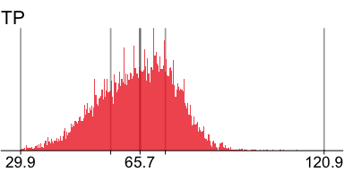

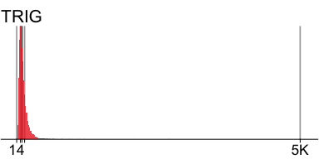 | 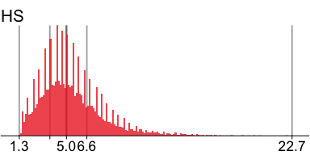
And a descriprive summary
n | missing | distinct | Info | Mean | Gmd | .05 | .10 | .25 | .50 | .75 | .90 | .95
14649 | 42 | 506 | 1 | 88.35 | 6.992 | 78.2 | 81.1 | 84.7 | 88.3 | 92.0 | 95.9 | 99.0
lowest : 51 52.6 54.9 56.3 57.5 , highest: 121 121.8 124.6 127.9 128.7

HGB: Parameter analysis value (Numeric)
n | missing | distinct | Info | Mean | Gmd | .05 | .10 | .25 | .50 | .75 | .90 | .95
14650 | 41 | 157 | 1 | 11.57 | 2.558 | 8.2 | 8.8 | 9.9 | 11.4 | 13.2 | 14.6 | 15.4
lowest : 3 3.1 3.5 3.9 4.1 , highest: 19.5 20.5 20.7 20.8 21

HCT: Parameter analysis value (Numeric)
n | missing | distinct | Info | Mean | Gmd | .05 | .10 | .25 | .50 | .75 | .90 | .95
14649 | 42 | 404 | 1 | 34.48 | 7.316 | 24.6 | 26.4 | 29.8 | 34.3 | 39.1 | 42.9 | 44.8
lowest : 0 0.1 0.2 9.7 9.8 , highest: 61.4 61.9 63.2 65.3 66.6

MCH: Parameter analysis value (Numeric)
n | missing | distinct | Info | Mean | Gmd | .05 | .10 | .25 | .50 | .75 | .90 | .95
14649 | 42 | 232 | 1 | 29.58 | 2.693 | 25.3 | 26.7 | 28.4 | 29.7 | 31.0 | 32.4 | 33.4
lowest : 14.9 15.6 15.9 16 16.5 , highest: 42 42.3 42.4 42.5 47.4

MCHC: Parameter analysis value (Numeric)
n | missing | distinct | Info | Mean | Gmd | .05 | .10 | .25 | .50 | .75 | .90 | .95
14649 | 42 | 124 | 0.999 | 33.47 | 1.546 | 31.1 | 31.7 | 32.6 | 33.5 | 34.4 | 35.2 | 35.6
lowest : 23.7 24.4 24.8 25.1 26.1 , highest: 38.3 38.4 38.9 39.3 43.5

RDW: Parameter analysis value (Numeric)
n | missing | distinct | Info | Mean | Gmd | .05 | .10 | .25 | .50 | .75 | .90 | .95
14635 | 56 | 173 | 1 | 15 | 2.385 | 12.4 | 12.7 | 13.4 | 14.5 | 16.0 | 18.0 | 19.5
lowest : 10.6 11.1 11.2 11.3 11.4 , highest: 28.6 28.9 29.1 29.7 31.8

MPV: Parameter analysis value (Numeric)
n | missing | distinct | Info | Mean | Gmd | .05 | .10 | .25 | .50 | .75 | .90 | .95
13989 | 702 | 71 | 0.999 | 10.38 | 1.132 | 8.9 | 9.2 | 9.7 | 10.3 | 11.0 | 11.7 | 12.2
lowest : 7.3 7.7 7.8 7.9 8 , highest: 14.2 14.3 14.6 14.8 15

LYM: Parameter analysis value (Numeric)
n | missing | distinct | Info | Mean | Gmd | .05 | .10 | .25 | .50 | .75 | .90 | .95
14429 | 262 | 114 | 0.998 | 1.366 | 1.162 | 0.2 | 0.4 | 0.7 | 1.0 | 1.6 | 2.1 | 2.6
lowest : 0 0.1 0.2 0.3 0.4 , highest: 149.9 357.5 366.8 375.1 578.1

MONO: Parameter analysis value (Numeric)
n | missing | distinct | Info | Mean | Gmd | .05 | .10 | .25 | .50 | .75 | .90 | .95
14445 | 246 | 67 | 0.996 | 0.8527 | 0.5965 | 0.1 | 0.3 | 0.5 | 0.8 | 1.1 | 1.5 | 1.8
lowest : 0 0.1 0.2 0.3 0.4 , highest: 13.9 14.6 16.2 17.3 20.4

EOS: Parameter analysis value (Numeric)
n | missing | distinct | Info | Mean | Gmd | .05 | .10 | .25 | .50 | .75 | .90 | .95
14556 | 135 | 36 | 0.867 | 0.1148 | 0.1585 | 0.0 | 0.0 | 0.0 | 0.1 | 0.1 | 0.3 | 0.4
lowest : 0 0.1 0.2 0.3 0.4 , highest: 3.8 5.3 9.6 11.5 15.8

BASO: Parameter analysis value (Numeric)
n | missing | distinct | Info | Mean | Gmd | .05 | .10 | .25 | .50 | .75 | .90 | .95
14545 | 146 | 18 | 0.337 | 0.01725 | 0.03111 | 0.0 | 0.0 | 0.0 | 0.0 | 0.0 | 0.1 | 0.1
Value 0.000 0.065 0.195 0.260 0.390 0.455 0.585 0.650 0.780 0.845 0.975 1.040
Frequency 12671 1636 109 59 31 14 6 7 1 2 1 2
Proportion 0.871 0.112 0.007 0.004 0.002 0.001 0.000 0.000 0.000 0.000 0.000 0.000
Value 1.170 1.300 1.365 1.495 2.145 6.500
Frequency 1 1 1 1 1 1
Proportion 0.000 0.000 0.000 0.000 0.000 0.000
For the frequency table, variable is rounded to the nearest 0.065

NT: Parameter analysis value (Numeric)
n | missing | distinct | Info | Mean | Gmd | .05 | .10 | .25 | .50 | .75 | .90 | .95
12224 | 2467 | 149 | 1 | 83.22 | 30.56 | 35 | 48 | 67 | 83 | 101 | 118 | 128
lowest : 4 5 6 7 8 , highest: 148 149 150 151 152

APTT: Parameter analysis value (Numeric)
n | missing | distinct | Info | Mean | Gmd | .05 | .10 | .25 | .50 | .75 | .90 | .95
12142 | 2549 | 631 | 1 | 40.06 | 9.533 | 30.1 | 31.4 | 34.1 | 37.7 | 42.7 | 49.9 | 56.6
lowest : 21.4 21.6 23.4 23.5 23.6 , highest: 160.7 163 168.7 171.6 176.1

SODIUM: Parameter analysis value (Numeric)
n | missing | distinct | Info | Mean | Gmd | .05 | .10 | .25 | .50 | .75 | .90 | .95
13409 | 1282 | 58 | 0.994 | 137.2 | 5.034 | 129 | 132 | 135 | 137 | 140 | 142 | 144
lowest : 106 108 109 110 112 , highest: 161 165 166 168 170

CA: Parameter analysis value (Numeric)
n | missing | distinct | Info | Mean | Gmd | .05 | .10 | .25 | .50 | .75 | .90 | .95
13415 | 1276 | 185 | 1 | 2.214 | 0.2213 | 1.89 | 1.96 | 2.09 | 2.22 | 2.35 | 2.45 | 2.51
lowest : 1.03 1.15 1.18 1.2 1.23 , highest: 3.84 3.88 3.96 4.18 4.4

PHOS: Parameter analysis value (Numeric)
n | missing | distinct | Info | Mean | Gmd | .05 | .10 | .25 | .50 | .75 | .90 | .95
13449 | 1242 | 306 | 1 | 1.048 | 0.3993 | 0.55 | 0.64 | 0.81 | 0.99 | 1.20 | 1.47 | 1.74
lowest : 0.3 0.31 0.32 0.33 0.34 , highest: 4.36 4.43 4.53 5.48 6.22

MG: Parameter analysis value (Numeric)
n | missing | distinct | Info | Mean | Gmd | .05 | .10 | .25 | .50 | .75 | .90 | .95
12822 | 1869 | 146 | 0.999 | 0.8136 | 0.1609 | 0.59 | 0.64 | 0.72 | 0.81 | 0.89 | 0.98 | 1.06
lowest : 0.2 0.21 0.22 0.26 0.28 , highest: 1.83 1.88 1.96 2.07 2.22

HS: Parameter analysis value (Numeric)
n | missing | distinct | Info | Mean | Gmd | .05 | .10 | .25 | .50 | .75 | .90 | .95
11630 | 3061 | 169 | 1 | 5.413 | 2.625 | 2.2 | 2.7 | 3.7 | 5.0 | 6.6 | 8.5 | 10.0
lowest : 1.3 1.4 1.5 1.6 1.7 , highest: 19.8 20.2 22.2 22.3 22.7

GBIL: Parameter analysis value (Numeric)
n | missing | distinct | Info | Mean | Gmd | .05 | .10 | .25 | .50 | .75 | .90 | .95
13250 | 1441 | 885 | 1 | 1.406 | 1.477 | 0.33 | 0.39 | 0.53 | 0.77 | 1.23 | 2.34 | 3.96
lowest : 0.11 0.12 0.13 0.14 0.15 , highest: 42.82 43.83 45.1 51.72 51.77

TP: Parameter analysis value (Numeric)
n | missing | distinct | Info | Mean | Gmd | .05 | .10 | .25 | .50 | .75 | .90 | .95
13108 | 1583 | 649 | 1 | 64.9 | 12.97 | 45.20 | 49.47 | 56.90 | 65.70 | 73.30 | 78.80 | 82.00
lowest : 29.9 30 30.3 30.5 30.6 , highest: 107.8 108.1 108.7 112.8 120.9

ALB: Parameter analysis value (Numeric)
n | missing | distinct | Info | Mean | Gmd | .05 | .10 | .25 | .50 | .75 | .90 | .95
13015 | 1676 | 401 | 1 | 33.42 | 8.513 | 21.3 | 23.6 | 27.9 | 33.6 | 39.1 | 43.2 | 45.2
lowest : 10 10.2 10.5 10.6 10.7 , highest: 52.9 53.2 53.7 54 55.7

AMY: Parameter analysis value (Numeric)
n | missing | distinct | Info | Mean | Gmd | .05 | .10 | .25 | .50 | .75 | .90 | .95
10778 | 3913 | 488 | 1 | 90.83 | 100.5 | 18 | 23 | 33 | 49 | 76 | 125 | 187
lowest : 8 9 10 11 12 , highest: 4984 5248 40372 43970 56146

PAMY: Parameter analysis value (Numeric)
n | missing | distinct | Info | Mean | Gmd | .05 | .10 | .25 | .50 | .75 | .90 | .95
7577 | 7114 | 280 | 0.999 | 41.66 | 47.28 | 7 | 9 | 14 | 22 | 36 | 64 | 97
lowest : 1 2 3 4 5 , highest: 1673 2083 2116 3066 38369

LIP: Parameter analysis value (Numeric)
n | missing | distinct | Info | Mean | Gmd | .05 | .10 | .25 | .50 | .75 | .90 | .95
10992 | 3699 | 444 | 1 | 63.82 | 89.88 | 6 | 8 | 14 | 23 | 40 | 79 | 135
lowest : 0 1 2 3 4 , highest: 11469 15843 18560 22339 45991

CHE: Parameter analysis value (Numeric)
n | missing | distinct | Info | Mean | Gmd | .05 | .10 | .25 | .50 | .75 | .90 | .95
12244 | 2447 | 997 | 1 | 4.79 | 2.378 | 1.70 | 2.17 | 3.15 | 4.60 | 6.22 | 7.65 | 8.49
lowest : 0.98 0.99 1 1.01 1.02 , highest: 12.39 12.55 12.97 13.32 13.89

AP: Parameter analysis value (Numeric)
n | missing | distinct | Info | Mean | Gmd | .05 | .10 | .25 | .50 | .75 | .90 | .95
13291 | 1400 | 672 | 1 | 118.8 | 91.51 | 42 | 49 | 63 | 84 | 123 | 206 | 302
lowest : 11 14 15 16 17 , highest: 1980 2132 2549 2596 2995

LDH: Parameter analysis value (Numeric)
n | missing | distinct | Info | Mean | Gmd | .05 | .10 | .25 | .50 | .75 | .90 | .95
12977 | 1714 | 1137 | 1 | 331.2 | 240.9 | 136 | 152 | 187 | 239 | 332 | 508 | 724
lowest : 39 46 54 55 56 , highest: 10473 10784 10822 11246 13906

CK: Parameter analysis value (Numeric)
n | missing | distinct | Info | Mean | Gmd | .05 | .10 | .25 | .50 | .75 | .90 | .95
12611 | 2080 | 1506 | 1 | 385 | 615.4 | 18 | 25 | 42 | 80 | 184 | 577 | 1155
lowest : 8 9 10 11 12 , highest: 60799 63011 82180 83880 98801

GLU: Parameter analysis value (Numeric)
n | missing | distinct | Info | Mean | Gmd | .05 | .10 | .25 | .50 | .75 | .90 | .95
10499 | 4192 | 389 | 1 | 126.4 | 48.3 | 78 | 85 | 97 | 113 | 138 | 177 | 216
lowest : 19 22 23 26 28 , highest: 843 848 890 1349 1403

TRIG: Parameter analysis value (Numeric)
n | missing | distinct | Info | Mean | Gmd | .05 | .10 | .25 | .50 | .75 | .90 | .95
9630 | 5061 | 538 | 1 | 141.7 | 90.33 | 54 | 64 | 83 | 115 | 165 | 241 | 307
lowest : 14 15 16 20 22 , highest: 1796 2247 2662 2918 5440

CHOL: Parameter analysis value (Numeric)
n | missing | distinct | Info | Mean | Gmd | .05 | .10 | .25 | .50 | .75 | .90 | .95
9646 | 5045 | 339 | 1 | 150.8 | 59.23 | 74 | 89 | 113 | 145 | 182 | 219 | 243
lowest : 25 26 27 28 29 , highest: 646 662 676 710 1104

BASOR: Parameter analysis value (Numeric)
n missing distinct Info Mean Gmd .05 .10 .25
13959 732 419 0.322 0.145 0.2679 0.0000 0.0000 0.0000
.50 .75 .90 .95
0.0000 0.0000 0.5501 1.0526
lowest : 0 0.13587 0.15456 0.165289 0.181818 , highest: 11.1111 15.2174 16.6667 18.4211 23.6559

EOSR: Parameter analysis value (Numeric)
n missing distinct Info Mean Gmd .05 .10 .25
13959 732 927 0.891 1.297 1.825 0.0000 0.0000 0.0000
.50 .75 .90 .95
0.5882 1.7857 3.4900 5.0000
lowest : 0 0.183486 0.20284 0.217865 0.218818 , highest: 39.1753 46.6019 46.9027 50 73.4884

LYMR: Parameter analysis value (Numeric)
n | missing | distinct | Info | Mean | Gmd | .05 | .10 | .25 | .50 | .75 | .90 | .95
13959 | 732 | 3121 | 1 | 14.61 | 11.87 | 2.752 | 4.000 | 6.757 | 11.340 | 18.182 | 27.869 | 36.620
lowest : 0 0.321543 0.44843 0.460829 0.463679 , highest: 97.2414 97.4194 98 99.1848 100

MONOR: Parameter analysis value (Numeric)
n | missing | distinct | Info | Mean | Gmd | .05 | .10 | .25 | .50 | .75 | .90 | .95
13959 | 732 | 2334 | 1 | 8.793 | 5.4 | 2.000 | 3.390 | 5.634 | 8.000 | 10.870 | 14.141 | 17.021
lowest : 0 0.274725 0.341297 0.344828 0.456621 , highest: 68.5446 69.2308 70.3704 72.7273 100

NEUR: Parameter analysis value (Numeric)
n | missing | distinct | Info | Mean | Gmd | .05 | .10 | .25 | .50 | .75 | .90 | .95
13959 | 732 | 3850 | 1 | 75.15 | 15.6 | 47.42 | 57.88 | 69.23 | 78.33 | 85.32 | 90.13 | 92.63
lowest : 0 1.48483 1.93548 1.96078 2.41379 , highest: 99.1228 99.1667 99.4764 99.4845 100

PDW: Parameter analysis value (Numeric)
n | missing | distinct | Info | Mean | Gmd | .05 | .10 | .25 | .50 | .75 | .90 | .95
13589 | 1102 | 167 | 1 | 12.29 | 2.375 | 9.3 | 9.8 | 10.8 | 12.0 | 13.4 | 15.1 | 16.4
lowest : 6.6 6.8 6.9 7 7.1 , highest: 24.1 24.7 24.9 25.2 25.3

RBC: Parameter analysis value (Numeric)
n | missing | distinct | Info | Mean | Gmd | .05 | .10 | .25 | .50 | .75 | .90 | .95
14230 | 461 | 65 | 0.999 | 3.936 | 0.8772 | 2.7 | 2.9 | 3.4 | 3.9 | 4.5 | 4.9 | 5.2

E.1.2 Full descriptive summaries
For U2, we present only a limited number of statistics are presented for brevity. However, a full set of descriptive summaries are available according to the specifications in the IDA plan as a data set. The summary statistics can be viewed and analysed in the following directory data/results/U2-descriptive-stats.csv.

Appendix F — Multivariate analyses
First load the required packages and data. Note:, from the univariate analyses the analysis data set for the lab parameters has been updated to include transformed variables. Therefore, we load the second iteration of the data data/IDA/ADLB_02.rds.

F.1 V1: Association with structural variables
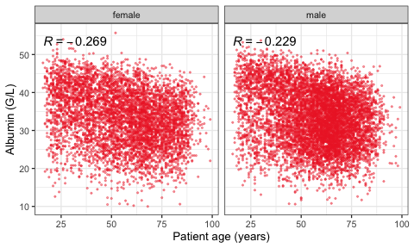 | 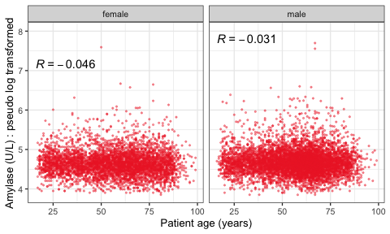 | 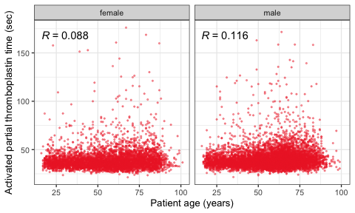

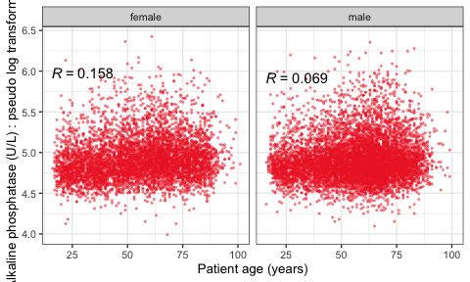 | 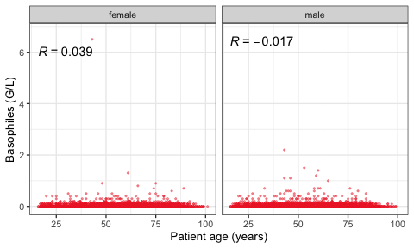 | 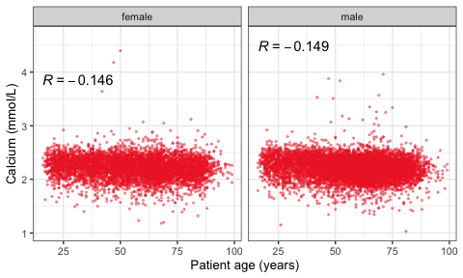

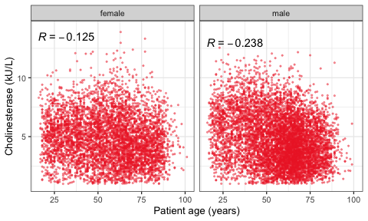 | 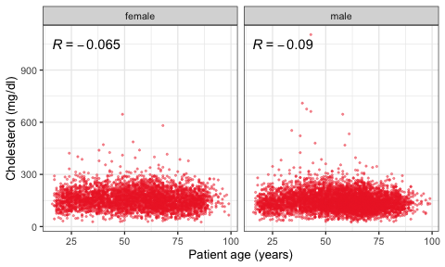 | 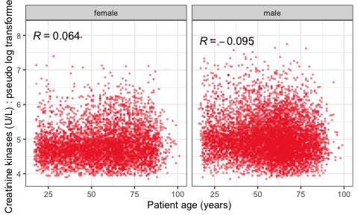

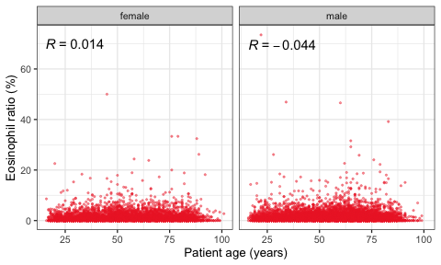 | 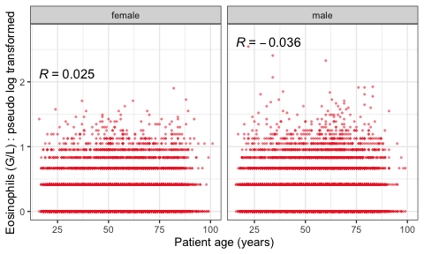 | 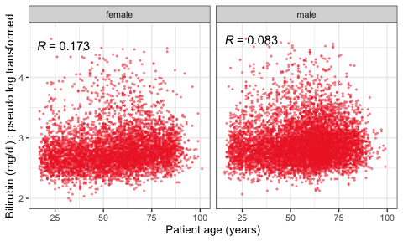

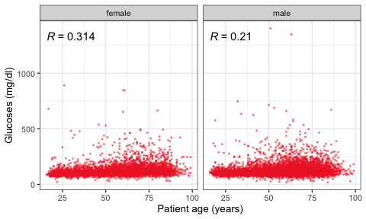 | 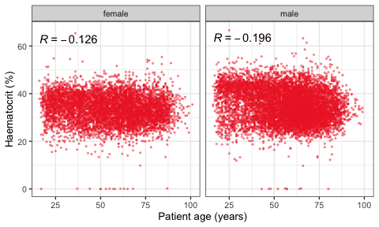 | 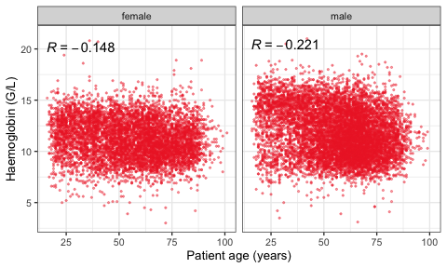

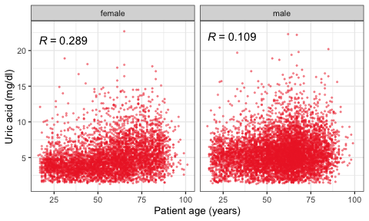 | 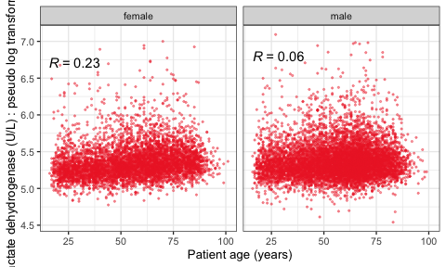 | 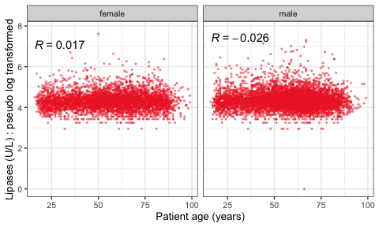

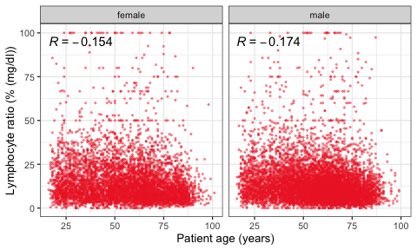 | 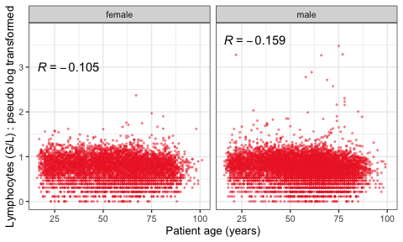 | 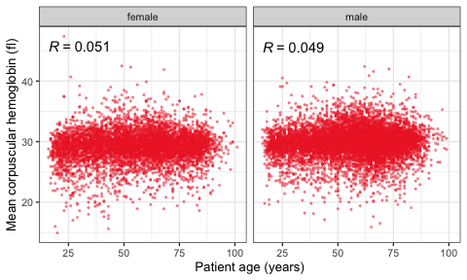

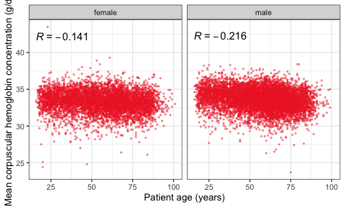 | 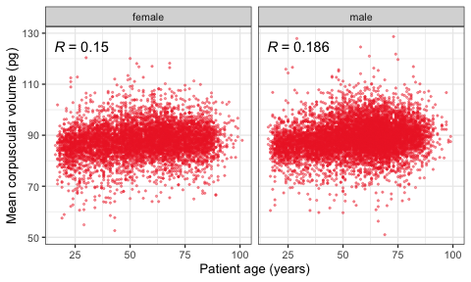 | 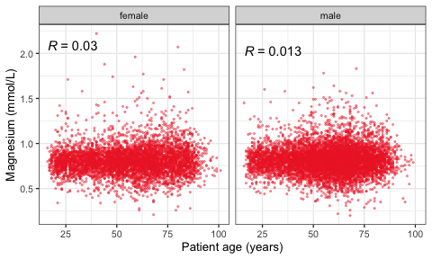

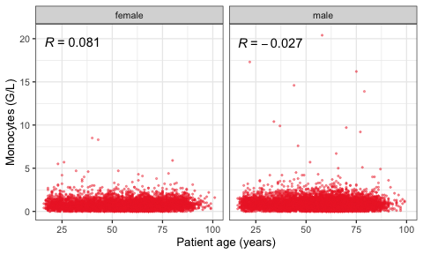 | 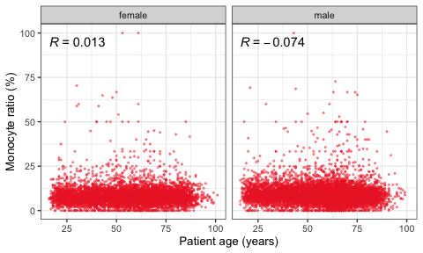 | 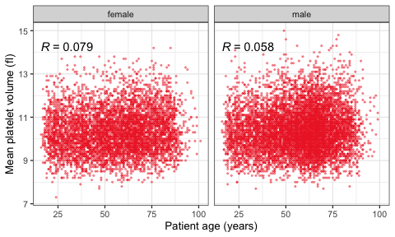

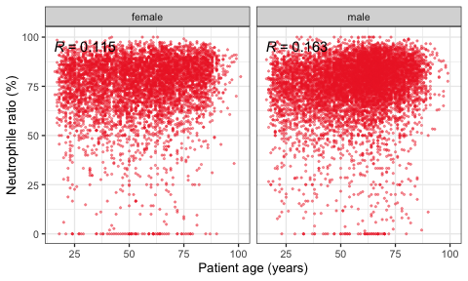 | 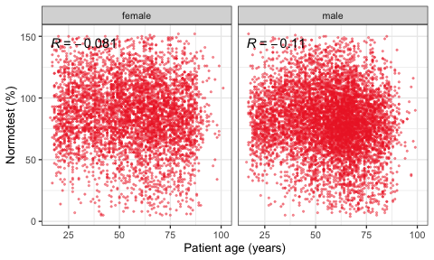 | 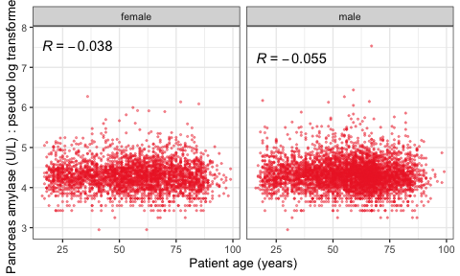

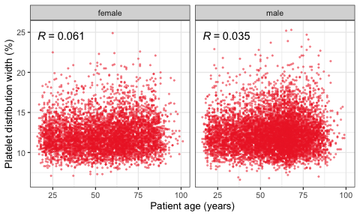 | 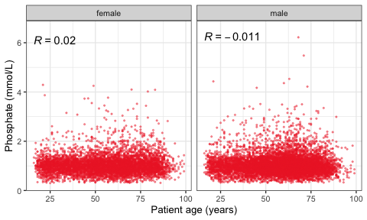 | 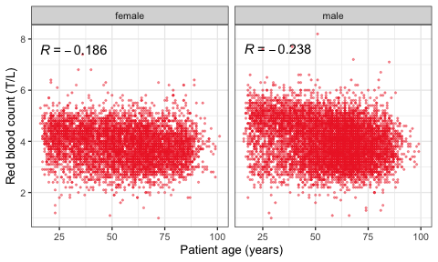

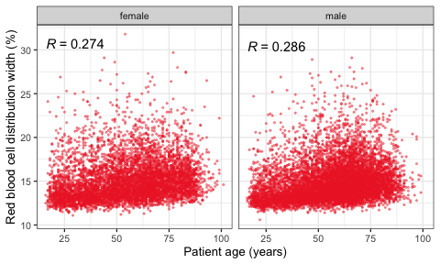 | 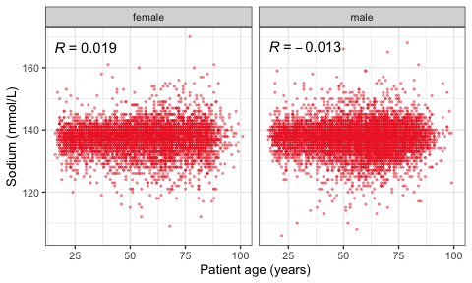 | 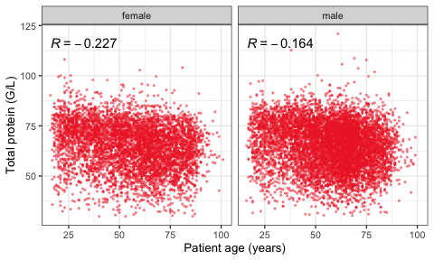

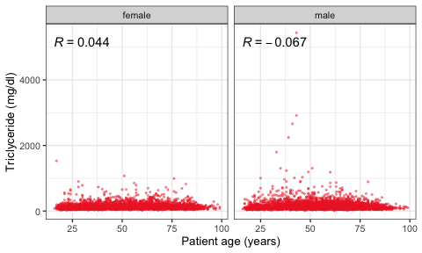

F.2 VE3: Redundancy

F.2.1 Linear model
VIF for the all predictor model.
The available sample size is 3979 (0.42 %).
Parameter code | Variance inflation factor | Multiple R-squared
SEX | 1.3 | 0.25
MCV | 129.5 | 0.99
HGB | 254.3 | 1.00
HCT | 249.4 | 1.00
PLT | 1.9 | 0.48
MCH | 179.4 | 0.99
MCHC | 47.5 | 0.98
RDW | 1.9 | 0.47
MPV | 9.2 | 0.89
MONO | 4.3 | 0.77
BASO | 2.6 | 0.62
NT | 1.5 | 0.32
APTT | 1.2 | 0.18
FIB | 2.9 | 0.66
SODIUM | 1.4 | 0.30
POTASS | 1.4 | 0.29
CA | 2.1 | 0.52
PHOS | 1.6 | 0.36
MG | 1.3 | 0.23
BUN | 3.2 | 0.69
HS | 1.8 | 0.43
TP | 4.5 | 0.78
ALB | 6.3 | 0.84
CHE | 2.8 | 0.65
GLU | 1.3 | 0.20
TRIG | 1.4 | 0.29
CHOL | 1.9 | 0.47
CRP | 2.8 | 0.65
EOSR | 47.3 | 0.98
LYMR | 1,321.2 | 1.00
MONOR | 321.4 | 1.00
NEU | 8.9 | 0.89
NEUR | 2,179.1 | 1.00
PDW | 9.1 | 0.89
RBC | 40.1 | 0.98
AGE | 1.5 | 0.31
ALAT_T | 3.9 | 0.74
AMY_T | 2.7 | 0.63
AP_T | 2.3 | 0.57
ASAT_T | 6.6 | 0.85
CK_T | 2.2 | 0.55
CREA_T | 2.9 | 0.65
EOS_T | 3.5 | 0.71
GBIL_T | 1.6 | 0.38
GGT_T | 2.6 | 0.62
LDH_T | 2.2 | 0.55
LIP_T | 2.2 | 0.54
LYM_T | 4.5 | 0.78
PAMY_T | 3.4 | 0.71
WBC_T | 15.7 | 0.94

