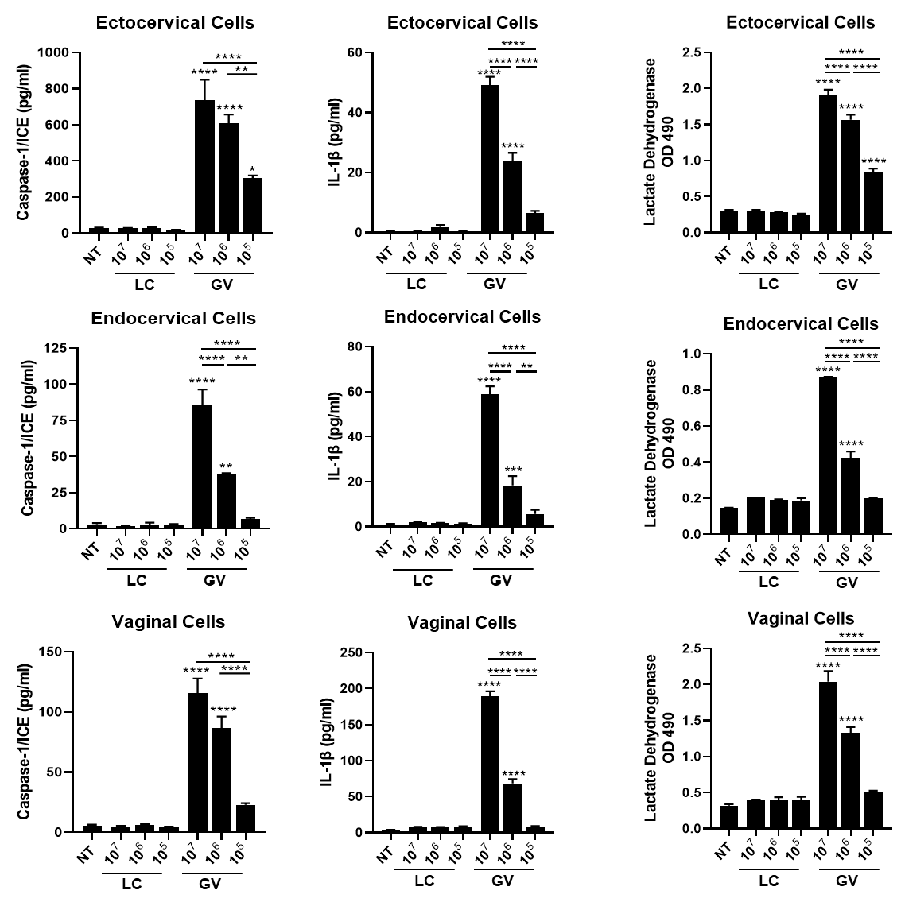
Supplementary Figure 1: Dose response of L. crispatus (LC) and G. vaginalis (GV) shows a dose-dependent increase in cell death, caspase-1 and IL-1b suggesting that GV activates an immune response through inflammasome-mediate mechanisms. Values are mean ± SEM. Asterisks over the individual bars represent comparisons to non-treated control; asterisks over solid lines represent comparisons between treatment groups. *p<0.05, **p<0.01, ***p<0.001, ****p<0.0001.

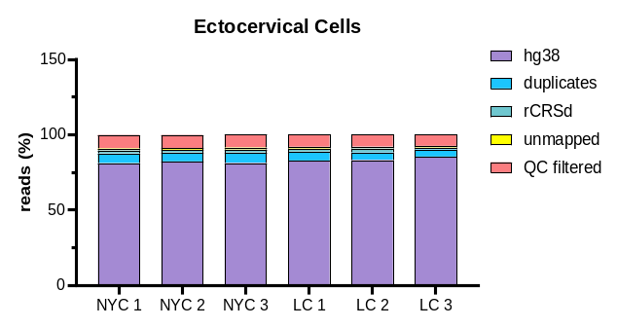
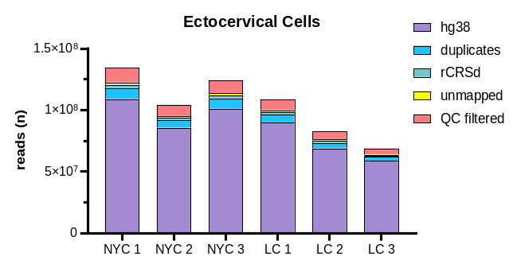
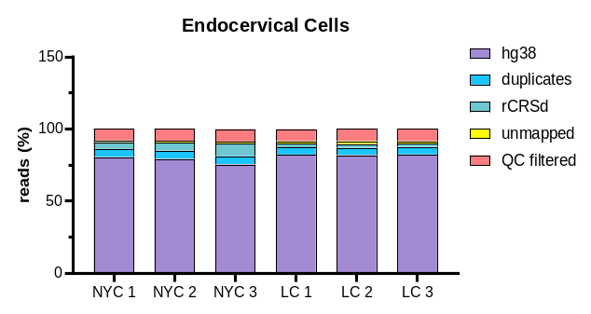
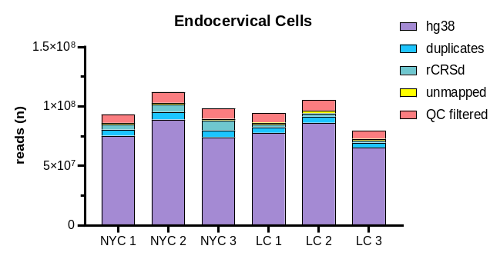
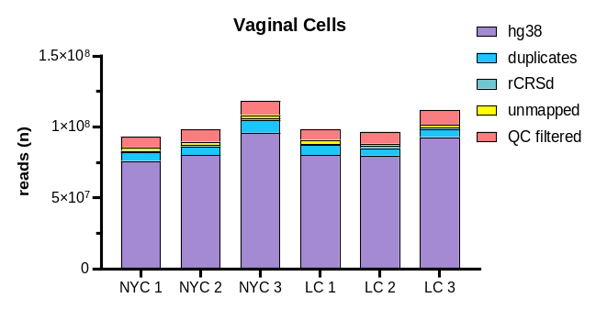
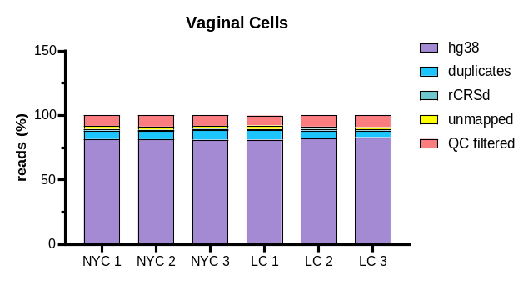
Supplementary Figure 2: Mapping (number and percentage) of reads for each cell type. hg38 = mapped to the human reference genome and used for downstream analysis. Duplicates = removed for the same exact DNA fragment. rCRSd = mitochondrial genome per revised Cambridge Reference Sequence doubled genome. QC filtered = poor quality reads that were removed (MAPQ score <10).

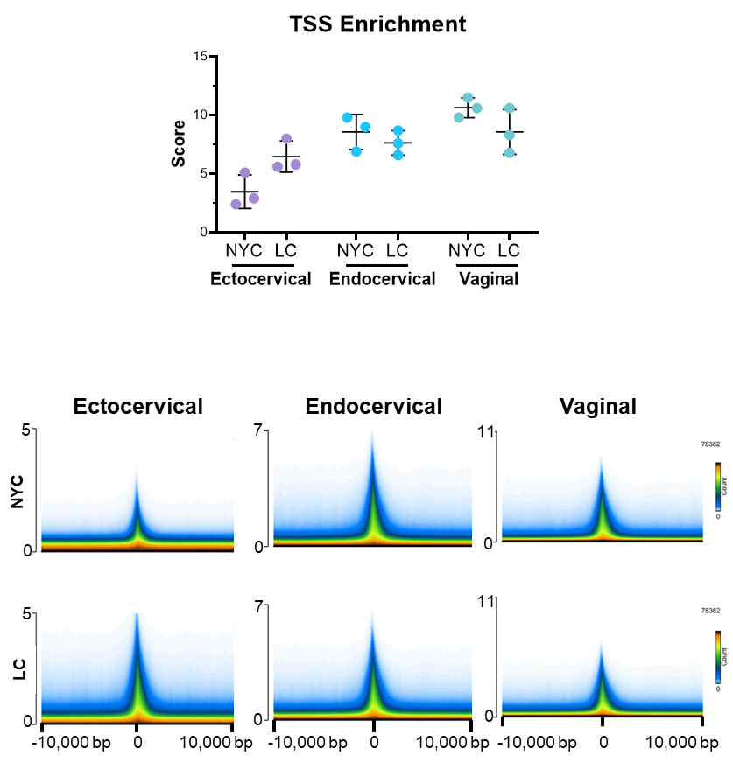
Supplementary Figure 3: Enrichment of reads around the TSS. Top: Graph of TSS enrichment score for each biological replicate. Bottom: Density of counts around the TSS for each condition by cell types.

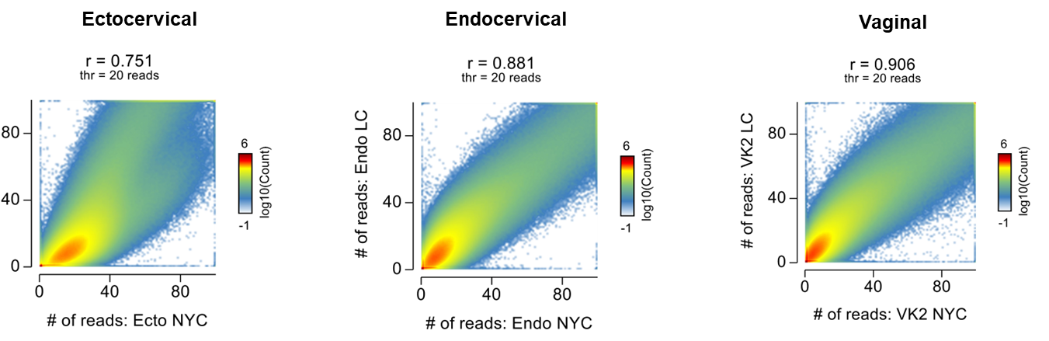
Supplementary Figure 4: Correlation between treatment conditions of read counts (not normalized)

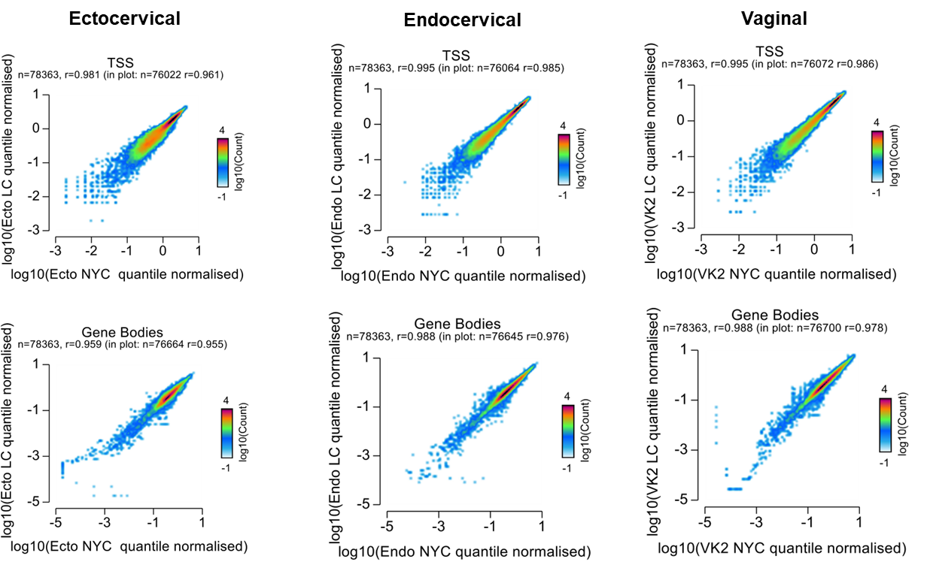

Supplementary Figure 5: Correlation of normalized read counts between conditions at TSS or within the gene bodies

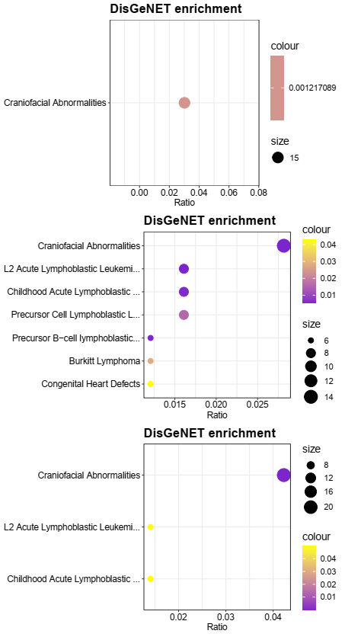
FDR
FDR
FDR

Supplementary Figure 6: Random DisGeNET enrichment bubble charts for random motif lists that were generated

Supplemental Table 1: Number of differentially expressed genes in cervicovaginal epithelial cells after bacterial exposure
 | Ectocervical | Endocervical | Vaginal
Comparison | Log2FC  ≥ 1 and ≤ -1  p≤0.05 | Log2FC  ≥ 1 and ≤ -1  p≤0.05 | Log2FC  ≥ 1 and ≤ -1  p≤0.05
Live LC vs NTC | 6 ↑  4 ↓ | 15 ↑  5 ↓ | 3 ↑  8 ↓
Live GV vs NTC | 237 ↑  111 ↓ | 457 ↑  123 ↓ | 237 ↑  214 ↓
LC sups vs NYC | 562 ↑  224 ↓ | 776 ↑  370 ↓ | 289 ↑  135 ↓
GV sups vs NYC | 38 ↑  7 ↓ | 204 ↑  45 ↓ | 105 ↑  128 ↓
Differentially expressed genes were chosen based on a cut-off of Log2 Fold Change (FC) of ≥ 1 or ≤ -1
with an adjusted p value ≤ 0.05.

Supplemental Table 2: List of overlapping genes altered by bacteria exposure between epithelial cell types.
Live GV |  |  | LC sups |  |  | GV sups
ecto/endo  n=46 | endo/vag  n=66 | ecto/vag  n=37 | ecto/endo  n=133 | endo/vag  n=61 | ecto/vag  n=67 | ecto/endo  n=3 | endo/vag  n=39 | ecto/vag  n=3
NTSR1 | TRIM22 | NLRP3 | RCN3 | MMP2 | CCNA1 | PDZK1IP1 | CXCL10 | STC1
LCE3E | PTPN22 | VGLL3 | KPNA7 | PSTPIP1 | PTPRR | IL36G | CTSS | RUNDC3A
SOD2 | TGM2 | C17orf99 | OR2B6 | SLC16A14 | TMEM151A | IFITM1 | IL23A | novel protein
NR4A2 | ZMYND15 | NCF2 | CILP | TGM2 | GDF15 |  | INHBA
PAPSS2 | GFPT2 | H2AC8 | DNAI1 | DPP4 | KBTBD13 |  | CCL20
HRK | TNFRSF9 | PPBP | MMRN2 | RASAL1 | AKR1B10 |  | PTGS2
SPRR2D | GASK1B | IL1RL1 | CCL22 | KCNQ5 | PTPRZ1 |  | IL1R2
PLA2G4E | CSF1 | PSG4 | CRYM | AKR1C2 | NOS1 |  | SAA2
LIF | NFKB2 | IFIT2 | ARHGAP30 | AHR | LCE1B |  | TRHDE
DLL1 | NANOS3 | SPINK5 | WFDC5 | LGALS7B | SEMA3A |  | KRT34
ANXA9 | TENT5C | FPGT-TNNI3K | UAP1L1 | JPH2 | IQCH |  | MRGPRX3
PCDHGC5 | HDAC9 | NRG2 | SCX | TBC1D3B | DNASE1L3 |  | CXCL8
MUC2 | LAMB3 | PTX3 | NEFH | ABCC2 | FAM110C |  | CD70
SGK1 | FMN1 | PSG1 | ZNF556 | HR | H3C14 |  | BIRC3
CCDC158 | ZDHHC11B | H2AC19 | GSTA4 | RHCE | NEFM |  | SERPINB2
KYNU | MAP3K8 | CHST2 | LAMP3 | ETV7 | TLCD3B |  | ZC3H12A
ENKUR | FA2H | PLOD2 | KLHL30 | S1PR4 | CDH2 |  | IL32
SLPI | LTB | OASL | LRRC75A | CYP7B1 | EGR1 |  | TGM2
BMP2 | PCDHGC4 | DLL4 | PIBF1 | PTGS2 | MGAT5B |  | XAF1
RHCG | NT5DC4 | KLHDC1 | NCF2 | CPM | ZCCHC12 |  | KRT4
PGLYRP4 | CA9 | BLNK | KRTAP3-2 | NPIPB7 | CLDN9 |  | VNN1
S100A8 | ENO2 | TMEM158 | PRR22 | FAM166B | MYPN |  | NFKB2
PI3 | CALB2 | IL20 | KLHDC7B | ITGB8 | H1-5 |  | G0S2
SLC6A14 | DSG1 | ADAMTS1 | SHOC1 | C8orf88 | H2BC9 |  | TNFRSF1B
SLITRK6 | G0S2 | NR4A1 | PTPRB | CAVIN2 | ESPNL |  | TNFAIP3
ALOX12 | TMEM132A | AQP3 | STX19 | MAPK8IP2 | APOBEC3A |  | TNIP1
RORA | MMP1 | IFIT1 | MFAP5 | ARRDC4 | NEFL |  | C1orf68
DMBT1 | CXCL17 | PALMD | IL6R | BHLHA15 | H3C8 |  | SCHIP1
RASGEF1B | SGPP2 | CEMIP | VASH1 | PPP1R3F | LCE1E |  | CXCL3
SERPINB4 | DUSP19 | RSAD2 | CORO2B | SMIM1 | SLC6A14  BCL2A1 |  | TNF
SEMA6C | SULT1E1 | ETFBKMT | NEU1 | AMTN | LYPD1 |  | LTB
RPL3L | SESN3 | PPP2R2B | C15orf62 | CAPN8 | CNNM1 |  | NFKBIZ
SPRR2A | INHBA | PSG6 | STON1 | ZDHHC11 | MYH15 |  | TRPV3
PATL2 | IRAK2 | CXCL5 | PCDHGC5 | IFNE | TUBB2B |  | CXCL2
TRAF1 | NDRG1 | ADM | H1-3 | CDRT1 | S100A4 |  | NFKBIA
ZNF396 | TCAF2 | RNF157 | H2BC18 | COL11A2 | BLACAT1 |  | IL24
IL33 | AMH | LCE1F | AOC3 | LGALS7 | AK8 |  | ICAM1
KLF15 | KCTD11 |  | FOXL1 | TG | H2BC6 |  | IL6
TET1 | ICAM1 |  | P2RX6 | SPATA25 | SPTB |  | CSF2
TMEFF1 | TNFRSF1B |  | PDGFD | ANXA10 | BEX1
RNF224 | NEXN |  | KIT | TREM2 | ABHD12B
ITGB3 | MRGPRX3 |  | MYCT1 | CLEC7A | H2AC11
LCN2 | TNIP1 |  | SLC29A3 | CAMK2A | EIF4E3
SERPINB3 | IL7R |  | OLR1 | APOD | COX6B2
SERPINA3 | ADAM8 |  | TRIM63 | PATL2 | KIAA1614
SPRR2E | BTBD19 |  | FPGT-TNNI3K | USH1G | SLC7A7
 | NFKBIE |  | CLCN7 | MYL5 | PLPP3
 | IL32 |  | TNFAIP8L1 | WFDC2 | SPANXB1
 | CFB |  | PODXL | SLC47A2 | PSG6
 | TRPV3 |  | PER2 | RSAD2 | NDRG4
 | BORCS7-ASMT |  | POM121L2 | CLDN1 | PLEKHF1
 | TMEM135 |  | IL36G | TNFRSF6B | ELAPOR1
 | IL1B |  | PER3 | ATP8B3 | BORCS7-ASMT
 | NFKBIA |  | PSG1 | TMEM107 | PFKFB4
 | LAMA4 |  | GREM1 | CLTRN | SCNN1G
 | PPFIA4 |  | H2AC19 | PARD3B | KPRP
 | FAM47E |  | NATD1 | TTLL10 | TIMP4
 | MMP10 |  | NR4A3 | ZBTB32 | RELN
 | B4GALNT2 |  | SLC23A3 | AMIGO2 | TCN2
 | RND1 |  | SPAG4 | PDCD6-AHRR | GJA5
 | APOL3 |  | GBP4 | TNS2 | NPTXR
 | FOLR3 |  | TMEM265 |  | CYP1B1
 | C1QTNF1 |  | TEF |  | ROS1
 | ASB2 |  | NWD2 |  | H2BC17
 | ANKRD37 |  | THSD7B |  | ESM1
 |  |  | PROC |  | novel protein
 |  |  | CCR4
 |  |  | DNAJC6
 |  |  | CEP57L1
 |  |  | STX3
 |  |  | AP5Z1
 |  |  | RLN2
 |  |  | ACRV1
 |  |  | PPP1R15A
 |  |  | CITED2
 |  |  | KRT9
 |  |  | SEMA5B
 |  |  | ECM2
 |  |  | CENPE
 |  |  | FLCN
 |  |  | TLN2
 |  |  | CTNS
 |  |  | ACP5
 |  |  | CDH16
 |  |  | CYGB
 |  |  | IL1R2
 |  |  | RNASE7
 |  |  | DDIT3
 |  |  | OSR1
 |  |  | ZNF878
 |  |  | SORCS3
 |  |  | PRODH
 |  |  | CTSE
 |  |  | RDH12
 |  |  | SP140
 |  |  | H3C2
 |  |  | RAB3IL1
 |  |  | HYAL4
 |  |  | WNT2B
 |  |  | PAX8
 |  |  | SERHL2
 |  |  | SEMA4G
 |  |  | SLAMF7
 |  |  | SEC14L2
 |  |  | NKX1-2
 |  |  | ADAP2
 |  |  | ANGPTL2
 |  |  | KLF15
 |  |  | HMMR
ADM
PDLIM3
 |  |  | FOSB
 |  |  | NEURL1B
 |  |  | DEFB103B
 |  |  | GOLGA8R
 |  |  | CRYBB2
 |  |  | ODF3B
 |  |  | DNER
 |  |  | IFITM1
 |  |  | TMTC1
 |  |  | CALHM2
 |  |  | DEPDC4
 |  |  | SCG5
 |  |  | SH2D5
 |  |  | FAM222A
 |  |  | LRTM2
 |  |  | FOLR3
 |  |  | AS3MT
 |  |  | ABCA13
 |  |  | RDM1
 |  |  | KLHL24
 |  |  | CSF2
 |  |  | CRCT1

Supplemental Table 3: List of overlapping genes between bacterial exposures in each cervicovaginal cell line.
Ectocervical Cells |  |  | Endocervical Cells |  |  | Vaginal Cells
LC sups/ Live GV  n=91 | Live GV/  GV sups  n=9 | LC sups/ GV sups  n=9 | LC sups/ Live GV  n=95 | Live GV/  GV sups  n=80 | LC sups/ GV sups  n=23 | LC sups/ Live GV  n=37 | Live GV/  GV sups  n=90 | LC sups/ GV sups  n=23
HSD17B | PGBD5 | SYS1-DBNDD2 | EDN1 | RFLNA | PSTPIP1 | DACT2 | EDN1 | CAPN8
NTSR1 | RCSD1 | CDH16 | PADI3 | TNIP3 | SQSTM1 | KCNH3 | IGHMBP2 | SRCIN1
NR4A2 | STC1 | EVA1B | UBE2F-SCLY | CNTNAP1 | QPRT | SGPP2 | CXCL3 | ZDHHC11
PAPSS2 | CSF3 | SPNS2 | GPR143 | CXCL3 | ADAM23 | SLC16A14 | KLK6 | AKR1B10
SQSTM1 | PDZK1IP1 | NDRG4 | VEPH1 | C1R | FRA10AC1 | CALB1 | SPAG17 | TAS2R4
NAT8L | CXCL1 | ELAPOR1 | RBM24 | C15orf48 | NACAD | H3C10 | TMEM158 | MACROD1
NPW | ZP4 | IFITM1 | HBEGF | SOD2 | STX19 | H4C8 | EPDR1 | DNAJC15
IL24 | SAA1 | RUNDC3A | LAMP3 | NFKB2 | SHFL | LIFR | NLRP3 | GRIK5
SLC6A6 | MMP9 | novel protein | TNFSF10 | SAMSN1 | SCHIP1 | H2BC21 | CLCA4 | RASAL1
NCF2 |  |  | PLA2G4E | IL24 | HOXA5 | TNFSF15 | INHBA | RYR2
H2AC8 |  |  | LCN12 | ELF3 | TPGS1 | H2AC8 | ADAMTS1 | LIPH
H3C14 |  |  | FAM133B | ZBTB20 | PPP2R2C | H3C14 | CXCL2 | ALPP
PPBP |  |  | DNAH11 | SERPINA1 | WNK4 | NEXN | NDRG1 | RASSF4
PSG4 |  |  | PLAAT2 | HEPHL1 | TRANK1 | MS4A4E | IL1R2 | ANKRD22
EGR1 |  |  | CD40 | STAT5A | H2AC19 | HDAC11 | AQP3 | CYP7B1
PCDHGC5 |  |  | CIITA | CARD14 | POU2F2 | METTL7A | VNN1 | ITPR1
FAM229A |  |  | TENT5C | STEAP4 | INSYN1 | MAFB | IFI44L | PLEKHA7
RRAD |  |  | DLL1 | SERPINB2 | CDRT1 | IL7R | RNASE7 | CTAGE4
SLC19A3 |  |  | RET | CTSS | TMC5 | RRAD | NFKB2 | ANKRD1
RTL5 |  |  | ALPP | ZC3H12A | RSAD2 | FMN1 | CAVIN4 | ASIC3
LEF1 |  |  | VILL | RP1 | TNS2 | ZDHHC11B | SLC2A3 | PRRT2
ZFPM2 |  |  | PCDHGC5 | IL23A | CHKB-CPT1B | H1-5 | IL24 | FBXO32
MYPN |  |  | IFI27 | PDGFB | PLXNA3 | RSAD2 | AMH | DEPP1
P2RX6 |  |  | ACCS | LTB |  | TTN | DNAH11
SGK1 |  |  | NIPAL4 | CCDC158 |  | DNAH3 | ICAM1
MYCT1 |  |  | RRAD | CSF3 |  | CD177 | TNFRSF1B
OLR1 |  |  | AOC3 | ENKUR |  | FGD3 | GBP6
FPGT-TNNI3K |  |  | OAS3 | STX11 |  | SYT14 | ZNF467
NRG2  RDH16 |  |  | EDAR | APOBEC3A |  | H2AC13 | SLC5A10
PSG1 |  |  | UNC13D | GBP2 |  | BORCS7-ASMT | PIWIL2
GREM1 |  |  | METTL7B | CD83 |  | SLC9A2 | MRGPRX3
H2AC19 |  |  | LMO2 | SH2D3C |  | IGFBP3 | CXCL1
CHST2 |  |  | CPT1B | ICOSLG |  | TNFSF9 | ZP4
NR4A3 |  |  | OLR1 | E2F5 |  | NRK | IL1RL1
LCE1E |  |  | BMP2 | G0S2 |  | PDXP | CSPG5
SLC6A14 |  |  | CALB2 | RHCG |  | BCL2A1 | CXCL8
SLITRK6 |  |  | IQCD | SOCS3 |  | ESM1 | TNIP1
KIF5C |  |  | DSG1 | SLITRK6 |  |  | SAA1
IL6 |  |  | ACSL5 | FOXO1 |  |  | IFIT2
TMEM265 |  |  | VEGFA | DISP3 |  |  | SCHIP1
ATP6V0A4 |  |  | CAVIN2 | BCL2A1 |  |  | CXCL10
STX3 |  |  | LCE1C | PDZK1IP1 |  |  | SERPINB2
BLNK |  |  | ADRA1D | DTX2 |  |  | CTSS
PPP1R15A |  |  | MAPK8IP2 | BMF |  |  | TNF
BCL2A1 |  |  | ZBP1 | ALOXE3 |  |  | ZC3H12A
CITED2 |  |  | COL8A1 | EBI3 |  |  | STC1
FLT1 |  |  | RNF213 | INHBA |  |  | IL23A
IL20 |  |  | PCDHB6 | DSCAM |  |  | ETFBKMT
MYH15 |  |  | CAPN8 | SERPINB4 |  |  | BTBD19
PLCB4 |  |  | PPP1R15A | IFNK |  |  | IL32
RASGEF1B |  |  | ZDHHC11 | VNN1 |  |  | LTB
IL1R2 |  |  | NPFF | CD74 |  |  | CXCL5
SERPINB4 |  |  | PML | ICAM1 |  |  | SERPINB13
RNASE7 |  |  | MMP3 | TNFRSF1B |  |  | CSF3
RPL3L |  |  | BATF2 | MRGPRX3 |  |  | NFKBIZ
GDPD3 |  |  | GPR179 | ZP4 |  |  | DPYSL4
TMEM221 |  |  | PARP12 | TRAF1 |  |  | CCL20
WNT2B |  |  | FLCN | TNIP1 |  |  | TRPV3
RASD1 |  |  | SP100 | RHBDL2 |  |  | ENO2
BEX1 |  |  | IFI6 | IL7R |  |  | TMEM135
NFATC2 |  |  | SLC2A12 | CCL5 |  |  | NFKBIA
CD70 |  |  | PLXDC2 | ADAM8 |  |  | CALB2
NKPD1 |  |  | RNASE7 | RELB |  |  | SAA2
KLF15 |  |  | PLCD1 | TNFAIP2 |  |  | PPFIA4
PPP2R2B |  |  | SLC2A6 | NFKBIE |  |  | PTX3
PSG6 |  |  | CAVIN4 | ANKRD33B |  |  | DSC1
ADM |  |  | GBP1 | TRPV3 |  |  | TRHDE
ANK3 |  |  | OAS2 | BORCS7-ASMT |  |  | DSG1
FOSB |  |  | COL14A1 | LCN2 |  |  | TAF4
DEFB103B |  |  | LGALS9 | NFKBIA |  |  | CCIN
ANKRD1 |  |  | CCDC9B | NOD2 |  |  | G0S2
RNF157 |  |  | PATL2 | SYNPO |  |  | HPGD
ACTBL2 |  |  | PCDH17 | SERPINB3 |  |  | PSG1
KPRP |  |  | BTBD19 | SERPINA3 |  |  | KRT34
TIMP4 |  |  | TMEM229B | N4BP3 |  |  | TMEM132A
ZNF804A |  |  | KLF15 | S100A9 |  |  | NELL2
SERPINB3 |  |  | TRIML2 | BIRC3 |  |  | RUNDC3A
ETV1 |  |  | SLC6A12 | MMP9 |  |  | CPPED1
SLCO4C1 |  |  | RARRES1 | PIK3IP1 |  |  | TNFAIP3
FAM155B |  |  | TET1 | ESM1 |  |  | ALDH3B2
GJA5 |  |  | TCP11L2 |  |  |  | DLL4
ROS1 |  |  | CLDN1 |  |  |  | C1QTNF1
SLC16A10 |  |  | CCN3 |  |  |  | KRT23
C1orf68 |  |  | ITGB3 |  |  |  | IFIT3
KLHL24 |  |  | KRT6B |  |  |  | CSF2
CSF2 |  |  | FAM47E |  |  |  | MEF2C
MCTP1 |  |  | TEPP |  |  |  | PLXNA4
CRCT1 |  |  | CDA |  |  |  | BIRC3
LCE1F |  |  | B4GALNT2 |  |  |  | MMP9
ESM1 |  |  | SCG5 |  |  |  | CD14
novel protein |  |  | APOL3
 |  |  | YPEL2
 |  |  | KRT75
 |  |  | ASB2
 |  |  | APBA1

Supplemental Table 4: List of overlapping genes with divergent regulation in ectocervical cells exposed to live G. vaginalis or L. crispatus supernatant
Ectocervical Cells
Gene | log2FoldChange |  |  | Function
 | Live GV | LC Sups
PPBP | 2.57 |  | -1.27 | antimicrobial protein with bactericidal and antifungal activity
BCL2A1 | 2.06 |  | -1.50 | direct transcription target of NF-kappa B in response to inflammatory mediators
ESM1 | 1.86 |  | -1.32 | regulated by cytokines
TMEM265 | 1.86 |  | -8.16 | Integral cell membrane component
PAPSS2 | 1.44 |  | -1.39 | Bifunctional enzyme with both ATP sulfurylase and APS kinase activity, which mediates two steps in the sulfate activation pathway
EGR1 | 1.11 |  | -1.19 | regulation of cell survival, proliferation, and cell death
MYH15 | -1.15 |  | 1.18 | Enables ATP binding activity; actin filament binding activity; and calmodulin binding activity
TIMP4 | -1.22 |  | 1.37 | irreversibly inactivates matrix metalloproteinases
BLNK | -1.26 |  | 1.09 | downstream of the B-cell receptor, important for NFkB activation
P2RX6 | -1.39 |  | 1.69 | P2X receptor of ATP-gated ion channels that mediate rapid and selective permeability to cations
RDH16 | -1.42 |  | 1.31 | regulates steroid metabolic process
TMEM221 | -1.51 |  | 1.24 | Integral cell membrane component
SLCO4C1 | -1.93 |  | 1.54 | organic anion transporter involved in the membrane transport of bile acids, conjugated steroids, thyroid hormone, eicosanoids, peptides, and numerous drugs
RTL5 | -2.11 |  | 2.77 | long terminal repeat retrotransposon with unknown function
RNF157 | -3.31 |  | 3.66 | ubiquitinates APBB1 for its degradation by the proteasome prevents apoptosis and promotes survival

Supplemental Table 5: List of overlapping genes with divergent regulation in endocervical cells exposed to live G. vaginalis or L. crispatus supernatant
Endocervical Cells
Gene | log2FoldChange |  | Function
 | Live GV | LC Sups
TEPP | 1.56 | -1.08 | unknown function
CD40 | 1.30 | -1.15 | receptor on antigen-presenting cells of the immune system and is essential for mediating a broad variety of immune and inflammatory responses
AOC3 | 1.24 | -1.04 | cell surface protein with adhesive properties
PCDHB6 | 1.11 | -1.02 | calcium-dependent cell-adhesion protein
PCDHGC5 | 1.05 | -1.50 | calcium-dependent cell-adhesion protein
PLAAT2 | -1.07 | 1.80 | has both phospholipase and acyltransferase activities and acts as a tumor suppressor
ALPP | -1.08 | 2.12 | alkaline phosphatase, a metalloenzyme that catalyzes the hydrolysis of phosphoric acid monoesters
CAPN8 | -1.18 | 1.59 | membrane trafficking of mucus cells
CAVIN2 | -1.18 | 1.04 | calcium-independent phospholipid-binding protein, plays an important role in caveolar biogenesis and morphology
VEPH1 | -1.18 | 1.47 | negative regulation of transforming growth factor beta receptor signaling pathway
EDAR | -1.21 | 1.23 | activates the NFkB, JNK, and caspase-independent cell death pathways
COL14A1 | -1.23 | 1.74 | plays an adhesive role by integrating collagen bundles
FAM133B | -1.28 | 1.12 | Enables RNA binding activity
UNC13D | -1.35 | 1.14 | vesicle maturation during exocytosis
VILL | -1.37 | 1.62 | plays a role in actin-bundling, possible tumor suppressor
TCP11L2 | -1.38 | 2.54 | predicted to be involved in signal transduction
CCN3 | -1.43 | 2.19 | negative regulator of pro-inflammatory activation reducing monocyte adhesion
PLXDC2 | -1.44 | 1.88 | integral component of membrane, may play a role in tumor angiogenesis
RBM24 | -1.55 | 1.30 | regulation of pre-mRNA splicing, mRNA stability and mRNA translation
COL8A1 | -1.75 | 1.24 | one of the two alpha chains of type VIII collagen
FAM47E | -2.37 | 1.41 | positive regulation of histone methylation and protein localization to chromatin
ADRA1D | -3.28 | 1.42 | activates mitogenic responses and regulates growth and proliferation
DSG1 | -3.96 | 1.54 | interaction of plaque proteins and intermediate filaments mediating cell-cell adhesion
KLF15 | -4.01 | 2.67 | DNA-binding transcription activator activity, RNA polymerase II-specific and RNA polymerase II cis-regulatory region sequence-specific DNA binding activity

Supplemental Table 6: List of overlapping genes with divergent regulation in vaginal cells exposed to live G. vaginalis or L. crispatus supernatant
Vaginal Cells
Gene | log2FoldChange |  | Function
 | Live GV | LC Sups
BORCS7-ASMT | 26.79 | -25.10 | read-through transcript is a candidate for nonsense-mediated mRNA decay (NMD), and is therefore unlikely to produce a protein product
BCL2A1 | 2.60 | -1.46 | direct transcription target of NF-kappa B in response to inflammatory mediators
IGFBP3 | 1.74 | -2.51 | IGF-binding protein prolongs the half-life of IGFs and have been shown to either inhibit or stimulate the growth promoting effects of IGFs
ESM1 | 1.33 | -1.42 | gene is regulated by cytokines
SYT14 | -1.05 | 2.11 | involved in the trafficking and exocytosis of secretory vesicles
DNAH3 | -1.08 | 1.87 | large proteins that are constituents of the microtubule-associated motor protein complex
H4C8 | -1.22 | 2.39 | Core component of a nucleosome, encodes a replication-dependent histone that is a member of the histone H4 family
RSAD2 | -1.25 | 1.31 | cellular antiviral response and innate immune signaling, inhibit both DNA and RNA viruses, including HIV
NEXN | -1.34 | 1.52 | filamentous actin-binding protein that may function in cell adhesion and migration
KCNH3 | -2.16 | 2.09 | capable of binding glycoprotein 120 of the HIV-1 envelope
FMN1 | -2.34 | 1.45 | formation of adherens junction and the polymerization of linear actin cables
METTL7A | -2.63 | 2.41 | enables methyltransferase activity
TTN | -5.21 | 5.62 | key component in the assembly and functioning of vertebrate striated muscles

 | Ectocervical |  |  |  | Endocervical |  |  |  | Vaginal
 | Live Bacteria |  | Supernatants |  | Live Bacteria |  | Supernatants |  | Live Bacteria |  | Supernatants
Gene | LC | GV | LC | GV | LC | GV | LC | GV | LC | GV | LC | GV
Inflammasome Associated Pathway Genes
NOD1 | 0.06 | 0.02 | -0.19 | -0.04 | 0.32 | 0.30 | 0.49 | 0.33 | -0.05 | -0.01 | -0.11 | -0.04
NOD2 | -0.11 | 0.41 | 0.11 | 0.64 | 1.13 | 2.29 | 0.81 | 1.24 | -0.42 | 0.17 | 0.01 | 0.20
NEK7 | -0.09 | 0.26 | 0.25 | 0.05 | -0.38 | -0.39 | 0.37 | -0.25 | 0.02 | 0.07 | 0.32 | -0.01
PYCARD | 0.34 | -0.27 | -0.60 | 0.31 | 0.04 | -0.01 | -0.43 | 0.04 | -0.13 | -0.07 | -0.09 | 0.00
CASP1 | 0.15 | 0.29 | -0.52 | -0.08 | -0.17 | 0.79 | -0.07 | 0.47 | -0.31 | -0.59 | 0.43 | -0.16
IL18 | -0.01 | 0.41 | 0.25 | -0.05 | -0.22 | -0.46 | 0.29 | -0.38 | 0.16 | 0.10 | 0.86 | 0.03
IL1B | 0.16 | 0.96 | -0.87 | 0.11 | 0.31 | 2.06 | 0.08 | 0.76 | 0.15 | 1.37 | -0.77 | 0.43
IL1A | 0.12 | 1.28 | -0.55 | 0.25 | 0.30 | 2.07 | 0.53 | 0.91 | 0.23 | 1.12 | -0.23 | 0.37
HMGB1 | -0.07 | -0.13 | -0.18 | -0.07 | -0.04 | -0.18 | -0.62 | -0.29 | 0.00 | -0.06 | -0.09 | -0.16
GSDMD | -0.08 | 0.00 | -0.11 | -0.03 | 0.15 | 0.45 | 0.28 | 0.59 | -0.11 | 0.00 | -0.15 | 0.09
NOD-like Receptor – CARD (NLRC)
NLRC3 | 1.29 | -1.38 | -0.25 | -1.83 | 0.67 | 0.00 | 3.00 | 0.00 | 1.24 | -0.08 | 2.89 | 4.99
NLRC4 | 0.88 | -1.16 | 2.39 | 1.66 | 0.72 | 2.94 | 0.00 | 2.00 | 2.32 | -0.51 | 1.31 | 0.14
NLRC5 | -0.13 | -0.50 | 1.44 | -0.10 | 0.39 | 0.76 | 1.75 | -0.23 | -0.90 | -0.80 | 1.47 | -0.01
NOD-like Receptor – PYD (NLRP)
NLRP1 | 0.01 | 0.36 | -0.15 | 0.23 | 0.29 | 1.21 | 0.58 | 0.51 | 0.13 | 0.72 | -0.01 | 0.61
NLRP2 | 0.00 | 0.00 | 0.00 | 1.28 | 0.06 | 0.10 | -0.41 | -0.20 | -0.04 | 0.12 | 0.06 | 0.07
NLRP2B | 0.00 | 0.00 | 0.00 | 1.57 | 0.00 | 0.00 | 0.00 | 0.00 | 0.00 | 0.00 | -0.94 | -2.28
NLRP3 | 0.01 | 1.44 | -0.15 | 0.16 | 0.16 | 1.27 | 2.21 | 1.78 | 0.08 | 1.82 | -0.12 | 1.07
NLRP4 | 0.00 | 0.00 | 0.00 | 0.00 | 0.00 | 1.14 | 0.00 | 0.68 | 0.00 | 0.00 | 0.00 | 0.00
NLRP5 | 0.00 | 0.00 | 0.00 | 0.00 | 0.79 | 0.00 | 0.00 | 0.68 | -0.76 | -1.98 | 0.00 | 0.00
NLRP6 | 2.57 | 0.00 | 2.93 | 2.80 | 0.76 | 0.00 | -0.39 | -1.26 | 0.00 | 0.00 | 0.00 | 0.00
NLRP7 | 0.00 | 0.00 | 0.00 | 1.95 | -1.64 | 0.19 | -1.49 | -1.03 | -0.10 | 0.06 | 0.50 | -0.13
NLRP8 | 0.00 | 0.00 | 0.00 | 0.00 | 0.00 | 0.00 | -2.08 | -2.01 | 0.00 | 0.00 | 0.00 | 0.00
NLRP9 | 0.00 | 0.00 | 0.00 | 0.00 | 0.00 | 1.12 | 0.00 | 0.00 | 0.00 | 0.00 | -0.91 | -2.25
NLRP10 | 0.87 | 2.09 | 0.25 | -1.16 | 0.22 | 1.54 | 1.89 | 1.26 | -0.19 | -0.33 | 0.66 | 0.50
NLRP11 | 0.54 | 2.86 | 2.12 | 1.22 | 1.57 | 0.18 | -2.56 | 0.21 | 0.53 | -0.14 | 0.72 | 0.12
NLRP12 | 0.00 | 0.00 | -0.90 | -0.55 | 0.00 | 0.00 | 1.72 | 0.00 | 1.09 | 1.08 | 1.09 | 0.00
NLRP13 | 0.00 | 0.00 | 0.00 | 0.00 | 0.79 | 1.14 | 0.00 | 0.00 | 0.00 | -0.06 | 0.00 | 0.00
NLRP14 | 0.89 | -0.31 | -1.40 | -0.12 | -0.72 | -0.48 | -1.77 | 0.26 | -0.43 | 0.13 | -0.47 | 0.12
Caspase recruitment domains (CARDs)
CARD6 | -0.02 | 0.05 | 0.67 | 0.17 | -0.09 | 0.78 | 0.51 | 0.40 | 0.17 | 0.28 | 0.14 | 0.15
CARD8 | 0.43 | 0.11 | -0.11 | 0.36 | 0.27 | 0.32 | -0.19 | -0.06 | -0.13 | -0.04 | 0.07 | -0.14
CARD9 | 0.19 | 1.17 | 1.30 | -0.03 | 1.01 | 1.01 | 0.32 | 0.25 | -0.28 | 0.24 | 0.48 | 0.37
CARD10 | -0.13 | -0.17 | -0.11 | -0.04 | 0.22 | 0.03 | 0.40 | -0.06 | -0.03 | 0.07 | 0.23 | -0.02
CARD11 | 0.01 | -0.20 | -0.46 | 0.15 | 0.23 | 0.76 | 0.20 | 0.64 | 0.08 | 0.14 | -0.32 | 0.12
CARD14 | 0.76 | 0.28 | 0.29 | 1.11 | 0.92 | 3.33 | 1.24 | 1.85 | 0.37 | 0.43 | 0.65 | -0.59
CARD18 | -0.15 | 0.20 | 0.48 | -0.48 | 1.14 | 0.21 | 0.56 | -0.78 | 0.85 | 0.11 | 0.44 | -0.54
CARD19 | 0.03 | -0.17 | -0.08 | 0.11 | 0.00 | 0.04 | -0.68 | -0.08 | -0.14 | -0.06 | -0.38 | -0.08
Supplemental Table 7: List of inflammasome-related genes detected by RNA-sequencing
Altered genes after bacteria exposure are shown as Log2FoldChange from either non-treated control (NTC) for live bacteria or NYC media for bacterial supernatants, yellow shading denotes adjusted p<0.05.

