Genetic confounding in health disparities research
Sonali Gupta, Shivam Sharma, I. King Jordan, Leonardo Mariño-Ramírez

Contents
Supplementary Figure 1. UK Biobank study cohort construction S2
Supplementary Table 1. Ethnic health disparities in the UKB. S3
Supplementary Figure 2. Genetic ethnic differences S5
Supplementary Figure 3. Genetic confounding S6
Supplementary Table 2. Genetic confounding S7

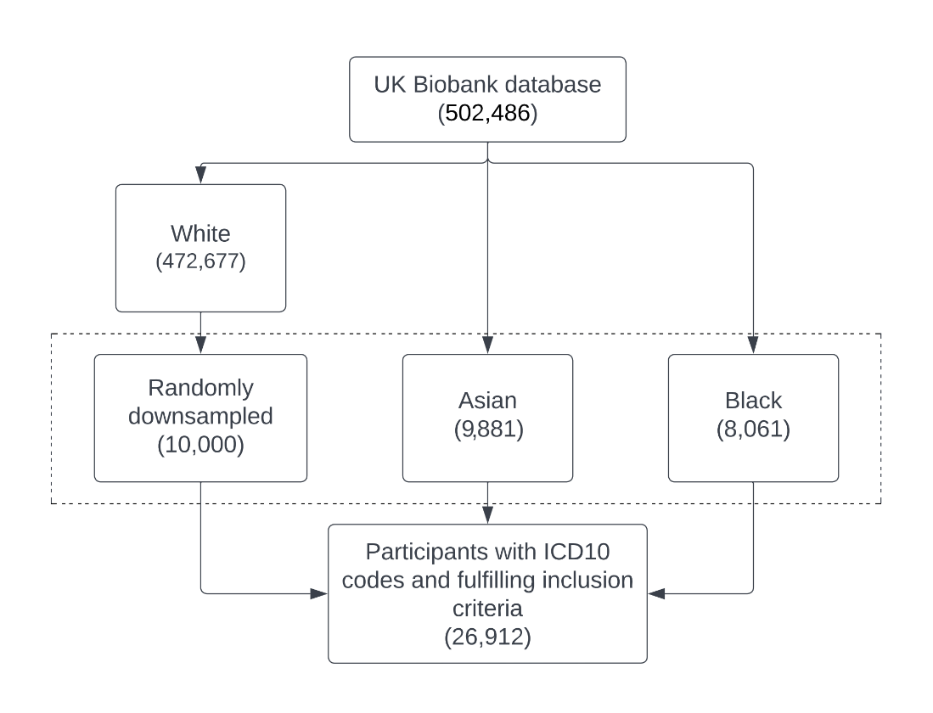

Supplementary Figure 1. UK Biobank study cohort construction. Inclusion criteria for each step of the cohort construction are shown along with the number of individuals participants retained.

Asian
Disease | Estimate | SE | t-value | p-value
Type 2 diabetes | 1.61 | 0.05 | 33.43 | 4.52e-245
Hypercholesterolemia | 1.06 | 0.04 | 25.63 | 6.94e-145
Cataract | 1.19 | 0.05 | 23.74 | 1.57e-124
Essential hypertension | 0.72 | 0.03 | 20.97 | 1.13e-97
Coronary atherosclerosis | 0.92 | 0.05 | 17.5 | 1.50e-68
Other chronic ischemic heart disease unspecified | 0.99 | 0.06 | 16.93 | 2.48e-64
Nonspecific chest pain | 0.77 | 0.05 | 16.84 | 1.35e-63
Senile cataract | 1.02 | 0.06 | 16.47 | 5.74e-61
Iron deficiency anemias unspecified or not due to blood loss | 1.04 | 0.07 | 15.47 | 5.91e-54
Angina pectoris | 0.91 | 0.06 | 15.35 | 3.37e-53
Other anemias | 0.87 | 0.06 | 14.49 | 1.31e-47
Type 2 diabetes with ophthalmic manifestations | 2.06 | 0.15 | 13.93 | 4.05e-44
Other non-epithelial cancer of skin | -2.71 | 0.20 | -13.35 | 1.16e-40
Myocardial infarction | 0.80 | 0.06 | 12.51 | 6.19e-36
Diabetic retinopathy | 1.79 | 0.15 | 11.95 | 6.17e-33
Hyperlipidemia | 0.98 | 0.08 | 11.58 | 4.93e-31
Unstable angina intermediate coronary syndrome | 1.13 | 0.1 | 11.2 | 3.86e-29
Other mental disorder | -0.55 | 0.05 | -11.11 | 1.10e-28
Vitamin D deficiency | 1.42 | 0.13 | 10.82 | 2.87e-27
Diverticulosis | -0.57 | 0.06 | -10.36 | 3.77e-25
Supplementary Table 1. Ethnic health disparities in the UKB. Effect size estimates, standard errors (SE), z-values, and p-values for health outcomes modeled by Asian or Black ethnicity, with the White ethnic group as reference and age and sex as covariates.

Black
Disease | Estimate | SE | t-value | p-value
Type 2 diabetes | 1.37 | 0.05 | 25.49 | 2.46e-143
Essential hypertension | 0.91 | 0.04 | 24.08 | 4.26e-128
Uterine leiomyoma | 1.34 | 0.08 | 17.70 | 3.88e-70
Cataract | 0.96 | 0.06 | 16.93 | 2.80e-64
Glaucoma | 1.19 | 0.10 | 12.01 | 2.99e-33
Nonspecific chest pain | 0.58 | 0.05 | 11.34 | 8.34e-30
Dental caries | 1.25 | 0.11 | 10.95 | 6.50e-28
Other non-epithelial cancer of skin | -2.89 | 0.26 | -10.94 | 7.15e-28
Type 2 diabetes with ophthalmic manifestations | 1.75 | 0.16 | 10.77 | 4.62e-27
Other anemias | 0.71 | 0.07 | 10.69 | 1.11e-26
Hypercholesterolemia | 0.51 | 0.05 | 10.52 | 6.79e-26
Cancer of prostate | 1.03 | 0.10 | 10.50 | 8.93e-26
Obesity | 0.59 | 0.06 | 9.97 | 2.13e-23
Diabetic retinopathy | 1.61 | 0.16 | 9.82 | 9.02e-23
Primary open angle glaucoma | 1.49 | 0.15 | 9.81 | 1.06e-22
Abdominal pain | 0.44 | 0.05 | 9.76 | 1.61e-22
Senile cataract | 0.69 | 0.07 | 9.55 | 1.26e-21
Type 1 diabetes | 1.54 | 0.17 | 9.06 | 1.26e-19
Hypoglycemia | 1.59 | 0.18 | 8.69 | 3.60e-18
Other abnormal blood chemistry | 0.76 | 0.09 | 8.52 | 1.56e-17

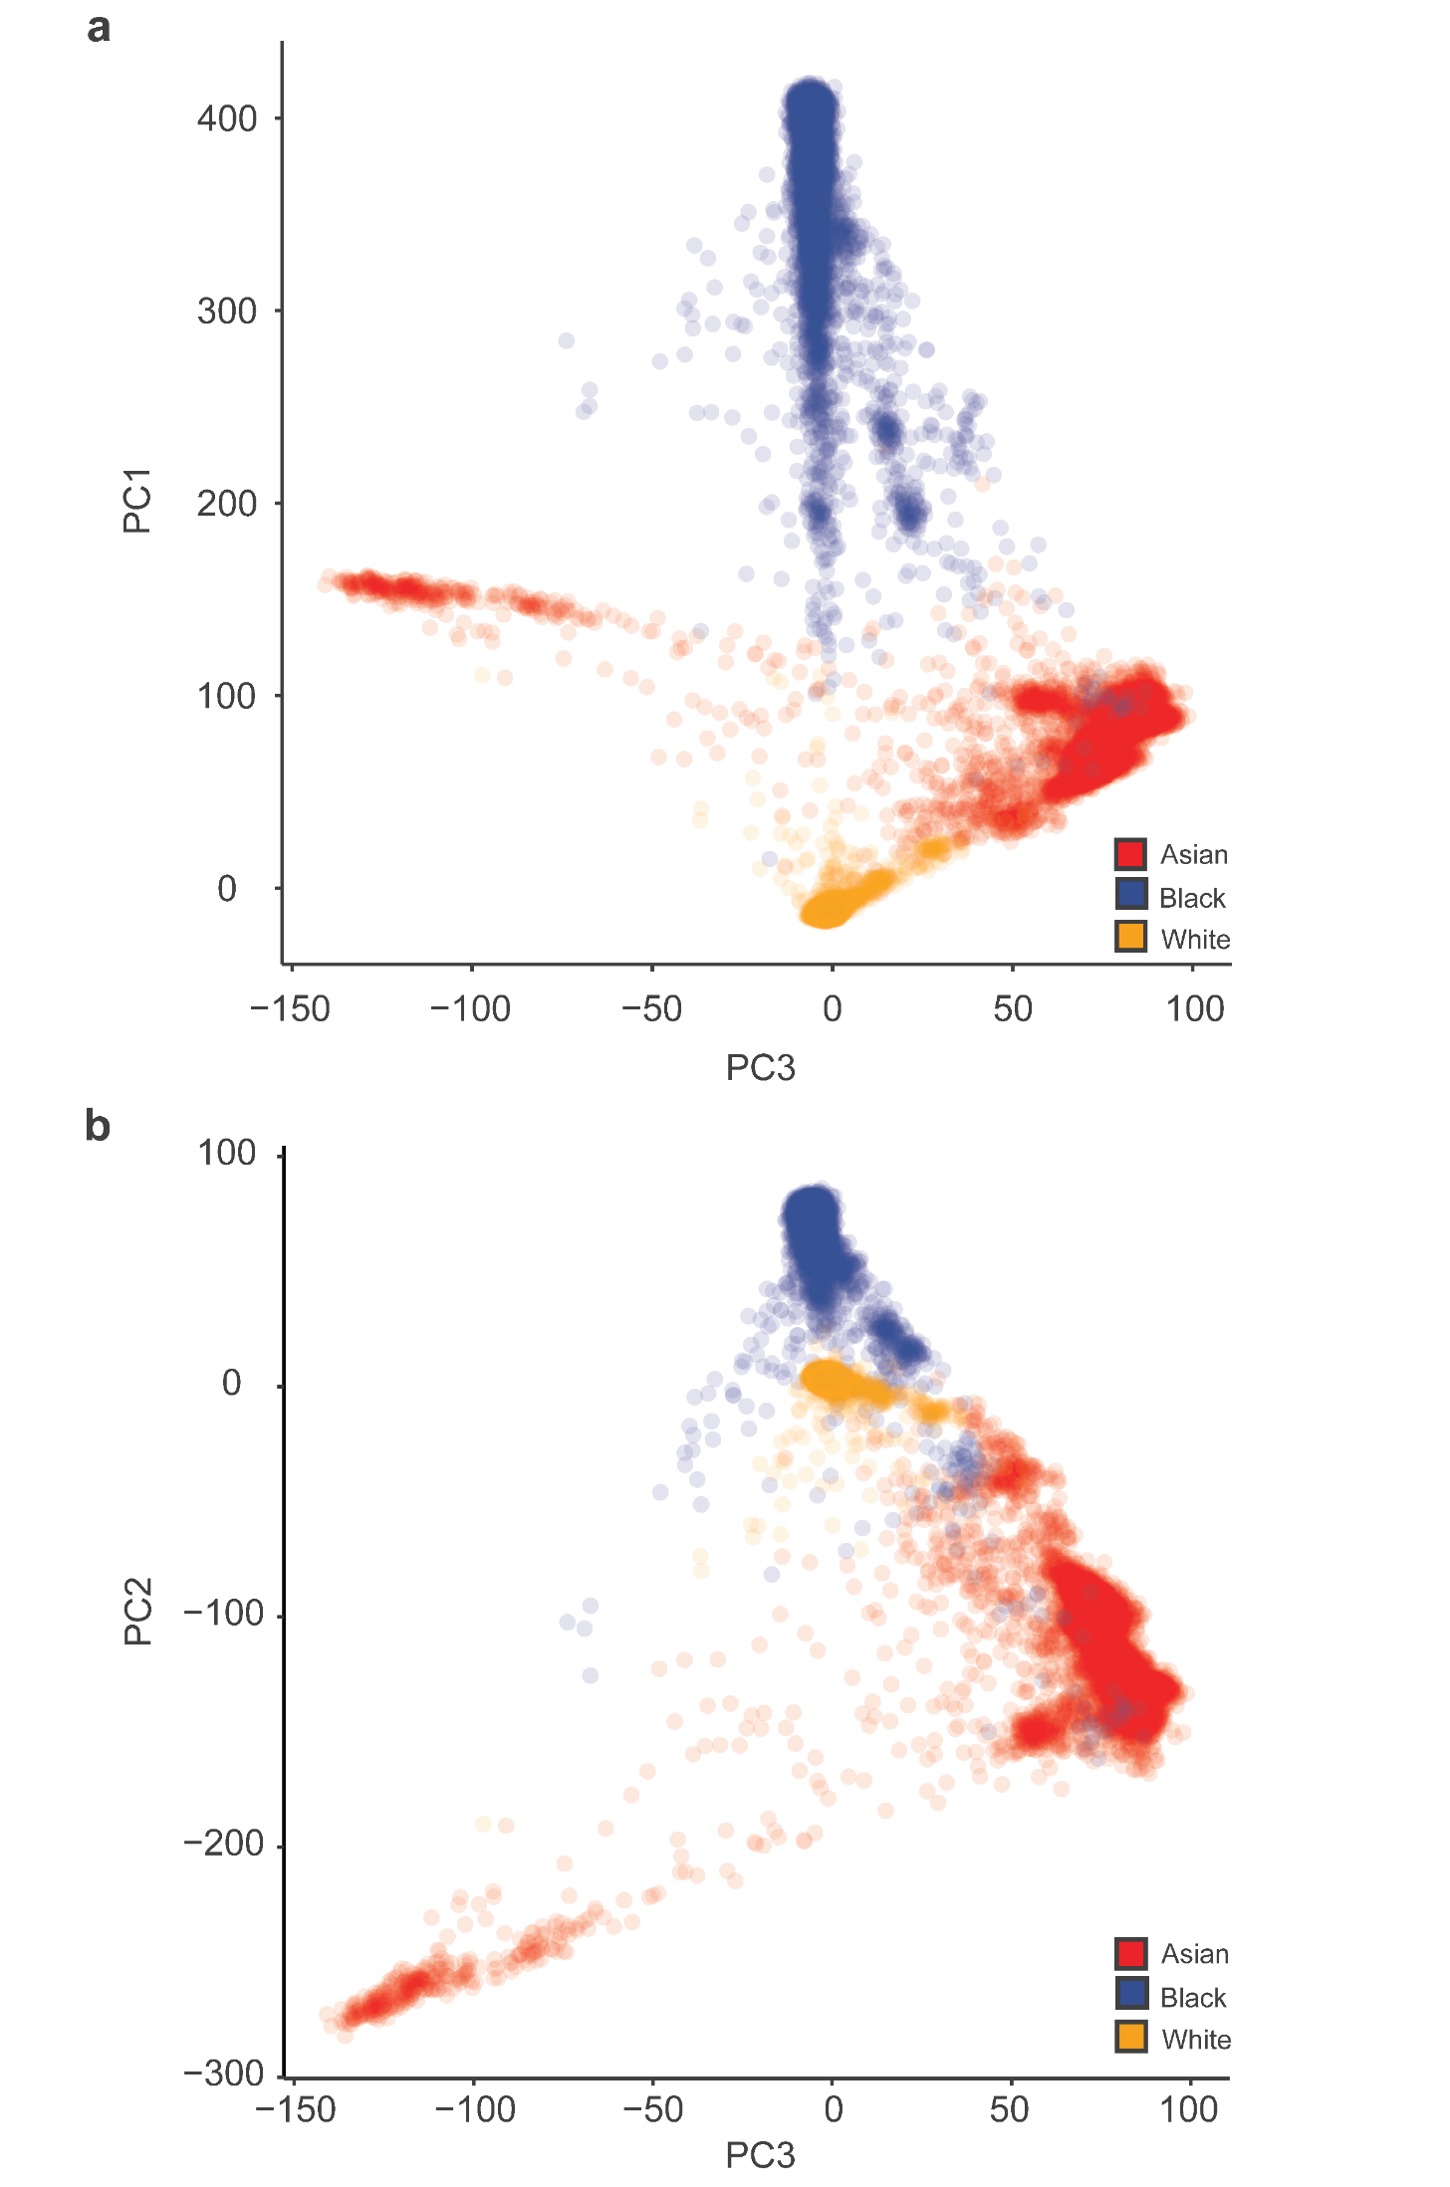

Supplementary Figure 2. Genetic ethnic differences. (A) Genetic principal component analysis (PCA) with UKB participants’ self-identified ethnicity color-coded as shown: Asian (red), Black (blue), and White (orange). Top: PC1 x PC3. Bottom: PC2 x PC3.

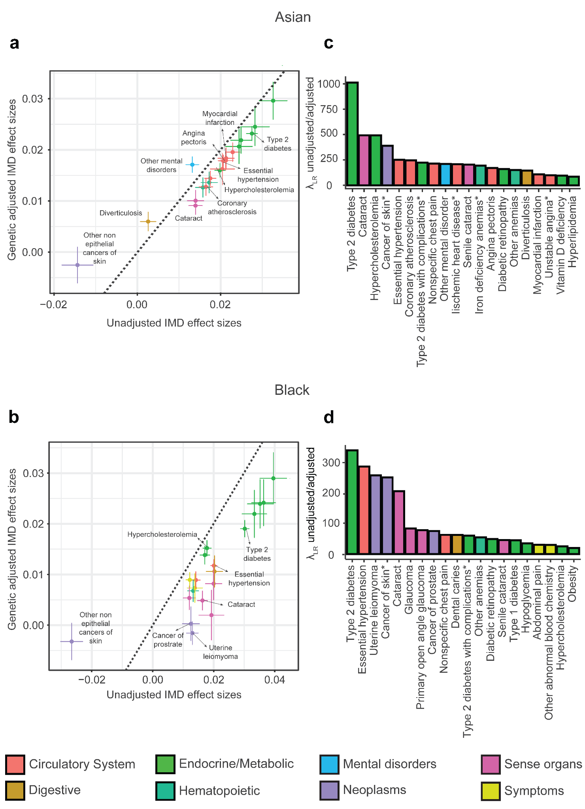

Supplementary Figure 3. Genetic confounding. (A and B) Index of Multiple Deprivation (IMD) effect size estimates and standard errors for unadjusted models (x-axis) plotted against IMD effect size estimates and standard errors for genetic adjusted models (y-axis). The dashed line corresponds to the unity line, where effect size estimates are equal between unadjusted and adjusted models. Values below the unity line show IMD effect size estimates that are attenuated when genetic PCs are included in the adjusted model. Values above the unity line show line show IMD effect size estimates that increase when genetic PCs are included in the adjusted model. Results are shown for Asian-White (A) and Black-White (B) comparisons. (C and D) $λ_{LR}$ test statistic values for log likelihood ratio tests comparing the unadjusted and adjusted models. Results are shown for Asian-White (C) and Black-White (D) comparisons. Health conditions are color-coded by related groups as shown in the key.

Supplementary Table 2. Genetic confounding. Effect size estimates, standard errors (SE), z-values, and p-values for health outcomes modeled by unadjusted socioeconomic deprivation and genetic adjusted socioeconomic deprivation.

Asian (TDI)
 | Unadjusted |  |  |  |  |  |  | Genetic adjusted
Disease | Estimate | SE |  |  | z-value |  | p-value | Estimate |  | SE |  |  | z-value | p-value |  | Δ Estimate
Type 2 diabetes with ophthalmic manifestations | 0.1762 | 0.0168 |  |  | 10.4715 |  | 1.1680e-25 | 0.1396 |  | 0.0183 |  |  | 10.4715 | 2.6189e-14 |  | 0.0366
Type 2 diabetes | 0.1335 | 0.0063 |  |  | 21.2676 |  | 2.2683e-100 | 0.0973 |  | 0.0067 |  |  | 14.4544 | 2.3766e-47 |  | 0.0362
Cataract | 0.0758 | 0.0073 |  |  | 10.4529 |  | 1.4216e-25 | 0.0419 |  | 0.0077 |  |  | 5.4340 | 5.5118e-08 |  | 0.0340
Diabetic retinopathy | 0.1607 | 0.0172 |  |  | 9.3220 |  | 1.1402e-20 | 0.1276 |  | 0.0186 |  |  | 6.8608 | 6.8486e-12 |  | 0.0331
Senile cataract | 0.0662 | 0.0092 |  |  | 7.2233 |  | 5.0742e-13 | 0.0347 |  | 0.0097 |  |  | 3.5765 | 3.4816e-04 |  | 0.0315
Unstable angina intermediate coronary syndrome | 0.1048 | 0.0139 |  |  | 7.5669 |  | 3.8209e-14 | 0.0758 |  | 0.0147 |  |  | 5.1518 | 2.5800e-07 |  | 0.0291
Vitamin D deficiency | 0.1374 | 0.0161 |  |  | 8.5162 |  | 1.6483e-17 | 0.1086 |  | 0.0171 |  |  | 6.3606 | 2.0099e-10 |  | 0.0288
Hypercholesterolemia | 0.1061 | 0.0060 |  |  | 17.7729 |  | 1.1446e-70 | 0.0799 |  | 0.0063 |  |  | 12.7661 | 2.5364e-37 |  | 0.0262
Iron deficiency anemias unspecified or not due to blood loss | 0.0887 | 0.0093 |  |  | 9.5070 |  | 1.9624e-21 | 0.0639 |  | 0.0098 |  |  | 6.4850 | 8.8750e-11 |  | 0.0249
Coronary atherosclerosis | 0.0813 | 0.0076 |  |  | 10.6688 |  | 1.4253e-26 | 0.0566 |  | 0.0080 |  |  | 7.0611 | 1.6513e-12 |  | 0.0247
Other chronic ischemic heart disease unspecified | 0.1020 | 0.0084 |  |  | 12.1410 |  | 6.4025e-34 | 0.0778 |  | 0.0088 |  |  | 8.8072 | 1.2832e-18 |  | 0.0242
Angina pectoris | 0.0905 | 0.0085 |  |  | 10.6066 |  | 2.7763e-26 | 0.0667 |  | 0.0090 |  |  | 7.4459 | 9.6306e-14 |  | 0.0238
Other anemias | 0.0770 | 0.0087 |  |  | 8.8703 |  | 7.2939e-19 | 0.0540 |  | 0.0091 |  |  | 5.9208 | 3.2044e-09 |  | 0.0230
Hyperlipidemia | 0.1155 | 0.0120 |  |  | 9.6297 |  | 5.9923e-22 | 0.0947 |  | 0.0126 |  |  | 7.5259 | 5.2344e-14 |  | 0.0208
Myocardial infarction | 0.1000 | 0.0093 |  |  | 10.7466 |  | 6.1484e-27 | 0.0806 |  | 0.0097 |  |  | 8.2722 | 1.3151e-16 |  | 0.0195
Essential hypertension | 0.0871 | 0.0051 |  |  | 16.9198 |  | 3.2145e-64 | 0.0677 |  | 0.0053 |  |  | 12.7165 | 4.7859e-37 |  | 0.0194
Nonspecific chest pain | 0.0796 | 0.0066 |  |  | 12.0362 |  | 2.2930e-33 | 0.0604 |  | 0.0069 |  |  | 8.7433 | 2.2650e-18 |  | 0.0192
Diverticulosis | 0.0037 | 0.0082 |  |  | 0.4567 |  | 6.4791e-01 | 0.0263 |  | 0.0084 |  |  | 3.1293 | 1.7522e-03 |  | -0.0226
Other mental disorder | 0.0627 | 0.0072 |  |  | 8.6568 |  | 4.8513e-18 | 0.0870 |  | 0.0074 |  |  | 11.6844 | 1.5319e-31 |  | -0.0243
Other non epithelial cancer of skin | -0.0824 | 0.0158 |  |  | -5.2086 |  | 1.9022e-07 | -0.0142 |  | 0.0156 |  |  | -0..9107980 | 3.6240e-01 |  | -0.0682
Black (TDI)
 | Unadjusted |  |  |  |  |  |  |  | Genetic adjusted
Disease | Estimate |  | SE | z-value |  | p-value |  |  | Estimate |  | SE | z-value |  |  | p-value |  | Δ Estimate
Uterine leiomyoma | 0.0800 |  | 0.0100 | 8.9110 |  | 5.0400e-19 |  |  | -0.0100 |  | 0.0100 | -0.4500 |  |  | 6.5400e-01 |  | 0.0900
Primary open angle glaucoma | 0.1399 |  | 0.0181 | 7.7234 |  | 1.1326e-14 |  |  | 0.0549 |  | 0.0215 | 2.5546 |  |  | 1.0630e-02 |  | 0.0850
Type 2 diabetes with ophthalmic manifestations | 0.1994 |  | 0.0192 | 10.4049 |  | 2.3543e-25 |  |  | 0.1215 |  | 0.0224 | 5.4338 |  |  | 5.5156e-08 |  | 0.0779
Cancer of prostate | 0.0569 |  | 0.0120 | 4.7252 |  | 2.2985e-06 |  |  | -0.0141 |  | 0.0145 | -0.9754 |  |  | 3.2938e-01 |  | 0.0710
Glaucoma | 0.1035 |  | 0.0122 | 8.5172 |  | 1.6340e-17 |  |  | 0.0332 |  | 0.0145 | 2.2936 |  |  | 2.1814e-02 |  | 0.0703
Diabetic retinopathy | 0.1872 |  | 0.0195 | 9.6227 |  | 6.4102e-22 |  |  | 0.1169 |  | 0.0228 | 5.1353 |  |  | 2.8172e-07 |  | 0.0702
Type 2 diabetes | 0.1498 |  | 0.0065 | 22.9947 |  | 5.2705e-117 |  |  | 0.0855 |  | 0.0076 | 11.2681 |  |  | 1.8849e-29 |  | 0.0643
Hypoglycemia | 0.2024 |  | 0.0221 | 9.1381 |  | 6.3539e-20 |  |  | 0.1390 |  | 0.0258 | 5.3813 |  |  | 7.3952e-08 |  | 0.0634
Type 1 diabetes | 0.1800 |  | 0.0200 | 8.9720 |  | 2.9100e-19 |  |  | 0.1200 |  | 0.0200 | 4.8100 |  |  | 1.5500e-06 |  | 0.0600
Cataract | 0.0923 |  | 0.0071 | 13.0570 |  | 5.7966e-39 |  |  | 0.0385 |  | 0.0084 | 4.6023 |  |  | 4.1788e-06 |  | 0.0538
Dental caries | 0.1350 |  | 0.0131 | 10.2913 |  | 7.7111e-25 |  |  | 0.0812 |  | 0.0152 | 5.3402 |  |  | 9.2849e-08 |  | 0.0538
Other abnormal blood chemistry | 0.0518 |  | 0.0111 | 4.6562 |  | 3.2213e-06 |  |  | 0.0039 |  | 0.0132 | 0.2942 |  |  | 7.6857e-01 |  | 0.0479
Essential hypertension | 0.0920 |  | 0.0047 | 19.7594 |  | 6.6601e-87 |  |  | 0.0449 |  | 0.0054 | 8.3073 |  |  | 9.7935e-17 |  | 0.0471
Senile cataract | 0.0607 |  | 0.0091 | 6.6494 |  | 2.9436e-11 |  |  | 0.0180 |  | 0.0108 | 1.6636 |  |  | 9.6195e-02 |  | 0.0427
Other anemias | 0.0694 |  | 0.0083 | 8.3575 |  | 6.4076e-17 |  |  | 0.0302 |  | 0.0098 | 3.0871 |  |  | 2.0211e-03 |  | 0.0392
Nonspecific chest pain | 0.0637 |  | 0.0064 | 9.8798 |  | 5.0951e-23 |  |  | 0.0349 |  | 0.0076 | 4.6103 |  |  | 4.0212e-06 |  | 0.0288
Obesity | 0.0780 |  | 0.0074 | 10.5326 |  | 6.1115e-26 |  |  | 0.0549 |  | 0.0087 | 6.3219 |  |  | 2.5829e-10 |  | 0.0231
Abdominal pain | 0.0426 |  | 0.0057 | 7.4446 |  | 9.7275e-14 |  |  | 0.0203 |  | 0.0067 | 3.0356 |  |  | 2.4009e-03 |  | 0.0223
Hypercholesterolemia | 0.0880 |  | 0.0061 | 14.3464 |  | 1.1225e-46 |  |  | 0.0742 |  | 0.0072 | 10.3457 |  |  | 4.3757e-25 |  | 0.0137
Other non epithelial cancer of skin | -0.1250 |  | 0.0147 | -8.5022 |  | 1.8611e-17 |  |  | -0.0178 |  | 0.0159 | -1.1208 |  |  | 2.6239e-01 |  | -0.1072

Asian (IMD)
 | Unadjusted |  |  |  | Genetic adjusted
Disease | Estimate | SE | z-value | p-value | Estimate | SE | z-value | p-value | Δ Estimate
Cataract | 0.0140 | 0.0017 | 8.4495 | 2.9259e-17 | 0.0091 | 0.0017 | 5.2056 | 1. 9342e-07 | 0.0049
Type 2 diabetes | 0.0275 | 0.0013 | 20.5524 | 7.3194e-94 | 0.0232 | 0.0014 | 16.2603 | 1.8886e-59 | 0.0043
Unstable angina intermediate coronary syndrome | 0.0204 | 0.0030 | 6.9111 | 4.8093e-12 | 0.0162 | 0.0031 | 5.2230 | 1.7602e-07 | 0.0042
Senile cataract | 0.0140 | 0.0020 | 6.8959 | 5.3521e-12 | 0.0100 | 0.0021 | 4.7507 | 2.0275e-06 | 0.0039
Hypercholesterolemia | 0.0198 | 0.0013 | 15.2201 | 2.6008e-52 | 0.0160 | 0.0014 | 11.8255 | 2.8808e-32 | 0.0038
Vitamin D deficiency | 0.0244 | 0.0032 | 7.5200 | 5.4764e-14 | 0.0206 | 0.0034 | 6.0435 | 1.5083e-09 | 0.0038
Diabetic retinopathy | 0.0283 | 0.0035 | 8.1295 | 4.3091e-16 | 0.0245 | 0.0037 | 6.5481 | 5.8281e-11 | 0.0037
Coronary atherosclerosis | 0.0165 | 0.0017 | 9.8371 | 7.7964e-23 | 0.0128 | 0.0017 | 7.3113 | 2.6455e-13 | 0.0037
Iron deficiency anemias unspecified or not due to blood loss | 0.0173 | 0.0020 | 8.6241 | 6.4580e-18 | 0.0136 | 0.0021 | 6.5041 | 7.8181e-11 | 0.0036
Other chronic ischemic heart disease unspecified | 0.0229 | 0.0018 | 12.7717 | 2.3593e-37 | 0.0195 | 0.0019 | 10.5041 | 8.2704e-26 | 0.0033
Angina pectoris | 0.0212 | 0.0018 | 11.5370 | 8.5783e-31 | 0.0179 | 0.0019 | 9.3776 | 6.7484e-21 | 0.0033
Other anemias | 0.0157 | 0.0019 | 8.4289 | 3.4889e-17 | 0.0126 | 0.0019 | 6.5123 | 7.4031e-11 | 0.0031
Nonspecific chest pain | 0.0175 | 0.0014 | 12.1890 | 3.5572e-34 | 0.0144 | 0.0015 | 9.7183 | 2.5190e-22 | 0.0031
Hyperlipidemia | 0.0249 | 0.0025 | 9.8821 | 4.9764e-23 | 0.0219 | 0.0026 | 8.3544 | 6.5756e-17 | 0.0030
Type 2 diabetes with ophthalmic manifestations | 0.0326 | 0.0034 | 9.6466 | 5.0816e-22 | 0.0296 | 0.0037 | 8.0221 | 1.0396e-15 | 0.0030
Myocardial infarction | 0.0213 | 0.0020 | 10.6522 | 1.7037e-26 | 0.0183 | 0.0021 | 8.8551 | 8.3646e-19 | 0.0030
Essential hypertension | 0.0206 | 0.0012 | 17.7505 | 1.7095e-70 | 0.0179 | 0.0012 | 15.0951 | 1.7452e-51 | 0.0028
Diverticulosis | 0.0026 | 0.0019 | 1.3734 | 1.6962e-01 | 0.0060 | 0.0019 | 3.1689 | 1.5299e-03 | -0.0034
Other mental disorder | 0.0132 | 0.0016 | 8.3554 | 6.5211e-17 | 0.0171 | 0.0016 | 10.7167 | 8.4998e-27 | -0.0039
Other non epithelial cancer of skin | -0.0144 | 0.0038 | -3.8119 | 1.3788e-04 | -0.0025 | 0.0036 | -0.7080 | 4.7892e-01 | -0.0119

Black (IMD)
 | Unadjusted |  |  |  | Genetic adjusted
Disease | Estimate | SE | z-value | p-value | Estimate | SE | z-value | p-value | Δ Estimate
Primary open angle glaucoma | 0.0193 | 0.0041 | 4.6789 | 2.8841e-06 | 0.0020 | 0.0050 | 0.3989 | 6.8998e-01 | 0.0173
Uterine leiomyoma | 0.0130 | 0.0020 | 6.5848 | 4.5552e-11 | -0.0016 | 0.0023 | -0.6811 | 4.9580e-01 | 0.0146
Cancer of prostate | 0.0125 | 0.0029 | 4.3925 | 1.1208e-05 | 0.0003 | 0.0034 | 0.0808 | 9.3558e-01 | 0.0123
Type 2 diabetes with ophthalmic manifestations | 0.0364 | 0.0040 | 9.1621 | 5.0894e-20 | 0.0242 | 0.0046 | 5.2693 | 1.3693e-07 | 0.0122
Glaucoma | 0.0200 | 0.0028 | 7.2482 | 4.2238e-13 | 0.0082 | 0.0032 | 2.5434 | 1.0979e-02 | 0.0118
Cataract | 0.0163 | 0.0017 | 9.7439 | 1.9594e-22 | 0.0049 | 0.0019 | 2.5214 | 1.1688e-02 | 0.0114
Diabetic retinopathy | 0.0333 | 0.0041 | 8.1867 | 2.6838e-16 | 0.0220 | 0.0047 | 4.6671 | 3.0543e-06 | 0.0114
Type 1 diabetes | 0.0352 | 0.0042 | 8.3568 | 6.4464e-17 | 0.0239 | 0.0048 | 4.9502 | 7.4119e-07 | 0.0113
Type 2 diabetes | 0.0302 | 0.0015 | 20.7461 | 1.3287e-95 | 0.0190 | 0.0016 | 11.6114 | 3.6087e-31 | 0.0111
Hypoglycemia | 0.0396 | 0.0045 | 8.8488 | 8.8451e-19 | 0.0290 | 0.0051 | 5.6846 | 1.3114e-08 | 0.0106
Dental caries | 0.0203 | 0.0028 | 7.3153 | 2.5681e-13 | 0.0106 | 0.0032 | 3.3632 | 7.7039e-04 | 0.0097
Essential hypertension | 0.0201 | 0.0011 | 18.0951 | 3.4830e-73 | 0.0117 | 0.0012 | 9.6037 | 7.7133e-22 | 0.0083
Senile cataract | 0.0120 | 0.0021 | 5.7286 | 1.0128e-08 | 0.0054 | 0.0024 | 2.2592 | 2.3871e-02 | 0.0066
Other anemias | 0.0133 | 0.0019 | 6.9966 | 2.6229e-12 | 0.0068 | 0.0021 | 3.1500 | 1.6330e-03 | 0.0065
Nonspecific chest pain | 0.0141 | 0.0015 | 9.4089 | 5.0141e-21 | 0.0089 | 0.0017 | 5.2831 | 1.2699e-07 | 0.0052
Obesity | 0.0171 | 0.0017 | 10.3124 | 6.1963e-25 | 0.0138 | 0.0018 | 7.5221 | 5.3919e-14 | 0.0032
Abdominal pain | 0.0122 | 0.0013 | 9.1492 | 5.7340e-20 | 0.0089 | 0.0015 | 6.0428 | 1.5147e-09 | 0.0032
Hypercholesterolemia | 0.0178 | 0.0014 | 12.5080 | 6.7482e-36 | 0.0152 | 0.0016 | 9.6578 | 4.5535e-22 | 0.0026
Other abnormal blood chemistry | 0.0100 | 0.0000 | 5.4600 | 4.8200e-08 | 0.0100 | 0.0000 | 2.5500 | 1.0800e-02 | 0.0000
Other non epithelial cancer of skin | -0.0266 | 0.0037 | -7.1612 | 7.9999e-13 | -0.0032 | 0.0036 | -0.8896 | 3.7368e-01 | -0.0233

