Supplementary information
The origin of exceptionally large ductility in Molybdenum Alloys dispersed with Irregular-Shaped La₂O₃ Nano-Particles
Yujie Chen^{1,2,#}, Yan Fang^{1,#}, Pengming Cheng³, Xiaoxing Ke⁴, Manchen Zhang⁴, Jiawei Zou¹, Jun Ding^{5,}*, Bozhao Zhang⁵, Lin Gu^{2,}*, Qinghua Zhang⁶, Gang Liu^{3,} *, Qian Yu^{1,}*
¹Center of Electron Microscopy and State Key Laboratory of Silicon Materials, Department of Materials Science and Engineering, Zhejiang University, Hangzhou 310027, China
²Beijing National Center for Electron Microscopy and Laboratory of Advanced Materials, School of Materials Science and Engineering, Tsinghua University, Beijing 100084, China
³State Key Laboratory for Mechanical Behavior of Materials, School of Materials Science and Engineering, Xi’an Jiaotong University, Xi’an 710049, China
⁴Faculty of Materials and Manufacturing, Beijing University of Technology, Beijing 100124, China
⁵Center for Alloy Innovation and Design State Key Laboratory for Mechanical, Xi’an Jiaotong University, Xi’an 710049, China
⁶Beijing National Laboratory for Condensed Matter Physics, Collaborative Innovation Center of Quantum Matter, Institute of Physics, Chinese Academy of Sciences, Beijing 100190, China
#These authors contributed equally: Yujie Chen, Yan Fang
Correspondence should be addressed to: yu_qian@zju.edu.cn; dingsn@xjtu.edu.cn; lingu@mail.tsinghua.edu.cn; lgsammer@mail.xjtu.edu.cn.

Extended data Fig. 1|The atomic-scale structure of La₂O₃ nanoparticle at the interface. a, The iDPC-STEM image showing the atomic-scale structure of the La₂O₃ nanoparticle. The high-resolution iDPC-STEM image in Fig. 1e is acquired at the location of Region III, which is marked by the orange square. b, The perfect crystal structure model of the La₂O₃ nanoparticle. The perfect crystal structure model of La₂O₃ is provided by CrystalMaker software and has the space group of P$\overline{3}m1$.

Extended data Fig. 2|HAADF-STEM image and the region where the EELS spectrum taken from. Region I (blue rectangle) is in the internal La₂O₃ particle. Region II (green rectangle) is in proximity to the amorphous layer.

Extended data Fig. 3|The atomic-scale structure of Mo matrix near La₂O₃ nanoparticle. a, The iDPC-STEM image showing the aggregation of oxygen atoms near the particle-matrix interface in the Mo matrix. Region IV (marked by light blue square) is the typical cluster of oxygen atoms, which is magnified as Fig. 1f. b, The crystal structure model of the Mo matrix, with the oxygen atoms occupy octahedral interstitial sites.

Extended data Fig. 4|Dislocation interactions at room temperature with the participation of particle. Particle 1 and 2 are marked by p1, and p2, respectively. Dislocation 1 and 2 (marked by yellow and orange dashed lines) were pinned by particle 1 and 2 (marked as p1 and p2), respectively. Their interaction produced a dislocation loop and two single armed dislocations attached to p1 and particle 3 (marked as p3), respectively.

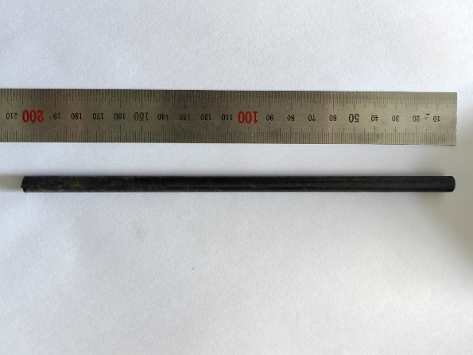
Extended data Fig. 5|A bar of Mo-La₂O₃ alloy after the process of rotary swaging.

Extended data Fig. 6|HAADF-STEM image of the amorphous interface after the treatment of rotary-swaging.

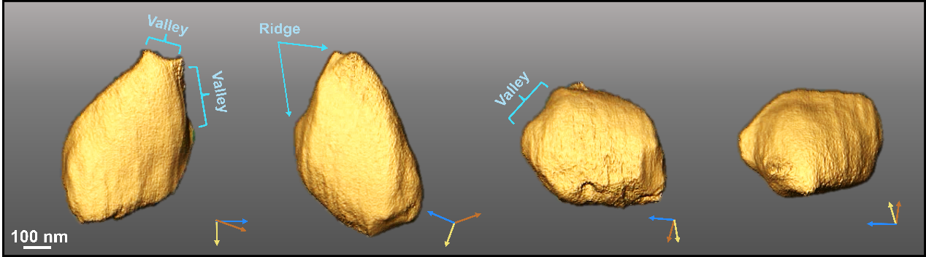
Extended data Fig. 7|The three-dimensional tomography of the La₂O₃ particles, with the long axis of approximately 500 nm.

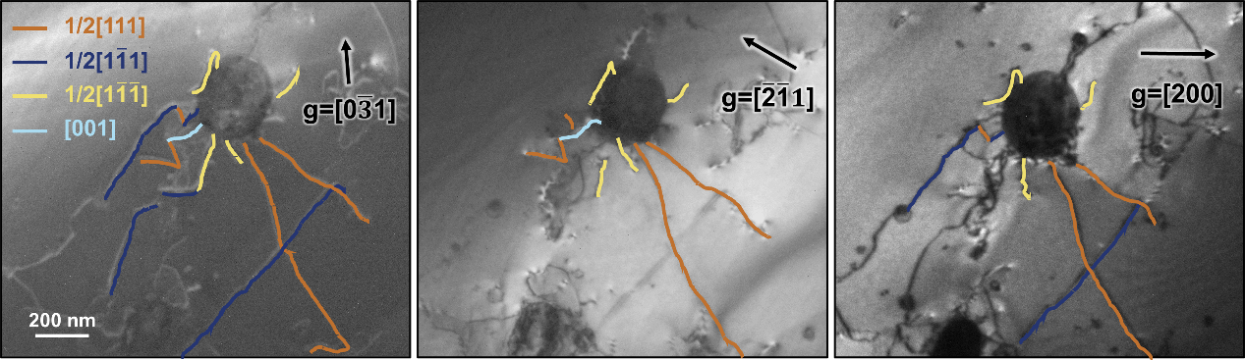
Extended data Fig. 8|The center dark-field TEM image with different diffraction vectors.

Extended data Fig. 9| In situ TEM straining experiments on the Mo-La2O3 alloy processed by rotary swaging. Dislocation 1 and 2 (marked as d1 and d2 by blue and yellow dashed lines, respectively) are first pinned at the interface of particle 1 (marked as p1) with one end. d1 and d2 function as single arm sources. After several cycles, d1 and d2 detach from the surface of p1 and keep gliding.

Supplementary video 1 In Situ TEM tensile observation on sintered Mo-La₂O₃ alloy at room temperature.
Supplementary video 2 Molecular dynamics simulation showing edge dislocations in Mo gliding across the embedded amorphous spherical MoPd particles with periodic boundary condition.
Supplementary video 3 Molecular dynamics simulation showing edge dislocations in Mo gliding across the embedded amorphous spherical MoPd particles with two additional notches.
Supplementary video 4 The three-dimensional tomography of the La₂O₃ particle with particle size of approximately 100 nm.
Supplementary video 5 The three-dimensional tomography of the La₂O₃ particle with particle size of approximately 400 nm.
Supplementary video 6 The three-dimensional tomography of the particles and dislocations accumulated at the interface.
Supplementary video 7 In situ TEM tensile observation of the formation of Frank-Read dislocation sources at room temperature.
Supplementary video 8 In situ TEM tensile observation of the formation of Frank-Read dislocation sources at -50 °C.

