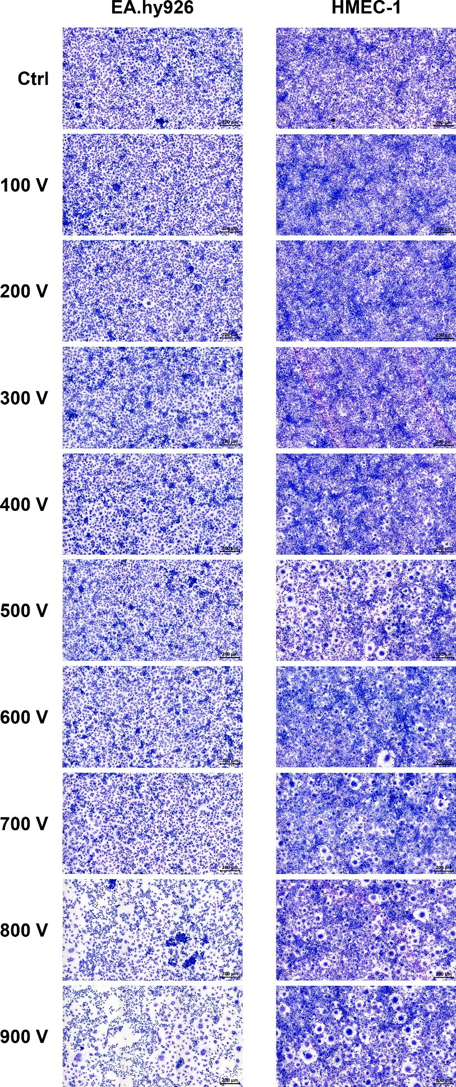
Supplementary Fig. S1. Endothelial cells EA.hy926 and HMEC-1 after electroporation. Representative images show untreated monolayer of EA.hy926 and HMEC-1 cells after exposure to electric pulses with increasing voltage stained with Giemsa stain. Scale bar: 200 µm.
Supplementary Fig. S2. Dot plot showing the top 25 significantly enriched KEGG pathways based on the number of DEGs (Count) involved. An adjusted P value of < 0.05 was considered statistically significant.

Supplementary Fig. S3. KEGG analysis of Regulation of actin cytoskeleton (hsa04810) presented by usage of the Pathview R package. Genes are colored based on log₂FC. Genes in white rectangles were not significantly expressed (P value > 0.05).
Supplementary Fig. S4. KEGG analysis of the Ca²⁺ signaling pathway (hsa04020) presented by usage of the Pathview R package. Genes are colored based on log₂FC. Genes in white rectangles were not significantly expressed (P value > 0.05).

Supplementary Fig. S5. Pearson correlation between samples of EA.hy926 and HMEC-1 cells. Pearson’s correlation plot visualizing the correlation values between samples. Scale bar represents the range of the correlation coefficients displayed.

