Supporting Information
Light-triggered conformational changes of an animal-like cryptochrome tracked by native time-resolved IMS-MS
Rene Zangl,ª Sejla Soravia,ª Martin Saft,^{b}, Jan Gerrit Löffler,^{c} Jonathan Schulte,ª Christian Joshua Rosner,^{b} Jens Bredenbeck,^{c} Lars-Oliver Essen^{b}*, Nina Morgner ª*
- Institute of Physical and Theoretical Chemistry, Goethe University, Max-von-Laue-Str. 9, 60438 Frankfurt/Main, Germany
- Department of Chemistry, Philipps University, Hans-Meerwein-Str. 4, 35032 Marburg, Germany
- Institute of Biophysics, Goethe University, Max-von-Laue-Str. 1, 60438 Frankfurt/Main, Germany

* E-Mail: morgner@chemie.uni-frankfurt.de, essen@chemie.uni-marburg.de
Tel.: +49 69 798-29441, +49 6421 28-22032
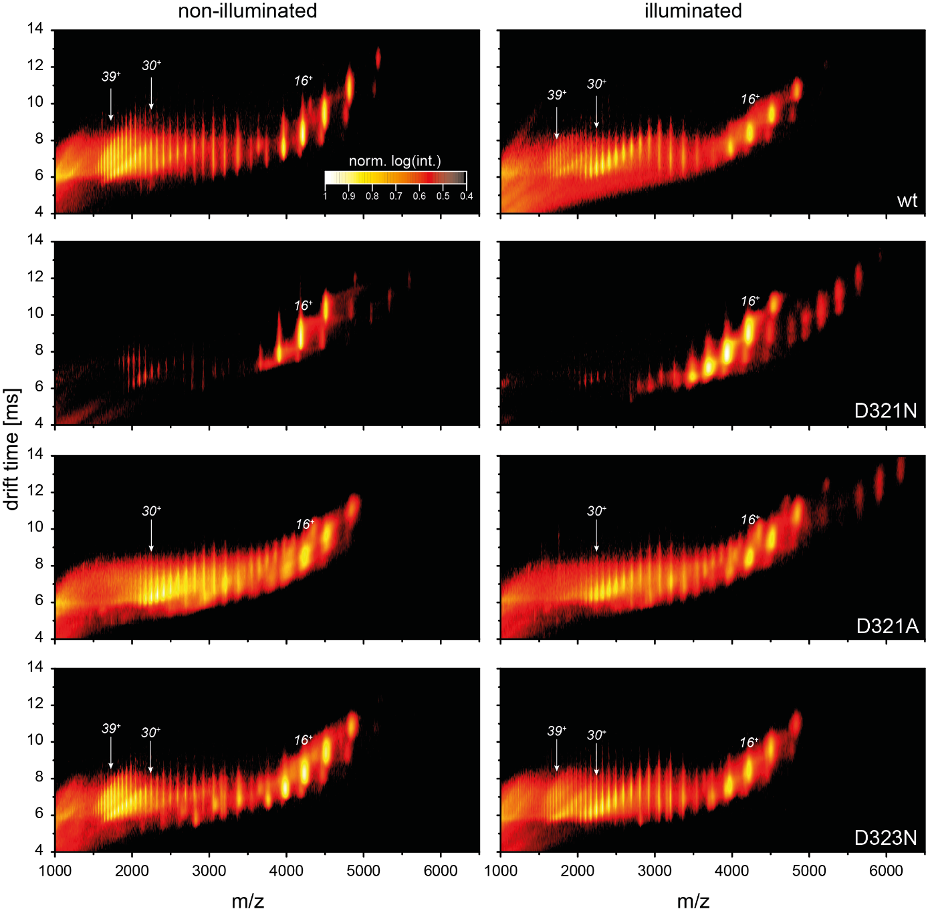
Figure S 1: Driftscope plot under non-illuminated and illuminated conditions of each CraCRY variant. CSs depicted in Figure 1 are also highlighted here. A distinct intensity decrease of signals around CS 39+ and a subsequent raise of the population with an average CS of 30+ is visible. For illustration, a logarithmic intensity scale was used which depicts minor dimer fractions are present.
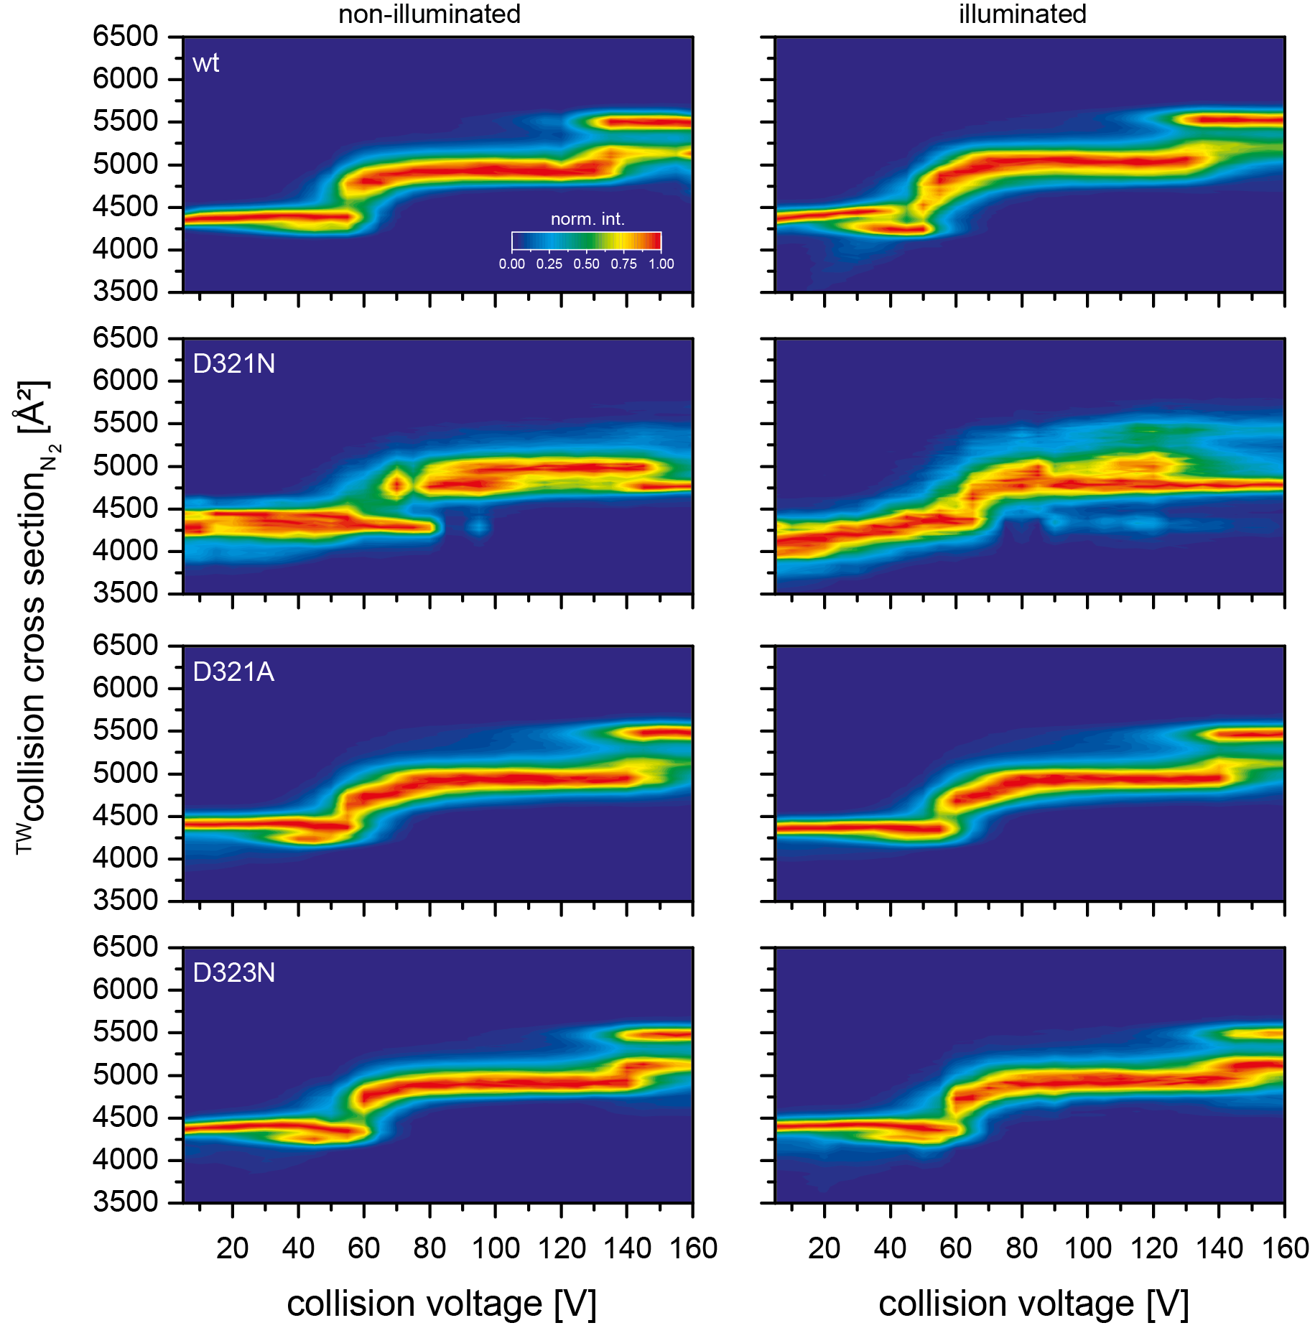
Figure S 2: CIU of CS 14+ for each tested CraCRY variant under non-illuminated and under illuminated conditions. There are no significant differences apparent between the unfolding patterns acquired under both conditions.
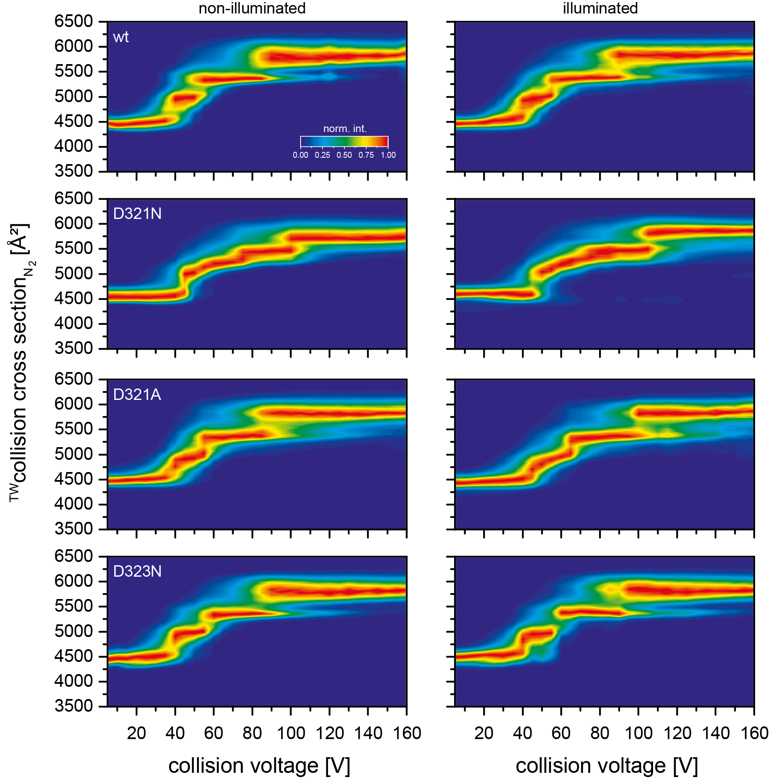
Figure S 3: CIU of CS 16+ for each tested CraCRY variant under non-illuminated and under illuminated conditions. There are no significant differences visible between the unfolding patterns acquired under both conditions.

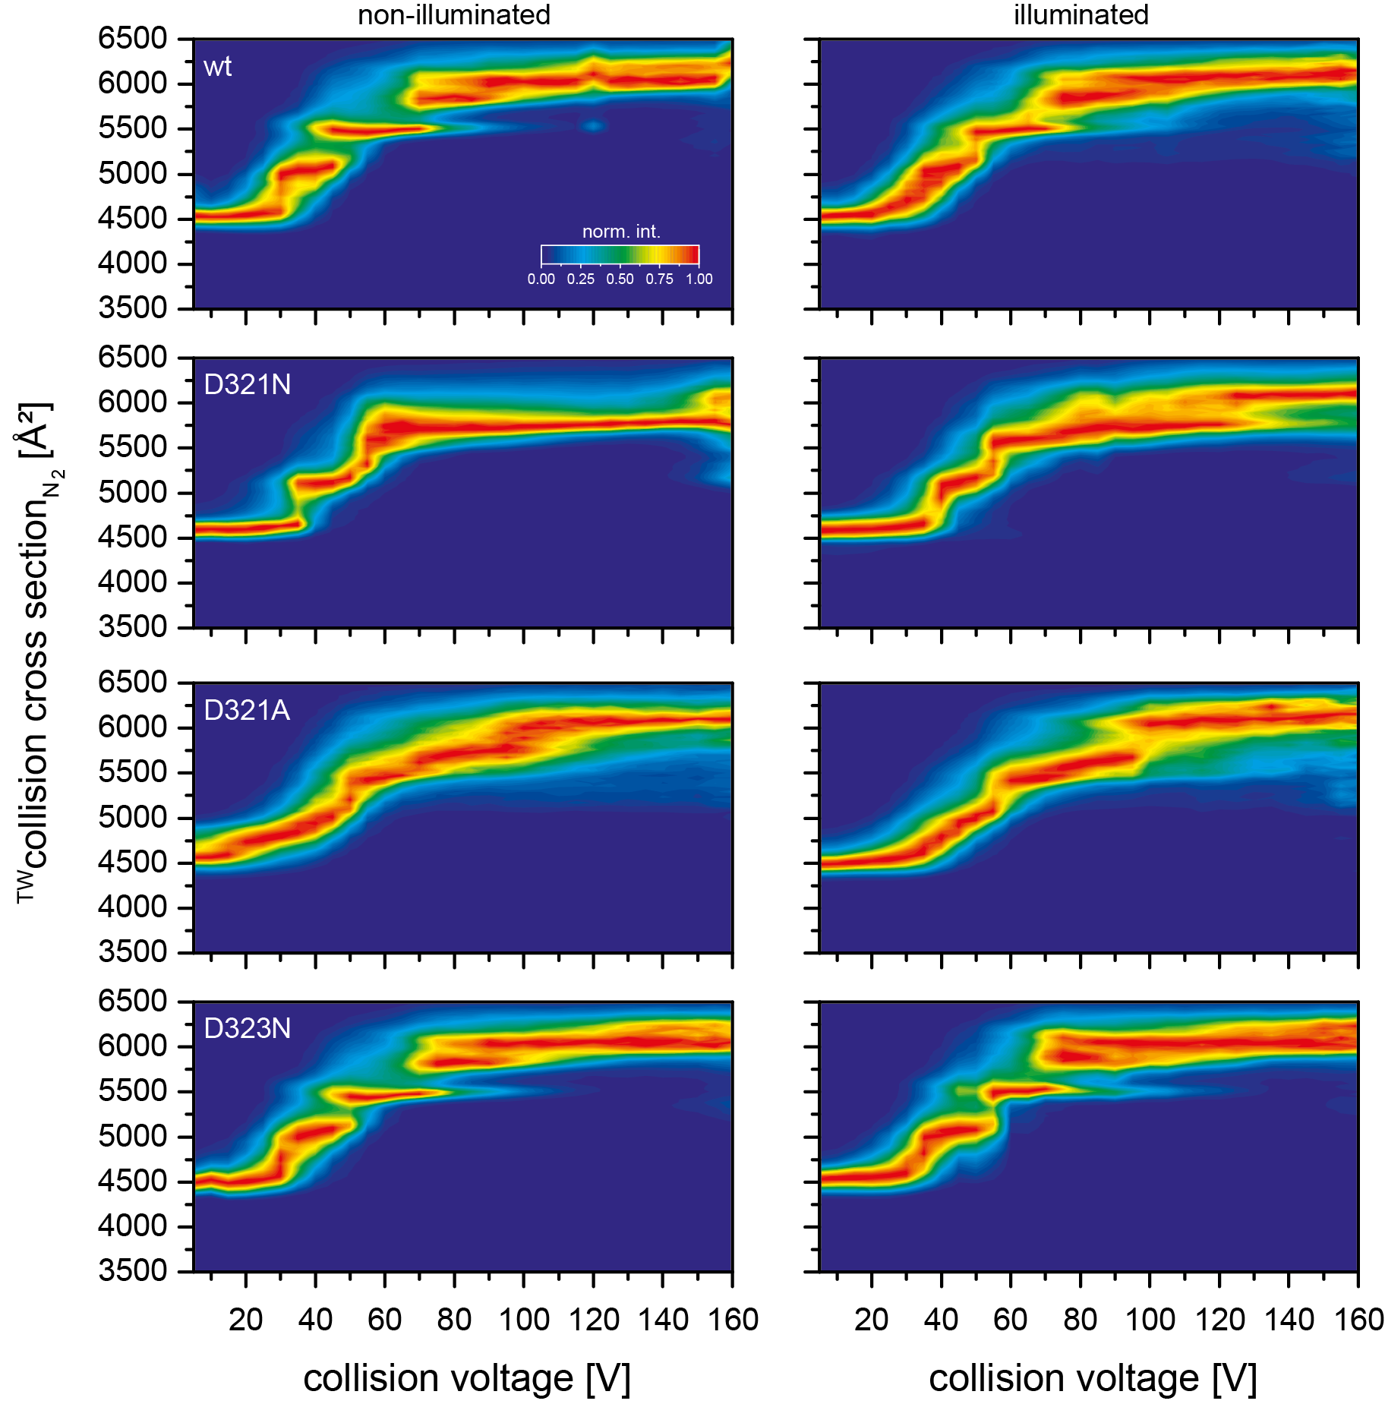
Figure S 4: CIU of CS 17+ for each tested CraCRY variant under non-illuminated and under illuminated conditions. There are no significant differences between the unfolding patterns acquired under both conditions.
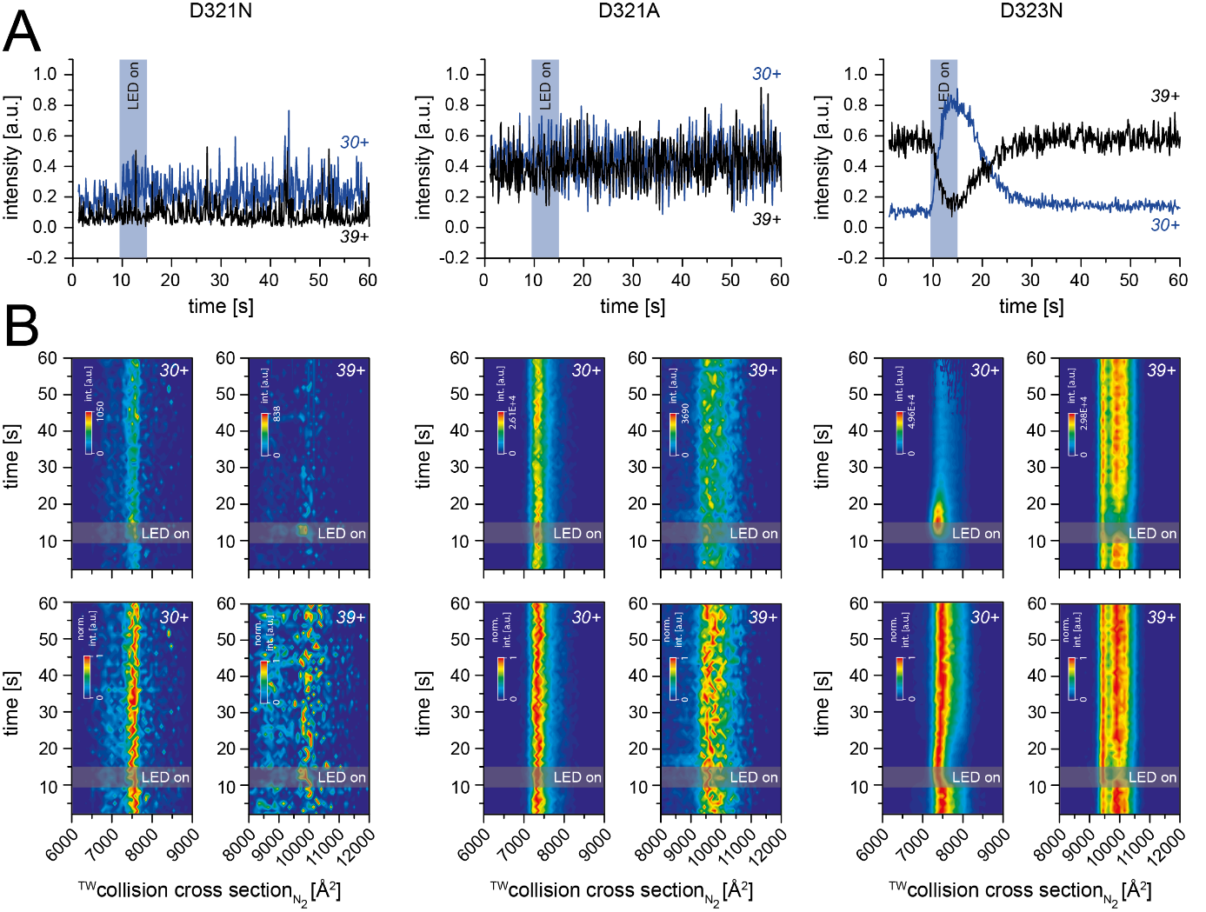
Figure S 5: Evolution of signal intensity over time for CraCRY D321N, D321A and D323N. Illumination was performed over a period of 6 seconds, after 9 seconds of initial data acquisition. A: Ion count of CS 30+ and 39+ of each variant. Corresponding to Figure 1, the ion count of the CS 30 and 39+ for D321N and D321A is not affected by illumination. D323N variant demonstrates a similar behavior to CraCRY wt, only differing in their transition rates. B: ATD of medial CS 30+ and high CS 39+ as a function of time. Non-normalized contour plots (top row) illustrate the response of the respective mobilograms, while the normalized illustration (bottom row) better reflects the transition towards lower CCS.
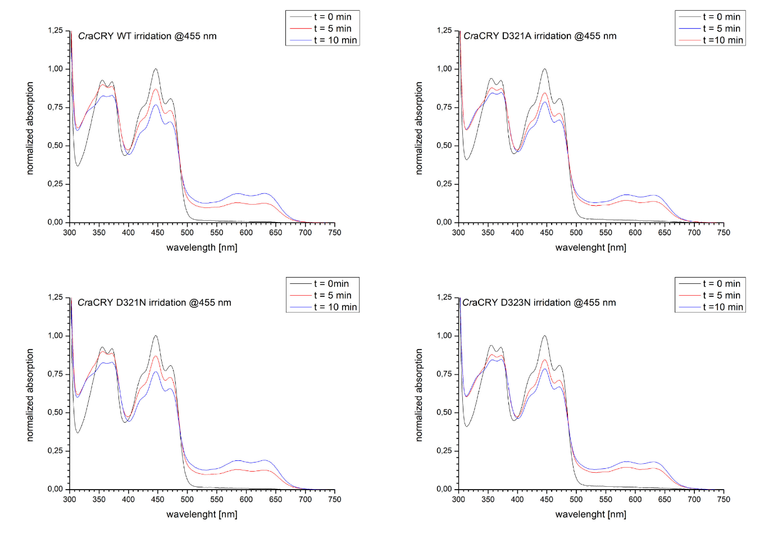
Figure S 6: UV/Vis spectra of CraCRY wt, D321A, D321N and D323N. Spectra recorded prior to illumination indicate for all variants the presence of the FAD chromophore bound in its oxidized form (black). Sample illumination results in an increase in absorbance between 550 to 650 nm, which is characteristic of the presence of semireduced FADH•. This state is stable for at least several minutes for all tested variants (red, blue).
PYP as model system for IMS based rate constant determination
To determine rate constants for conformational changes in proteins with IMS, the following aspects have to be considered: Photochemical mechanisms are generally associated with electronical processes such as charge transfer. In order to obtain meaningful insights into such processes with ESI-MS, one has to ensure that these are not affected in their nature by the electrospray ionization process to exclude any false positive effects, based on ESI charges, instead of the regular chromophore photoactivation.
Our instrumental set-up is based on a modification of a nESI Source of a Synapt SI mass spectrometer by Camacho et al., using LEDs at the wavelengths required by the investigated protein system.¹ The high output power of the used LED in our case allows uniform illumination of the sample. Camacho et al. described already in detail how to observe light-induced conformational changes for the UVR8 photoreceptor. In this work we expand their approach to determine rate constants for such changes.
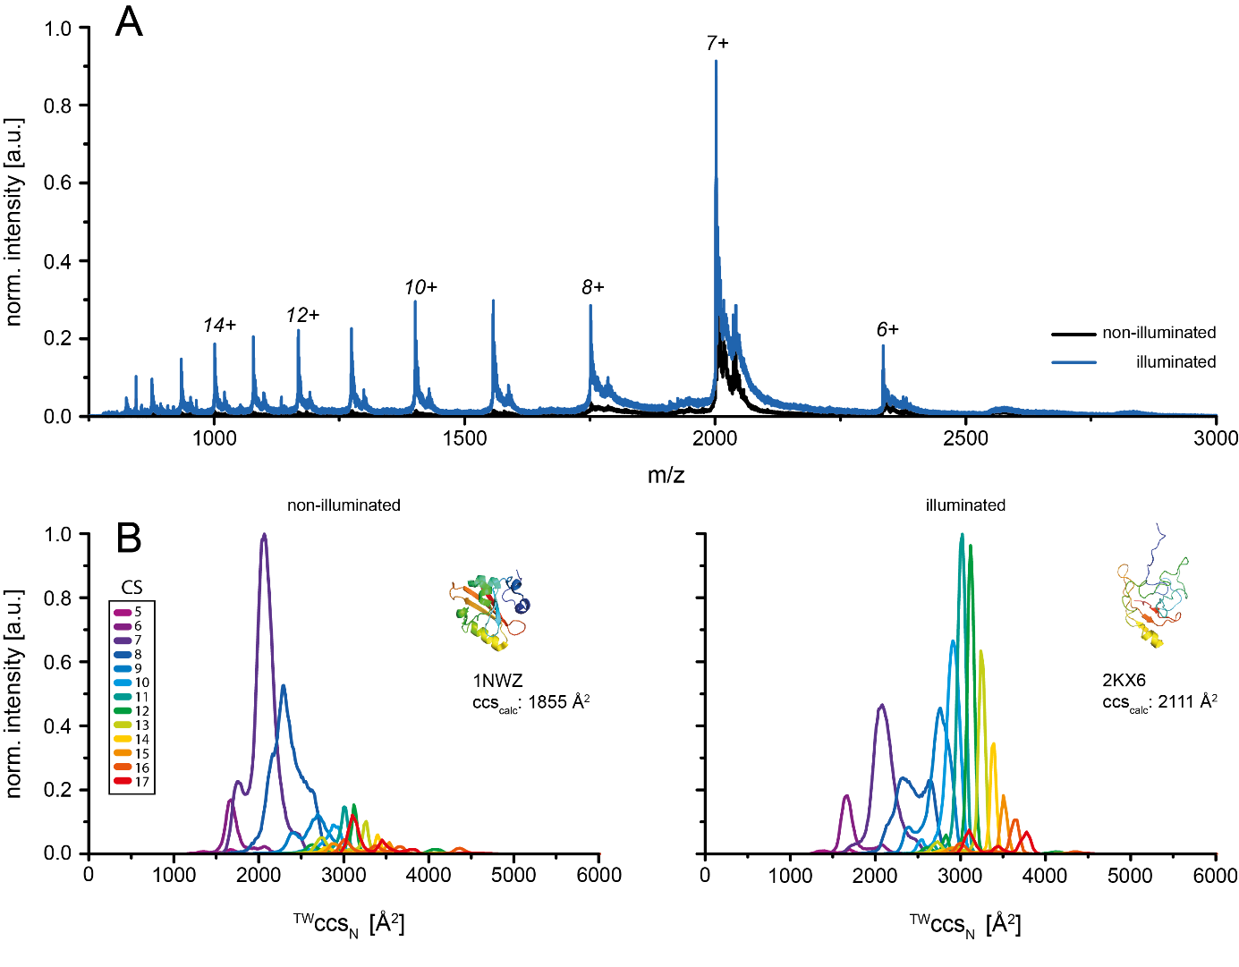
For validating the feasibility of this method, we chose the well-characterized photoactive yellow protein (PYP) and a set of PYP mutants as model system. For these light-active proteins the respective photocycles are understood in detail, for example investigated in a 2D-IR spectroscopy study by Schmidt-Engler et al.² PYP undergoes conformational changes upon blue light excitation, resulting in an enlarged and mostly unfolded structure, where the N-terminus is detached from the protein. To induce these conformational changes and analyse them by ESI-IMS-MS, sample excitation was performed by irradiating the ESI capillary using a 445 nm LED. The mass spectrum of PYP in the dark shows a single charge state (CS) distribution with a dominant CS 7+, representing the native fold (Figure S7, black).
Figure S 7: Mass spectrum and ion mobilogram of PYP wt. B: Mass spectra of PYP, recorded under non-illuminated (black) and illuminated conditions (blue). For PYP a low-charged distribution forms the dominant species in the spectrum under non-illuminated conditions. Sample illumination subsequently leads to the emergence of additional charge states, due to the formation of disordered structure elements. B: Ion mobility data of PYP under non-illuminated and illuminated conditions. The extracted ion mobilograms of the non-irradiated PYP wt show high signal intensities for low charge states with collision cross sections about 2100 Å². Data acquisition of PYP wt during nESI capillary illumination results in a shift to higher charge states with an averaged collision cross section about 3000 Å².
When the ESI capillary is illuminated, a second, higher CSD appears with CS up to 17+ (Figure S7, blue). The appearance of one and after illumination a second charge state distribution can be understood by the ESI ionisation mechanism, which leads to charge deposition on proteins according to their surface area.³ Consequently, the appearance of these signals confirm a conformational transition from a native well-folded state to a less compact, more elongated conformation, which can be visualised by the corresponding PDB entries 1NWZ and 2KX6 of PYP’s ground state and lit-state conformation.^{4,5} As the appearance of the additional charge state distribution is caused by sample illumination, the light-triggered CSs can be assigned to the lit-state conformation of PYP underlining that light-induced structural changes can be traced by our setup.
The light-induced conformational decompaction can also be seen as a function of the CCS. Here, the species around the low CS 7+ represents the compact conformation with a CCS of 2050 Å². Sample illumination leads to the appearance of high CSs around 11+, which have a CCS of 3000 Å², with the CCS of the low CSs remaining unchanged. While the general increase in size as a result of the conformational reorientation of the N-terminus is consistent with the literature, the comparison with the calculated CCs based on the PDB entries 1NWZ and 2KX6, corresponding to PYP’s ground state and lit-state conformation shows that a direct match of experimental and theoretical CCS is observed only for the dark state with a calculated CCS of 1860 Å². The calculated CCS of the lit-state conformation, on the other hand, is 2100 Å² and thus shows a high discrepancy with the experimental CCS of 3000 Å². However, consideration of the structural properties of these models, shows an increase of disordered structure motifs during the transition into the lit-state conformation, which pick up more charges in the ESI process. This leads to an increase of the CCS, based on Coulomb repulsion, explaining the larger than expected CCS, which are generally observed for intrinsically disordered proteins.⁶ Accordingly, the increased CCSs represent the lit-state conformation, with the deviation from the calculated CCS, indicating the more flexible nature of the N-terminus after illumination,
CIU of PYP and its mutants
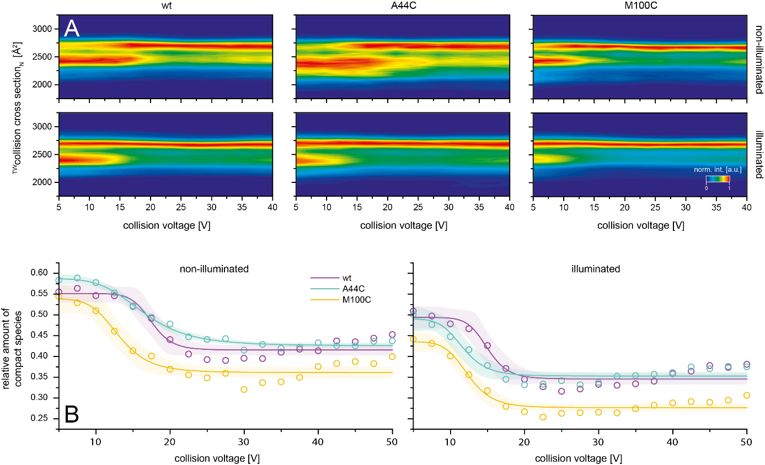
Figure S 8: A: CIU contour plots for the 8+ charge state of PYP wt, A44C and M100C under non-illuminated, as well as under illuminated conditions. In general, a transition from a compact species of 2450 Å² to a single CIU product of 2690 Å² can be observed, where the collision energy required for this transition is affected by sample illumination at 445 nm. B: Comparison of the relative amount of the compact species as a function of the collision voltage (CV). Illumination shifts the CIU50 values to lower CV, while reducing the overall amount of the compact species.

Assuming that the resulting MS signals reflect different conformational states, the altered conformation should also result in differences in their CIU behaviour.
The CIU fingerprint of the 8 times charged PYP wt, recorded in absence of any light source shows at low collision voltages a compact ion species about 2450 Å² that unfolds after a single transition step at 17.5 V into a final unfolding product about 2690 Å². The equivalent experiment recorded during sample illumination resulted in contour plots, which differs in so far, as the extended conformation is already higher populated at lower collision voltages and turnover to the extended conformation occurs at lower CV, albeit this collision induced turnover is incomplete.
The same CIU experiment of PYP A44C variant, resulted for the dark state in similar observations as for PYP wt. The respective residue is known to be located in the solvent exposed α3 helix, while only minor influences with regard to PYP's photocycle are identified. In case of PYP wt, the A44 side chain is assumed to undergo a weak hydrogen bond to D24 in dark state, while signalling state transition results in sidechain solvent exposure.⁴ The similarity in the CIU behaviors of PYP A44C and PYP wt in the dark state reflects the lack of influence of the mutation on the overall structure in this state. Unexpectedly illumination leads to a shift in the A44C CIU plots, showing transition into the extended structure already at lower CVs, than for PYP wt.
For PYP M100C the respective turnover of compact into the extended conformation occurs in both cases - with and without illumination - already at lower collision voltages than for PYP wt. This difference is not unexpected. In case of PYP wt, M100 is pointing towards the chromophore p-coumaric acid (pCA) and acts by charge-transfer interaction on R52 that is next neighboured to pCA and necessary for dark state recovery, while replacement to a hydrophobic amino acid decelerates this transition.⁷ Our data shows that this goes hand in hand with a reduced stability.
Comparison of all CIU experiments, performed for all tested variants under both conditions show in all cases a reduction of the compact species as response to illumination, with CCS signals for compact and extended states appearing at similar values as for PYP wt. (Figure S8). While in the dark unfolding and therewith gas phase stability is similar for PYP wt and PYP A44C, the M100C variant unfolds at lower collision energies, indicating decreased gas phase stability (Figure S8). Upon sample illumination the A44C as well as the M100C variant exhibit a turnover shifted towards lower collision voltages, compared to PYP wt. As CIU data reflects on the gas phase stability of the selected PYP ions, the destabilizing effects on the PYP structure caused by the introduction of the mutations can be observed. Our data shows a generally destabilizing effect of M100C, while A44C only affects the lit state.
Time-dependent conformational transition of PYP
Several studies have shown, that a mutation such as M100C strongly decreases the recovery kinetics from the signalling to the dark state, ^{7–9} which we want to use to determine the feasibility of distinguishing differences in kinetics using the given setup..
Figure S9 depicts the ATDs of the respective CS 10+ before and after an illumination period of 6 seconds. Table S1 shows the rate constants determined for these transitions for different PYP mutants. In the case of PYP wt, directly at the start of sample illumination a rapid increase in signal intensity is observed, which immediately drops to the initial level after the illumination period ends. In literature, lifetimes on the µs time scale have been reported for the transition from the stable ground state (pG) to the PYP intermediate state (pB), with recovery lifetimes in the range of hundreds of ms, depending on the buffer conditions.^{10,11} Respective rate constants of the forward reaction in this order of magnitude cannot be adequately determined by IMS, due to the duration of the mobility experiment itself.¹² Nevertheless, the native conformation of proteins in vacuo is preserved for several milliseconds, which should allow the examination of structural transitions on this time scale reliably.¹³
For the transition of the pB state, back to the pG state of PYP wt, several lifetimes are published, all in the range of hundreds of ms, depending on the respective buffer conditions. Literature values of wt and mutants are shown in table S1 for comparison with our data.^{11,14,15}
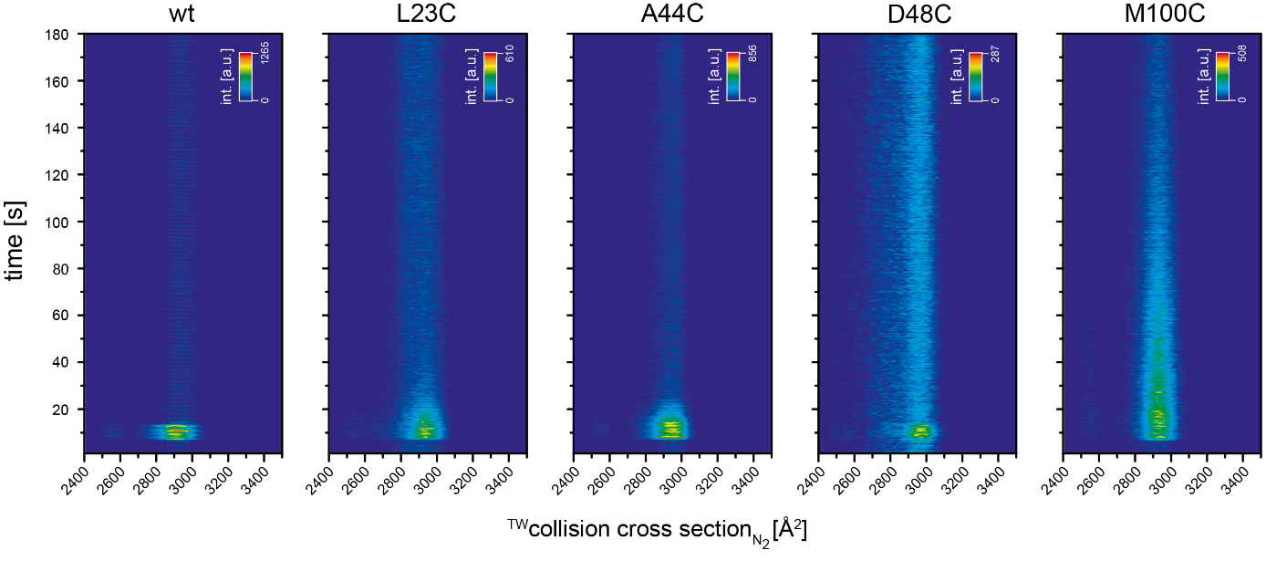
Figure S 9 Time-dependent evolution of ATD from PYP CS 10+. 6 s after data acquisition was initiated the samples were illuminated for 6 s. In the case of PYP wt, a clear increase in intensity is observed during the illumination period, which drops to the initial level immediately after the sample irradiation is terminated. PYP A44C variant shows an equivalent rapid increase in intensity, with the decay to the initial level occurring within 10 s after end of the illumination period. Similar observations can be made for PYP L23C, D48C and M100C variant. For PYP M100C, the initial intensity level is not reached until the end of the experiment. Estimated rate constants are in a good agreement with rate constants found for the respective alanine mutants.¹⁵

Table S 1: Estimated rate constants for PYP dark state recovery. For comparison, rate constants found for respective alanine mutants are additionally listed. ¹⁵
 | Rate constants [s⁻¹]
position of mutation | IMS | Ref. 15
wt | 1.17 ± 0.17 | 1.09
L23 | 0.138 ± 0.014 | 0.36
A44 | 0.228 ± 0.016 | 0.25
D48 | 0.97 ± 0.11 | 1.04
M100 | 0.017 ± 0.001 | 0.02

In the case of the A44C variant, a delayed signal decay compared to the PYP wild type (0.228 ± 0.016 s⁻¹ compared to 1.17 ± 0.17 s⁻¹) can be observed. This is remarkable and supports our CIU findings that the conformational stability has been altered in the illuminated state, despite the fact that this amino acid residue was not expected to have any direct structural effect.
Our results for the M100C variant fit our expectations. M100C is known to strongly decrease the recovery kinetics from the signalling to the dark state and our determined rate constant of 0.0165 s⁻¹ is in the order of a magnitude according to literature values.¹⁵ Similarly, the rate constants of two additional tested mutants D48C and L23C show high agreement with literature when comparing with the respective alanine variants.¹⁵
In summary, these observations show that conformational changes of photoactive proteins upon excitation can be characterised in a time-dependent manner, based on their characteristic charge state distribution and CCS. The high agreement of the experimentally determined rate constants of the transition from pB back to the pG state (table S1) with literature values suggest that the state present at the particular time during the photocycle is preserved during ionization. Additionally, altered gas phase stabilities, depending on the respective system, can be examined by differences in their respective CIU behaviour, thus validating the applicability of this method for the more complex photoreceptor CraCRY.

References

1. Camacho, I. S. et al. Native mass spectrometry reveals the conformational diversity of the UVR8 photoreceptor. Proceedings of the National Academy of Sciences of the United States of America 116, 1116–1125; 10.1073/pnas.1813254116 (2019).
2. Schmidt-Engler, J. M., Zangl, R., Guldan, P., Morgner, N. & Bredenbeck, J. Exploring the 2D-IR repertoire of the -SCN label to study site-resolved dynamics and solvation in the calcium sensor protein calmodulin. Physical chemistry chemical physics : PCCP 22, 5463–5475; 10.1039/c9cp06808b (2020).
3. Christofi, E. & Barran, P. Ion Mobility Mass Spectrometry (IM-MS) for Structural Biology: Insights Gained by Measuring Mass, Charge, and Collision Cross Section. Chemical reviews 123, 2902–2949; 10.1021/acs.chemrev.2c00600 (2023).
4. Getzoff, E. D., Gutwin, K. N. & Genick, U. K. Anticipatory active-site motions and chromophore distortion prime photoreceptor PYP for light activation. Nature structural biology 10, 663–668; 10.1038/nsb958 (2003).
5. Ramachandran, P. L. et al. The short-lived signaling state of the photoactive yellow protein photoreceptor revealed by combined structural probes. Journal of the American Chemical Society 133, 9395–9404; 10.1021/ja200617t (2011).
6. Stuchfield, D. & Barran, P. Unique insights to intrinsically disordered proteins provided by ion mobility mass spectrometry. Current opinion in chemical biology 42, 177–185; 10.1016/j.cbpa.2018.01.007 (2018).
7. Kumauchi, M., Hamada, N., Sasaki, J. & Tokunaga, F. A role of methionine 100 in facilitating PYP(M)-decay process in the photocycle of photoactive yellow protein. Journal of biochemistry 132, 205–210; 10.1093/oxfordjournals.jbchem.a003211 (2002).
8. Sasaki, J., Kumauchi, M., Hamada, N., Oka, T. & Tokunaga, F. Light-induced unfolding of photoactive yellow protein mutant M100L. Biochemistry 41, 1915–1922; 10.1021/bi011721t (2002).
9. Devanathan, S. et al. New insights into the photocycle of Ectothiorhodospira halophila photoactive yellow protein: photorecovery of the long-lived photobleached intermediate in the Met100Ala mutant. Biochemistry 37, 11563–11568; 10.1021/bi9803776 (1998).
10. Konold, P. E. et al. Confinement in crystal lattice alters entire photocycle pathway of the Photoactive Yellow Protein. Nature communications 11, 4248; 10.1038/s41467-020-18065-9 (2020).
11. Kim, T. W. et al. Protein structural dynamics of photoactive yellow protein in solution revealed by pump-probe X-ray solution scattering. Journal of the American Chemical Society 134, 3145–3153; 10.1021/ja210435n (2012).
12. May, J. C. & McLean, J. A. Ion mobility-mass spectrometry: time-dispersive instrumentation. Analytical chemistry 87, 1422–1436; 10.1021/ac504720m (2015).
13. Breuker, K. & McLafferty, F. W. Stepwise evolution of protein native structure with electrospray into the gas phase, 10(-12) to 10(2) s. Proceedings of the National Academy of Sciences of the United States of America 105, 18145–18152; 10.1073/pnas.0807005105 (2008).
14. Mix, L. T. et al. Not All Photoactive Yellow Proteins Are Built Alike: Surprises and Insights into Chromophore Photoisomerization, Protonation, and Thermal Reisomerization of the Photoactive Yellow Protein Isolated from Salinibacter ruber. Journal of the American Chemical Society 143, 19614–19628; 10.1021/jacs.1c08910 (2021).
15. Philip, A. F., Kumauchi, M. & Hoff, W. D. Robustness and evolvability in the functional anatomy of a PER-ARNT-SIM (PAS) domain. Proceedings of the National Academy of Sciences of the United States of America 107, 17986–17991; 10.1073/pnas.1004823107 (2010).

