Supplementary file 1: Figures S1-S7

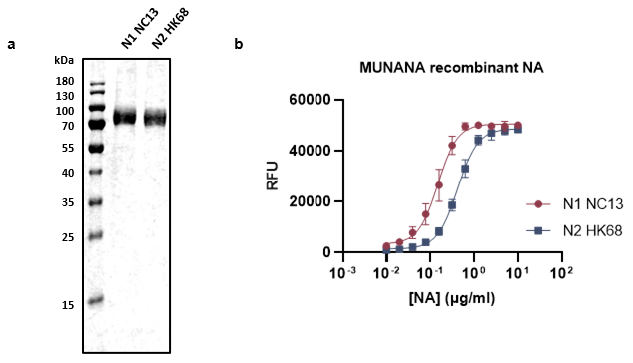
Figure S1. NA recombinant proteins quality control. (a) Representative image of purified recombinant soluble N1 NC13 and N2 HK68 proteins separated on Coomassie stained SDS-PAGE under reducing conditions. (b) Enzymatic activity of purified recombinant NA proteins determined in a MUNANA assay.
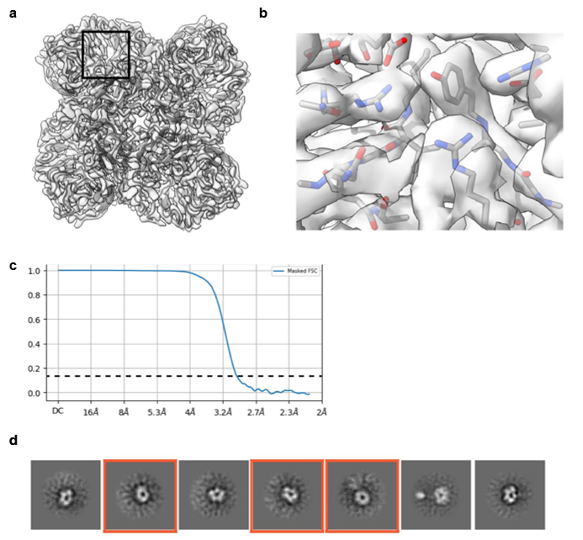
Figure S2. Structural characterization of NA antigens. (a) N1 NC13 cryo-EM map with the atomic model built. (b) Zoom in of the boxed region in (a) with a stick representation of the atomic model. (c) FSC curve of masked map after B-factor sharpening. The dotted line represents the cut-off at 0.143. (d) Negative stain of 2D classes of recombinant N2 HK68 stabilized with tetrabrachion domain display the closed conformation, top views marked in red.

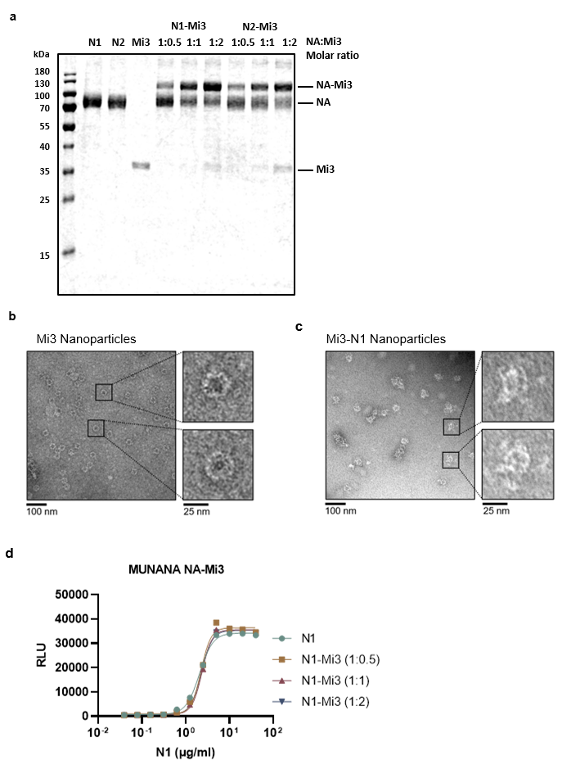
Figure S3. Conjugation of NA antigens to Mi3 nanoparticles. (a) Conjugation of NA-SpyTag to Mi3-SpyCatcher nanoparticles in varying ratios was demonstrated by reduced electrophoretic mobility on SDS-PAGE. Marker and first two lanes with NA proteins are the same as depicted in Fig. S1a. (b) Electron micrograph of negatively stained Mi3 nanoparticles. (c) Electron micrograph of negatively stained Mi3-N1 nanoparticles. (d) Enzymatic activity of unconjugated N1 and N1-Mi3 were compared at equal molar concentrations of N1 in the MUNANA assay.

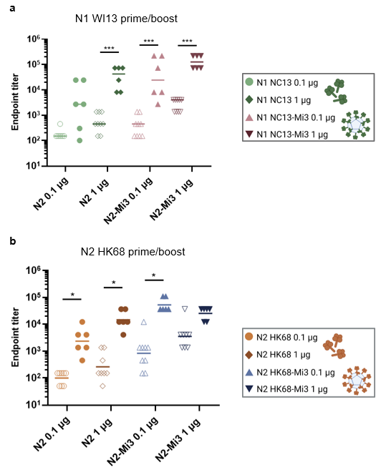
Figure S4. NA-binding endpoint titers prime vs. boost serum. Endpoint titers of antibodies binding N1 WI13 (a) from mice immunized with N1 NC13 and N1 NC13-Mi3 (Fig. 2b and c) and N2 HK68 (b) from mice immunized with N2 HK68 and N2 HK68-Mi3 (Fig. 3a and b). Data from sera taken after prime and boost immunizations are graphed to display the increase in endpoint titers. Open symbols: day 21 (post-prime). Closed symbols: day 42 (post-boost). Bars represent the geometric means for each group. Groups were compared with Mann-Whitney U test using GraphPad Prism 9.3.1 and statistical significance is indicated (*, P < 0.05; ***, P < 0.001).

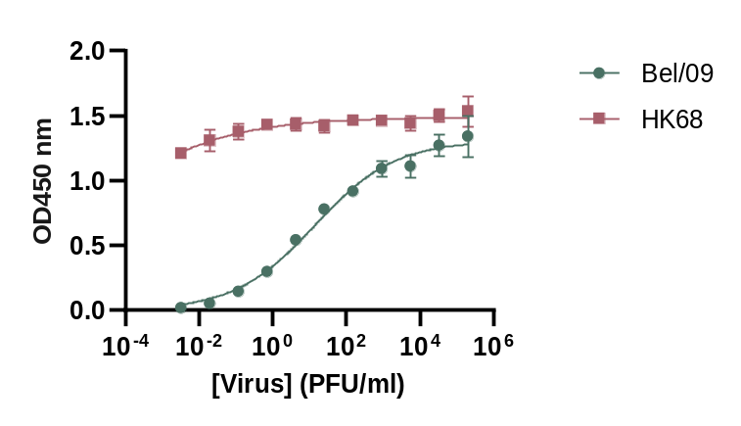
Figure S5. H3N2 HK68 has higher NA enzymatic activity than H1N1 Bel/09. NA activity of H3N2 HK68 and H1N1 Bel/09 quantified in an ELLA assay. A dilution series of the viruses was incubated in wells coated with the glycoprotein fetuin and the removal of sialic acids was detected by binding of PNA lectin (mean ±SD).
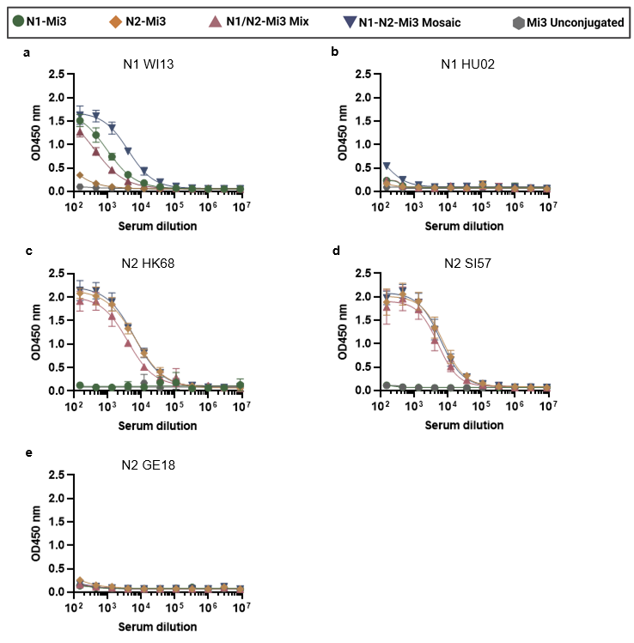
Figure S6. Cross-reactivity of serum from mice immunized with NA-Mi3 nanoparticles with heterologous NAs. Sera from mice (n=12) immunized with homotypic, mix, or mosaic NA-Mi3 formulations taken at day 42 post-immunization were pooled for the individual groups. NA-binding antibodies in the pooled serum samples were quantified in ELISA. (a and c) Reactivity against homologous N1 WI13 and N2 HK68. (b, d, and e) Reactivity against heterologous N1 (HU02) and N2 (SI57 and GE18) NAs. Symbols indicate the mean of three technical replicates and error bars indicate the standard deviation.

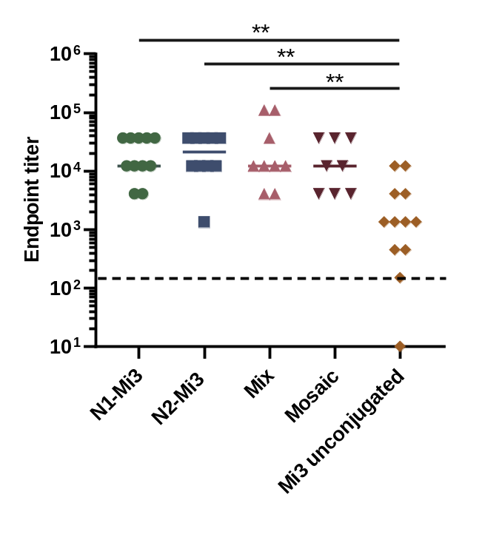
Figure S7. Anti-scaffold antibodies induced by (NA)-Mi3 nanoparticles. Antibodies binding the Mi3 nanoparticle carrier in sera from mice (n=12) immunized with homotypic NA-Mi3 or combined formulations taken at day 42 post-immunization were quantified in ELISA and endpoint titers were determined. Groups were compared with Kruskal-Wallis and Dunn’s post-hoc test using GraphPad Prism 9.3.1 (**, P < 0.01).

