Supplementary Information 2
Table S2. Summary of merged fields. DWC definition is provided according to Darwin Core List of Terms (http://rs.tdwg.org/dwc/doc/list/2023-09-18).
Merged field | Number of records | DWC definition
Ctrl_habitat | 16903 | A category of description of the habitat in which the dwc:Event occurred.
Ctrl_fieldNotes | 9079 | Either, a) an indicator of the existence of, b) a reference to (publication, URI), or c) the text of notes taken in the field about the dwc:Event.
Ctrl_municipality | 8583 | The full, unabbreviated name of the next smaller administrative region than county (city, municipality, etc.) in which the dcterms:Location occurs.
Ctrl_stateProvince | 3884 | The name of the subsequent administrative region below country in which dcterms:Location occurs.
Ctrl_year | 3639 | The four-digit year in which the dwc:Event occurred, according to the Common Era Calendar.
Ctrl_eventDate | 3639 | The date-time or interval during which a dwc:Event occurred. For occurrences, this is the date-time when the dwc:Event was recorded. Not suitable for a time in a geological context.
Ctrl_locality | 2344 | Less specific geographic information can be provided in other geographic terms (dwc:higherGeography, dwc:continent, dwc:country, dwc:stateProvince, dwc:county, dwc:municipality, dwc:waterBody, dwc:island, dwc:islandGroup). This term may contain information modified from the original to correct perceived errors or standardize the description.
Ctrl_level0Name | 1249 | Additional properties from database of Global Administrative Areas level 0 subdivision or Country. Is the familiar concept of first-level political entity
Ctrl_level1Name | 1250 | Additional properties from database of Global Administrative Areas level 1 subdivision or State/Province. Is a primary subdivision of a country, be it state, province, department.
Ctrl_level2Name | 1242 | Additional properties from database of Global Administrative Areas level 2 subdivision or County. Is a second-level political subdivision of a country, regardless of local labels.
Ctrl_level3Name | 302 | Additional properties from database of Global Administrative Areas level 3 subdivision. Is a third-level political subdivision of a country, regardless of local labels.
Ctrl_countryCode | 184 | The standard code for the country in which the dcterms:Location occurs.

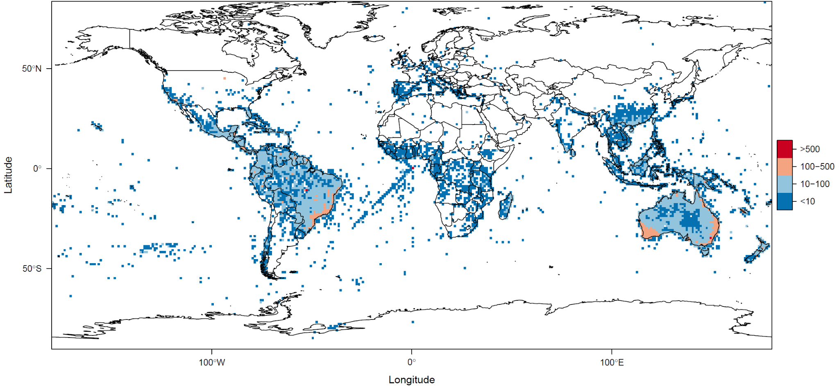
Figure S1. Myrtaceae taxon richness in 1 x 1 degree grid squares, GBIF data. A geometric pattern produced by records with zero-zero and longitude-equal-latitude coordinates is visible near the western coast of the African continent. Map created with custom R script. Base map source: ESRI (http://www.esri.com/data/basemaps, © Esri, DeLorme Publishing Company).
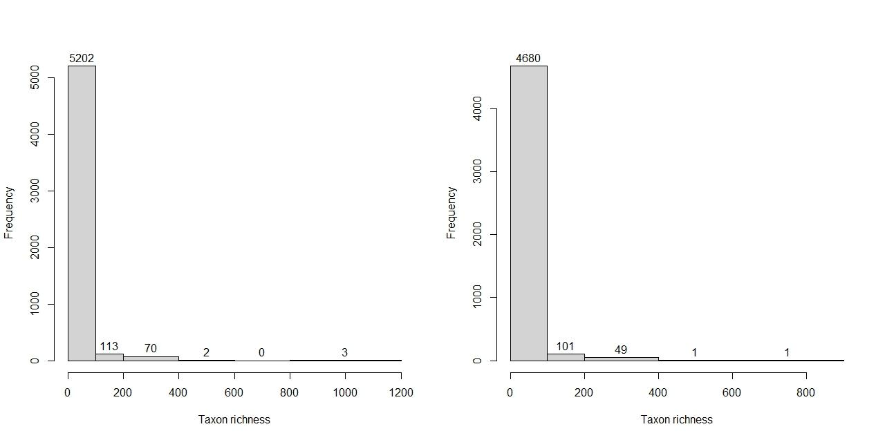
Figure S2. Myrtaceae taxon richness in 1 x 1 degree grid squares, GBIF (left) and ParseGBIF (right) data.
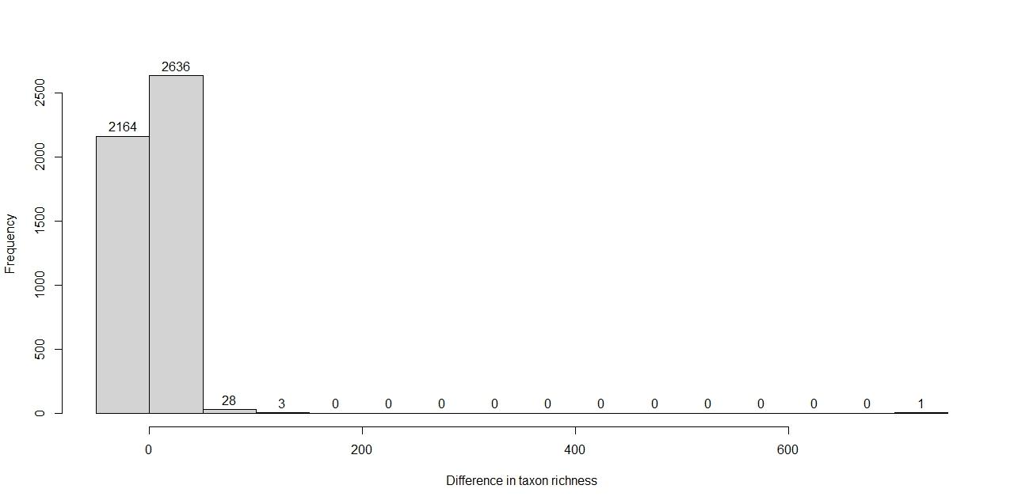
Figure S3. Difference between GBIF and ParseGBIF in taxon richness in 1 x 1 degree grid squares. The majority of values are below 20, with a single grid square (far right) having 736 taxa.

