Supplemental Tables and Figures

Fig S1 Relationship between length of growing period (days) and protein content (%) of 300 spring wheat genotypes evaluated in 8 environments (combination of year x location)

Fig S2 Relationship between protein content (%) and grain yield (g m⁻²) of 300 spring wheat genotypes evaluated in 8 environments (combination of year x location)
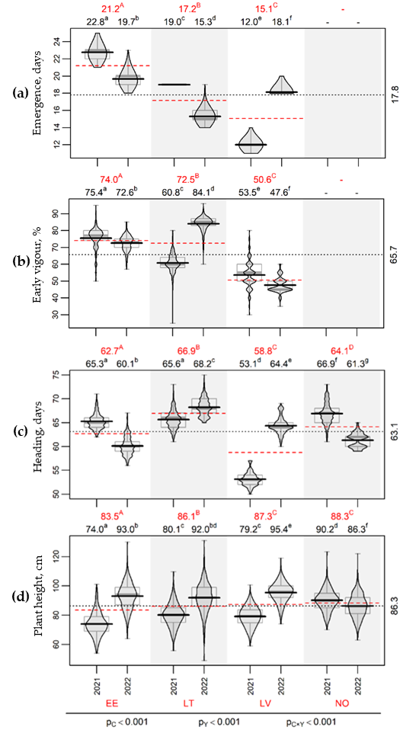
Fig S3 Distribution of the values of the plant emergence (a), early vigour (b), heading (c), plant height (d) by countries (EE: Estonia, LT: Latvia, LT: Lithuania, NO: Norway) and years. For each country and year combination in background the box plot indicating the median and inter-quartile range is presented in grey, bold black lines and black numerical values above the figure mark the average values by countries and years (means without common superscript letter are statistically significantly different), red dashed lines and red numerical values above the figure mark the average values by countries over years (means without common superscript letter are statistically significantly different), horizontal dotted line and numerical value at the left side of figure indicate the overall mean. Countries and years combinations without data are left empty. P-values under the figure show statistical significance of country (p_{C}), year (p_{Y}) and country by year interaction (p_{C×Y}) effects for all the traits
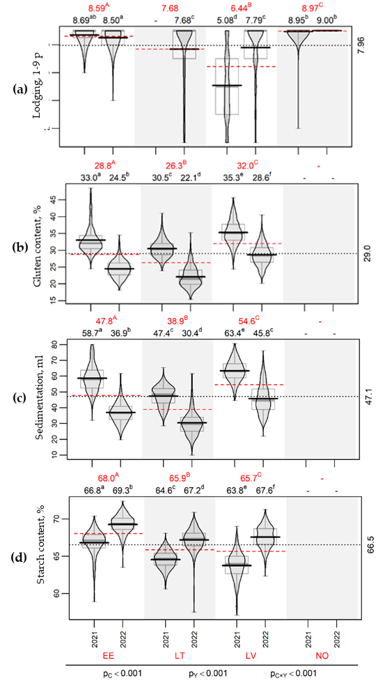
Fig S4 Distribution of the values of the lodging (a), gluten (b), sedimentation (c) and starch content (d) by countries (EE: Estonia, LT: Latvia, LT: Lithuania, NO: Norway) and years. For each country and year combination in background the box plot indicating the median and inter-quartile range is presented in grey, bold black lines and black numerical values above the figure mark the average values by countries and years (means without common superscript letter are statistically significantly different), red dashed lines and red numerical values above the figure mark the average values by countries over years (means without common superscript letter are statistically significantly different), horizontal dotted line and numerical value at the left side of figure indicate the overall mean. Countries and years combinations without data are left empty. P-values under the figure show statistical significance of country (p_{C}), year (p_{Y}) and country by year interaction (p_{C×Y}) effects for all the traits

Table S1 Spearman’s rank correlation coefficients for fourteen traits of 300 spring wheat genotypes evaluated in 8 environments (combination of year x location)

Trait | Emergence, days | Early vigour, % | Lodging, 1–9 p | Heading, days | Test weight, kg hl-1 | Starch content, % | Growing period, days | 1000 grain weight, g | Plant height, cm | Grain yield, g m⁻² | Protein content, % | Gluten content, % | Sedimentation, ml | Drought tolerance, 1–5 p
Emergence, days | 1 | 0.24 | 0.53 | 0.5 | 0.47 | 0.39 | 0.07 | -0.02 | -0.12 | 0.06 | -0.08 | -0.06 | -0.05 | -0.04
Early vigour, % | 0.24 | 1 | 0.23 | 0.41 | 0.37 | 0.29 | 0.09 | -0.02 | 0.03 | -0.11 | -0.36 | -0.41 | -0.38 | 0
Lodging, 1–9 p | 0.53 | 0.23 | 1 | 0.43 | 0.51 | 0.48 | 0.23 | 0.22 | -0.04 | 0.12 | -0.43 | -0.31 | -0.31 | -0.05
Heading, days | 0.5 | 0.41 | 0.43 | 1 | 0.28 | 0.29 | 0.59 | -0.01 | 0.19 | -0.13 | -0.43 | -0.45 | -0.48 | -0.07
Test weight, kg hl⁻¹ | 0.47 | 0.37 | 0.51 | 0.28 | 1 | 0.73 | 0.41 | 0.44 | 0.34 | 0.34 | -0.52 | -0.44 | -0.4 | -0.07
Starch content, % | 0.39 | 0.29 | 0.48 | 0.29 | 0.73 | 1 | 0.48 | 0.4 | 0.43 | 0.51 | -0.81 | -0.73 | -0.68 | -0.05
Growing period, days | 0.07 | 0.09 | 0.23 | 0.59 | 0.41 | 0.48 | 1 | 0.26 | 0.55 | 0.26 | -0.51 | -0.63 | -0.64 | -0.13
1000 grain weight, g | -0.02 | -0.02 | 0.22 | 0.01 | 0.44 | 0.4 | 0.26 | 1 | 0.32 | 0.46 | -0.52 | -0.28 | -0.26 | -0.11
Plant height, cm | -0.12 | 0.03 | -0.04 | 0.19 | 0.34 | 0.43 | 0.55 | 0.32 | 1 | 0.45 | -0.46 | -0.5 | -0.5 | -0.12
Grain yield, g m⁻² | 0.06 | -0.11 | 0.12 | -0.13 | 0.34 | 0.51 | 0.26 | 0.46 | 0.45 | 1 | -0.37 | -0.41 | -0.41 | -0.17
Protein content, % | -0.08 | -0.36 | -0.43 | -0.43 | -0.52 | -0.81 | -0.51 | -0.52 | -0.46 | 0.45 | 1 | 0.98 | 0.95 | 0.09
Gluten content, % | -0.06 | -0.41 | -0.31 | -0.45 | -0.44 | -0.73 | -0.63 | -0.28 | -0.5 | 0.45 | 0.98 | 1 | 0.96 | 0.08
Sedimentation, ml | -0.05 | -0.38 | -0.31 | -0.48 | -0.4 | -0.68 | -0.64 | -0.26 | -0.5 | 0.45 | 0.95 | 0.96 | 1 | 0.09
Drought tolerance, 1–5 p | -0.04 | 0 | -0.05 | -0.07 | -0.07 | -0.05 | -0.13 | -0.11 | -0.12 | 0.45 | 0.09 | 0.08 | 0.09 | 1

