Supplementary Materials for

Early combination treatment with existing HIV antivirals: an effective treatment for COVID-19?

Authors: Roberto Nico Dallocchio, Alessandro Dessì, Andrea De Vito, Giovanna Delogu, Pier Andrea Serra, Giordano Madeddu

Correspondence to: giordano@uniss.it

This file includes:

Figs. S1 to S4
Tables S1 to S2

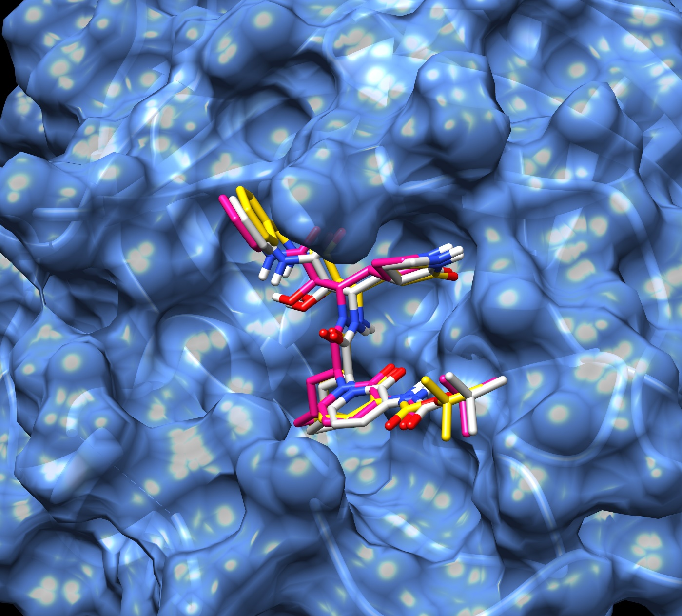

Figure S1. O6K from Xray 6y2f (yellow), O6K, active torsion 0, blind docking on 50% population of O6K conformers at lowest energy (violet), O6K, active torsion 0, docking restricted to the site grid with 100% population of O6K conformers (white).

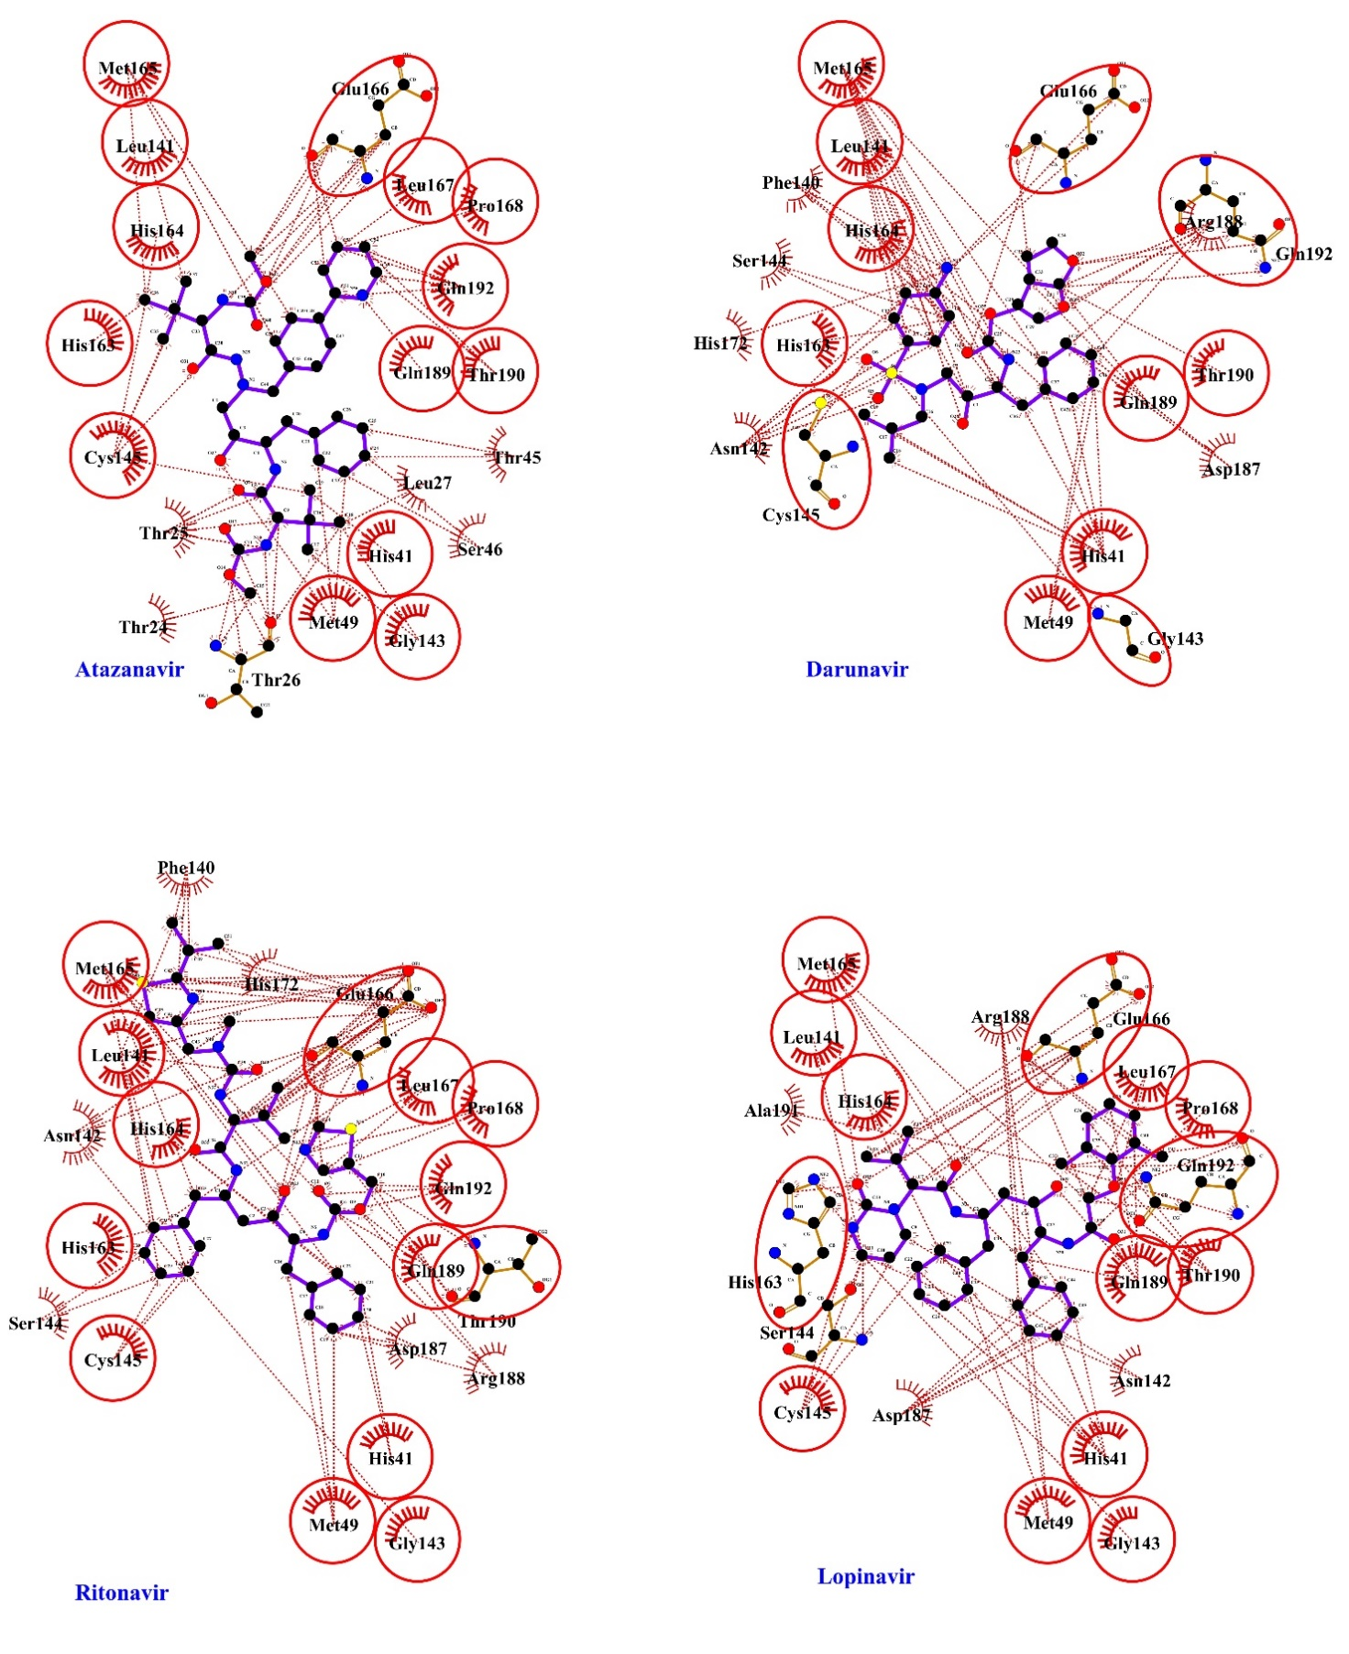

Figure S2. Estimated hydrophobic interactions of antiviral drugs with the amino acids residues of SARS-CoV-2 M^{pro}.

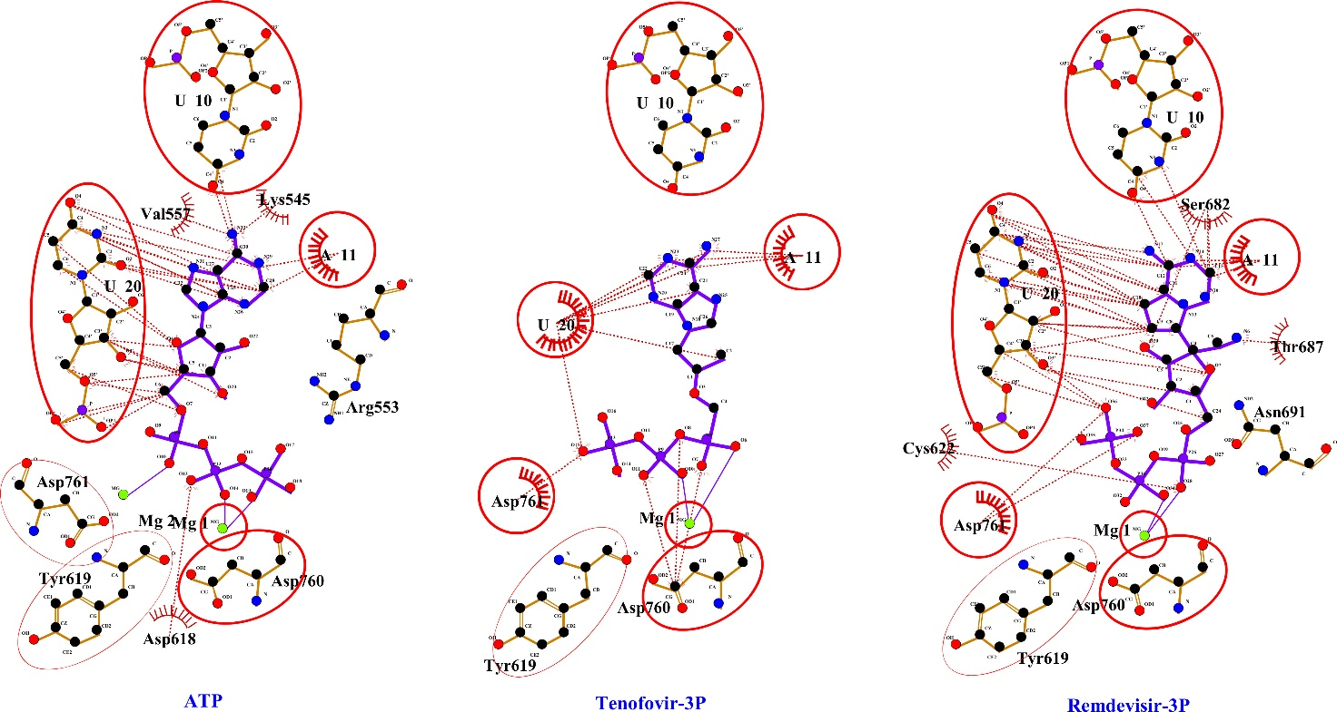

Figure S3. Estimated hydrophobic interactions of adenosine-3P (ATP), tenofovir-3P, and remdesivir-3P with the amino acids residues of SARS-CoV-2 RdRp.
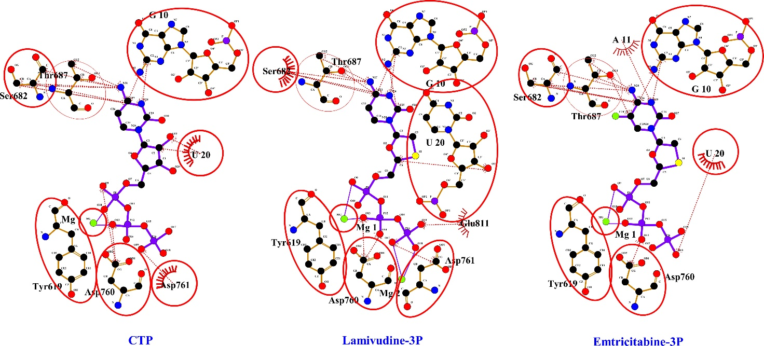

Figure S4. Estimated hydrophobic interactions of cytosine-3P (CTP), lamivudine-3P, and emtricitabine-3P with the amino acids residues of SARS-CoV-2 RdRp.
Table S1. Estimated H-bond of antiviral drugs with the amino acids residues of SARS-CoV-2 M^{pro}

Hydrogen bond interactions
Ligands | n° H-bond | Protein Atom | Ligand Atom
Atazanavir | 5 | Thr26:O(OA)ª | H13(HD)^{b}
Atazanavir | 5 | Thr26:HN(HD) | O14(OA)
Atazanavir | 5 | Glu166:HN(HD) | O42(OA)
Atazanavir | 5 | Thr190:HN(HD) | N56(NA)^{c}
Atazanavir | 5 | Gln192:HE22(HD) | N56(NA)
Darunavir | 7 | Phe140:O(OA) | H15(HD)
Darunavir | 7 | Gly143:HN(HD) | O6(OA)
Darunavir | 7 | Glu166:OE2(OA) | H14(HD)
Darunavir | 7 | Glu166:HN(HD) | O20(OA)
Darunavir | 7 | Glu166:HN(HD) | O26(OA)
Darunavir | 7 | Gln192:HE22(HD) | O30(OA)
Darunavir | 7 | Gln192:HE22(HD) | O32(OA)
Ritonavir | 5 | Glu166:HN(HD) | O23(OA)
Ritonavir | 5 | Glu166:O(OA) | H24(HD)
Ritonavir | 5 | Thr190:HN(HD) | O9(OA)
Ritonavir | 5 | Gln192:HE22(HD) | O7(OA)
Ritonavir | 5 | Gln192:HE22(HD) | O9(OA)
Lopinavir | 5 | Ser144:OG(OA) | H14(HD)
Lopinavir | 5 | His163:HE2(HD) | O15(OA)
Lopinavir | 5 | Glu166:HN(HD) | O5(OA)
Lopinavir | 5 | Glu166:O(OA) | H29(HD)
Lopinavir | 5 | Gln192:HE22(HD) | O31(OA)
ªOxygen acceptor;
^{b}Hdrogen donor;
^{c}Nitrogen acceptor.

Table S2. Estimated interactions of H-bonds of adenosine-3P (ATP), tenofovir-3P and remdesivir-3P, cytosine-3P (CTP), emtricitabine-3P and lamivudine-3P with the amino acids
residues of SARS-CoV-2 RdRpª.

Hydrogen bond interactions
Active Metabolite | n° H-bond | Protein Atom | Ligand Atom
ATP | 4 | Arg553:HH12(HD) | O18(OA)^{b}
ATP | 4 | U20:HO3(HD) | O20(OA)
ATP | 4 | U20:O3’(OA) | H21(HD)^{c}
ATP | 4 | U10:O4(OA) | H34(HD)
Tenofovir-3P | 2 | U20:O4(OA) | H28(HD)
Tenofovir-3P | 2 | U10:O4(OA) | H29(HD)
Remdevisir-3P | 4 | Asn691:HD22(HD) | O22(OA)
Remdevisir-3P | 4 | U10:H3(HD) | N14(NA)^{d}
Remdevisir-3P | 4 | U10:O4(OA) | H18(HD)
Remdevisir-3P | 4 | U20:O4(OA) | H19(HD)
CTP | 4 | Thr687:OG1(OA) | H32(HD)
CTP | 4 | Ser682:O(OA) | H33(HD)
CTP | 4 | U20:’HO3(HD) | O9(OA)
CTP | 4 | G10:H21(HD) | N28(NA)
Emtricitabine-3P | 3 | Ser682:O(OA) | H30(HD)
Emtricitabine-3P | 3 | Thr687:OG1(OA) | H29(HD)
Emtricitabine-3P | 3 | G10:H21(HD) | N25(NA)
Lamivudine-3P | 4 | Thr687:OG1(OA) | H28(HD)
Lamivudine-3P | 4 | Thr687:OG1(OA) | H29(HD)
Lamivudine-3P | 4 | G10:H21(HD) | N24(NA)
Lamivudine-3P | 4 | G10:H1(HD) | O26(OA)
ªin 7BV2 crystal of SARS-CoV-2 RdRp, uracil was replaced with guanine base for interactions with CTP, emtricitabine-3P and lamivudine-3P;
^{b}Oxygen acceptor;
^{c}Hdrogen donor;
^{d}Nitrogen acceptor.

