Supporting Information

Firefly-inspired Bipolar Information Indication System Actuated by White Light

Hanwen Huang ^{a†}, Jiamiao Yin ^{b†}, Qianwen Zhou ^{c}, Huateng Li ª, Junying Yang ª, Yaoben Wang ª, Ming Xu ^{b,d}* and Changchun Wang ª*
ª State Key Laboratory of Molecular Engineering of Polymers, Department of Macromolecular Science, Laboratory of Advanced Materials, Fudan University, Shanghai, 200433, China.
^{b} State Key Laboratory of Molecular Engineering of Polymers, Department of Chemistry, Fudan University, Shanghai, 200433, China.
^{c} Institute of Microscale Optoelectronics, Shenzhen University, Shenzhen 518060, China.
^{d} School of Chemistry and Chemical Engineering, Shanghai Jiao Tong University, Shanghai 200240, China

† These authors contributed equally to this work.
* Corresponding author. E-mail address: ccwang@fudan.edu.cn (C. C. Wang); xu-ming@sjtu.edu.cn

Materials
Styrene, sodium persulfate, sodium dodecyl sulfate (SDS), ethyl acrylate (EA), ethanol were purchased from Sinopharm Chemical Reagent (China, Shanghai). Butanediol diacrylate (BDDA) and allyl methacrylate (AMA) were obtained from TCI (Shanghai). Potassium hydroxide (KOH), sodium hydroxide (NaOH), aluminum oxide, and propylene carbonate were obtained from Aladdin (China, Shanghai). Dowfax2A1 was purchased from Dow Chemicals. Before emulsion polymerization, chemicals were purified to remove stabilizers. Typically, EA was extracted with 1 M sodium hydroxide solution and treated with water to a neutral state after which the remained water was removed by sodium sulfate. Styrene was treated with alumina oxide column (basic, 200-300 mesh). Water used in this project was all deionized.
Palladium (Ⅱ) octaethylporphine (PdOEP, 85%) were obtained from Sigma-Aldrich. Perylene and BODIPY were purchased from J&K Scientific Co., Ltd. (1,10-Phenanthroline)tris[4,4,4-trifluoro-1-(2-thienyl)-1,3-butanedionato]europium(III) [Eu(TTA)3phen] was purchased from Tokyo Chemical Industry Co., Ltd. CU was prepared by the methods described in the literature¹.

Characterization
Absorption spectra were obtained from a Shimadzu UV-2600 spectrophotometer. Fluorescence spectra and decay curves of afterglow were measured on a fluorescence spectrometer (Edinburgh FS5 or FLS1000). Afterglow spectra were recorded by a Hamamatsu C14631 fiber optic spectrometer. Afterglow photographs were recorded by a lab-built imaging platform via an EMCCD (DU897, Andor).
The reflectance spectra were acquired using a Choptics EK2000-Pro spectrometer with an Ideaoptics FIB-Y-600-UV fiber and a Choptics LS2000-DH light source. A standard aluminum mirror, with a reflectivity of 100%, was used as the reference. Fluorescent intensity was recorded using an Edinburgh FS5 fluorescence spectrometer, and phosphorescent intensity was measured using a photonic multichannel analyzer PMA-12 from Hamamatsu (model C14631). The excitation wavelength used was 365 nm.
Optical pictures were taken using a Sigma 55 mm f/1.4 lens, with a viewing angle of 0°. The ultra-small angle X-ray scattering (USAXS) experiments were conducted at Beamline BL10U1 in the Shanghai Synchrotron Radiation Facility (SSRF) in China. The X-ray wavelength used was 0.124 nm. The USAXS detector employed was an Eiger 4 M, with the detector positioned 27600 mm away from the sample and a pixel size of 75 μm. The number of pixels on the x and y axes were 2070 and 2167 respectively. The exposure time was set to 20 s, and the obtained USAXS data was analyzed using FIT 2D software.
Transmission electron microscopy (TEM) images of particles after each emulsion polymerization step were captured using a JEOL JEM 1400 electron microscope. Dynamic light scattering (DLS) tests were performed at 25 °C using a Malvern Zetasizer Nano ZS90 instrument. The DLS measurements were conducted under He-Ne laser light source with a wavelength of 632.8 nm and a testing angle of 90°.
HPLC (high performance liquid chromatograph) was performed to calculate the content of mecobalamin using Waters e2695 HPLC. The chromatographic column was C18 reverse-phase column (SunFire, 4.6 × 150 mm, 5 μm). The mobile phase was acetonitrile containing 0.47 wt% sodium hexane sulfonate and acetonitrile containing 0.03 mol/L sodium dihydrogen phosphate (volume ratio81:19). The flow velocity was 0.8 mL/min and the detection wavelength 266 nm.

TABLES
Table S1. DLS size, polymer dispersity index (PDI) after each step of emulsion polymerization for red, gold, green and blue photonic crystal films. Samples were prepared by 500 mL stepwise emulsion polymerization with 0.08 g (Red), 0.09 g (Gold), 0.10 g (Green) and 0.13 g (Blue) SDS in the seed preparation, respectively.
Sample Name |  | Size (nm) | PDI
Red | Seed | 52 | 0.056
Red | Core | 188 | 0.033
Red | CI | 207 | 0.039
Red | CIS | 225 | 0.037
Gold | Seed | 47 | 0.062
Gold | Core | 166 | 0.012
Gold | CI | 190 | 0.031
Gold | CIS | 204 | 0.017
Green | Seed | 40 | 0.057
Green | Core | 140 | 0.019
Green | CI | 159 | 0.026
Green | CIS | 186 | 0.028
Blue | Seed | 32 | 0.069
Blue | Core | 113 | 0.032
Blue | CI | 121 | 0.035
Blue | CIS | 147 | 0.025

Table S2. Absorption peak, emission peak and FWHW (full width at half maximum) of different emitters.
Emitter | Absorption peak/nm | Emission peak/nm | FWHW/nm
Perylene | 436, 409, 388 | 450, 470, 504 |  | 39
Bodipy | 500 | 525 |  | 32
Eu complex | 342 | 614 |  | 8

FIGURES
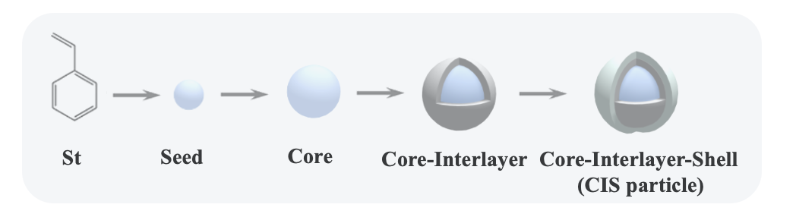
Figure S1. Schematic of stepwise emulsion polymerization to fabricate CIS particles.

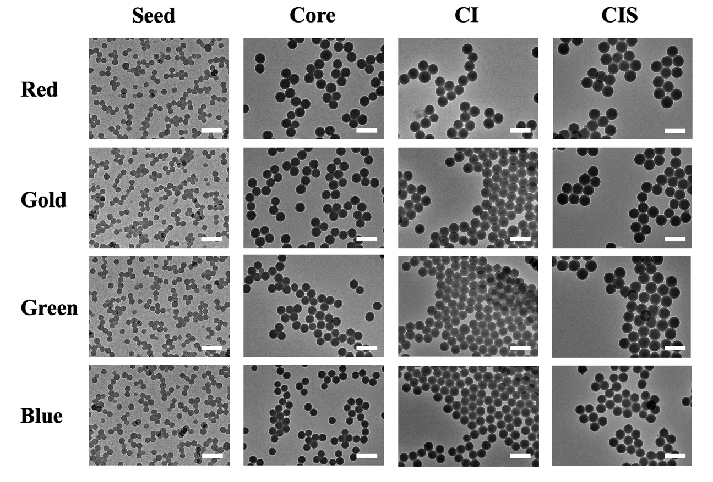
Figure S2. TEM images of particles after each step of emulsion polymerization for red, gold, green and blue photonic crystal films. Samples were prepared by 500 mL stepwise emulsion polymerization with 0.08 g (Red), 0.09 g (Gold), 0.10 g (Green) and 0.13 g (Blue) SDS in the seed preparation, respectively. The scale bar is 350 nm.

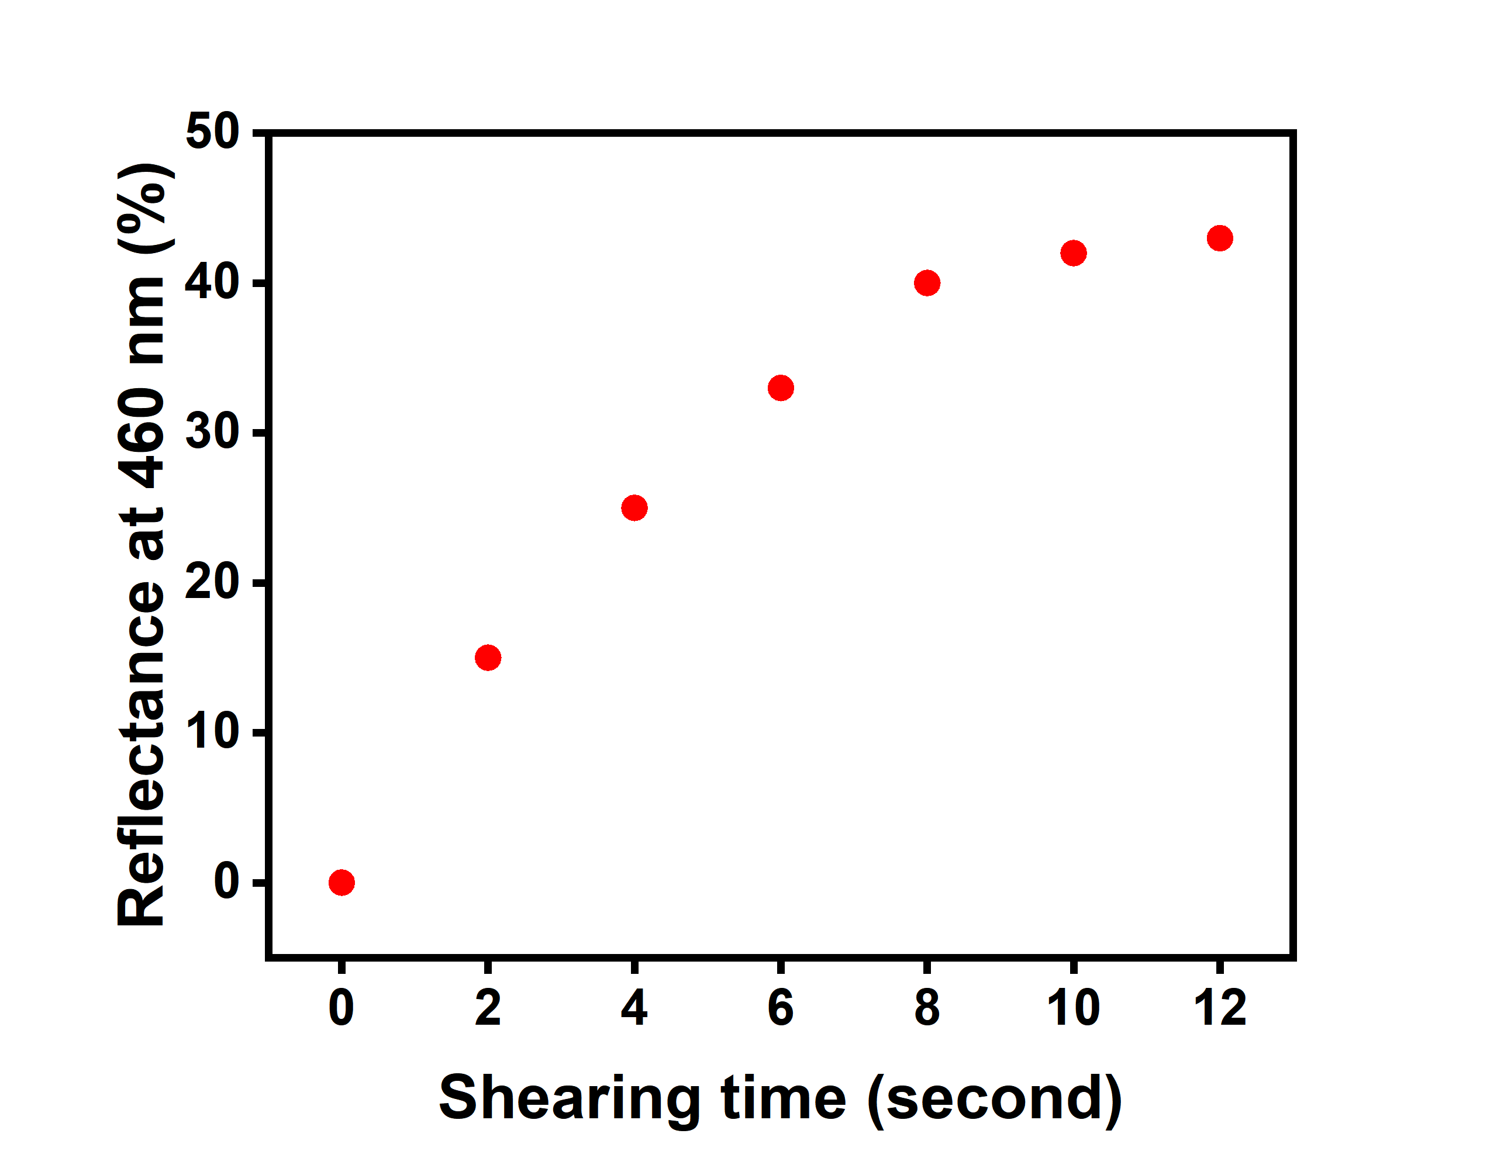
Figure S3. Reflectance of blue photonic crystal film undergoing different shearing time (the rotation-shearing angular velocity was 1/3 rad/s and rotation-shearing amplitude 1/6 rad with corresponding rotation-shearing frequency at 0.5 Hz).

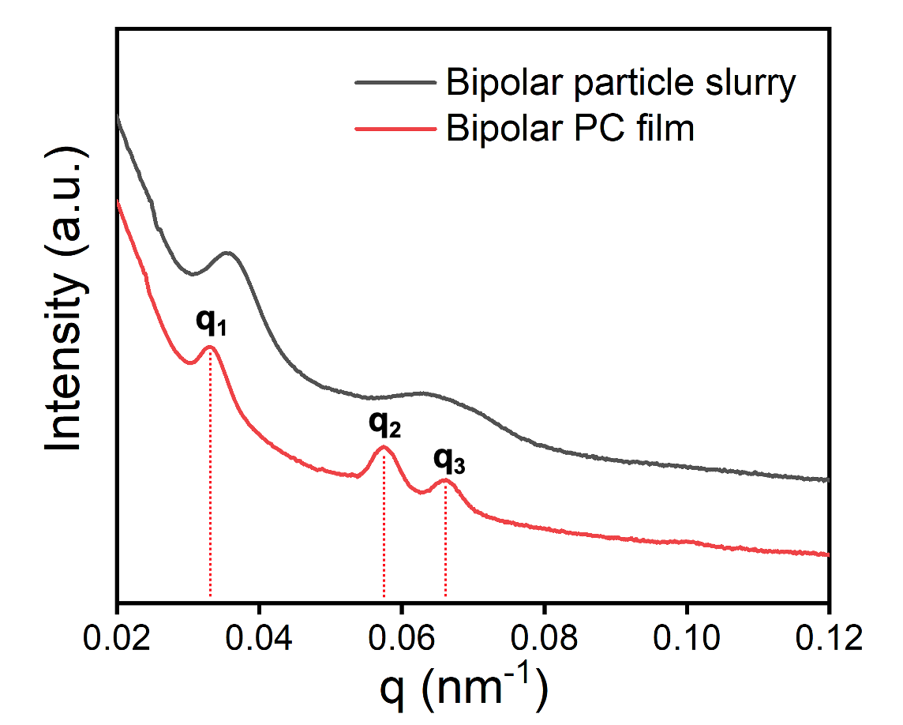
Figure S4. 1D USAXS curves of bipolar particle slurry (disordered, before MSAT) and bipolar photonic crystal film (ordered, after MSAT).

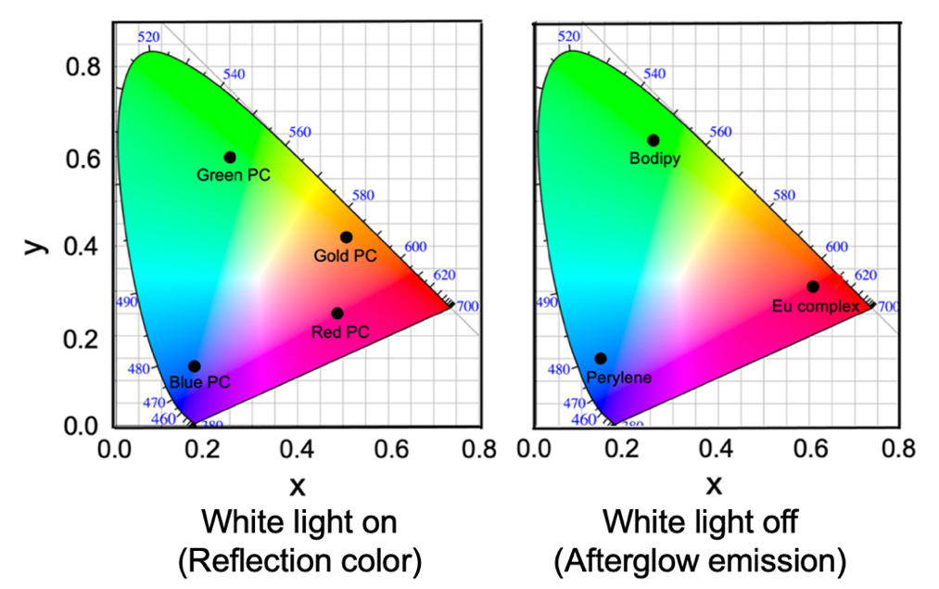
Figure S5. CIE diagram of bipolar information indication system with different reflection colors and afterglow when white light is on and off, respectively.

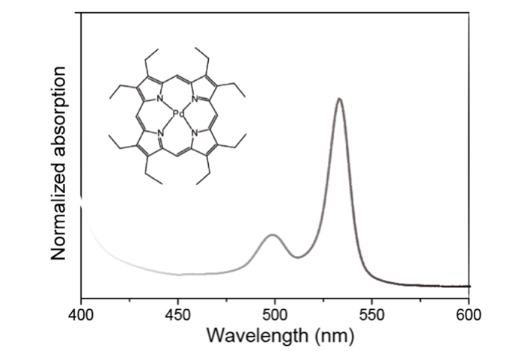
Figure S6. Absorbance spectrum of sensitizer PdOEP.
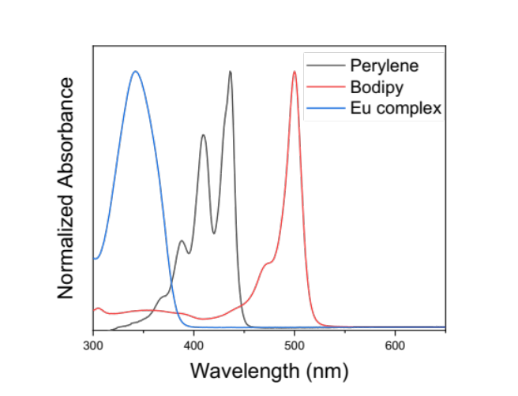
Figure S7. Absorbance spectra of different emitters.

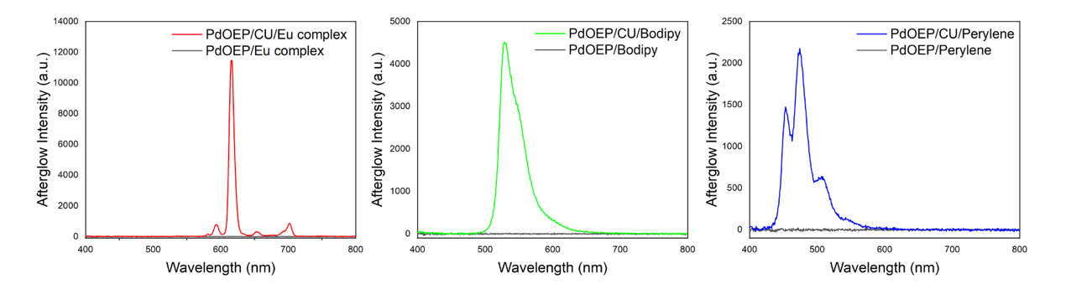
Figure S8. a) Afterglow emission spectra of photochemical reactions with different emitters, with and without the presence of CU. The afterglow emission spectrum was collected after being irradiated with white light for 1 min with a fixed power density of 50 mW/cm².
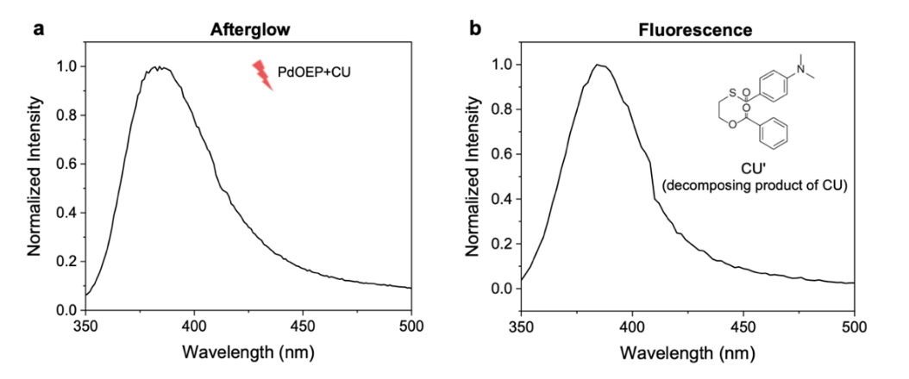
Figure S9. a) Afterglow emission spectra of CU sensitized by PdOEP without adding emitter. The afterglow emission spectrum was collected after being irradiated with white light for 1 min with a fixed power density of 50 mW/cm². b) Photoluminescence emission spectrum of decomposing product of CU in toluene (λ_{Ex}=330 nm).
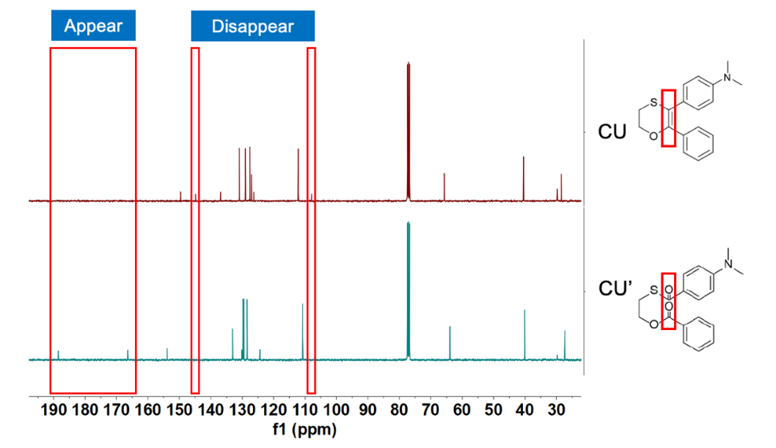
Figure S10. ¹³C NMR spectra of CU and CU’.
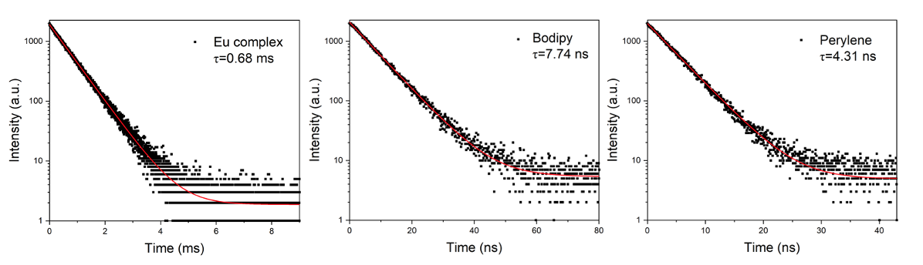
Figure S11. Fluorescence decays and lifetime of different emitters.

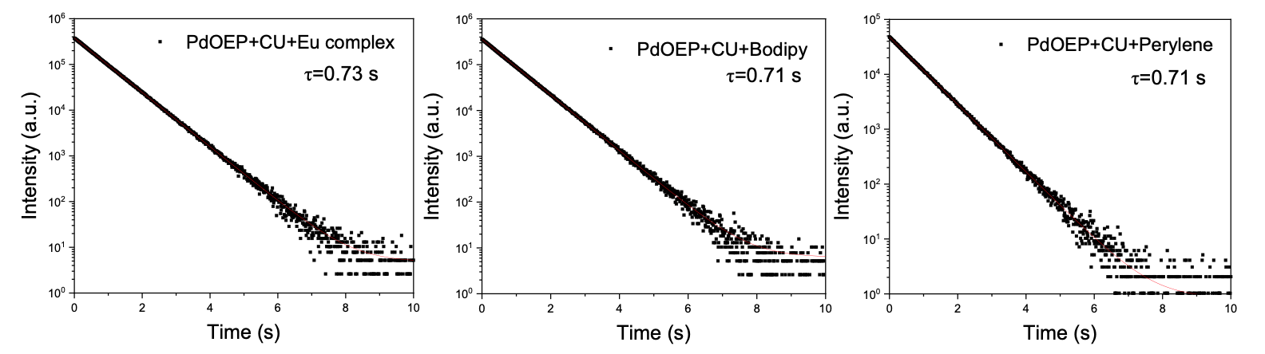
Figure S12. Afterglow decays of photochemical reaction systems with different composition of emitters and their lifetime.

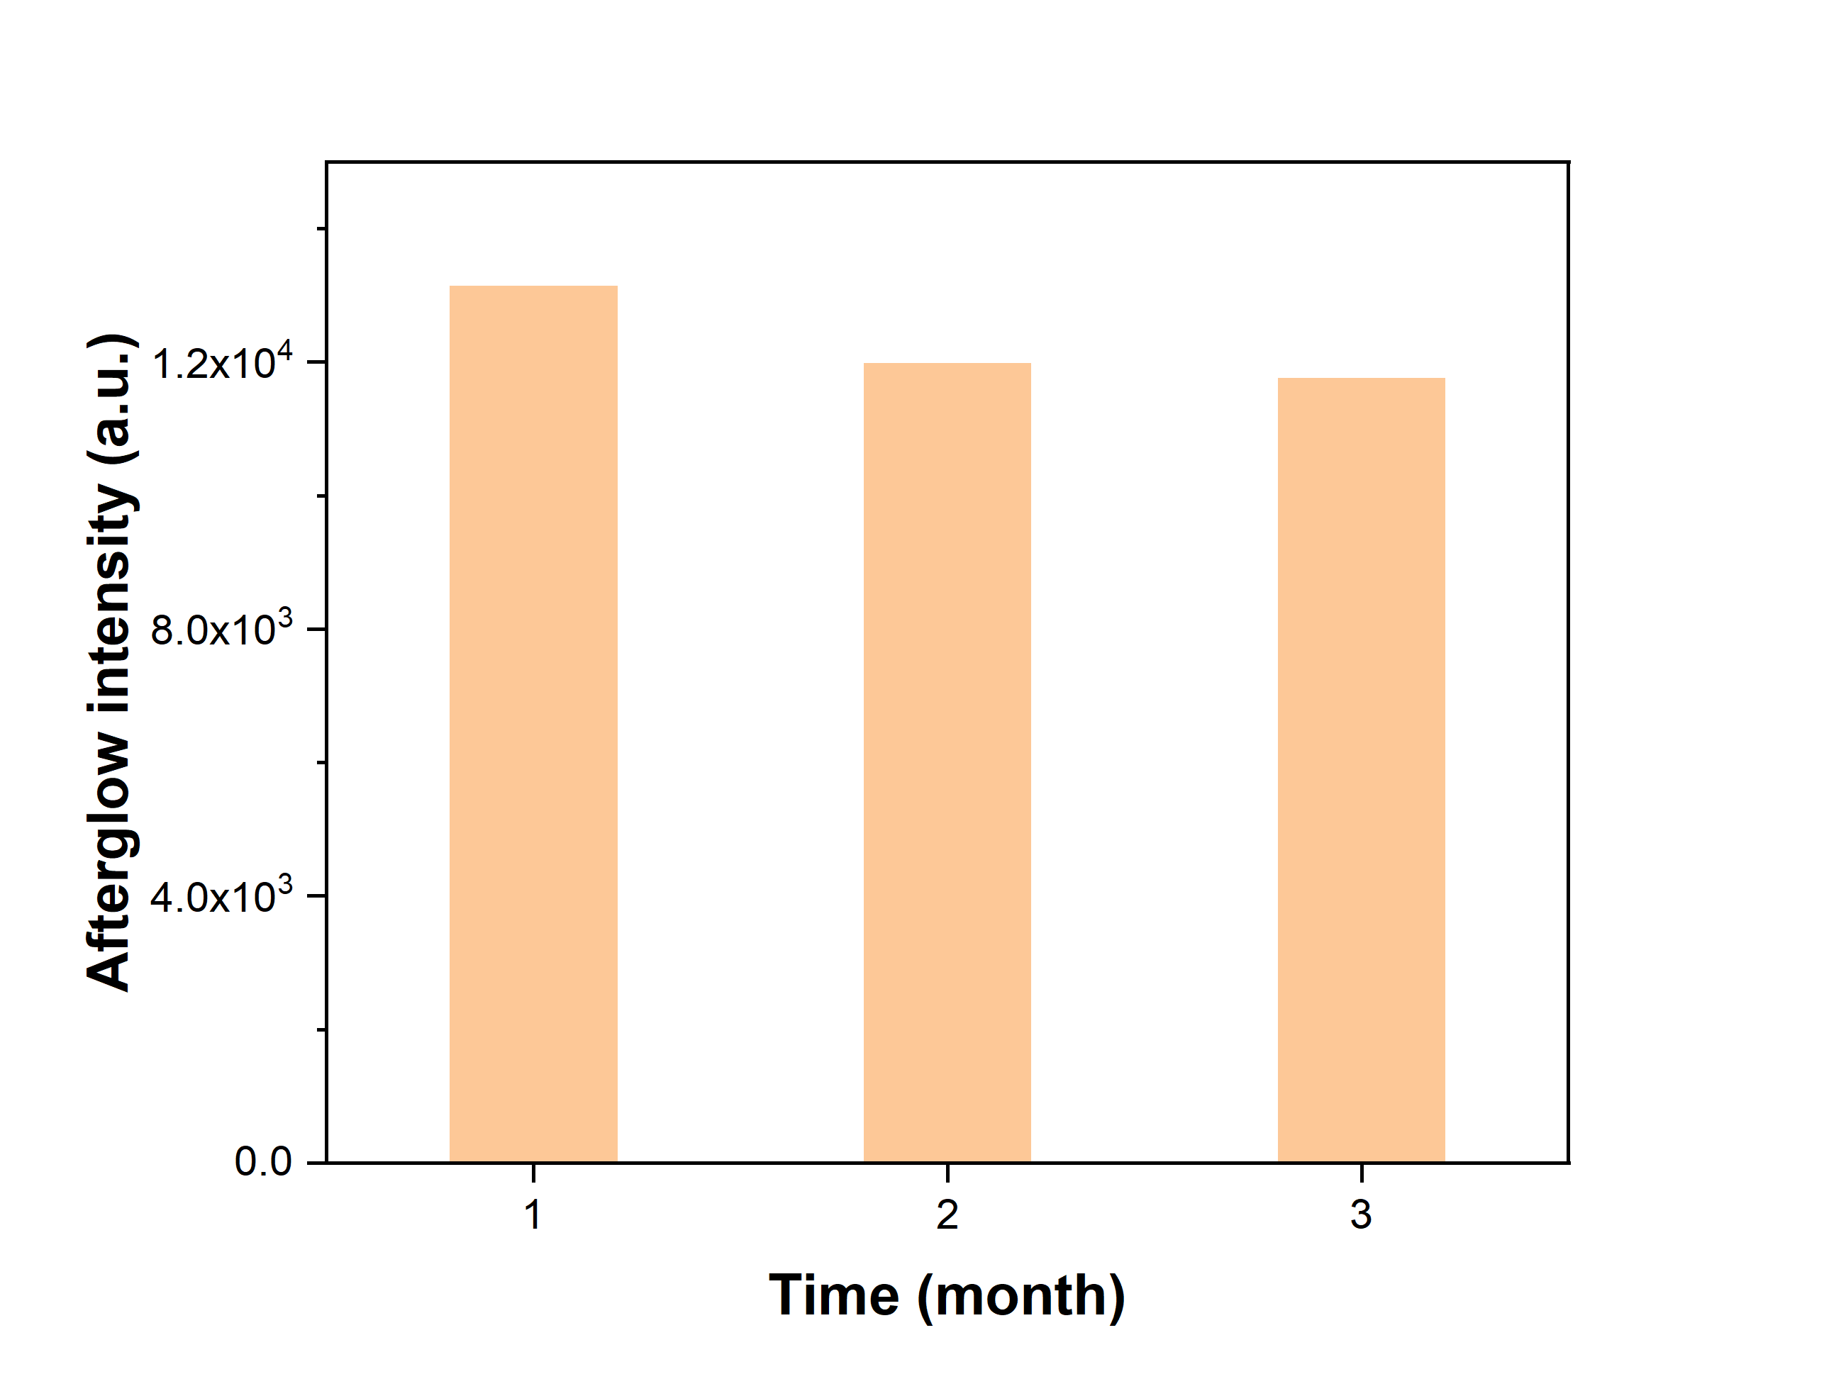
Figure S13. Afterglow intensity of bipolar PC film at a CU concentration of 12 mM stored in darkness for different time periods.

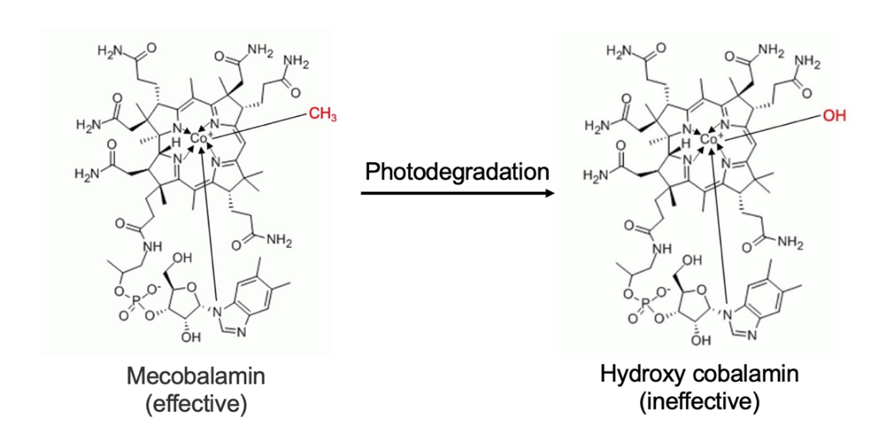
Figure S14. The chemical formula of mecobalamin and hydroxy cobalamin.

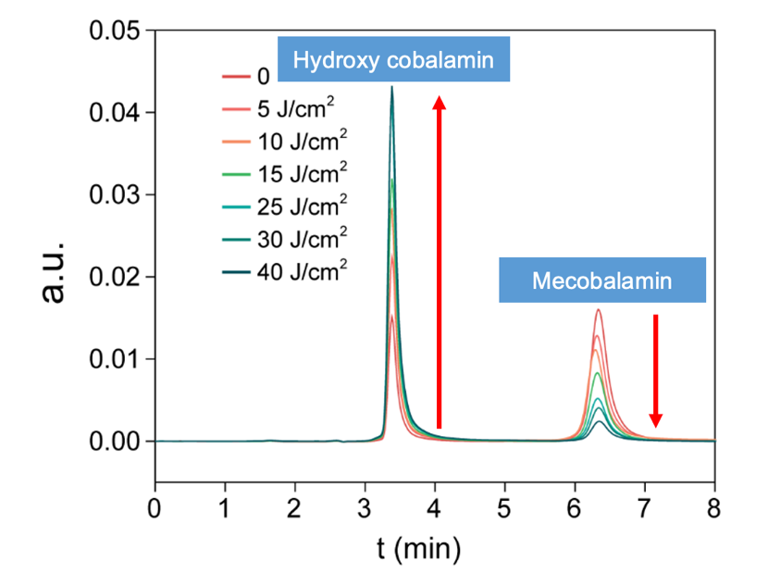
Figure S15. A typical HPLC (high performance liquid chromatograph) chromatogram of mecobalamin under different white light dose.

Reference
- Singh, S.; Ullman, E. F., Reversible Formation of Excited States in Intramolecular Donor Assisted Chemiluminescence Reactions of Dioxetanes. Chem. Commun. 2003, 1756-1757.

