Supplementary Material
Supplementary Part 1: cMOOP definitions
Supplementary Section 1.1
In this section, we describe the mathematical formulation of constrained multi-objective problem for silver nanoparticle synthesis, as well as further details on implementation of the experimental workflow.
We defined the optimization problem as the following:
$max\left\{\begin{aligned}y_{1}=min{\left(3,δ\left(A_{max}\left(t_{end}\right)\right)×log10\left(1-cosim(A\left(λ,t_{end}\right),A_{target}\left(λ,t_{end}\right)\right)\right)}/3 \\ y_{2}=\max_{t}\left(\frac{A_{max}\left(t \right)}{t}\right) \\ y_{3}=1-Q_{seed}\end{aligned}\right.$ (1)
$st \left\{\begin{aligned}c_{1}=0.3-\frac{Q_{AgNO3}}{Q_{AA}} ≤0 \\ c_{2}=2-\frac{Q_{AgNO3}}{Q_{AA}}-\frac{Q_{seed}}{Q_{AgNO3}}≤0 \\ 0.6{≤Q}_{tsc},Q_{ag},Q_{pva},Q_{seed},Q_{aa}≤24\end{aligned}\right.$ (2)
The objective functions are as stated in equation (1). $y_{1}$ represents the cosine similarity between the final absorbance spectrum of the sample and the target optical signature for the desired AgNP product, with gating function applied on $δ\left(A\right)$ to return non-zero results only in the operation range of the hyperspectral sensor, i.e., when $A∈[0.3:1.2]$. This is to ensure good accuracy of the spectral measurement due to equipment sensitivity and is an unknown constraint as we defined previously. $y_{2}$ represents the best reaction rate of the chemical condition. The reaction rate was calculated as the ratio between A_{max}, the maximal absorbance amplitude over the wavelengths and t, the reaction time. The best reaction rate is defined as the maximal reaction rate obtained over the reaction time. It indicates what would be the highest reaction rate achievable if the reactor was cut to its optimal length. Finally, $y_{3}$ returns the inverse of $Q_{seed}$ to minimize seed usage.
We also include 2 complex constraints as described in equation (2), as well as a set of box constraints for the inputs. These complex constraints are calculated based on the 5 inputs of the experimental system, the flowrates of silver seeds (Q_{seed}), silver nitrate (Q_{AgNO3}), ascorbic acid (Q_{AA}), trisodium citrate (Q_{TSC}) and polyvinyl alcohol (Q_{PVA}). These constraints are informed by domain expertise and are meant to prevent the algorithm from exploring the region of the decision space where secondary nucleation of AgNP would be more likely occur, leading to a high probability of clogging the microfluidic system. For candidates that violate constraints $c_{1}$ and $c_{2}$, they undergo post-repair after being selected for optimization and before evaluation, as follows:
$if c_{1}>0: Q_{AA}^{repaired}=min\left(\frac{Q_{AgNO3}^{suggested}}{0.3},Q_{AA}^{suggested}\right)$ (3)
$$if c_{2}>0: Q_{seed}^{repaired}=max\left(\left(2-\frac{Q_{AgNO3}^{suggested}}{Q_{AA}^{repaired}}\right).Q_{AgNO3}^{suggested},Q_{seed}^{suggested}\right)$$

If there are several suggested candidates with extremely low flow rates in a same batch, we shuffle all the candidates of the batch to minimize consecutive low flowrate samples. This aims to prevent retro diffusion of reactants into the input channels and potential clogging of the channels.

Supplementary Section 1.2
In this section, we describe the pseudo code for implementing EGBO. The prior distribution $D={\left\{x_{i},y_{i}\right\}}_{i=1}^{n}$ is separately fed through the EA algorithm in parallel, and the proposed solutions re-grouped again with the baseline stochastic QMC sampling $χ_{BO}$. To maximize exploitation as well as ease of integration with the respective EA libraries, we present only the top stochastic candidates utilizing the built in optimize_aqcf function from the BoTorch library to generate $χ_{BO}$. The combined candidate pool is then re-ranked again by evaluated acquisition value ${\hat{α}}_{qNEHVI}$.
Input: Reference point $r$, Prior distribution $D$, batch size $i$
Output: Proposed candidates $χ_{cand}$
1: $χ_{QMCpool}=ξ_{D}^{256}(x)$
2: $χ_{BO}={\hat{α}}_{qNEHVI}\left({\left\{χ_{QMCpool|r}\right\}}_{j=1}^{i}\right)$
3: repeat
4: $χ_{EA}=Selection+Crossover+Mutation(D_{t})$
5: until $\left|χ_{EA}\right|=256$
6: $χ_{pool}=χ_{BO}+χ_{EA}$
7: for $χ_{cand}<q$
8: if ${\hat{α}}_{qNEHVI}\left(χ_{pool,1|r}\right)>{\hat{α}}_{qNEHVI}\left(χ_{pool,2|r}\right)$ then
9: $χ_{cand}=χ_{pool,1}$
10: else
11: $χ_{cand}=χ_{pool,2}$
12: end if
13: end if

Supplementary Section 1.3
In this section, we list down all the equations for the synthetic problems applied in this work and supplementary. Table 1 describes the mathematical formulation and reference points set for the synthetic problems from ZDT [1] and MW [2] test suites, as well as 1 problem from DASCMOP [3]. All problems are bi-objective except for DASCMOP which has 3 objectives, and scalable $x∈{\left(0,1\right)}^{n}$ variables. Excluding results for dimensional contour, all other optimization runs are performed with $n=8$ variables which represents a reasonably difficult and practical number of experimental parameters for materials experimentation. Implementation of the synthetic problems was coded manually to wrap with BoTorch API.

Table 1: List of synthetic problems, where n_constr is the number of constraints, UPF is the unconstrained PF, CPF is the constrained PF, and ref_pt is the reference point set for HV computation. Mixed indicates that the constrained PF contains a mixture of convex and concave segments.
Name | n_constr | UPF | CPF | ref_pt
ZDT1 | 0 | Convex | - | [11, 11]
ZDT2 | 0 | Concave | - | [11, 11]
ZDT3 | 0 | Disconnected | - | [11, 11]
MW3 | 2 | Linear | Mixed | [1.1, 1.1]
MW5 | 3 | Concave | Discrete | [1.2, 1.2]
MW7 | 2 | Concave | Disconnected | [1.2, 1.2]
MW10 | 3 | Concave | Disconnected | [1.5, 1.5]
DASCMOP9 | 7 | Concave | Disconnected | [1.6, 1.6, 1.6]

ZDT1
$$\min\left\{\begin{aligned}f_{1}\left(x\right)=x_{1} \\ f_{2}\left(x\right)=g\left(x\right)h\left(f_{1},x\right)\end{aligned}\right.$$
$$g\left(x\right)=1+\frac{9}{n-1}\sum_{i=2}^{n}{x_{i}}$$
$$h\left(f_{1},g\right)=1-\sqrt{{f_{1}}/g}$$

ZDT2
$$\min\left\{\begin{aligned}f_{1}\left(x\right)=x_{1} \\ f_{2}\left(x\right)=g\left(x\right)h\left(f_{1},x\right)\end{aligned}\right.$$
$$g\left(x\right)=1+\frac{9}{n-1}\sum_{i=2}^{n}{x_{i}}$$
$$h\left(f_{1},g\right)=1-{\left({f_{1}}/g\right)}^{2}$$

ZDT3
$$\min\left\{\begin{aligned}f_{1}\left(x\right)=x_{1} \\ f_{2}\left(x\right)=g\left(x\right)h\left(f_{1},x\right)\end{aligned}\right.$$
$$g\left(x\right)=1+\frac{9}{n-1}\sum_{i=2}^{n}{x_{i}}$$
$$h\left(f_{1},g\right)=1-\sqrt{{f_{1}}/g}-\left({f_{1}}/g\right)sin\left(10πf_{1}\right)$$

MW3
$$\min\left\{\begin{aligned}f_{1}\left(x\right)=x_{1} \\ f_{2}(x)=g_{3}\left(1-{f_{1}}/{g_{3}}\right)\end{aligned}\right.$$
$$st\left\{\begin{aligned}c_{1}\left(x\right)=1.05-f_{1}-f_{2}+0.45sin{\left(0.75πl\right)}^{6}≥0 \\ c_{2}\left(x\right)=0.85-f_{1}-f_{2}+0.3sin{\left(0.75πl\right)}^{2}≤0\end{aligned}\right.$$
$$g_{3}=1+\sum_{i=m}^{n}{2{\left(x_{i}-{\left(x_{i-1}-0.5\right)}^{2}-1\right)}^{2}}$$
$$l=\sqrt{2}f_{1}-\sqrt{2}f_{2}$$

MW5
$$\min\left\{\begin{aligned}f_{1}\left(x\right)={g_{1}x}_{1} \\ f_{2}(x)=g_{1}\sqrt{1-{\left({f_{1}}/{g_{1}}\right)}^{2}}\end{aligned}\right.$$
$$st\left\{\begin{aligned}c_{1}\left(x\right)={\left(1.7-0.2sin\left(2l_{1}\right)\right)}^{2}-{f_{1}}^{2}-{f_{2}}^{2}≥0 \\ c_{2}\left(x\right)={\left(1+0.5sin\left(6{l_{2}}^{3}\right)\right)}^{2}-{f_{1}}^{2}-{f_{2}}^{2}≤0 \\ c_{3}\left(x\right)={\left(1-0.45sin\left(6{l_{2}}^{3}\right)\right)}^{2}-{f_{1}}^{2}-{f_{2}}^{2}≤0\end{aligned}\right.$$
$$g_{1}=1+\sum_{i=m}^{n}{\left(1-exp\left(-10{\left(z_{i}-0.5-{i-1}/{2n}\right)}^{2}\right)\right)}$$
$$z_{i}={x_{i}}^{n-m},x_{i}=\left(x_{m},…,x_{n}\right)$$
$$l_{1}=arctan\left({f_{2}}/{f_{1}}\right)$$
$$l_{2}=0.5π-2\left|arctan\left({f_{2}}/{f_{1}}\right)-0.25π\right|$$

MW7
$$\min\left\{\begin{aligned}f_{1}\left(x\right)={g_{3}x}_{1} \\ f_{2}(x)=g_{3}\sqrt{1-{\left({f_{1}}/{g_{3}}\right)}^{2}}\end{aligned}\right.$$
$$st\left\{\begin{aligned}c_{1}\left(x\right)={\left(1.2+0.4sin{\left(4l\right)}^{16}\right)}^{2}-{f_{1}}^{2}-{f_{2}}^{2}≥0 \\ c_{2}\left(x\right)={\left(1.15-0.2sin{\left(4l\right)}^{8}\right)}^{2}-{f_{1}}^{2}-{f_{2}}^{2}≤0\end{aligned}\right.$$
$$g_{3}=1+\sum_{i=m}^{n}{2{\left(x_{i}-{\left(x_{i-1}-0.5\right)}^{2}-1\right)}^{2}}$$
$$l=arctan\left({f_{2}}/{f_{1}}\right)$$

MW10
$$\min\left\{\begin{aligned}f_{1}\left(x\right)=g_{2}{x_{1}}^{n} \\ f_{2}(x)=g_{2}\left(1-{\left({f_{1}}/{g_{1}}\right)}^{2}\right)\end{aligned}\right.$$
$$st\left\{\begin{aligned}c_{1}\left(x\right)=\left(2-4{f_{1}}^{2}-f_{2}\right)\left(2-8{f_{1}}^{2}-f_{2}\right)≥0 \\ c_{2}\left(x\right)=\left(2-2{f_{1}}^{2}-f_{2}\right)\left(2-16{f_{1}}^{2}-f_{2}\right)≤0 \\ c_{3}\left(x\right)=\left(2-{f_{1}}^{2}-f_{2}\right)\left(1.2-1.2{f_{1}}^{2}-f_{2}\right)≤0\end{aligned}\right.$$
$$g_{2}=1+\sum_{i=m}^{n}{\left(1.5+\frac{0.1}{n}{z_{i}}^{2}-1.5cos\left(2πz_{i}\right)\right)}$$
$$z_{i}=1-exp\left(-10{\left(x_{i}-{i-1}/n\right)}^{2}\right),x_{i}=\left(x_{m},…,x_{n}\right)$$

DASCMOP9
$$min\left\{\begin{aligned}f_{1}\left(x\right)=cos\left(0.5πx_{1}\right)cos\left(0.5πx_{2}\right)+g\left(x\right) \\ f_{2}\left(x\right)=cos\left(0.5πx_{1}\right)sin\left(0.5πx_{2}\right)+g\left(x\right) \\ f_{3}\left(x\right)=sin\left(0.5πx_{1}\right)+g\left(x\right)\end{aligned}\right.$$
$$st\left\{\begin{aligned}c_{1}\left(x\right)=sin\left(aπx_{1}\right)-b≥0 \\ c_{2}\left(x\right)=cos\left(aπx_{2}\right)-b≥0 \\ c_{3}\left(x\right)=\left(e-g\left(x\right)\right)\left(g\left(x\right)-d\right)≥0 \\ c_{k+3}\left(x\right)=\sum_{j=1,j≠k}^{3}{{f_{j}}^{2}+{\left(f_{k}-1\right)}^{2}-r^{2}}≥0 \\ c_{7}\left(x\right)=\sum_{j=1}^{3}{{\left(f_{j}-1/{\sqrt{3}}\right)}^{2}}-r^{2}≥0\end{aligned}\right.$$
$$g\left(x\right)=\sum_{j=3}^{n}{{\left(x_{j}-cos\left(\frac{0.25j}{n}π\left(x_{1}+x_{2}\right)\right)\right)}^{2}}$$
$$a=20,d=0.5,k=1,2,3$$
$$η={\left(b+1\right)}/2,ζ=exp\left(d-e\right),γ=2r$$
(η, ζ, γ) is the difficulty triplet for tuning the problem, which was set to [0.75, 0.75, 0.75] for this work.

Supplementary Part 2: further analysis for the experimental AgNP cMOOP
In this part, we furnish additional plots and analysis of the optimization campaign for AgNP synthesis.
Supplementary Figure 2.1
Figure 2.1: Evolution of each objective of the AgNP cMOOP with the iteration number. Solid lines highlight the best objective value obtained from initialization up to the considered iteration.

Supplementary Figure 2.2
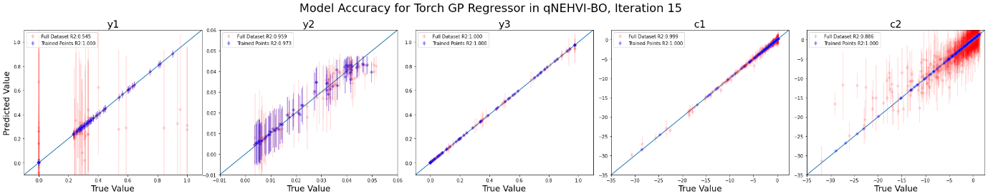
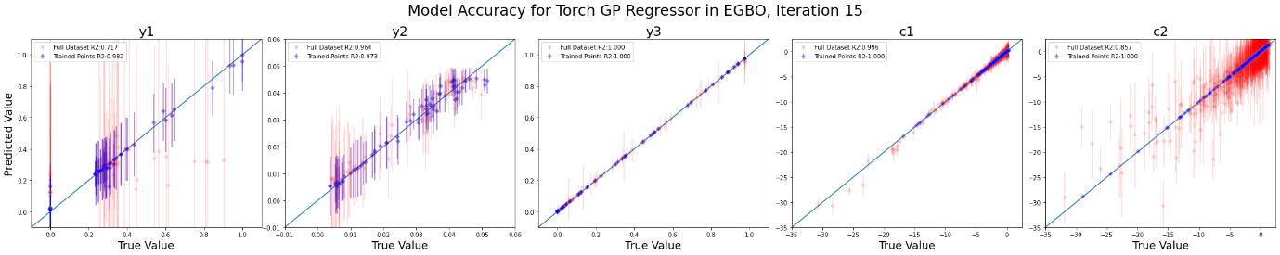
Figure 2.2: Gaussian process constraint predictions for the AgNP cMOOP after 15 iterations. The Gaussian process surrogate model prediction for algorithm qNEHVI-BO and EGBO at the 15th iteration. The predictions of the known and trained data points for each campaign are shown in blue, and the overall dataset (meaning points from both algorithms together) in red. Red points for constraints c1 and c2 also include the additional 256 virtual samples generated prior to start of experimental campaign as initialization.

Supplementary Figure 2.3

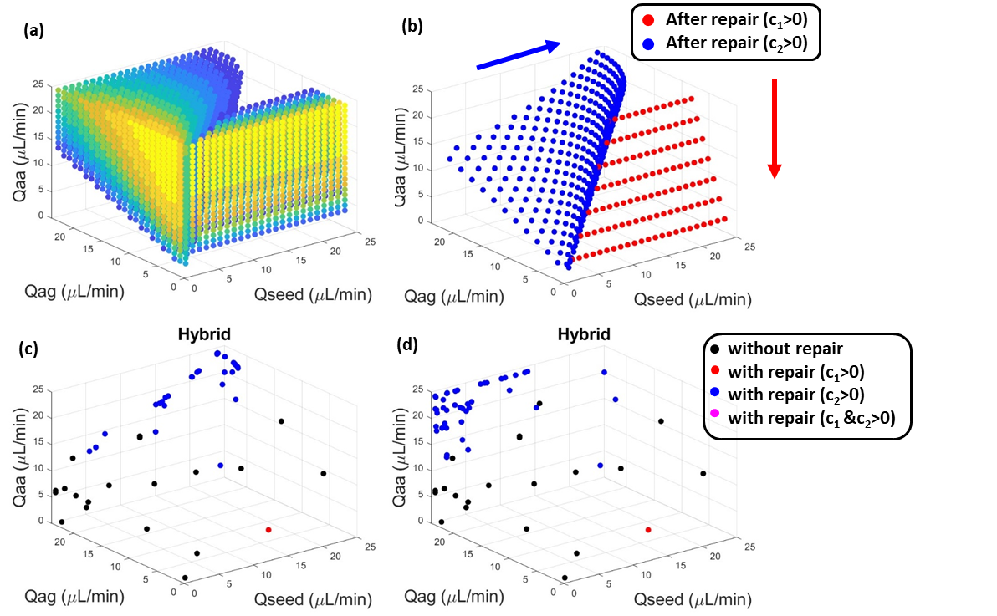
Figure 2.3: Repair operator for the AgNP cMOOP. (a) Location of the infeasible points, with their constraint violation intensity from low (blue) to high (yellow); (b) Projection of the infeasible points after repair, the red (resp. blue) arrow showing the projection direction for candidates violating the c₁ (resp. c₂) constraint; Location of the EGBO candidates (c) after repair and (d) before repair: the blue points violating the c₂ constraint are all projected along a same line.

Supplementary Figure 2.4
Figure 2.4: Surrogate model trained with the experimental data of the AgNP cMOOP. Data points are coloured following their y₁ value.
Supplementary Part 3: further analysis for the synthetic cMOOPs
This section provides further analysis on optimization performed for synthetic problems as listed above in section 1.3.
Supplementary Figure 3.1
Figure 3.1: Constraint violations (a) CV1 and (b) CV2 in the decision (top) and objective (bottom) spaces for n=2 MW7 problem. The true unconstrained POS and PF are highlighted in blue (dashed line), while the constrained POS and PF are highlighted in red (solid line). The feasible space is coloured in grey.

Supplementary Discussion 3.2
In this section, we compare the performance of EGBO (using U-NSGA-III) against qNEHVI-BO on other synthetic benchmarks as described in section 1.3. Like NSGA-III [4], [5], U-NSGA-III [6] considers non-dominated solutions that have the best distribution across all reference vectors. But it additionally includes a tournament selection that hierarchically ranks parents based on feasibility, optimality, and diversity, which increases selection pressure compared to NSGA-III random selection.
We also include a variant algorithm where the U-NSGA-III evolution component is replaced by MOEA/D-Epsilon [7], thereby named EGBO (MOEA/DIEpsilon). We evaluate the perform of these algorithms using the same metrics described by AKY Low et al. [8], namely probability density map, dimensional contour plots and also logHV.
It can be observed in Fig. 3.2.1 that both hybrid frameworks clearly outperform qNEHVI-BO in terms of logHV difference for the same evaluation budget. We attribute this to better exploitation of the entire PF given the 2 changes we have made: firstly, the evolution mechanism provides a secondary candidate pool which has solutions closer to PF, and secondly the hierarchical acquisition function is able to prioritize exploration with solutions that have higher expected HV improvement at the beginning to efficiently reach the PF, followed by exploitation with solutions that have higher predicted HV improvement to cover the PF. Notably, the MOEA/D-IEpsilon version was significantly superior for ZDT1 and ZDT2, as seen in Fig. 3.2.1a-b respectively, and conversely, performs poorly on ZDT3 in Fig. 3.2.1c where it was comparable to qNEHVI-BO. We discuss this further in Fig. 3.2.2.

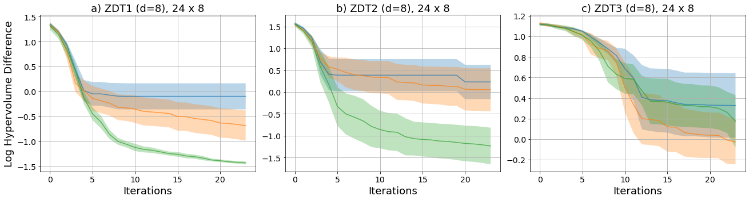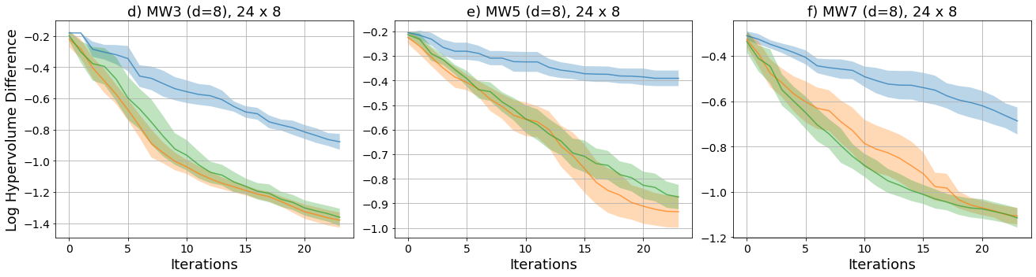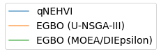
Figure 3.2.1: Mean of log HV difference for both hybrid optimizers as well as qNEHVI-BO for a) ZDT1 b) ZDT2 c) ZDT3 d) MW3 e) MW5 f) MW7. Shaded regions indicate a 95% confidence interval across 10 runs. We clearly see that both variants of EGBO outperform the original by 1-2 orders of magnitude.
The probability density maps presented in Fig. 3.2.2 illustrate the objective space and how the optimizers can resolve the PF over multiple runs. For all problems, solutions are distributed much closer to the PF for EGBO, irrespective of the EA chosen as compared to qNEHVI-BO. This indicates that the hybrid framework is superior in exploiting the PF, with lesser evaluation wastage (as indicated by solutions far away from PF). The hypothesis formulated based on the results reported in Fig. 3.2.1 is supported by the density results from Fig. 3.2.2, i.e., the integration of an evolutionary mechanism alongside a hierarchical acquisition can efficiently resolve the PF and balance the exploration-exploitation trade-off. We can also observe that there is a higher consistency of results as reflected by the brighter colours, indicating that the same solutions are being evaluated across different runs and initializations.
The MOEA/D-IEpsilon version slightly outperforms U-NSGA-III for ZDT1 and ZDT2, as seen in Fig. 3.2.2a-c where we can observe that the PF has better coverage. This reflects the better log HV difference score as shown previously in Fig. 3.2.1. We also note that in Fig. 3.2.2c that for ZDT3 which has a discontinuous PF, EGBO was unable to consistently sample from the middle regions, although they were able to better exploit the PF at the extrema. We hypothesize that the discontinuous objective landscape creates many local optima regions that causes the EA component to converge towards during the early iterations of the optimization process. This leads to EGBO to completely miss out on the middle regions across many runs, especially so for the MOEA/D-IEpsilon version. This is corroborated by the original MOEA/D paper [29] where it was shown to outperform NSGA-II in ZDT1 and ZDT2, but not in ZDT3, where the authors noted that “poor performance of MOEA/D on ZDT3 could be attributed to the fact that the objectives in ZDT3 are disparately scaled”. This appears to be a weakness of decomposition methods where neighbourhoods are unable to converge well if they are formed in between disconnected regions and should be considered for specific problems.
We also observe that for Fig. 3.2.2a-c that all 3 algorithms had a high preference for solutions at $x_{1}=0$ (as seen by the brighter colours along the extrema line). We attribute this to the way the test suite was constructed where $f_{1}\left(x\right)=x_{1}$. This is due to such extrema points being preferred when the reference point is set to be far away from the PF nadir. This is not observed for the MW test suite in Fig. 3.2.2d-f, where distribution of solutions was more balanced, since they are formulated as $f_{1}\left(x\right)=g(x)x_{1}$, where $g(x)$ represents a distance function used to adjust the PF. Interestingly, EGBO was also able to consistently resolve the constrained PF regions that are separated away from unconstrained PF, as can be seen by the brighter regions in Fig. 3.2.2d for MW3 problem.
We also note for the constrained problems in Fig. 3.2.2d-f, that while the hybrid frameworks maintain superior convergence towards the PF, there appears to be a high density of solutions within the infeasible regions (near the blue line). This is due to perturbation introduced by the crossover/mutation mechanism in proposing new candidates.

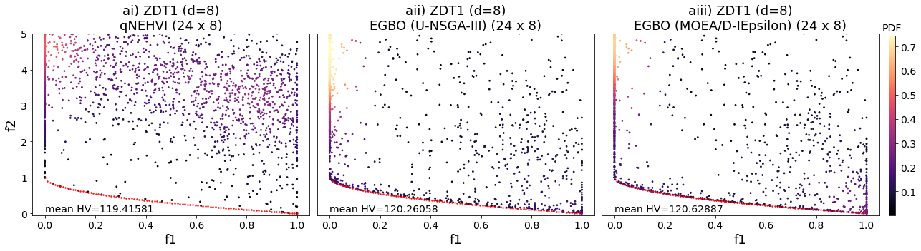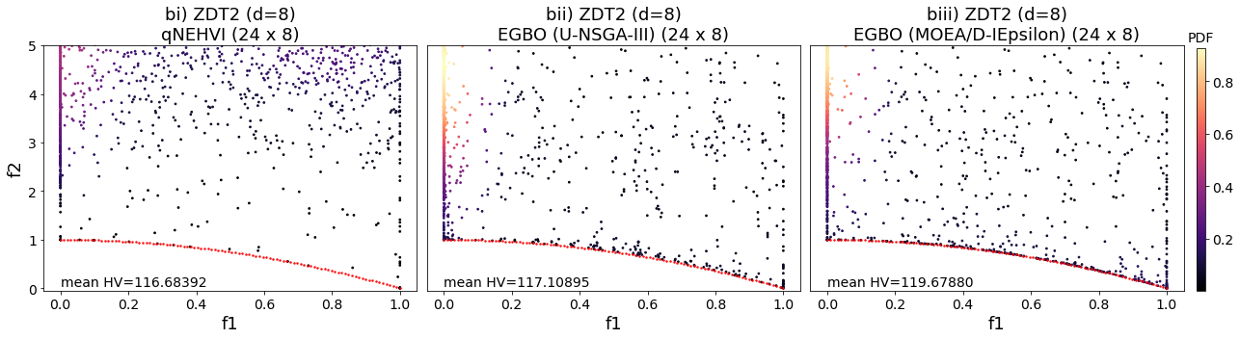 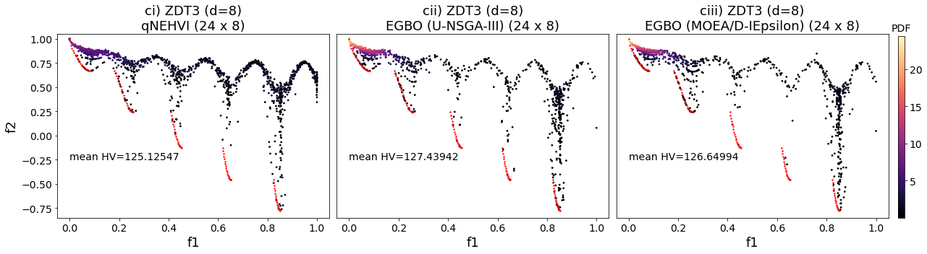 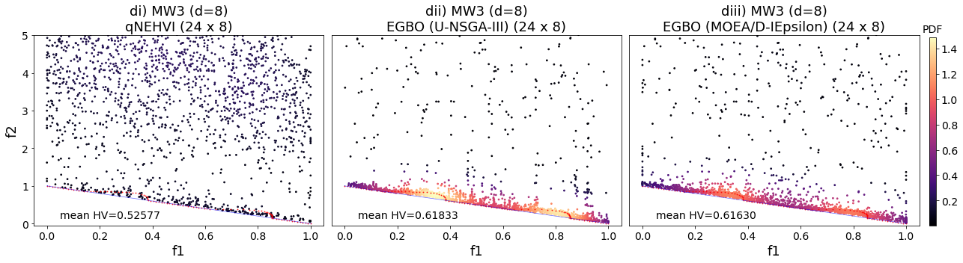 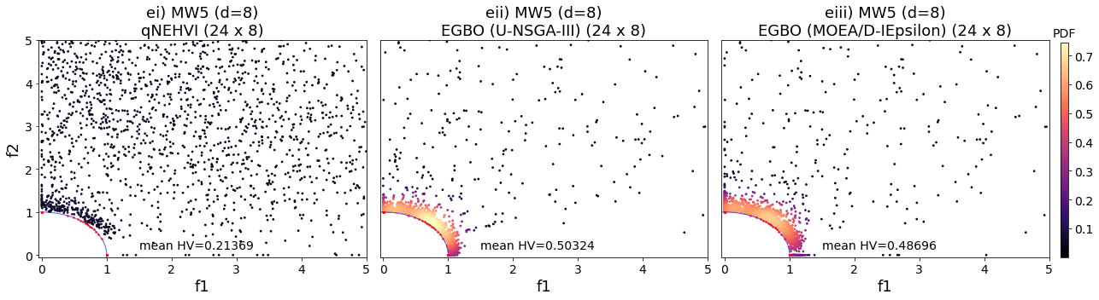 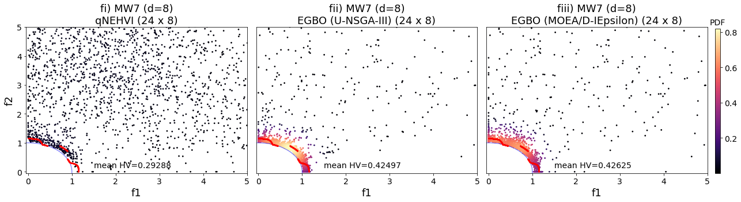 Figure 3.2.2: Probability density map for both hybrid optimizers as well as qNEHVI-BO for a) ZDT1 b) ZDT2 c) ZDT3 d) MW3 e) MW5 f) MW7. Brighter colours indicate a higher probability of occurrence across different runs. The true unconstrained PF is shown in red, with additional unconstrained PF for MW problems shown in blue. We can clearly observe much higher consistency of optimization for both hybrid frameworks, as well as lesser wastage of evaluations far away from the PF.
In Fig. 3.2.3, we can compare the speed of convergence and log HV difference score of the three optimizers across a range of dimensions. In other words, these plots provide a means of assessing their ability to perform at higher dimensionalities with respect to evaluation budget. Across all sub figures, both variants of EGBO were able to demonstrate higher convergence compared to qNEHVI-BO, which appears to plateau around 4 or so dimensions for most problems. The MOEA/D-IEpsilon version has much better scalability for ZDT1 and ZDT2, as seen in Fig. 3.2.3aiii and biii, where the -logHV score is clearly better even up to 12 dimensions, which corroborates our results in Fig. 3.2.1 and 3.2.2. We anticipate that EGBO would present superior results with good convergence for even higher dimensionalities if a larger evaluation budget was allowed, whereas qNEHVI-BO would not benefit.

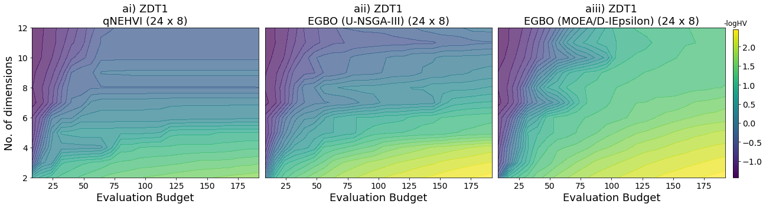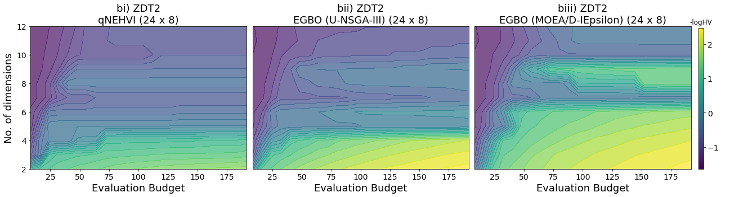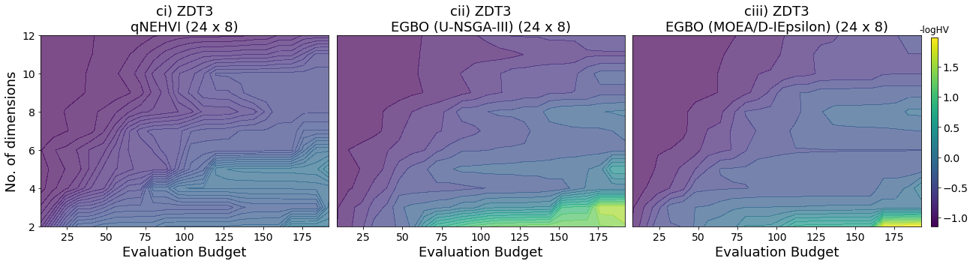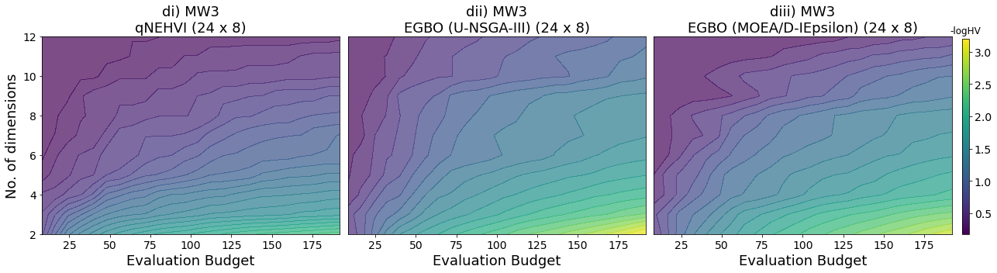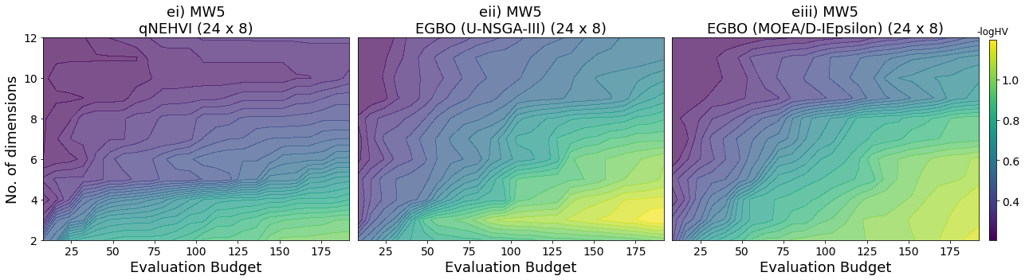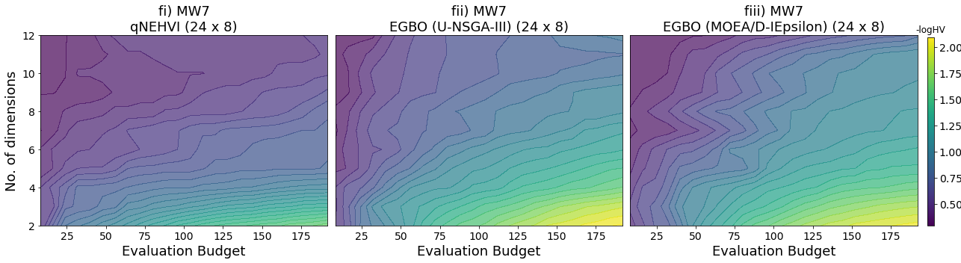
Figure 3.2.3: Dimensionality contour plots for both hybrid optimizers as well as qNEHVI-BO for a) ZDT1 b) ZDT2 c) ZDT3 d) MW3 e) MW5 f) MW7. Brighter colours indicate a better log HV difference score. Results here indicate that EGBO not only converge faster, as seen by the brighter colour at a lower evaluation budget, but also scale better to high dimensionality, as compared to qNEHVI-BO which plateaus earlier.
To further test the limits of EGBO, we attempt optimization on selected 2-objective and 3-objective problems MW10 and DASCMOP9 which we deemed as more difficult to resolve, either through hard objective functions, or exceptionally discontinuous objective landscapes which are more reflective of materials properties. DASCMOP allows for constraints to be tuned according to 3 different difficulties: feasibility, convergence, and diversity. Here, we set the difficulty triplet (η, ζ, γ) to [0.75, 0.75, 0.75], following the settings recommended by the authors.
Here, we only present results for probability density maps in Fig. 3.2.4 to illustrate and explain optimization on difficult problems, omitting the metrics for brevity of discussion. We clearly observe that it still maintains improvement in terms of over-exploration as compared to qNEHVI-BO, shown by the greater density of solutions closer to the PF. However, the U-NSGA-III variant appears to over-exploit for the given problems. In particular, Fig. 3.2.4aii indicates that it was consistently finding solutions close the unconstrained PF (in blue), where it then proceeded to exploit. However, the true constrained PF (in red) is very far away from those solutions, where EGBO failed to cross over and exploit. In comparison, the MOEA/D-IEpsilon appears to do marginally better as seen in Fig. 3.2.4aiii where there was a more even distribution of solutions. With respect to our discussion in Fig. 3.2.2 on why decomposition methods may fail for discontinous regions, we hypothesize that the overall larger feasible regions can be broken down into neighbourhoods, whereas ZDT3 is more disparate and fails to be resolved if neighbourhoods are formed in between segments.
As for DASCMOP9 in Fig. 3.2.4b, we also note that the U-NSGA-III variant of EGBO was consistently evaluating only a limited region of the PF, whereas qNEHVI-BO was able to provide more coverage, albeit across different runs. This suggests to us that extremely discontinuous objective landscapes require a higher preference for exploration and stochasticity, or perhaps simply higher batch sizes alongside larger evaluation budgets to have enough evaluations to resolve. Typically, benchmarking of such problems with EAs are done with much larger populations of 100-300 (which is analogous to evaluating hundreds of solutions per batch) that make it much more likely to have better coverage across the entire PF. Furthermore, they would rely on a greater evaluation budget, at orders of magnitude more. As such, while it may be difficult to resolve such problems, we can conclude that integrating the explorative capabilities of BO alongside the exploiting capabilities of EA does allow for more efficient optimization in this context and is relevant to materials experimentation.

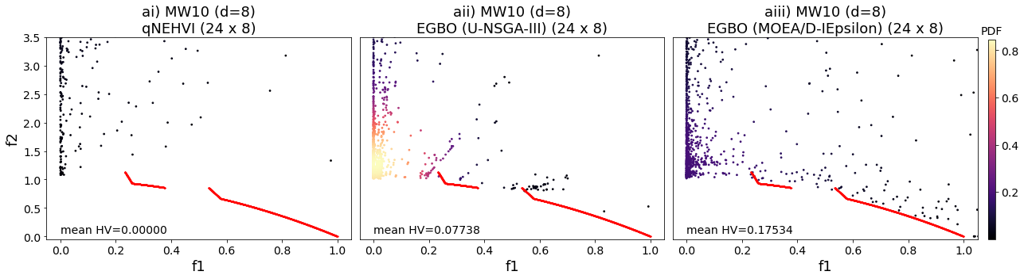

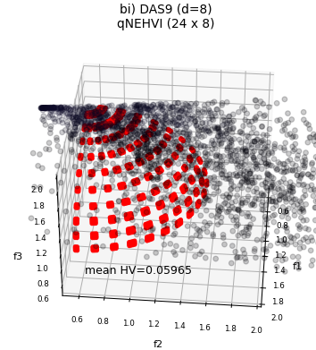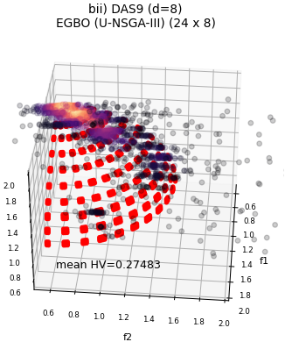
Figure 3.2.4: Probability density map for both hybrid optimizers as well as qNEHVI-BO for a) MW10 b) DASCMOP9. Brighter colours indicate a higher probability of occurrence across different runs. The true unconstrained PF is shown in red, with additional unconstrained PF for MW problems shown in blue. EGBO (MOEA/D-IEpsilon) was omitted for DASCMOP9 as the algorithm did not have package requirements that were compatible with our framework in solving 3-objective problems. We also omitted the unconstrained PF as well as PDF colour bar for DASCMOP9 for brevity. In general, the results indicate less over-exploration by EGBO, although it was unable to consistently resolve all disconnected regions.
The previous section has demonstrated the ability of EGBO to deal with several crucial considerations: wastage, feasibility, diversity of non-dominated solutions. Here we extend our study to 2 other real-world problems which are also bi-objective, thin film [9] and concrete [10]. The extracted datasets are used to train appropriate regressors to simulate the objective landscape, following the implementation detailed in AKY Low et al [8].
For the 2 problems selected, both variants of EGBO outperformed qNEHVI-BO, which is consistent with supports the results obtained for synthetic benchmarks. This is shown in Fig. 3.2.5 which illustrates the log HV difference on both thin film and concrete problems. For the concrete problem, which has higher dimensionality at $n=7$, this was indeed the case, however the U-NSGA-III version was marginally worse, but given the trend observed in Fig. 3.2.5b, it is likely that it would reach the same log HV difference given enough iterations.

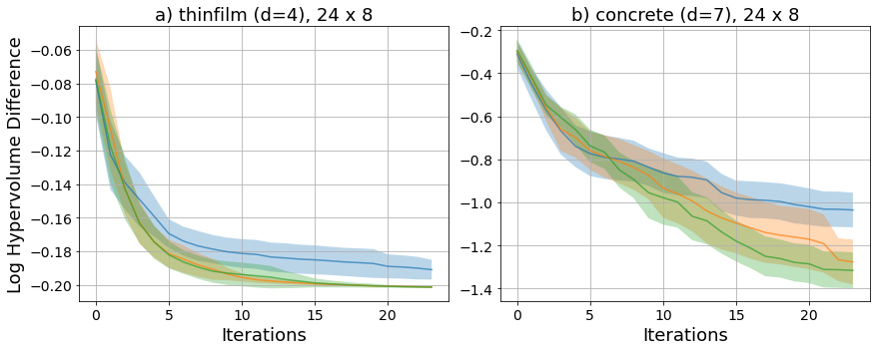
Figure 3.2.5: Mean of log HV difference for both hybrid optimizers as well as qNEHVI-BO for a) thin film and b) concrete. Shaded regions indicate a 95% confidence interval across 10 runs. HV_{max} is determined by taking the PF generated from NSGA-II with 500 generations with 100 population. EGBO shows improvement over the original.
Based on Fig. 3.2.6, it can be observed that both hybrid frameworks were also able to ensure efficient exploitation of the PF, particularly for the thin film problem as seen in Fig. 3.2.6aii and aiii, where the bright regions indicate that with the limited evaluation budget, the algorithms were able to consistently reach and flesh out most of the PF. Furthermore, there is a notable improvement in evaluation wastage as compared to qNEHVI-BO, with fewer non-optimal solutions.
As for the concrete problem, while both frameworks did outperform qNEHVI-BO, it is apparent that they were unable to fully exploit the PF consistently, as seen by the disparate solutions that exist along the estimated PF represented by the red line. From the results presented, it seems that the concrete dataset problem is a much more difficult to solve than the thin film dataset optimization problem. The underlying objective landscape appears to have many local optima points within a region near slump≈30, which all 3 optimizers tend to sample mostly from.
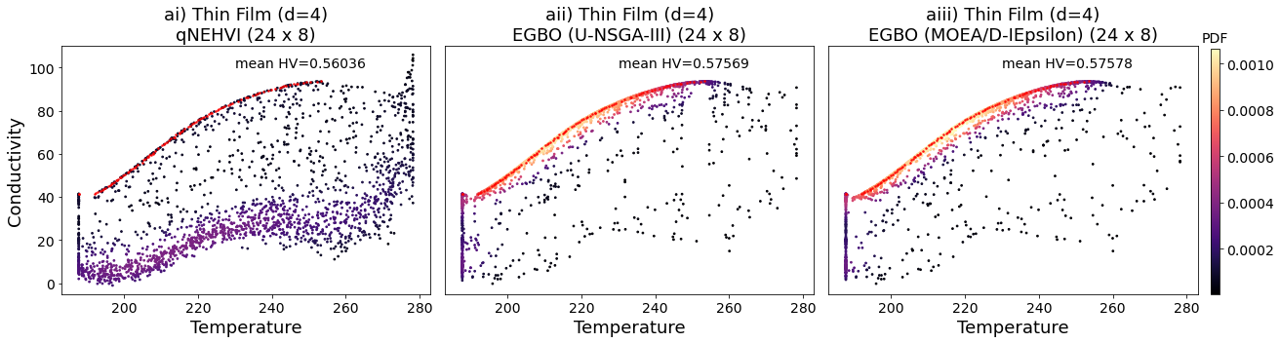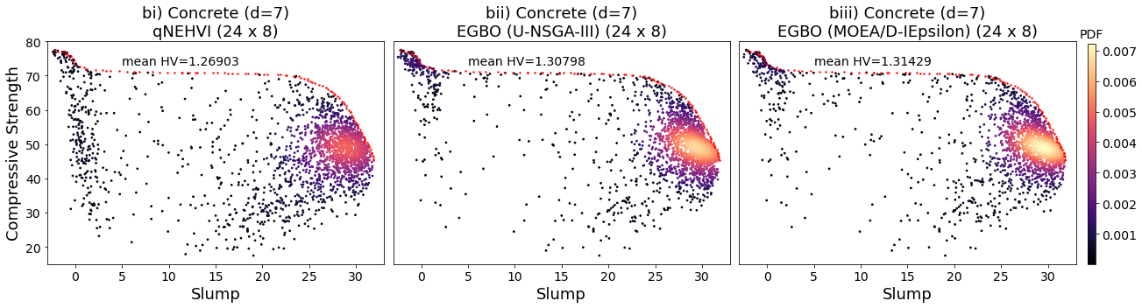
Figure 3.2.6: Probability density map for both hybrid optimizers as well as qNEHVI-BO for a) thin film and b) concrete. Brighter colours indicate a higher probability of occurrence across different runs. The PF is shown in red and is generated from NSGA-II with 500 generations with 100 population. Results here indicate better exploitation of the PF by EGBO.

Supplementary Section 3.3
Further variations of the EGBO framework were investigated. We tested two different EAs in the EGBO framework: U-NSGA-III and MOEA/D-IEpsilon. And for each of these EAs, we propose to use in parallel either the original qNEHVI-BO or qNEHVI-Sobol. qNEHVI-BO follows the optimization procedure for optimization on the qNEHVI acquisition function as per the original implementation in BoTorch [11], [12], while qNEHVI-Sobol greedily maximizes on a discrete pool of Sobol samples. Results are reported in Fig. 3.3 for the synthetic problem MW7 performed at $n=8$, following the same protocol as for Fig. 3 in the main article. We see that U-NSGA-III and MOEA/D-IEpsilon achieve comparable performance. And even if qNEHVI-Sobol is less exploitative than qNEHVI-BO, the EGBO made of qNEHVI-Sobol has a performance similar to EGBO made of qNEHVI-BO. This shows that the good performance comes from the framework, and not from the individual performance of each algorithm.
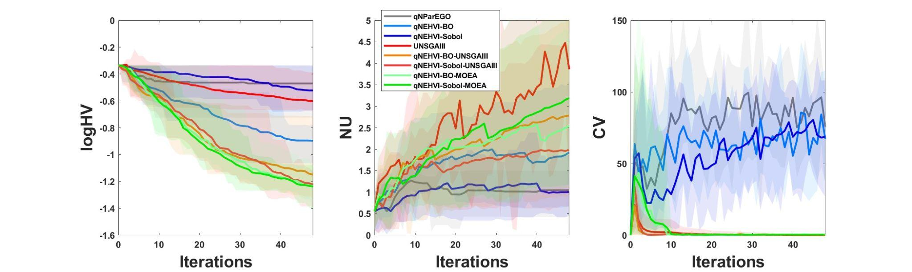
Figure 3.3.1: Performance of other algorithms on MW7 problem, using the 3 metrics of logHV, NU and CV as described in the main manuscript. The results illustrate that the hybrid framework of EGBO, regardless of the EA component strongly outperforms the baseline of either qNEHVI-BO or qNEHVI-Sobol in terms of reaching the PF, attaining good coverage of the PF, as well as minimizing infeasible samples.
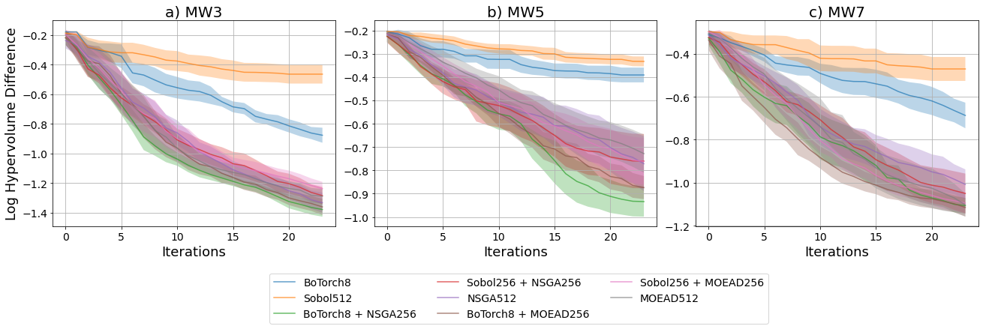
Figure 3.3.2: Log hypervolume difference for different optimization workflows, with mean and 2 standard deviations reported for problems MW3 (a), MW5 (b) and MW7 (c).

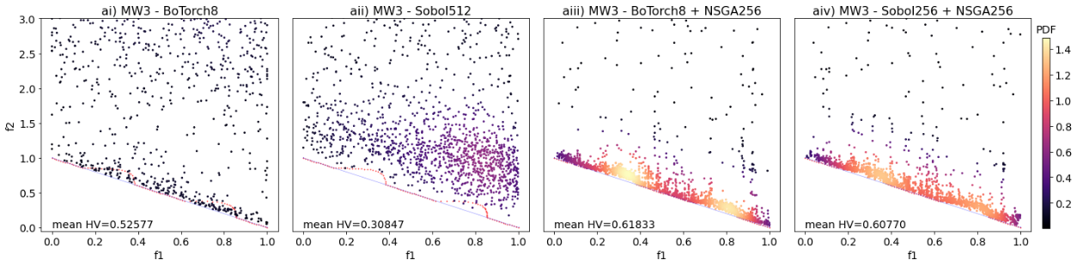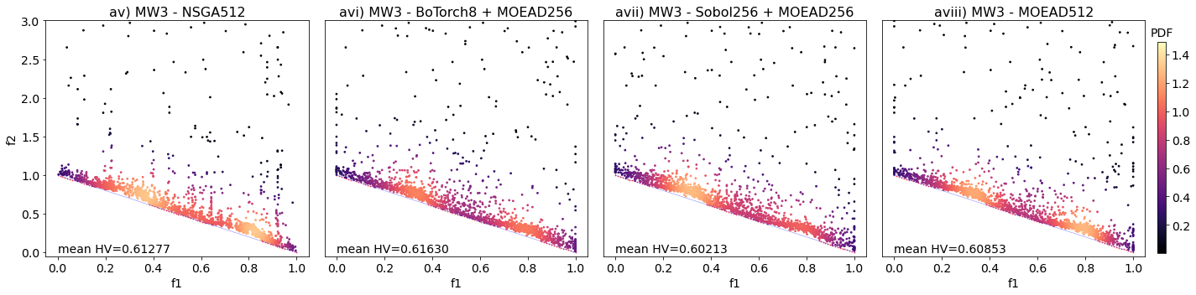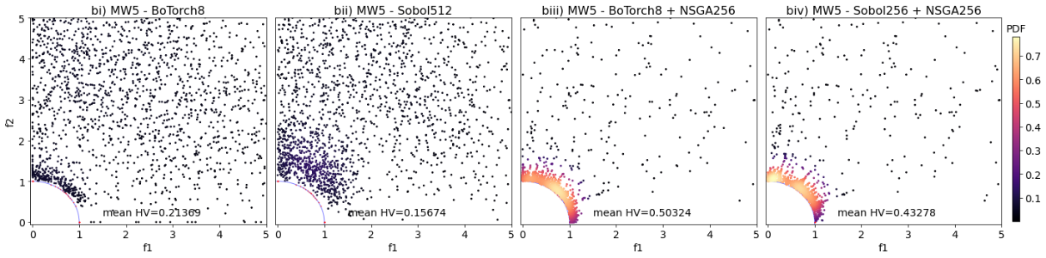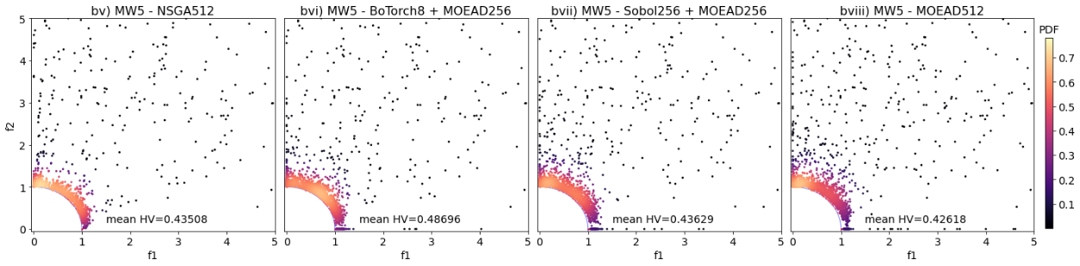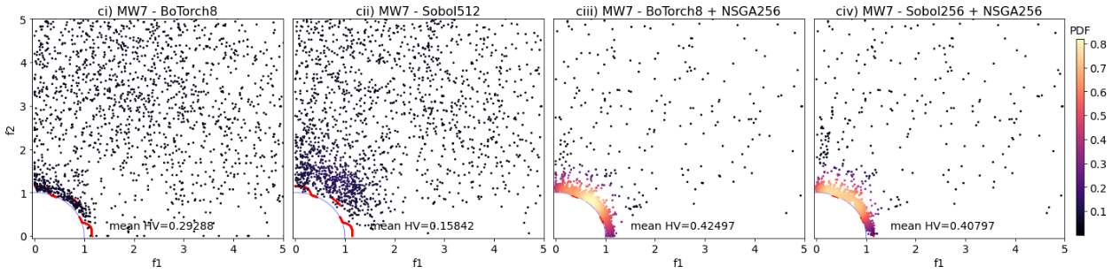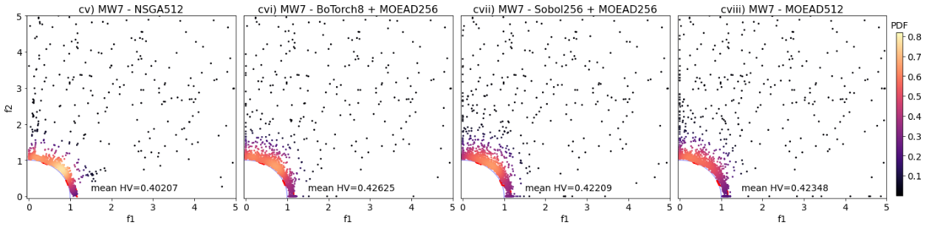
Figure 3.3.3: Probability density maps in objective space for 10 runs of 24 iterations × 8 points per batch for problems MW3 (a), MW5 (b) and MW7 (c). Solutions are colored by their respective probability density value, normalized for each given problem. The true PF is represented in red, with unconstrained PF for MW3, 5, 7 additionally shown in blue. The mean HV score is also reported across all runs.
References
[1] E. Zitzler, K. Deb, and L. Thiele, “Comparison of multiobjective evolutionary algorithms: Empirical results,” Evol Comput, vol. 8, no. 2, pp. 173–195, 2000.
[2] Z. Ma and Y. Wang, “Evolutionary constrained multiobjective optimization: Test suite construction and performance comparisons,” IEEE Transactions on Evolutionary Computation, vol. 23, no. 6, pp. 972–986, 2019.
[3] Z. Fan et al., “Difficulty adjustable and scalable constrained multiobjective test problem toolkit,” Evol Comput, vol. 28, no. 3, pp. 339–378, 2020.
[4] K. Deb and H. Jain, “An evolutionary many-objective optimization algorithm using reference-point-based nondominated sorting approach, part I: solving problems with box constraints,” IEEE transactions on evolutionary computation, vol. 18, no. 4, pp. 577–601, 2013.
[5] H. Jain and K. Deb, “An evolutionary many-objective optimization algorithm using reference-point based nondominated sorting approach, part II: Handling constraints and extending to an adaptive approach,” IEEE Transactions on evolutionary computation, vol. 18, no. 4, pp. 602–622, 2013.
[6] H. Seada and K. Deb, “U-NSGA-III: a unified evolutionary optimization procedure for single, multiple, and many objectives: proof-of-principle results,” in International conference on evolutionary multi-criterion optimization, Springer, 2015, pp. 34–49.
[7] Z. Fan et al., “An improved epsilon constraint-handling method in MOEA/D for CMOPs with large infeasible regions,” Soft comput, vol. 23, no. 23, pp. 12491–12510, 2019, doi: 10.1007/s00500-019-03794-x.
[8] A. K. Y. Low, E. Vissol-Gaudin, Y.-F. Lim, and K. Hippalgaonkar, “Mapping pareto fronts for efficient multi-objective materials discovery,” Journal of Materials Informatics, vol. 3, no. 2, p. 11, 2023, doi: 10.20517/jmi.2023.02.
[9] B. P. MacLeod et al., “A self-driving laboratory advances the Pareto front for material properties,” Nat Commun, vol. 13, no. 1, pp. 1–10, 2022.
[10] I.-C. Yeh, “Modeling slump of concrete with fly ash and superplasticizer,” Computers and Concrete, An International Journal, vol. 5, no. 6, pp. 559–572, 2008.
[11] S. Daulton, M. Balandat, and E. Bakshy, “Parallel bayesian optimization of multiple noisy objectives with expected hypervolume improvement,” Adv Neural Inf Process Syst, vol. 34, pp. 2187–2200, 2021.
[12] M. Balandat et al., “BoTorch: a framework for efficient Monte-Carlo Bayesian optimization,” Adv Neural Inf Process Syst, vol. 33, pp. 21524–21538, 2020.

We maintain only the top 8 candidates from optimize_acqf to minimize computational load from BoTorch. We note that for a GTX1650 with 4GB memory, it is unable to allocate enough memory space past 12 candidates following this workflow.

