Table 1. Structure and properties of phytochemical compounds of Hyptis suaveolens and Plectranthus ampoinicus (ligand compounds) retrieved from PubChem database (https://pubchem.ncbi.nlm.nih.gov/).

S. No. | Plant source | Compound Structure | Compound name and ID | Molecular formula | Molecular weight (g/mol)
1. | Hyptis suaveolens | 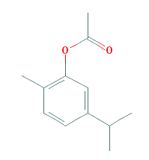 | Carvacryl acetate  (80792) | C₁₂H₁₆O₂ | 192.25
2. | H. suaveolens | 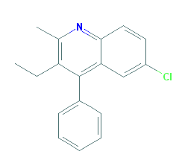 | 6-Chloro-3-ethyl-2-methyl-4-phenylquinoline  (624600) | C₁₈H₁₆ClN | 281.8
3. | H. suaveolens | 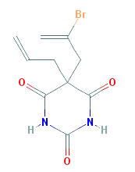 | Brallobarbital  (68416) | C₁₀H₁₁BrN₂O₃ | 287.11
4. | H. suaveolens | 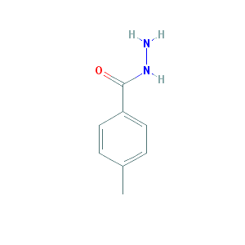 | 4-methylbenzohydrazide (77174) | C₈H₁₀N₂O | 150.18
5. | H. suaveolens | 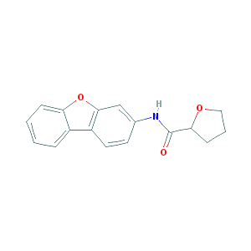 | N-dibenzofuran-3-yloxolane-2-carboxamide (4916597) | C₁₇H₁₅NO₃ | 281.3
6. | H. suaveolens | 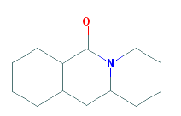 | Dodecahydropyrido [1,2-b] isoquinolin-6-one (610048) | C₁₃H₂₁NO | 207.31
7. | H. suaveolens | 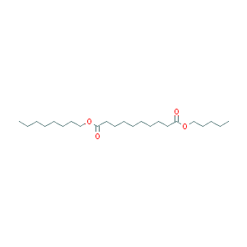 | Sebacic acid, octyl pentyl ester (91729267) | C₂₃H₄₄O₄ | 384.6
8. | H. suaveolens | 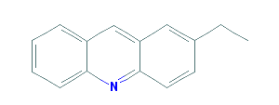 | 2-Ethylacridine (610161) | C₁₅H₁₃N | 207.27
9. | H. suaveolens | 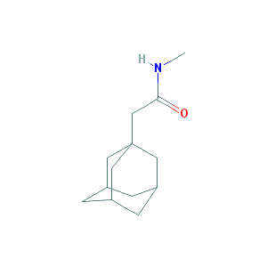 | N-Methyl-1-adamantaneacetamide (610088) | C₁₃H₂₁NO | 207.31
10. | H. suaveolens | 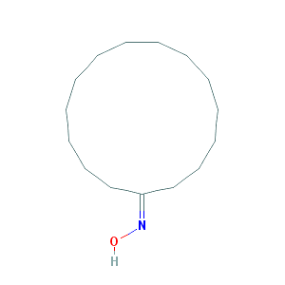 | Cyclopentadecanone Oxime (551985) | C₁₅H₂₉NO | 239.4
11. | H. suaveolens | 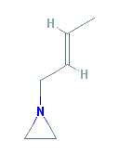 | 1-[(E)-but-2-enyl] aziridine (5362969) | C₆H₁₁N | 97.16
12. | H. suaveolens | 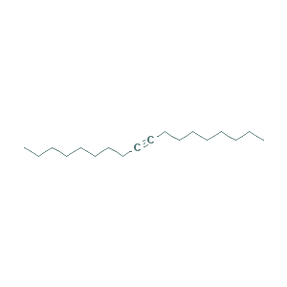 | 9-Octadecyne (141998) | C₁₈H₃₄ | 250.5
13. | H. suaveolens | 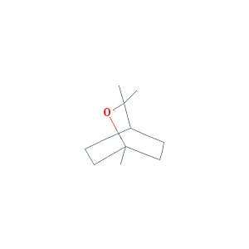 | Eucalyptol (2758) | C₁₀H₁₈O | 154.25
14. | H. suaveolens | 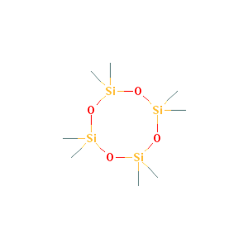 | Cyclotetrasiloxane, octamethyl-  (11169) | C₈H₂₄O₄Si₄ | 296.61
15. | Plectranthus ampoinicus | 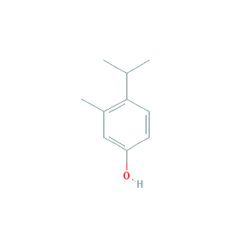 | 3-Methyl-4-isopropylphenol  (18597) | C₁₀H₁₄O | 150.22
16. | P. ampoinicus | 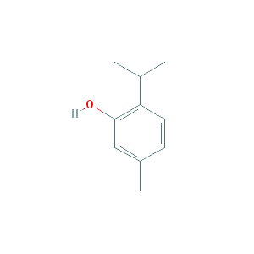 | Thymol (6989) | C₁₀H₁₄O | 150.22
17. | P. ampoinicus | 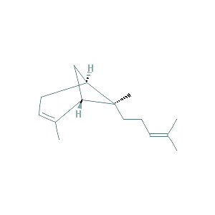 | Trans-alpha-Bergamotene  (6429302) | C₁₅H₂₄ | 204.35
18. | P. ampoinicus | 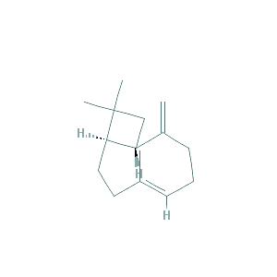 | Caryophyllene (5281515) | C₁₅H₂₄ | 204.35

