Supplemental Material
Table S2. Phenotypic and genetic association of BMI with IGF-1
stratification | N | Observational association |  |  |  | Genetic association (Model 1) |  |  |  | Sensitivity analysis (Model 2)
stratification | N | Beta(95%CI) | P linear | P non-linear |  | Beta(95%CI) | P linear | P non-linear |  | Beta(95%CI) | P linear | P non-linear
Total | 244,991 | -0.107(-0.112, -0.102) | < 2×10⁻¹⁶ | <0.001 |  | -0.004(-0.049, 0.041) | 0.867 | 4.93×10⁻⁶ |  | -0.006(-0.046,0.045) | 0.979 | 9.45×10⁻⁵
gender stratification
Male | 119,362 | -0.094(-0.102, -0.087) | < 2×10⁻¹⁶ | <0.001 |  | -0.028(-0.035, 0.092) | 0.379 | 2.08×10⁻⁶ |  | -0.028(-0.036,0.093) | 0.385 | 7.94×10⁻⁶
Female | 125,629 | -0.109(-0.116, -0.102) | < 2×10⁻¹⁶ | <0.001 |  | -0.032(-0.096, 0.032) | 0.327 | 0.05 |  | -0.026(-0.092,0.04) | 0.44 | 0.048
age stratification
39-50 | 65,698 | -0.099(-0.108, -0.089) | < 2×10⁻¹⁶ | <0.001 |  | 0.092(0.014, 0.197) | 0.021 | 0.004 |  | 0.063(-0.026,0.152) | 0.164 | 0.001
50-60 | 87,942 | -0.127(-0.135, -0.118) | < 2×10⁻¹⁶ | <0.001 |  | -0.047( -0.12, 0.027) | 0.215 | 0.026 |  | -0.112(-0.197, -0.027) | 0.001 | 0.012
60-73 | 91,351 | -0.082(-0.091, -0.074) | < 2×10⁻¹⁶ | <0.001 |  | -0.047(-0.13, 0.035) | 0.26 | 0.005 |  | -0.089(-0.186,0.007) | 0.069 | 0.032

Notes:
P non-linear: The P non-linear is the Quadratic P-value reported in piecewise MR.
Model 1: Model 1 used the BMI-PRS constructed with 96 SNPs as instrumental variables, with adjusted covariates including age, sex, assessment center, and top 10 genetic principal components.
Model 2: Model 2 used the BMI-PRS constructed with the remaining 75 SNPs after the removal of outliers by Radial MR, with adjusted age, sex, smoking status, alcohol drinking status, MET, assessment center, and top 10genetic principal components.
Table S3. Robustness verification for non-linear Mendelian randomization

stratification | N | Doubly-ranked method |  |  | Log transformation method
stratification | N | Quadratic P-value | Cochran Q P-value |  | Quadratic P-value | Cochran Q P-value
Total | 244,991 | 1.81×10⁻⁴ | 5.74×10⁻⁴ |  | 1.42×10⁻⁴ | 6.49×10⁻⁴
gender stratification
Male | 119,362 | 7.19×10⁻⁴ | 1.61×10⁻³ |  | 1.34×10⁻³ | 4.87×10⁻³
Female | 125,629 | 0.060 | 0.146 |  | 0.049 | 0.076
age stratification
39-50 | 65,698 | 0.004 | 0.011 |  | 0.003 | 0.013
50-60 | 87,942 | 0.113 | 0.271 |  | 0.044 | 0.131
60-73 | 91,351 | 0.025 | 0.044 |  | 0.017 | 0.033

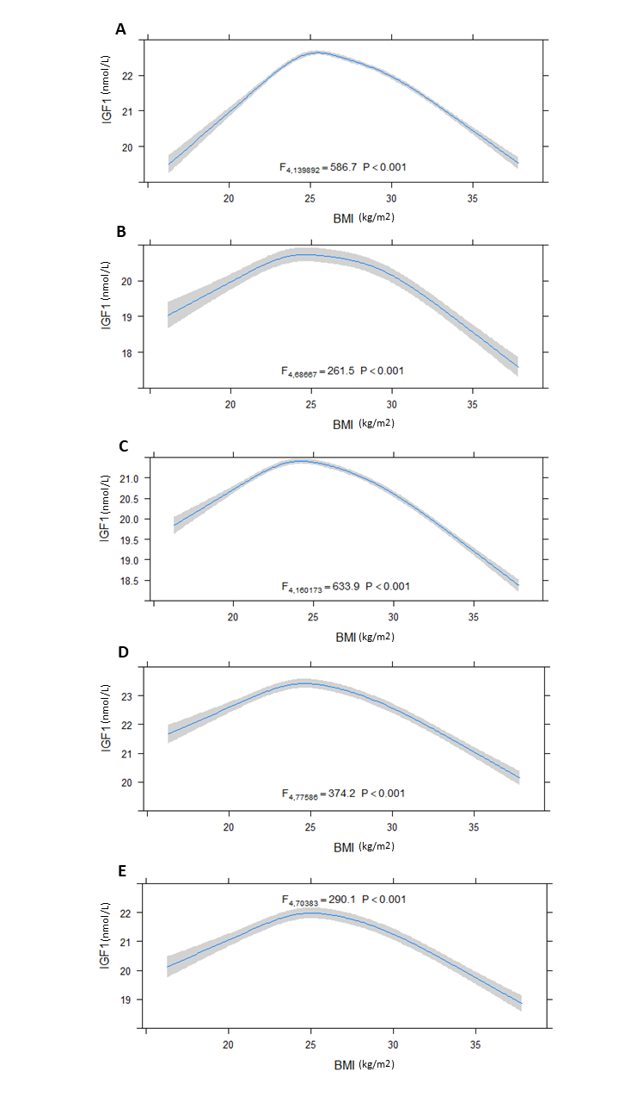
Figure S1. Restricted cubic spline model stratified by sex and age
Notes: A. observational associations in male; B. observational associations in female; C. observational associations in ages 39-50; D. observational associations in ages 50-60; E. observational associations in ages 60-73; Restricted cubic spline model adjusted for age、sex、smoking、alcohol、assessment center、MET and TDI.

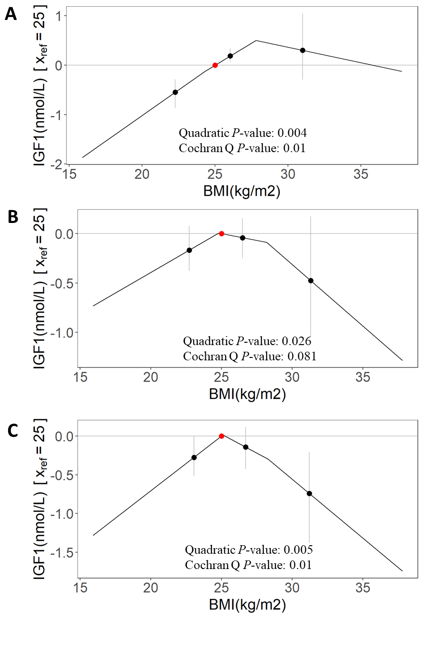
Figure S2. Non-linear MR stratified by age
Notes: A. non-linear genetic associations in ages of 39-50; B. non-linear genetic associations in ages of 50-60; C. non-linear genetic associations in ages of 60-73; Non-linear MR adjusted for age、sex、assessment center and top 10 genetic principal components. Stratums with significant LACE are marked. The red dot represents the reference point of BMI (25kg/m²).

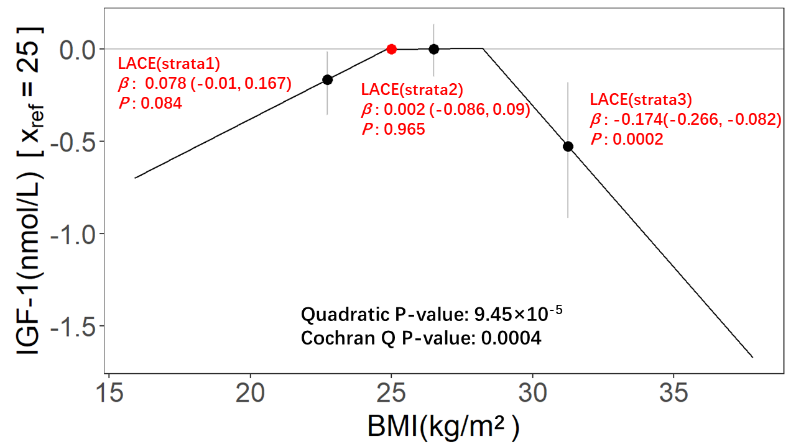
Figure S3. Non-linear Mendelian randomization for sensitivity analyses in the total sample.
Notes: BMI-PRS consists of 75 SNPs, the model adjusted for age, sex, assessment center, smoking status, alcohol drinking status, MET, and top 10 genetic principal components. The red dot represents the reference point of BMI (25kg/m²).

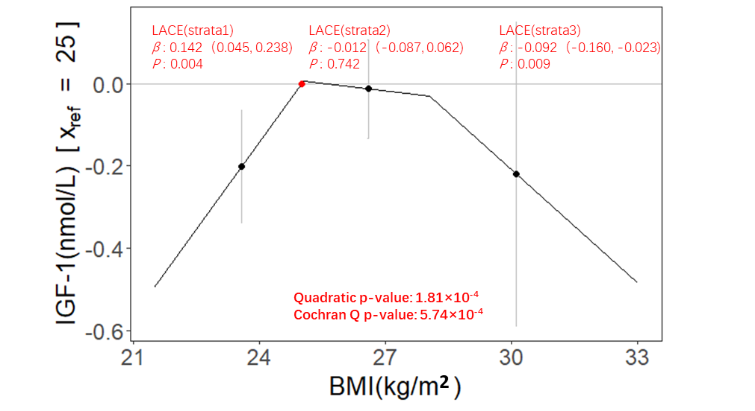
Figure S4. Non-linear Mendelian randomization for robustness verification with the doubly-ranked stratification method.
Notes: BMI-PRS consists of 96 SNPs, the model adjusted for age, sex, assessment center, and top 10 genetic principal components. The red dot represents the reference point of BMI (25kg/m²).

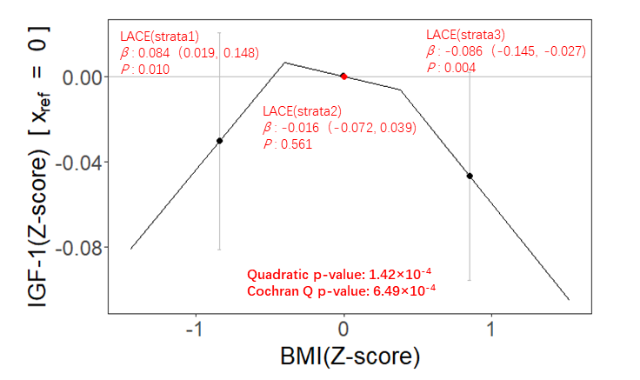
Figure S5. Non-linear Mendelian randomization for robustness verification with the log transformation method.
Notes: BMI-PRS consists of 96 SNPs, the model adjusted for age, sex, assessment center, and top 10 genetic principal components. The red dot represents the reference point of BMI (Z-score=0).

