Supplementary Material
Supplementary Table S1. Worst-state ECOG scores relative to baseline (N=40)
n (%) | Baseline Scores |  |  |  |  |  | Total  No. (%)
n (%) | 0 | 1 | 2 | 3 | 4 | 5 | Total  No. (%)
Worst-state Scores
0 | 25 (69.4) | 3 (8.3) |  |  |  |  | 28 (77.8)
1 |  | 8 (22.2) |  |  |  |  | 8 (22.2)
2
3
4
5
Total | 25 (69.4) | 11 (30.6)
ECOG, Eastern Cooperative Oncology Group.
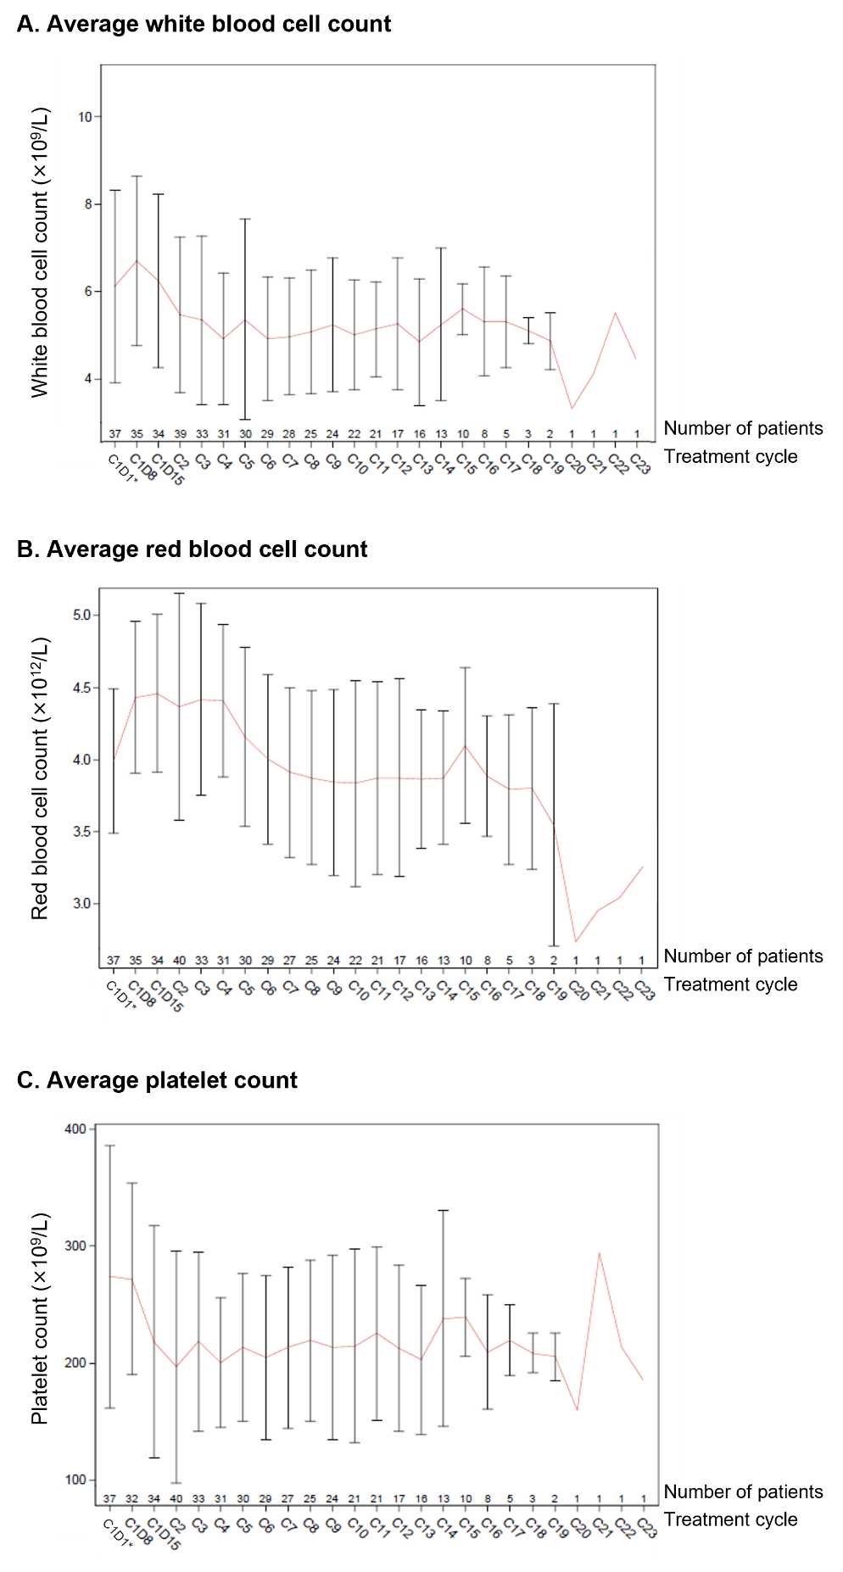
Supplemental Figure S1. Complete blood count in the intention-to-treat population (N=40). *For some patients, the data used were from the screening period.

