Non-invasive monitoring and classification of coronary heart disease by metabolomics and lipidomics
Zhicai Wang^{1,2,†}, Yan Cang^{1,†}, Yan Li³, Yi Zhang^{1,2}, Junyuan Hu³, Yawei Xu^{1,2}, Li Liu^{3, #}, Zheng Liu^{1,2,4,#}

¹ Department of Cardiology, Shanghai Tenth People’s Hospital, Tongji University School of Medicine, Shanghai, China.
² Pan-Vascular Research Institute, Heart, Lung, and Blood Center, Tongji University School of Medicine, Shanghai, China.
³ Metanotitia Inc., Shenzhen, China.
⁴ Cryo-electron Microscopy Center, Southern University of Science and Technology, Shenzhen, China
† These authors contributed equally: Zhicai Wang and Yan Cang
# Corresponding authors
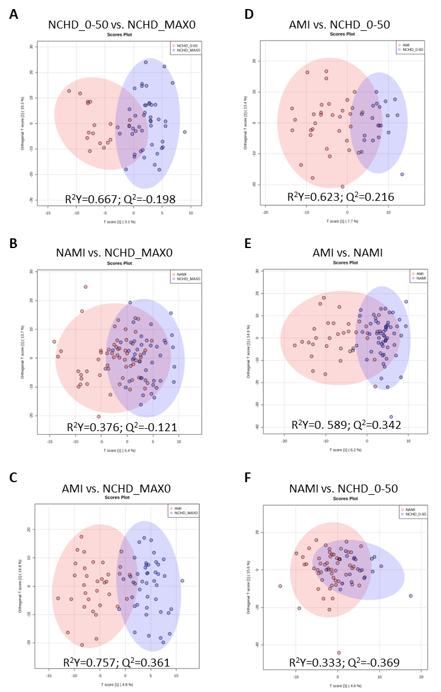
Figure S1. Classification of suspected CHD sub-groups.
The orthogonal projection to latent structure-discriminant analysis (OPLSDA) score plots compared (A) NCHD_0-50 to NCHD_MAX0, (B) NAMI to NCHD_MAX0, (C) AMI to NCHD_MAX0, (D) AMI to NCHD_0-50, （E）AMI to NAMI, and (F) NAMI to NCHD_0-50.
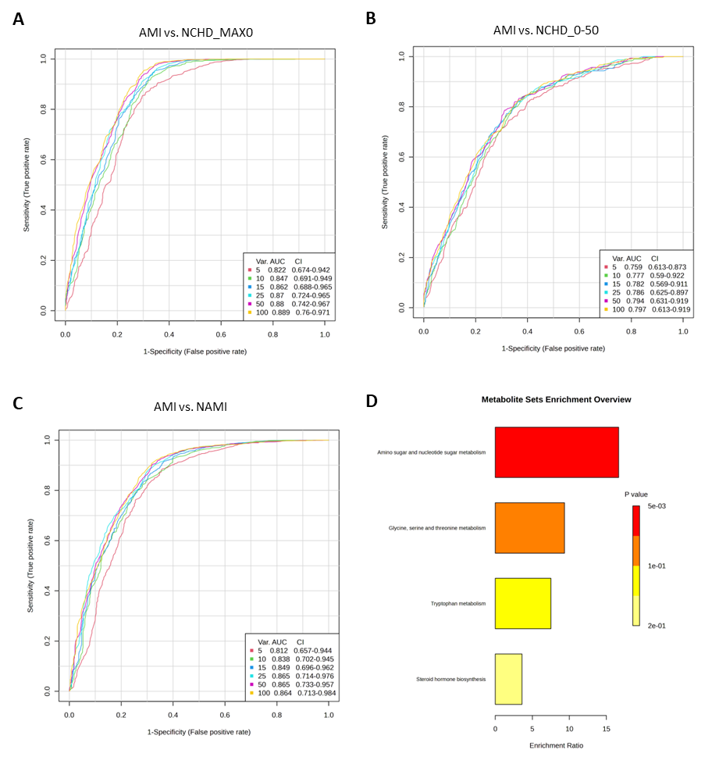
Figure S2. Putative diagnostic biomarkers of AMI.
ROC analysis was generated by Monte-Carlo cross validation (MCCV) using balanced sub-sampling (MetaboAnalyst 5.0 (https://www.metaboanalyst.ca/). In each MCCV, two thirds (2/3) of the samples were used to evaluate the feature importance. The top 2, 3, 5, 10 ...100 (max) important features were then used to build classification models which was validated on the 1/3 the samples that were left out. The procedure was repeated multiple times to calculate the performance and confidence interval of each model. The area under the ROC curve reflected the diagnostic value of (A) AMI vs. NCHD_MAX0, (B) AMI vs. NCHD_0-50, (C) AMI vs. NAMI. (D) Pathway enrichment analysis of shared markers from (A), (B) and (C)). Detail was provided in supplementary table 5.

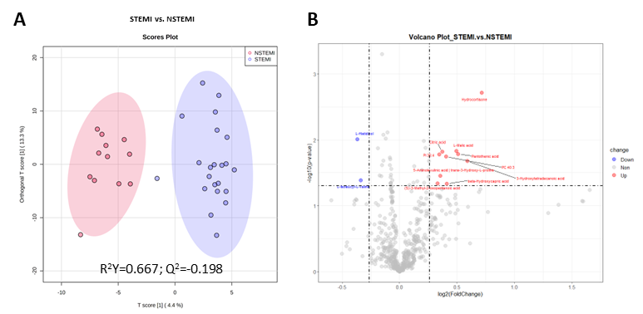
Figure S3. Classification of STEMI and NSTEMI.
(A) Scores plot of OPLSDA analyses of STEMI vs. NSTEMI. (B) Volcano plots of different metabolites compared STEMI to NSTEMI. Red and blue dots present accumulated and depleted metabolites, separately, and grey means no significance (|Log2FC| > 0.25, p < 0.05).

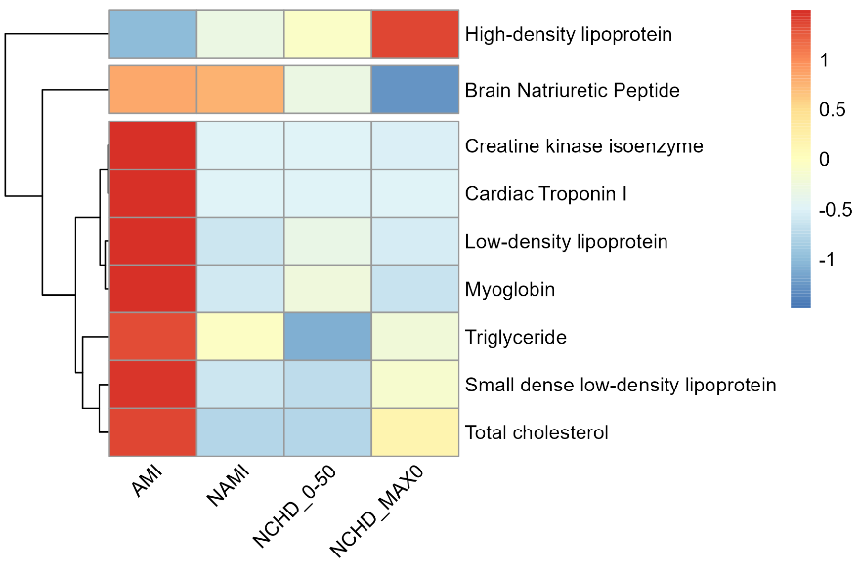
Figure S4. Relative intensity of clinical parameters in sub-groups.
The hierarchical cluster analysis was based on the scaled intensity of clinical parameters, which were filtered with a 70% coverage cut-off.

